Isabel Wyss

Homework: Week 5

1. **Proportional harvesting:** Suppose that a population grows according to the logistic model, but is harvested at a rate proportional to the size of the population. The differential equation

x' = 1.25 x -0.16 x^2 -h x

models such a population where h is the harvesting constant. Use Phaser' Xi vs Time view with default Algorithm Dormand-Prince 5(4) and the step size 0.01. Show that

If h > 1.25, then, regardless of initial population size, such a population tends towards extinction. Try several such h values and several initial conditions.

* What happens to the population for h = 1.25 ?
* What happens to the population if 0 < h < 1.25?

When h > 1.25, the value of the initial conditions or the h value have no effect, as they will all reach zero (extinction) eventually. In the graph below, h = 5 and there are three different initial conditions which all head towards zero, extinction.

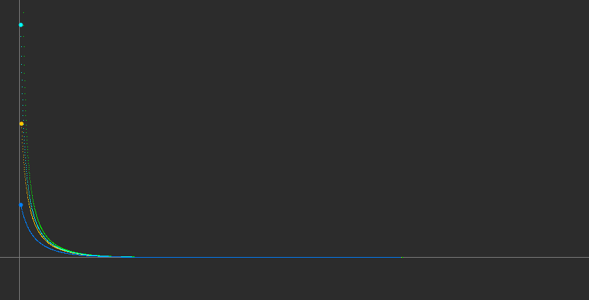

When h = 1.25, the populations still eventually head towards extinction, but take much more time to do so, as shown in the graph below.

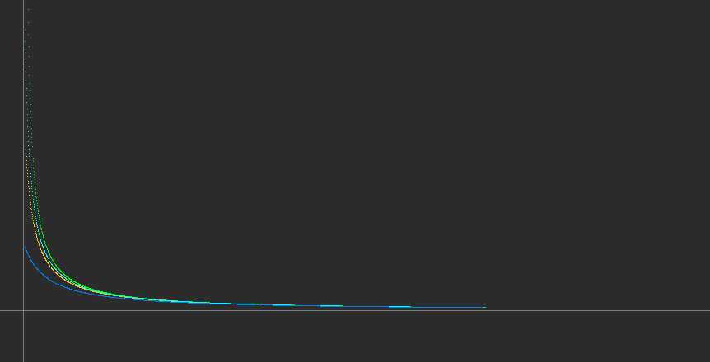

When 0 < h < 1.25, the populations adjust themselves until they have reached an asymptotically stable point, at y = 5, which shows equilibrium. In the graph below, h = 0.5.

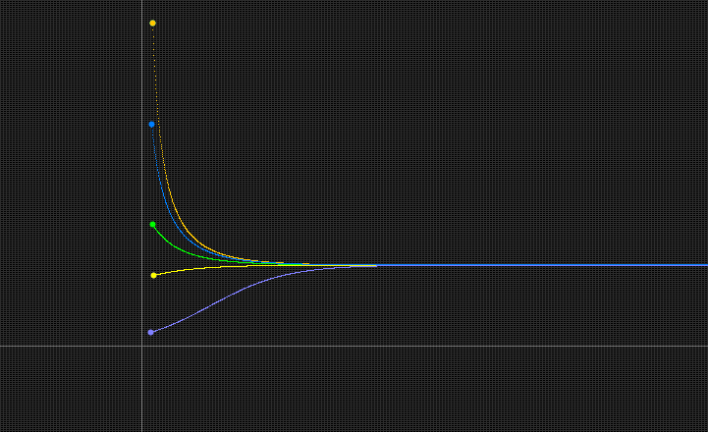

**2. Another form of Logistic:** Consider the continuous analog of the logistic model using the ODE:

x' = r x (1 - x/k)

where x(t) is the population size at time t, r (growth rate) and k (carrying capacity) are positive parameters. This form of the Logistic ODE is preferred by ecologists.

* + Find the equilibrium points and determine their stability types using the Linearization Theorem for the positive values of the parameters.
  + For r = 1 and k = 1.5, several solutions of this equation with various initial conditions are displayed in the picture below. Describe what happens to the population as the initial population size varies.
  + Download the following phaser Project file [logisticODE.ppf](http://www.math.miami.edu/~hk/csc210/week5/logisticODE.ppf) by just clicking on it ( or by right-click and save it to our computer. Now load this file into Phaser). You should see the following XivsTime view:

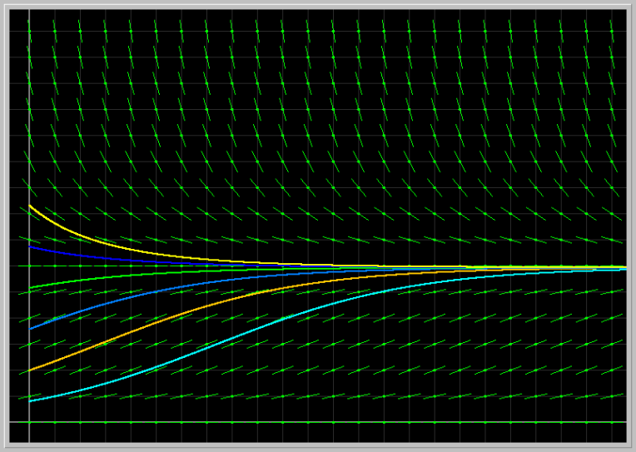

* + Fix the parameter r = 1 and vary the parameter k from 0.5 to 3.0. Next fix k = 1.5 and vary r from 0.5 to 4.0. Describe the results of your experiments from the biological viewpoint.

dx/dt = rx*(-1/k)+(1-1/k)*x

dx/d t= -(r/k)*x+x-(x/k)

* When r =1 and k=1.5:

dx/dt = -(1/1.5)*x+x-(x/1.5)

dx/dt = -1/3x

-1/3x = 0

x = 0

x= r*x1(1-x/k)=0

* Equilibrium points: at x = 0 and x =k

x’’= r-2*r*x1/k → x’’ (0) = r → x’’ (k) = -r

* 0 = unstable equilibrium point, k = asymptotically stable equilibrium point

Varying k from 0.5 to 3.0:

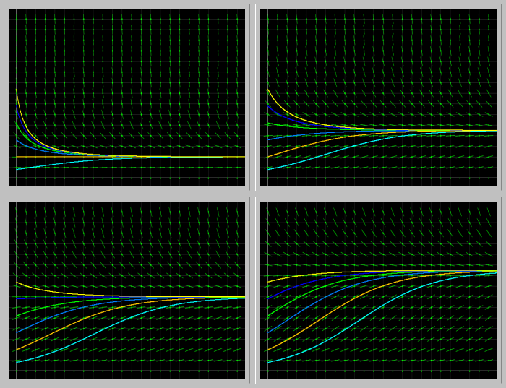

In this situation, the fixed point is the same as the carrying capacity (k). This means that when k is varied, the fixed point also does so. This is because as the carrying capacity of the population is shifted, either increased or decreased, the asymptotically stable fixed point shifts accordingly.

Varying r from 0.5 to 4.0:

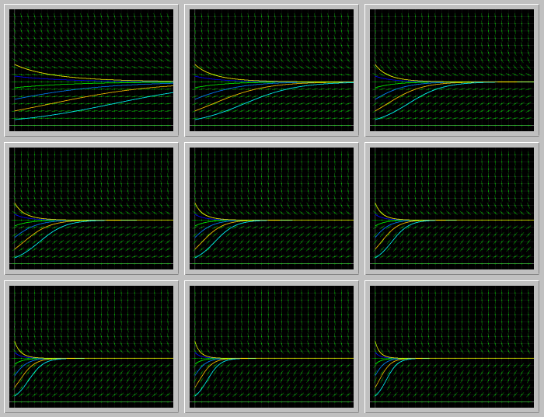

In this situation, the carrying capacity (k) does not change as the growth rate (r) of the population changes. As time goes on, the the growth rate eventually converges to the population’s carrying capacity.

**3. Gompertz model of cancer growth:** The differential equation

x' = a*(exp(-b*t))*x

is used to describe the growth of a tumor, where x(t) is a measure of its size (e.g. weight or number of cells), and a and b are parameters specific to a particular tumor. To get started, let us take a = 3 and b = 2, and x(0) = 5; the solution in the Xi vs Time view is shown in the image below.

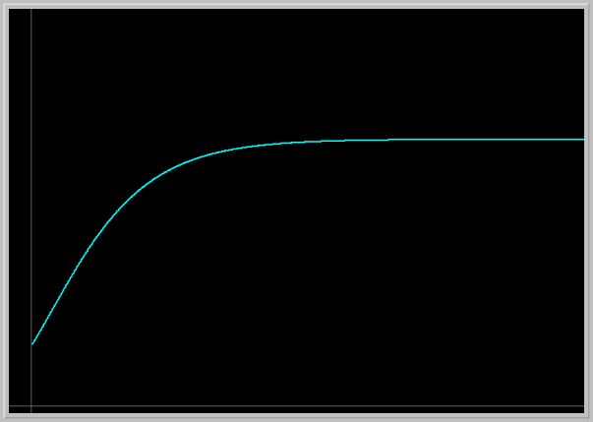

Load the image into your PHASER by clicking on the picture. This picture is not to scale. Adjust the Window size to get a true aspect ratio and draw the Direction Field. Using the Direction Field and solution curves answer the following questions.

Explain what this model predicts for the tumor growth. Experiment with several different initial tumor sizes. How does the future size of tumor depend on its initial size?

Experiment with several values of the parameters a and b. Explain the roles of these parameters in the tumor growth.

Consult the famous article "Dynamics of Tumor Growth" by A.K. Laird in British Journal of Cancer (1964) 18, 490-502. doi:10.1038/bjc.1964.55

Verify that the formula for Gompertz curve x = x_0 exp((a/b)(1 - exp(-bt)) that she gives in this article satisfies Gompertz's differential equation above.

* The growth of the tumor is dependent its initial size. The bigger the initial size is at the beginning, the more the tumor grows. The smaller the initial size is, the less tumor growth can be seen.
* There is a limit to how much the tumor can grow in your body, as it can not grow indefinitely, and eventually plateaus to a stable point as seen on the graph on Phaser.
* Several conditions were tested, it can be seen through the direction fields that despite the initial conditions, the graph will lead to a stabilizing point. However, the bigger the size *y), the bigger the tumor becomes before it stops growing
* Varying a → As a becomes larger, tumor also grows larger larger
* Varying b → As b becomes larger, the tumor becomes smaller due to the differential equation x' = a*(exp(-b*t))*x. As b or t increases, the ratio becomes smaller and therefore the tumor grows less

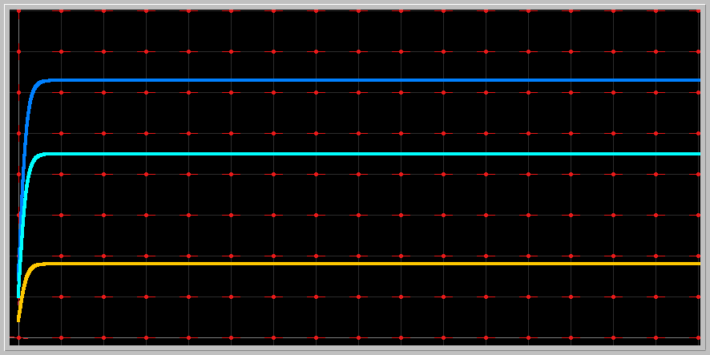

**4. Epidemics:** For certain infectious diseases, a susceptible individual becomes infected and then either dies or recovers with immunity to the disease. Let S(t) denote the number of susceptible individuals and I(t) the number of infections in a population of fixed size. The change in the numbers of susceptibles and infecteds is often modeled (Kermack-McKendrick) with the pair of differential equations

S' = -r*S*I

I' = r*S*I - a*I

where the parameters r (infection rate) and a (death or recovery rate) take on nonnegative values.

The problem is to determine how the number of infected individuals change in time. If the number of infected individuals increase from the initial value I_0 at some some point in future time, then we say that an epidemic occurs.

* + Enter these equations into Phaser. Set a = 0.6 and r = 0.003, and the initial number of infected individuals I_0 =20. Using the Xi-Values and Xi-vs-Time views, answer the following questions.
  + If the initial number of Suceptibles S_0 is small enough, infecteds I(t) decreases from I_0 monotonically to zero --- no epidemics. If S_0 is suffciently large, the infected population first increases from I_0 to some maximum value before it dies out --- epidemics. What is the smallest number of suceptibles S_0 for which epidemics occur? This is called the threshold value for an epidemic to occur.

The smallest number of susceptibles S_0 for which epidemics occur: 200 → threshold value for an epidemic

* + How does the threshold value depend on the parameters a and r?

Threshold value depends on a and r because if r, the infection rate, is too big, then a needs to also be bigger, or the population will become extinct. The threshold signifies the point until which a can account for r, or the recovery rate can account for the infection rate.