Hannah Machado

CSC 210

March 2nd, 2017

*Homework 5*

**1.Proportional harvesting:** Suppose that a population grows according to the logistic model, but is harvested at a rate proportional to the size of the population. The differential equation

x' = 1.25 x -0.16 x^2 -h x

models such a population where h is the harvesting constant. Use Phaser' XivsTime view with default Algorithm Dormand-Prince 5(4) and the step size 0.01. Show that

If h > 1.25, then, regardless of initial population size, such a population tends towards extinction. Try several such h values and several initial conditions.

What happens to the population for h = 1.25 ?

What happens to the population if 0 < h < 1.25?

If h>1.25, it does not matter the initial conditions or the actual value of h. Eventually, they will all reach zero, or extinction. In the graph below, h=4 and several initial conditions tend to 0 (extinction) proving the statement.

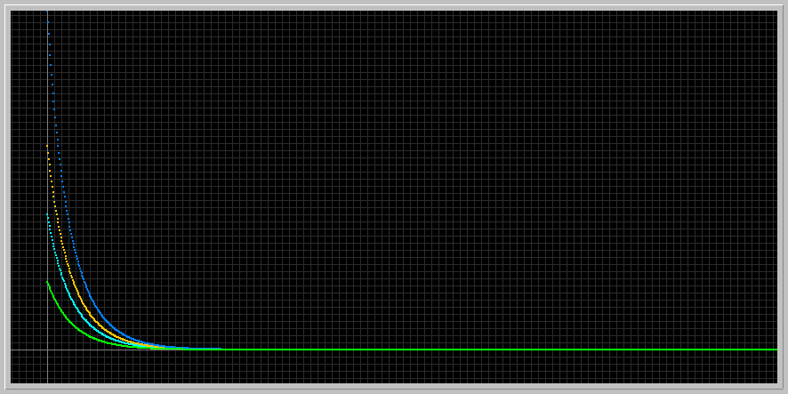

When h=1.25, populations take more time, since the graph is scaled a lot larger in phaser, but will also eventually go toward zero, or extinction. The graph below proves so

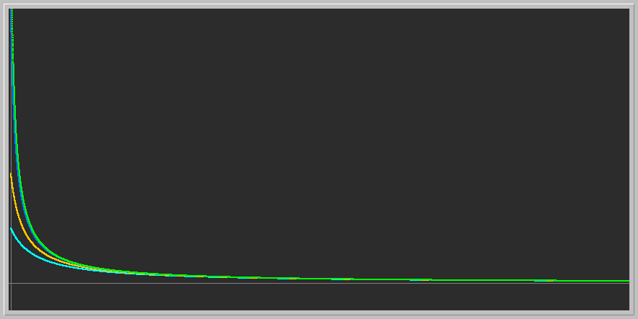

Finally, when 0<h<1.25, the populations adjust until they reach an asymptotically stable point at y=1.5 where they stay equilibrium. In the graph below, h=1 and the initial points from below and above all stabilize to the same stability point

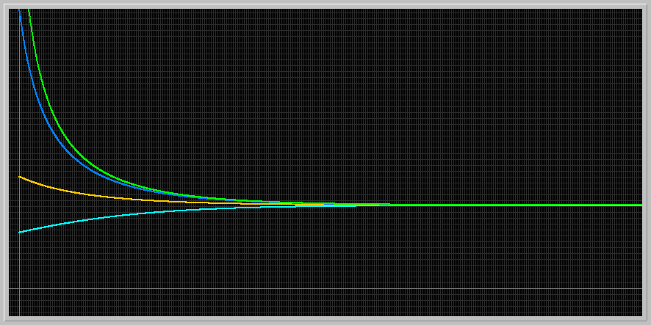

**2.Predator-Prey model:** Consider the generalized predator-prey (as it appears in Phaser ODE Library)

x1' = x1*(a - b*x2 - m*x1)

x2' = x2(c - d*x1 - n*x2),

where the parameters take on nonnegative values.

* Take a = 1.5, b = 1.1, c = 1, d = 1, m = 0, n = 0, and the initial population sizes x1 = 1.5, x2 = 0.7. Determine the period and the amplitudes of the prey and predator populations.

For prey:

Period: 7.107308 - 0.703016= 5.4135

Amplitude: (2.099045 - 0.366348)/2= 0.86634

For predator :

Period: 6.116589 - 1.693735= 4.4228

Amplitude: (2.558472 - 0.628878)/2= 0.964797

GRAPH:

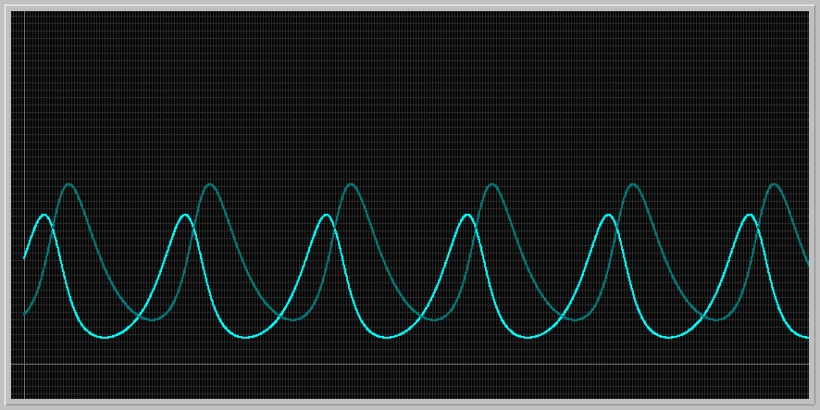

* Using the the same setting as above, increase m from 0 to 3. What happens to the populations?

When m is increased from 0 to 3, the population oscillates a little but eventually the predator dies out and prey grows until it reaches its carrying capacity, where it stabilizes (like the logistic model). Since a population cannot grow more than its carrying capacity, it stabilizes at that point.

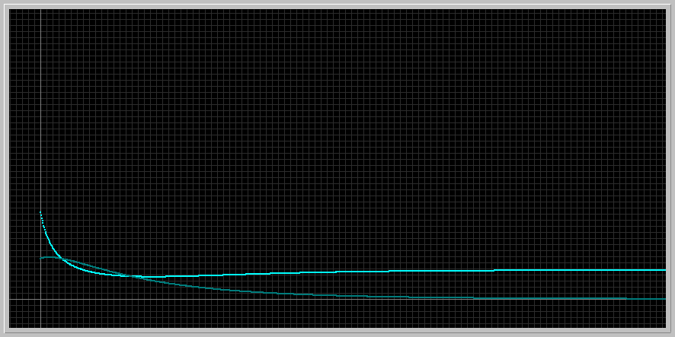

* This time, reset m = 0 and increase n from 0 to 3. What happens to the populations?

When n is set to 3, the predator grows to a point where the predator-prey ratio instead of oscillating stabilizes. If the predator grows a bit more it will probably overcomes the prey, but as it is there is an equilibrium on the amount of predator to the amount of prey.

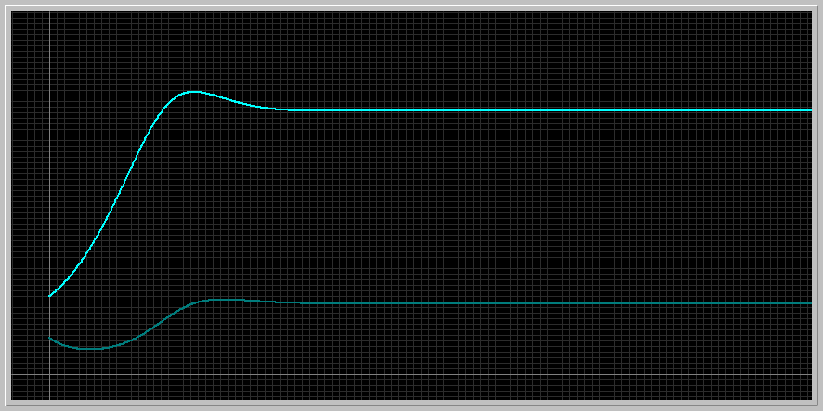

**3.Another form of Logistic:** Consider the continuous analog of the logistic model using the ODE:

x' = r x (1 - x/k)

where x(t) is the population size at time t, r (growth rate) and k (carrying capacity) are positive parameters. This form of the Logistic ODE is preferred by ecologists.

* Find the equilibrium points and determine their stability types using the Linearization Theorem for the positive values of the parameters.
* For r = 1 and k = 1.5, several solutions of this equation with various initial conditions are displayed in the picture below. Describe what happens to the population as the initial population size varies.
* Download the following phaser Project file [logisticODE.ppf](http://www.math.miami.edu/~hk/csc210/week5/logisticODE.ppf) by just clicking on it ( or by right-click and save it to our computer. Now load this file into Phaser). You should see the following XivsTime view
* 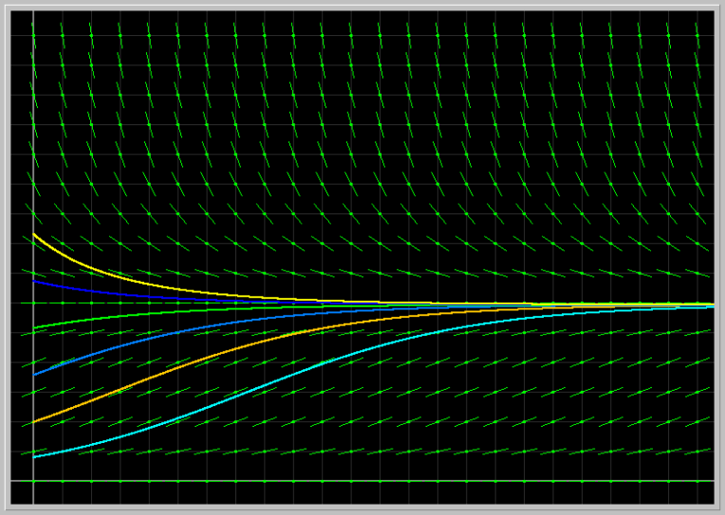
* Fix the parameter r = 1 and vary the parameter k from 0.5 to 3.0. Next fix k = 1.5 and vary r from 0.5 to 4.0. Describe the results of your experiments from the biological viewpoint.

dx/dt= rx*(-1/k)+(1-1/k)*x

dx/dt= -(r/k)*x+x-(x/k)

When r=1 and k=1.5

dx/dt= -(1/1.5)*x+x-(x/1.5)

dx/dt= -1/3x

-1/3x=0

x=0. Since it is <1. The point at k=1.5 is an asymptotically stable fixed point. Another one would be at zero, but it is not biologically relevant since there is no population existent at 0. The graphs below prove the statement.

Varying k:

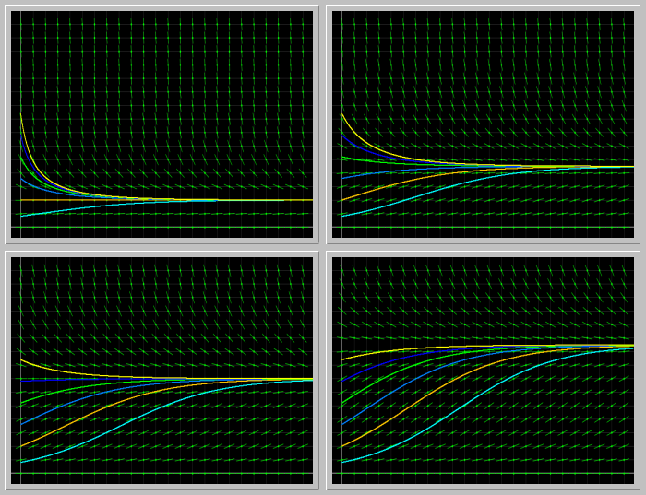

Here, the fixed point is the carrying capacity, so if you move the k, the fixed point also has to move, because you are shifting the carrying capacity of the population, the asymptotically fixed point shifts accordingly. If the carrying capacity increases, the fixed point increases , and so on. The graph above shows a gallery of the increment of k.

Varying r:

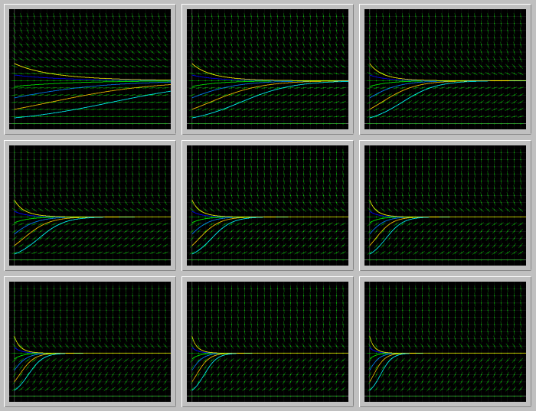

Despite the change in r, which is the growth rate, the carrying capacity does not change, so even though the population may grow faster, it will stop at its carrying capacity. The growth rate eventually converges to the population’s carrying capacity

**4.Gompertz model of cancer growth:** The differential equation

x' = a*(exp(-b*t))*x

is used to describe the growth of a tumor, where x(t) is a measure of its size (e.g. weight or number of cells), and a and b are parameters specific to a particular tumor. To get started, let us take a = 3 and b = 2, and x(0) = 5; the solution in the XivsTime view is shown in the image below.

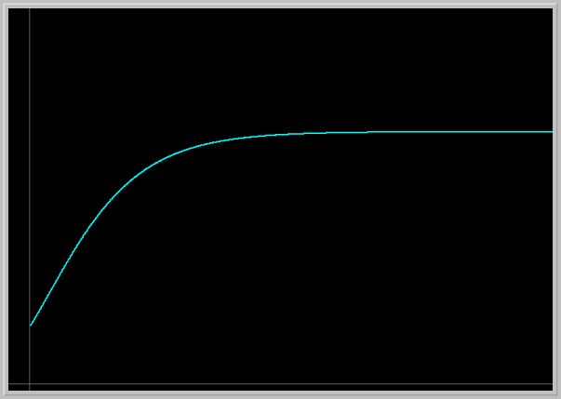

Load the image into your PHASER by clicking on the picture. This picture is not to scale. Adjust the Window size to get a true aspect ratio and draw the Direction Field. Using the Direction Field and solution curves answer the following questions.

Explain what this model predicts for the tumor growth. Experiment with several different initial tumor sizes. How does the future size of tumor depend on its initial size?

Experiment with several values of the parameters a and b. Explain the roles of these parameters in the tumor growth.

You may want to consult the famous article "Dynamics of Tumor Growth" by A.K. Laird in British Journal of Cancer (1964) 18, 490-502. doi:10.1038/bjc.1964.55

The tumor grows depending on its initial size. The bigger it is in the beginning, the more it grows and the smaller it is, the less it grows. There is a limit, however, to how much it can grow. The limits of your body, for example, do not allow a tumor grow more than a certain size, so it plateaus into a stable point, which is shown on the graph. Several conditions were tested and the direction fields show us that no matter where you start there will be a stabilizing point, but the higher up you start in the y value (size), the bigger it gets before it stops growing

Varying A- As it gets larger, tumor gets larger

Varying B- inverse effect, as it gets larger, the tumor gets smaller because the equation is f(x)= a*1/e^bt as b or t grows, the bottom grow part of the division grows, making ratio smaller and consequently the tumor will grow less.

