**Hannah Machado**

**CSC210**

**Apr. 5, 2017**

**# Homework 9**

1. **Multiplication table:** Write an R code that prints out the 9x9 multiplication table. For this problem, you need to use two for statements, one inside the other. Separate the entries on a line of the table with tabs.

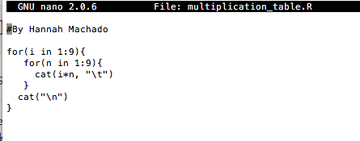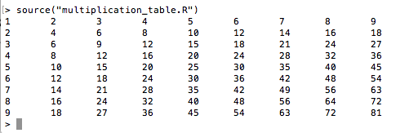

2. **Logistic XivsTime plot:** Please write an R code to recreate the picture below. Use a for loop to iterate with the logistic map with the indicated initial condition and parameter. In plotting, make sure to get the initial point right.

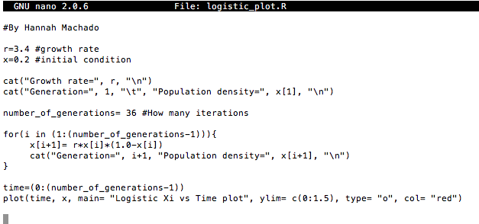

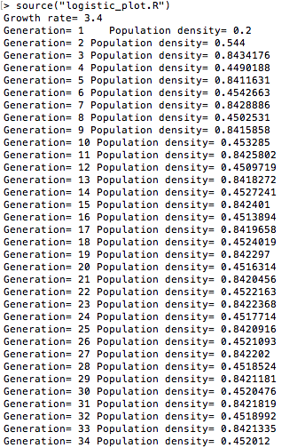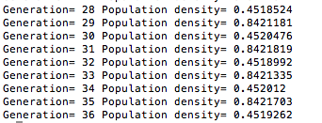

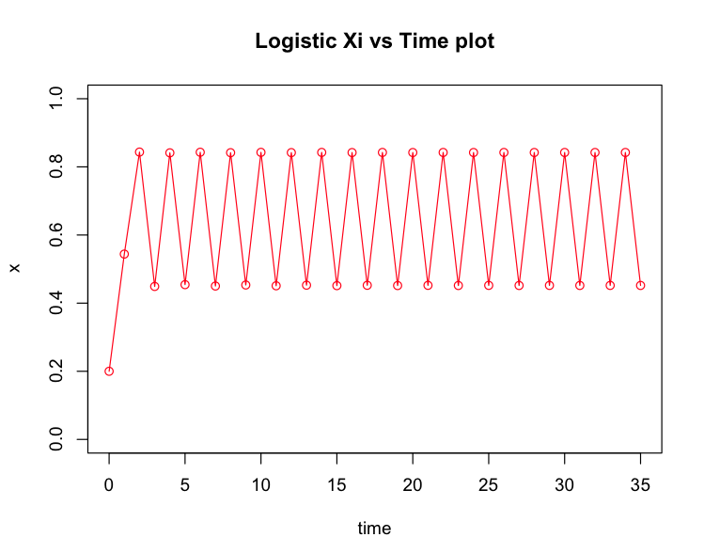

3. **Computing with Euler:** Write an R code that computes the solution of the frictionless planar pendulum with Euler's algorithm. Take step_size = 0.1, number_of_steps = 200. Set the parameters in the pendulum as g = 1, L = 1.3, initial_position = 0.7, initial_velocity = 0.0. Plot the position and the angular velocity of the pendulum vs. time, as shown in the figure below. Note: after you plot the position variable with plot(...), you can add the velocity using points(...) function of R. You might look at some of the sample R codes below.

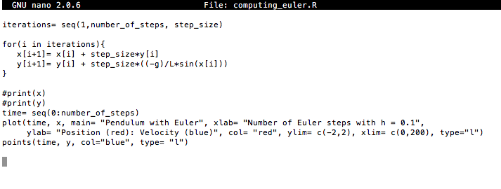

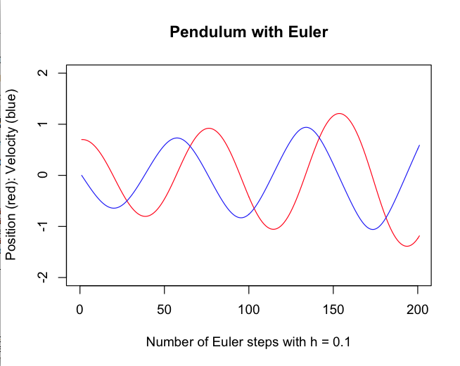

4. Write an R code that asks the user to enter an integer. Your code should print out whether the number is odd or even. You should use the %% operator of R. a%%b gives the remainder of the division a/b. For example: 21%%2 is 1, but 22%%2 is 0.

