Hannah Machado

CSC 210

April. 27th, 2017

#Homework 12

1. **Keyboard inputs:** Write a Perl program that asks the user to enter a DNA sequence from the keyboard and captures the sequence in a variable. Next, your program should ask the user for a second shorter DNA sequence to be entered. Now, your program should report if the second sequence is a substring of the first string

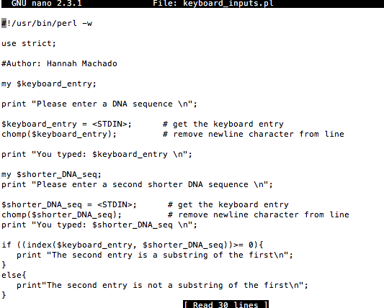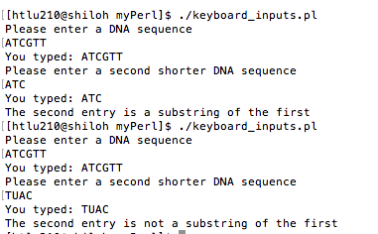

2. **Arguments as input:** Write a Perl program that takes two strings as command-line arguments and reports if the second argument is a substring of the first argument.

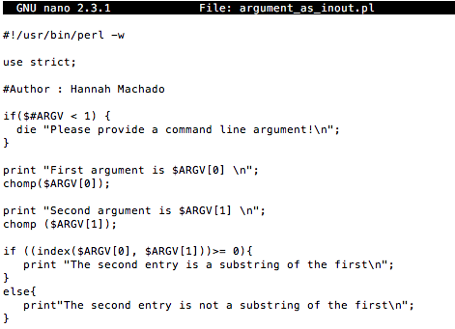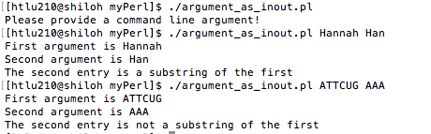

3. **Counting Zika virus genome bps:** Download the FASTA file (NC_012532.1) containing the [Zika virus genome](http://www.ncbi.nlm.nih.gov/nuccore/NC_012532.1?report=fasta&to=10794). (You can use the "Send" widget on the upper-right corner of the NCBI Web page containing the genome to download a FASTA file.) Now, write a Perl program that reads the file, stores the sequence without white characters (spaces, end-of-line, etc.), and prints out the number of nucleotides (bps) in the complete Zika virus genome.

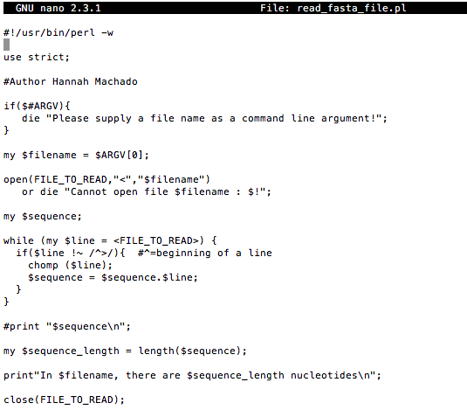



**4. Logistic growth model:** Consider the discrete logistic model

x[n+1] = r * x[n] * (1.0 - x[n])

governing the growth of a single population with non-overlapping generations. Here, r is the growth rate and x[n] is the density of the n-th generation. Fix the growth rate r = 3.1 and initial population density x[0] = 0.43. Write a Perl program that computes the population densities for 12 generations and writes them out to a file, each generation and its population density on a separate line, as below:

At year 0, the population density is 0.43  
At year 1, the population density is ...

