**Hannah Machado**

**CSC 210**

**March, 23, 2017**

**Homework 7**

**1.Small angle approximation:**

* The Second-order differential equation given by x''=(-g/l)x is the small angle approximation to the pendulum equation by replacing sin(x) with x.
* Convert this 2nd-order ODE to a pair of first order differential equations. Enter your pair of ODEs into Phaser Custom Equation Library.
* Set g=l=1 and start the pendulum with 14 degrees displacement and release. Determine the period of the oscillations in the nonlinear pendulum equation (use Pendulum ODE in Phaser) and in the small angle approximation. What is the difference in the periods?
* Set g=l=1 and start the pendulum with 81 degrees displacement and release. Determine the period of the oscillations in the nonlinear pendulum equation and in the small angle approximation. What is the difference in the periods?

take the second order eq and convert to a pair of first order eqs

enter in phaser

x1=x

x2=x’

x1’=x2

x2’= (-g/l)x1

This is the graph of the custom equation in Phaser:

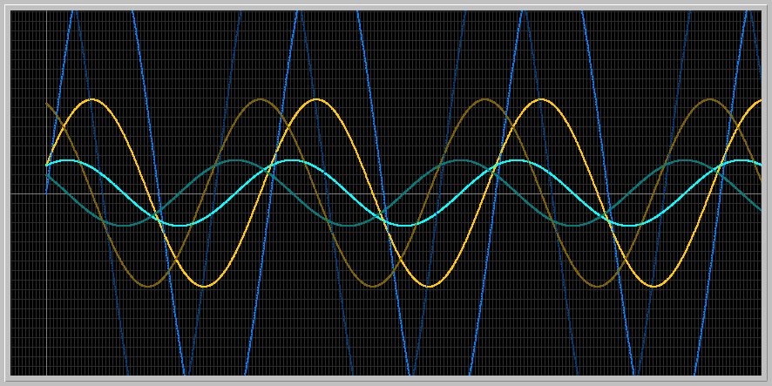

Graph using Pendulum ODE in Phaser

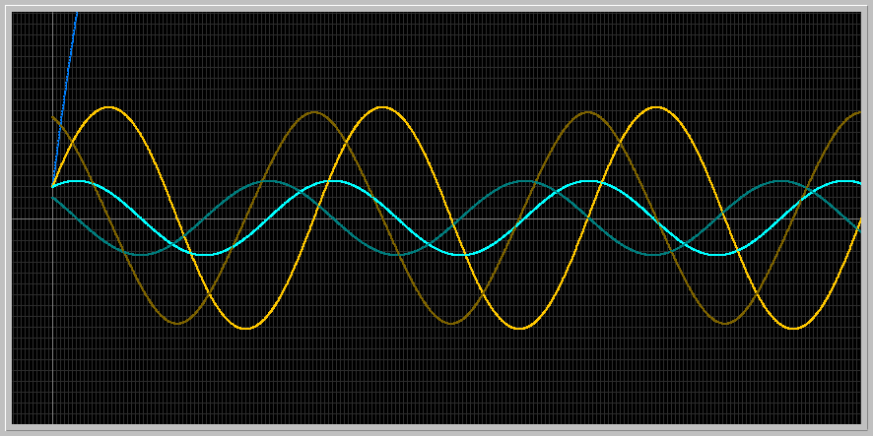

With these two graphs it is observable that the approximation used is good for small angles (green and yellow lines) but not for big angles (dark blue). The approximation gives an oscillatory motion while the actual pendulum ODE gives more of an exponential function, meaning the pendulum is unbound. The periods in the linear pendulum are be independent of the initial condition, so that may account for these results.

**2.Lunar Pendulum:**

* In the pendulum equation in PHASER set m = 1.2, l = 1.3, and g = 1. Note that x1 is the angular position and x2 is the angular velocity of the pendulum. What is the period of the pendulum motion starting with initial angle of 1.2 radians and zero velocity? To increase the period by 15% how much do you need to change the length of the pendulum? Use the Xi vs Time view to determine the period.

15.7366-7.8921= 7.8445 is the period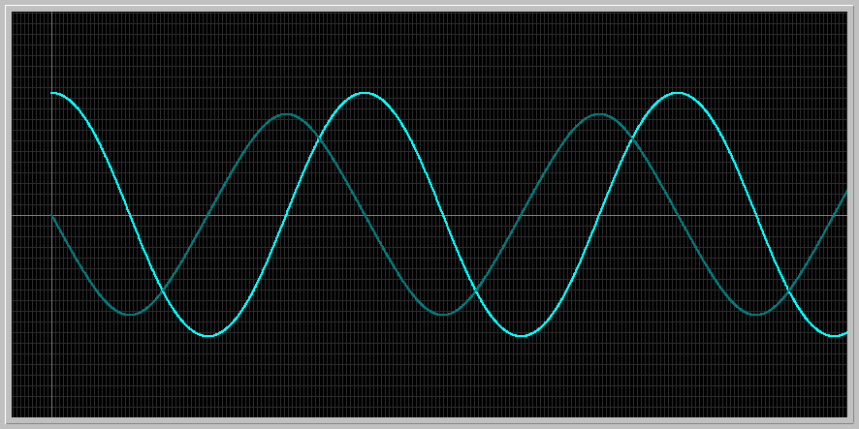

When l is increased from 1.3 to 1.7, the new period turns out to be want it to be

17.9779- 8.9640= 9.0139, which is about 15% more than the previous period of 7.8445

* If you take your grandfather's clock to the moon, does it slow down or speed up? By how much? (You need to look up the value of g for the moon relative to earth.)

It slows down. Since the gravity in the moon is only 17% of that on earth, the clock will slow down and the new period will increase to about 19.4872 under the same conditions stated in the question.

**3.Over the top:** In the pendulum equation in Phaser set m = 1.4, l = 1.3, and g = 1. Assume that pendulum is at its stable equilibrium position. How much minimal initial velocity do you need to impart on the bob so that the pendulum goes over the top? Does this initial velocity depend on the length of the pendulum? Does it depend on the mass of the pendulum?

The pendulum is bounded when it keeps oscillating back and forth between positions, but at a certain critical point the graph does not oscillate anymore but rather keeps growing, which means that the pendulum is doing complete turns and adds 2pi every time it goes around. Therefore, the graph looks more like an exponential function rather than oscillation. This initial velocity required so that the pendulum goes over the top does not depend on the mass of the pendulum, meaning that for any m you choose, the same initial velocity will be required to make the pendulum go over the top. If you change the length of the pendulum, however, this velocity does change.

With the assigned numbers in this problem, the graph becomes unbound when the inital velocity is set to 1.74. In this picture, the initial positions are 1.73 for the dark blue line and 1.74 for the green line. The green line does not oscillate periodically, meaning that the pendulum is going around and is unbound.

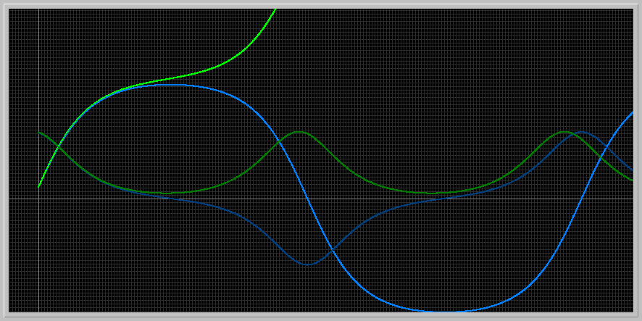

When I keep the angle of the motion and change only the length of the pendulum, the length of the circle that the pendulum has to make to go around increases. Since it has to travel a longer distance, the time increases. This graph shows the same initial velocities with an increase in the length to 1.5. It is observed that now the slower initial velocity is also unbound, meaning that the longer the pendulum, the smaller the initial velocity required for it to go around becomes.

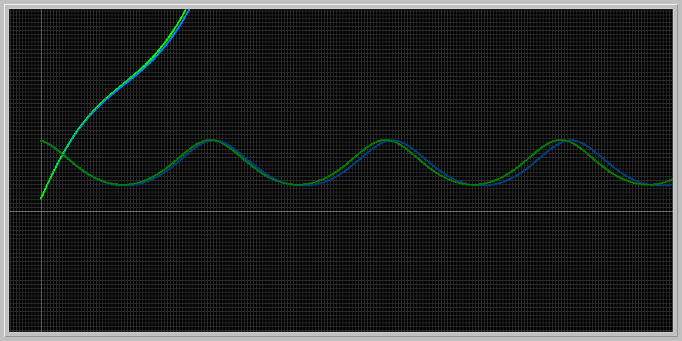

**4.Escape velocity:** For this investigation use the Kepler ODE in the ODE Equation Library of Phaser. Suppose that a particle of mass = 1.1 is positioned at the coordinates (2.2, 0). For this problem, first you should load the equation defaults for Kepler ODE. Then set the appropriate initial conditions to follow the shapes of the orbits.

For m=1.1

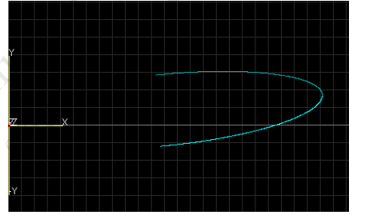

* Use the initial velocity components (0.0, 0.4) and admire the elliptical orbit. Double the mass to m=2.2. Notice that the orbit gets flattened. Find the value of the vertical velocity component (0.4) that gives the previous elliptical orbit with m = 1.1.

The orbit gets more flattened when the mass is doubled to 2.2:

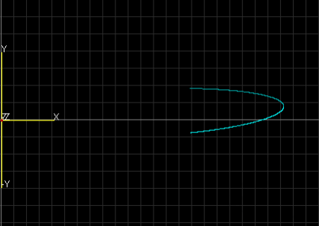

The previous elliptical orbit has a period of 7.5. When doubling the mass to 2.2, the vertical velocity component must be increased from 0.4 to .82.

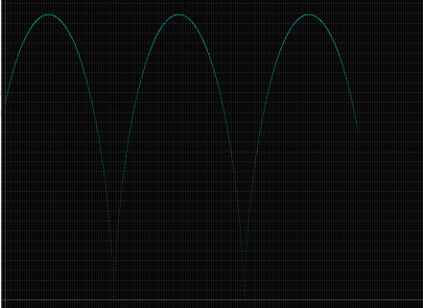

* Set m =1.1 and find the minimum vertical velocity so that the particle escapes to infinity; that is, its orbit ceases to be an ellipse. You might need to use a fairly long time and a big window size to get a good estimate of the vertical escape velocity.

The escape velocity needed is 1.044

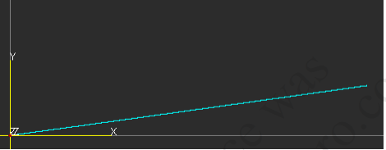

* Next, double the mass of the particle. What is the new escape velocity?

The new escape velocity needed is 1.47

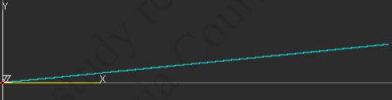

**5.Onset of chaos in the Lorenz Equations:** Load the Lorenz ODE in the ODE library of Phaser. Load the Equation Defaults. Set the parameter value r = 15, leave the other two parameters as they are. Notice that the two solutions approach an equilibrium value. You should be able to see this in Xi Vs. Time and Phaser Portrait views. Now, increase the value of the parameter r gradually. What is the smallest value of r for which the solutions become chaotic? A chaotic solution is one that is not equilibrium or periodic. Although there are sophisticated tests for chaotic solutions, at this point you can decide by inspection if a solution is chaotic. If necessary, you can take longer times.

In the beginning, the solutions approach an equilibrium value, but when r reaches the value of 17, the graph already starts to change, becoming it is still not chaotic, since it is periodic.When r reaches 18, however, it starts being a little chaotic but eventually goes back into equilibrium. In another gallery on the bottom, r is increased by a bigger number, and it is observed again that the graph eventually becomes chaotic when r is around 35

