Hannah Machado

CSC 210

Feb. 23rd, 2017

Homework 4

1. Linear maps in the plane: Consider the linear map in two variables depending on a parameter a:

x1 -> 0.8*x1 + a*x2

x2 -> -a*x1 + 0.8*x2

Notice that the origin is a fixed point for all values of a. Determine the parameter values for which the origin is unstable, stable, or asymptotically stable. Draw phase portraits to support your findings.

Hint: There are two values of the parameter a for which the origin is stable.

Optional: Can you answer the same questions for the linear map:

x1 -> -0.8*x1 + a*x2

x2 -> -a*x1 - 0.8*x2

Stable: a = 0, a = 0.6615 → stable because the graph is spiraling in toward the fixed point

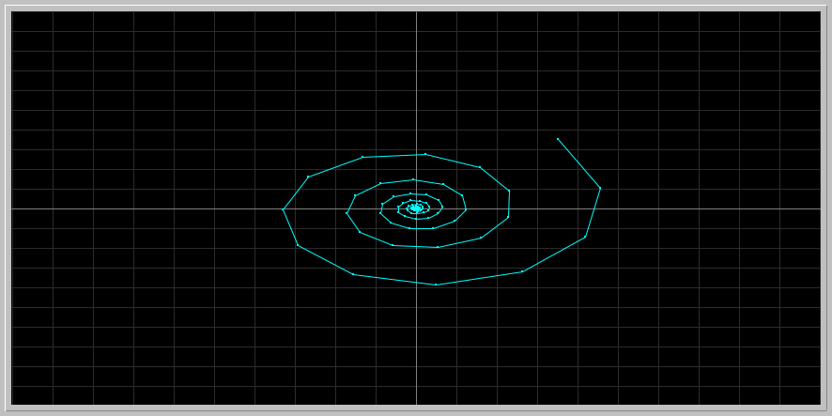

Asymptotically stable: a < 0.6615 → converging toward fixed point (0)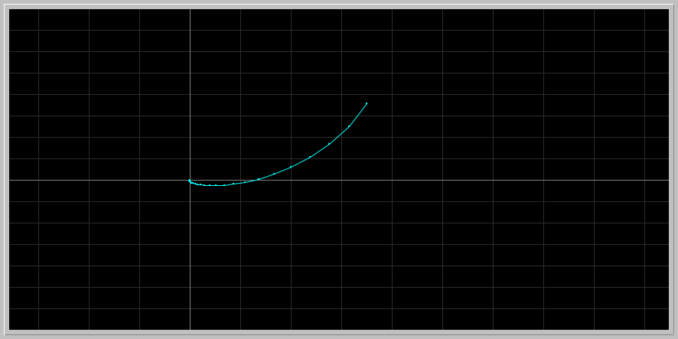

Unstable: a > 0.6615

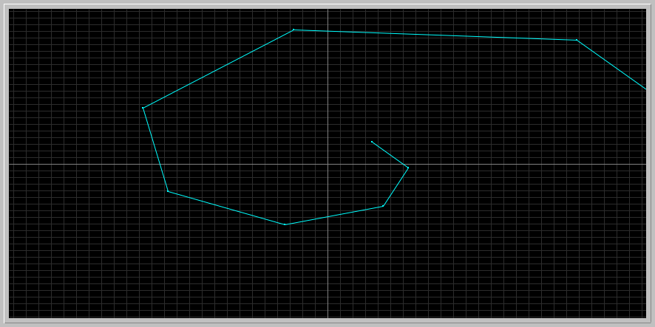

As a conclusion, the points in the graph that are smaller than 1 converge to the fixed point of zero and are stable or asymptotically stable, while at 1 and above they start to diverge, or move away, form the stable fixed point, thus becoming unstable.

2. Bifurcation diagram for Discrete Predator-Prey: Download the following phaser Project file [discrete_pp_bifurcation.ppf](http://www.math.miami.edu/~hk/csc210/week4/discrete_pp_bifurcation.ppf) by just clicking on it ( or by right-click and save it to our computer. Now load this file into Phaser). You should see the following bifurcation diagram:

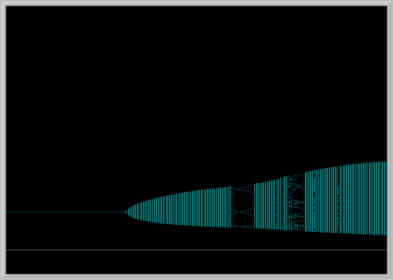

In this diagram, parameter b is fixed and a is varied. The horizontal axis is the parameter a and the vertical axis is the x1 variable (prey). Notice that the prey population is periodic with period 6 in a small window of the bifurcation diagram. Pick an a value in this window and for this value of the parameter a, plot the prey and predator in the Xi vs. Time window, and also in the Phase Portrait view. Is the predator population is periodic also? Interpret your pictures in biological terms.

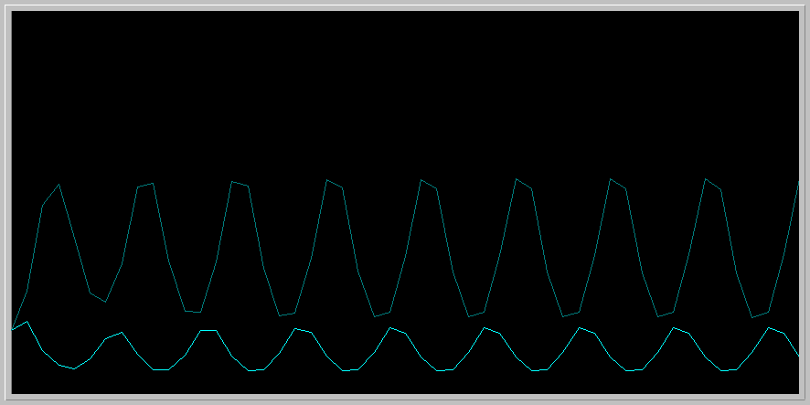

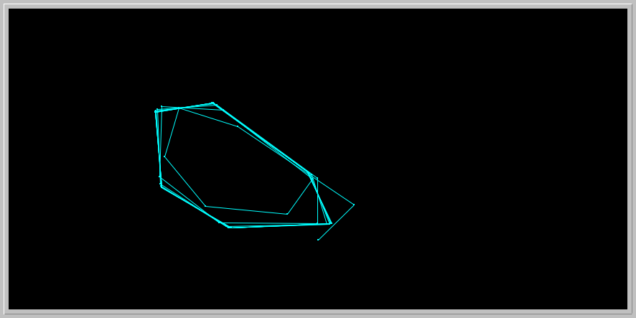

Yes, the predator population is periodic also. From the graphs, it is possible to conclude that as the population of predators increases, that of prey decreases, and vice versa. This makes sense biologically. In the Phase Portrait view, there is a period-6 behavior when you observe the graph slowly, coinciding with the model above. This periodic behavior maintains a stable equilibrium among the populations.

3. Nicholson-Bailey model: The following pair of difference equations is a famous model that describes the interaction of host-parasitoid populations (one insect feeds on another):

Hn+1 = k Hn e( -a Pn )

Pn+1 = c Hn [1 - e( -a Pn ) ]

Variables

Hn : Density of host at generation n

Hn+1 : Density of host at generation n+1

Pn : Density of parasitoid at generation n

Pn+1 : Density of parasitoid at generation n+1

Parameters

k : Reproductive rate of host

a : Searching efficiency constant of parasitoid

c : Average number of viable eggs deposited by parasitoid on a single host

You can read more about this model at [Phaser Web site .](http://www.phaser.com/modules/ecology/nicholson/index.html)

In 1941, Debach and Smith in their laboratory experiment started with 36 housefly, [Musca domestica,](http://en.wikipedia.org/wiki/Housefly) and 18 of its pupal parasite [Nasonia vitripennis](http://www.rochester.edu/College/BIO/labs/WerrenLab/nasonia/) and followed the populations for seven generations. They arranged the fecundity rate of the host to be 2 (k = 2, c = 1), and determined the searching efficiency constant to be a = 0.045. Please read their original paper at the link below:

DE BACH, P. and SMITH, H.S. [1941]. "Are Population Oscillations Inherent in the Host-Parasite Relation?" Ecology, 22, 363-369. [JSTOR URL](http://links.jstor.org/sici?sici=0012-9658%28194110%2922%3A4%3C363%3AAPOIIT%3E2.0.CO%3B2-X)

In particular examine their data on Table I on page 367 and Figure 1 on page 368 of their article. Their Figure 1 looks like the following Phaser view: Download the following phaser Project file [debach_smith.ppf](http://www.math.miami.edu/~hk/csc210/week4/debach_smith.ppf) by just clicking on it ( or by right-click and save it to our computer. Now load this file into Phaser).

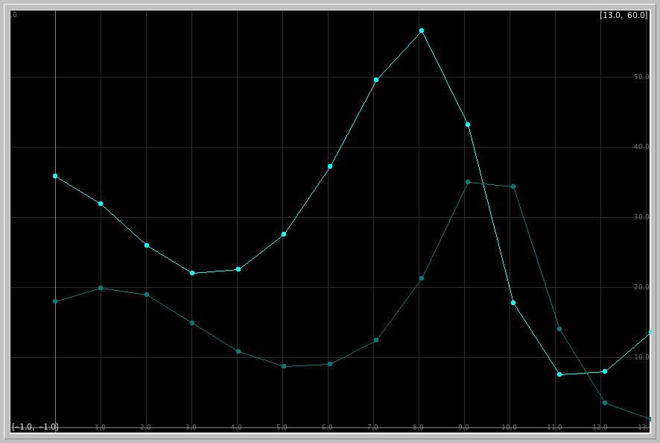

What is the experimental count of the host and parasitoid in the second and fifth generations in the paper of DeBach and Smith?

What does the Phaser simulation of the Nicholson-Bailey model predict for these counts?

What are the relative errors in the model predictions?

DeBach paper prediction:

For 2nd generation:

host: 26

Parasite: 18

For 5th generation:

host: 29

parasite: 9

Phaser simulation prediction:

For 2nd generation:

host: 26.0787

Parasite: 18.9451

For 5th generation:

host: 28.1169

parasite: 8.7541

Both models obtained very close values of the same conditions. As the population of parasites rises slowly on the first generations, the number of hosts decreases. Because of this, the parasites begin to not find enough hosts for all of them, and therefore start decreasing, while the host population rises again, to a bigger extent. When both lines cross there is a ratio of 1:1, which would be equilibrium. Relative errors account for the fact that a and k are approximated, but the relative population densities are periodical

4. Radioisotopes used in nuclear medicine: Investigate which radioisotopes are used in nuclear medicine. Select one used in Positron Emission Tomography (PET) imaging, and another one in radiotheraphy for cancer treatment. Look up their half-lives. Use Phaser and the ODE x1' = k*x1, determine the decay constants k of the two radioisotopes you have selected. Use at least two initial conditions for each to make sure that k does not depend on the initial amount. Here is a link to get you started on [radioisotopes in nuclear medicine.](https://www.radiochemistry.org/nuclearmedicine/radioisotopes/01_isotopes.shtml)

PET- fluorine-18: half life of 109.8 minutes k= 0.00010519

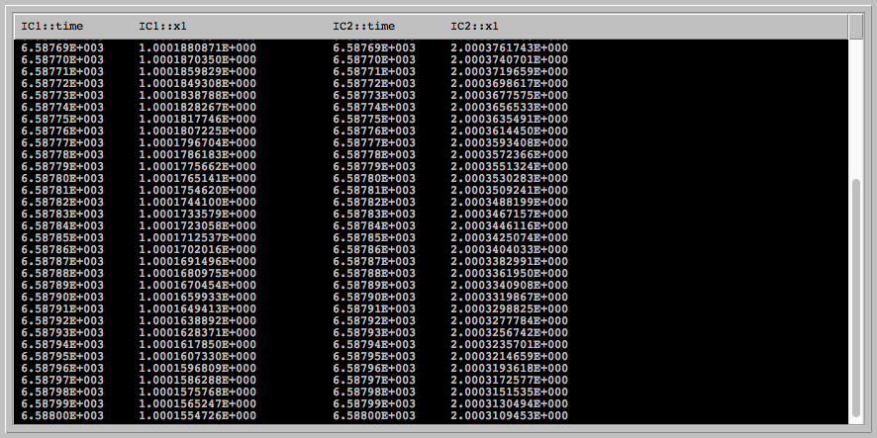

Radiotheraphy- strontium-89: Half life of 50.5 days k= 2.64 *10^-9

