**Hannah Machado**

**CSC210**

**Homework 3**

**Feb. 16, 2017**

1. **Sensitive dependence on initial conditions:** In the Logistic model, first set a = 2.25. Now take two initial population sizes and determine the population densities after 90 generations. Suppose that you make 0.0002 percent error in the determination of the initial population sizes. Determine the relative percentage error in the population densities after 90 generations. Repeat the same experiment with the growth rate a = 4.0. What are the biological implications of these experiments?

a=2.25

0.00000E+000 2.100000000000000E-001

1.00000E+000 3.732750000000000E-001

2.00000E+000 5.263667423437500E-001

3.00000E+000 5.609357885209012E-001

4.00000E+000 5.541453667740059E-001

5.00000E+000 5.559036283280439E-001

6.00000E+000 5.554682647644599E-001

7.00000E+000 5.555773611090444E-001

8.00000E+000 5.555501030973484E-001

1.20000E+001 5.555555342577236E-001

1.70000E+001 5.555555555763542E-001

1.80000E+001 5.555555555503559E-001

1.90000E+001 5.555555555568555E-001

2.00000E+001 5.555555555552306E-001

2.10000E+001 5.555555555556367E-001

2.20000E+001 5.555555555555353E-001

2.30000E+001 5.555555555555606E-001

2.40000E+001 5.555555555555544E-001

2.70000E+001 5.555555555555556E-001

2.80000E+001 5.555555555555556E-001

2.90000E+001 5.555555555555556E-001

3.00000E+001 5.555555555555556E-001

3.10000E+001 5.555555555555556E-001

4.20000E+001 5.555555555555556E-001

4.30000E+001 5.555555555555556E-001

4.40000E+001 5.555555555555556E-001

4.50000E+001 5.555555555555556E-001

4.60000E+001 5.555555555555556E-001

5.80000E+001 5.555555555555556E-001

5.90000E+001 5.555555555555556E-001

6.80000E+001 5.555555555555556E-001

6.90000E+001 5.555555555555556E-001

8.20000E+001 5.555555555555556E-001

8.30000E+001 5.555555555555556E-001

8.40000E+001 5.555555555555556E-001

8.50000E+001 5.555555555555556E-001

8.60000E+001 5.555555555555556E-001

8.70000E+001 5.555555555555556E-001

8.80000E+001 5.555555555555556E-001

8.90000E+001 5.555555555555556E-001

9.00000E+001 5.555555555555556E-001

a=4

0.00000E+000 2.100000000000000E-001

1.00000E+000 6.636000000000000E-001

2.00000E+000 8.929401600000000E-001

3.00000E+000 3.823921226366973E-001

4.00000E+000 9.446735487283934E-001

1.90000E+001 9.140340421239800E-001

2.00000E+001 3.143032478499135E-001

2.10000E+001 8.620668649636373E-001

2.20000E+001 4.756303411816127E-001

2.30000E+001 9.976244789163015E-001

5.00000E+001 1.621739376530543E-001

5.10000E+001 5.434942063966302E-001

5.80000E+001 4.237817912318577E-001

5.90000E+001 9.767631386087036E-001

6.00000E+001 9.078763865591288E-002

6.10000E+001 3.301809732927851E-001

6.90000E+001 1.333421289748654E-001

7.00000E+001 4.622480224612630E-001

7.10000E+001 9.942991527676588E-001

7.20000E+001 2.267339029269888E-002

7.60000E+001 4.379269209339086E-001

8.40000E+001 4.927714407733121E-002

8.50000E+001 1.873956285956526E-001

8.60000E+001 6.091140279155713E-001

8.70000E+001 9.523765156481597E-001

8.80000E+001 1.814219523601216E-001

8.90000E+001 5.940321102478535E-001

9.00000E+001 9.646318489693420E-001

Analysing the numbers, we can conclude that for a=2.25 the errors in your calculations do not make such a big difference because the numbers will eventually merge into equilibrium. After a number of iterations, the numbers stabilize around 5.55.., probably with very slight differences if the number of significant figures is increased. When you increase a to 4, however, the model is chaotic. The numbers do not seem to converge to a fixed point but rather vary constantly, so that There is no certain prediction of what the next value will be. Biologically speaking, you already expect big discrepancies when increasing “a” and in real life you cannot be sure of what is going on. a=4 is more of a chaotic model, whereas a=2.25 is more fixed and stable.

1. **Logistic vs. Logistic**: Note that in the Equation -> MAP Library of Phaser, there are two versions of the logistic MAP:
   * Logistic MAP: x1->a x1 (1 - x1)
   * Logistic III MAP: x1 -> a x1 - a x1 x1

These two maps are mathematically identical (just open up the parantheses). On the computer, however, they can behave differently.

* + Set a = 1.7 and compute 70 iterates of the initial condition 0.21 first using Logistic MAP and next using Logistic III MAP. In the Xi Values view, look at the two sets of numbers. Do the numbers look the same at each iterate?

Logistic MAP version:

0.00000E+000 2.100000000000000E-001

1.00000E+000 2.820300000000000E-001

2.00000E+000 3.442314344700000E-001

3.00000E+000 3.837514617876344E-001

4.00000E+000 4.020266715179299E-001

5.00000E+000 4.086820857404454E-001

6.00000E+000 4.108237655099839E-001

7.00000E+000 4.114809186437088E-001

8.00000E+000 4.116794328009251E-001

9.00000E+000 4.117391115963772E-001

1.00000E+001 4.117570264829455E-001

1.10000E+001 4.117624019622762E-001

1.20000E+001 4.117640146973062E-001

1.30000E+001 4.117644985260267E-001

1.40000E+001 4.117646436753820E-001

1.50000E+001 4.117646872202551E-001

1.60000E+001 4.117647002837230E-001

1.70000E+001 4.117647042027639E-001

1.80000E+001 4.117647053784762E-001

1.90000E+001 4.117647057311899E-001

2.00000E+001 4.117647058370040E-001

2.10000E+001 4.117647058687483E-001

2.20000E+001 4.117647058782715E-001

2.30000E+001 4.117647058811285E-001

2.40000E+001 4.117647058819856E-001

2.50000E+001 4.117647058822428E-001

2.60000E+001 4.117647058823200E-001

2.70000E+001 4.117647058823430E-001

2.80000E+001 4.117647058823500E-001

2.90000E+001 4.117647058823521E-001

3.00000E+001 4.117647058823526E-001

5.30000E+001 4.117647058823529E-001

5.40000E+001 4.117647058823529E-001

5.50000E+001 4.117647058823529E-001

5.60000E+001 4.117647058823529E-001

5.70000E+001 4.117647058823529E-001

5.80000E+001 4.117647058823529E-001

5.90000E+001 4.117647058823529E-001

6.00000E+001 4.117647058823529E-001

6.10000E+001 4.117647058823529E-001

6.60000E+001 4.117647058823529E-001

6.70000E+001 4.117647058823529E-001

6.80000E+001 4.117647058823529E-001

6.90000E+001 4.117647058823529E-001

7.00000E+001 4.117647058823529E-001

Logistic MAP III version:

0.00000E+000 2.100000000000000E-001

1.00000E+000 2.820300000000000E-001

2.00000E+000 3.442314344700000E-001

3.00000E+000 3.837514617876344E-001

4.00000E+000 4.020266715179299E-001

5.00000E+000 4.086820857404454E-001

6.00000E+000 4.108237655099838E-001

7.00000E+000 4.114809186437088E-001

8.00000E+000 4.116794328009250E-001

9.00000E+000 4.117391115963772E-001

1.00000E+001 4.117570264829455E-001

1.10000E+001 4.117624019622763E-001

1.20000E+001 4.117640146973063E-001

1.30000E+001 4.117644985260268E-001

1.40000E+001 4.117646436753820E-001

1.50000E+001 4.117646872202551E-001

1.60000E+001 4.117647002837230E-001

2.30000E+001 4.117647058811285E-001

2.40000E+001 4.117647058819856E-001

2.50000E+001 4.117647058822428E-001

2.60000E+001 4.117647058823199E-001

3.30000E+001 4.117647058823529E-001

3.40000E+001 4.117647058823529E-001

3.50000E+001 4.117647058823529E-001

3.60000E+001 4.117647058823529E-001

3.70000E+001 4.117647058823529E-001

3.80000E+001 4.117647058823529E-001

3.90000E+001 4.117647058823529E-001

4.00000E+001 4.117647058823529E-001

4.10000E+001 4.117647058823529E-001

4.20000E+001 4.117647058823529E-001

4.30000E+001 4.117647058823529E-001

4.40000E+001 4.117647058823529E-001

5.10000E+001 4.117647058823529E-001

5.20000E+001 4.117647058823529E-001

5.30000E+001 4.117647058823529E-001

5.80000E+001 4.117647058823529E-001

5.90000E+001 4.117647058823529E-001

6.00000E+001 4.117647058823529E-001

6.10000E+001 4.117647058823529E-001

6.50000E+001 4.117647058823529E-001

6.60000E+001 4.117647058823529E-001

6.70000E+001 4.117647058823529E-001

6.80000E+001 4.117647058823529E-001

6.90000E+001 4.117647058823529E-001

7.00000E+001 4.117647058823529E-001

The values on both logistic MAP models when a=1.7 seem to look exactly the same under these conditions, but if you set the number of significant figures to 15, it is noticeable a slight difference on the last digits, thus evidencing a tiny discrepancy

* + Now set a = 4.0, compute 70 iterations of the same initial condition with both versions of the Logistic. Do the numbers look the same? If not, at what iterate the values have no digits in common?

Logistic MAP version:

0.00000E+000 2.100000000000000E-001

1.00000E+000 6.636000000000000E-001

2.00000E+000 8.929401600000000E-001

3.00000E+000 3.823921226366973E-001

4.00000E+000 9.446735487283934E-001

5.00000E+000 2.090617402451886E-001

6.00000E+000 6.614197160433677E-001

7.00000E+000 8.957747010899142E-001

8.00000E+000 3.734495439087563E-001

9.00000E+000 9.359399282523928E-001

1.00000E+001 2.398255158211945E-001

1.10000E+001 7.292369511291699E-001

1.20000E+001 7.898016809480104E-001

1.30000E+001 6.640599428788303E-001

1.70000E+001 2.027626198826455E-001

1.80000E+001 6.465997594438851E-001

1.90000E+001 9.140340421239800E-001

2.00000E+001 3.143032478499135E-001

2.10000E+001 8.620668649636373E-001

2.20000E+001 4.756303411816127E-001

2.30000E+001 9.976244789163015E-001

2.40000E+001 9.479511933117774E-003

2.50000E+001 3.755860314651060E-002

3.10000E+001 7.066200533136669E-003

3.20000E+001 2.806507737264867E-002

3.30000E+001 1.091097152188637E-001

3.40000E+001 3.888191410548886E-001

3.50000E+001 9.505552664169090E-001

3.60000E+001 1.879998076159529E-001

3.70000E+001 6.106235198092705E-001

3.80000E+001 9.510497474600317E-001

3.90000E+001 1.862165012649666E-001

4.00000E+001 6.061596636864052E-001

4.50000E+001 7.720956580298129E-002

4.60000E+001 2.849929950059855E-001

4.70000E+001 8.150879512140152E-001

4.80000E+001 6.028783319990172E-001

4.90000E+001 9.576641952204000E-001

5.00000E+001 1.621739376530543E-001

5.10000E+001 5.434942063966302E-001

5.20000E+001 9.924330160397092E-001

5.30000E+001 3.003889885614142E-002

5.40000E+001 1.165462536466077E-001

5.50000E+001 4.118528976301931E-001

5.60000E+001 9.689203533752272E-001

6.20000E+001 8.846459926728569E-001

6.30000E+001 4.081898412828499E-001

6.40000E+001 9.662835790253268E-001

6.50000E+001 1.303184957253268E-001

6.60000E+001 4.533423415888593E-001

6.70000E+001 9.912922516463572E-001

6.80000E+001 3.452769388900950E-002

6.90000E+001 1.333421289748654E-001

7.00000E+001 4.622480224612630E-001

Logistic MAP III version:

0.00000E+000 2.100000000000000E-001

1.00000E+000 6.636000000000000E-001

2.00000E+000 8.929401600000000E-001

3.00000E+000 3.823921226366975E-001

4.00000E+000 9.446735487283936E-001

5.00000E+000 2.090617402451880E-001

6.00000E+000 6.614197160433661E-001

1.20000E+001 7.898016809479240E-001

1.30000E+001 6.640599428790308E-001

1.40000E+001 8.923373405701165E-001

1.50000E+001 3.842856447774738E-001

1.60000E+001 9.464407519817401E-001

1.70000E+001 2.027626198799135E-001

1.80000E+001 6.465997594373889E-001

1.90000E+001 9.140340421315988E-001

2.00000E+001 3.143032478246774E-001

2.10000E+001 8.620668649261473E-001

2.20000E+001 4.756303412902039E-001

2.30000E+001 9.976244789374721E-001

2.40000E+001 9.479511848837330E-003

2.50000E+001 3.755860281578033E-002

2.60000E+001 1.445918166812271E-001

2.70000E+001 4.947400929201981E-001

3.50000E+001 9.505556525879935E-001

3.60000E+001 1.879984156840289E-001

3.70000E+001 6.106200455372959E-001

3.80000E+001 9.510528221013065E-001

3.90000E+001 1.862054066977890E-001

4.00000E+001 6.061318128571999E-001

4.10000E+001 9.549441531985773E-001

4.20000E+001 1.721032698817182E-001

4.30000E+001 5.699349375109547E-001

4.40000E+001 9.804364180613554E-001

4.50000E+001 7.672339280149831E-002

4.60000E+001 2.833476551941013E-001

4.70000E+001 8.122470459604239E-001

4.80000E+001 6.100071291559557E-001

4.90000E+001 9.515937261394596E-001

5.00000E+001 1.842524260459153E-001

5.10000E+001 6.012138781684393E-001

5.50000E+001 9.964169218389468E-001

6.10000E+001 4.068131305514022E-001

6.20000E+001 9.652648294494800E-001

6.30000E+001 1.341145539093853E-001

6.60000E+001 2.004957890143144E-002

6.70000E+001 7.859037314922687E-002

6.80000E+001 2.896557055899686E-001

6.90000E+001 8.230211112365842E-001

7.00000E+001 5.826294467819291E-001

Now, the numbers do not look the same at all. Even the first numbers are different for the same iteration on both versions of the logistic MAP, evidencing big discrepancies.

* + Do you prefer, or trust, one set of numbers over the other? What do you make of this puzzling, and disturbing, computational experiment?

In my opinion, there is no way to choose one way over the other. You can look to both expressions and there is no way to come to a conclusion to which one is more “trustable”. The first one does 2 multiplications and 1 subtraction, whereas the second one does three multiplications and 1 subtraction. There is a chance that the increase in the number of mathematical procedures opens the window for the margin of error. The computer in this case can be trying to make some optimization to increase the speed of the processing, and you may end up having bigger errors.

1. **Ricker model:**

**xn+1 = xn * exp(r*(1- xn/k))**

This is a biologically important fisheries model containing two parameters r (growth rate) and k (carrying capacity). We assume that both parameters take on non-negative values. See the following link for further info on this model. [Ricker MAP](http://www.phaser.com/modules/ecology/ricker/index.html) and also the link above to the original paper of Ricker.

* + Construct the bifurcation diagram of the Ricker MAP by fixing k = 1, and varying r. (see Figure 5 on the link above.) Do not forget to leave out the transients.

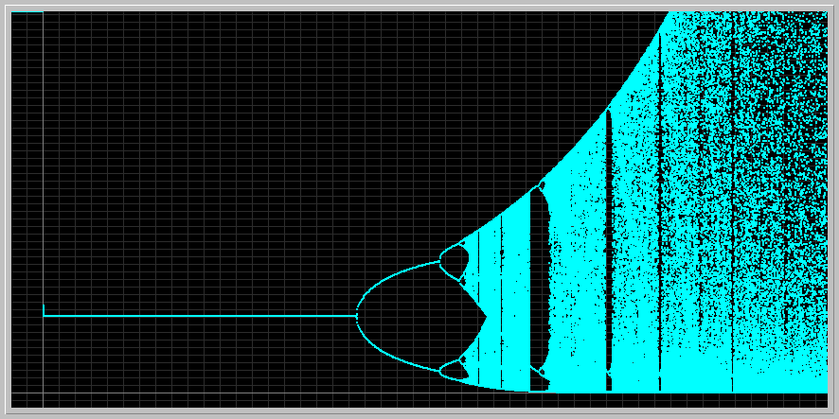

* + By examining your bifurcation diagram, locate a value of r for which the map has a periodic orbit of period 3. Draw a stair-step diagram of your period-3 orbit. What are the values of the population size on this orbit?

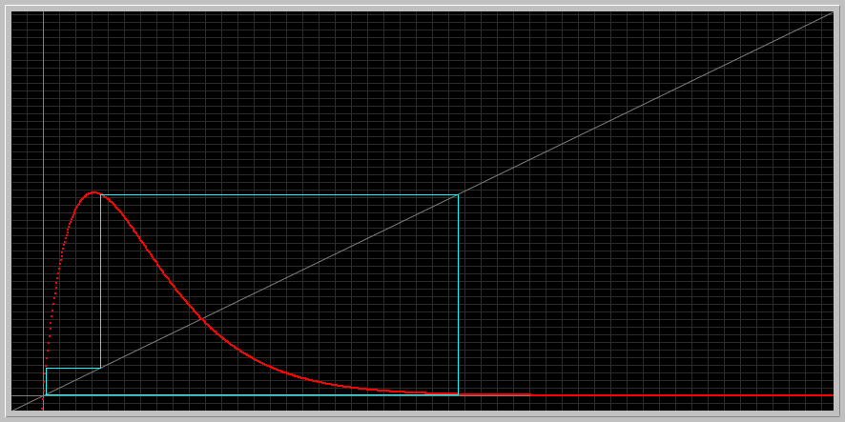

9.25000E+002 2.686776373426209E+000

9.26000E+002 1.364146127410091E-002

9.27000E+002 2.995821652996900E-001

9.28000E+002 2.686776373426208E+000

9.29000E+002 1.364146127410095E-002

9.30000E+002 2.995821652996907E-001

9.31000E+002 2.686776373426209E+000

9.32000E+002 1.364146127410091E-002

9.33000E+002 2.995821652996900E-001

9.34000E+002 2.686776373426208E+000

9.35000E+002 1.364146127410095E-002

9.36000E+002 2.995821652996907E-001

9.37000E+002 2.686776373426209E+000

9.38000E+002 1.364146127410091E-002

9.39000E+002 2.995821652996900E-001

9.40000E+002 2.686776373426208E+000

9.41000E+002 1.364146127410095E-002

9.42000E+002 2.995821652996907E-001

9.43000E+002 2.686776373426209E+000

9.44000E+002 1.364146127410091E-002

9.45000E+002 2.995821652996900E-001

9.46000E+002 2.686776373426208E+000

9.57000E+002 2.995821652996900E-001

9.58000E+002 2.686776373426208E+000

9.67000E+002 2.686776373426209E+000

9.68000E+002 1.364146127410091E-002

9.69000E+002 2.995821652996900E-001

9.70000E+002 2.686776373426208E+000

9.71000E+002 1.364146127410095E-002

9.72000E+002 2.995821652996907E-001

9.73000E+002 2.686776373426209E+000

9.74000E+002 1.364146127410091E-002

9.75000E+002 2.995821652996900E-001

9.76000E+002 2.686776373426208E+000

9.77000E+002 1.364146127410095E-002

9.82000E+002 2.686776373426208E+000

9.83000E+002 1.364146127410095E-002

9.84000E+002 2.995821652996907E-001

9.85000E+002 2.686776373426209E+000

9.86000E+002 1.364146127410091E-002

9.94000E+002 2.686776373426208E+000

9.95000E+002 1.364146127410095E-002

9.96000E+002 2.995821652996907E-001

9.97000E+002 2.686776373426209E+000

9.98000E+002 1.364146127410091E-002

9.99000E+002 2.995821652996900E-001

1.00000E+003 2.686776373426208E+000

Values of my population size in this orbit oscillate between:

9.80000E+002 1.364146127410091E-002

9.81000E+002 2.995821652996900E-001

9.82000E+002 2.686776373426208E+000

* + Now increase r a little so that this period-3 solution undergoes a period-doubling bifurcation. Draw a step-step diagram of your period-6 orbit. What are the values of the population on this orbit?

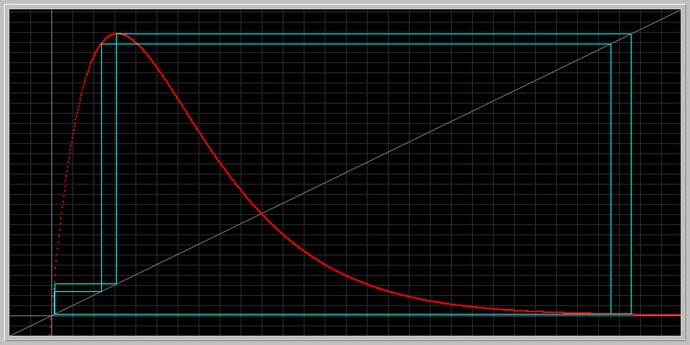

9.33000E+002 3.092184513839391E-001

9.34000E+002 2.762318103131952E+000

9.35000E+002 1.035300806422152E-002

9.36000E+002 2.385211715871776E-001

9.37000E+002 2.666030556470515E+000

9.38000E+002 1.355870936219542E-002

9.39000E+002 3.092184513839391E-001

9.45000E+002 3.092184513839391E-001

9.46000E+002 2.762318103131952E+000

9.47000E+002 1.035300806422152E-002

9.48000E+002 2.385211715871776E-001

9.49000E+002 2.666030556470515E+000

9.50000E+002 1.355870936219542E-002

9.51000E+002 3.092184513839391E-001

9.52000E+002 2.762318103131952E+000

9.53000E+002 1.035300806422152E-002

9.54000E+002 2.385211715871776E-001

9.55000E+002 2.666030556470515E+000

9.56000E+002 1.355870936219542E-002

9.57000E+002 3.092184513839391E-001

9.58000E+002 2.762318103131952E+000

9.59000E+002 1.035300806422152E-002

9.60000E+002 2.385211715871776E-001

9.61000E+002 2.666030556470515E+000

9.62000E+002 1.355870936219542E-002

9.63000E+002 3.092184513839391E-001

9.64000E+002 2.762318103131952E+000

9.65000E+002 1.035300806422152E-002

9.66000E+002 2.385211715871776E-001

9.67000E+002 2.666030556470515E+000

9.68000E+002 1.355870936219542E-002

9.69000E+002 3.092184513839391E-001

9.70000E+002 2.762318103131952E+000

9.71000E+002 1.035300806422152E-002

9.85000E+002 2.666030556470515E+000

9.86000E+002 1.355870936219542E-002

9.87000E+002 3.092184513839391E-001

9.88000E+002 2.762318103131952E+000

9.89000E+002 1.035300806422152E-002

9.90000E+002 2.385211715871776E-001

9.95000E+002 1.035300806422152E-002

9.96000E+002 2.385211715871776E-001

9.97000E+002 2.666030556470515E+000

9.98000E+002 1.355870936219542E-002

9.99000E+002 3.092184513839391E-001

1.00000E+003 2.762318103131952E+000

In my period 6, the values of the population size oscillate between:

9.63000E+002 3.092184513839391E-001

9.64000E+002 2.762318103131952E+000

9.65000E+002 1.035300806422152E-002

9.66000E+002 2.385211715871776E-001

9.67000E+002 2.666030556470515E+000

9.68000E+002 1.355870936219542E-002

1. **Verifying calculations in the scientific literature:** Read as much of the Nature article linked above as you can. This could be difficult reading for you, but do not be discouraged. In particular, examine Table 3 on page 464 regarding the periodic orbits of the Logistic map. Try to verify the first three numbers on the 4th row: period 5(a) orbit appears for a = 3.7382 and disappears at a = 3.7411. Is the claim in the paper true? Support your answer by drawing stair-step diagrams, Xi-values, for at least three parameter values: two near the boundaries, and one inside.
   * Notice that there other parameter windows for which there are period 5 orbits. If you like, you can explore the rows 5(b) and 5(c).

for a= 3.71

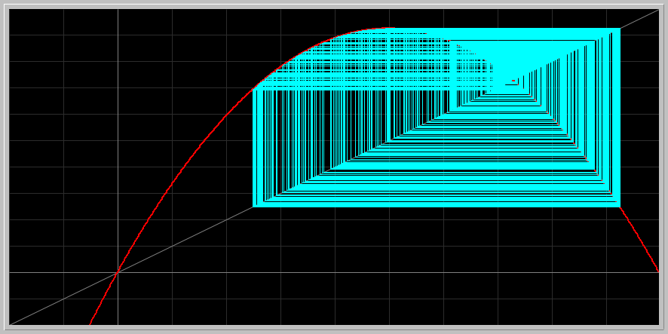

9.25000E+002 2.847859064655623E-001

9.26000E+002 7.556635365327976E-001

9.27000E+002 6.850001390847840E-001

9.28000E+002 8.005250590782452E-001

9.29000E+002 5.924301956929239E-001

9.30000E+002 8.958042046086625E-001

9.31000E+002 3.462878072883259E-001

9.32000E+002 8.398422043216636E-001

9.33000E+002 4.990219945602511E-001

9.34000E+002 9.274964514048850E-001

9.42000E+002 3.344667563578665E-001

9.43000E+002 8.258413448749552E-001

9.44000E+002 5.335997206689986E-001

9.45000E+002 9.233116280402811E-001

9.46000E+002 2.626949552494396E-001

9.47000E+002 7.185762313803171E-001

9.48000E+002 7.502526392903947E-001

9.49000E+002 6.951561173195909E-001

9.64000E+002 8.911278188340678E-001

9.65000E+002 3.599405988295283E-001

9.66000E+002 8.547222809733825E-001

9.67000E+002 4.606785035436611E-001

9.74000E+002 7.006255554079902E-001

9.75000E+002 7.781702239789435E-001

9.76000E+002 6.404251212834813E-001

9.77000E+002 8.543417135094476E-001

9.78000E+002 4.616796347492697E-001

9.79000E+002 9.220520490421578E-001

9.80000E+002 2.666453719064629E-001

9.91000E+002 4.685519474134208E-001

9.92000E+002 9.238308841573787E-001

9.93000E+002 2.610629858635300E-001

9.94000E+002 7.156927731522842E-001

9.95000E+002 7.548982884326446E-001

9.96000E+002 6.864496600757418E-001

9.97000E+002 7.985275049958456E-001

9.98000E+002 5.968697297031446E-001

9.99000E+002 8.926863077834593E-001

1.00000E+003 3.554085902505529E-001

For a= 3.74

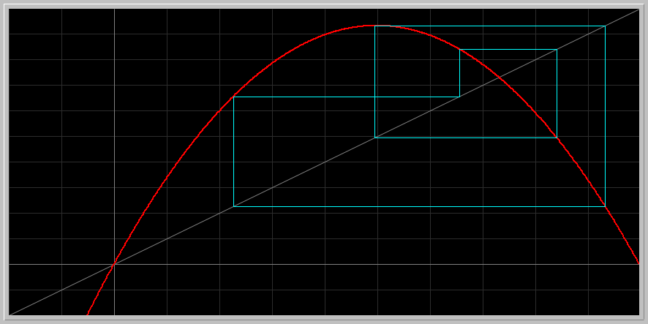

9.25000E+002 2.847859064655623E-001

9.26000E+002 7.556635365327976E-001

9.27000E+002 6.850001390847840E-001

9.28000E+002 8.005250590782452E-001

9.29000E+002 5.924301956929239E-001

9.30000E+002 8.958042046086625E-001

9.31000E+002 3.462878072883259E-001

9.32000E+002 8.398422043216636E-001

9.33000E+002 4.990219945602511E-001

9.34000E+002 9.274964514048850E-001

9.35000E+002 2.494855687744162E-001

9.36000E+002 6.946697482640496E-001

9.51000E+002 6.236095633374586E-001

9.52000E+002 8.708137074091496E-001

9.64000E+002 8.911278188340678E-001

9.65000E+002 3.599405988295283E-001

9.66000E+002 8.547222809733825E-001

9.67000E+002 4.606785035436611E-001

9.68000E+002 9.217636718899705E-001

9.69000E+002 2.675481528241295E-001

9.70000E+002 7.270343747421907E-001

9.71000E+002 7.362695068629176E-001

9.72000E+002 7.203956316702563E-001

9.73000E+002 7.472895901558809E-001

9.74000E+002 7.006255554079902E-001

9.75000E+002 7.781702239789435E-001

9.76000E+002 6.404251212834813E-001

9.77000E+002 8.543417135094476E-001

9.78000E+002 4.616796347492697E-001

9.79000E+002 9.220520490421578E-001

9.80000E+002 2.666453719064629E-001

9.81000E+002 7.254742411005831E-001

9.82000E+002 7.388886700864308E-001

9.83000E+002 7.157784742590881E-001

9.84000E+002 7.547611016722183E-001

9.85000E+002 6.867090577873509E-001

9.86000E+002 7.981683899159924E-001

9.87000E+002 5.976647177556966E-001

9.88000E+002 8.921125467801474E-001

9.89000E+002 3.570791549396468E-001

9.90000E+002 8.517181748952400E-001

9.91000E+002 4.685519474134208E-001

9.92000E+002 9.238308841573787E-001

9.93000E+002 2.610629858635300E-001

9.94000E+002 7.156927731522842E-001

9.95000E+002 7.548982884326446E-001

9.96000E+002 6.864496600757418E-001

9.97000E+002 7.985275049958456E-001

9.98000E+002 5.968697297031446E-001

9.99000E+002 8.926863077834593E-001

1.00000E+003 3.554085902505529E-001

for a= 3.742

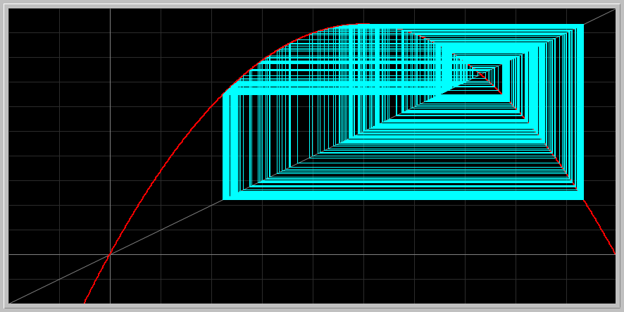

9.25000E+002 4.961764683874136E-001

9.26000E+002 9.349453234664683E-001

9.27000E+002 2.274763953239883E-001

9.28000E+002 6.572335095050293E-001

9.29000E+002 8.425383118478571E-001

9.30000E+002 4.961764683874116E-001

9.31000E+002 9.349453234664683E-001

9.32000E+002 2.274763953239886E-001

9.33000E+002 6.572335095050300E-001

9.34000E+002 8.425383118478562E-001

9.35000E+002 4.961764683874136E-001

9.36000E+002 9.349453234664683E-001

9.37000E+002 2.274763953239883E-001

9.38000E+002 6.572335095050293E-001

9.39000E+002 8.425383118478571E-001

9.54000E+002 8.425383118478562E-001

9.55000E+002 4.961764683874136E-001

9.56000E+002 9.349453234664683E-001

9.57000E+002 2.274763953239883E-001

9.58000E+002 6.572335095050293E-001

9.59000E+002 8.425383118478571E-001

9.60000E+002 4.961764683874116E-001

9.61000E+002 9.349453234664683E-001

9.62000E+002 2.274763953239886E-001

9.63000E+002 6.572335095050300E-001

9.64000E+002 8.425383118478562E-001

9.65000E+002 4.961764683874136E-001

9.66000E+002 9.349453234664683E-001

9.67000E+002 2.274763953239883E-001

9.68000E+002 6.572335095050293E-001

9.69000E+002 8.425383118478571E-001

9.70000E+002 4.961764683874116E-001

9.71000E+002 9.349453234664683E-001

9.72000E+002 2.274763953239886E-001

9.73000E+002 6.572335095050300E-001

9.74000E+002 8.425383118478562E-001

9.75000E+002 4.961764683874136E-001

9.76000E+002 9.349453234664683E-001

9.77000E+002 2.274763953239883E-001

9.78000E+002 6.572335095050293E-001

9.79000E+002 8.425383118478571E-001

9.80000E+002 4.961764683874116E-001

9.81000E+002 9.349453234664683E-001

9.82000E+002 2.274763953239886E-001

9.83000E+002 6.572335095050300E-001

9.84000E+002 8.425383118478562E-001

9.85000E+002 4.961764683874136E-001

9.86000E+002 9.349453234664683E-001

9.87000E+002 2.274763953239883E-001

9.88000E+002 6.572335095050293E-001

9.94000E+002 8.425383118478562E-001

9.95000E+002 4.961764683874136E-001

9.96000E+002 9.349453234664683E-001

9.97000E+002 2.274763953239883E-001

9.98000E+002 6.572335095050293E-001

9.99000E+002 8.425383118478571E-001

1.00000E+003 4.961764683874116E-001

As you can observe from the outcome of the three graphs, the numbers show a period 5 pattern of oscillation, whereas when I go beyond or below those points the 5 fixed points disappear and the numbers don’t seem to converge anywhere anymore. Therefore, the graphs support the theory, and the numbers given for a= 3.372 oscillate at around:

3.00000E+001 8.425223775414615E-001

3.10000E+001 4.962040262616201E-001

3.20000E+001 9.349211102227736E-001

3.30000E+001 2.275490839180985E-001

3.40000E+001 6.573640866899035E-001

Since 3.742 is between a = 3.7382 and a = 3.7411, the theory is valid.