Hannah Machado

Feb. 9th, 2016

CSC 210

Homework 2

**Shifting around:** Describe the fixed points and their stability types of the linear map

x1 -> a*x1 + b

for all values of the parameters a, b and initial conditions x0.

First take the derivative of f(x):

f(x)= a*x1+b

f’(x)=a

So our boundaries are -1<a<1

Therefore, according to the linearization theorem:

if |a|<1, then a is an asymptotically stable fixed point

if |a|>1, then a is unstable

So, all points when a is between -1<a<1 are asymptotically stable. Observing the graph when a=0.5 and b=0:

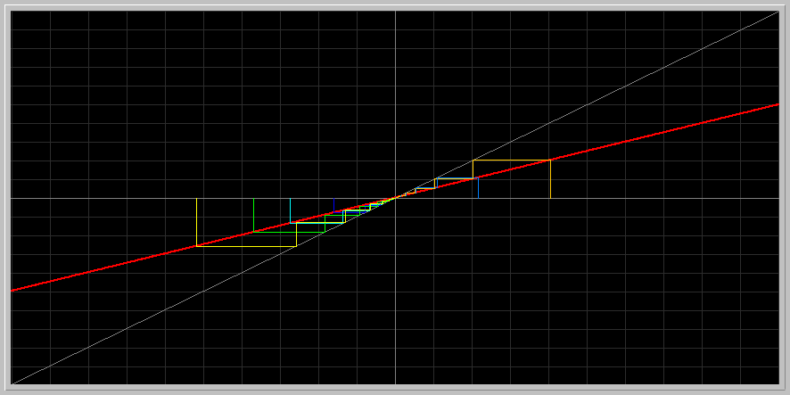

We can see that the points converges towards 0.

For a=1, b=0, however,

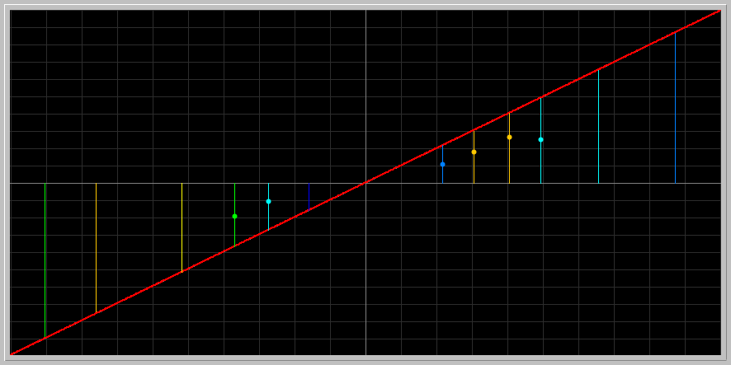

There are no specific fixed points, each point in the graph converges to a different one.

For a=-1, b=0:



There is also no fixed point, and the iterations are shaped like a square, repeating itself.

When shifting b and making a=0.5, b=0.2:

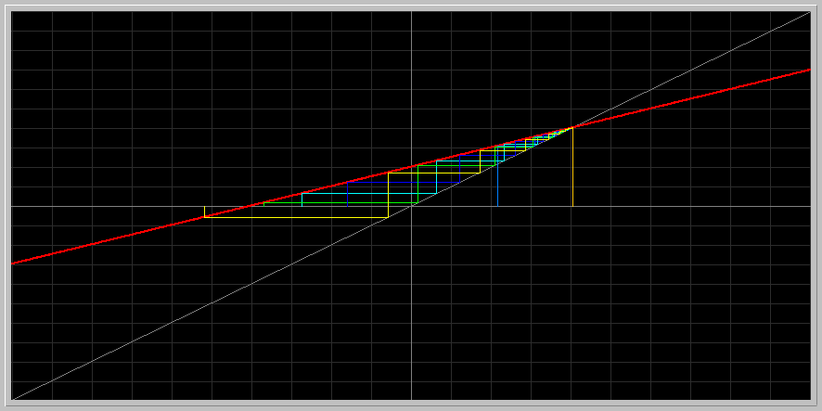

This equation shifts along the y axis, and the stable point changes, but still exists, only now is approximately 0.4.

2. **Who is faster?:** Using the Linearization Theorem, prove that x* = sqrt(2) is an asymptotically stable fixed point of the map

x1 -> x1 - 0.25*(x1*x1 -2.0).

1. Do you think approach to the fixed point is faster or slower than that of Newton?
2. Are there other fixed points of this difference equation? If there are, what are their stability types?

Following the linearization theorem, take the derivative of the equation to find our f’(x) and plug our x*=sqrt(2) value.

f’(x*)= 1-0.5*sqrt(2)

f’(x*) = 1-0.7

f’(x*)= 0.3.

Now look at the absolute value of the answer:

|0.3|=0.3, which is <1. Therefore, according to the linearization theorem, sqrt(2) is an asymptotically stable fixed point. Plugging it in Phaser we can observe:

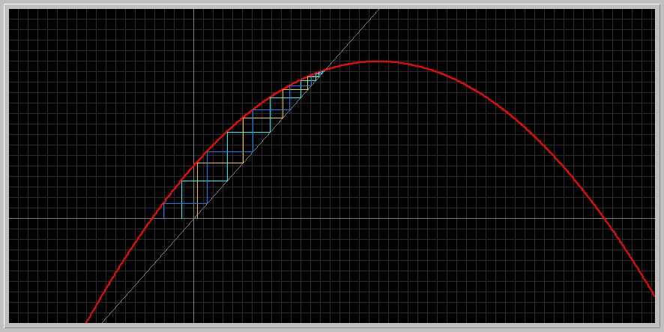

Here we see that the conditions are converging to a value of approximately 1.41, which is sqrt(2) and it is therefore an asymptotically stable fixed point on the graph

1. This approach is slower than that of Newton’s in the sense that it requires more iterations to reach the fixed point. Newton’s, however, has more computational steps within the iteration, so it can be denoted as more “expensive” in the scientific world. That is why it is not more commonly used.
2. Yes, there are other fixed points in the equation. To determine, find the possible values for x1 in the equation by setting it equal to zero.

x1 -> x1 - 0.25*(x1*x1 -2.0). = F(x1)=x1

x1-0.25 = (x1^2-2)=x1

-0.25(x1^2-2)=0

x1^2-2=0

x1= +- sqrt(2)

We see that the other fixed point has the value -sqrt2

Plugging it into the derivative equation, we have that

f’(x*)= 1-0.5*-sqrt(2)= 1.17

Since |1.17|>1, by the linearization theorem we can establish that this is an unstable fixed point.

**3. As a parameter is varied:** Consider the map x1 -> a + x1 + 1.2*x1*x1 where a is a parameter. Draw at least three stair step diagrams, say, for a = -0.14, a = 0, and a = 0.14. Describe the changes in the number and stability types of fixed points as the parameter a is changed pass 0.

To algebraically find the fixed points, take the derivative and set it to 0.

f(x)= a + x1 + 1.2*x1*x1

f’(x)= 1+2.4*x1=0

x1= -1 / 2.4= -0.41

When a is negative, there is a fixed point at about -0.41 where the points on the left side of the graph converge to -0.41. As you move past x=0.33, however, they start to go diverge away from the point, meaning it is unstable.

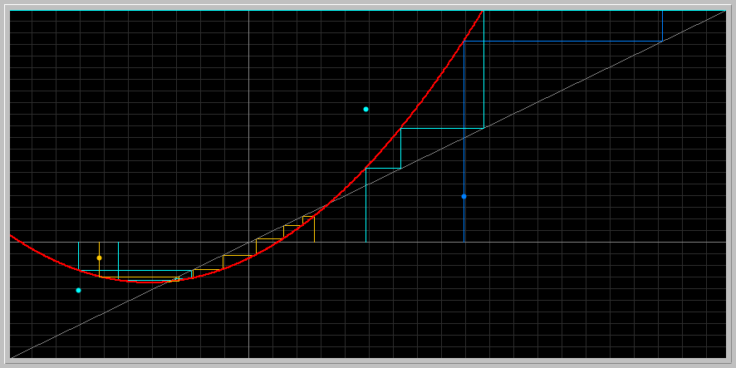

At a=0, the points on the left side of the graph converge to 0, but as you move across the y-axis they once again start to diverge away from the point, meaning it becomes unstable.

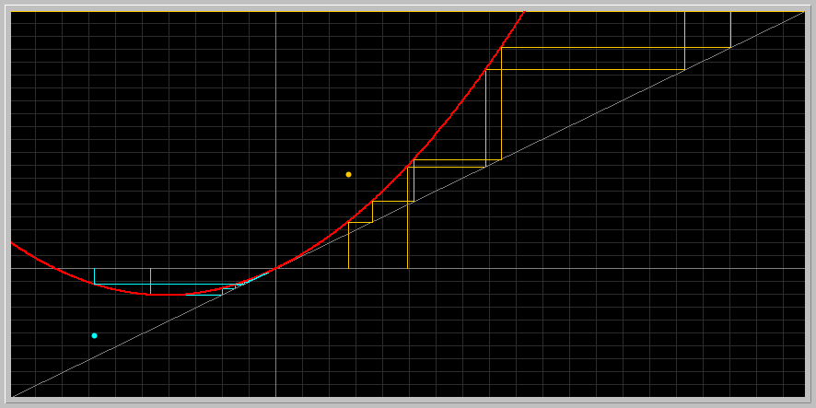

As you move a past 0, The points do not converge to any fixed point, but rather move away from it

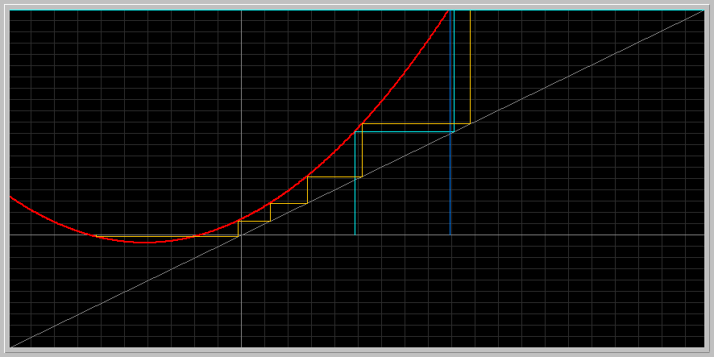

Here is a combination of all three:

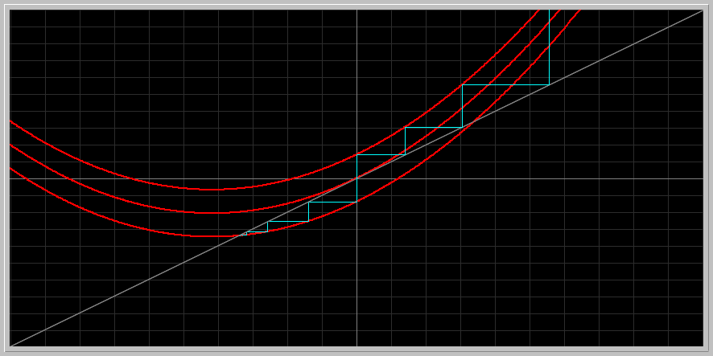

**4. Investing for Med School:** Suppose you want to make an investment that will pay for your child's Medical School education. You figure you will need $77,000 when your child starts Med School, 15 years from now. You can buy a long term certificate of deposite, or CD, that pays a 6.5 per cent annual interest compounded monthly. What size CD should you buy?

First, find an equation to model the data

Xn+1= Xn + (0.065/12)Xn

Xn+1= (1+0.005416)Xn

Xn+1= 1.005416*xn

Now, plugging in Phaser and observe for which x value the output is 77000.

Since the span of years is 15 years and there are 12 months in each year, it means that he is allowed 180 months to raise money.

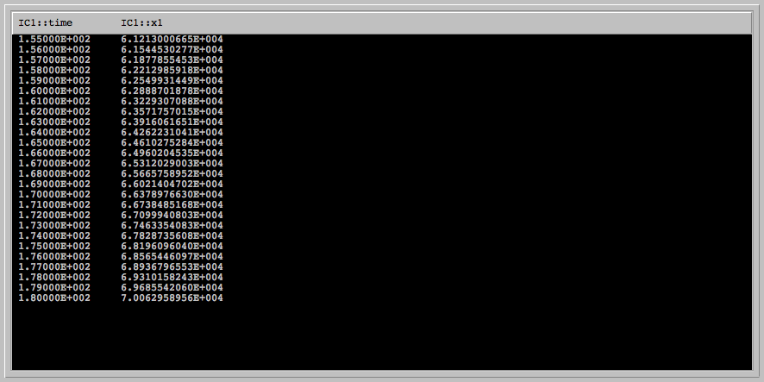

These results were obtained by plugging in x0= 26500

Therefore, the CD size should be $26500.

**5. Beverton-Holt Stock-recruitment model:**

**xn+1 = rxn/[1 + ((r - 1)/k)xn]**

This is a biologically important fisheries model containing two parameters r (growth rate) and k (carrying capacity). Despite its complicated form, this model has simple dynamics. We assume that both parameters take on non-negative values. Enter this model into Phaser.

* 1. To understand the geometric meanings of the parameters, fix k (say at 1.2) and vary r make a Gallery of growth curves using the stair-step view of PHASER (study the Phaser Tutorials Lesson 6 and Lesson 13 to learn about the Gallery and making SlideShow). You may want to take big window size (-1 , 15; -1, 15) to see what happens as the population gets large. Next, fix r = 1.45 and vary k. Describe biologically what you observe in these two sequences.

When k is fixed and r changes,



When r is fixed and k changes,

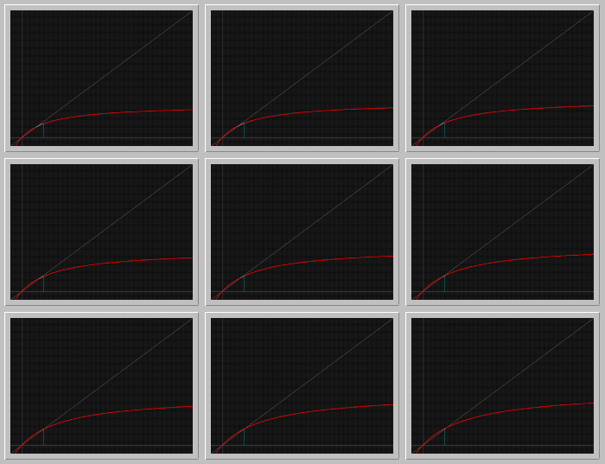

Biologically speaking, these graphs show that the population will increase until a certain point because of the growth factor. The point in the graph has a value of 1.97

* 1. Find the fixed points of the model as a function of the parameters. For what ranges of the parameters they are biologically significant?
     1. To find the fixed points, Find the derivative of the function and set it to zero.
        1. **f(xn)= rxn/[1 + ((r - 1)/k)xn]**
        2. f’(**xn**)=**(1 + ((r - 1)/k)xn)**\*r - r**xn* (r - 1)/k)/** **(1 + ((r - 1)/k)xn)**^2
        3. Now plug in k=1.2
        4. f’(**xn**)=**(1 + ((r - 1)/1.2)xn)**\*r - r**xn* (r - 1)/1.2)/** **(1 + ((r - 1)/1.2)xn)**^2
        5. Simplify: r**(1 + (r - 1)/1.2)xn** - **xn* (r - 1)/1.2)/ (1 + ((r - 1)/1.2)xn)**^2
        6. **So f’(x)= r/(1 + ((r - 1)/1.2)xn)**^2
     2. According to the graph the fixed point is 0.069 and 1.21 obs:(Am having trouble with this part, need help!!)
  2. Determine the stability type of the fixed points, using the Linearization Theorem. Can the positive fixed point become unstable as the parameter r or k is increased?

Yes. If r or k is increased too much, the time to reach the carrying capacity and the carrying capacity itself will not be a stable fixed point anymore. It will stay forever increasing and the population will not stop growing

* 1. Write a summary of the possible dynamics of a population described by the Beverton-Holt model and interpret your findings in biological terms

Using the Beverton-Holt model, we can say that R changes how quickly you get to the carrying capacity of a population, or, in other words, the time it takes to reach it. K, on the other hand, changes the carrying capacity itself.