Biography of an Anita Borg -

An Influential Software Engineer

Hannah Mahon

17329071

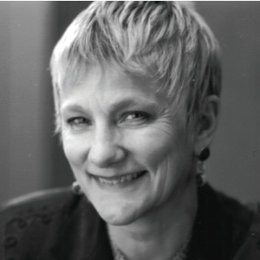

# Introduction

"Women will change the corporation more than we expect" – Anita Borg

Anita Borg was an American software engineer that specialised in operating systems and mass email communications. Along with this, she was a massive advocate for women in technology and campaigned extensively for women’s rights in the male dominated technology industry. Her influence encouraged many women to become part of the industry and countless organisations to change their mentality towards women in computer science. I have decided to write about her, as being a woman in this industry, I find not only her work fascinating but the impact she’s had especially for women inspiring. The above quote was Borg’s overall mentality behind the endless campaigning and advocating for women. This quote I find extremely uplifting and encouraging which is exactly what Anita Borg aimed to do in her lifetime.

# Early Life:

Anita Borg Naffz was born on the 17th of January 1949 in Chicago. Originally, she worked in a small insurance firm and taught herself to program there. In 1981, she obtained a PhD in computer science from New York University for investigating the synchronization of operating systems (Wikipedia.org, 2019). Borg had an interest in languages, compiling and AI particularly which eventually led her to the field of operating systems (Ethw.org, 2019).



# Career:

Having had plenty of experience with operating systems, Borg along with her team build a fault intolerant unix-based operating system for Auragen Systems originally. This system was then bought by a company called Nixdorf and was renamed Targon. This system was not only fault intolerant, but it was a multi-processor system which used message passing. This was the first of its kind and would shape how operating systems are made today (Ethw.org, 2019).

In 1986, Borg joined Digital Equipment Corporation where she developed a method for “generating complete address traces for analysing and designing high-speed memory systems” (Wikipedia.org, 2019). This was invented because at the time current data collection systems didn’t allow for retrieving all the data present for multiple programs at one time.

In 1987, Borg was working on a project called “Systers”. This started out as a mailing list for female computer scientists working in operating systems. This eventually expanded to a mailing list for all women in the computing industry. This idea was founded at a technology convention, there was so few women present, Borg collected all the emails of each women attendee to make a community for the few women of the industry. The main aim of this was to increase the number of women in the industry and to improve work environments for women as well. (Wikipedia.org, 2019).

This experience with Systers led her into the email communications industry where she developed “Mecca”. This was an email and web-based system for communicating in virtual communities. The difference between Mecca and other email distribution systems was that Mecca was the first of its kind to introduce automatic administration of a membership-based email community (Borg, 1992).

In 1994, Borg founded the Grace Hopper Celebration of women in computing, a technical conference promoting the work of women and campaigning for more women in science and technology (Encyclopedia Britannica, 2019). In 1997, Borg founded the Institute for Women and Technology, the aim of which was to increase the number of women in technology, to encourage the development of technology by women and for women’s voices to be heard in the male dominated industry of computer science. Both the conference and the institute grew massively and convinced technical organisations to hire more women to fill their roles. This worked massively in their favour as it has been proven that organisations that have women within their workforce improve greatly in innovation and overall bottom line results (AnitaB.org, 2019).

Up until her death in 2003, Borg continued to be the president of the Institute for women and technology, playing a key role in campaigning for women’s rights across the industry. After her passing in 2003, the institute was renamed the Anita Borg Institute in her honour (AnitaB.org, 2019).

# Impact:

Borg received many awards and honourable positions for not only her work in technology but also for her role in gender equality in the field. In 1995, she received the August Ada Lovelace Award from the association for women in computing for her work on behalf of all women in the industry. In 1999, Borg was promoted to the position of the commission on the advancement of women and minorities in Science, Engineering and Technology by President Clinton. Her main role in this position was to suggest ways to increase the participation of women in the industry (Wikipedia.org, 2019).

In 2002, she received the Heinz Award for Technology, the Economy, and Employment. Between the years of 1998-99, she was a member of the National Academy of Engineering’s Committee for the Celebration of Women in Engineering. She also was a member of the National Research Council’s Committee on Women in Science and Engineering (AnitaB.org, 2019).

Borg passed away in 2003, however her legacy still lives on with us today. Borg’s dedication to increasing the representation of women within the technology industry has had a massive impact globally. The Anita Borg Institute has continued her legacy by still promoting and campaigning for women in technology. The renamed the institute after her after her passing in 2003. There mission is still inspired by Borg as it aims to “connect, inspire and guide” women in the technology industry today (AnitaB.org, 2019).

The institute works with computer scientists in over 80 countries and works with academic institutions and Fortune 500 companies from all over the world (AnitaB.org, 2019).

# Conclusion

There is no doubt that Borg has a massive impact globally with not only her work such as the mass email communications but for her role in gender equality within the technology industry. Before her endless campaigning, women within the industry were not taken seriously or their work wasn’t deemed credible. Thanks to her amazing work, women are now viewed as an asset within the industry and no longer a liability. I am truly inspired by her vision.   
Anita Borg once said, “I believe women think differently” (A-Z Quotes, 2019). I consider this quote to sum up the entire premise behind her view and vision for the industry.

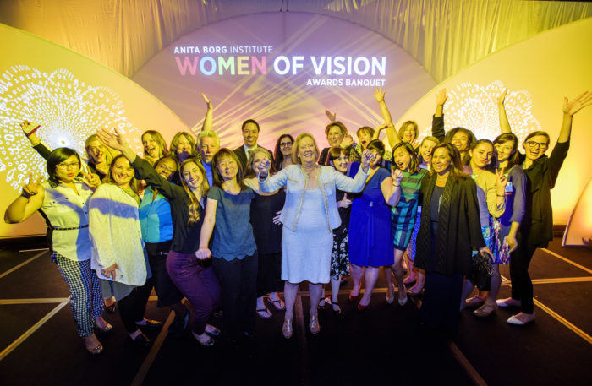

# Bibliography:

AnitaB.org. (2019). *Our History - AnitaB.org*. [online] Available at: https://anitab.org/about-us/mission-and-history/ [Accessed 9 Oct. 2019].

A-Z Quotes. (2019). *TOP 6 QUOTES BY ANITA BORG | A-Z Quotes*. [online] Available at: https://www.azquotes.com/author/1677-Anita_Borg [Accessed 8 Oct. 2019].

Borg, A. (1992). Mecca: A Message-Enabled Communication and Information System. *NSL Technical Note*.

En.wikipedia.org. (2019). *Anita Borg*. [online] Available at: https://en.wikipedia.org/wiki/Anita_Borg [Accessed 7 Oct. 2019].

En.wikipedia.org. (2019). *Systers*. [online] Available at: https://en.wikipedia.org/wiki/Systers [Accessed 11 Oct. 2019].

Encyclopedia Britannica. (2019). *Anita Borg | American computer scientist*. [online] Available at: https://www.britannica.com/biography/Anita-Borg [Accessed 9 Oct. 2019].

Ethw.org. (2019). *Oral-History:Anita Borg - Engineering and Technology History Wiki*. [online] Available at: https://ethw.org/Oral-History:Anita_Borg [Accessed 11 Oct. 2019].