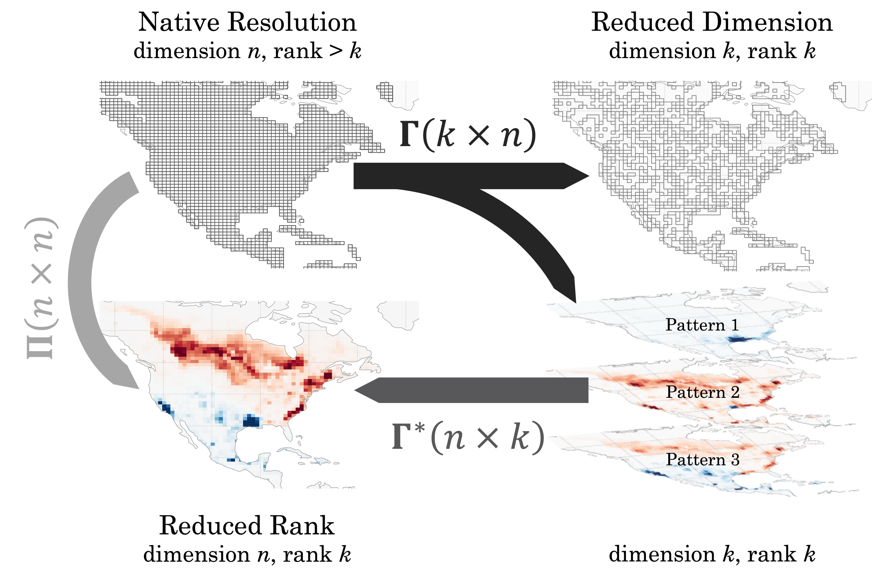

Figure 1. Dimension and rank reductions of a gridded emissions field. The linear transformation matrix $Γ$ reduces the dimension of the original state space (upper left) either discretely by aggregating grid cells to generate a multiscale grid (upper right) or non-discretely by projecting along the patterns given by the rows of $Γ$ (lower right, with positive values in red and negative in blue). The reverse transformation $Γ^{*}$ restores the dimension but not the rank, producing a low-rank subspace of the original state space (lower right). The projection $Π=Γ^{*}Γ$ reduces rank but not dimension.

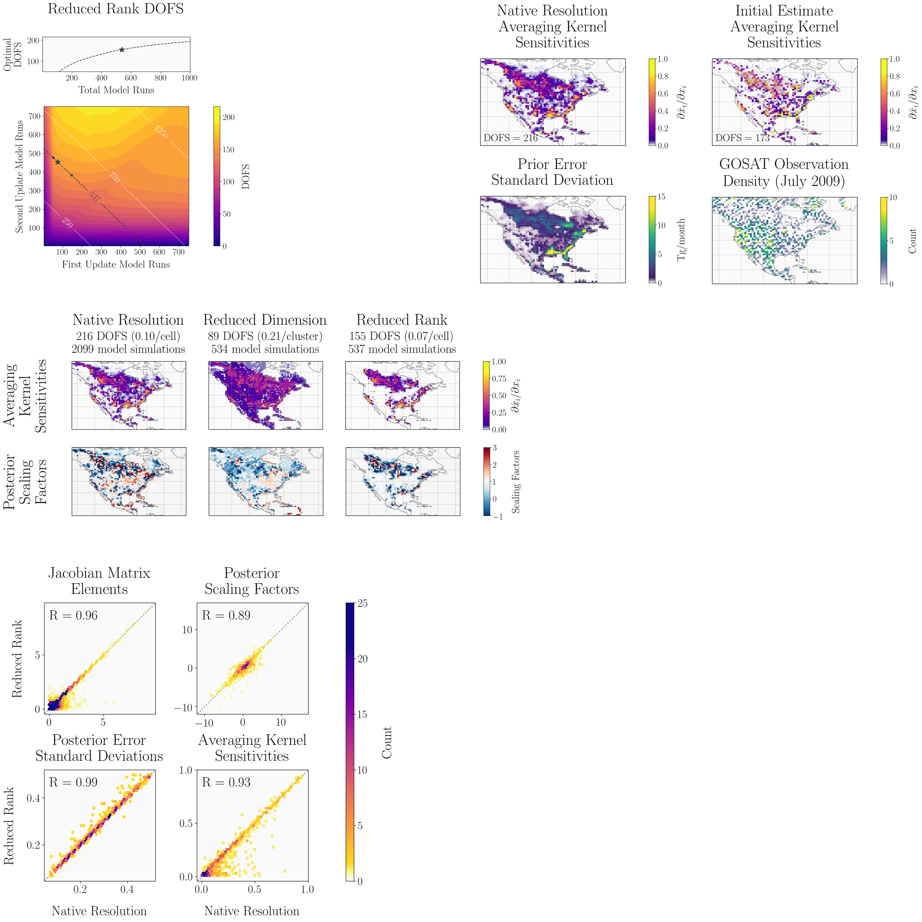
Figure 2. Averaging kernel sensitivities for the demonstration inversion of GOSAT observations for July 2009. The top panels show the sensitivities given by the diagonal elements of the averaging kernel matrix A of the native-resolution inversion (left) and initial-estimate inversion (right). The DOFS of each inversion are inset in each panel. The lower left panel shows the error standard deviations on the prior emissions estimate given by the square roots of the diagonal elements of a S_{A}. The lower right panel shows the GOSAT observation density, a proxy of S_{O}. The quantities shown in the lower panel largely drive the native-resolution and initial-estimate averaging kernel sensitivity patterns.

Figure 3. Results from the demonstration inversion at native-resolution compared to the reduced-dimension and reduced-rank methods. The figure shows the averaging kernel sensitivities and posterior scaling factors with respect to the prior emissions estimate for each inversion. The degrees of freedom for signal (DOFS) give the number of pieces of information that the inversion can independently constrain.

Figure 4. The sensitivity of the reduced-rank inversion DOFS to the number of forward model runs. The bottom panel shows the sensitivity of the DOFS to the partitioning of model runs between the first (x-axis) and second (y-axis) update. The lines represent the total number of simulations. Our inversion uses a signal-to-noise ratio of 2.5 for the first update and an information content threshold of 98.5% for the second update (star), requiring 537 forward model runs and generating 155 DOFS, accounting for 72% of the native-resolution DOFS at a quarter of the computational expense. Using a signal-to-noise ratio of 1 or 4 with the same total number of model simulations (dots) does not substantially decrease the DOFS. The top panel shows the DOFS as a function of the total number of model runs for all optimal first- and second-update partitions.
Figure 5. Comparison statistics between the reduced-rank and native-resolution inversions for the elements with reduced-rank averaging kernel sensitivity greater than 0.01. Individual panels compare binned counts for Jacobian matrix elements [ppb], posterior scaling factors [dimensionless], posterior error standard deviations [dimensionless], and averaging kernel sensitivities [dimensionless]. Correlation coefficients are inset and the 1:1 line (dotted) is shown.

