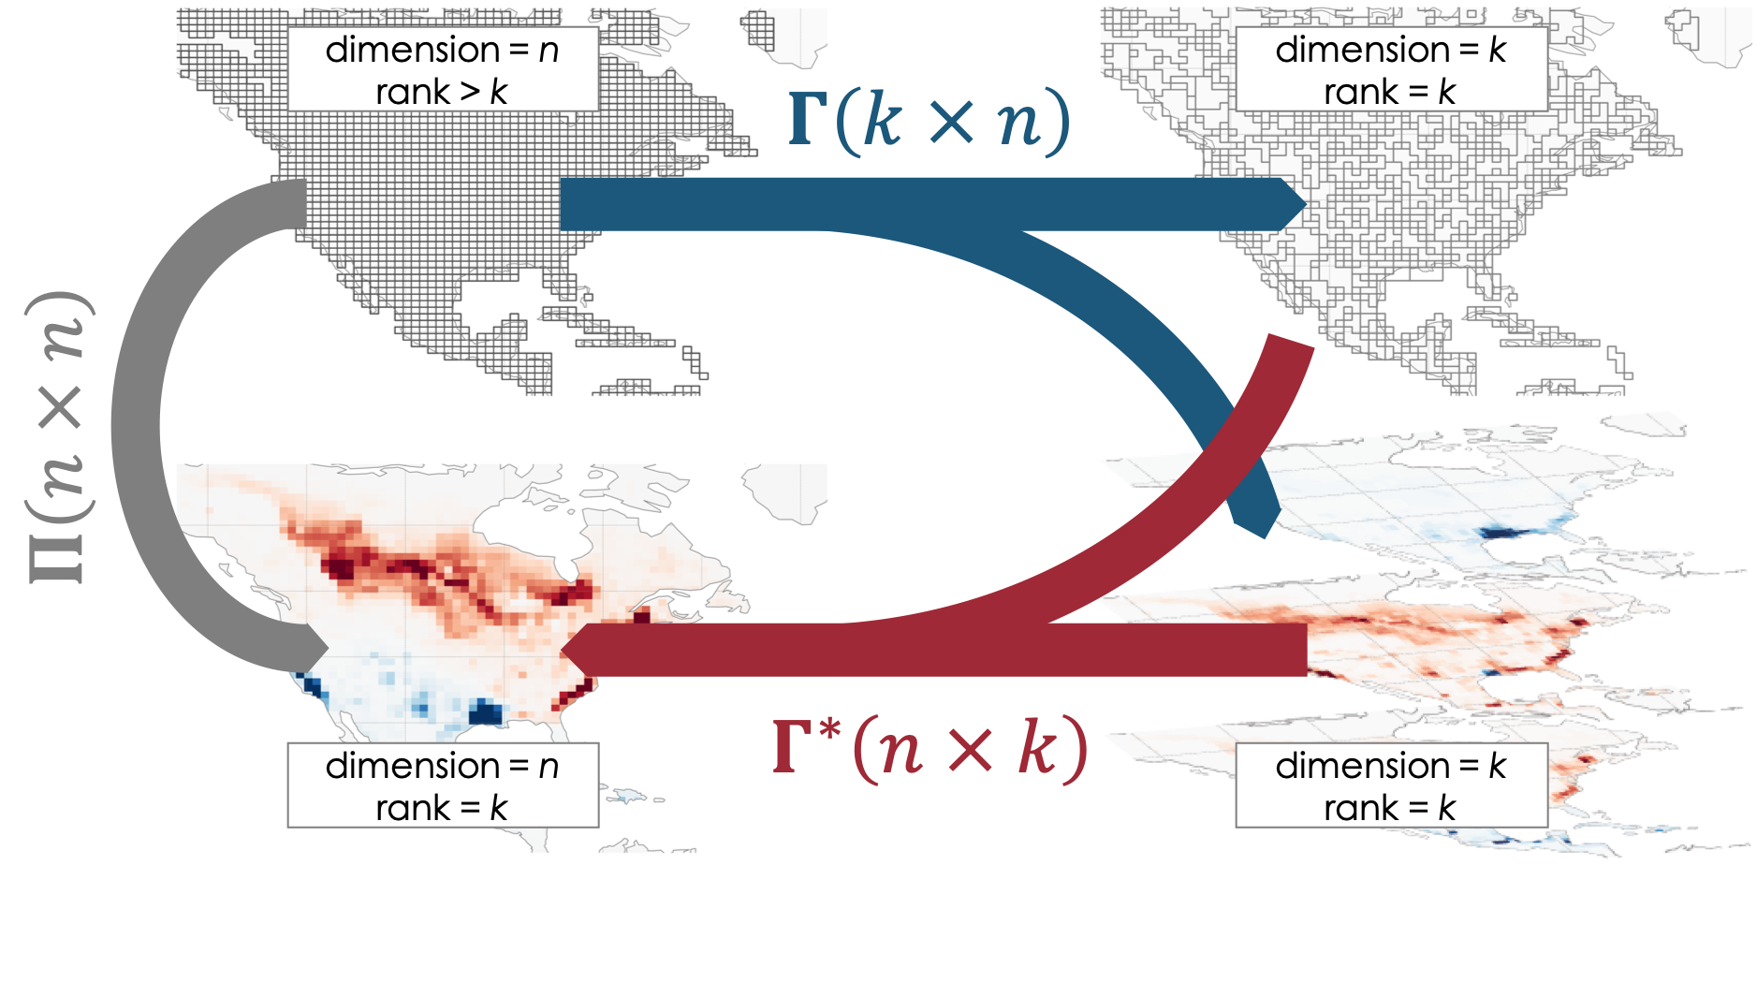

**Figure 1**. Dimension and rank reductions of a gridded emissions field. The linear transformation reduces the dimension of the original state space (upper left) either discretely to an aggregated multiscale grid (upper right) or non-discretely to the singular vectors of the original grid (lower right, with positive singular values in red and negative in blue). The reverse linear transformation restores the dimension but not the rank, producing a low-rank subspace of the original state space (lower right). The projection reduces rank but not dimension.

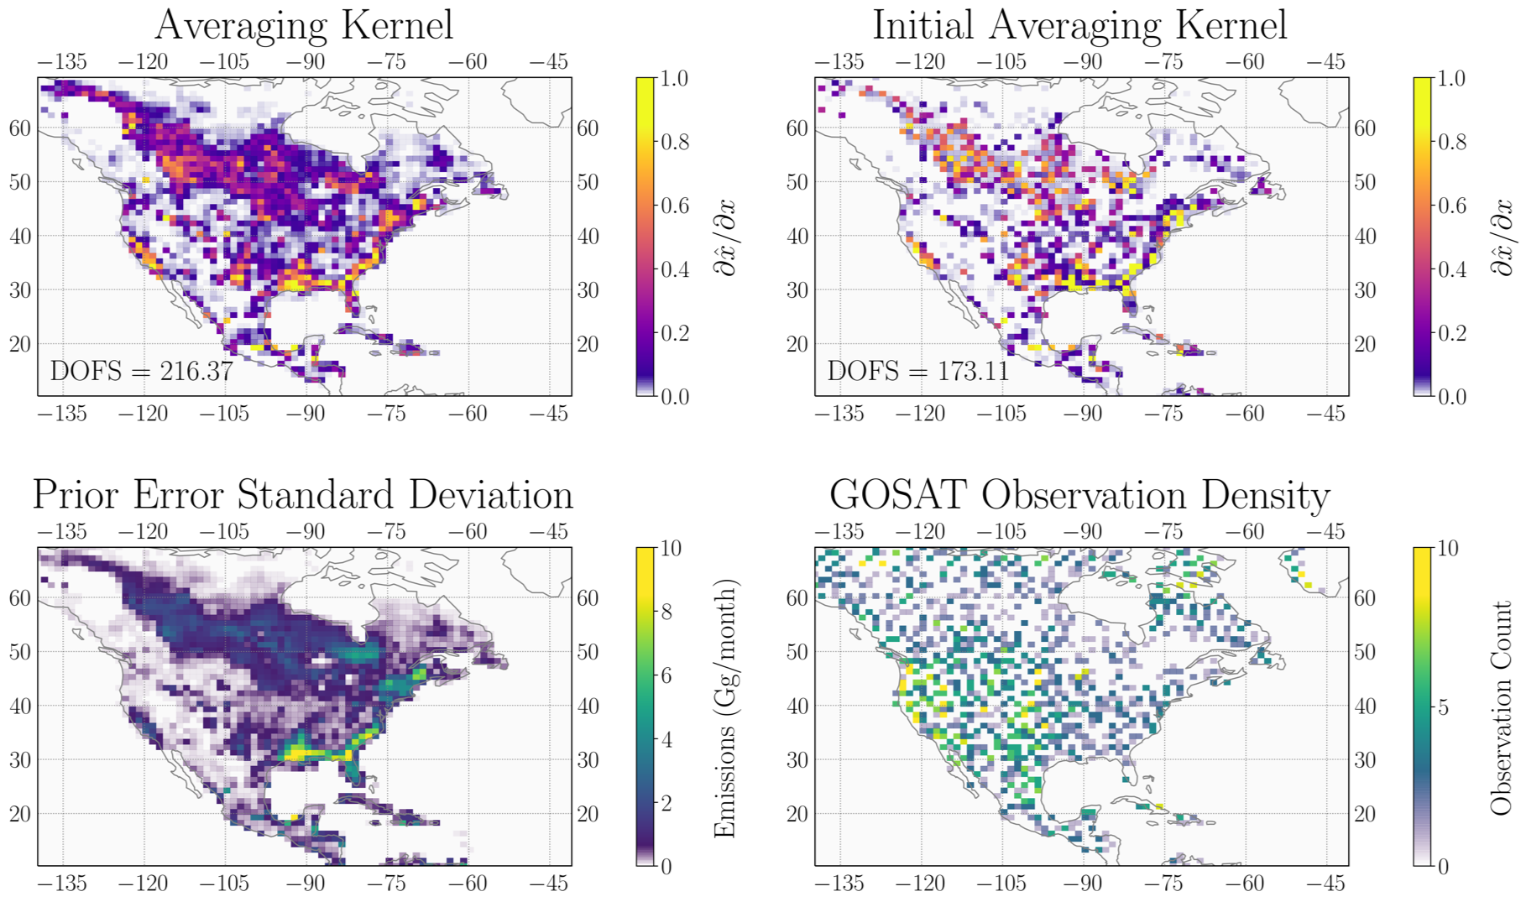

**Figure 2**. Averaging kernel sensitivities the demonstration GOSAT inversion. The top left panel shows the averaging kernel sensitivities from the fully constructed averaging kernel matrix **A**, while the top right panel shows those from the initial estimate **A**(0). The bottom left panel shows the error standard deviation for the prior emission estimate, and the bottom right panel shows the number of GOSAT inversions during the 1-month July 2009 demonstration period.

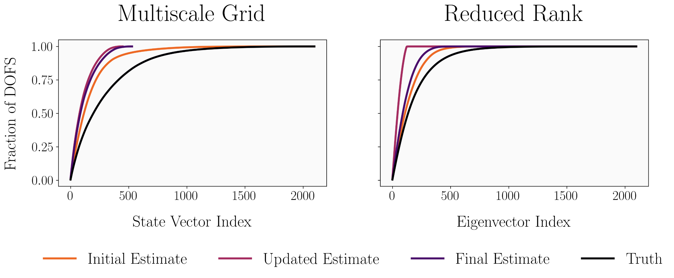

**Figure 3**. Information content spectrum for successive updates of multiscale (left) and reduced rank (right) Jacobian matrices. The spectrum associated with the initial estimate of the averaging kernel (orange) underestimates the native-resolution solution (black) but still reproduces the rate of information content accumulation. Subsequent updates of the Jacobian increase the rate at which information content accumulates due to the reductions in dimension (left) and rank (right).

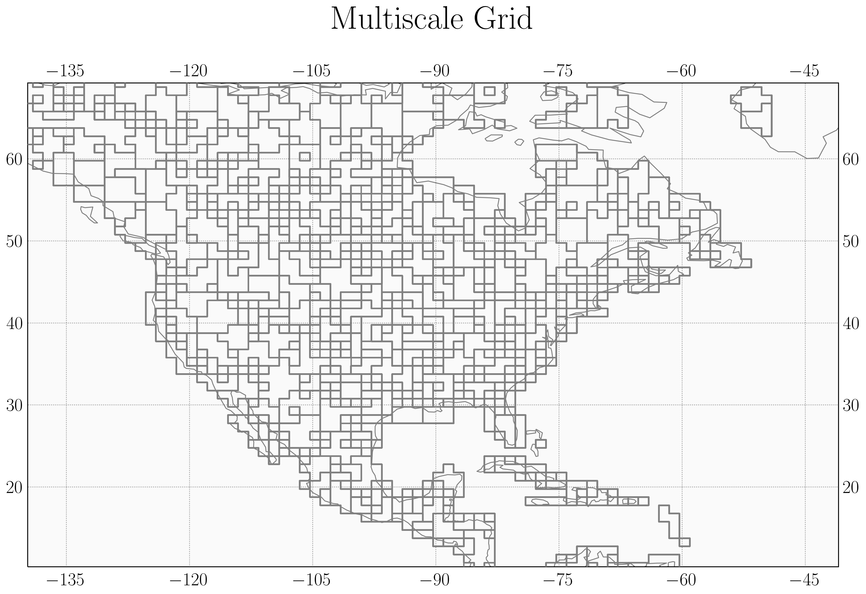

**Figure 4.** The multiscale grid that preserves native resolution in areas with highest information content and aggregates grid boxes elsewhere. The native resolution grid is clustered into ~200 grid boxes with cluster size 1, ~100 with cluster size ~3, ~100 with cluster size ~5, and ~150 with cluster size ~8 using a K-means clustering algorithm. The resulting grid has dimension ~550 and requires ~550 model runs to construct the associated Jacobian matrix.

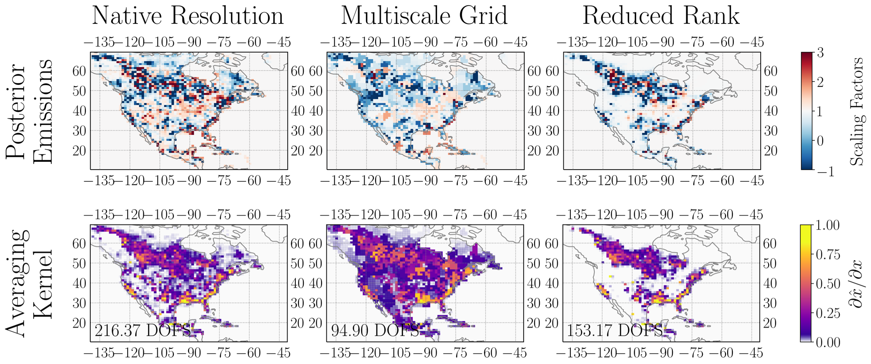

**Figure 5**. The posterior scaling factors (top) and diagonal averaging kernel values (bottom) associated with the native resolution Jacobian matrix (left), multiscale grid Jacobian matrix (center), and reduced-rank Jacobian matrix (right). The multiscale grid produces an exact posterior solution at significantly reduced dimension, resulting in a decrease in DOFS. The reduced-rank Jacobian matrix optimizes the posterior scaling factors only in the areas with largest information content and defaults to the prior value (a scaling factor of 1) elsewhere, a pattern which is also reflected in the distribution of this solution’s information content, as given by the averaging kernel.

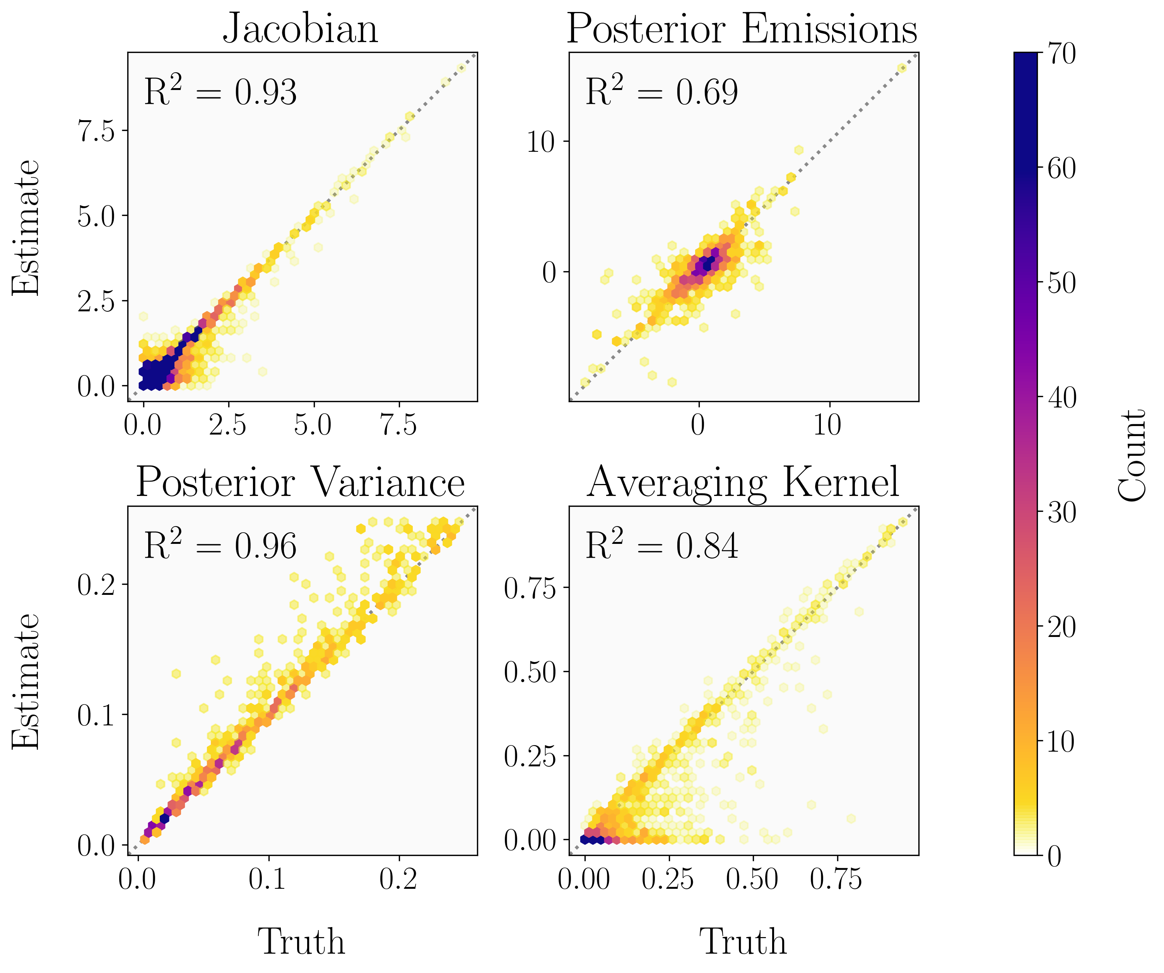

**Figure 6.** The correspondence of an analytic inversion conducted with the reduced-rank Jacobian matrix with the native-resolution inversion as given by the Jacobian matrix (upper left), posterior scaling factors (upper right), posterior variance (lower left), and diagonal averaging kernel values (lower left). The reduced-rank Jacobian accurately captures the true Jacobian matrix, while the posterior variance is overestimated and the diagonal elements of the averaging kernel are underestimated, consistent with the loss of information content incurred by reducing the rank. The posterior scaling factors exhibit the lowest correlation coefficient (r2 = 0.69) due to the propagation of errors in the posterior error covariance matrix and Jacobian matrix.

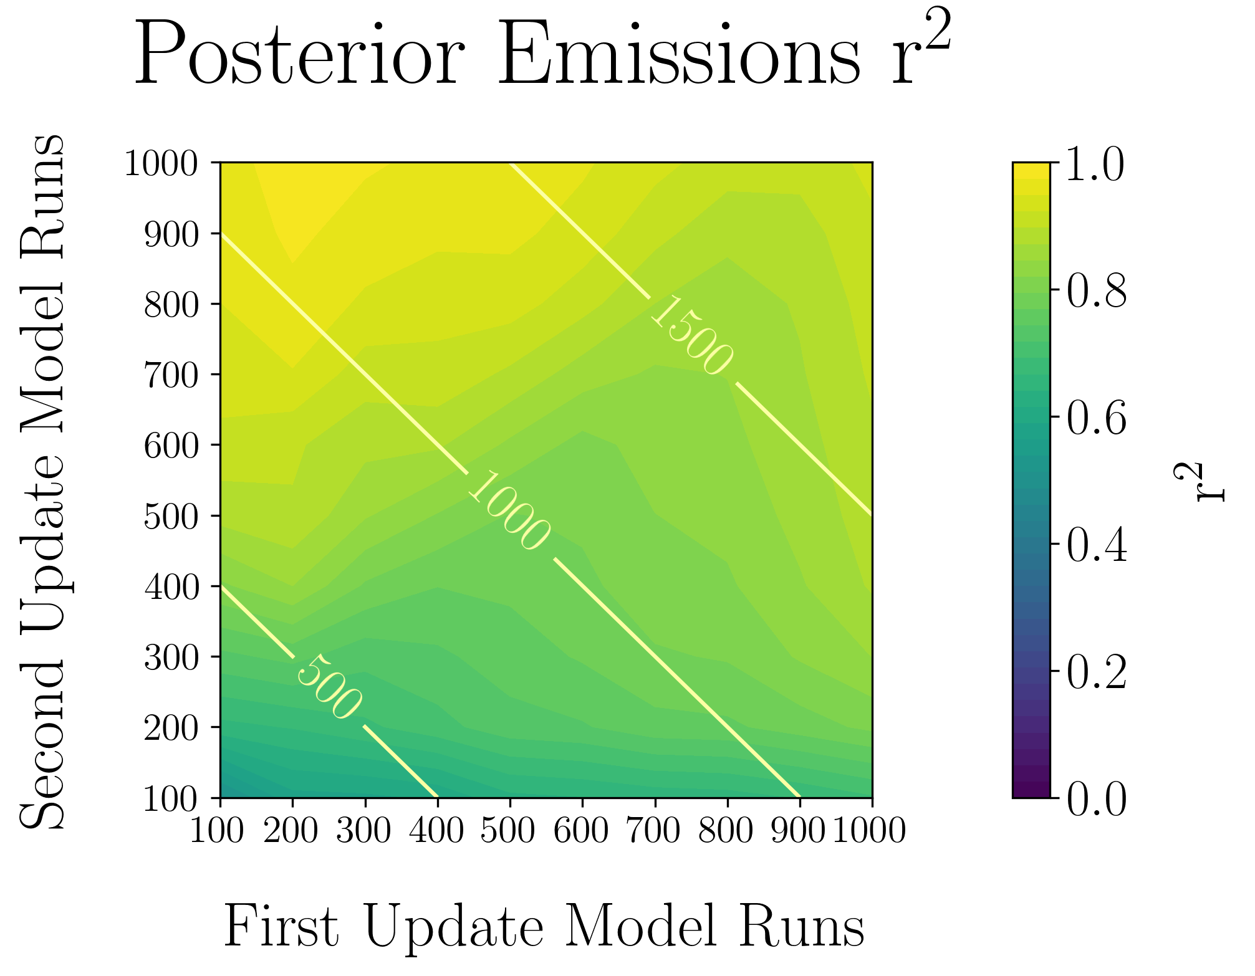

**Figure 7.** The sensitivity of the correlation of the reduced-rank scaling factors to the native-resolution scaling factors to the number of model runs conducted in the first (x axis) and second (y axis) update. The correlation improves as the total number of model runs increases (diagonal contours) but there is a stronger dependence on the number of model runs conducted in the second update than in the first update.