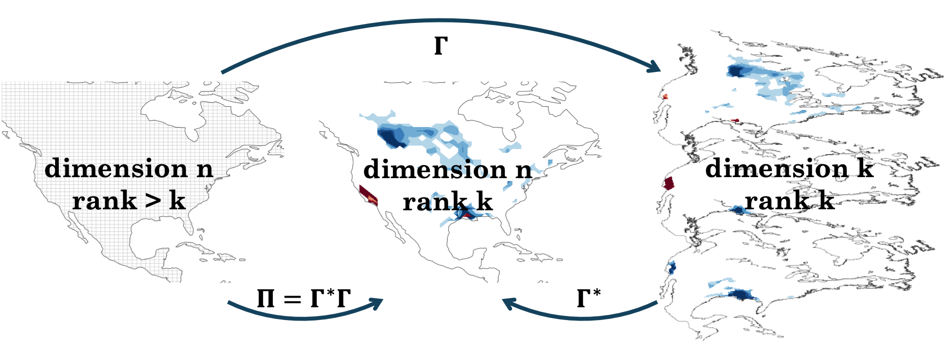

Figure

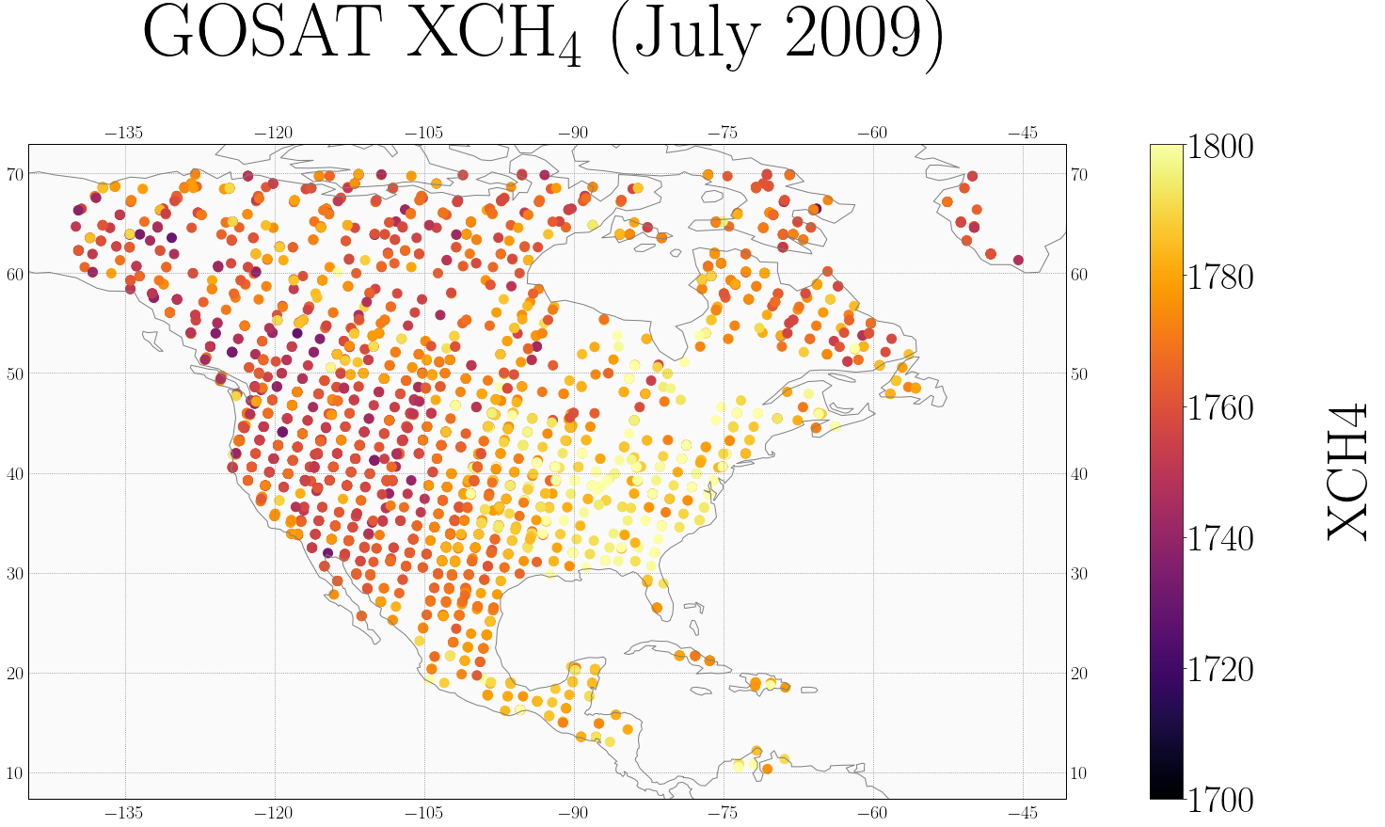

Figure : GOSAT atmospheric methane retrievals for July 2009

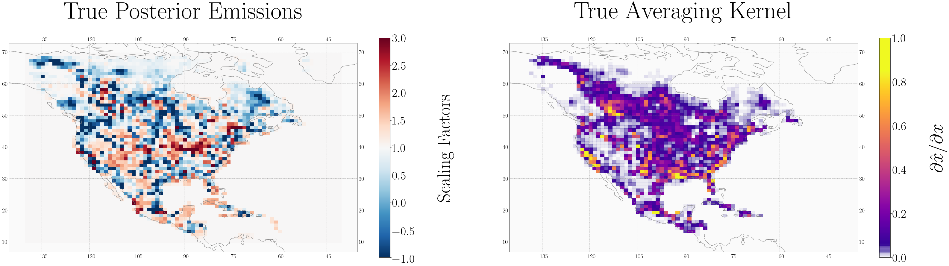

Figure : Information content of the true inverse system, as given by the diagonal elements of the averaging kernels. The inversion can better constrain emissions in grid boxes with large (closer to one) averaging kernel values.

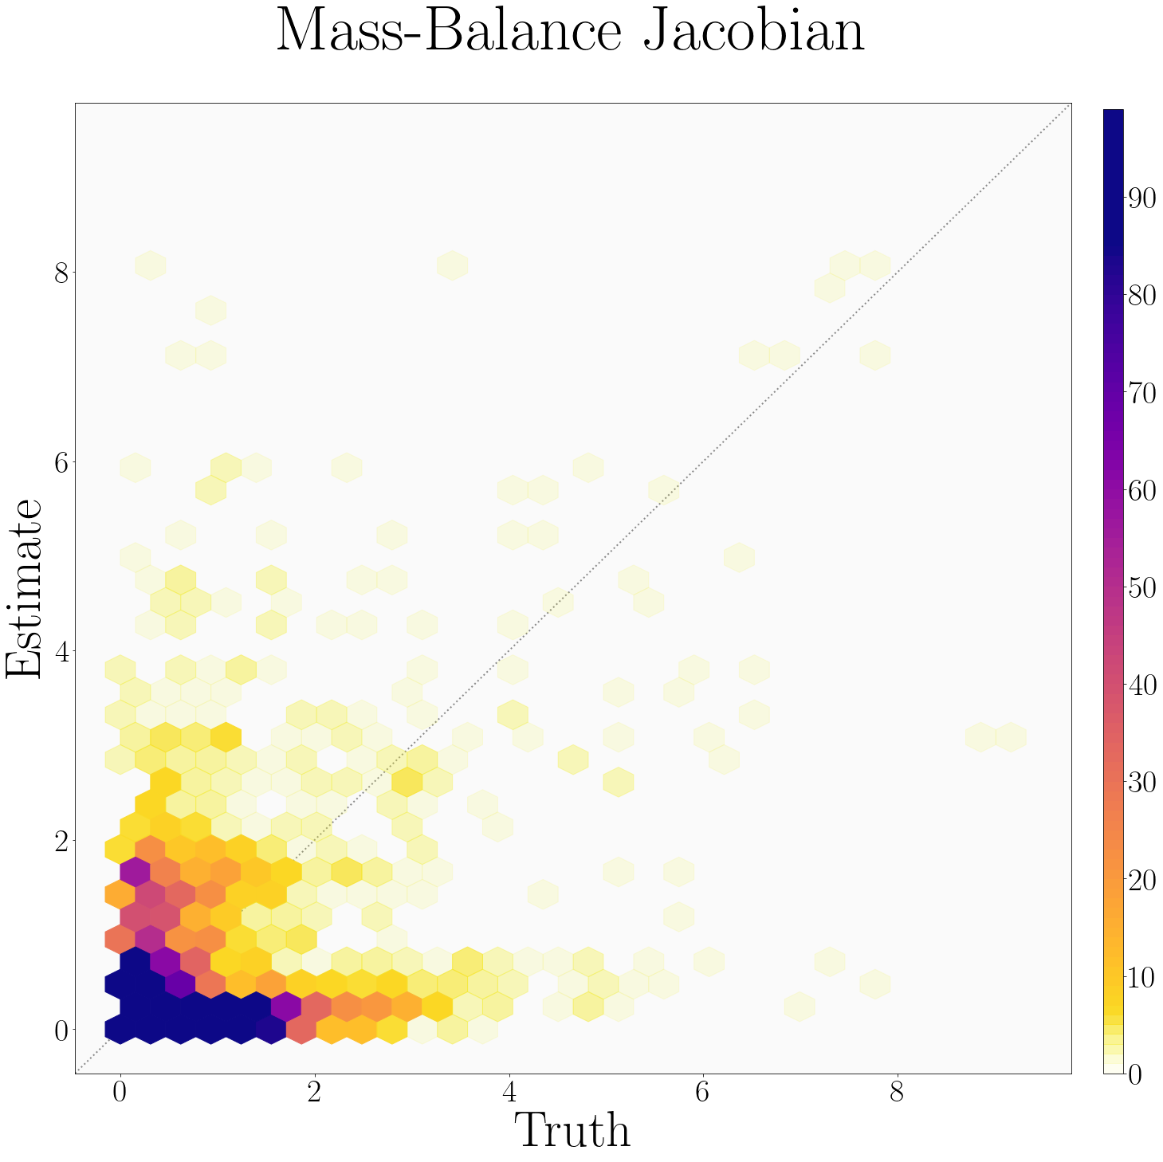

Figure

*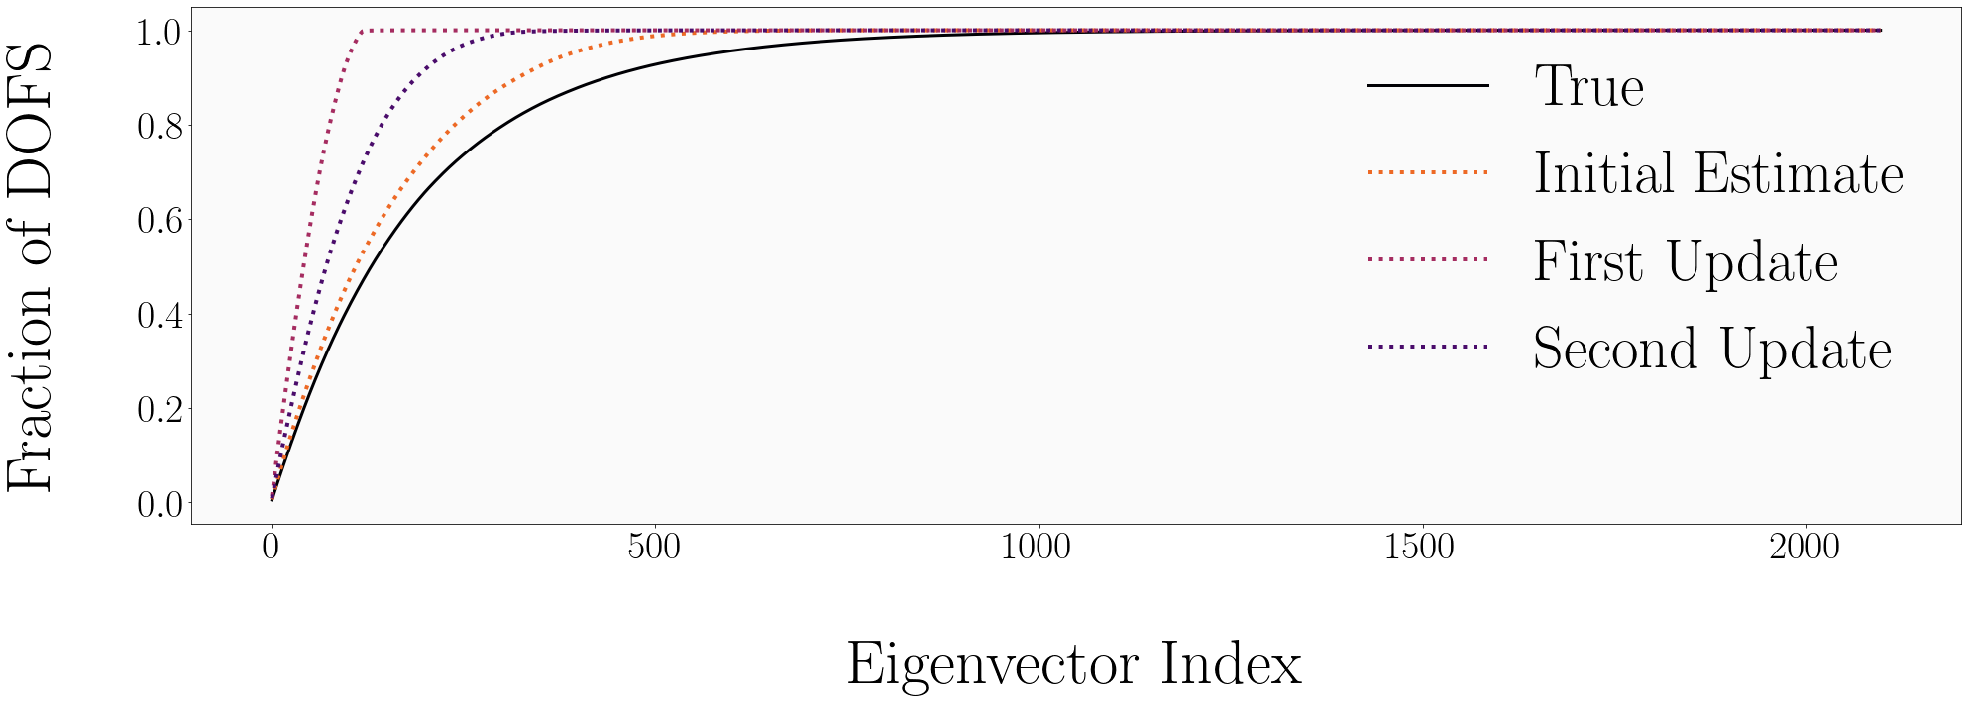*

Figure : The spectra of the eigenvalues associated with the true Jacobian (black) and the estimated Jacobian (red dashes). The two spectra are similar, demonstrating that similar fractions of information content are captured by each eigenvector.

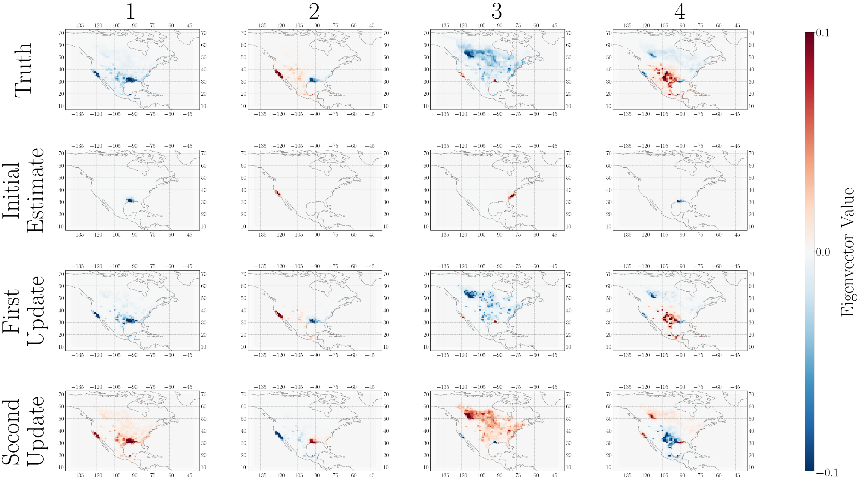

Figure

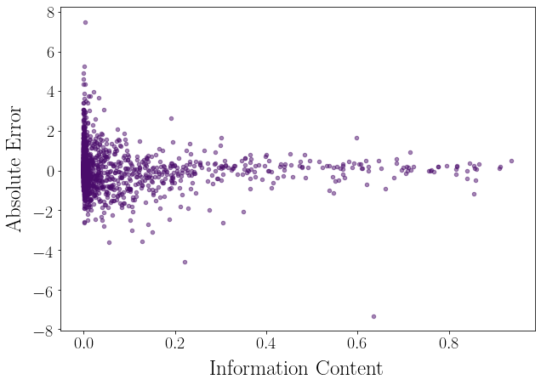

Figure 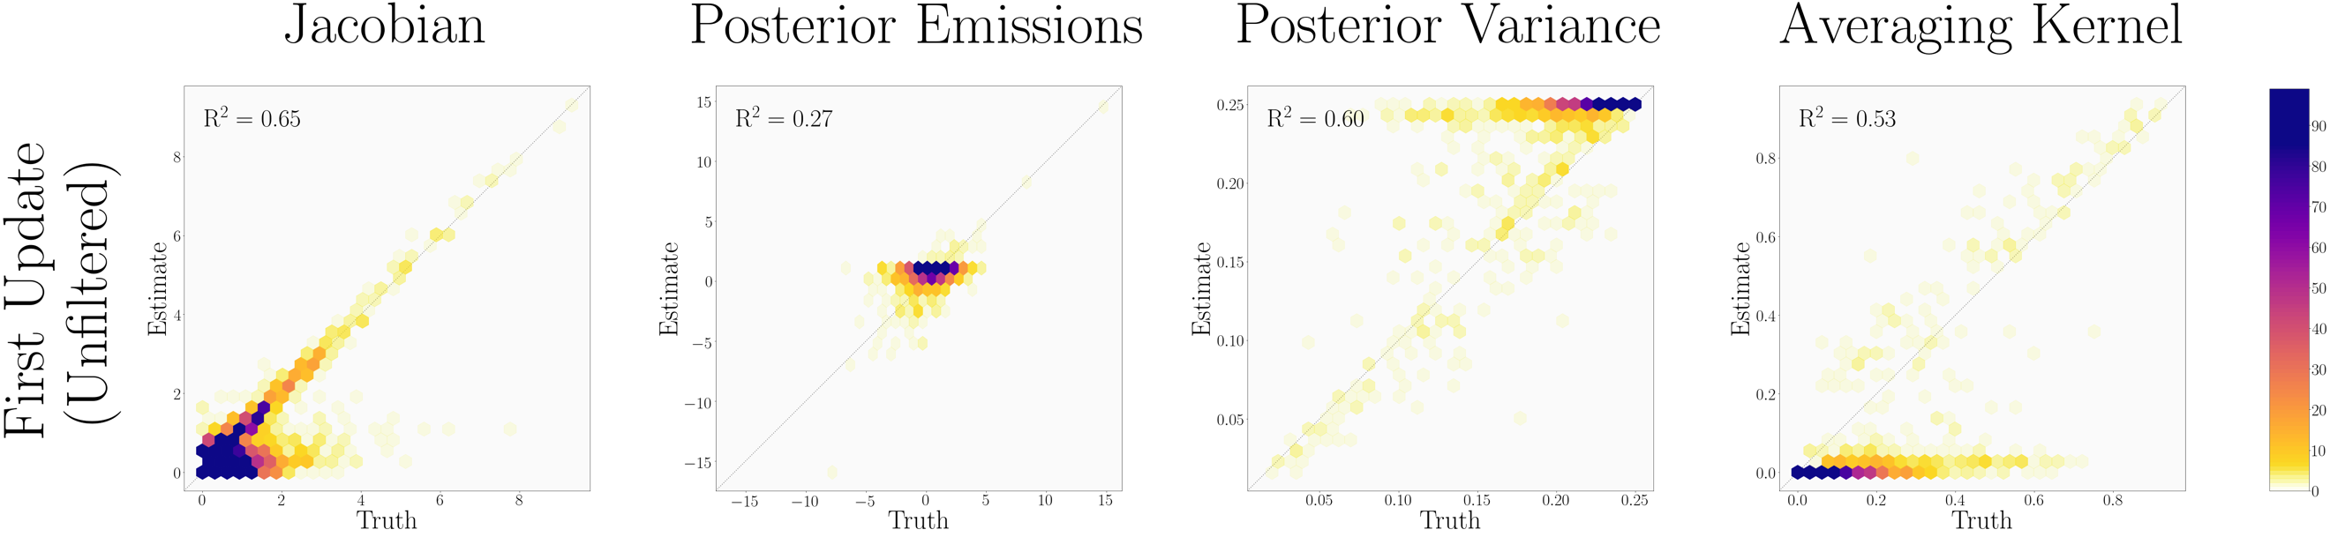

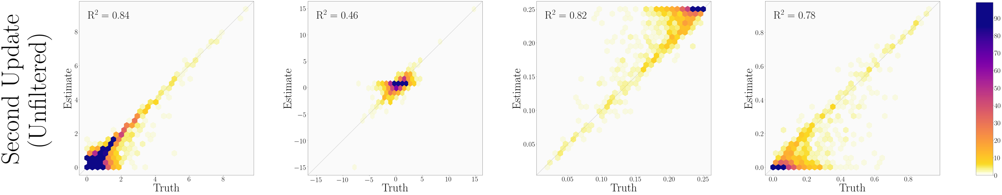

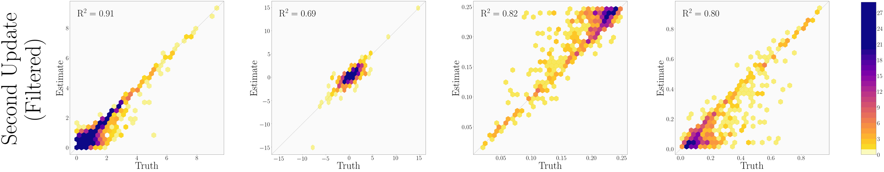

Figure

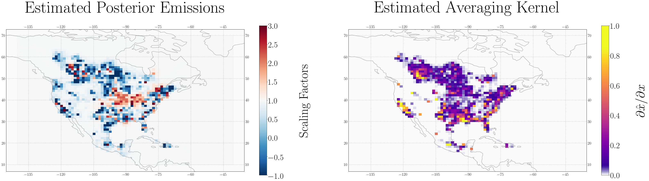

Figure