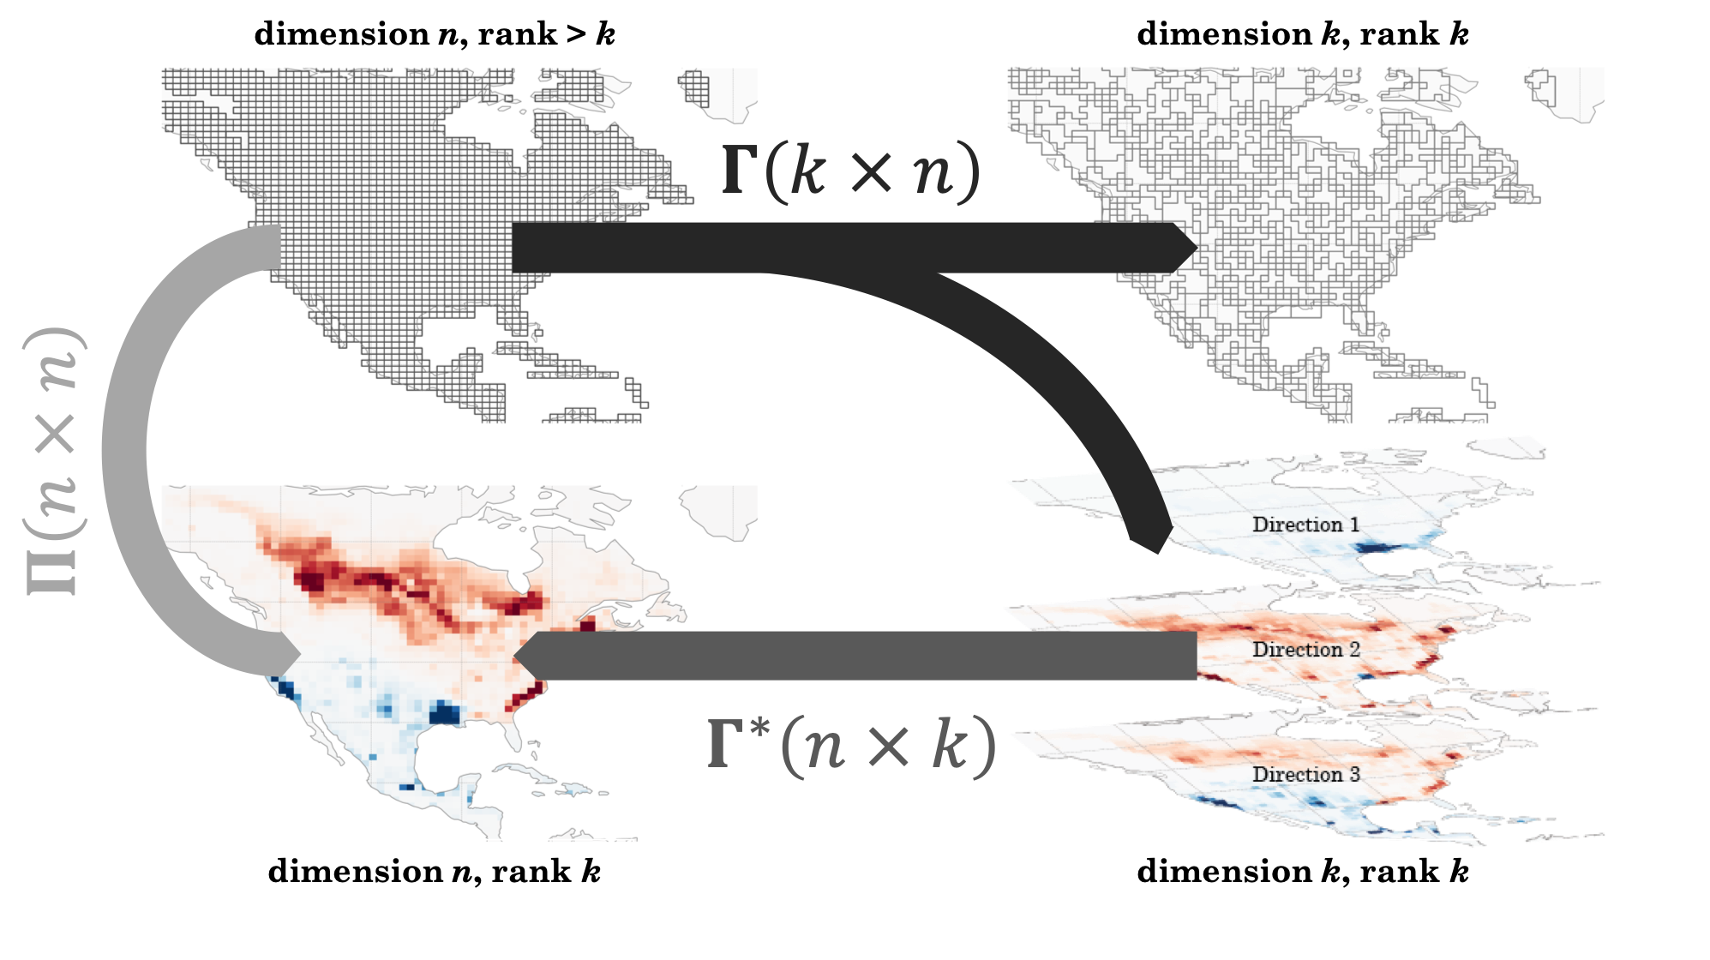

**Figure 1**. Dimension and rank reductions of a gridded emissions field. The linear transformation reduces the dimension of the original state space (upper left) either discretely by aggregating grid cells to generate a multiscale grid (upper right) or non-discretely by projecting along the directions given by the columns of (lower right, with positive values in red and negative in blue). The reverse transformation restores the dimension but not the rank, producing a low-rank subspace of the original state space (lower right). The projection reduces rank but not dimension.

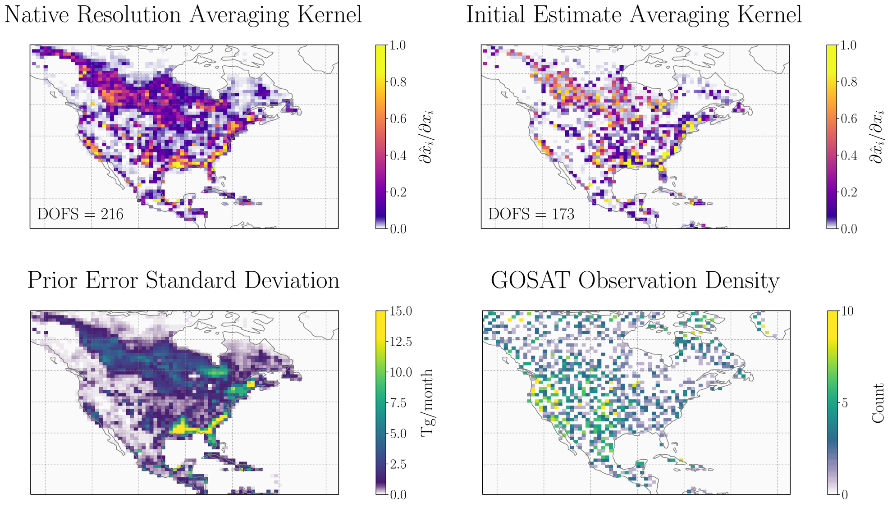

**Figure 2**. Dependence of the averaging kernel on prior errors and observational density. The averaging kernel (equation 4) is a function of the Jacobian matrix and prior and observational error covariance matrices. In the absence of a well-constrained Jacobian matrix, the prior error (lower left) and observational density (lower right) still generate patterns of information content (upper right) consistent with the native resolution averaging kernel (upper left).

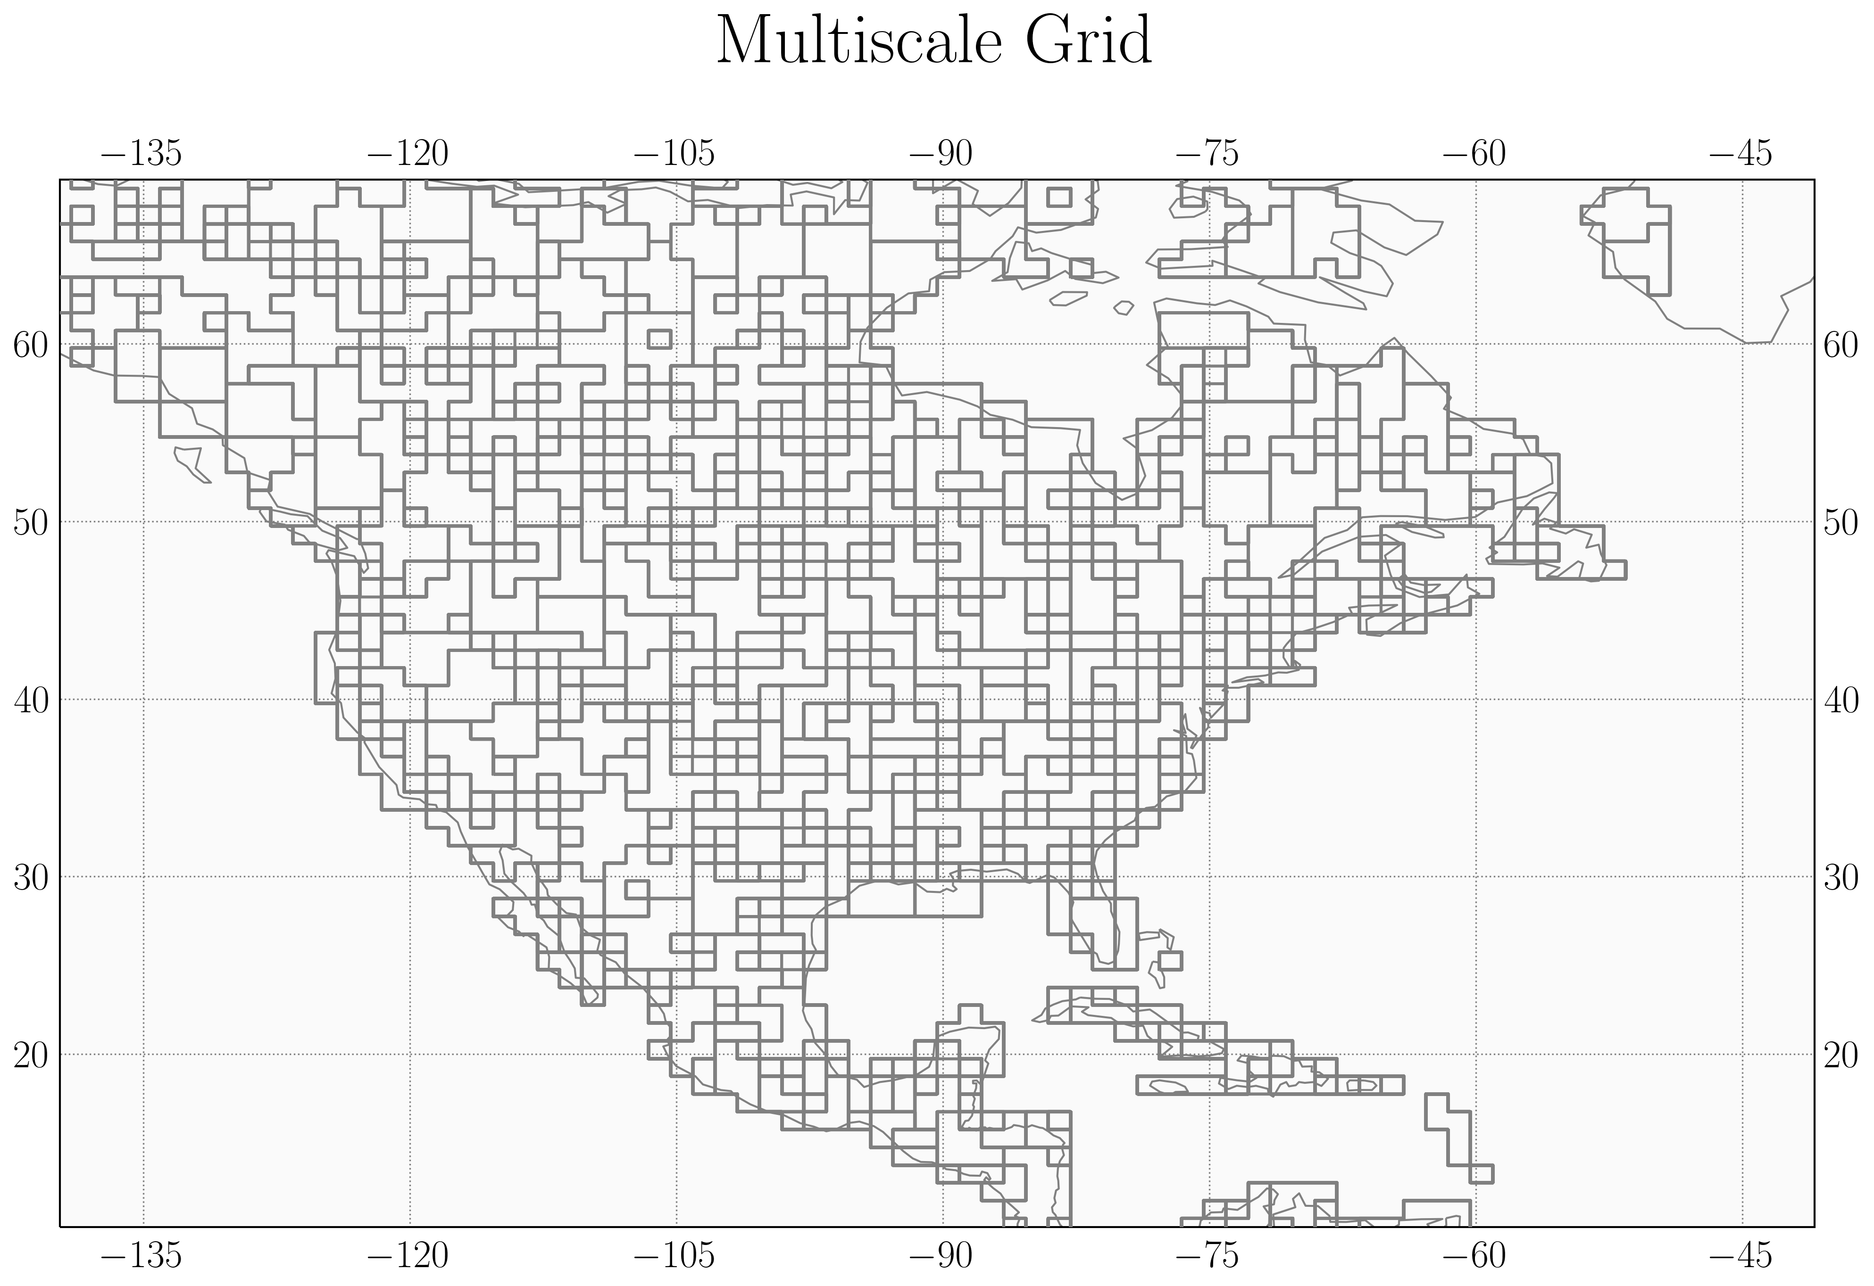

**Figure 3.** The multiscale grid that preserves native resolution in areas with highest information content and aggregates grid boxes elsewhere. The native resolution grid is clustered into ~200 grid boxes with cluster size 1, ~100 with cluster size ~3, ~100 with cluster size ~5, and ~150 with cluster size ~8 using a K-means clustering algorithm. The resulting grid has dimension ~550 and requires ~550 model runs to construct the associated Jacobian matrix.

**Figure 4**. The posterior scaling factors (top) and diagonal averaging kernel values (bottom) associated with the native resolution Jacobian matrix (left), multiscale grid Jacobian matrix (center), and reduced-rank Jacobian matrix (right). The multiscale grid produces an exact posterior solution at significantly reduced dimension, resulting in a decrease in DOFS. The reduced-rank Jacobian matrix optimizes the posterior scaling factors only in the areas with largest information content and defaults to the prior value (a scaling factor of 1) elsewhere, a pattern which is also reflected in the distribution of this solution’s information content, as given by the averaging kernel.

**Figure 5.** The correspondence of an analytic inversion conducted with the reduced-rank Jacobian matrix with the native-resolution inversion as given by the Jacobian matrix (upper left), posterior scaling factors (upper right), posterior variance (lower left), and diagonal averaging kernel values (lower left). The reduced-rank Jacobian accurately captures the true Jacobian matrix, while the posterior variance is overestimated and the diagonal elements of the averaging kernel are underestimated, consistent with the loss of information content incurred by reducing the rank. The posterior scaling factors exhibit the lowest correlation coefficient (r2 = 0.69) due to the propagation of errors in the posterior error covariance matrix and Jacobian matrix.

**Figure 6.** The sensitivity of the reduced-rank inversion DOFS to the number of model runs conducted in the first (x axis) and second (y axis) update. The star represents the inversion solved here. The correlation improves as the total number of model runs increases (diagonal contours) but there is a stronger dependence on the number of model runs conducted in the second update than in the first update.