Denison University

**Final Project Report**

**Dong Dong, Ngan Nguyen, Huy Phan**

**DA220 - Applied Statistics**

**Dr. Zhe Wang**

**May 8, 2022**

**Abstract:**

During the COVID-19 pandemic, there has been an increasing number of people who are diagnosed with mental health issues such as depression, bipolar and anxiety disorder, and so on. This is because the pandemic prevented people from seeing each other and caused social isolation. As a result, the number of people who used both prescribed and non-prescribed anti-anxiety drugs has significantly increased recently. However, there has been a debated issue concerned by a large number of people regarding the danger of anti-anxiety drugs’ side effects. In this project, we want to investigate the effect of anti-anxiety drugs on memory recall. This research utilizes data from an experiment executed by Mr. Almohalwas at UCLA to explore the time participants finish the memory test before and after drug exposure when being primed with happy and sad memories. After using two-sample t-test, Anova, and linear regressions, we can conclude that Alprazolam (Xanax) has a significant effect on participant's ability to recall memory whether it is positive or negative memory. Moreover, when the drug Alprazolam (Xanax) is used in stronger doses, its side effect makes participants take a notably longer time to recall the memory.

**Introduction:**

Young adults, especially teenagers in modern time, have been taking drugs on a frequent basis as an escape. According to an article published by the PEW charitable trusts, “This school year, addiction specialists say they’re expecting an onslaught of teens addicted to Xanax and other sedatives in a class of anti-anxiety drugs known as benzodiazepines, or “benzos.” Many teens view Xanax as a safer and more plentiful alternative to prescription opioids and heroin — with similar euphoric effects” (Vestal, 1). This has long been an ongoing trend. However, these folks are not aware of the potential lethal or permanent side effects of these medications.

Anti-anxiety drugs like many other mental health-related drugs affect the memory of those who take them. “A number of prescription and over-the-counter medications can interfere with or cause loss of memory. Possible culprits include: [antidepressants](https://www.webmd.com/depression/guide/depression-medications-antidepressants), [antihistamines](https://www.webmd.com/allergies/antihistamines-for-allergies), anti-[anxiety medications](https://www.webmd.com/anxiety-panic/guide/anxiety-panic-guide-treatment-care), muscle relaxants, [tranquilizers](https://www.webmd.com/a-to-z-guides/tc/prescription-medications-minor-tranquilizers-and-sleeping-pills), sleeping pills, and pain medications given after surgery.” (Dunkin, 1). Among other side effects, temporary or permanent memory loss is one of most known. This side effect is especially dangerous to the users, which is the reason why we want to focus our research on memory recall.

In this experiment, there are three medicines that are included: Alprazolam (Xanax), Triazolam (Halcion), and sugar pills (Placebo):

* According to WebMD, Xanax or [Alprazolam](https://www.webmd.com/drugs/2/drug-8171/alprazolam+oral/details) is used to treat anxiety and panic disorders. It produces a calming effect and works by enhancing the effects of a certain natural chemical in the body (GABA). This drug has a long-term effect.
* Triazolam or Halcion is used to treat insomnia (trouble in sleeping) since it can slow down the nervous system. This medicine is for short-term (usually 7 to 10 days) use only.
* Sugar pills (Placebo) have no known therapeutic value.

**Data**

This data set is collected from an experiment conducted under the supervision of Mr. Almohalwas at UCLA. The participants were 198 islanders who mimic real-life humans in response to external factors. All the participants were all genders and above 25 years old to ensure a fully developed prefrontal cortex, a region responsible for higher-level cognition and memory recall. They were stimulated to anti-anxiety drug addiction by taking Alprazolam (Xanax), Triazolam (Halcion), and sugar pills (Placebo). Each person was given a different type of drugs and different dosages:

A - Alprazolam (Xanax, Long-term) [1mg/3mg/5mg]

T - Triazolam (Halcion, Short-term) [0.25mg/0.5mg/0.75mg]

S- Sugar Tablet (Placebo) [1 tab/2tabs/3tabs]

The drugs and dosage were equally distributed among participants. They were given a memory test both before and after drug administration to test if there is any time difference. Dosages follow a 1:1 ratio to ensure validity and participants are tested every day for 1 week to mimic addiction. They were divided into two groups: the happy group was primed with positive memory while the sad group recalled negative memory. Happy or Sad memories were primed 10 minutes prior to testing. The data set can be found on Kaggle (<https://www.kaggle.com/datasets/steveahn/memory-test-on-drugged-islanders-data> ). It was made and collected by Steve Ahn.

**Ethical Considerations:**

As previously stated, we didn’t create the data ourselves but obtained it from Steve Ahn (<https://www.kaggle.com/datasets/steveahn/memory-test-on-drugged-islanders-data>). The experiment was executed under the supervision of Mr. Almohalwas at UCLA and all aspects of the experiment such as experimental design, data collection and preprocessing was done by Steve Ahn. UCLA is a respectable public research institution and we believe that all research under the supervision of this university’s faculty and staff is conducted in an ethical way and the data represents real human and information. I understand that we have a responsibility in the data analysis process not to use this data for personal gain or financial purposes, but only for educational purposes.

The purpose of this analysis is to have a deep understanding on how different anti- anxiety drugs can affect the memory of our brain. We understand that by downloading the data, analyzing and making interpretations and conclusions, our work can affect various stakeholders of this experiment. Therefore, we make sure that we prevent misleading or false interpretations which can lead to negative consequences for the stakeholders. We hope that our analysis can contribute positively to the community and the medical field.

**3. Methods**

3.1. Two-sample t-test for the time difference between happy and sad group

1. Hypotheses:

* Research hypothesis:

Firstly, we want to explore whether happy or sad memories can affect the time finishing memory test after exposure to drugs. We predict that there is a significant difference in the time changing after taking drugs between happy and sad groups.

* Testing hypothesis:

H0: µ1 − µ2 = 0

H: µ1 − µ2 ≠0

µ1 and µ2 are the actual means of time difference after exposure to drugs in happy and sad groups, respectively.

1. Analyzing the data

* Step 1: Import the data and get the summary information.

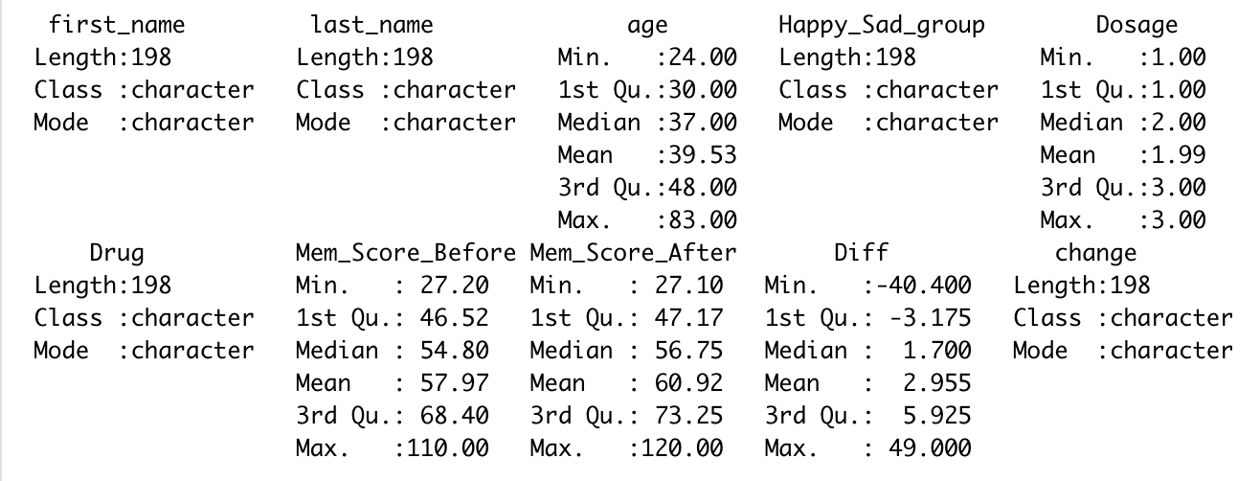

* Step 2: Have a visualization

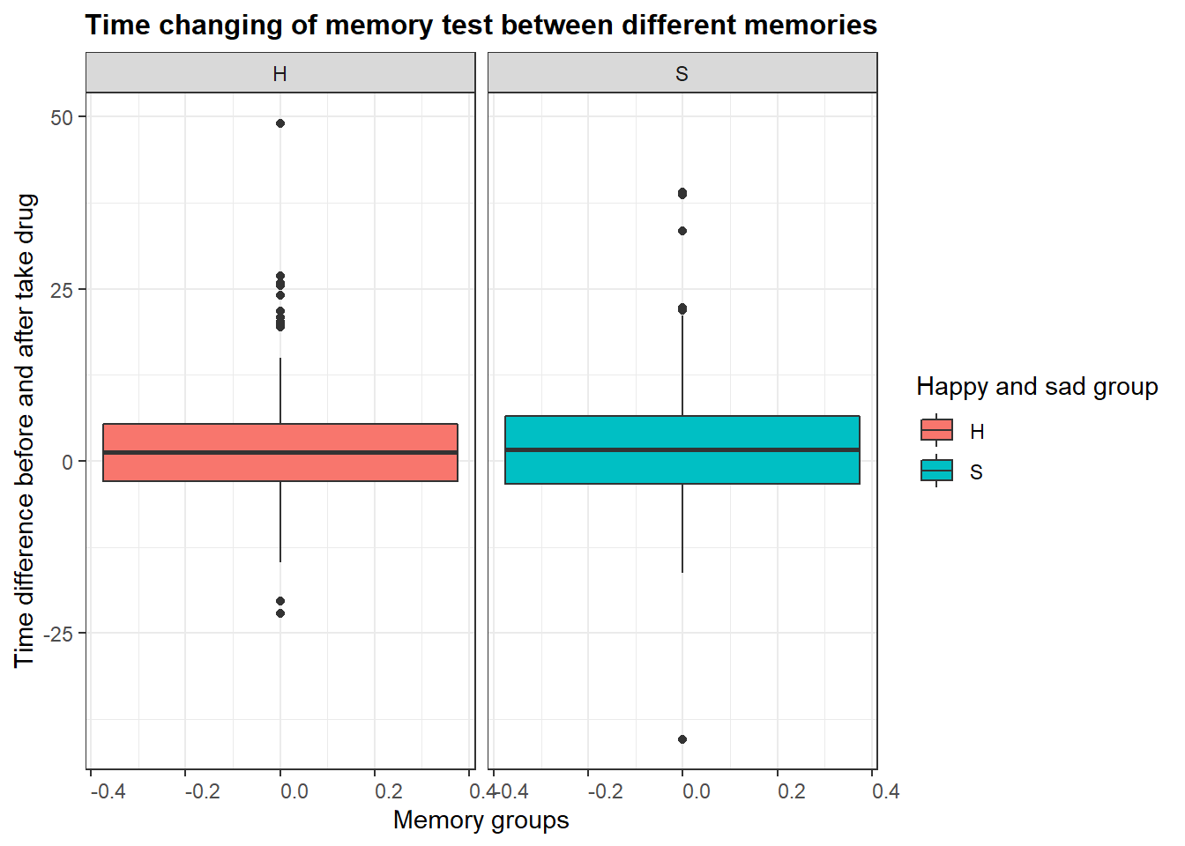

*Figure. Boxplot for happy and sad group*

From this comparative box plot, it can be seen that the true average for time changing of memory test in the happy group is similar to that in the sad group.

* Step 3: Check the assumption.

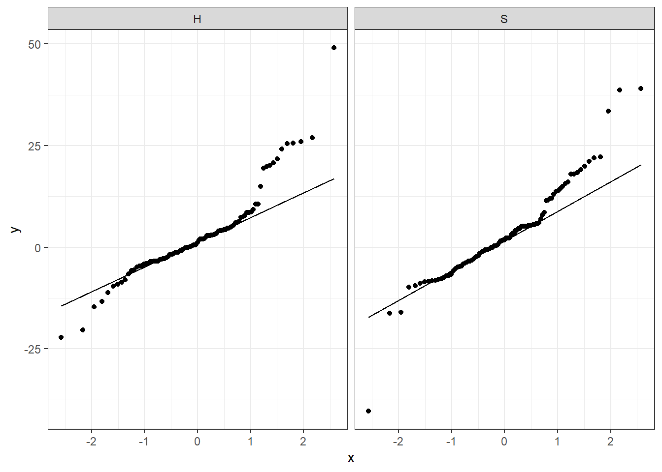

*Figure. QQ plot for happy and sad group*

Although there are some outliers, overall most of the points fall on the straight line. We also try to exclude all the outliers and the results remain the same. The QQ plot shows that the data follows a normal distribution. Therefore, it is satisfactory to conduct two-sample t-test.

* Step 4: Conduct a Two-sample t-test

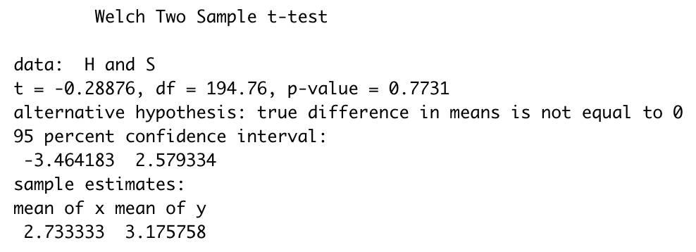

*Figure. Welch Two-Sample t-test*

The p-value is 0.7731, which is really high. This means that we can not reject the null hypothesis that there is no difference between the time changing after taking drugs between happy and sad groups. In other words, there is no statistically significant difference in the time changing of the memory test between the two groups.

3.2: Time changing of memory test between different drugs.

1. Hypotheses:

* Research hypothesis:

We want to test to see the time difference between different drugs. We use three different boxplots of the data about the time. By doing this, we gain some valuable insights about how much of the effect it can have on the participants.

* Testing hypotheses:

H0: The means of the three groups are not the same.

H: At least one sample mean is not equal to the others.

1. Analyzing the data:

* Step 1: Have a visualization

Boxplot:

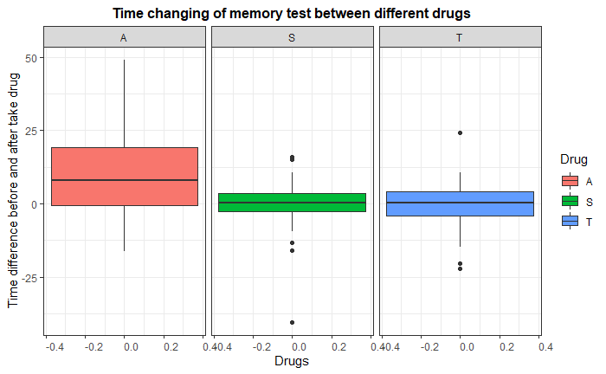

*Figure 3.2.1. Box plot showing the time changing of memory between different drugs*

From the graph, we can see that drug A (Alprazolam) has the biggest differences between two trials. There is a huge gap between before and after the drug use. The participant takes a noticeably longer time to complete the test under the influence of Xanax.

For drug S (Placebo), there is the least amount of difference. However, there are a few noticeable outliers. For drug T, the difference is larger than that of drug S. However, it is still significantly smaller than that of drug A.

* Step 2: Check the distribution

Pie chart:

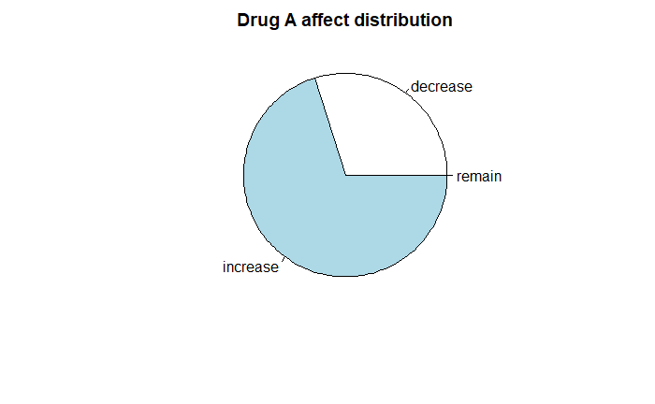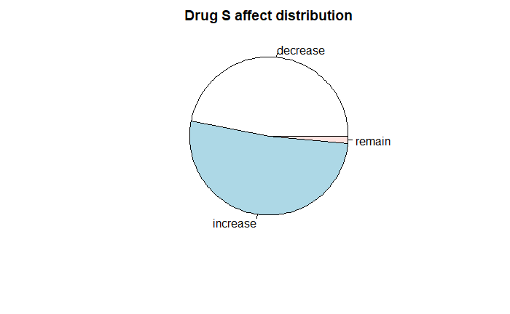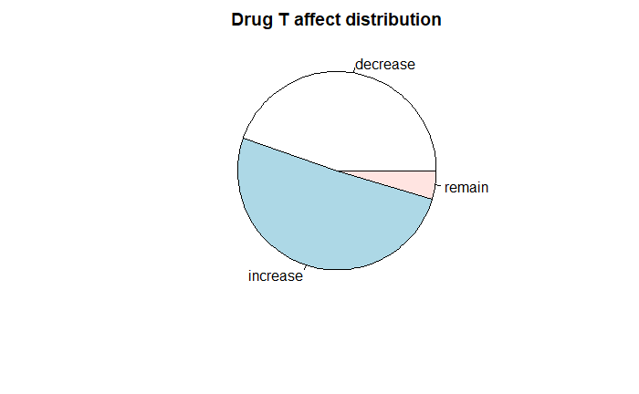

*Figure 3.2.2: Pie charts showing how different time difference are distributed*

From the three pie charts, we can see that only drug A (Alprazolam) doesn’t have any participants with the same testing time. Most Xanax takers see an increase in the amount of time they take to complete the test. Only roughly one fourth of them see a decrease.

Drug S (Placebo) sees a little bit more than half of the participants have an increased amount of time. Other than that, most of them show a decrease in the amount of time while only a small percentage of them remain the same amount of time.

Drug T (Triazolam) sees more participants with an increased amount of time than that of drug S but still nothing compared to that of drug A. However, this drug has the highest number of participants that can keep the same amount of time. A large percentage of them can see their time decreased.

* Step 3: Check the assumption

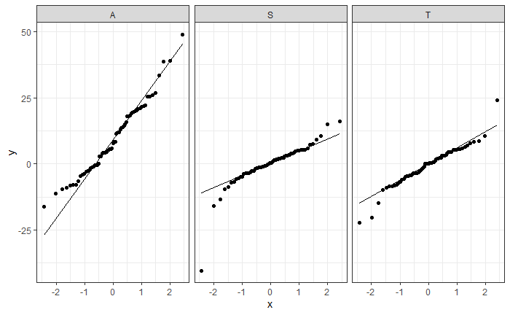

*Figure 3.2.3. QQ plot for the time difference for different drugs*

Although there are still many outliers, the QQ plot still shows that the data follows a normal distribution. Therefore, we can conduct an ANOVA test.

* Step 4: Conduct an ANOVA test

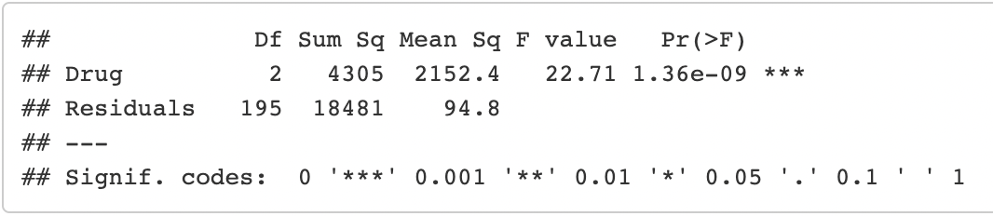

From the ANOVA table, we can see the p-value is 1.36e-09, which is significantly small. Therefore, we can reject the null hypothesis. We can conclude that there is a remarkable difference in the time needed to complete the test before and after taking the drug.

* Step 5: Check residuals plot

|  |  |
| --- | --- |
|  |  |

*Figure 3.2.4. Residual plots of the time difference between different types of drugs*

All the assumptions are satisfied except for the fact that there are still some outliers. We have tried to run the ANOVA test again; however, the result is not significantly different so we keep our first result.

3.5: Two-way ANOVA test for different dosages among drugs.

1. Hypotheses:

* Research hypothesis:

We want to see if there are significant differences among the effects of dosages 1, 2, and 3 in three types of anti-anxiety medications being used - Alprazolam (Xanax), Triazolam (Halcion), and sugar pills (Placebo). By doing so, we can get some insights about the dangerous level of side effects of each drug when increasing its dosages.

* Testing hypotheses:

H0: The means of the six groups are not the same.

H: At least one sample mean is not equal to the others.

1. Analyzing the data:

* Step 1: Have a visualization

Boxplot:

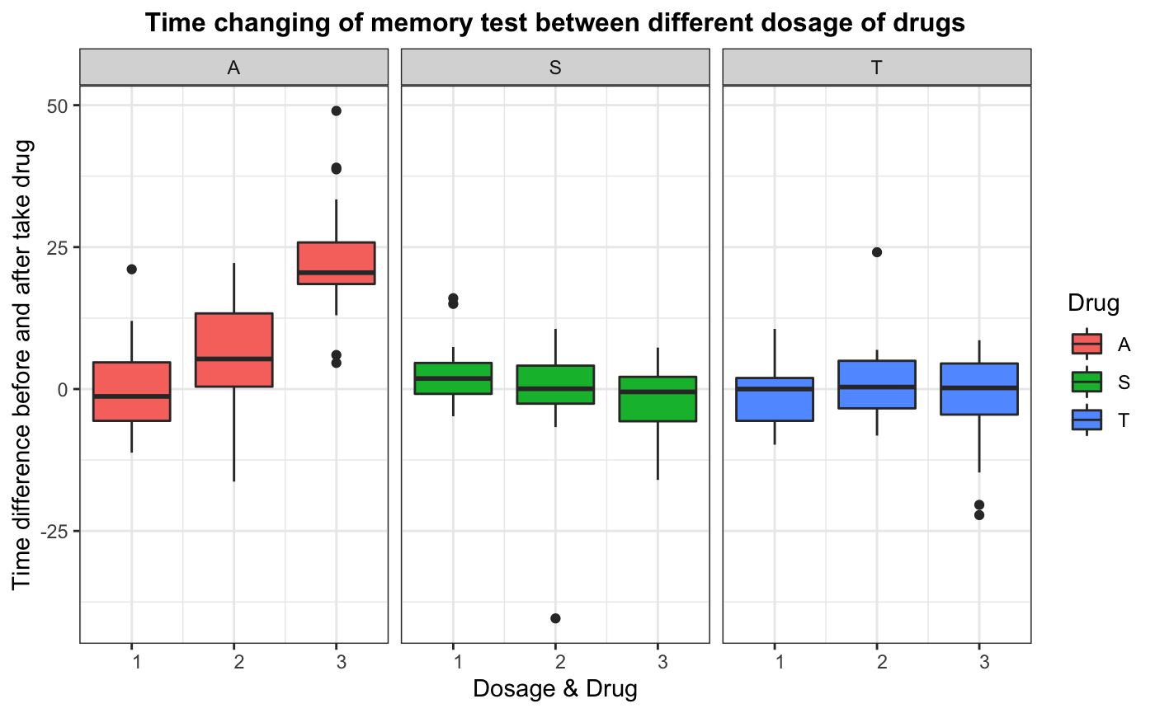

*Figure 3.5.1: Boxplot for drug x dosage effect*

Observing the boxplot, drug A(Alprazolam) has a notable higher side effect than the other two drugs. When using more doses, the participants using drug A(Alprazolam) take remarkably more time doing the memory test. For drug T(Triazolam) using participants, the time slightly increases when taking a higher dosage, while in contrast, it tends to decrease in drug S(sugar pills) using participants.

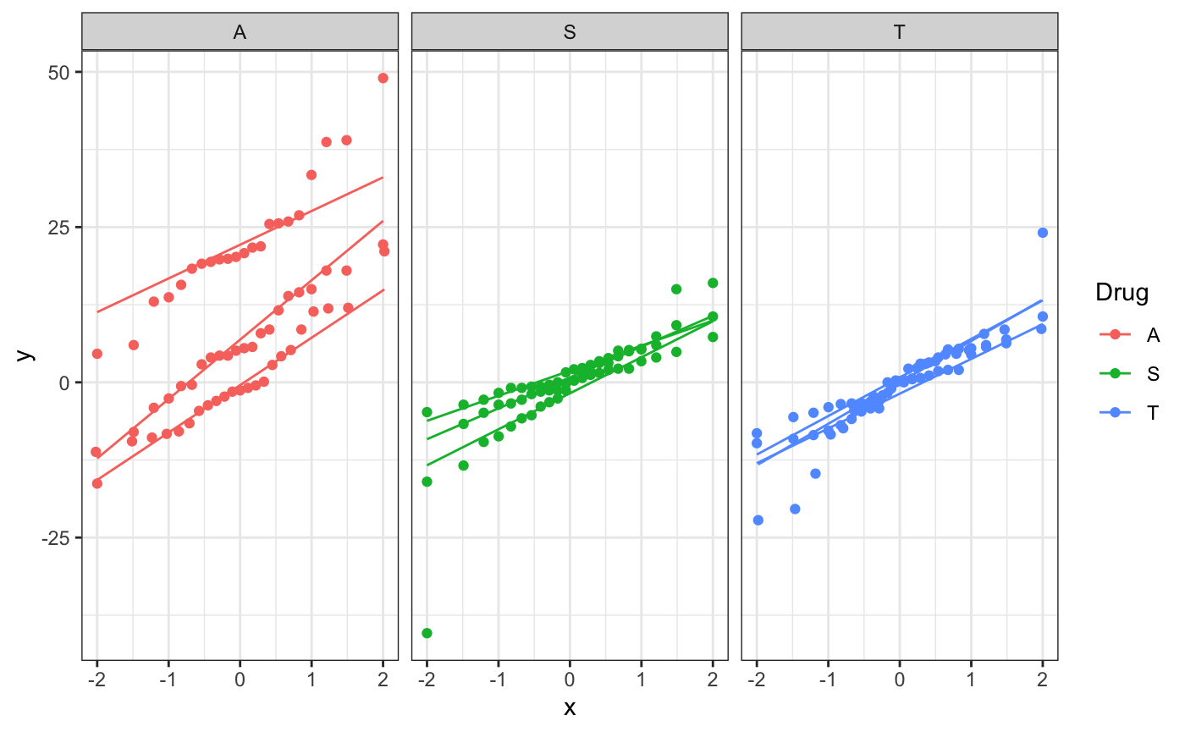

*Figure 3.5.2: Q-Q plot for drug x dosage effect data*

From the Q-Q plot, although there are some outliers, the data mostly follow a normal distribution and are satisfied for the ANOVA test.

* Step 3: Conduct a Two-way ANOVA test

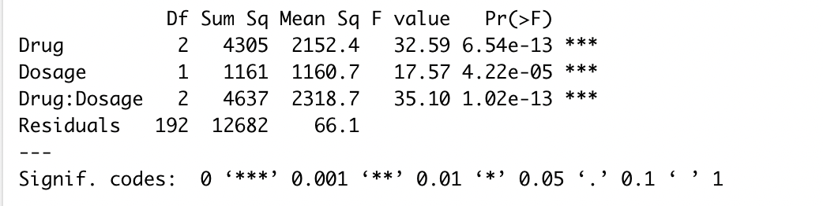

In the ANOVA table, the p-value of drug is 4.45e-10, of dosage is 0.000396 and of the two combined is 1.02e-13, which are both remarkably small. Both p-values are smaller than 0.05 so we can reject the null hypothesis. We conclude that there are significant differences between the effect on memory test of three dosages among three types of drugs being used. From the boxplot and ANOVA table, Drug A(Alprazolam) effect is significantly larger while drug T (Triazolam) is quite similar to sugar pills so we can not conclude that drug T (Triazolam) effect is not influenced by placebo effect.

* Step 4: Check the residual plots

| ​​ |  |
| --- | --- |
|  |  |

*Figure 3.5.3: Residual plots for two-way ANOVA test*

All the assumptions are satisfied except that there are a few outliers. We have tried the two-way ANOVA test again with eliminated outliers data and see no significant difference so we keep our first result.

3.6: Linear regression between age and memory test effect:

1. Hypotheses:

* Research hypothesis:

We want to predict if age and the time participants take the memory test after using anti-anxiety drugs have a linear relationship with each other. When increasing the age, the effect might increase or decrease with it.

* Testing hypotheses:

Y = 0 + 1X

Y is the time participants take the memory test after using anti-anxiety drugs while X is the participants’ age.

1. Analyzing the data:

* Step 1: Have a visualization

Bar graph:

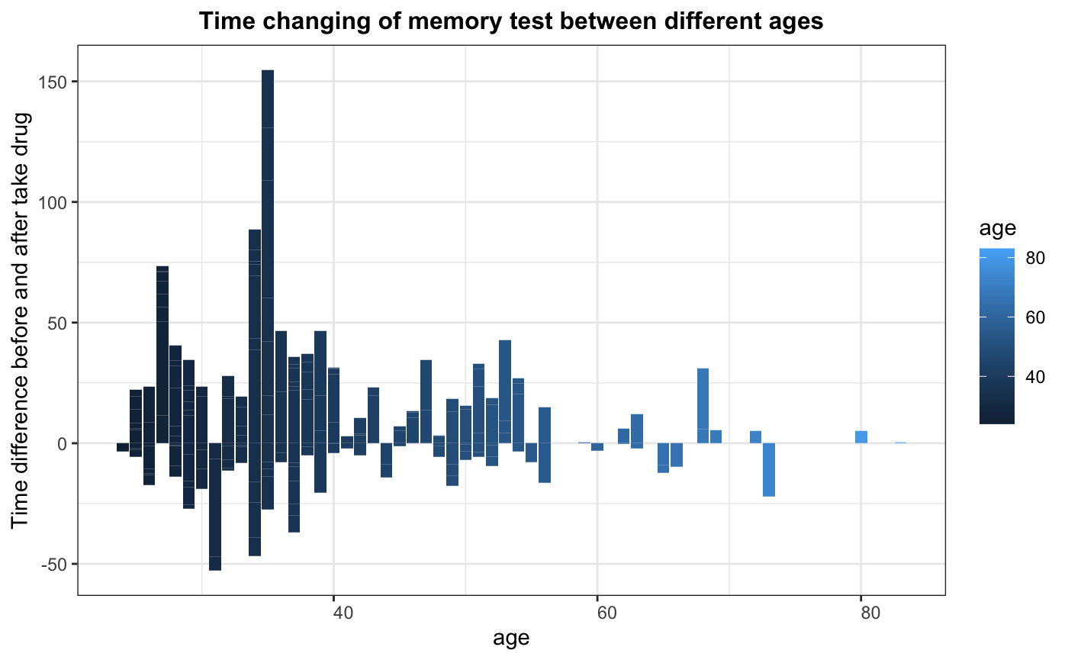

*Figure 3.6.1: Bar graph for effect in different ages*

Observing the bar graph, the effect seems to decrease when participants are older.

* Step 2: Conduct a linear regression

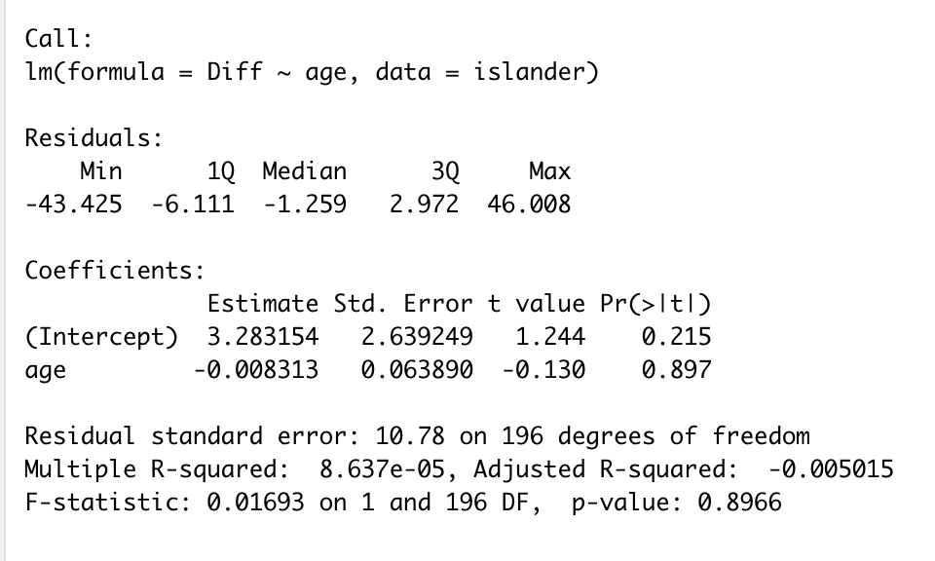

From the linear regression table, we observed 1 = -0.008313. This means for every one year increase in age, the time difference between two times taking a memory test, before and after taking anti-anxiety medication, will decrease by 0.008313. However, p-value here is 0.897 > 0.05, so we fail to reject the null hypothesis and can conclude that there is no significant linear relationship between age and the level of effect from anti-anxiety medication on memory. Another evidence we get from the linear regression table is the R squared value, which is really small from only 8.637e-05, so there is a small percentage of cases that will follow the linear regression.

* Step 3: Check residual plots

| ​​ |  |
| --- | --- |
|  |  |

*Figure 3.6.2: Residuals plot for linear regression*

All the assumptions are satisfied except a few outliers. We have tried to exclude the outliers from the data and fit the linear regression again but there is no significant difference so we keep out initial result.

**CONCLUSION**

From the result of two-sample t-test, ANOVA test, and linear regression, it can be seen that Alprazolam (Xanax) has a significant effect on participant's ability to recall memory whether it is positive or negative memory and regardless of their age. When the drug Alprazolam (Xanax) is used in stronger doses, its side effect makes participants take a notably longer time to recall the memory. Therefore, when using the drug Alprazolam (Xanax), people should be conscious of its side effect on memory recall.

The medicine Alprazolam (Xanax) is also being cited as one of the most regularly given anti-anxiety drugs and one of the easiest to become addicted to, making this case appear to be a prevalent issue. Hopefully, this study can serve as a backbone/foundation for future research on the safety of anti-anxiety medications.

**REFERENCE**

* Ait-Daoud, N., Hamby, A. S., Sharma, S., & Blevins, D. (2018). *A review of Alprazolam use, misuse, and withdrawal*. Journal of addiction medicine. Retrieved April 28, 2022, from https://www.ncbi.nlm.nih.gov/pmc/articles/PMC5846112/
* Chowdhury, Z. S. (2016). *The effect of chronic alprazolam intake on memory, attention, and psychomotor performance in Healthy Human Male Volunteers*. Behavioral neurology. Retrieved April 28, 2022, from https://www.ncbi.nlm.nih.gov/pmc/articles/PMC4947648/
* Hendrie, D. (n.d.). *Anxiety and depression medication rates spike amid ongoing uncertainty*. NewsGP. Retrieved May 5, 2022, from https://www1.racgp.org.au/newsgp/clinical/use-of-anxiety-and-depression-medication-spikes-as
* Mary Anne Dunkin. *Memory Loss*. www.webmd.com/brain/memory-loss. Accessed 6 May 2022.
* Melinda. (2022, April 6). *Anxiety medication*. HelpGuide.org. Retrieved April 28, 2022, from https://www.helpguide.org/articles/anxiety/anxiety-medication.htm
* *The Pros and cons of 6 leading anxiety medications*. Banner. (n.d.). Retrieved April 28, 2022, from https://www.bannerhealth.com/healthcareblog/better-me/how-to-evaluate-the-pros-and-cons-of-6-top-anxiety-medications
* Vestal, Christine. *“Teen Xanax Abuse Is Surging”* The Pew Charitable Trusts, 24 Aug. 2018,www.pewtrusts.org/en/research-and-analysis/blogs/stateline/2018/08/24/teen-xanax-abuse-is-surging. Accessed 6 May 2022.
* *“Xanax-Uses,Side Effects,and More”*<https://www.webmd.com/drugs/2/drug-9824/xanax-oral/details>. Accessed 6 May 2022