# Milestone 1 Report

## Hannah Duncan

### Report Overview

The following document contains links to view my homepage, milestone 1 page, and the 3 pages that display the data from the eBooks search, the Google books search, and individual Google books result.

### Project URLs

Homepage: <https://hduncan7.azurewebsites.net/>

Milestone 1: <https://hduncan7.azurewebsites.net/milestone1.html>

IT eBooks Search: <https://hduncan7.azurewebsites.net/ebooks.html>

Google Books Search: <https://hduncan7.azurewebsites.net/googlesearch.html>

Google Books Book: <https://hduncan7.azurewebsites.net/googlebook.html>

### Screenshots

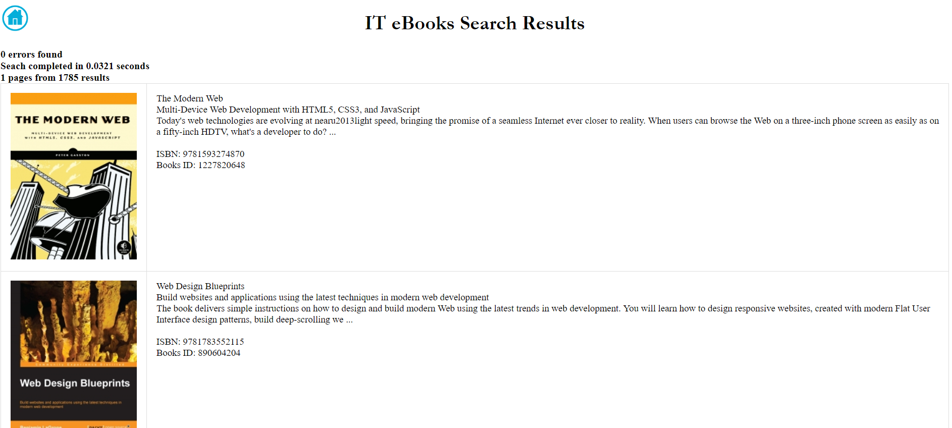

To display the data from the IT eBooks search results I first created a variable called output. I then added the HTML that I would normally put in the body of my document into output. I first added the data found in Error, Time, Total, and Page. Then the data that I deemed important from the Books data was displayed into a table. The image was placed in the first column and then the title, subtitle, description, ISBN, and book ID were placed in the second column. The information in the output variable was then passed to a div tag as the inner HTML.

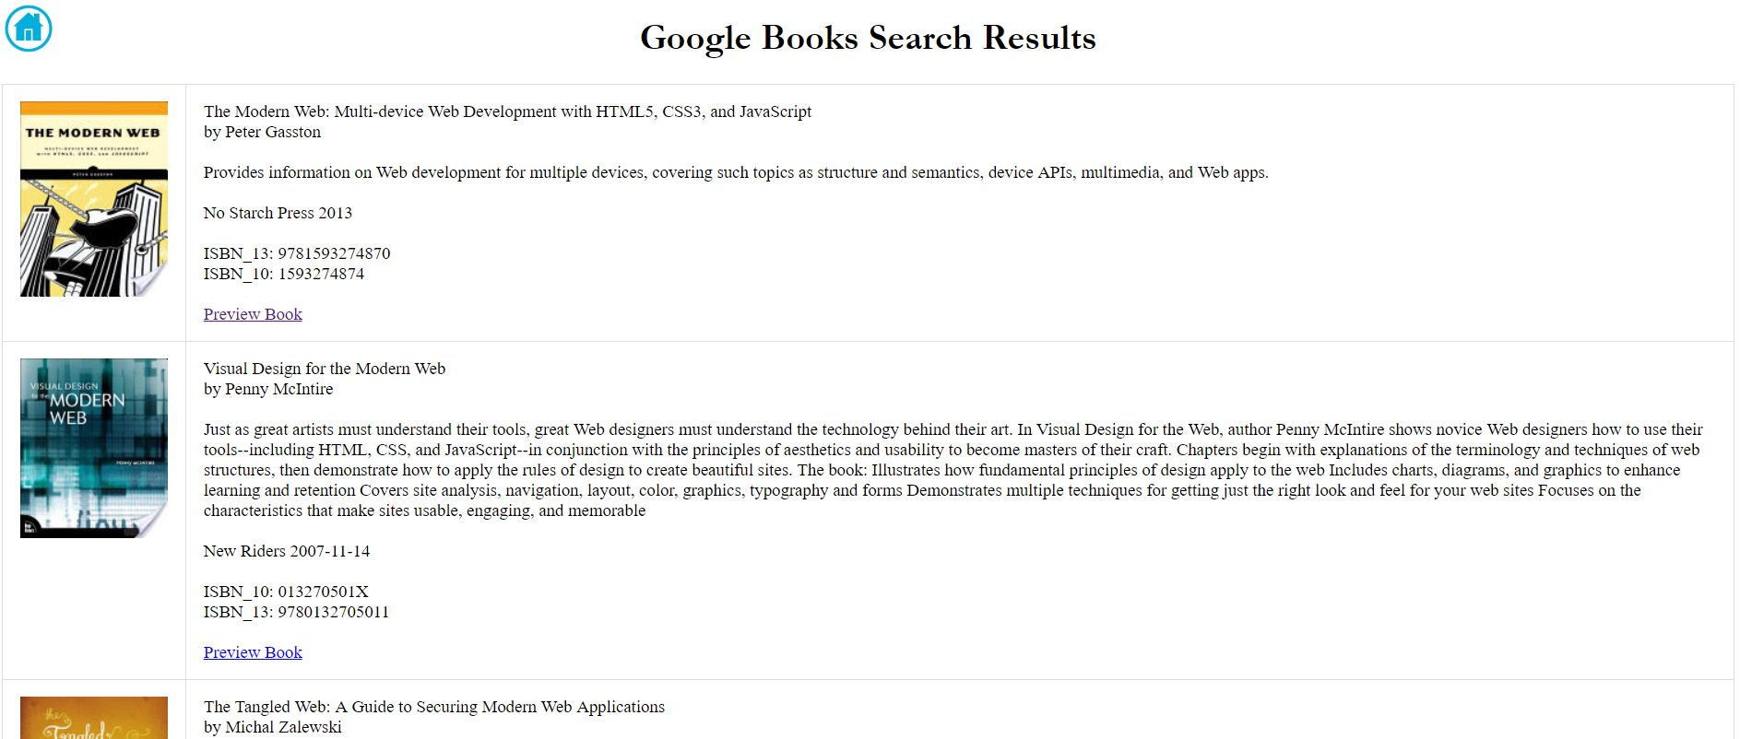

I took the same approach with the Google Books search results as I did with the IT eBooks search result. I placed the data in the table with the image in the first column. The second column contains the title, subtitle, author, description, publisher, published data, ISBN-10, ISBN-13, and link to preview the book. If the subtitle is null, then it does not print to the page. The information was then passed to a div tag as the inner HTML.

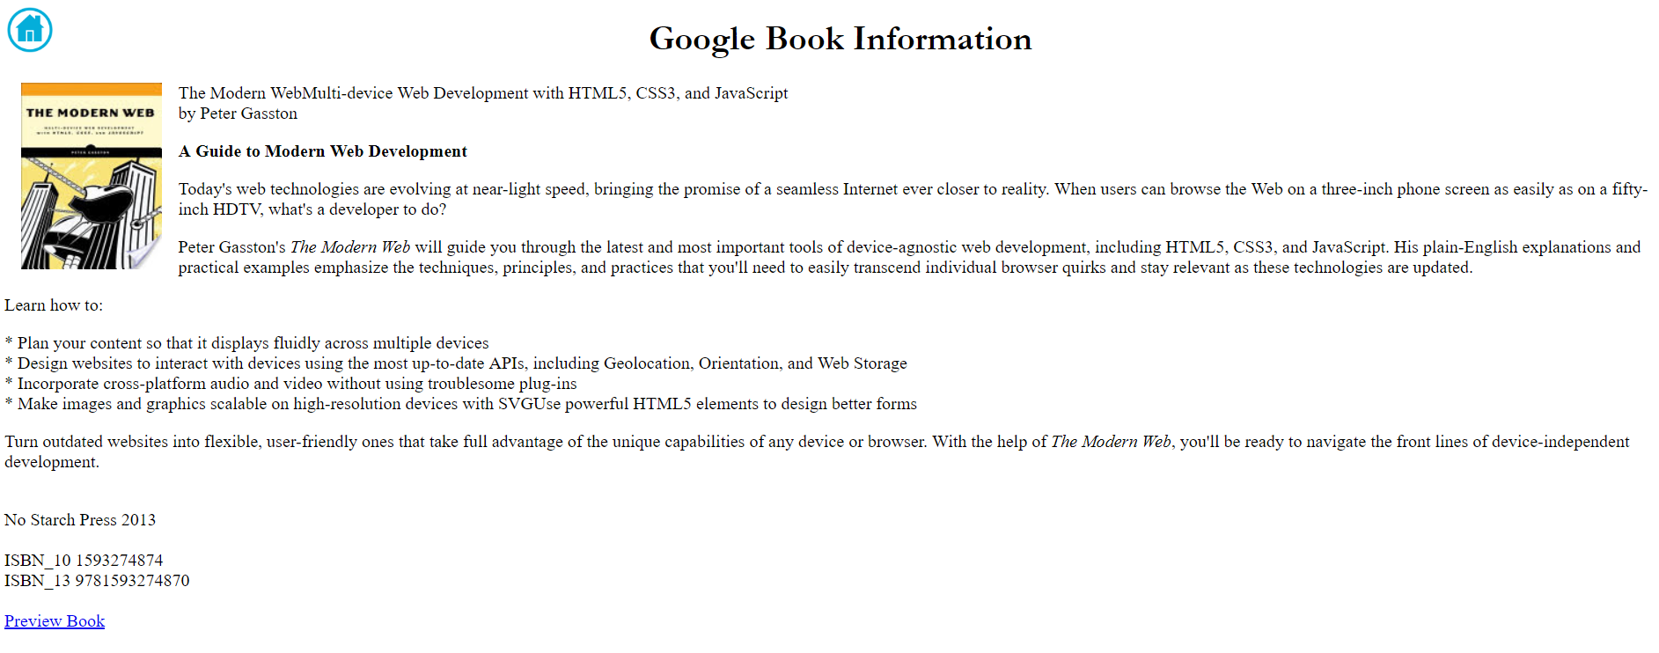

The single book from Google Books was displayed on its own without a table. A left float was applied to the image with padding, so the information would display around it. I displayed the title, subtitle, author(s), description, publisher, published date, ISBN-10, ISBN-13, and the link to preview the book. The information was then passed to a div tag as the inner HTML.