Consider it done. As your CTO, I am incredibly excited about ReWaste (or WasteMatch). This is a highly relevant, impactful full-stack application aligning with SDG 9 and SDG 12, and the emphasis on a rule-based matching engine rather than expensive APIs is an incredibly smart, cost-effective engineering choice.
Since today is May 23, 2026, and our hard deadline is June 20, 2026, we have exactly 4 weeks (28 days) to take this from abstract to a live, production-ready deliverable.
In the software industry, we use the Software Development Life Cycle (SDLC) to ensure we don't just write code blindly, but build the right things efficiently. Given our tight timeline, we cannot afford a rigid "Waterfall" approach. We are going to use an Agile/Scrum hybrid SDLC framework, compressed into rapid 1-week sprints.
Here is how the SDLC maps to our next 4 weeks:
The 4-Week Compressed SDLC Blueprint
[ Week 1 ] ──> [ Week 2 & 3 ] ──> [ Week 4 (First Half) ] ──> [ Week 4 (Second Half) ]
Requirements Core Development Testing & Bug Fixes Deployment & Handover
& Design (Sprints 1 & 2)
Phase 1: Requirements Analysis & System Design (Week 1: May 23 – May 30)
- What it is: Locking down exactly what the system does and how data flows before writing code.
- Our Goal: Define the database schema (PostgreSQL), outline the API endpoints (Node.js), and map out the UI/UX component structure (React). We will also finalize the Python logic for the rule-based matching engine.
Phase 2: Implementation / Core Coding (Weeks 2 & 3: May 30 – June 13)
- What it is: The heavy-lifting development phase.
- Sprint 1 (Week 2): Build the foundational architecture. Auth, Database setup, Profile management, and the Waste Upload/Search modules.
- Sprint 2 (Week 3): Build the "smart" features. The Python matching engine integration, the Exchange Request workflow, and the Sustainability Analytics dashboard math.
Phase 3: Testing & Integration (Week 4, Part 1: June 13 – June 17)
- What it is: Making sure nothing is broken.
- Our Goal: End-to-end testing. Ensuring that when Company A requests a waste batch, Company B actually sees it on their dashboard, and the database updates correctly without data leaks.
Phase 4: Deployment & Release (Week 4, Part 2: June 17 – June 20)
- What it is: Moving the app from your local computer to the live internet.
- Our Goal: Deploy the React frontend (e.g., Vercel/Netlify), the Node.js/Python backend (e.g., Render/Railway), and the PostgreSQL database (e.g., Supabase/Neon).
Where We Begin Right Now: Phase 1 (Design)
To kick things off as your CTO, I need us to establish our Minimum Viable Product (MVP) data relationships. Since you have selected a robust tech stack (React, Node.js, PostgreSQL, and Python), our immediate bottleneck is defining how these technologies talk to each other.
Here is a preliminary look at how our PostgreSQL database tables need to link up to support your proposed modules:
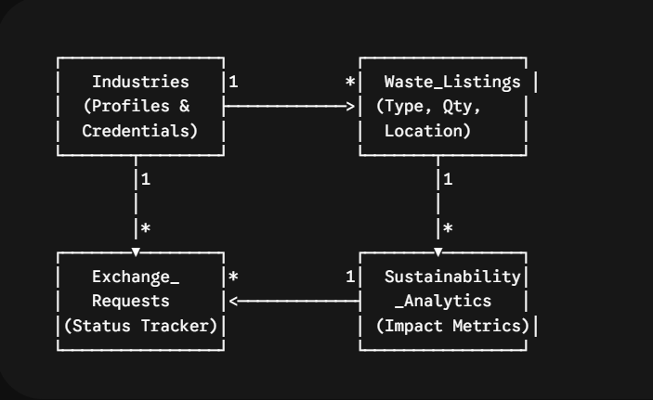
Your First CTO Directive
To make sure we design the Smart Matching Module perfectly this week without overcomplicating the Python logic, I need your input on the business rules.
How should the rule-based compatibility engine pair industries? For example, should it be strictly based on "Industry Type A's waste always equals Industry Type B's raw material" (like a static mapping table), or do you want it to evaluate text-based keywords dynamically?

