COMP 237 Intro to AI
Hannah Raju
301543568
October 12, 2025

Assignment 3 Analysis Report: Linear Regression

Exercise 1: Sampling and Noise

The purpose of this exercise was to examine the impact of adding noise to a linear function. X was defined by randomly selecting 100 values from a uniform distribution with a seed value of 68. Y was defined by the function y=12x-4 and a scatter-plot was generated to demonstrate this relationship (Figure 1). Next, noise was randomly generated from a Gaussian distribution and the scatter-plot was regenerated with the added noise (Figure 2).

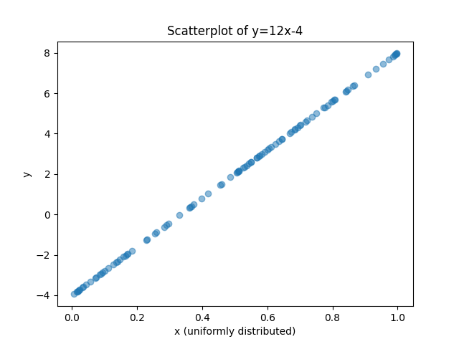Figure 1: Scatter-plot of y=12x-4

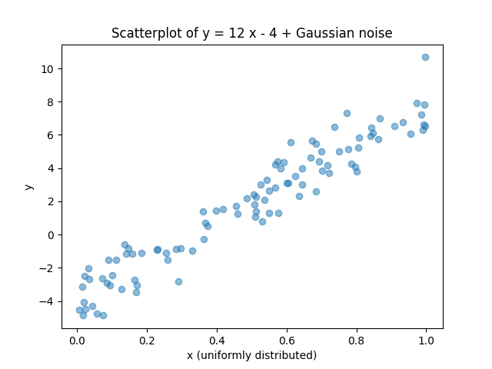Figure 2: Scatter-plot of y = 12x - 4 + noise

Comparing the two plots seen above, we can see the addition of noise has scattered the points randomly outward from the line y=12x-4. Though the data is noticeably more random, a best fit line would still be linear. Because the noise is normally distributed, the values differ enough to create realistic noise useful for experimentation, by adding an approximated realism into data. If the noise was uniformly distributed, for instance, it would have similar impact to adding a constant and the data would more strongly linear, like in figure 1.

Exercise 2: Commerce website predictions

The purpose of this exercise was to explore the built-in functionalities of important Python libraries including Pandas, Matplotlib and Scikit-learn. Sample expense data from the provided “Ecom Expense.csv” file was loaded in to a Pandas Dataframe object ecom_exp_hannah.

Table 1: All variables and their data types from the original “Ecom Expenses.csv” dataset
Variable | Data type
Transaction ID | Categorical
Age | Numerical
Items | Numerical
Monthly Income | Numerical
Transaction Time | Numerical
Record | Numerical
Gender | Categorical
City Tier | Categorical
Total Spend | Numerical

During the exploration stage of the experiment, different metrics about the data are printed to the terminal including the first three records, the shape of the ecom_exp_hannah dataframe, the column names and types of columns, and the number of missing data values per column (Figure 3).

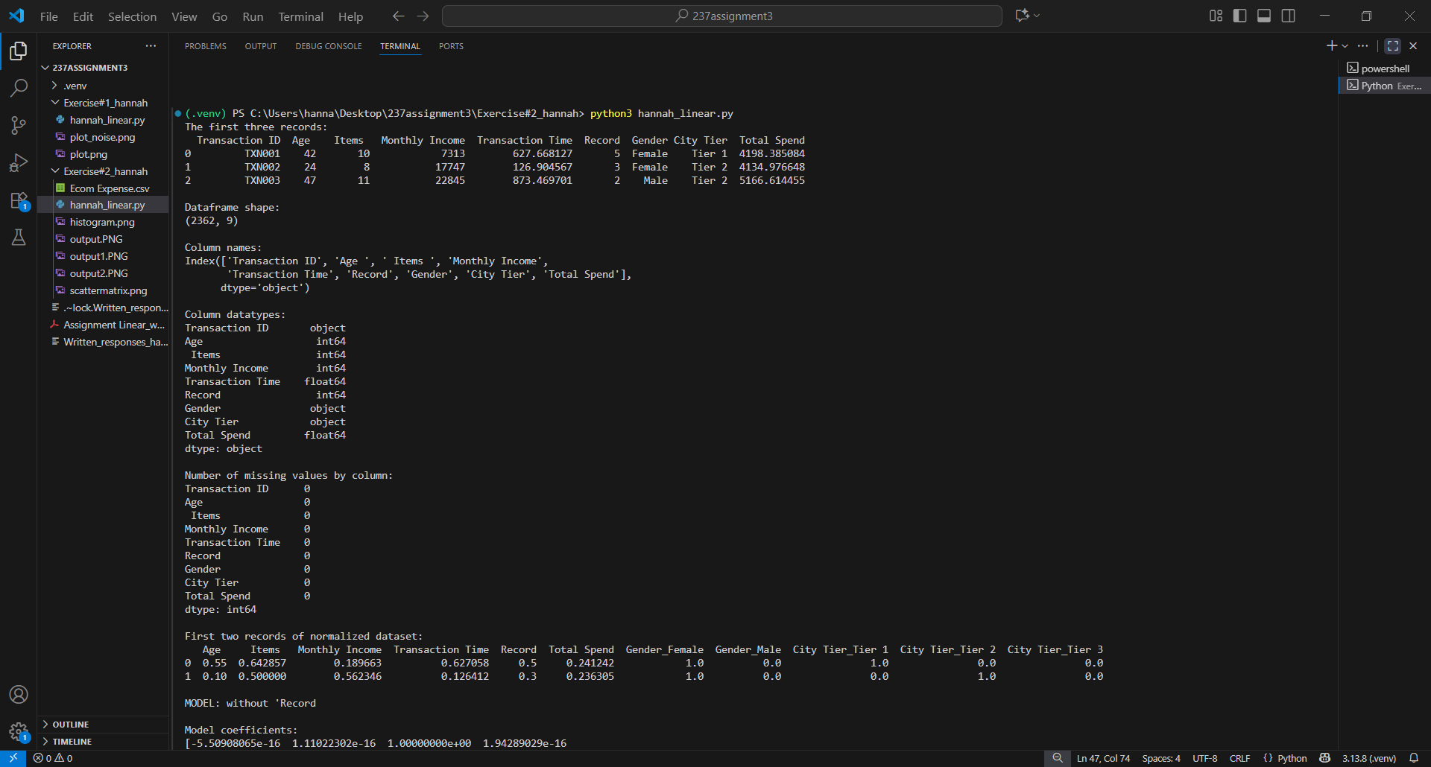Figure 3: Screenshot of exercise 2b (initial exploration) terminal output

Next, the data is transformed to interface with Scikit-learn’s linear regression function. Pandas get_dummies is used to create a one hot encoding of each categorical variable (Gender and City Tier). The result is a sparse binary matrix with one column for each possible value. The two new encoded data structures gender_encoded and city_encoded are joined with the main dataframe ecom_exp_hannah. The unwanted Transaction ID column is dropped along with the original categorical Gender and City Tier columns. A function normalize() is defined to normalize numerical data in a dataframe according to the equation in figure 5. The ecom_exp_hannah is passed to the normalize() function and the normalized dataframe is returned. The first two normalized records are displayed to the terminal (Figure 3).
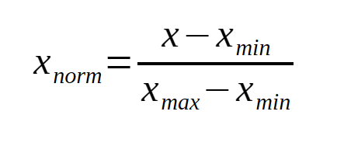Figure 5: Equation used for normalization of the dataset

A histogram was generated (Figure 6) for each variable in the dataset. A scatter-plot matrix was generated (Figure 7) to visualize the relationship between the following four variables:
- Age
- Monthly income
- Transaction time
- Total spend

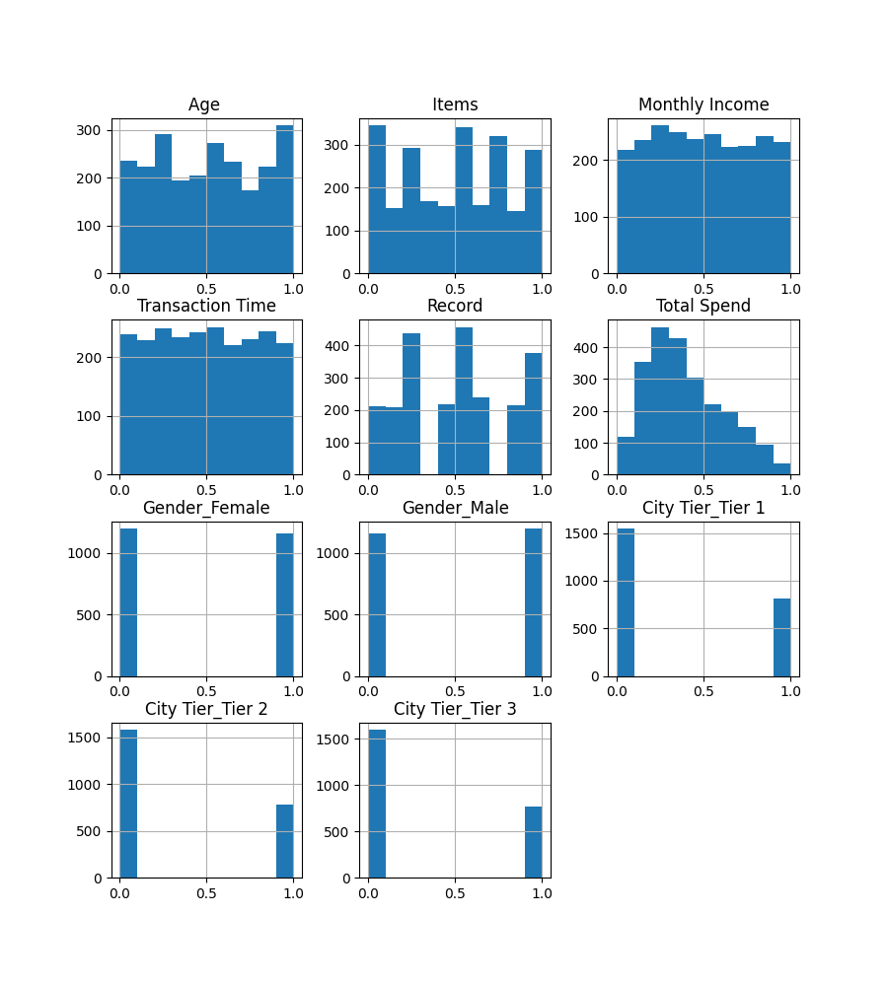Figure 6: One histogram is generated for each variable in the dataset

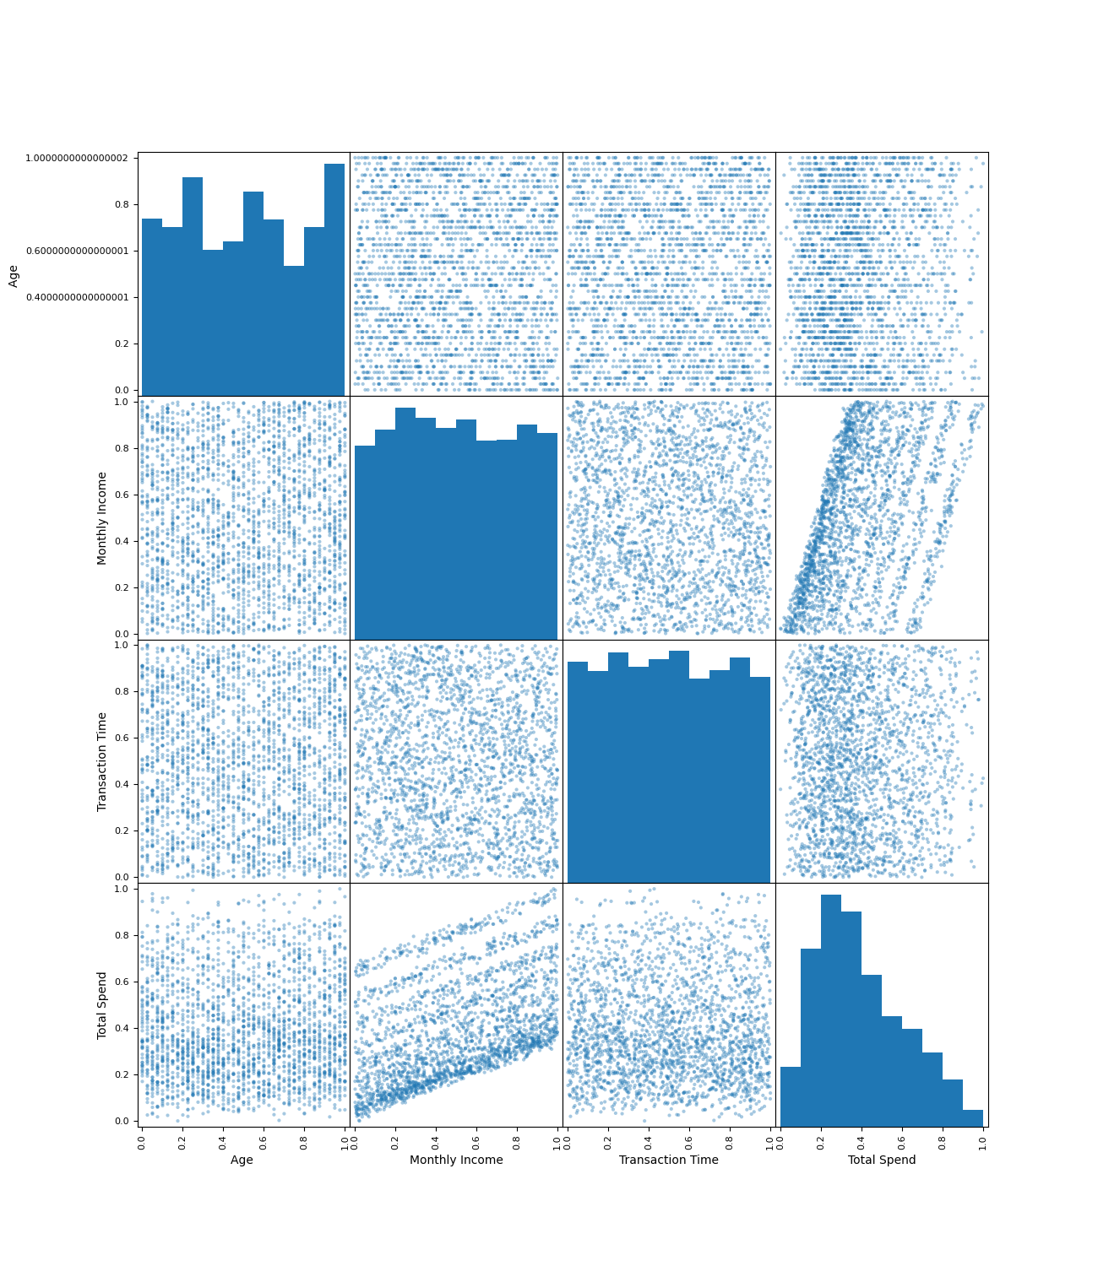Figure 7: Scatter-plot matrix demonstrating the relationships between Age, Monthly Income, Transaction Time, and Total Spend

The relationship between the predictor variables (Monthly income, Transaction time, Gender_encoded, and CityTier_encoded) and the output variable (Total spend) is assumed to be linear. The Age, Items, and Records columns are dropped and the Scikit-learn function train_test_split() is used to divide the dataset into 65% training data and 35% testing data. A linear regression model was fit to the training data and the model’s resulting coefficients and score is printed to the terminal. The Records column is added back into the dataset, train_test_split() is run again, and the new resulting coefficients and score are printed to the terminal (Figure 8).

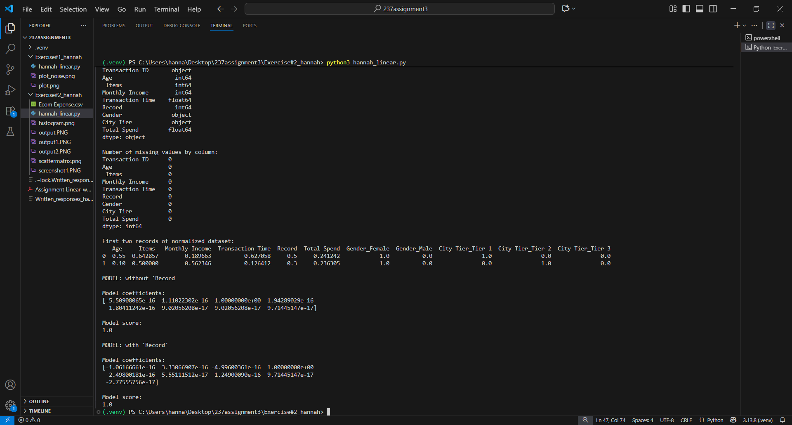Figure 8: Screenshot of terminal output for exercise 2d
In both cases with and without “Record” the linear regression fit results in a score of 1.0, which suggests the fit is exactly linear. The resulting coefficients for both cases are displayed in Table 2 below. The histogram for “Record” seen in figure 6 suggests there is no distribution for this variable, therefore incorporating it or not into the fit will not impact the shape so the fit remains perfectly linear.

Table 2: Comparing the resulting coefficients and score for Linear Regression with and without the “Record” variable
 | Linear Regression coefficient without “Record” | Linear Regression coefficient with “Record”
w0 | -5.50908065e-16 | -1.06166661e-16
Monthly income | 1.11022302e-16 | 3.33066907e-16
Transaction Time | 1.00000000e+00 | -4.99600361e-16
Record | n/a | 1.00000000e+00
Gender = female | 1.94289029e-16 | 2.49800181e-16
Gender = male | 1.80411242e-16 | 5.55111512e-17
City tier = 1 | 9.02056208e-17 | 1.24900090e-16
City tier = 2 | 9.02056208e-17 | 9.71445147e-17
City tier = 3 | 9.71445147e-17 | -2.77555756e-17
Model score | 1.0 | 1.0

