COMP 237 – Intro to AI
Hannah Raju
301543568
October 23, 2025

Assignment 4: Logistic Regression

The purpose of this analysis is to examine Titanic passenger data and build a logistic regression model to predict the likelihood of survival given other present characteristics such as passenger’s class, sex, or fare.

Part 1: Initial Exploration

The data file titled “titanic.csv” is read into a Pandas DataFrame object and the data is explored. Table 1 outlines the original columns of the dataset, their types, and their counts.

Table 1: Summary of data in “titanic.csv”
Column name | Description | Data Type | Count | Count missing
PassengerID | Unique Id of passenger | Integer | 891 | 0
Survived | Boolean: 0=no, 1=yes | Integer | 891 | 0
Pclass = [1,2,3] | Passenger class: first, second, third | Integer | 891 | 0
Name | Passenger name | Object | 891 | 0
Sex = [‘male’, ‘female’] | Passenger sex | Object | 891 | 0
Age | Passenger age | Float | 714 | 177
SibSp | Number of siblings/spouses aboard | Integer | 891 | 0
Parch | Number of parents/children aboard | Integer | 891 | 0
Ticket | Ticket number | Object | 891 | 0
Fare | Passenger fare | Float | 891 | 0
Cabin | Passenger cabin | Object | 204 | 687
Embarked | Port of embarkation (C = Cherbourg, Q = Queenstown, S = Southampton) | Object | 889 | 2

The columns PassengerID, Name, Ticket, Cabin will be dropped as they will not be useful in this context. PassengerID, Name, and Ticket are unique to each passenger and play no role in someone’s likelihood of survival and so will not impact the model. While Cabin would be a useful feature for the model, it has too many missing values.

Part 2: Data Visualization

The number of passengers survived is plotted against passenger class to visualize the likelihood of survival based on class (Figure 1). This plot suggests there is no real correlation between passenger class and likelihood of survival, besides the highest probability belonging to 1st class. Next, the number of passengers survived is plotted against passenger sex (Figure 2). This plot suggests a female passenger was about twice as likely to survive as a male passenger.

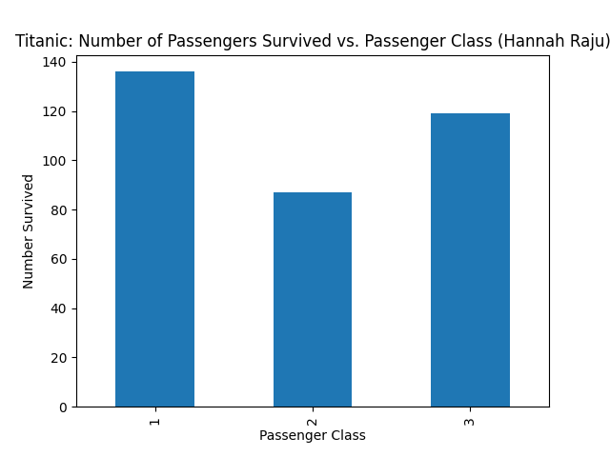Figure 1: Number of Passengers who Survived the Titanic vs. Passenger Class

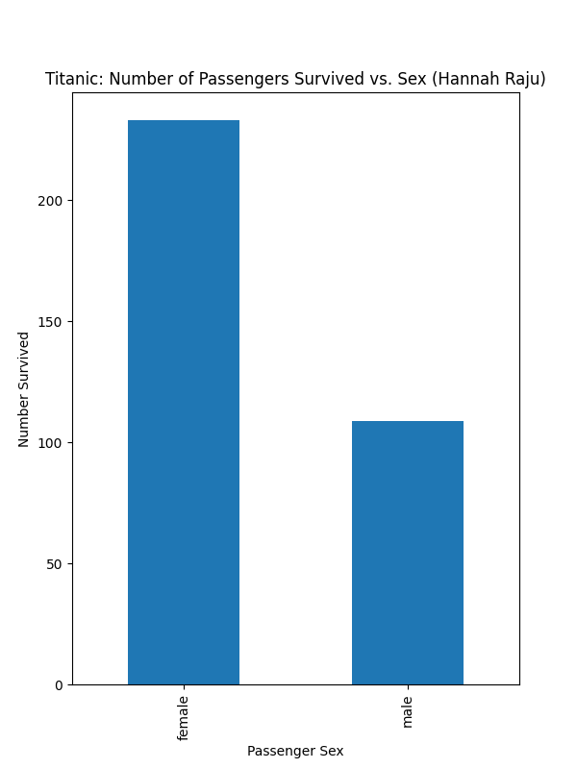Figure 2: Number of Passengers who Survived the Titanic vs. Passenger Sex

A scatter-plot matrix was constructed comparing the passenger class (pclass), passenger fare (fare), passenger siblings/spouses (sibsp), passenger parents/children (parch) given the passenger survived (Figure 3).

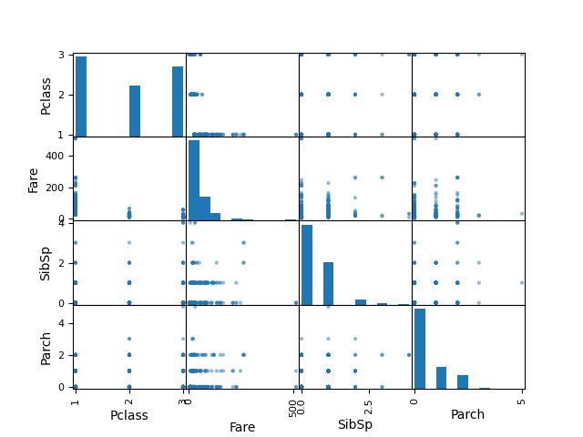Figure 3: Scatter-plot matrix comparing passenger class, passenger fare, passenger siblings/spouses, and passenger parents/children for those passengers who survived.

Part 3: Data Transformation

Pandas GetDummies is used to handle the categorical variables Sex and Embarked. The resulting encodings were added to the DataFrame and the original columns plus the four mentioned above (see Part 1: Initial Exploration) are dropped from the dataframe. The data-type of the entire dataframe is converted to float. A Normalize() function was defined according to the formula in Figure 4 and the Dataframe was normalized. Table 2 summarizes the dataset after transformation.

Figure 4: Normalization equation

After transformation, the dataset contains the following eleven columns:
- Survived
- Pclass
- Age
- SibSp
- Parch
- Fare
- Sex_female
- Sex_male
- Embarked_C
- Embarked_Q
- Embarked_S

A histogram was constructed to compare the number of passengers survived given their port of embarkation (Figure 4). The resulting plot suggests passengers were several times more likely to survive if they embarked from Southampton rather than Queenstown.

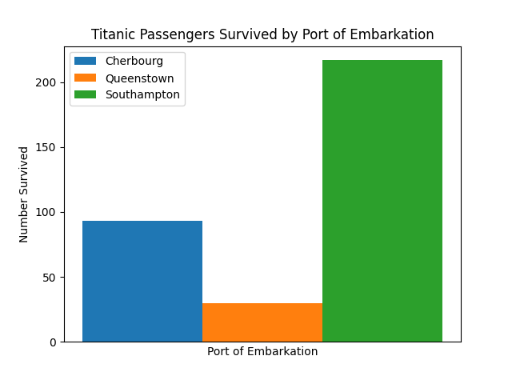Figure 4: Histogram of Passengers Survived per Port of Embarkation

Finally, the dataset was split into subsets using Scikit-learn’s train_test_split() function with 70% training/30% testing, with y(label)=survived and x(predictors) = {pclass, age, sibsp, parch, fare, sex, and embarked}.

Model Training and Evaluation

Scikit-learn’s LogisticRegression was used to train a model on the training data. The resulting coefficients/weights are summarized in Table 2.

Table 2: Logistic regression model coefficients
Variable | Weight
Pclass | -2.083
Age | -1.888
SibSp | -1.039
Parch | -0.412
Fare | 0.646
Sex_female | 1.808
Sex_male | -0.700
Embarked_C | 0.412
Embarked_Q | 0.572
Embarked_S | -0.014

Next, Scikit-learn’s cross_val_score() function was used to validate the model on vrious train/test splits to determine the best split scenario. For each split, the min, max, and mean reported scores and the results are summarized in Table 3. As seen in the table, the maximum mean score=0.801 is associated with the test/train split of 30/70. Therefore, the best split scenario occurs when test size = 0.3.

Table 3: cross_val_score() for various test/train splits with folds = 10.
Test/Train split | Min score | Mean score | Max score
10/90 | 0.738 | 0.798 | 0.825
15/85 | 0.724 | 0.800 | 0.822
20/80 | 0.690 | 0.795 | 0.859
25/75 | 0.701 | 0.796 | 0.866
30/70 | 0.742 | 0.801 | 0.857
35/65 | 0.702 | 0.796 | 0.897
40/60 | 0.698 | 0.788 | 0.870
45/55 | 0.673 | 0.782 | 0.837
50/50 | 0.689 | 0.791 | 0.864

Part 4: Model Testing

The model was rebuilt with a 30/70 train/test split and survival probabilities were predicted using the test data. The resulting probabilities were converted to boolean based on a threshold value for each 0.5 and 0.75. The training accuracy, test accuracy, confusion matrix, and a classification report were generated for each threshold. The results are summarized in tables 4-7 below.

Table 4: Confusion matrix for threshold = 0.5
TN = 152 | FP = 19
FN = 32 | TP = 65

Table 5: Summary stats for threshold = 0.5
Test accuracy | 0.81
Train accuracy | 0.80
Precision | 0.77
Recall | 0.67

Table 6: Confusion matrix for = 0.75
TN = 168 | FP = 3
FN = 65 | TP = 32

Table 7: Summary stats for threshold = 0.75
Test accuracy | 0.75
Train accuracy | 0.77
Precision | 0.91
Recall | 0.33

In both threshold cases, test accuracy ~= train accuracy. This means the model fits the data without any significant over- or under-fitting. The data suggests that increasing the threshold will increase precision and decrease recall.

