Measurement Chapter

Hannah Andrews

6/28/2021

# Introduction

*Intro: Why should CAMS fit together? Why should we care? What are the advantages of analyzing this – pros and cons*

The defining of CAM is a fraught. The healing approaches encompassed by the term CAM are diverse. What unites them? In part, they have been defined by biomedicine in opposition to biomedicine (Gale 2014; Sointu 2021). The terms “complementary” and “alternative” themselves indicate difference from some norm, in this case the dominant paradigm of biomedicine. Issues of power struggles between biomedicine and other healing traditions and practices aside, this definition does seem to resonate with CAM users. Studies examining motivations for CAM use have found that some CAM users are motivated to use CAM due to the failure of biomedicine to address their ailments, particularly chronic conditions (cite). CAM users also report turning to CAM due to dissatifcation with interactions with biomedical physicians (cite).

However, motivation for CAM use extends beyond dissatisfaction with biomedicine and biomedical definitions of health.

In this chapter, I investigate whether there is an underlying construct or constructs driving the use of complementary and alternative medicines. This is in part an answer to the call from health lifestyles perspectives to examine the ways in which individual behaviors coalesce into meaningful behavioral patterns (Cockerham 2005). CAMs are also united by their holistic philosophies and the belief that individuals are experts on their own well-being (cite).

o What have others done to group them, including industry/professional groups?

There have been attempts by institutional bodies to organize CAMs into domains of similar practices. In the United Kingdom (UK), the House of Lords Select Committee on Science and Technology proposed that CAMs be categorized into three groups for research and policy purposes based on the CAM’s claim regarding having its own distinct diagnostic approach (Mills 2001). These groups included (1) professionally organized alternative therapies, which includes therapies such as chiropractic and acupuncture; (2) complementary therapies, which includes therapies such as massage, hypnotherapy, and meditation and (3) alternative disciplines that may be further subdivided into long established and traditional systems of health care such as Ayurvedic medicine and other alternative disciplines such as crystal therapy.

In their Strategic Plan for 2005-2009, the National Center for Complementary and Alternative Medicine (NCCAM) grouped CAMs into four domains: (1) mind-body medicine, including practices such as meditation and yoga; (2) biologically based treatments, including practices such as use of herbs and vitamins and special diets; (3) manipulative and body-based practices, including practices such as chiropractic care and massage; and (4) energy medicine, including practices that involve the use of verifiable energy fields as well as biofields. NCCAM placed whole medical systems (e.g. Ayurveda, traditional Chinese Medicine) into a class of their own due to their use of practices that fall under multiple domains. On their current website, the National Center for Complementary and Integrative Health (NCCIH, formerly NCCAM) classifies CAMs into three domains based on their primary therapeutic input, and a fourth domain for practices that represent a combination of domains. The domains include (1) nutritional approaches, such as special diets, supplements, and herbs; (2) psychological approaches, such as meditation, hypnosis, and relaxation therapies; (3) physical approaches, such as acupuncture and massage; (4) combination approaches, for example practices that combine psychological and physical approaches such as yoga or tai chi. CAMs previously categorized as alternative medical systems involve multiple practices that are not easily fit in the new domains are not included in the classification.

(Can add in critiques of domains within research - See Ayers and Kronenfeld pg. 238)

Clearly there are many ways to justify the conceptual classifications of CAMs. CAMs vary in terms of their therapeutic input, their level of professional organization, and their relation to biomedicine. The question remains whether these classifications of CAMs represent actual patterns of CAM use. To my knowledge, there has been only one test of these proposed CAM domains in the literature. Ayers and Kronenfeld (2010) utilized data from the 2002 National Health Interview Survey (NHIS) to test whether the five domains (including whole medical systems) reflect actual patterns of CAM use using confirmatory factor analysis. After dropping CAMs that did not load properly (hypnosis, biofeedback, and energy healing), the authors found that the CAM domains proposed by NCCAM did not fit the data. The authors then conducted an exploratory factor analysis on the NHIS data. The authors found a well-fitting four factor solution. The four factors include mind-body medicine, alternative medical systems, prayer, and manipulative treatments. Meditation, guided imagery, relaxation, and deep breathing load onto mind-body medicine. Ayurveda, folk medicine, naturopathy, homeopathy, herbal therapy, vitamins, and biofeedback load onto alternative medical systems. Pray for self, asked others to pray for self, prayer groups, and healing rituals load onto prayer. Acupuncture, chiropractic, and massage load onto manipulative therapies.

CAM Classifications According to Institutions and Previous Research

UK House of Lords

NCCAM

NCCIH

Ayers and Kronenfeld (2010)

Ayurveda

Alternative Disciplines

Alternative Medical Systems

Alternative Medical Systems

Alternative Medical Systems

Folk medicine

Alternative Disciplines

Alternative Medical Systems

Alternative Medical Systems

Alternative Medical Systems

Naturopathy

Alternative Disciplines

Alternative Medical Systems

Alternative Medical Systems

Alternative Medical Systems

Homeopathy

Professionally Organized Alt. Therapies

Alternative Medical Systems

Alternative Medical Systems

Alternative Medical Systems

Acupuncture

Professionally Organized Alt. Therapies

Alternative Medical Systems

Physical

Manipulative Treatments

Herbal therapy

Professionally Organized Alt. Therapies

Biologically Based Practices

Nutritional

Alternative Medical Systems

Chiropractic

Professionally Organized Alt. Therapies

Manipulative Treatments

Physical

Manipulative Treatments

Vitamins

Complementary Therapies

Biologically Based Practices

Nutritional

Alternative Medical Systems

Special Diet

Complementary Therapies

Biologically Based Practices

Nutritional

NA

Prayer

Complementary Therapies

Mind-Body Treatments

Psychological

Prayer

Healing ritual

Complementary Therapies

Mind-Body Treatments

Psychological

Prayer

Hypnosis

Complementary Therapies

Mind-Body Treatments

Psychological

NA

Biofeedback

Complementary Therapies

Mind-Body Treatments

Psychological and Physical

Alternative Medical Systems

Deep breathing

Complementary Therapies

Mind-Body Treatments

Psychological and Physical

Mind-Body Medicine

Guided imagery

Complementary Therapies

Mind-Body Treatments

Psychological and Physical

Mind-Body Medicine

Meditation

Complementary Therapies

Mind-Body Treatments

Psychological and Physical

Mind-Body Medicine

Massage

Complementary Therapies

Manipulative Treatments

Physical

Manipulative Treatments

Energy healing

Complementary Therapies

Energy Medicine

NA

NA

o What are the advantages of using these data to test this? MIDUS is representative of non-institutionalzed, English-speaking adults in the continental United States. MIDUS includes data on CAM use for a variety of CAMs. This is important for testing possible underlying constructs or groupings of CAMs.

# Data Description

Data presented in the exploratory factor analysis come from Wave 1 of the Midlife in the United States (MIDUS) dataset. These data were collected between 1995 and 1996. Only cases with no missing values on the complementary and alternative medicine (CAM) items are included in analyses (*N* = 6157).

## Measures Description

Descriptive statistics for each CAM item are presented in Table 1. Biofeedback was the least used CAM (0.8%), followed by hypnosis (1.2%), acupuncture (1.2%), and energy healing (1.5%). Fewer than 100 people report using each of these CAMs. The most frequently utilized CAMs were prayer or spiritual healing (30%), exercise and movement therapy (17.5%), relaxation techniques (13.2%), and chiropractic care (12.0%).

Descriptive Statistics for CAM Use in the Last 12 Months at each Wave

Wave 1 Frequency

Wave 1 Percent

Wave 2 Frequency

Wave 2 Percent

Wave 3 Frequency

Wave 3 Percent

Biofeedback

48

0.8

29

0.8

28

1.0

Hypnosis

72

1.2

37

1.0

26

1.0

Acupuncture

74

1.2

73

1.9

95

3.6

Energy Healing

93

1.5

86

2.2

71

2.7

Homeopathy

142

2.3

151

3.9

122

4.6

Imagery Techniques

184

3.0

147

3.8

96

3.6

Vitamins

282

4.6

415

10.8

244

9.1

Herbal Therapy

301

4.9

364

9.5

197

7.4

Massage

519

8.4

634

16.5

488

18.2

Special Diet

669

10.9

1326

34.6

806

30.1

Chiropractic

739

12.0

630

16.4

450

16.8

Relaxation Techniques

813

13.2

901

23.5

616

23.0

Exercise and Movement Therapy

1078

17.5

579

15.1

494

18.5

Prayer or Spiritual Healing

1853

30.1

1678

43.8

1078

40.3

1 Wave 1 n = 6157

2 Wave 2 n = 3834

3 Wave 3 n = 2675

(Move to data section.) It should be noted that utilization of prayer and spiritual healing was originally measured separately. Upon inspection of the data, I found that nearly all respondents who reported using spiritual healing also reported using prayer. Out of 196 respondents that report using spiritual healing, only 11 (5.6%) report using spiritual healing but not prayer for health or healing purposes. Given that these data were collected via survey, it is impossible to know exactly how the respondents interpreted the survey questions and how their interpretations effected the data collected. It does appear that the two questions measured the same behavior in those that use spiritual healing. The variables were combined so that all respondents that report using prayer or spiritual healing are coded as 1 or yes on the new prayer or spiritual healing variable.

Crosstab of Prayer and Spiritual Healing

Spiritual Healing

Prayer

No

Yes

No

4304 (72.2%)

11 (5.6%)

Yes

1657 (27.8%)

185 (94.4%)

Total

5961 (100.0%)

196 (100.0%)

# Factor Analysis

In this section, I will present factor analysis results. First, I will present results from the exploratory factor analysis conducted using the Wave 1 data. Second, I will present results from the confirmatory factor analysis conducted on the solution found in the exploratory factor analysis using Wave 2 and Wave 3 data.

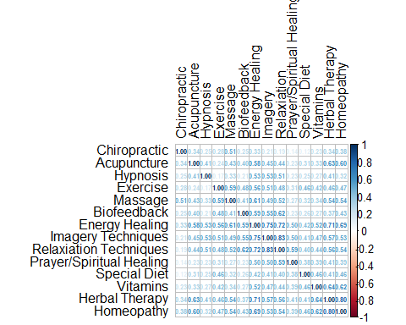

Tetrachoric Correlations for CAM items

## Exploratory Factor Analysis: Wave 1

### Assumption Testing

The factorability of the 14 CAM items was examined. First, it was observed that all items correlated with at least one other item with a correlation of .3, suggesting factorability. Next, the Kaiser-Meyer-Olkin measure of sampling adequacy was 0.87, above the recommended value of at least .6. Bartlett’s test of sphericity was significant (2(91) = 55383.32, *p* <.01) indicating that the correlations between variables are higher than would be expected by chance.

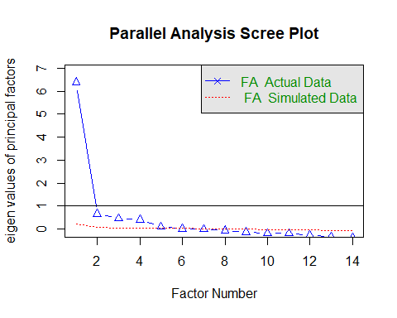

### Results

First, I ran the exploratory factor analysis on all 14 CAMs. After examining one through six factor solutions using different extraction and rotation methods (See Appendix (create appendix for model fit statistics including all CAMs)), I found that the five and six factor maximum likelihood solutions fit the data best; however, biofeedback consistently loaded onto its own factor. Biofeedback is utilized by the smallest number of respondents (48). In light of the few cases reporting use of biofeedback and failure to load with other items, I dropped biofeedback and ran the analysis with the other 13 CAMs.

I ran one through five factor models using various extraction and rotation methods (See Appendix (model fit statistics dropping biofeedback)). While the five factor maximum likelihood solutions fit the data best, the four factor maximum likelihood solution with cluster rotation fit the data nearly as well and produced more interpretable factors. The four factor maximum likelihood solution with cluster rotation was chosen as the final measurement model. Model fit was evaluated using the chi-squared statistic, root mean square of approximation (RMSEA), root mean square residual (RMSR), comparative fit index (CFI), and Tucker-Lewis index (TLI). The null hypothesis for the 2 states that the model fits the analyzed covariance matrix (maybe reword), thus a significant 2 indicates a poor fitting model. It should be noted that the 2 is sensitive to large sample sizes and may indicate a model is a poor fit by mistake (Byrne 1989). The normed 2 (2/*df*) minimizes this sensitivity. The 2 for the model presented here indicates poor fit 2(32)=2108.319, *p*<.001. The CFI is above the desired cutoff of 0.90 (CFI=0.959). The TLI is just below the desired cutoff of 0.90 (TFI= 0.899). The RMSR indicates good fit (RMSR= 0.025); however, the RMSEA is higher than the desirable 0.08 cutoff (RMSEA= 0.103).

Exploratory Factor Analysis of CAMs Wave 1 (n = 6157)

Factor 1

Factor 2

Factor 3

Factor 4

Communality

Uniqueness

Item Complexity

Factor 1 (Mind Body Practices)

Prayer or Spiritual Healing

0.52

-0.03

0.30

-0.22

0.40

Energy Healing

0.52

0.26

0.10

0.14

0.77

Imagery Techniques

0.93

-0.07

0.07

-0.05

0.83

Relaxation and Meditation Techniques

0.95

-0.10

0.07

-0.03

0.84

Hypnosis

0.68

0.20

-0.37

0.04

0.43

Factor 2 (Alternative Medical Systems)

Homeopathy

-0.04

0.66

0.32

0.07

0.79

Herbal Therapy

0.06

0.70

0.23

0.04

0.82

Acupuncture

0.21

0.67

-0.27

0.15

0.59

Factor 3 (Physical and Nutritional Approaches)

Vitamins

-0.01

0.40

0.56

-0.18

0.57

Exercise and Movement

0.06

-0.21

0.64

0.35

0.63

Special Diet

0.10

0.09

0.52

-0.08

0.36

Factor 4 (Manipulative Treatments)

Massage

0.06

0.00

0.13

0.79

0.82

Chiropractic

-0.17

0.25

-0.05

0.56

0.36

The four factors in the final model account for 0.63 of the variance in the data.

The cluster rotation factor loadings for the 13 CAM types are shown in Table . Five items had moderate to high loadings on Factor 1, Mind-Body Medicine (prayer or spiritual healing, energy healing, imagery techniques, relaxation and meditation techniques, and hypnosis). This factor measures the use of the mind to improve health and wellness. Three items had moderate to high loadings on Factor 2, Alternative Medical Systems (homeopathy, herbal therapy, and acupuncture). This factor measures use of CAM build on complete systems of theory and practice. Three items loaded moderately to heavily on Factor 3, Physical and Nutritional Approaches (vitamins, exercise and movement, and special diet). This factor measures… Two items loaded moderately to heavily on Factor 4, Manipulative Treatments (massage and chiropractic care). This factor measures use of external physical manipulation to promote health and wellness.

(Insert reliability discussion here.)

## Confirmatory Factor Analysis: All waves

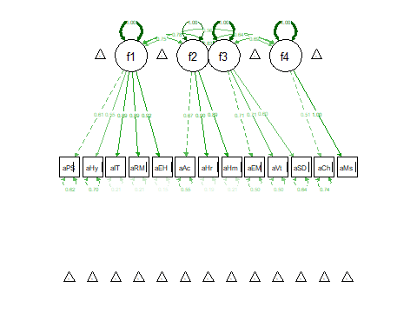

Goodness of Fit Statistics

Model

Chi-Square(df)

CFI

TLI

RMSR

RMSEA

Wave 1 Exploratory Factor Analysis

2108.319(32) p<.001

0.97

0.9

0.025

0.103

Wave 1 Confirmatory Factor Analysis

224.89(59) p<.001

0.99

0.99

0.056

0.021

Wave 2 Confirmatory Factor Analysis

287.999(59) p<.001

0.99

0.98

0.078

0.032

Wave 3 Confirmatory Factor Analysis

203.217(59) p<.001

0.99

0.99

0.07

0.03

Fit Guidelines

>.95

>.95

<.08

<.08

1 Wave 1 n = 6157, Wave 2 n = 3834, Wave 3 n = 2675

2 Values meeting fit guidelines indicate good model-data fit.

Confirmatory Factor Analysis Standardized Loadings for All Waves

Wave 1

Wave 2

Wave 3

Factor 1 (Mind Body Practices)

Prayer or Spiritual Healing

0.61

0.75

0.72

Energy Healing

0.55

0.88

0.92

Imagery Techniques

0.89

0.77

0.78

Relaxation and Meditation Techniques

0.89

0.89

0.89

Hypnosis

0.55

0.68

0.73

Factor 2 (Alternative Medical Systems)

Homeopathy

0.89

0.91

0.91

Herbal Therapy

0.90

0.91

0.88

Acupuncture

0.67

0.57

0.64

Factor 3 (Physical and Nutritional Approaches)

Vitamins

0.71

0.74

0.75

Exercise and Movement

0.71

0.68

0.71

Special Diet

0.60

0.42

0.53

Factor 4 (Manipulative Treatments)

Massage

1.00

0.94

0.89

Chiropractic

0.51

0.52

0.53