Boulder Open Space and Mountain Parks

Figures and statistics

Eve-Lyn Hinckley and Hannah Miller

Table of Contents

#load necessary packages  
library(readxl)  
library(tidyverse)

## ── Attaching packages ──────────────────────────────────────────────────────────────── tidyverse 1.3.0 ──

## ✓ ggplot2 3.3.2 ✓ purrr 0.3.4  
## ✓ tibble 3.0.1 ✓ dplyr 1.0.0  
## ✓ tidyr 1.1.0 ✓ stringr 1.4.0  
## ✓ readr 1.3.1 ✓ forcats 0.5.0

## ── Conflicts ─────────────────────────────────────────────────────────────────── tidyverse_conflicts() ──  
## x dplyr::filter() masks stats::filter()  
## x dplyr::lag() masks stats::lag()

library(ggplot2)  
library(dplyr)  
library(lme4)

## Loading required package: Matrix

##   
## Attaching package: 'Matrix'

## The following objects are masked from 'package:tidyr':  
##   
## expand, pack, unpack

library(LMERConvenienceFunctions)

# Visualizations

## `summarise()` regrouping output by 'Invasion' (override with `.groups` argument)

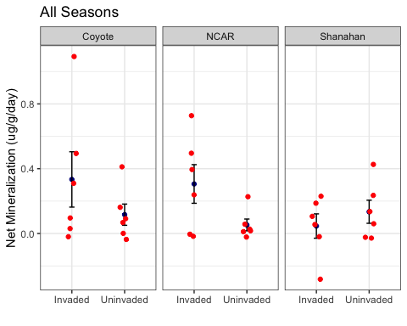

## `summarise()` regrouping output by 'Invasion' (override with `.groups` argument)

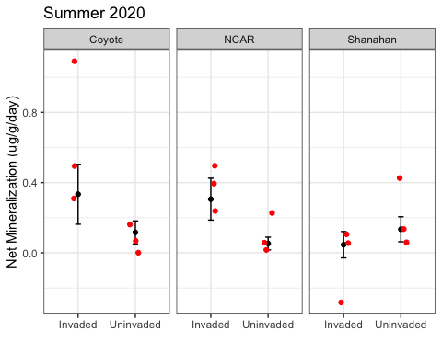

## `summarise()` regrouping output by 'Invasion' (override with `.groups` argument)

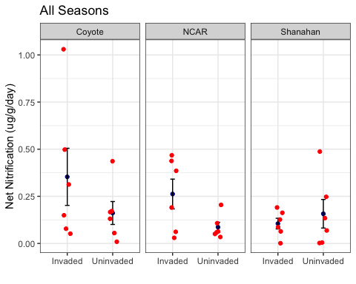

## `summarise()` regrouping output by 'Invasion' (override with `.groups` argument)

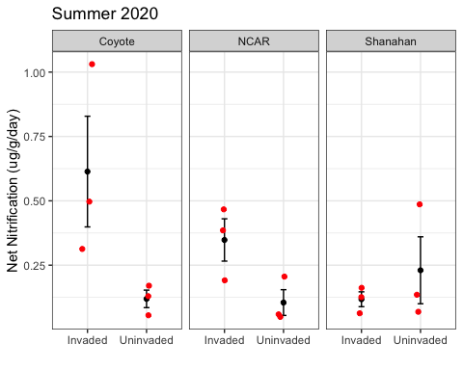

# Vegetation Biomass

Summer20 %>%   
 group_by(Invasion, Site) %>%   
 summarise(mn = mean(Biomass_.g._per_m.2),   
 sd = sd(Biomass_.g._per_m.2),   
 n = length(Biomass_.g._per_m.2),   
 se = sd / sqrt(n)) %>%   
 ggplot(aes(x = Invasion, y = mn,)) + labs(y = "Biomass (g/m^2)", x = "") +  
 geom_point() +  
 geom_errorbar(aes(ymax = mn + se, ymin = mn - se), width = 0.1) +  
 facet_grid(~Site) +  
 geom_jitter(data = Summer20, aes(x = Invasion, y = Biomass_.g._per_m.2), col = 2, width = .1) +  
 theme_bw()

## `summarise()` regrouping output by 'Invasion' (override with `.groups` argument)

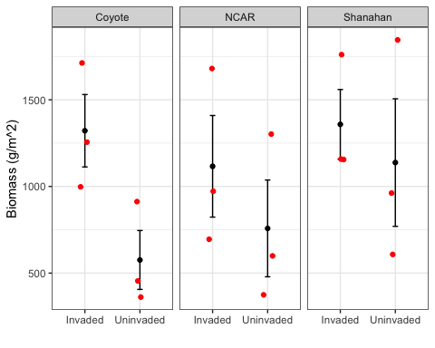

# Soil and Vegetation C and N

#Soil total N  
Summer20 %>%   
 group_by(Invasion, Site) %>%   
 summarise(mn = mean(Soil_N),   
 sd = sd(Soil_N),   
 n = length(Soil_N),   
 se = sd / sqrt(n)) %>%   
 ggplot(aes(x = Invasion, y = mn,)) + labs(y = "Soil Total N", x = "") +  
 geom_point() +  
 geom_errorbar(aes(ymax = mn + se, ymin = mn - se), width = 0.1) +  
 facet_grid(~Site) +  
 geom_jitter(data = Summer20, aes(x = Invasion, y = Soil_N), col = 2, width = .1) +  
 theme_bw()

## `summarise()` regrouping output by 'Invasion' (override with `.groups` argument)

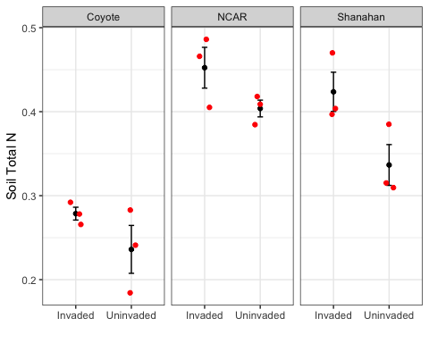

#Soil C:N  
Summer20 %>%   
 group_by(Invasion, Site) %>%   
 summarise(mn = mean(Soil_CN),   
 sd = sd(Soil_CN),   
 n = length(Soil_CN),   
 se = sd / sqrt(n)) %>%   
 ggplot(aes(x = Invasion, y = mn,)) + labs(y = "Soil C:N", x = "") +  
 geom_point() +  
 geom_errorbar(aes(ymax = mn + se, ymin = mn - se), width = 0.1) +  
 facet_grid(~Site) +  
 geom_jitter(data = Summer20, aes(x = Invasion, y = Soil_CN), col = 2, width = .1) +  
 theme_bw()

## `summarise()` regrouping output by 'Invasion' (override with `.groups` argument)

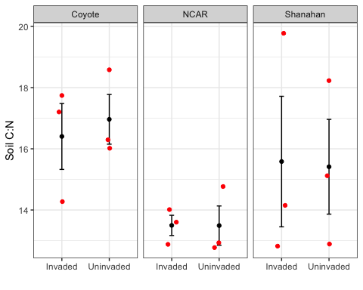

# Veg total N  
Summer20 %>%   
 group_by(Invasion, Site) %>%   
 summarise(mn = mean(Veg_N),   
 sd = sd(Veg_N),   
 n = length(Veg_N),   
 se = sd / sqrt(n)) %>%   
 ggplot(aes(x = Invasion, y = mn,)) + labs(y = "Vegetation Total N", x = "") +  
 geom_point() +  
 geom_errorbar(aes(ymax = mn + se, ymin = mn - se), width = 0.1) +  
 facet_grid(~Site) +  
 geom_jitter(data = Summer20, aes(x = Invasion, y = Veg_N), col = 2, width = .1) +  
 theme_bw()

## `summarise()` regrouping output by 'Invasion' (override with `.groups` argument)

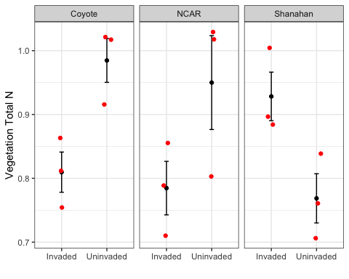

# Veg C:N  
Summer20 %>%   
 group_by(Invasion, Site) %>%   
 summarise(mn = mean(Veg_CN),   
 sd = sd(Veg_CN),   
 n = length(Veg_CN),   
 se = sd / sqrt(n)) %>%   
 ggplot(aes(x = Invasion, y = mn,)) + labs(y = "Vegetation C:N", x = "") +  
 geom_point() +  
 geom_errorbar(aes(ymax = mn + se, ymin = mn - se), width = 0.1) +  
 facet_grid(~Site) +  
 geom_jitter(data = Summer20, aes(x = Invasion, y = Veg_CN), col = 2, width = .1) +  
 theme_bw()

## `summarise()` regrouping output by 'Invasion' (override with `.groups` argument)

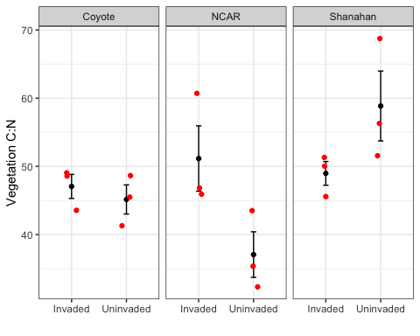

## R Markdown

This is an R Markdown document. Markdown is a simple formatting syntax for authoring HTML, PDF, and MS Word documents. For more details on using R Markdown see <http://rmarkdown.rstudio.com>.

When you click the **Knit** button a document will be generated that includes both content as well as the output of any embedded R code chunks within the document. You can embed an R code chunk like this:

summary(cars)

## speed dist   
## Min. : 4.0 Min. : 2.00   
## 1st Qu.:12.0 1st Qu.: 26.00   
## Median :15.0 Median : 36.00   
## Mean :15.4 Mean : 42.98   
## 3rd Qu.:19.0 3rd Qu.: 56.00   
## Max. :25.0 Max. :120.00

## Including Plots

You can also embed plots, for example:

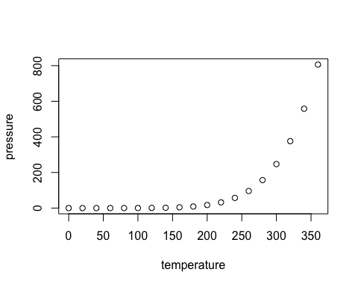

Note that the echo = FALSE parameter was added to the code chunk to prevent printing of the R code that generated the plot.