

*User’s Manual*

*Hannah Roach*

*Dill Junye*

*Elijah Roberson*

*CSC 478: Software Engineering Capstone*

*11/1/2018*

TABLE OF CONTENTS

USER MANUAL

INTRODUCTION……………………………………2

RERQUIREMENTS………………………………….3

System Requirements

Game Requirements

INSTALL INSTRUCTIONS…………………………4

Executable Instructions

Alternate Instructions

HOW TO PLAY……………………………………...5

Keyboard commands

Rules

Special Abilities

TROUBLESHOOTING…………………………….…7

TECHNICAL SUPPORT…………………………….11

CREDITS…………………………………………….12

NOTES………………………………………………...13

INTRODUCTION

Invader Z is available for everyone. The history of Invader Z started in year 2018. Hannah Roach (Coder), Elijah Roberson (Documentation Specialist), and Dill Junye (Tester) imagined a world of zombies. This world remains overridden with zombie hoards and it is up to you to conquer the zombie hoard and save yourself. The games character features a fearless warrior dressed in black to blend in with the shadows of the night to help you in your quest to win back the new world that’s in despair. Or a tank fully loaded and armored up to keep anything from stopping its path forward.

Invader Z is a microworld, with a seemingly never-ending zombie hoard. Your goal is to strategically eliminate each zombie until you complete the level and proceed to the following level. Each level will become increasingly harder in a multitude of ways. Can you save yourself and eliminate every zombie?

SYSTEM REQUIREMENTS

Computer Requirements

No less than 64 MB RAM memory

610 MB free hard drive space for installation

Windows XP/Vista/7/8/10

macOS 10.7/10.8/10.9/10.10/10.11/10.12/10.13/10.14

DirectX Certified Video Card Capable of supporting 800x600x16 resolution mode

DirectX Compatible Sound Card

Keyboard, Mouse

Python Requirements

Python 3.7

Python Packages:

pip 18.1

pygame 1.9.4

setuptools 40.5.0

INSTALLATION INSTRUCTIONS

To run this file, a few things need to be set-up on your computer first:

1. Make sure you have Python installed (Just running the zombie_invasion.py from the command line will give dependency issues).
2. Head over to <https://www.python.org/ftp/python/3.7.1/python-3.7.1.exe> and download (save) the python-3.7.1.exe.
3. After it’s finished the download, run the set-up file (double click on the python-3.7.1.exe and follow the instructions to install). It should look similar to the image below:

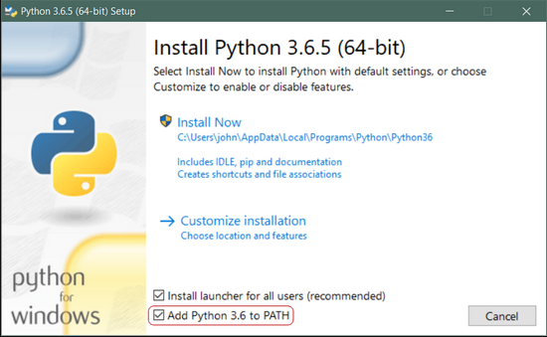

That should be all there is to it. A few minutes later you should have a working Python 3 installation on your system.

1. Feeling impatient? don’t worry you are almost there, now you just need to install Pygame.
2. Now navigate over to your CMD (command prompt) and open it
3. Type this script in the command line: *py -m pip install -U pygame –user*

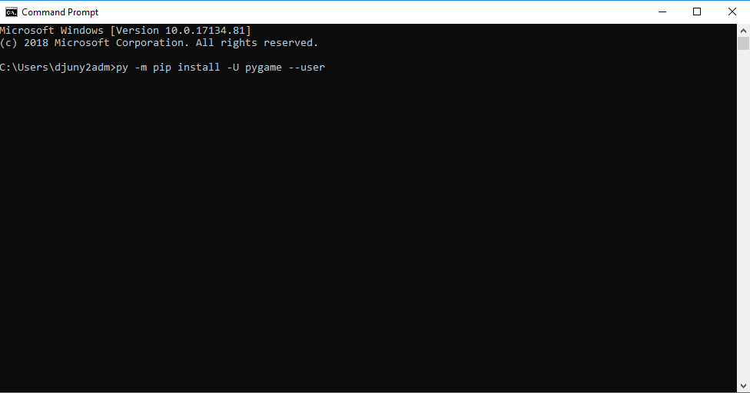

1. If you get 'PermissionError: [WinError 5] Access is denied', before starting the command prompt right click and "Run as administrator".
2. You should now have successfully installed Pygame in your repository.
3. Now download and extract the zip file containing the game (ZombieInvasion.zip)
4. Once unzip, double click on the folders 🡪ZombieInvasion🡪ZombieInvasion🡪zombie_package (this folder contains all the files, including the zombie_invasion.py file you need to run in order to play this game).
5. Now just double click on the zombie_invasion.py file to run the game or just run it from command prompt and enjoy!!!!

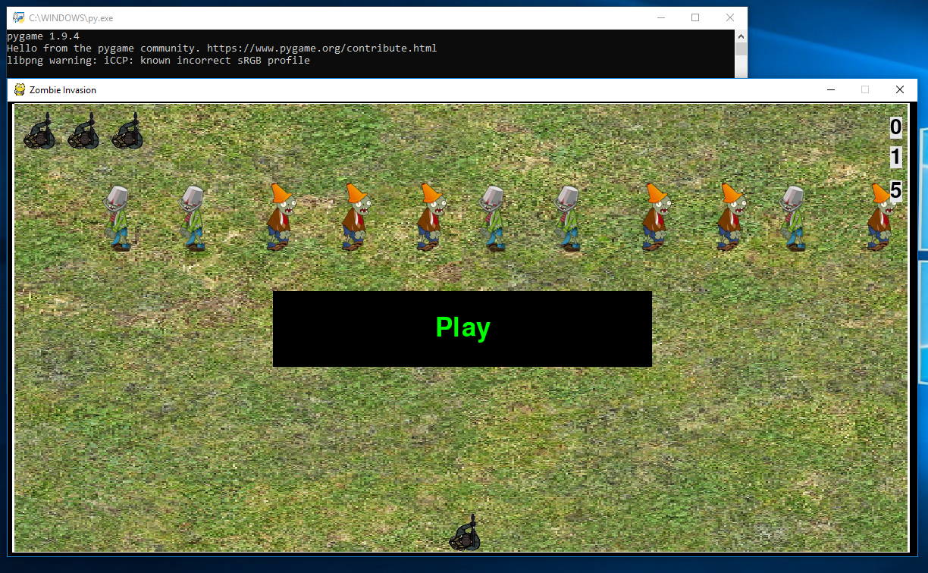

HOW TO PLAY

Your primary game input device is a standard keyboard.

**Game Objective**

The objective of the game is to eliminate every zombie at each level progressing through the game.

When you have successfully beaten level 15, you have won the game.

**Begin New Game**

Click the play button in the middle of the application window

**Movement**

You can control your character with the arrow keys on the keyboard moving left, right, up or down

To rotate your character left 90 degrees, press the letter “z”

To rotate your character left 45 degrees, press the letter “x”

To rotate your character right 45 degrees, press the letter “c”

To rotate your character right 90 degrees, press the letter “v”

**Weapons**

You fire your characters weapon by clicking in the spacebar on the keyboard

To fire the mega bullet, press the letter “b”

As you move through levels, you will acquire more mega bullets

After level 12, you will be given a special mega bullet of a random size, capable of killing many zombies

The number of mega bullets remaining will be displayed on the screen

Use your mega bullets wisely; if you die during a level, you will not get new mega bullets until the next level

**Lives**

Your character is given 4 total lives, once your lives are gone, you lose

If a zombie hits the bottom edge of the screen, you lose a life

If a zombie collides with you, you lose a life

With each level, the game becomes more difficult; the zombies become smaller and there are more zombies to kill

**Points**

Each zombie killed will increment your score by one point

After you kill all of the zombies, you will move to the next level

TROUBLESHOOTING

If you are unable to run the game, do the following:

1. Open your terminal or command prompt.
2. cd into the directory of ZombieInvasion
3. cd again into the zombie_invasion
4. Type “python –version” to ensure that Python is installed
5. If Python is not installed, go to <https://www.python.org/downloads/> to install python
6. In the ZombieInvasion/zombie_invasion directory type “python zombie_invasion.py”

TECHNICAL SUPPORT

Technical support E-mail: support@csc478

Please try to adhere to the report rules. Thank you!

Fill the subject field with “Invader Z”.

The message body should contain text information about your:

* Windows and DirectX version
* Core processor
* RAM memory amount
* Hard drive free space amount
* Video card and its driver version
* Sound card and its driver version
* Detailed problem description

CREDITS

Coder

Hannah Roach

Elijah Roberson

Documentation Specialist

Elijah Roberson

Dill Junye

Architect

Hannah Roach

Tester

Dill Junye