Main Dashboard:

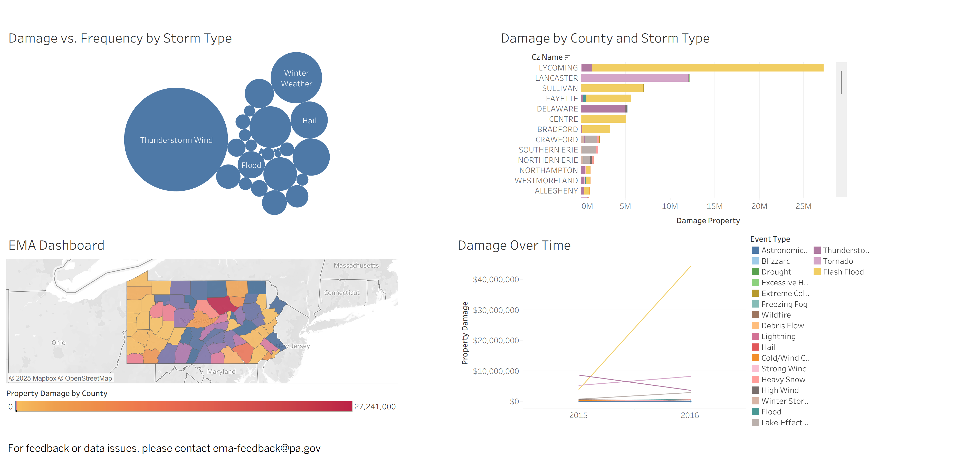

Drill-Down:

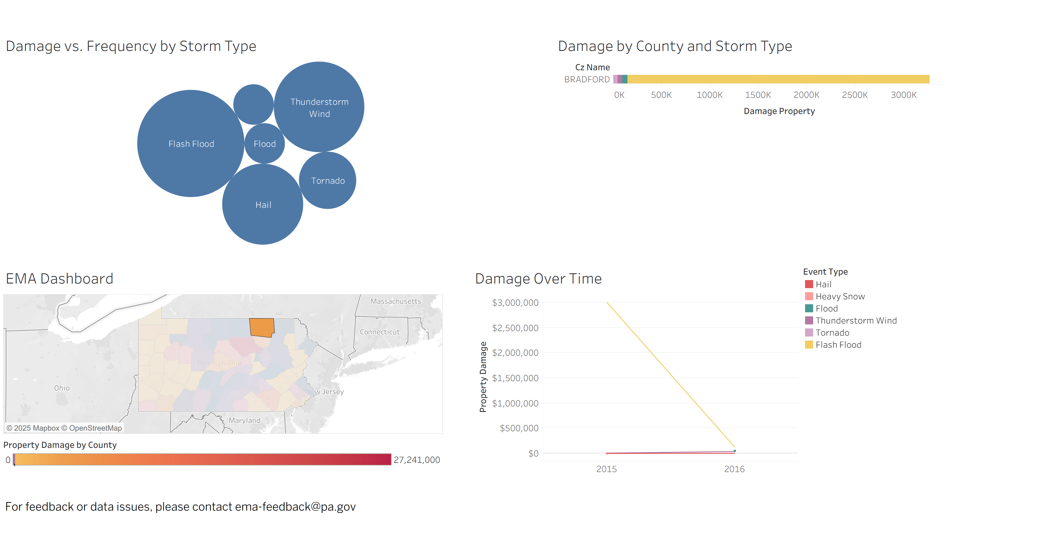

# **Introduction**

The Emergency Management Agency (EMA) dashboard provides real-time analysis of storm events in Pennsylvania for operational decision-making. Users can explore storm frequency, damage severity, and geographical impact using interactive visualizations. Filters allow narrowing by date, storm type, and county. The dashboard supports risk assessment, resource allocation, and public communication during and after severe weather events.

# **Navigation**

The dashboard consists of the following key sections:  
 - Line chart: Shows the dollar amount of property damage by storm type from 2015-2016.  
 - Heat Map: Shows Pennsylvania counties shaded by total damage.  
 - Bubble Chart: Compares event frequency and damage by storm type.  
 - Stacked Bar Chart: Breaks down damage by county and storm type.

# **Filters**

Located on the right-hand side:  
 - Date Range: Adjusts the time period for analysis.  
 - Storm Type: Filters all visuals by selected event types.  
 - County: Focuses on a specific geographic area.

# **Interactivity**

- Click a County on the heat map to update all visuals to show only that county’s data.  
 - Click a Storm Type on the bubble chart to filter all visuals.  
 - Hover Tooltips provide extra details..

# **Drill-Throughs**

Drill-through functionality allows the user to move from a high-level visual to more specific data:  
 - From Heat Map to Stacked Bar Chart: Clicking a county filters the bar chart to that region.  
 - From Bubble Chart to Map: Selecting a storm type updates the map to only show relevant events.

# **Formatting**

The dashboard follows standard EMA formatting:  
 - Color Coding: Red = high damage, yellow = moderate, purple = low.  
 - Font: Clear sans-serif (Tableau Book) for readability.  
 - Legends: Present for each chart.

# **Feedback Mechanism**

A dedicated feedback email (ema-feedback@pa.gov) is displayed in the dashboard footer for reporting issues or requesting enhancements.