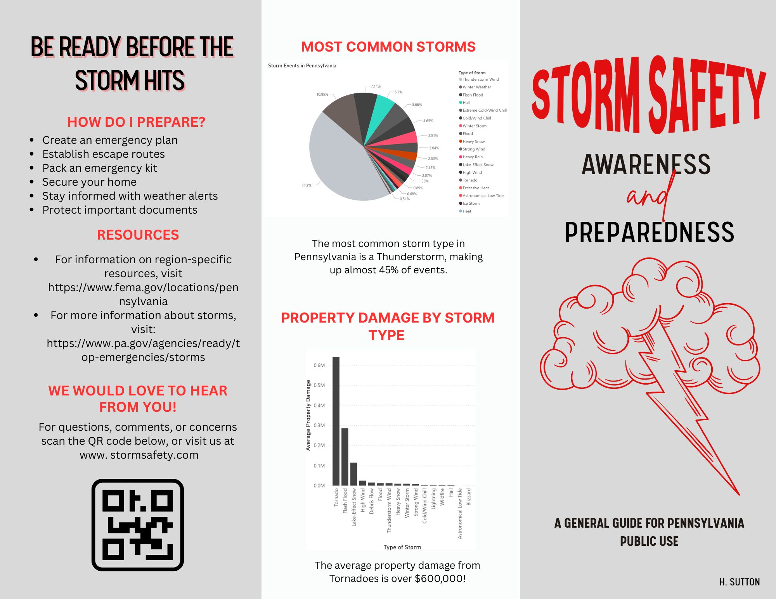

References

Preparation, & Preparation. (2025, June 10). *The Ultimate 2025 Storm Preparation Checklist: 10 effective tips to stay safe*. Preparation Call. <https://www.preparationcall.com/storm-preparation-checklist/>