FUTURE ENERGY BUSINESS · ENERGY-TRANSITION VENTURE CASE

EnergyOS Secure
The security layer for AI-enabled smart homes and vehicle-to-home (V2H)
Business plan, market analysis and investor pitch storyline

Date: 9 November 2026
Status: hypothesis-driven, pre-revenue, pre-customer-validation
Perspective: written as founder-CEO, CTO, strategy consultant and early-stage investor
Companion: 34-slide investor pitch deck (same storyline, same numbers)

How to read this document. Facts carry a reference [R#] to the list at the end. Every business figure (prices, customer counts, costs, revenue) is an illustrative planning assumption to be validated with customers, not market research. The product name is a working title; alternatives are proposed in section 15.

Contents
1. Executive summary
2. The pitch storyline
3. Context: the Dutch energy transition
4. Evidence: cyber-physical incidents 2025–2026
5. Problem definition and gap analysis
6. Solution and technology
7. Market definition, sizing and scenarios
8. Customers and buyers
9. Competition and strategy
10. Business model and pricing
11. Financial analysis
12. Go-to-market, validation and roadmap
13. Risks
14. Team and investor view
15. Name options
16. Hard questions (FAQ)
17. References

1. Executive summary
Decision in one sentence. Build a human-in-the-loop, cross-vendor cyber-physical incident intelligence platform for AI-enabled homes with V2H; sell it to HEMS platforms and EV-charger OEMs, starting in the Netherlands. Do not build another energy optimiser, a general SIEM, autonomous device response or an automatic CRA-compliance engine.
 | Summary
Situation | Dutch homes are becoming small power plants: 789,571 fully electric cars (Sep 2026), 3.2 million small solar installations and 650,000+ home charge points [R9–R10]. AI energy managers increasingly decide when energy flows, and vehicle-to-home (V2H) turns the car into the largest battery in the house.
Complication | Those decisions move real energy across three or four vendors. Each brand secures its own ecosystem; nobody owns the incident that crosses them. Attacks have moved onto physical equipment (Polish renewables, Dec 2025; European supermarket refrigeration, Oct–Nov 2026) and AI is speeding them up [R1, R2, R5].
Resolution | EnergyOS Secure — four modules: Detect (cyber-physical anomalies and AI EMS command risk scoring), Correlate (one cross-vendor case), Trace (firmware and SBOM exposure mapped to affected homes), Coordinate (human-reviewed remediation and CRA-support evidence). Built on the founder’s hierarchical federated-learning research, so vendors do not have to pool raw data.
Business | B2B enterprise SaaS: annual platform licence plus a per-home fee, OEM supply-chain module and integration fees. Netherlands first, then Belgium and Germany, then the EU.
Critical unknown | Willingness to pay. Our own stress test shows analyst-time savings alone do not justify per-home pricing; the pilot must prove other value (fast affected-device triage, avoided escalations, enterprise security reviews).
Ask | €1.2M pre-seed (proposed) for 24 months: two design partners, one paid pilot, a second customer on reusable connectors, seed-ready evidence.

2. The pitch storyline
A good pitch is a causal argument, not a feature list. The storyline below follows the consulting “answer first” pattern: each slide headline is a full sentence stating its conclusion, and the headlines read together tell the whole story.

2.1 Narrative arc
Act | Message | Deck slides
1. Hook | A connected home is now a multi-vendor power plant run partly by AI. When something goes wrong, nobody has the full picture. | Cover, executive summary, problem
2. Proof it is real | Big brands secure only their own ecosystem; recent attacks hit physical equipment and AI accelerates them; Dutch data shows the fleet growing fast. | Gap analysis, news timeline, lessons, incident, why now, Dutch market data
3. Our answer | Four modules turn fragmented signals into one decision humans can act on; we watch the AI that runs the home. | Product, architecture, AI, command risk scoring, moats
4. Where we win | Adjacent players are strong in their lanes; the multi-vendor home incident is the gap. Netherlands first. | Competition, strategy, customers, market, scenarios
5. How we make money | Platform plus per-home pricing; honest ROI stress test; unit economics; scenarios. | Model, revenue, ROI, unit economics, ARR
6. How we de-risk | The critical unknown is willingness to pay; every milestone tests it. | Statement, GTM, hypotheses, roadmap, risks
7. Why us, and the ask | The founder’s federated-learning research solves the data-sharing problem; €1.2M buys the answer. | Team, IC view, ask, FAQ, sources

2.2 Pitch scripts

30-second version
“Dutch homes now combine EVs, chargers, solar inverters and batteries from different brands, and AI energy managers decide when energy flows. When something goes wrong, the evidence is split across those vendors. EnergyOS Secure brings the cyber and physical signals together, flags risky AI decisions, finds which homes run the affected firmware and coordinates a human-led response. My PhD built the federated-learning methods that let us do this without vendors pooling their data. We sell to HEMS platforms and charger OEMs, starting in the Netherlands.”

90-second version
“In November 2026 attackers switched supermarket fridges across Europe, including the Netherlands, into defrost mode and spoiled food — a software change with physical consequences, through a third-party controller. A year earlier, attackers wiped control units at more than 30 Polish wind and solar sites. Homes are different, but they now hold the same kind of connected controllers: a bidirectional charger, an inverter, a battery, and an AI energy manager deciding when the car discharges. Samsung, LG and Hyundai each secure their own ecosystem; nobody secures the incident that crosses them. EnergyOS Secure detects and correlates cyber and physical anomalies, scores whether the AI’s commands make physical sense, maps vulnerabilities to the homes they affect and coordinates the humans who must act. We never control devices autonomously or claim to certify CRA compliance. Our first milestone is a paid pilot with a Dutch HEMS platform or charger OEM that proves measurably faster investigations.”

2.3 Standard pitch-deck checklist
Investors expect these elements; the deck covers each one.
Element | Where in the deck | Status
Problem | Slides 3–7 | Covered with gap analysis and incident evidence
Solution and product | Slides 10–14 | Covered, incl. architecture and AI
Why now | Slides 8–9 | Covered with real Dutch data and regulation
Market size | Slides 18–19 | Bottom-up, two lenses, honest flag
Business model | Slides 20–21 | Covered
Traction | Team slide (validation to date) | Pre-revenue: research, testbed, EU network
Competition | Slides 15–16 | Covered, incl. Porter and SWOT
Financials | Slides 22–24 | Illustrative, stress-tested
Team | Slide 30 | Founder–problem fit; commercial co-founder gap
Ask and use of funds | Slide 32 | €1.2M proposed

3. Context: the Dutch energy transition
The Netherlands concentrates the ingredients of the V2H home in one small, well-documented market, which makes it the natural beachhead.
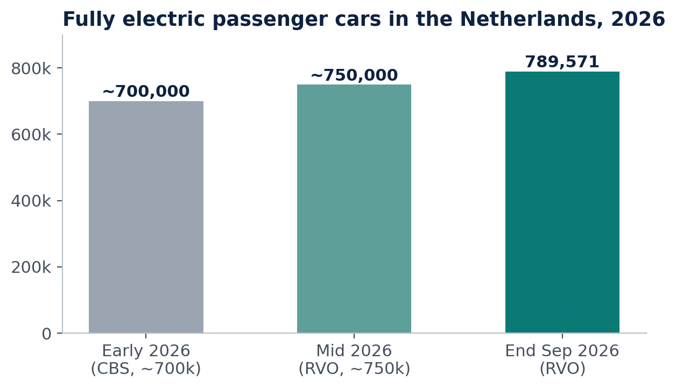
Figure 1. Fully electric passenger cars in the Netherlands, 2026. Sources: CBS (start of 2026), RVO via MobilityEnergy (Jul and Oct 2026) [R9]. Bars start at zero.
Indicator | Value | Source
Fully electric passenger cars | 789,571 at end Sep 2026 (~8.4% of fleet) | RVO [R9]
Share of new car sales, Jan–Sep 2026 | 42% fully electric | RVO [R9]
Small solar installations | 3.2 million+ at end 2025 | CBS via Solar Magazine [R10]
Home charge points | 650,000+ (estimate) | RVO [R9]
Public charge points | 135,000+ | RVO [R9]
End of net metering | 1 January 2027 | Dutch government [R12]
Home batteries | 4 in 10 solar buyers in 2026 also bought a battery (vendor data) | Zonneplan [R12]
Grid congestion | Household connection waiting lists since 1 July 2026 (Stedin; Liander ~7,300; Enexis ~11,000) | Grid operators [R11]

3.1 Why this matters for the business
- Net-metering end pushes households toward storage, smart control and V2H, adding software-controlled energy devices to homes.
- Grid congestion makes flexibility valuable, so more third parties (aggregators, suppliers, grid operators) will send commands into homes.
- High EV and solar density means many homes already combine several vendors — the multi-vendor problem exists today, not only in 2030.
- Regulation turns security into a workflow with deadlines: CRA reporting since 11 September 2026 (early warning within 24 hours, notification within 72 hours) and full obligations from 11 December 2027 [R4].

3.2 Technology enablers
ISO 15118-20 defines bidirectional power transfer between vehicle and charger, and OCPP 2.1 (2025) adds V2X support between chargers and back-end systems [R14]. Together they make V2H technically standardisable, but they also put more commands — from more parties — into the home’s energy path.

4. Evidence: cyber-physical incidents 2025–2026
The following incidents are used as analogies. None was an attack on homes, and we do not claim EnergyOS would have prevented them. Each one shows a mechanism that also exists in the connected V2H home.
Date | Incident | What went wrong | Lesson for the V2H home | Module
Nov 2025 | AI-orchestrated espionage [R5] | A state-backed group used an AI agent for 80–90% of a campaign against ~30 organisations | Attackers scale; human analysts cannot keep up without automation | Detect
29 Dec 2025 | Polish wind and solar sites [R2] | 30+ renewable sites lost monitoring and control; RTUs wiped; entry through exposed firewalls without MFA | Fleets of small energy assets, managed remotely, are a target | Detect, Correlate
Apr 2026 | AI finds zero-days at scale [R7] | Anthropic restricted a model that found thousands of severe vulnerabilities across major systems | Vulnerabilities arrive faster; knowing which homes are affected becomes urgent | Trace
May 2026 | EU curbs high-risk inverters [R8] | Commission moves to restrict high-risk solar-inverter suppliers, incl. residential systems; experts flag manufacturer cloud platforms | Supplier risk is now regulated; operators must know which homes run which inverter | Trace
Oct–Nov 2026 | Supermarket refrigeration hacks [R1] | Internet-exposed refrigeration controllers in ~10 countries incl. NL switched to defrost or extreme temperatures; retailer, installer and controller maker all involved | A remote setpoint change = a remote discharge command; responsibility splits across vendors | Detect, Correlate, Coordinate

The pattern across all five: internet-exposed controllers, third-party components, physical consequences, several companies involved in one incident — and AI compressing the attacker’s timeline. That is precisely the problem EnergyOS Secure addresses in the home.
Note: early reporting on the November 2026 refrigeration incidents differed on store counts and attribution; verify against primary sources before external use [R1].

5. Problem definition and gap analysis

5.1 Job to be done
“When abnormal behaviour occurs across connected energy products, help me determine whether it is a security incident, understand its operational impact, identify affected products and coordinate the response — without manually reconstructing evidence from multiple systems.”

5.2 MECE issue tree
Dimension | Observed or plausible pain | Buyer consequence
Fragmented visibility | Charger, inverter, battery and HEMS logs sit with different vendors | Slow incident reconstruction, incomplete context
Ambiguous diagnosis | Attacks, communication faults and misconfigurations look alike | False positives, wasted support time
Unknown blast radius | Firmware and component exposure across the installed fleet is unclear | Unprioritised vulnerability response
Coordination friction | Several manufacturers and operators must agree on evidence and ownership | Longer time to resolution, handoff failures
AI decision risk (new) | AI energy managers act on price and forecast feeds that can be manipulated | Valid, authenticated but harmful commands
Regulatory workload | CRA reporting needs fast, evidenced vulnerability handling | Product-security resource burden

5.3 Gap analysis: Samsung, LG and Hyundai
We compared the public positioning of three large consumer ecosystems with the functions a multi-vendor V2H home needs. Each invests heavily in AI energy features and in the security of its own devices; none publicly offers the cross-brand functions below.
Capability | Samsung SmartThings | LG ThinQ | Hyundai / Kia | EnergyOS Secure
AI energy saving and monitoring | Yes, own ecosystem | Yes, own ecosystem | In car and app | Partner, not compete
V2L / V2H capability | Via partners | Via partners | V2L; V2H/V2G in pilots | Monitors V2H commands
Security of own devices | Strong (Knox) | Own programme | Own vehicle security | Across all brands
Cross-brand incident correlation | Not offered | Not offered | Not offered | Core
AI EMS decision risk scoring | Not offered | Not offered | Not offered | Core
Firmware exposure across brands | Own devices | Own devices | Own vehicles | Core
Cross-vendor case and CRA evidence | Not offered | Not offered | Not offered | Core

Based on public product positioning, November 2026; “not offered” means not publicly offered as a cross-brand capability. Verify product by product before external use.
Insight: a real Dutch home mixes a Hyundai EV, a third-party charger, an inverter from another brand and an LG heat pump. No brand owns that incident. The big brands are therefore potential partners, channels or acquirers — not direct competitors.

6. Solution and technology

6.1 Four modules
Module | What it does | Primary buyer
Detect | Energy-domain anomaly detection from cyber and physical signals; risk-scores each V2H command the AI EMS issues | HEMS platform
Correlate (core) | Cross-device, cross-vendor and fleet-level evidence in one timeline; ranks hypotheses: attack, misconfiguration or fault | HEMS platform, MSSP
Trace | Maps firmware, SBOMs and advisories to the homes and functions actually affected, with confidence states | OEM product security
Coordinate | Human-reviewed cases, vendor assignment, remediation tracking, signed evidence supporting CRA reporting | OEM, HEMS, enterprise

Product boundary. We detect, explain and route; people decide. No autonomous physical response, no energy-price optimisation, and CRA support rather than automatic compliance. This keeps liability with the operator and shortens procurement.

6.2 Signature feature: command risk scoring for the AI EMS
Every V2H command is scored in four checks: (1) authentic? — signed, known session, trusted source; (2) within policy? — minimum charge, departure time, user and grid limits; (3) explainable by the AI EMS? — consistent with tariff, forecast and the EMS’s own objective; (4) fleet context — is the same pattern appearing in other homes, firmware versions or vendors? Low-risk commands are logged as evidence, elevated ones alert the operator and user, high-risk ones open a case. An operator-configured “hold for confirmation” is an opt-in roadmap option, not a default.
This covers a new attack class: a manipulated price or forecast feed that tricks a correctly coded AI into a harmful discharge. Generic security tools see a valid, authenticated command; we see that the decision makes no physical or economic sense.

6.3 Architecture
Layer | Components
Interfaces | White-label app API · SOC and PSIRT console · CRA evidence export
Cloud | Asset graph and digital twin · expected-behaviour models · correlation engine · SBOM matching · case management
Edge agent | Runs beside the AI EMS on the gateway: local data capture, command risk scoring, store-and-forward when offline, signed logs, local federated-learning client
Protocols | ISO 15118-20 · OCPP 2.0.1 / 2.1 · EEBus · SunSpec Modbus · DSMR P1 · MQTT
Devices | Bidirectional EV and charger · PV inverter · home battery · heat pump · smart meter
External data | Day-ahead prices (ENTSO-E) · weather and solar forecasts · grid-operator limits · NVD, CISA and vendor advisories

6.4 Where the AI sits
Component | Technique | Output | How we prove it
Federated learning | Hierarchical FL: models train at each vendor or HEMS; only model updates are shared | Cross-vendor detector without pooled raw data | Accuracy vs a centralised model; privacy guarantees
Expected behaviour | Replays the AI EMS objective (tariff, SOC, departure) to predict what it should do | Deviation score | Detection lead time
Anomaly detection | Physics-consistency checks plus unsupervised models | Ranked anomalies | Precision and recall on injected scenarios
Command risk scoring | Policy rules combined with anomaly and fleet scores | Low, elevated, high risk | Injected attacks caught; false-alarm rate
Exposure mapping | SBOM and firmware matching with confidence states | Affected-home list | Match precision
Investigation copilot | LLM over structured case data, with citations | Timeline and hypotheses | Analyst minutes per case

Design choice: the LLM only summarises evidence for people; risk scores come from rules and measurable models. Rules and physics checks establish the baseline; machine learning must demonstrate incremental value.

6.5 MVP scope (course prototype and first pilot)
- One bidirectional charger over OCPP, one inverter over SunSpec Modbus, a DSMR P1 smart meter, ENTSO-E day-ahead prices.
- Three predefined incident classes: spoofed discharge command, manipulated price feed, firmware advisory affecting part of the fleet.
- Benign-fault scenarios (communication loss, misconfiguration) to measure false alarms.
- Output: one correlated case with ranked hypotheses, affected-asset list and assigned owners.

7. Market definition, sizing and scenarios

7.1 Market definition
Energy-domain cyber-physical security operations and product-security intelligence, adjacent to HEMS operations, EV-charging security, OT security, exposure management and CRA workflows. B2B only: households benefit but are not buyers. Adjacent markets must not be added together into a TAM — that would double-count spending.

7.2 Netherlands first, then expand
Phase | Geography | Rationale
2026–27 | Netherlands | Net-metering end, grid congestion, high EV and solar density, real bidirectional pilots, founder proximity for design partners
2028 | Belgium and Germany | Similar device ecosystems, Dutch and German HEMS players, Germany’s §14a rules for controllable devices
2029+ | Wider EU | CRA applies EU-wide; reusable connectors and OEM relationships carry over

7.3 Two bottom-up sizing lenses
Lens A: accounts × contract value | Value | Assumption
TAM | €72M | 1,200 buyer organisations × €60k
SAM | €12M | 200 reachable accounts: NL first, then BE and DE
SOM | €0.72M | 12 customers won in the planning horizon

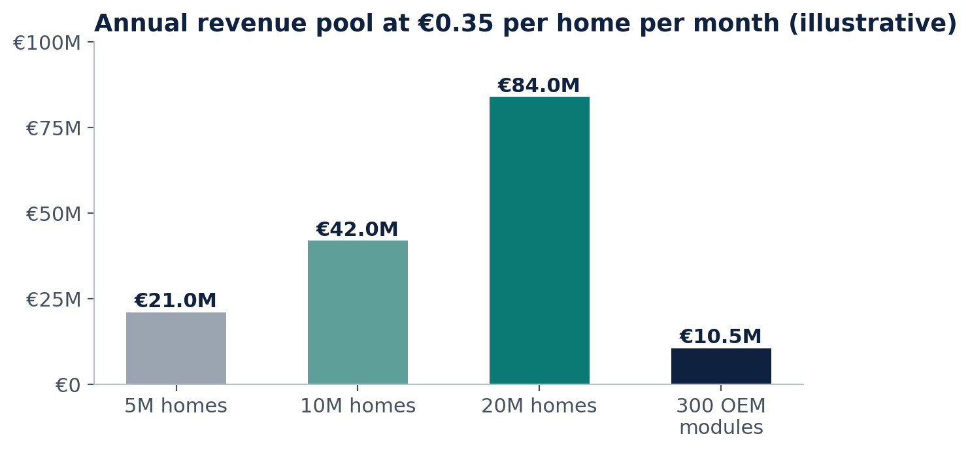
Figure 2. Lens B — homes × per-home fee. Home counts are scenarios to be replaced with sourced national installation data.
Investor flag. Both lenses point to roughly €100–200M combined: a strong niche with a plausible strategic exit, not a billion-euro market on day one. Going beyond it requires depot and fleet charging, commercial and industrial sites, aggregators and virtual power plants. Say this openly — investors trust founders who size honestly.

7.4 Scenario planning (consulting method)
Consulting firms such as Deloitte (Monitor Deloitte’s scenario-thinking practice, building on Shell’s scenario tradition) develop scenarios in six steps:
- Focal question: how will multi-vendor V2H homes in the Netherlands be secured by 2030?
- Driving forces: scan with STEEP (social, technological, economic, environmental, political) — e.g. EV adoption, AI EMS uptake, CRA enforcement, EU Data Act, grid congestion, threat activity.
- Rank by impact and uncertainty: predetermined trends (EV growth, CRA timeline) go into every scenario; the two most impactful and most uncertain forces become the axes.
- Build the 2×2: axis 1 — speed of AI EMS and V2H adoption; axis 2 — openness of data sharing and strictness of security enforcement.
- Write narratives: each quadrant is a plausible story, not a forecast.
- Derive implications and signposts: identify no-regret moves that work in all futures, and early indicators that show which future is arriving.
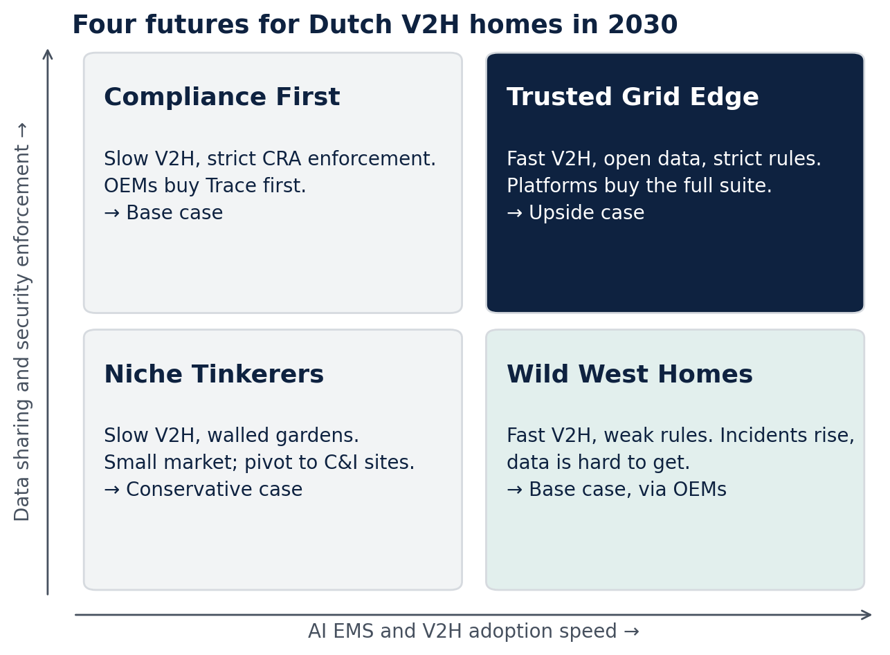
Figure 3. Four futures for Dutch V2H homes in 2030, linked to the revenue scenarios in section 11.
Element | Content
No-regret moves | Connectors for operator-owned data · Trace module for OEMs · human-led workflows · federated learning so data never has to be pooled
Signposts | CRA enforcement actions · EU Data Act device-data access in practice · certified bidirectional chargers in NL · publicly reported home-energy incidents · HEMS open-API commitments

8. Customers and buyers
Segment | Pain | Data access | Budget | Priority | Example accounts (discovery list)
HEMS / AI EMS platforms | Cross-vendor incidents | Good | Medium | 1 · beachhead | gridX, 1KOMMA5°, Tibber
EVSE / V2H OEMs | Product security, CRA | Strong (own) | Medium–high | 1 · parallel | Alfen, Easee, Wallbox
Battery and inverter OEMs | Firmware exposure | Strong (own) | Medium–high | 2 | SMA, Fronius, SolarEdge
Suppliers and aggregators | Trust in flexibility | Variable | Medium–high | 2 | Eneco, Vandebron
Managed security providers | Need energy detection | Via clients | Medium–high | 3 · channel | To identify
Households | Concern, no budget | Limited | Low | Not a buyer | —

Example accounts are a discovery list only; none has been contacted and none is a customer.

8.1 Ideal customer profile
EU HEMS operator or EVSE/V2H OEM with more than 5,000 active devices, several vendors or integrations, documented investigation pain and a named security or operations sponsor. Triggers: a device incident, a firmware advisory, a new product family, a product-security team expansion or a CRA workflow redesign.

8.2 Buying centre and RACI
Actor | Role | Accountability
Head of Product Security / CISO / CTO | Economic buyer | Budget, security policy
HEMS operations lead | Champion | Incident workflow and efficiency KPI
Platform architect | Technical gatekeeper | Integration, scalability, reliability
Procurement, legal, DPO | Approver | Contract, privacy, liability
OEM security engineer | Case collaborator | Firmware applicability and patching
EnergyOS analyst / AI | Evidence preparer | Explainable findings — never the final authority

RACI: EnergyOS is responsible for evidence processing; the customer’s incident owner is accountable for classification; the OEM is responsible for firmware applicability and patching; the manufacturer’s legal team is accountable for CRA reporting and submission.

9. Competition and strategy

9.1 Competitive landscape
Category and examples | Documented strengths | Honest overlap | Our wedge
HEMS: gridX, Kiwigrid [R13] | White-label HEMS, multi-vendor integration, diagnostics, APIs | Strong home data access; multi-vendor integration is not unique | Cyber-physical incident evidence + OEM coordination; partner rather than compete
EV security: VicOne, Upstream [R13] | EVSE protection, detection and response, firmware/SBOM | Direct cyber competitor for chargers | Whole-home, inter-device physical context and human case handoff
Product security: ONEKEY [R13] | SBOM, firmware analysis, CRA positioning | Generic SBOM/CRA is not a gap | Integrate; add operational impact and deployed-home context
OT security: Claroty, Nozomi | Asset visibility, OT threat detection | Strong at industrial sites | Residential multi-vendor fleets, lighter deployment
Status quo: SIEM + Jira + spreadsheets | Already owned by buyers | The real substitute | Energy semantics, firmware graph, vendor handoff

Public marketing silence is not evidence of a missing feature; competitor diligence must include product demos and customer interviews.

9.2 Porter’s five forces
Force | Assessment | Strategic response
Rivalry | High | Narrow wedge; integrate with incumbents
Buyer power | High | Paid design partners; measurable time-to-value
Supplier (data) power | High | Permissioned APIs; federated learning; portable data model
Substitutes | High | Show quantified cross-domain uplift over SIEM + manual
New entrants | Medium | Dashboards are easy; trust, data and integrations are hard

9.3 SWOT
Strengths | Weaknesses
Founder’s federated-learning and cyber-physical research · energy-domain focus · human-led design lowers liability · sits beside any HEMS | No traction yet · depends on third-party data · little labelled attack data · technical founder without commercial co-founder

Opportunities | Threats
V2H and AI EMS growth · CRA budgets · EU inverter-risk policy · MSSP and OEM channels · EU project network | Incumbents bundle features · in-house builds · data-sharing restrictions · false alarms erode trust · long procurement

9.4 Differentiation and moats
Not a moat (table stakes) | Potential moat | Proof required
Generic anomaly detection | Beside the command path: the edge agent sees every AI EMS command; hard to rip out | Deployed on a pilot fleet
SBOM / CVE scanning | Vulnerability → deployed home → affected function → case | Verified applicability precision
Price-based charge scheduling | Federated learning across vendors without moving their data | Accuracy close to a centralised model
Dashboards and LLM chat | Pattern library that grows with the fleet; integration depth | Lower onboarding effort for customer 2

Proposed USP: the only layer that reads both the AI energy manager’s decisions and the cyber evidence across vendors — and learns across them without pooling their data. This is a testable hypothesis, not a proven exclusive feature.

10. Business model and pricing

10.1 Business Model Canvas
Block | EnergyOS Secure
Customer segments | HEMS operators; EVSE/V2H OEMs; inverter and battery OEMs; later energy MSSPs and aggregators
Value propositions | Faster cross-vendor triage; AI EMS decision risk scoring; affected-home exposure context; auditable evidence
Channels | Founder-led direct sales; design-partner pilots; HEMS and OEM integrations; security integrators
Customer relationships | Annual enterprise contract; onboarding; named success owner; quarterly value review
Revenue streams | Platform SaaS; per-home fee; supply-chain and CRA module; integration and API fees
Key resources | Federated-learning and correlation IP; cyber-physical data model; device integrations; security expertise
Key activities | Ingestion, detection engineering, firmware mapping, support, compliance intelligence
Key partners | HEMS platforms, EVSE OEMs, SBOM vendors, SOCs/MSSPs, research labs, EU project consortium
Cost structure | Engineering, cloud, integrations, security assurance, sales, legal, support

10.2 Packaging and pricing (hypotheses)
Offer | Buyer | Illustrative pricing | Pilot success metric
Design-partner pilot | HEMS or OEM | €10k–€25k for 6–8 weeks | Agreed KPIs met
Monitor & Correlate | HEMS operator, MSSP | €15k–€60k/yr + €0.10–€0.60 per home per month | Triage time, correct grouping
Supply-Chain & CRA Intelligence | OEM product security | €20k–€100k/yr by product family | Time to find affected versions
Coordination & API | OEM, enterprise | €5k–€40k set-up + annual support | Onboarding time, handoffs closed

- Annual minimum commitments with usage bands — predictable budgets.
- No per-incident fees — customers must never pay more for more alerts.
- Clear liability — patching, operational response and CRA filing remain customer responsibilities.
- Value-based pricing — capture 20–40% of independently demonstrated value.

10.3 Revenue build
Homes per HEMS customer | Platform fee | Per-home (€0.35/month) | Annual contract value
5,000 | €30k | €21k | €51k
20,000 | €30k | €84k | €114k
100,000 | €30k | €420k | €450k (volume discount likely)

Example portfolio: 3 operators × 20,000 homes × €0.35 × 12 = €252k, plus 2 OEM modules × €35k = €70k → €322k ARR before platform fees, churn, discounts and integration revenue. ARR = platform fees + activated homes × net monthly price × 12 + OEM module ARR. Fleet-linked fees build net revenue retention above 100% into the model.

11. Financial analysis

11.1 Customer ROI stress test
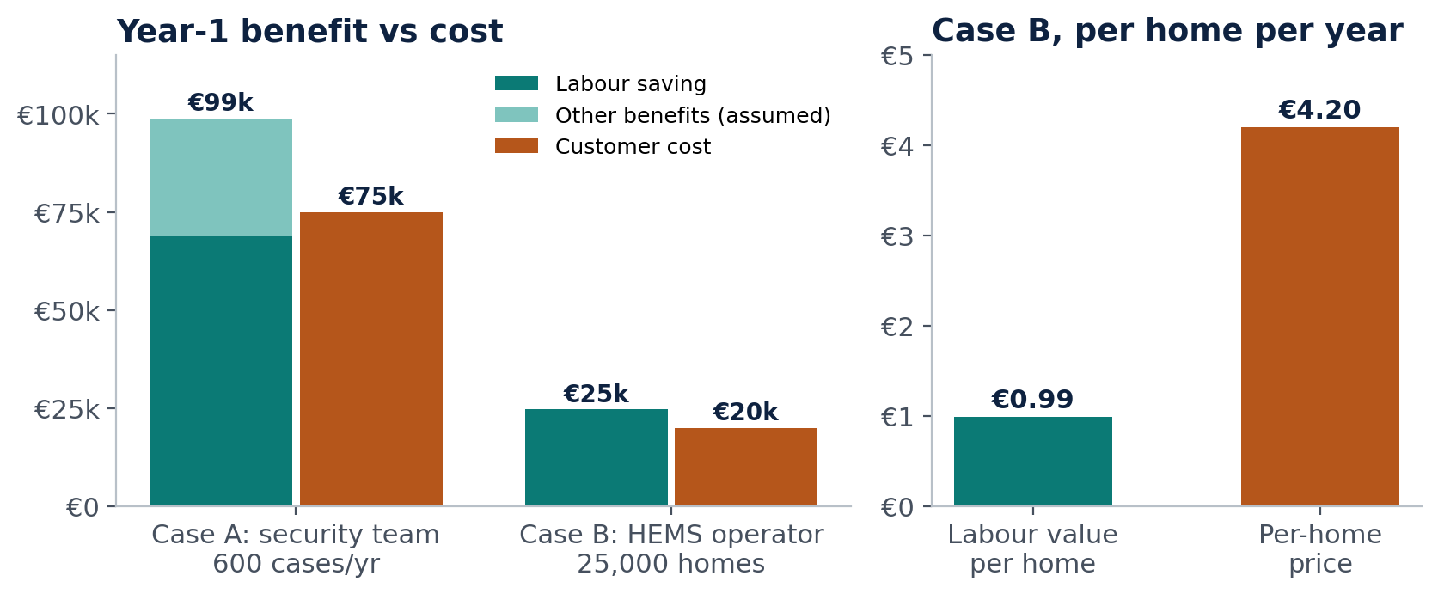
Figure 4. Year-1 customer benefit vs cost in two illustrative cases, and per-home labour value vs per-home price in case B.
 | Case A: security team | Case B: HEMS operator
Volume | 600 investigations/yr | 25,000 homes × 8 cases per 100 homes = 2,000 cases
Time and saving | 3 h per case, 45% saved | 45 min per case, 30% saved
Loaded cost | €85/h | €55/h
Labour value | €68,850 | €24,750
Other benefits | €30,000 (assumed) | Not included
Customer cost | €75,000 (€60k fee + €15k integration) | €20,000 platform fee
Year-1 net | +€23,850 (32% ROI) | +€4,750 before integration
Break-even / sensitivity | Labour alone needs 49% time saved | €6,188 (4 cases, 15%) to €55,688 (12 cases, 45%)

Key finding. In case B, labour value is €0.99 per home per year, while the suggested per-home price is €4.20 — four times higher. Per-home pricing cannot rest on analyst time alone. The pilot must measure: (1) time to identify affected devices inside the CRA’s 24-hour window, (2) avoided escalations, field visits and duplicate tickets, (3) enterprise deals unlocked by passing security reviews. Saved hours count only if capacity is redeployed or cost falls.

11.2 Unit economics
Metric | Planning case | Early customers | SaaS rule of thumb
Annual contract value | €60k | €60k | —
Gross margin | 80% | 60% | ≥ 75%
Gross profit per year | €48k | €36k | —
Customer acquisition cost | €45k | €75k | —
CAC payback | 11 months | 25 months | < 18 months
5-year LTV (10% churn) | €197k | €147k | —
LTV / CAC | 4.4× (healthy) | 2.0× (weak) | ≥ 3×

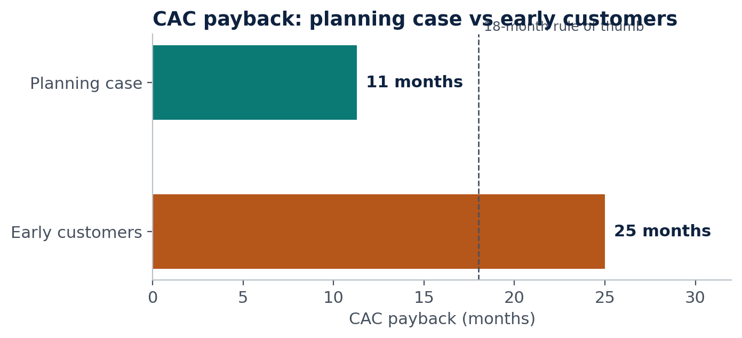
Figure 5. CAC payback in the planning case and with early, integration-heavy customers.
What closes the gap: price integration separately, reuse connectors from customer 2 onward, and sell through HEMS partners to cut CAC. LTV = gross profit over five years at 10% annual churn: €48k × (1 + 0.9 + 0.81 + 0.729 + 0.656) ≈ €197k.

11.3 Revenue scenarios
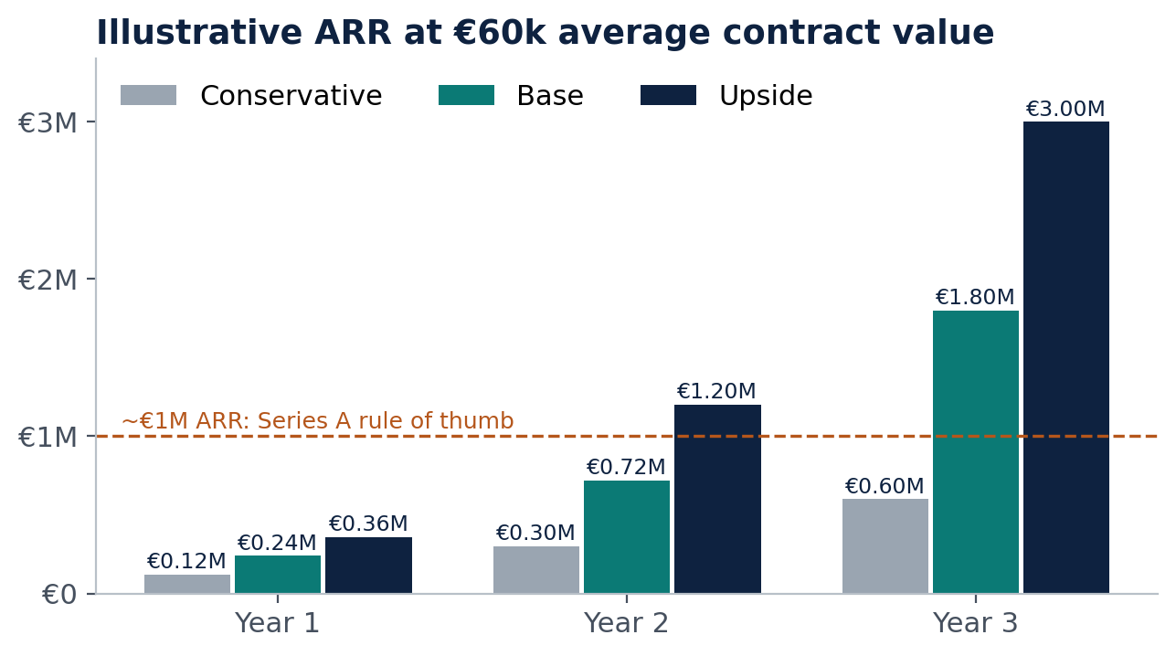
Figure 6. Illustrative ARR at €60k average contract value; excludes per-home upside, churn, discounts and integration revenue. Not a forecast.
Scenario | Year 1 | Year 2 | Year 3 | Linked future (7.4)
Conservative | 2 customers · €0.12M | 5 · €0.30M | 10 · €0.60M | Niche Tinkerers
Base | 4 · €0.24M | 12 · €0.72M | 30 · €1.80M | Compliance First / Wild West Homes
Upside | 6 · €0.36M | 20 · €1.20M | 50 · €3.00M | Trusted Grid Edge

Only the base case in year 3 and the upside from year 2 cross the ~€1M ARR line commonly associated with Series A readiness. The base case needs 18 new logos in year 3 — two to three sellers with 6–9-month enterprise cycles. The pre-seed must therefore buy proof, not scale. An investor-ready version needs a monthly model with sales-cycle length, contract start dates, renewals, hiring, gross margin and cash runway.

11.4 Funding
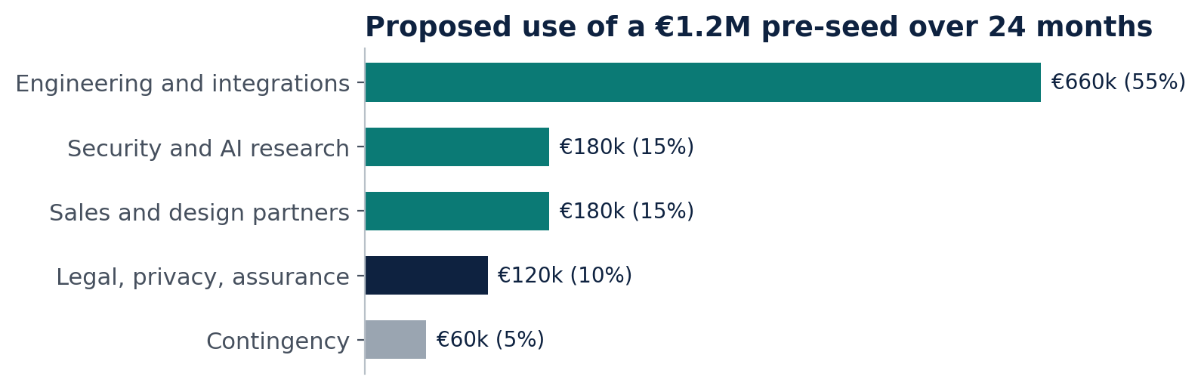
Figure 7. Proposed use of a €1.2M pre-seed over 24 months (~€50k per month, inside the €250–600k per year lean range).
Sequence: research prototype → design partner → paid pilot → repeatable product → seed round. Non-dilutive options to check: university entrepreneurship programmes, RVO innovation schemes, EU programmes (eligibility to verify). Spend is released stage by stage against the gates in section 12.

12. Go-to-market, validation and roadmap

12.1 Land and expand
Stage | Goal | Exit evidence
1. Beachhead | One HEMS or EVSE design partner in NL | Signed data-access agreement
2. Paid pilot | 6–8 weeks, three incident classes, baseline measured | Paid contract, agreed KPIs met
3. Productise | Reusable connectors, permissions, deployment package | Second customer onboards with clearly less effort
4. Expand | Trace module for OEMs whose products appear in managed fleets | OEM module ARR
5. Scale | HEMS, MSSP and OEM channels; BE and DE | Improving CAC and sales efficiency

12.2 Pilot acceptance criteria
- Access to two or more approved event or telemetry sources.
- Correct grouping of predefined incident scenarios.
- Measured change in analyst investigation time against the customer’s baseline.
- Documented false-alarm and missed-detection rates.
- Accurate mapping of a selected firmware or component exposure.
- Users rate the workflow useful; a decision on production deployment and pricing.
- Never define success as “the dashboard works”.

12.3 Hypotheses and gates
Hypothesis | Experiment | Go if…
H1 Fragmented triage is costly | 10–15 structured interviews, anonymised tickets | 3+ buyers quantify pain and offer data access
H2 Cross-domain evidence helps | Blind test: cyber-only vs combined evidence | Fewer wrong groupings, less review time
H3 Buyers will pay | Paid pilot offer to 3 qualified accounts | 1+ paid design partner or budgeted LOI
H4 Firmware context adds value | OEM product-security workflow test | Faster affected-version triage
H5 Deployment is repeatable | Integrate a second customer or vendor | Clearly less effort than the first
H6 Federated learning works here | Train across 2+ data silos on the testbed | Accuracy close to centralised baseline

Kill or pivot: no pilot data-sharing route, or no paid willingness after three qualified offers. Pivot options: integration layer sold through an existing HEMS or OT-security vendor, or a pure OEM Trace product.

12.4 24-month roadmap
Horizon | Product | Commercial | Gate
0–1 month | Lab testbed: charger, inverter, meter (course prototype) | Competitor diligence | Demo with honest limits
1–3 months | Correlation and case workflow | 10–15 interviews via EU-project network; 2 design partners | H1 passed
3–6 months | 2–3 device types on pilot data | First paid pilot | H2, H3 passed
6–12 months | Reusable connectors; Trace beta; FL across partners | First annual contracts in NL | H5, H6 passed; renewal intent
12–24 months | Multi-tenant production | BE and DE accounts; OEM module | Seed-ready: retention, attach rate

13. Risks
Risk | Likelihood / impact | Mitigation or kill criterion
No OEM telemetry or SBOM access | High / critical | Operator-owned data first; federated learning avoids pooling; kill if no data route
No measurable customer ROI | High / critical | Pilot measures triage time and the three other value levers
Incumbents already solve it | High / high | Head-to-head workflow demos; reposition as integration layer
False-alarm overload | High / high | Fault-vs-attack baselines, evidence thresholds, human review
Integrations too expensive | High / high | Two or three interfaces first; price onboarding separately
Long enterprise sales cycle | High / medium | Paid pilot, named sponsor, procurement mapped early
CRA overclaiming / liability | Medium / critical | Evidence support only; legal review; no automated filing
Breach of our own platform | Medium / critical | Tenant isolation, RBAC, data minimisation, secure SDLC
Overreliance on CRA urgency | Medium / medium | Sell operational value independently of deadlines

14. Team and investor view

14.1 Why this founder
[Founder name] is a PhD researcher in AI and cybersecurity for smart, cyber-physical environments.
- PhD focus: hierarchical federated learning for early-stage cyberattack detection in power grids, without centralising data — the exact technique that removes the data-sharing barrier in this market.
- Hands-on: simulates cyberattacks in controlled environments; designs AI detection models and correlation algorithms — the core of the Detect and Correlate modules.
- Breadth across cyber-physical domains: smart factories, intelligent transportation systems, air-traffic surveillance systems and power grids.
- Interdisciplinary education: computer science, technology policy and electrical engineering — able to talk to engineers, security teams and regulators.
- Network: works on a European Commission-funded project with 75 organisations from 15 countries — a pipeline for discovery interviews, design partners and advisers.
Gap to close: a commercial co-founder or early hire with enterprise energy sales experience, plus an advisory board drawn from the EU project consortium. Investors will ask who this is.

14.2 Mock investment-committee scorecard
Dimension | Today | Evidence needed to reach 4/5
Problem | 3/5 | 3+ buyers quantify pain
Timing | 4/5 | Already strong: CRA, V2H, incidents
Product | 2/5 | Lab demo beats cyber-only baseline
Market size | 2/5 | Named NL account list; per-home path
Traction | 1/5 | One paid pilot
Defensibility | 2/5 | Exclusive data or integration partner; FL results
Team | 3/5 | Deep technical fit; add commercial co-founder

Verdict: proceed to diligence on a small cheque, conditional on a signed design partner.

14.3 How different investors read the case
Investor type | View | What to show them
Venture capital | Strong timing, niche market | Expansion beyond €100M TAM; speed to paid pilot
Strategic / corporate VC | Best fit: OT security, HEMS or energy-device groups | Integration depth, data and the federated-learning capability
Private equity | Too early | Revisit at €5M+ ARR, net revenue retention above 110%, healthy margins

Exit logic: a capability acquisition by an OT-security vendor, an energy-device group or a large HEMS platform is the most plausible outcome for a focused niche leader.

15. Name options
“EnergyOS Secure” is descriptive but generic, and “EnergyOS” is used by other companies. Alternatives (trademark and domain checks required before use):
Name | Idea | Fit
Tessera | A tessera is one tile of a mosaic: we assemble fragments into one picture | Strong story fit; recommended
Veilo | From Dutch “veilig” (safe) | Local roots for an NL beachhead
Kilowatch | Kilowatt + watch | Clear, slightly playful
GridLens | A lens on the grid edge | Clear; check existing use
Concordia | Coordination across parties | Emphasises the Coordinate module
Sentinel V2H | Guardian of vehicle-to-home | Descriptive; common word

16. Hard questions (FAQ)
Question | Disciplined answer
Why not use a SIEM? | A SIEM handles logs. Energy-physics semantics, a firmware graph and multi-vendor handoff are what reduce triage effort. Must be proven in the pilot.
Why would OEMs share data? | They don’t have to share raw data: hierarchical federated learning keeps data with each vendor. We start with operator-owned data.
Is AI necessary? | Not for the first workflow. Rules and physics set the baseline; ML must show measurable incremental value.
Is CRA a guaranteed sales driver? | No. It creates obligations for relevant manufacturers; we support evidence and workflow, not automatic compliance.
Could you have stopped the fridge attacks? | No such claim. They illustrate cyber-physical consequences, not product effectiveness.
Why won’t VicOne or gridX copy this? | They may. Defensibility must come from partnerships, validated data, integrations, federated-learning results and workflow adoption.
Why no autonomous response? | Human-led decisions reduce safety, integration and liability burden and match enterprise security processes.
What proves the company works? | A paid pilot, measured triage improvements, repeatable onboarding and renewals — not the prototype alone.

17. References
Sources checked 9 November 2026. Several news items were still developing; verify each primary source before external distribution.
[R1] Supermarket refrigeration attacks, Oct–Nov 2026: Reuters, 2 Nov 2026 — https://www.reuters.com/business/european-retailers-hit-by-supermarket-fridge-hack-2026-11-02/ ; The Hacker News — https://thehackernews.com/2026/11/second-wave-of-cyberattacks-hits.html ; CBC — https://www.cbc.ca/news/business/europe-fridge-cyber-incident-9.7405834 ; CNBC, 9 Nov 2026 — https://www.cnbc.com/2026/11/09/europe-fridge-hacks-bomb-threats-cyberattack.html ; Wikipedia — https://en.wikipedia.org/wiki/2026_French_supermarket_refrigerator_hack
[R2] Polish renewable-energy attack, Dec 2025: The Hacker News — https://thehackernews.com/2026/01/poland-attributes-december-cyber.html ; Dragos — https://www.dragos.com/blog/poland-power-grid-attack-electrum-targets-distributed-energy-2025
[R3] NIST NVD, CVE-2026-4156 and CVE-2026-4157 — https://nvd.nist.gov/vuln/detail/CVE-2026-4156 ; https://nvd.nist.gov/vuln/detail/cve-2026-4157
[R4] European Commission, CRA reporting obligations — https://digital-strategy.ec.europa.eu/en/policies/cra-reporting ; CRA implementation timeline — https://digital-strategy.ec.europa.eu/en/factpages/cyber-resilience-act-implementation
[R5] Anthropic, “Disrupting the first reported AI-orchestrated cyber espionage campaign”, Nov 2025 — https://www.anthropic.com/news/disrupting-AI-espionage
[R6] ENISA Threat Landscape 2026 — https://www.enisa.europa.eu/topics/cyber-threats/threat-landscape ; Carnegie Endowment, “When AI Agents Attack”, Jul 2026 — https://carnegieendowment.org/research/2026/07/when-ai-agents-attack-autonomous-cyber-operations-and-europes-governance-gap
[R7] Claude Mythos Preview coverage, Apr 2026: Tom’s Hardware — https://www.tomshardware.com/tech-industry/artificial-intelligence/anthropics-latest-ai-model-identifies-thousands-of-zero-day-vulnerabilities-in-every-major-operating-system-and-every-major-web-browser-claude-mythos-preview-sparks-race-to-fix-critical-bugs-some-unpatched-for-decades
[R8] EU and solar-inverter risk: Euronews, 4 May 2026 — https://www.euronews.com/2026/05/04/eu-moves-to-ban-high-risk-inverters-from-china-over-cybersecurity-threats ; EU Smart Energy Expert Group summary — https://now.solar/2026/10/12/eu-experts-identify-three-major-cybersecurity-risks-for-internet-connected-solar-pv-review-energy/ ; DER exposure study — https://arxiv.org/pdf/2609.07783
[R9] Dutch EV fleet: RVO via MobilityEnergy, Oct 2026 — https://www.mobilityenergy.com/en/industry/2026/10/13/rvo-number-of-fully-electric-passenger-cars-in-the-netherlands-rises-to-800000-hydrogen-plays-a-marginal-role/ ; Jul 2026 — https://www.mobilityenergy.com/en/industry/2026/07/20/the-number-of-fully-electric-passenger-cars-in-the-netherlands-is-set-to-rise-to-750000/ ; CBS — https://www.cbs.nl/en-gb/news/2026/15/almost-a-quarter-more-cars-with-an-electric-motor
[R10] Dutch solar installations (CBS via Solar Magazine) — https://solarmagazine.nl/nieuws-zonne-energie/i44007/zakelijke-zonnepaneelmarkt-vorig-jaar-met-66-procent-gekrompen
[R11] Grid congestion: Stedin — https://www.stedingroep.nl/eng/press-and-media/persberichten/growing-pressure-on-the-electricity-grid-is-now-affecting-households-too ; RVO — https://english.rvo.nl/topics/grid-congestion/what-grid-congestion
[R12] End of net metering 1 Jan 2027 and battery uptake: Solar Magazine / Zonneplan — https://solarmagazine.nl/nieuws-zonne-energie/i45224/42-procent-zonnepaneelkopers-neemt-direct-ook-een-thuisbatterij-salderingsregeling-stopt-bijna-en-zonneplan-merkt-het (verify against the official Rijksoverheid page)
[R13] Competitors: gridX — https://www.gridx.ai/product ; Kiwigrid — https://kiwigrid.com/en/products ; VicOne — https://documents.vicone.com/solution-brief/ev-charging-system-protection.pdf ; ONEKEY — https://www.onekey.com/press-release/onekey-report-sbom-is-a-key-foundation-for-cra-compliance
[R14] Standards: ISO 15118-20 (ISO); OCPP 2.1 (Open Charge Alliance) — https://openchargealliance.org

