Software Requirements

Specification

for

Tutor Application

Version 2.1 approved

Prepared by <Tutor Group>

< Organization>

<02/28/2021>

Revision History

|  |  |  |  |
| --- | --- | --- | --- |
| Name | Date | Reason For Changes | Version |
| Klei Bendo | 03/10/2021 | Edited Section 4: System Features | 2.0 |
| Hunter McDaniels-Rossiter | 03/14/2021 | UI Mockup in section 3 added | 2.1 |

Table of Contents

Table of Contents 2

1. Introduction 1
   1. Purpose 1
   2. Document Conventions 1
   3. Intended Audience and Reading Suggestions 1
   4. Product Scope 1
   5. References 1
2. Overall Description 1
   1. Product Perspective 1
   2. Product Functions 1
   3. User Classes and Characteristics 2
   4. Operating Environment 2
   5. Design and Implementation Constraints 2
   6. User Documentation 2
   7. Assumptions and Dependencies 2
3. External Interface Requirements 2
   1. User Interfaces 2
   2. Hardware Interfaces 3
   3. Software Interfaces 3
   4. Communications Interfaces 3
4. System Features 3
   1. Private Messaging 3
   2. Direct Deposit 4
   3. Find a Tutor 5
   4. Create Profile 6

4.5. Apply for Tutoring 7

1. Other Nonfunctional Requirements 7
   1. Performance Requirements 7
   2. Safety Requirements 8
   3. Security Requirements 8
   4. Software Quality Attributes 8
   5. Business Rules 8
2. Other Requirements 8

Appendix A: Glossary 9

Appendix B: Analysis Models 9

Appendix C: To Be Determined List 9

# Introduction

## Purpose

This software is an application to connect tutors and tutees. This SRS covers the entire scope of the software and all parts of the system. The software requirements for this application are specified in this document. The revision and release number are TBD.

## Document Conventions

No standard conventions have been used throughout this document. Every requirement statement in this document has its own priority unless otherwise stated.

## Intended Audience and Reading Suggestions

This document may have many different types of readers. These include application managers, developers, tutor users, and tutee users. A general user (tutor or tutee) should read this document in the following order: Overall Description, System Features, Other Nonfunctional Requirements. An application manager should read all sections of this document in the order of the Table of Contents, found on page 2.

## Product Scope

This software is an application to connect tutors and tutees. Tutors and tutees are conveniently matched to increase the academic and professional success of all parties. The goal of this application is to best match tutees with appropriate tutors and facilitate the tutoring relationship between parties.

## References

<https://www.w3schools.com/> - Help with creating interactive toolbars.

# Overall Description

## Product Perspective

The product is supposed to be a tool to for users to find and acquire help/tutoring on resources related to college courses. This is a web-based system aimed at easily connecting students to tutors with minimal complexity.

## Product Functions

Major functions of the product are:

* User accounts: The system allows the creation of accounts by users, and also provide features to view and update profile accounts.
* Search: allows the user to search through courses and tutors to find one that best fits the user.
* Chat: Chat is for the user and the tutor to be able to communicate.

## User Classes and Characteristics

There are three main user classes for this application: Tutor, Tutee, and application manager. Tutor users frequently use the application and heavily rely on product functions to respond to listings and chat with tutees. Tutee users may use the application heavily to communicate with tutors and post listings each semester. Application managers regularly check the application and provide updates. The application managers are responsible to ensuring that the application meets all requirements that arise with the customer needs.

## Operating Environment

This software will operate as a web-based program. The application will be compatible with all major operating systems and web browsing platforms, including: Safari, Google Chrome, and Firefox.

## Design and Implementation Constraints

The development of this application will take place with 2-week sprint cycles, each cycle ending with a deliverable. The development team is responsible for maintain the delivered software, and ensuring that the software meets all programing standards, conventions, and security concerns. Memory requirements regarding this application have yet to be determined.

## User Documentation

Upon first creating an account on our website the user will be given a simple tutorial on the main features of the product. This tutorial will be accessible by the user at any time they wish to return to it. The application will also have a Q&A section to answer common questions for the user.

## Assumptions and Dependencies

This software depends on the user having knowledge of web-based applications, and access to the internet. The software does not currently have any dependencies on external factors.

# External Interface Requirements

3.1. UI Mockup

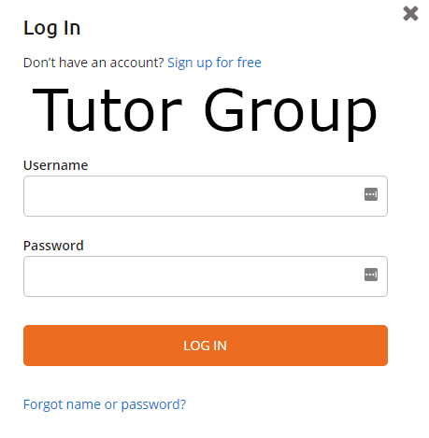

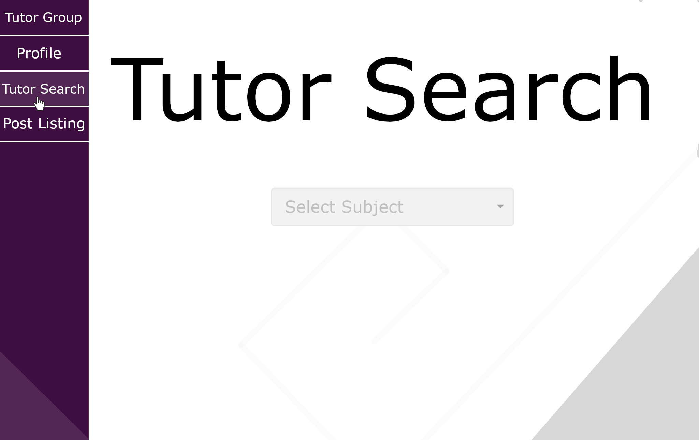

## User Interfaces

When the application is launched, a log in screen containing username and password text fields, a sign in button, and the name off the application will appear. After signing in the user will be taken to the home page. The main way to navigate around is a menu that takes a portion of the left side of the screen. This menu will have options to direct you to the various features of the application such as posting listings, searching for tutors, viewing your profile, etc. This menu will vary in features depending on if the user is a student or tutor and will be visible no matter where you are in the application. If an error message were to occur, the user would be informed by a pop-up in the middle of the screen, covering 25% of the screen.

## Hardware Interfaces

Local data for the interface will be stored in variables on the user’s system while data will be stored on a server. Other hardware interface specifics are TBD.

## Software Interfaces

This software must work with other specific software’s in order to accomplish all of its functions. This includes a pathway between the application and email, so that reminder emails, weekly update emails, and others may be sent to users and managers. On the back end, user profiles, schedules, and other user information must be stored so that each application feature can access the correct information.

## Communications Interfaces

Communications used by the application will need an interface to connect to the backend which will use a JavaScript add on. HTTP will be used since the application is a website. Communication security, encryption issues, data transfer rates, and synchronization mechanisms are TBD.

# System Features

## Private Messaging

4.1.1 Description and Priority

All users should be able to privately message each other through the application so that they can connect with each other. This is a high priority feature.

* Benefit: Easier communication
* Penalty: None
* Costs: UI design, Database Management, Encryption
* Risks: Malware attacks, identity stealing, account hacks

4.1.2 Stimulus/Response Sequences

* User A opens User B’s profile and clicks the private message icon on their profile
* System opens a chat window between both users.
* User A enters their message.
* User A presses the deliver message button.
* System encrypts the plaintext to ciphertext entered and sends it to user B.
* System decrypts the ciphertext back to plaintext once user B receives the message.
* System notifies user B through a pop up icon.
* User B clicks / taps the icon and opens the message.

4.1.3 Functional Requirements

REQ-1: The system shall ensure that only authorized users are able to view their private messages.

REQ-2: The system shall report to the user a list of all their private messages, ranked from the most recent date that a message was sent / received.

REQ-3: The system shall allow a user to send a message to another user by clicking the private message button on their profile.

REQ-4: The system shall notify the receiver in real-time that a new message has been received.

REQ-5: The system shall allow users to include photos as part of their message.

REQ-6: The system shall allow users to include videos as part of their message.

REQ-7: The system shall allow users to include files as part of their message.

## Direct Deposit

4.2.1 Description and Priority

This feature enables all users to enroll into direct deposit in order to receive and send their payments. This function is low priority.

4.2.2 Stimulus/Response Sequences

* User presses the “Direct Deposit” button from their menu.
* System opens up a new window that contains a form that the user needs to fill in with their bank account information.
* User fills in their bank account information.
* User presses the ‘enroll’ button.
* System checks whether the information provided is correct.
* If information provided is correct:
  + System saves the user’s bank account information
* If information provided is incorrect:
  + System asks the user to insert their bank details again.

4.2.3 Functional Requirements

REQ-1: The system shall ensure that only the authorized user is able to access their bank details

REQ-2: The system shall notify the user if any banking information is missing after they try to enroll into direct deposit.

REQ-3: The system shall notify the user if their banking information entered is incorrect after they try to enroll into direct deposit.

REQ-4: The system shall allow the user to register multiple bank accounts as part of direct deposit.

REQ-5: The system shall allow the user to select their preferred bank account for transactions, if the user has registered multiple bank accounts.

REQ-6: The system shall not allow the user to register the same bank again as part of direct deposit.

## Find a Tutor

4.3.1 Description and Priority

This feature will enable all users to search for a tutor by name or subject. This feature is of high priority.

4.3.2 Stimulus/Response Sequences

Sequence 1:

* User presses the ‘Find Tutor’ button in their menu.
* System shows the user two options to pick from: ‘Search by name’ , ‘Search by subject’.
* User clicks / taps ‘Search by name’ button.
* System opens up a new search box.
* User enters their text in the search box.
* User clicks / taps the search button.
* System checks whether the name matches to any tutor profile.
* System shows all the available tutor profiles (if any) that match that name.
* User presses the ‘Find Tutor’ button in their menu.
* System shows the user two options to pick from: ‘Search by name’ , ‘Search by subject’.
* User clicks / taps ‘Search by subject button’.
* System checks whether there is any subject with that name registered.
* System shows all the available tutor profiles (if any) for that subject.

4.3.3 Functional Requirements

REQ-1: The system shall generate a list of tutors with the same name as the name entered by the user, if the user initiates a “Search by name” search.

REQ-2: The system shall generate a list of tutors teaching the subject entered by the user, if the user initiates a “Search by subject” search.

REQ-3: The system shall notify the user if there were no matches found for their search.

## Create Profile

4.4.1 Description and Priority

This feature will enable all users who are logged in to create their own profiles. Based on what they want to do with the app they will be able to create a student or a tutor profile. This feature is high priority.

4.4.2 Stimulus/Response Sequences

Sequence 1

* User clicks / taps the ‘Create Profile’ button on their menu.
* System shows to the user two options: ‘Create student profile’, ‘Create tutor profile’
* User clicks / taps the ‘Create student profile’ button
* System opens a new window and asks the user to insert their full name, student ID and email
* User enters their full name, student ID and email
* User clicks/ taps the ‘Submit’ button
* System checks whether the user is a student at the University of Maine based on the information submitted
* If the user is a student at UMaine, then the system opens up a new window containing a form that the user needs to fill with their student profile details.
  + User fills in the rest of their profile
  + User clicks / taps the ‘Create profile’ button
  + System saves user’s information.
* If the user is not verified to be a UMaine student, the system will ask the user to insert their student information again (up to 3 tries), until they insert the correct information.

Sequence 2

* User clicks / taps the ‘Create Profile’ button on their menu.
* System shows to the user two options: ‘Create student profile’, ‘Create tutor profile’
* User clicks / taps the ‘Create tutor profile’ button
* System checks whether the user has applied to become a tutor on this app.
* If the user has applied:
  + System checks if their application is approved, declined, or under review.
  + If their application has been approved:
    - System opens up a new window containing a form that the user needs to fill in with their tutor profile details.
    - User fills in the rest of their profile
    - User clicks / taps the ‘Create profile’ button
    - System saves user’s information.
  + If their application has been declined:
    - System notifies the user that they can’t create a tutor profile on this application.
  + If their application is under review:
    - System notifies the user to wait for the result of their application.
* If the user has not applied:
  + System notifies the user to apply for a tutor first before creating a tutor profile.

4.4.3 Functional Requirements

REQ-1: The system shall ensure that the user has filled all the required information for their profile.

REQ-2: The system shall ensure that only UMaine students can create a student profile.

REQ-3: The system shall ensure that only users that have been approved of tutoring are able to create a tutor profile.

## 4.5. Apply for Tutoring

4.5.1 Description and Priority

This feature enables all users who want to become a tutor on this app to apply for this position. This is a high priority feature.

4.5.2 Stimulus/Response Sequences

* + User clicks ‘Apply to Tutor’ button on the home page
  + System prompts user for various questions and records the answer
  + Application managers review applicant answers
  + Application manager updates the system is the user’s application has been accepted or declined.

4.5.3 Functional Requirements

REQ-1: The system shall notify the user if they do not answer a required question.

REQ-2: The system shall send the user an email once their application status has been updated.

REQ-3: The system shall alert the application manager weekly with applications that need to be reviewed.

# Other Nonfunctional Requirements

## Performance Requirements

REQ-1: The system shall respond to user selections/movement through application within .5 seconds.

REQ-2: The system shall answer user searches with the correct information within 3 seconds.

REQ-3: The system shall send tutor user application to the application manager’s email within 5 seconds.

## Safety Requirements

REQ-1: The system shall require the user to pass a bot test before making an account.

REQ-2: The system shall not allow users to join from Wi-Fi’s that are determined to be untrustworthy.

REQ-3:The system shall require the user to join from a major operating system from the following list: Safari, Google Chrome, Firefox

## Security Requirements

REQ-1: The system shall require all users to create a password for their account with 8 characters and at least 1 uppercase letter, 1 lowercase letter, and 1 number.

REQ-2: The system shall not give information to users that are restricted from said information.

REQ-3: The system shall lock a user’s account for 24 hours after 5 failed log in attempts.

## Software Quality Attributes

The product is available to be accessed at any time if the user has access to the internet and an operating system. The only time the website would be down is when maintenance needs to be done or there is an outage.

REQ-1: The system shall not be inaccessible by users for maintenance for more than 4 hours in a row.

REQ-2: The system shall adapt to differing time zones for users in chat, so that they are notified a message is sent/received in their respected time zone.

REQ-3: The system shall allow the development team to test and change application functions without shutting down the entire system.

REQ-4: The system shall be compatible with operating system password key chains.

## Business Rules

Users each have different roles and can perform different actions. There are three roles each with varying function (see sections 2.3 for more details on the various user classes). Users are expected to follow their role, and have access to the information their role requires. If users are abusing/misusing the product or their roles/accounts, then we do enforce bans/removal from accessing the product.

# Other Requirements

TBD

Appendix A: Glossary

Appendix B: Analysis Models

Appendix C: To Be Determined List

1.1 Purpose

3.2 Hardware Interfaces

3.4 Communications Interfaces

6. Other Requirements