**SEQUENCE DIAGRAMS**

Tutor Application

Hannah Yelle, Chase Pisone, Klei Bendo, Calvin Mueller, Hunter McDaniels-Rossiter

**Table of Contents:**

**Analysis Diagrams:**

Send chat message*

Log user in

Create user profile*

Tutor search*

Process user payment

Direct Deposit Set up*

Submit Tutor application

Students with similar tutors/subjects

Create User Calendar

Compare Schedules

Tutor resources

Display tutor profile

Display student profile

Submit support request

*Design Diagram as well

Send Chat Message

|  |  |  |  |  |
| --- | --- | --- | --- | --- |
|  | Subject | Action/message | Other objects/data | Object acted |
| 1) | User | selects | Send message | PM portal |
| 2) | PM portal | verifies | friendship | Other User: Profile |
| 3) | If other user is a friend |  | | |
| 3.1.1) | PM portal | Delivers | message | Other User: Profile |
| 3.1.2) | PM portal | Updates | That message is delivered | User |
| 3.2) | else |  | | |
| 3.2.1) | PM portal | Send error message | Other user is not a friend | User |

Log User In

|  |  |  |  |  |
| --- | --- | --- | --- | --- |
|  | Subject | Action/message | Other objects/data | Object acted |
| 1) | User | submits | Username and password | Login GUI |
| 2) | Login GUI | Verifies | Username and Password | database |
| 3) | If verified: |  | | |
| 3.1.1) | Login GUI | Sets login | true | Home Screen UI |
| 3.2) | else |  | | |
| 3.2.1( | Login GUI | sends | Error msg | User |

Create User Profile

|  |  |  |  |  |
| --- | --- | --- | --- | --- |
|  | Subject | Action/message | Other objects/data | Object acted |
| 1) | User | Requests to make | profile | User Profile |
| 2) | User Profile | Requests | Profile information | User |
| 3) | User Profile | Saves | Profile information | database |
| 4) | User Profile | Sends | Confirmation msg | User |

Tutor Search

|  |  |  |  |  |
| --- | --- | --- | --- | --- |
|  | Subject | Action/message | Other objects/data | Object acted |
| 1) | User | searches | Tutor, specific attributes | Tutor Finder |
| 2) | Tutor Finder | Requests Query | Specific attributes | database |
| 3) | Data Base | Sends query | tutors | Tutor Finder |
| 4) | Tutor Finder | Sends | List of tutors | User |

Process User Payment

|  |  |  |  |  |
| --- | --- | --- | --- | --- |
|  | Subject | Action/message | Other objects/data | Object acted |
| 1. | Student User | Requests | make payment | Make Payment GUI |
| 2. | Make Payment GUI | Requests | withdrawal | Bank System |
| 3. | Bank System | verifies | valid account | Bank Account |
| 4. | Bank Account | returns | verification | Bank System |
| 5. | if valid |  |  |  |
| 5.1. | Bank System | substracts | amount | Bank Account |
| 5.2. | Bank Account | returns | payment receipt | Bank System |
| 5.3. | Bank System | sends | payment receipt | Make Payment GUI |
| 5.4. | Make Payment GUI | displays | payment receipt | Student User |
| 6. | else |  |  |  |
| 6.1. | Bank System | sends | error message | Make Payment GUI |
| 6.2. | Make Payment GUI | displays | error message | Student User |

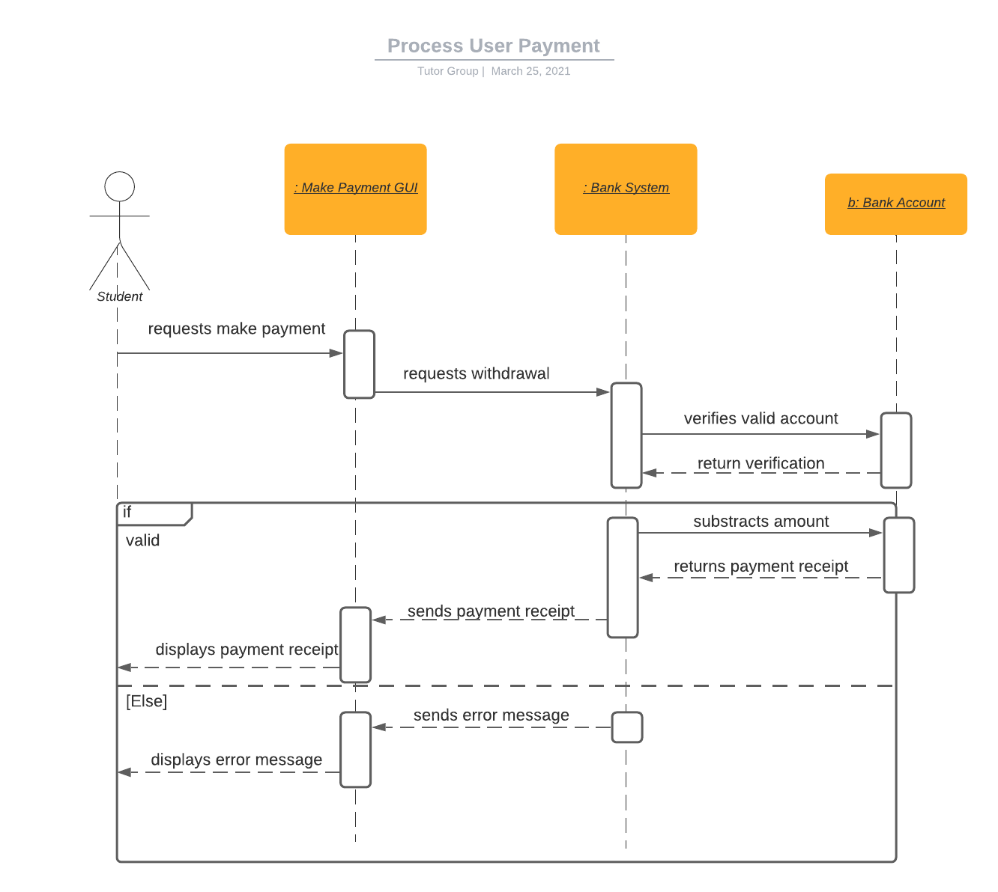

Direct Deposit Set-up

|  |  |  |  |  |
| --- | --- | --- | --- | --- |
|  | Subject | Action/message | Other objects/data | Object acted |
| 1. | User | requests | enrollment | Direct Deposit GUI |
| 2. | Direct Deposit GUI | requests | verification | Bank System |
| 3. | Bank System | verifies | valid account | Bank Account |
| 4. | Bank Account | returns | verification | Bank System |
| 5. | if valid |  |  |  |
| 5.1. | Bank System | creates | success message | s: Success Message |
| 5.2. | Bank System | returns | success message | Direct Deposit GUI |
| 5.3. | Direct Deposit GUI | displays | success message | User |
| 6. | else |  |  |  |
| 6.1. | Bank System | creates | error message | e: Error Message |
| 6.2. | Bank System | returns | error message | Direct Deposit GUI |
| 6.3. | Direct Deposit GUI | displays | error message | User |

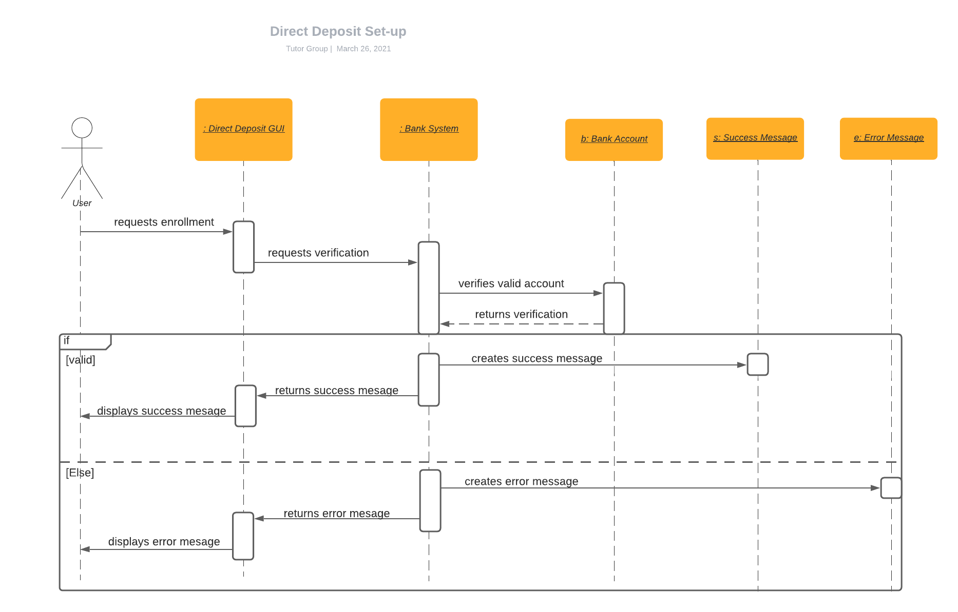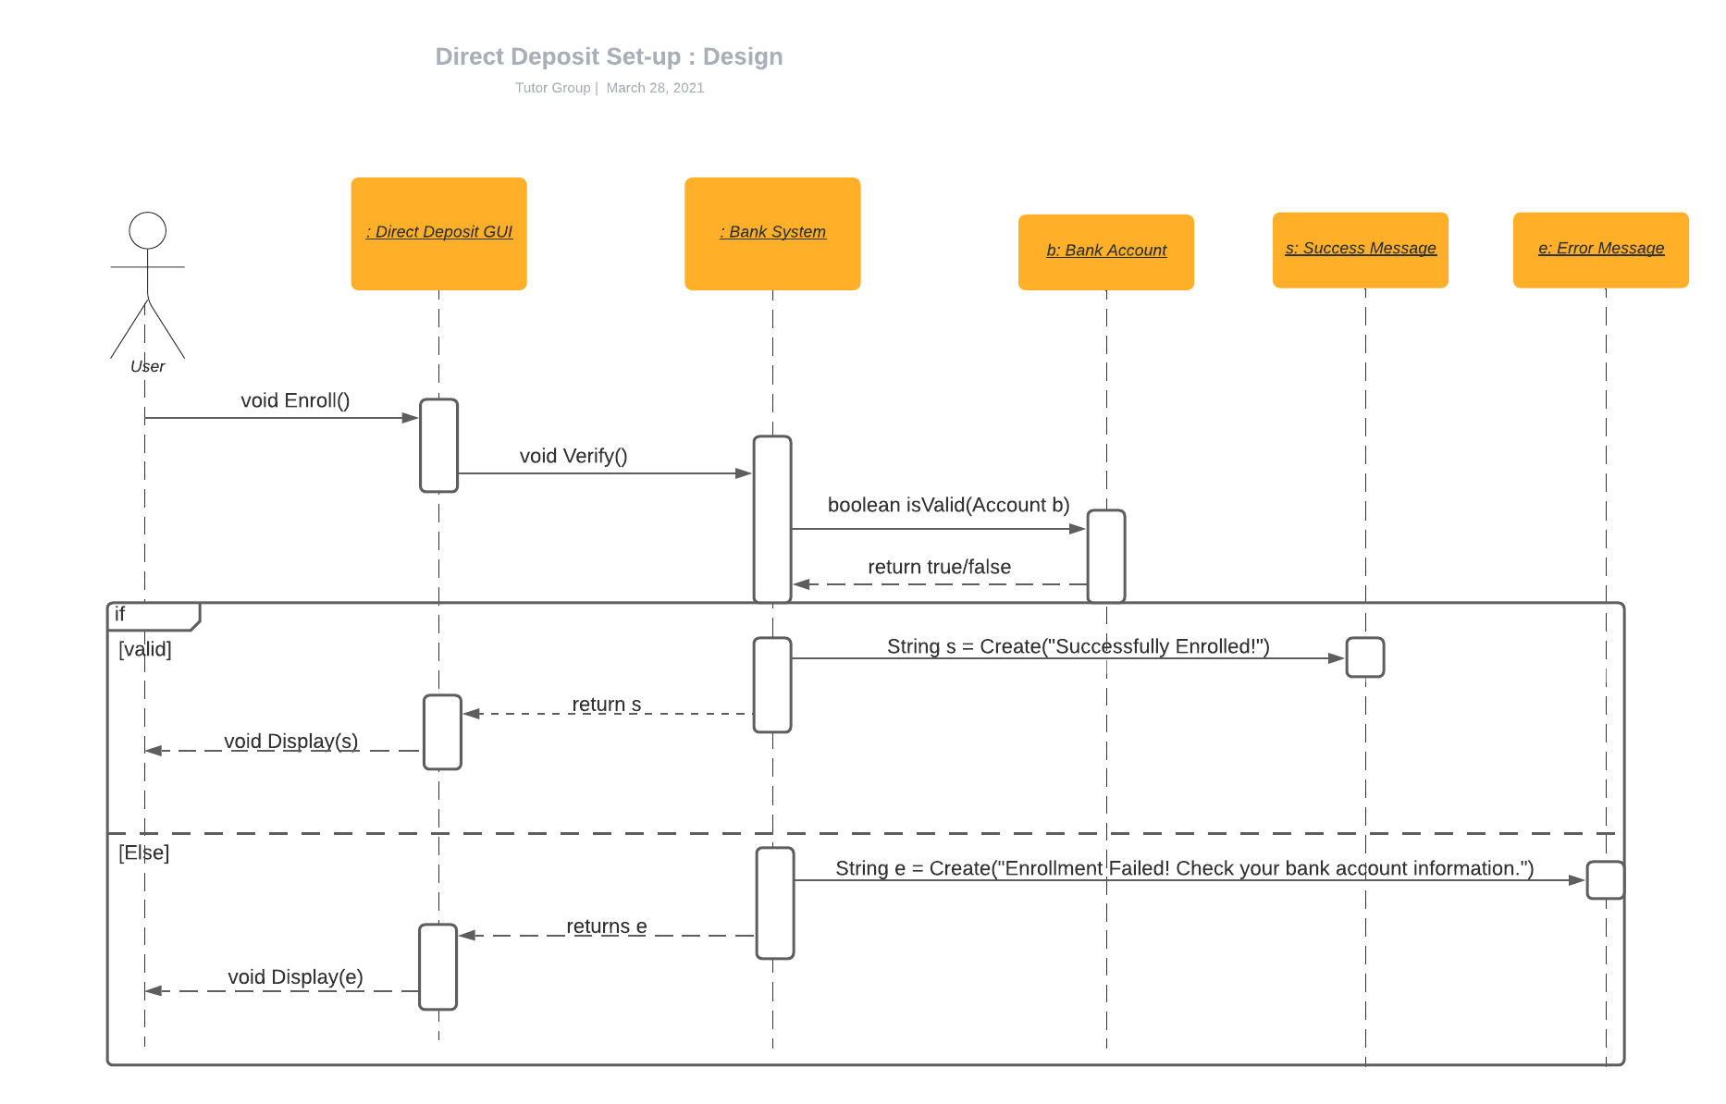

Submit Tutor Application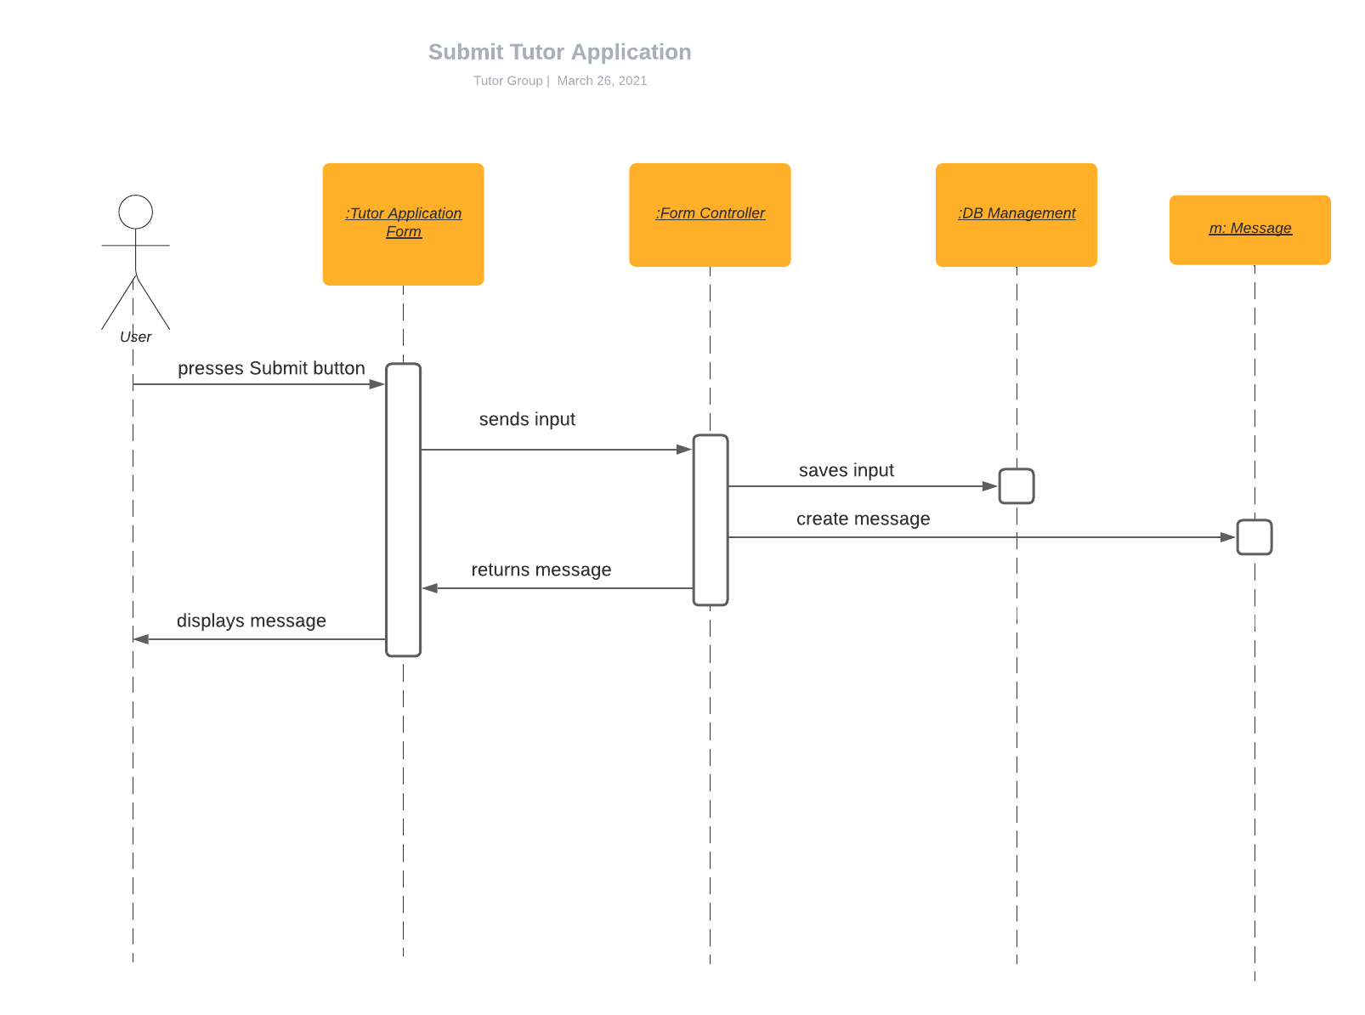

|  |  |  |  |  |
| --- | --- | --- | --- | --- |
|  | Subject | Action/message | Other objects/data | Object acted |
| 1 | User | presses | Submit button | Tutor Application Form |
| 2 | Tutor Application Form | sends | input | Form Controller |
| 3 | Form Controller | saves | Input | DB Management |
| 4 | Form Controller | creates | message | m: Message |
| 5 | Form Controller | returns | message | Tutor Application Form |
| 6 | Tutor Application Form | displays | message | User |

Students with similar tutors/subjects

|  |  |  |  |  |
| --- | --- | --- | --- | --- |
|  | Subject | Action/message | Other objects/data | Object acted |
| 1 | Student | presses | Search button | Community GUI |
| 2 | Community GUI | joins | tutors/subjects data | Search List |
| 3 | Search List | compares | Data | DB Management |
| 4 | DB Management | returns | Usernames with similar data | Search List |
| 5 | Search List | sends | usernames | Profile Controller |
| 6 | Profile Controller | Sends | usernames | Profile Manager |
| 7 | Profile Manager | Returns | User profiles | Profile Controller |
| 8 | Profile Controller | Returns | User profiles | Search list |
| 9 | Search List | Sends | User profiles | Community GUI |
| 10 | Community GUI | Displays | User profiles | Student |

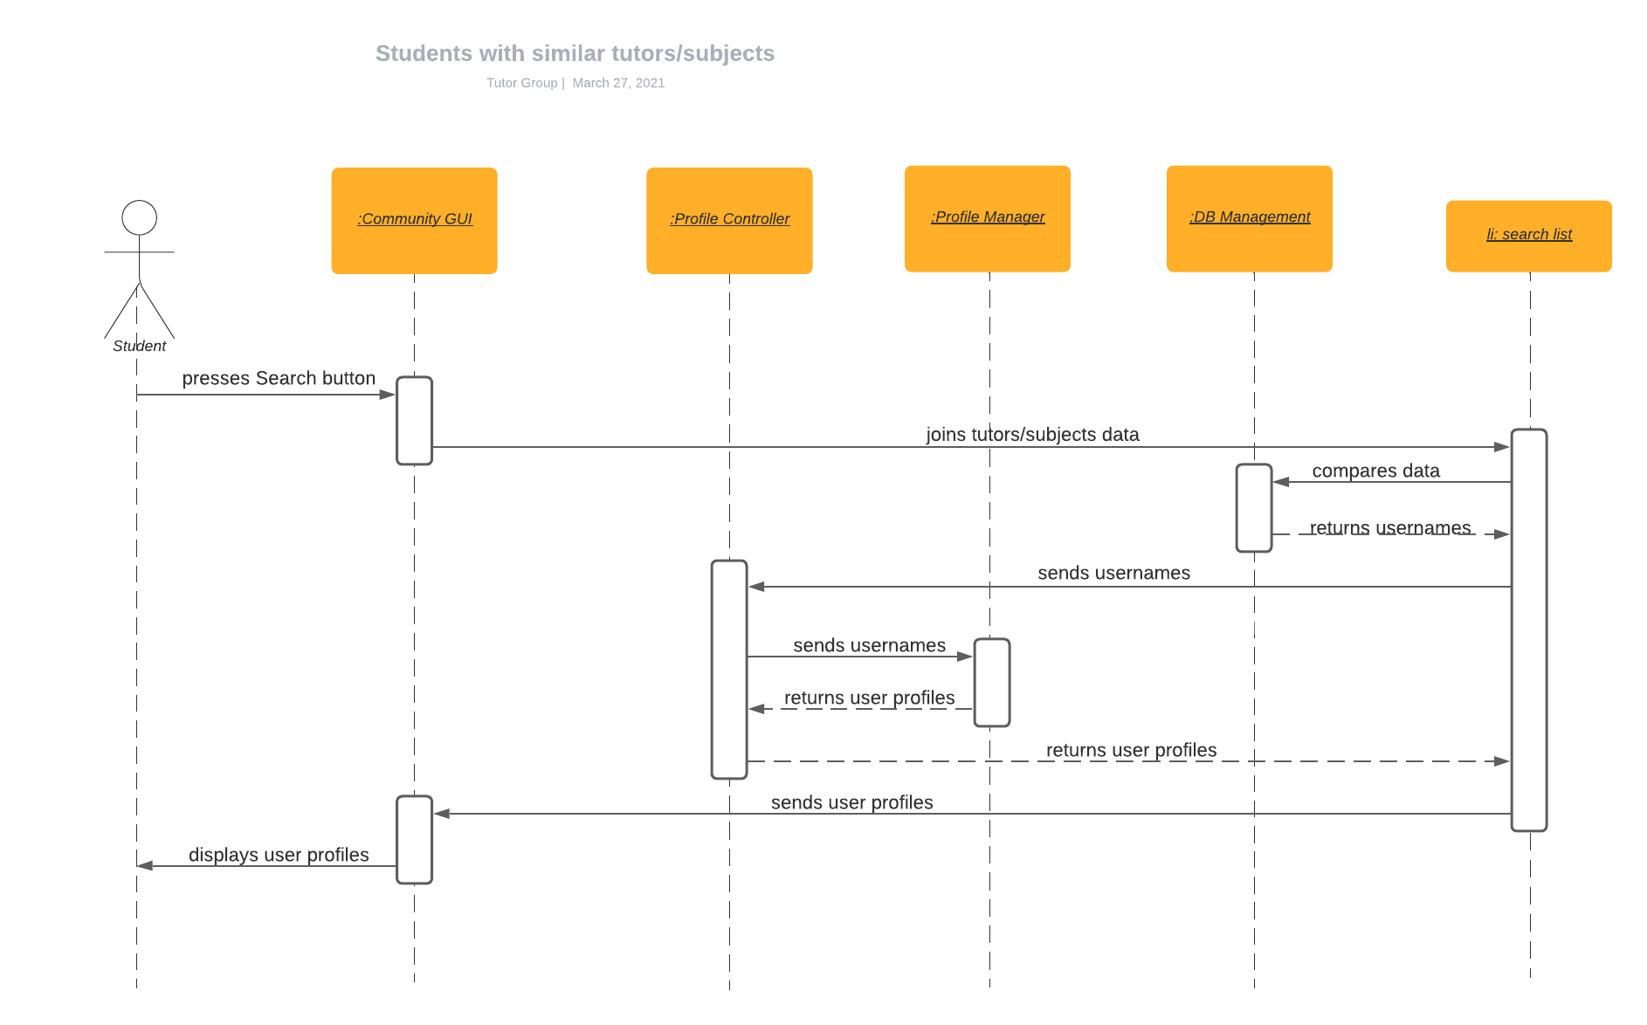

Create User Calendar

|  |  |  |  |  |
| --- | --- | --- | --- | --- |
|  | Subject | Action/message | Other objects/data | Object acted |
| 1 | User | presses | Calendar button | Calendar Portal |
| 2 | Calendar Portal | sends | request | Data base |
| 3 | Data base | Sends | data | Calendar Portal |
| 4 | Calendar Portal | displays | Calendar data | User |
| 5 | User | Edits | Calendar | Calendar Portal |
| 6 | Calendar Portal | sends | request | Data base |
| 7 | Data Base | Saves/sends | Data | Calendar Portal |
| 8 | Calendar Portal | Displays | Calendar | User |

Compare Schedules

|  |  |  |  |  |
| --- | --- | --- | --- | --- |
|  | Subject | Action/message | Other objects/data | Object acted |
| 1 | User | clicks | Compare schedules | Tutor pair portal |
| 2 | Tutor pair Portal | requests | Overlapping times | database |
| 3 | database | returns | Overlapping times | Tutor Pair portal |
| 4 | Tutor pair portal | returns | Overlapping times | User |

Tutor Resources

|  |  |  |  |  |
| --- | --- | --- | --- | --- |
|  | Subject | Action/message | Other objects/data | Object acted |
| 1 | User | presses | Tutor Resource button | Tutor resource portal |
| 2 | Tutor Resource Portal | sends | request | Data base |
| 3 | Data base | Sends | data | Tutor Resource Portal |
| 4 | Tutor Resource portal | displays | Files/data | User |
| 5 | User | Uploads | Files | Tutor Resource Portal |
| 6 | Tutor Resource Portal | sends | Files/data | Data base |
| 7 | Data Base | Saves/sends | Data | Tutor Resource portal |
| 8 | Tutor Resource Portal | Displays | New files/data | User |
| 9alt | User | uploads | files | Tutor Resources Portal |
| 10alt | Tutor Resource Portal | Sends | Files | Data Base |
| 11alt | Data base | Stores/sends | Files | Tutor Resource Portal |
| 12alt | Tutor Resource Portal | Displays | Files | User |

Display Tutor Profile

|  |  |  |  |  |
| --- | --- | --- | --- | --- |
|  | Subject | Action/message | Other objects/data | Object acted |
| 1 | Student User | Submits | Tutor search | Tutor Finder |
| 2 | Tutor Finder | Requests | data | Data base |
| 3 | Data base | returns | data | Tutor Finder |
| 4 | Tutor Finder | displays | Tutors | User |
| 5 | User | clicks | View tutor Profile | Tutor Finder |
| 6 | Tutor Finder | Requests | Profile data | Data base |
| 7 | Data Base | sends | Data | Tutor Finder |
| 8 | Tutor Finder | Displays | Profile data | User |

Display student profile

|  |  |  |  |  |
| --- | --- | --- | --- | --- |
|  | Subject | Action/message | Other objects/data | Object acted |
| 1 | Student User | clicks | View student requests | Tutor Finder |
| 2 | Tutor Finder | Requests | data | Data base |
| 3 | Data base | returns | data | Tutor Finder |
| 4 | Tutor Finder | displays | Student requests | User |
| 5 | User | clicks | View student Profile | Tutor Finder |
| 6 | Tutor Finder | Requests | Profile data | Data base |
| 7 | Data Base | sends | Data | Tutor Finder |
| 8 | Tutor Finder | Displays | Student Profile data | Tutor User |

**Submit Support Request**

|  |  |  |  |  |
| --- | --- | --- | --- | --- |
|  | Subject | Action/message | Other objects/data | Object acted |
| 1 | User | submit | Help request | Support portal |
| 2 | Support portal | sends | Help request | Manager UI |
| 3 | Support portal | sends | Confirmation msg | User |

