**Design Patterns**

Tutor Application

Kleition Bendo, Hannah Yelle, Calvin Mueller, Chase Pisone, Hunter McDaniels-Rossiter

**Table of Contents:**

**UML Classes:**

User

Student Profile

Tutor Profile

DB_Mgr

Tutor Application

Tutor Finder

Calendar

Date

Time

Tutor Pair

Login Form  
 Search

Profile Manager

Bank System

Bank Account

Make Payment

**Models:**

Create User Profile

Search Tutor

Calendar & Compare Schedules

Log In

Students with similar tutors/subjects

Direct Deposit Set up & Process User Payment

**Design Patterns:**

Singleton (DB_Mgr)

**UML Classes**

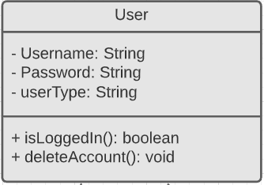

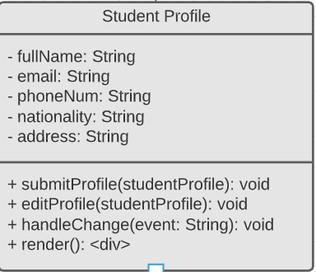

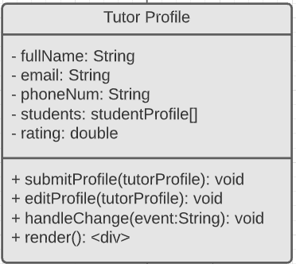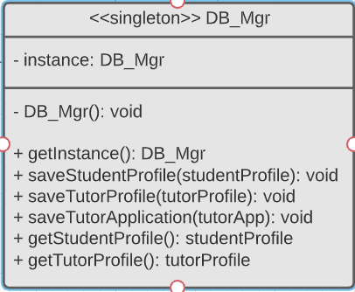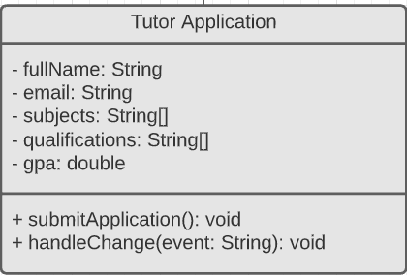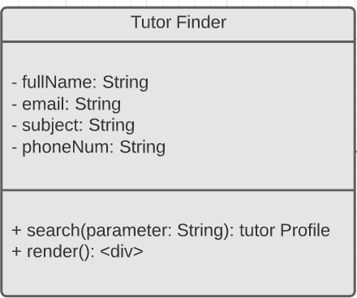

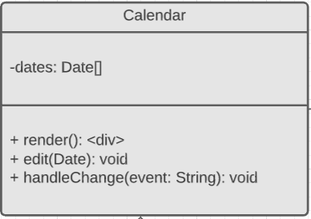

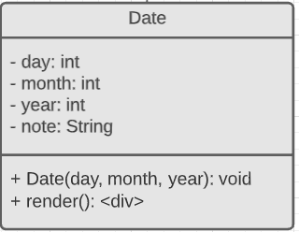

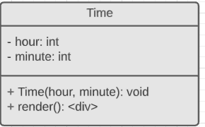

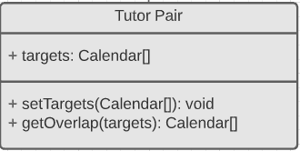

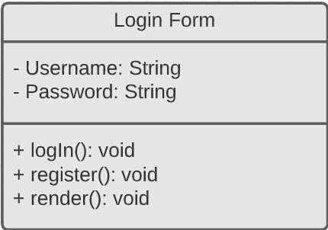

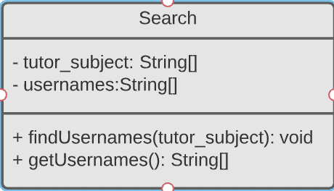

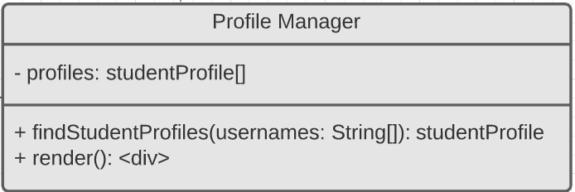

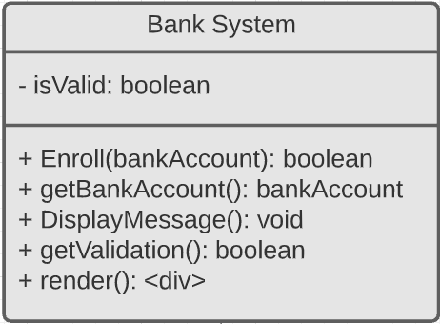

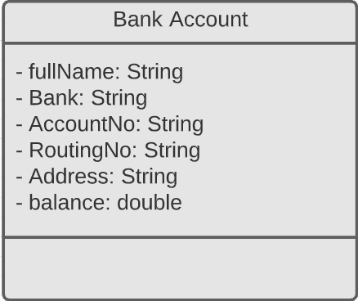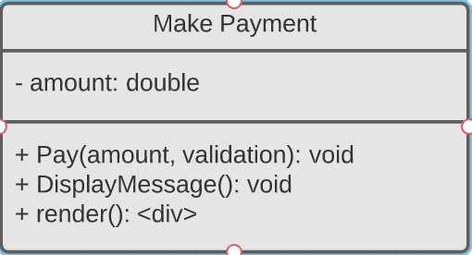

**Models**

Create User Profile

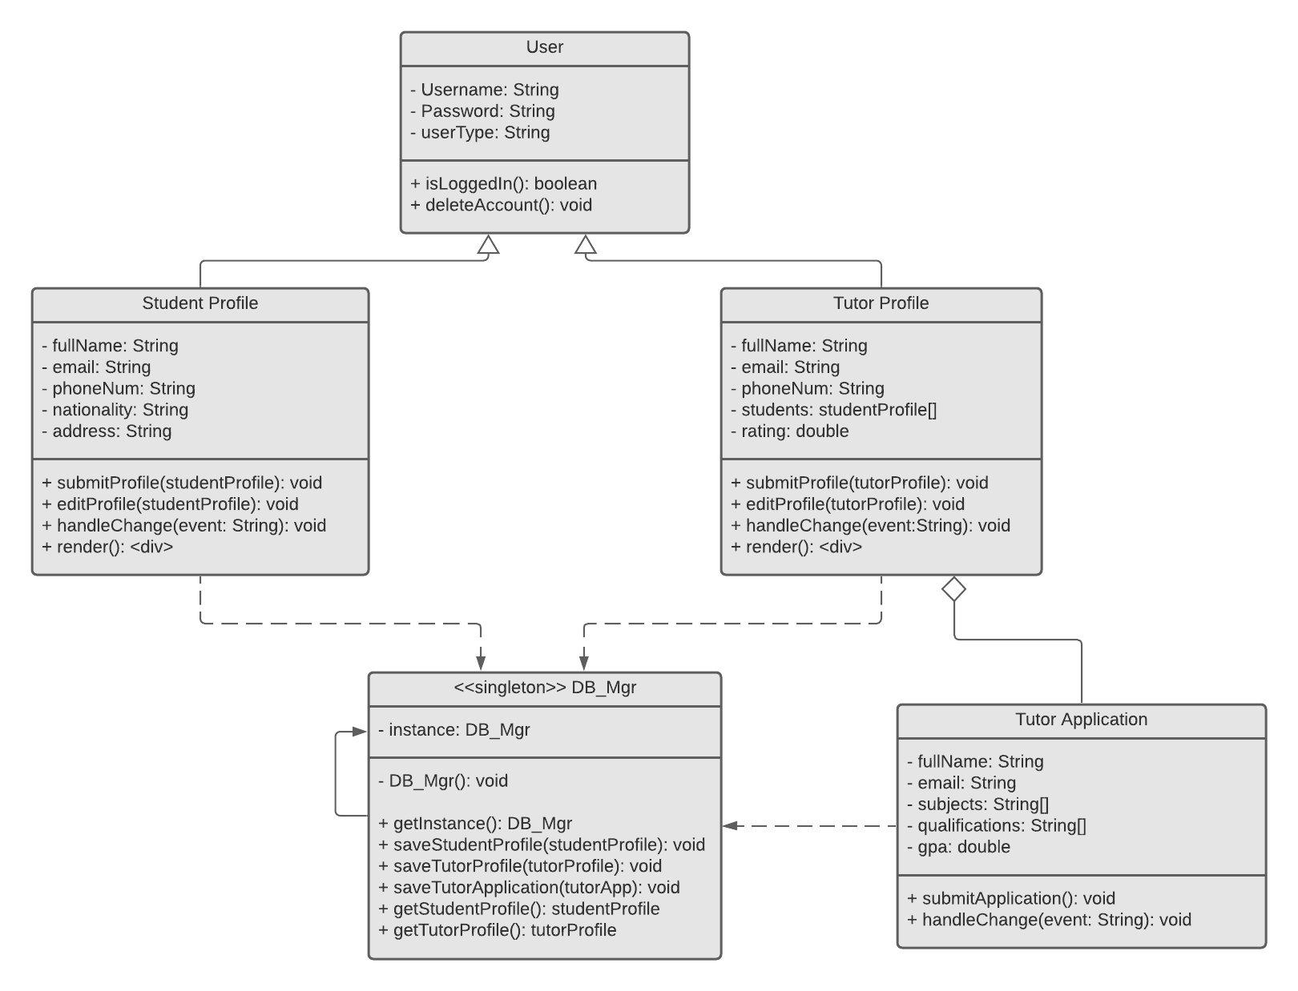

Search Tutor

Calendar & Compare Schedules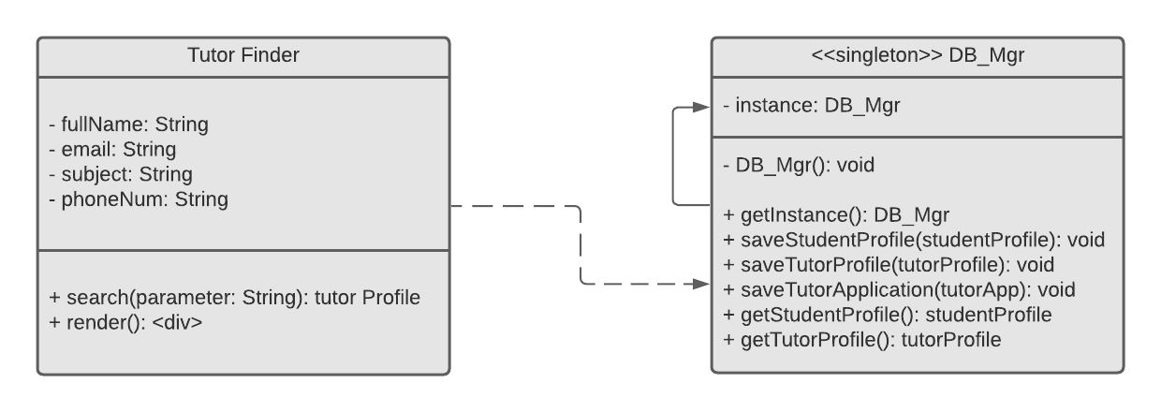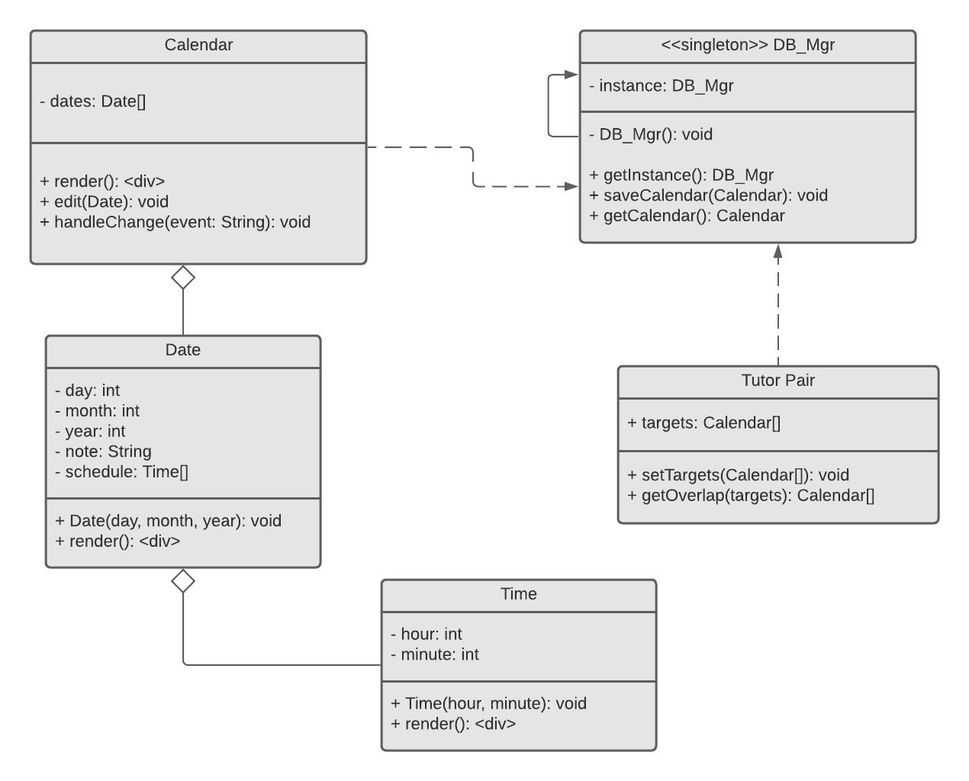

Log In

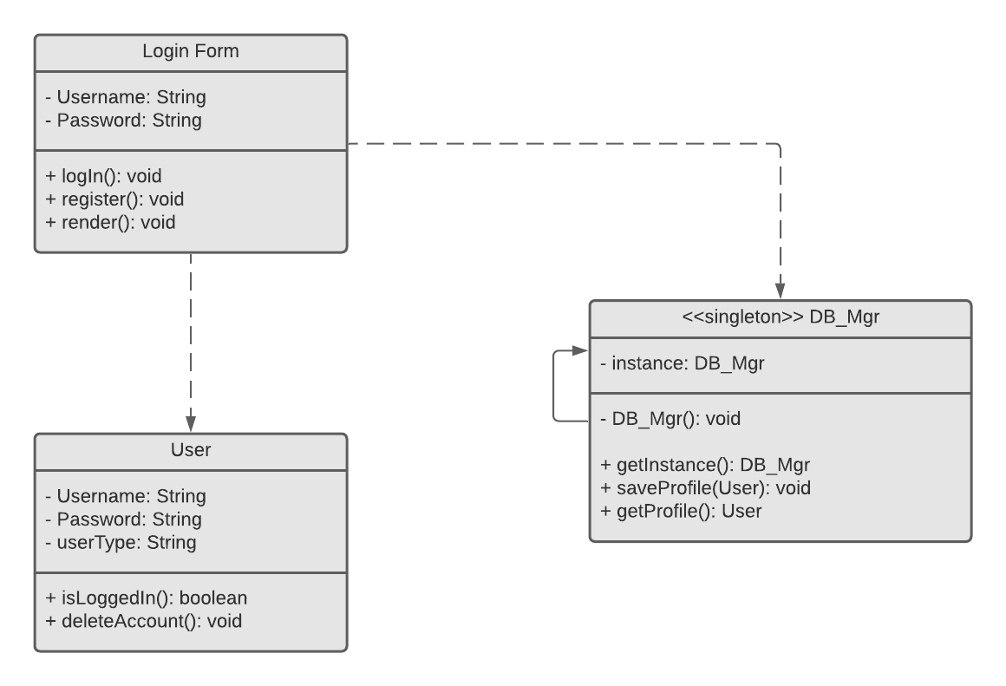

Students with similar tutor/subjects

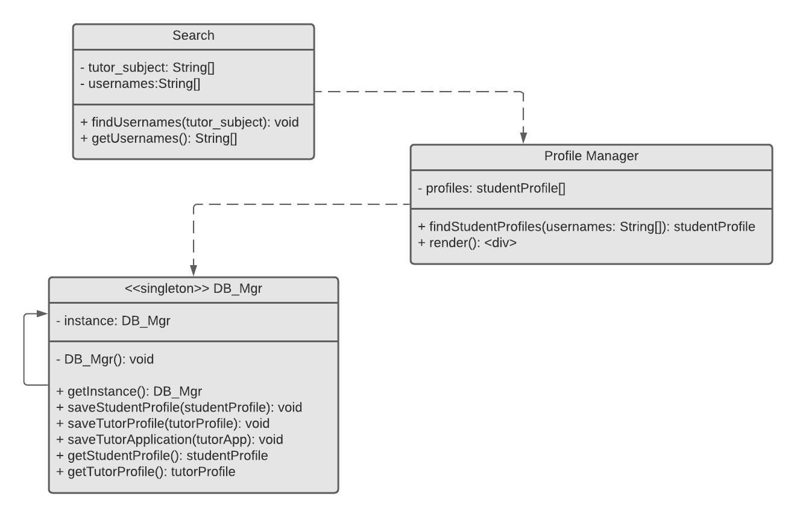

Direct Deposit Set up & Process User Payment

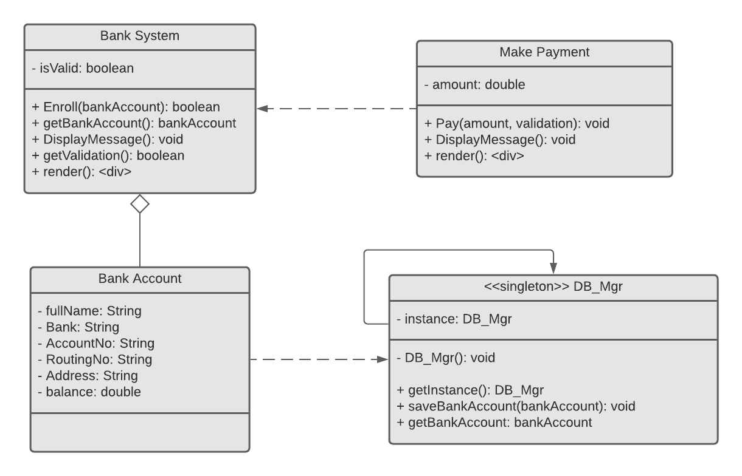

**Design Patterns**

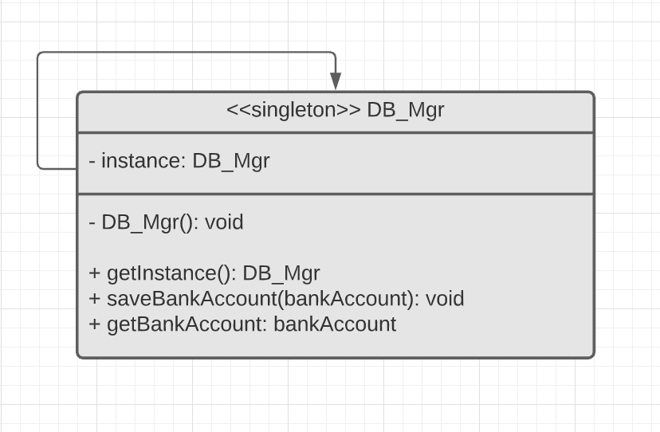

* A singleton design pattern is used when we want to ensure that exactly one object is needed to coordinate actions across the system.