- Display Fibonacci series up to n terms using command line arguments.
class fibonacci{
public static void main(String[] args){
int n = Integer.parseInt(args[0]);
int fib1 = 0;
int fib2 = 1;
for(int i = 1; i<=n; i++){
System.out.println(fib1);
int sum = fib1+fib2;
fib1 = fib2;
fib2 = sum;
}

}
}

Output: PS C:\Users\Administrator\Desktop\javapracticals> java fibonacci 5
0
1
1
2
3

- Demonstrate single inheritance.
class room {
int length, breadth;
{
// instance initializer block
length = 14;
breadth = 12;
}
int area() {
return length * breadth;
}
}

class bedroom extends room {
int height;
{
height = 10;
}
int volume() {
return length * breadth * height;
}
}

public class sinherit {
public static void main(String[] args) {
bedroom rm = new bedroom();
System.out.println("Area= " + rm.area());
System.out.println("Volume= " + rm.volume());
}

}

Output:
Area= 168
Volume= 1680

- Sort n elements using an array.
import java.util.Scanner;
public class sorting
{
public static void main(String[] args)
{
int n, temp;
Scanner s = new Scanner(System.in);
System.out.print("Enter no. of elements you want in array:");
n = s.nextInt();
int a[] = new int[n];
System.out.println("Enter all the elements:");
for (int i = 0; i < n; i++)
{
a[i] = s.nextInt();
}
for (int i = 0; i < n; i++)
{
for (int j = i + 1; j < n; j++)
{
if (a[i] > a[j])
{
temp = a[i];
a[i] = a[j];
a[j] = temp;
}
}
}
System.out.print("Ascending Order:");
for (int i = 0; i < n ; i++)
{
System.out.print(a[i]+"\t" );
}
}
}

Output:
Enter no. of elements you want in array:5
Enter all the elements:
12
54
34
10
Ascending Order:7 10 12 34 54
4. Implement constructor overloading by passing different number of parameters of different types.

class box{
double width,height,depth;
box(double w,double h, double d){
width=w;
height=h;
depth=d;
}
box(int lenght){
width=height=depth=lenght;

}
double volume(){
return width*height*depth;
}
}

class conover {
public static void main(String[] args) {
box ob1=new box(20,30,10);
box ob2=new box(4);
//double vol=ob1.volume();
System.out.println("Volume of box="+ob1.volume());
//vol=ob2.volume();
System.out.println("Volume of cube is="+ob2.volume());

}

}

Output:
Volume of box=6000.0
Volume of cube is=64.0

5. Demonstrate string methods
class stringmethods {
public static void main(String[] args) {
String st1=new String("welcome");
String st2="java";

System.out.println("The String st1 is: "+st1);
System.out.println("The String st2 is: "+st2);

System.out.println("The length of String is: "+st1.length());

System.out.println("Character position is "+st1.indexOf('e'));

System.out.println("The String in uppercase: "+st1.toUpperCase());
System.out.println("The String in lowecase : "+st1.toLowerCase());

System.out.println("st1 is equal to st2: "+st1.equals(st2));

int result=st1.compareTo(st2);
System.out.println("After compare: ");
if(result==0)
{
System.out.println(st1+ "is equal to "+st2);
}
else if(result>0){
System.out.println(st1+"is greater than" +st2);
}
else
{
System.out.println(st1+"is smaller than" +st2);
}

System.out.println("Character at an index of is is"+st1.charAt(3));

String st3=st1.substring(2,5);
System.out.println("Extracted substring is:"+st3);

System.out.println("After replacing l with r in St1 is: " +st1.replace('l','r'));

String st4=" Welcome Java ";
System.out.println("The string st4 is:" +st4.trim());

System.out.println("Concatenated string:"+st1.concat(st2));

}

}

Output:
The String st1 is: welcome
The String st2 is: java
The length of String is: 7
Character position is 1
The String in uppercase: WELCOME
The String in lowecase : welcome
st1 is equal to st2: false
After compare:
welcomeis greater thanjava
Character at an index of is: c
Extracted substring is:lco
After replacing l with r in St1 is: wercome
The string st4 is:Welcome Java
Concatenated string:welcomejava

6. Demonstrate vector methods.
import java.util.Vector;

public class vectortest {
public static void main(String[] args) {
Vector<String> list = new Vector<>();

list.addElement("JAVA");
list.addElement("WEB TECH");
list.addElement("ENGLISH");

System.out.println("The list of elements are: " + list);

int size = list.size();
System.out.println("The size of the list is: " + size);

String listarray[] = new String[size];
list.copyInto(listarray);

System.out.println("The copied list elements are:");
for (int i = 0; i < size; i++) {
System.out.println(listarray[i]);
}

list.insertElementAt("ARABIC", 2);
System.out.println("After inserting: " + list);

list.removeElement("ENGLISH");
System.out.println("After removing 'ENGLISH': " + list);

list.removeElementAt(0);
System.out.println("After removing element at index 0: " + list);

list.removeAllElements();
System.out.println("After removing all elements: " + list);
}
}

Output:
The list of elements are: [JAVA, WEB TECH, ENGLISH]
The size of the list is: 3
The copied list elements are:
JAVA
WEB TECH
ENGLISH
After inserting: [JAVA, WEB TECH, ARABIC, ENGLISH]
After removing 'ENGLISH': [JAVA, WEB TECH, ARABIC]
After removing element at index 0: [WEB TECH, ARABIC]
After removing all elements: []

7. Demonstrate concept of interface.
interface Area
{
final static float pi=3.142f;
float compute(float x, float y);

}
class rectangle implements Area
{
public float compute(float x, float y)
{
return x*y;
}
}

class circle implements Area{
public float compute(float x,float y)
{
return(pi*x*x);
}
}
public class interfacetest {

public static void main(String[] args) {
rectangle rect=new rectangle();
circle cr=new circle();
Area area;
area=rect;
System.out.println("Area of rectangle is="+area.compute(10,20));
area=cr;
System.out.println("Area of Circle=" +area.compute(10,0));
}
}

Output:
Area of rectangle is=200.0
Area of Circle=314.2

8. Demonstrate concept of creating, accessing and using a package.
package mathpack;

public class add {
public int addition(int a, int b){
return a+b;
}
}

Save as add.java
Compile: javac mathpack\add.java
package mathpack;

public class sub {
public int diff(int a,int b){
return a-b;
}

}

Save as sub.java
Complile:javac mathpack\sub.java

import mathpack.*;
public class calculator {
public static void main(String[] args) {
add ob=new add();
sub ob1=new sub();
int sum=ob.addition(10,20);
int difference=ob1.diff(50, 20);
System.out.println("Addition :" +sum);
System.out.println("Difference: "+difference);
}

}
Save: calculator.java
Compile: calculator.java
Run:java calculator

9. Demonstrate multithreaded programming.
class FirstThread extends Thread
{
public void run()
{
for(int i=0; i<4; i++)
{

System.out.println("FirstThread:" +i);
}
System.out.println(" First Thread Finished ");
}
}
class SecondThread extends Thread
{
public void run()
{
for(int i=0; i<4; i++)
{
System.out.println("Secondthread:" +i);

}
System.out.println(" Second Thread Finished ");
}
}
class ThirdThread extends Thread
{
public void run()
{
for(int i=0; i<4; i++)
{
System.out.println("Thirdthread:" +i);

}
System.out.println(" Third Thread Finished ");
}
}
class multithread
{
public static void main(String arg[])
{
FirstThread a1 = new FirstThread();
SecondThread b1 = new SecondThread();
ThirdThread c1 = new ThirdThread();
a1.start();
b1.start();
c1.start();

}
}

Output:
Secondthread:0
Secondthread:1
Thirdthread:0
FirstThread:0
FirstThread:1
Thirdthread:1
Secondthread:2
Thirdthread:2
FirstThread:2
Thirdthread:3
Secondthread:3
Third Thread Finished
FirstThread:3
Second Thread Finished
First Thread Finished

10. Demonstrate thread priority.
class FirstThread extends Thread
{
public void run()
{
for(int i=0; i<4; i++)
{
System.out.println("FirstThread:" +i);

}
System.out.println(" First Thread Finished ");
}
}
class SecondThread extends Thread
{
public void run()
{
for(int i=0; i<4; i++)
{
System.out.println("Secondthread:" +i);

}
System.out.println(" Second Thread Finished ");
}
}
class ThirdThread extends Thread
{
public void run()
{
for(int i=0; i<4; i++)
{
System.out.println("Thirdthread:" +i);

}
System.out.println(" Third Thread Finished ");
}
}
class threadpriority
{
public static void main(String arg[])
{
FirstThread a1 = new FirstThread();
SecondThread b1 = new SecondThread();
ThirdThread c1 = new ThirdThread();
c1.setPriority(Thread.MAX_PRIORITY);
a1.setPriority(Thread.MIN_PRIORITY);
b1.setPriority(Thread.NORM_PRIORITY);
a1.start();
b1.start();
c1.start();

}
}

Output:
Secondthread:0
Secondthread:1
FirstThread:1
Thirdthread:0
First Thread Finished
Secondthread:2
Thirdthread:1
Secondthread:3
Thirdthread:2
Second Thread Finished
Thirdthread:3
Third Thread Finished

11. Create an applet to draw a human face.
import java.applet.*;
import java.awt.*;
/*<applet code=face width=200 height=200></applet> */
public class face extends Applet {
public void paint(Graphics g){
g.drawOval(40,40,120,150);
g.drawOval(57,75,30,20);
g.drawOval(110,75,30,20);
g.fillOval(68,81,10,10);
g.fillOval(121,81,10,10);
g.drawOval(85,100,30,30);
g.drawOval(25,92,15,30);
g.drawOval(160,92,15,30);
g.fillArc(60,125,80,40,180,180);
}

}

Output:
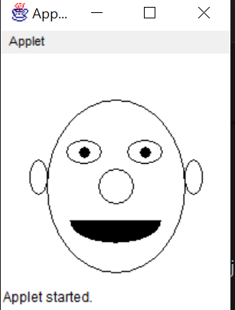

12. Demonstrate simple banner applet.
import java.applet.*;
import java.awt.*;

/* <applet code="simplebanner" width=400 height=80></applet> */

public class simplebanner extends Applet implements Runnable {

String msg = "A Simple Moving Banner";
Thread t = null;
boolean stopFlag;
int x = 0;
int y = 40;

public void init() {
setBackground(Color.magenta);
setForeground(Color.yellow);
}

public void start() {
t = new Thread(this);
stopFlag = false;
t.start();
}

public void run() {
for( ; ; ) {
try {
repaint();
Thread.sleep(50);

x += 5;

if (x > getWidth()) {
x = -msg.length() * 10;
}

if (stopFlag)
break;

} catch(Exception e) {}
}
}

public void stop() {
stopFlag = true;
t = null;
}

public void paint(Graphics g) {
Font f = new Font("Serif", Font.BOLD, 24); // Increased Font Size
g.setFont(f);

g.drawString(msg, x, y);
}
}

Output:
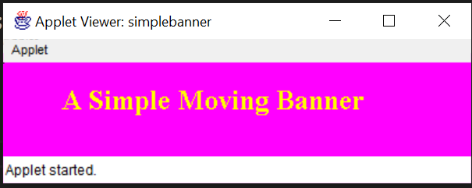

13. Program to count number of strings, integers and float values through command line arguments.

public class argcount {
public static void main(String[] args) {
int stringCount = 0;
int integerCount = 0;
int floatCount = 0;

for (String arg : args) {
try {
// Try to parse as an integer
Integer.parseInt(arg);
integerCount++;

} catch (NumberFormatException e1) {
try {
// If not an integer, try to parse as a float
Float.parseFloat(arg);
floatCount++;
} catch (NumberFormatException e2) {
// If not an integer or a float, it's a string

stringCount++;
}
}
}

System.out.println("Number of Strings: " + stringCount);
System.out.println("Number of Integers: " + integerCount);
System.out.println("Number of Floats: " + floatCount);
}
}

Output:
java argcount Aimca Bhatkal 2005 20.25
Number of Strings: 2
Number of Integers: 1
Number of Floats: 1

14. Program to accept a message from the keyboard and display the no. of words and non-alphabetical characters.
import java.util.Scanner;
public class countstr {
public static void main(String[] args) {
Scanner scanner = new Scanner(System.in);
System.out.println("Enter a message: ");
String message = scanner.nextLine();
count(message);
}
public static void count(String x) {
char[] ch = x.toCharArray();
int letter = 0;
int space = 0;
int num = 0;
int other = 0;

for (int i = 0; i < x.length(); i++) {
if (Character.isLetter(ch[i])) {
letter++;
}
else if (Character.isDigit(ch[i])) {
num++;
}
else if (Character.isSpaceChar(ch[i])) {
space++;
}
else {
other++;
}
}
System.out.println("letter: " + letter);
System.out.println("space: " + space);
System.out.println("number: " + num);
System.out.println("other: " + other);
}
}

Output:
Enter a message:
hello Aimca 2025@
letter: 10
space: 2
number: 4
other: 1

15. Demonstrate creation of list using an applet.
import java.awt.*;
import java.applet.*;
/*<applet code="listitem" width=150 height=150></applet>*/
public class listitem extends Applet {
List myList;

public void init() {
myList = new List(5, true);
myList.add("JAVA");
myList.add("Web Tech");
myList.add("Eng");
myList.add("WCM");
myList.add("C");
myList.add("Algo");
add(myList);
setBackground(Color.lightGray);
}

}

Output:
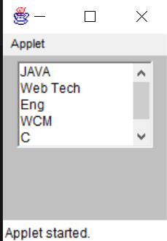

16. Demonstrate concept of event handling.
import java.applet.*;
import java.awt.*;
import java.awt.event.*;

/* <applet code="mouseevent" width=400 height=300></applet> */
public class mouseevent extends Applet implements MouseListener{
String msg;
public void init() {

setBackground(Color.black);
setForeground(Color.yellow);

// Register listeners

addMouseListener(this);
requestFocus();
}
public void mouseClicked(MouseEvent me) {
msg = "Mouse Clicked at";

setBackground(Color.orange);
repaint();
}

public void mousePressed(MouseEvent me) {
msg = "Mouse Pressed";
setBackground(Color.cyan);
repaint();
}

public void mouseReleased(MouseEvent me) {
msg = "Mouse Released";
setBackground(Color.red);
repaint();
}

public void mouseEntered(MouseEvent me) {
msg = "Mouse Entered Applet";
setBackground(Color.darkGray);
repaint();
}

public void mouseExited(MouseEvent me) {
msg = "Mouse Exited Applet";
setBackground(Color.gray);
repaint();
}
public void paint(Graphics g) {
Font f = new Font("Serif", Font.BOLD, 20);
g.setFont(f);
g.drawString(msg, 50, 80);
}
}

Output:
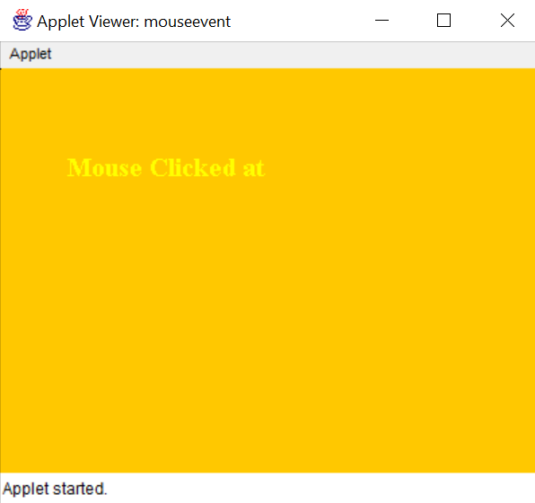

17. Program to demonstrate different types of fonts
import java.applet.*;
import java.awt.*;

/*
<applet code=FontDemo width=500 height=400>
</applet>
*/

public class FontDemo extends Applet {

Font f1, f2, f3, f4;

public void init() {
// Creating different font objects
f1 = new Font("Serif", Font.PLAIN, 20);
f2 = new Font("SansSerif", Font.BOLD, 22);
f3 = new Font("Monospaced", Font.ITALIC, 24);
f4 = new Font("Dialog", Font.BOLD + Font.ITALIC, 26);

}

public void paint(Graphics g) {
g.setColor(Color.black);

g.setFont(f1);
g.drawString("Serif - Plain - Size 20", 20, 80);

g.setFont(f2);
g.drawString("SansSerif - Bold - Size 22", 20, 120);

g.setFont(f3);
g.drawString("Monospaced - Italic - Size 24", 20, 160);

g.setFont(f4);
g.drawString("Dialog - Bold+Italic - Size 26", 20, 200);

g.setColor(Color.blue);
g.setFont(new Font("Courier", Font.BOLD, 30));
g.drawString("Different Font Styles Demo", 20, 260);
}
}

Output:
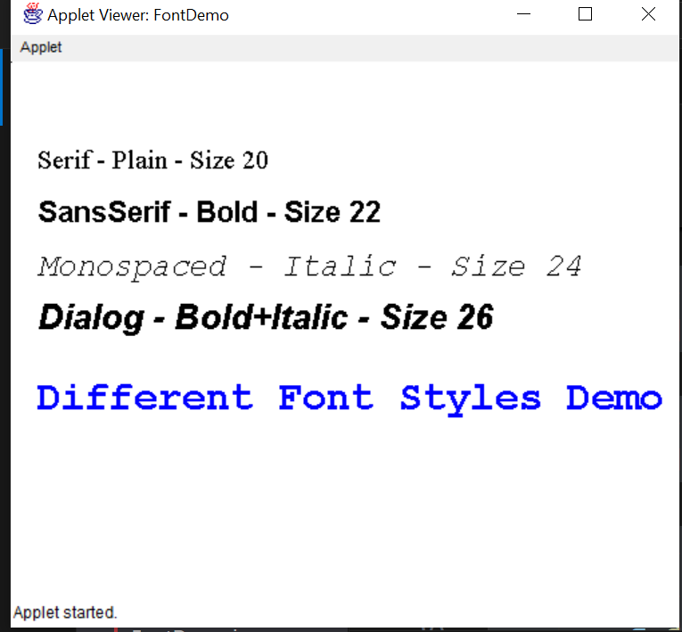

18. Create an applet to tokenize the string.
import java.applet.*;
import java.awt.*;
import java.util.StringTokenizer;

/* <applet code="tokenapplet" width=300 height=300>
</applet> */

public class tokenapplet extends Applet {

String str = "Welcome to Java Applet Tokenizer";
StringTokenizer st;

public void init() {
st = new StringTokenizer(str, " "); // tokenizing using space
setBackground(Color.lightGray);
}

public void paint(Graphics g) {
g.setFont(new Font("Serif", Font.BOLD, 16));
g.setColor(Color.blue);

int y = 50; // starting position

g.drawString("Original String:", 20, 30);
g.drawString(str, 20, 50);

g.drawString("Tokens:", 20, 80);
y = 110;

// Display each token
while (st.hasMoreTokens()) {
g.drawString(st.nextToken(), 40, y);
y += 20; // move text down
}
}
}

Output:
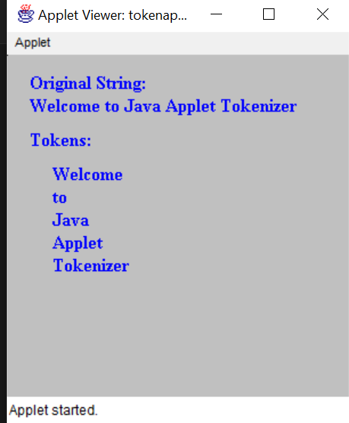

19. Design a simple calculator using java applets
import java.applet.*;
import java.awt.*;
import java.awt.event.*;

/* <applet code=calculator1 width=250 height=250></applet> */
public class calculator1 extends Applet implements ActionListener {

TextField t1;
String op = "";
int num1 = 0, num2 = 0;

Button b[] = new Button[10];
Button add, sub, mul, div, eq, clr;

public void init() {

setLayout(new GridLayout(5, 4));
setBackground(Color.lightGray);

t1 = new TextField(15);
add(t1);

// Create digit buttons 0–9
for (int i = 0; i <= 9; i++) {
b[i] = new Button(String.valueOf(i));
b[i].addActionListener(this);
add(b[i]);
}

add = new Button("+");
sub = new Button("-");
mul = new Button("*");
div = new Button("/");
eq = new Button("=");
clr = new Button("Clear");

add(add);
add(sub);
add(mul);
add(div);
add(eq);
add(clr);

add.addActionListener(this);
sub.addActionListener(this);
mul.addActionListener(this);
div.addActionListener(this);
eq.addActionListener(this);
clr.addActionListener(this);
}

public void actionPerformed(ActionEvent e) {

String s = e.getActionCommand();

// If digit pressed
if (s.charAt(0) >= '0' && s.charAt(0) <= '9') {
t1.setText(t1.getText() + s);
}

// Operator buttons
else if (s.equals("+") || s.equals("-") || s.equals("*") || s.equals("/")) {
num1 = Integer.parseInt(t1.getText());
op = s;
t1.setText("");
}

// Equal button
else if (s.equals("=")) {
num2 = Integer.parseInt(t1.getText());

int result = 0;

if (op.equals("+"))
result = num1 + num2;
else if (op.equals("-"))
result = num1 - num2;
else if (op.equals("*"))
result = num1 * num2;
else if (op.equals("/"))
result = num2 != 0 ? num1 / num2 : 0;

t1.setText(String.valueOf(result));
}

// Clear button
else if (s.equals("Clear")) {
t1.setText("");
num1 = num2 = 0;
op = "";
}
}
}

Output:
