GEMS-RAG: Complete System Architecture and Build Documentation
Structure-aware multimodal RAG over the MUTCD 11th Edition
Repository: github.com/hannanazad/MRAG_stp2
Scope of this document: full system design (what it is and how it works) and full build mechanics (which code built it, how, and where everything lives).

Part I — System Design and Architecture

1. Design Thesis
GEMS-RAG is built over the MUTCD 11th Edition, a roughly 1,100-page federal standards manual mixing normative text, tables, figures, and sign diagrams. The core design bet: a regulatory document is not a flat bag of paragraphs. It has three explicit structures, and the system encodes all three at ingest time and exploits them at retrieval time, rather than relying on semantic similarity alone.
structure | what it is in the MUTCD | how GEMS-RAG uses it
Hierarchy | Part → Chapter → Section | hierarchy prior (w_hierarchy) rewards retrieval candidates clustered in the same section neighborhood
Normative typology | every provision is a Standard (shall), Guidance (should), Option (may), or Support (informational) statement | rule-type weight (w_ruletype) favors provisions whose normative type fits the question; modal verbs extracted per chunk
Cross-reference web | sections citing figures, tables, sign codes, and other sections | knowledge graph edges; graph proximity prior (w_graph) boosts candidates graph-close to query entities

2. High-Level Architecture
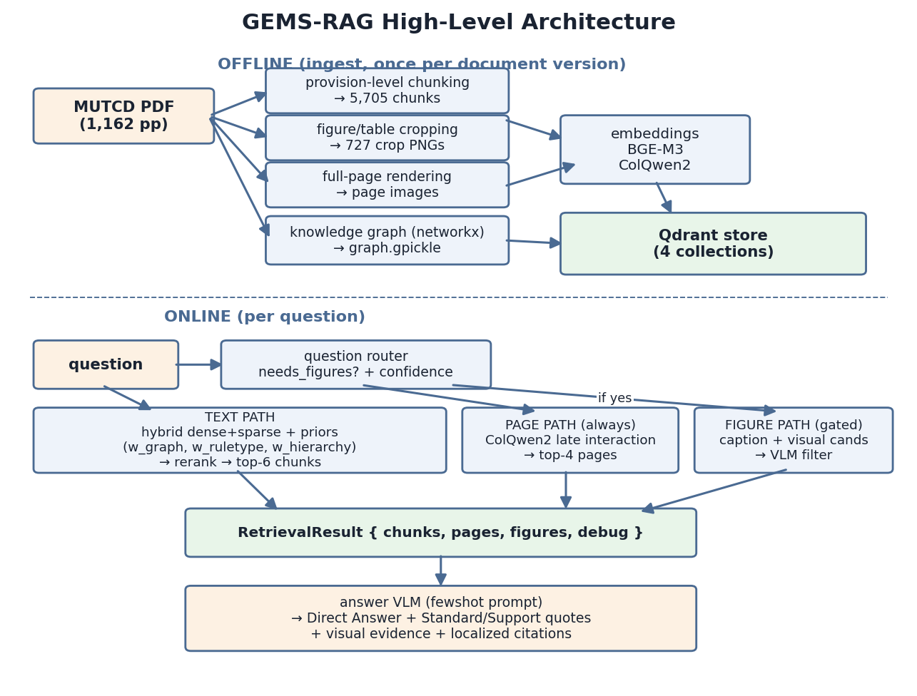

3. Document Processing and Extraction
The source PDF was parsed into provision-level chunks rather than fixed-size windows. Each chunk corresponds to one normative statement block within a section, and carries the structure with it. A real chunk from the store:
field | example value
chunk_id | MUTCD11e_2A15_Standard_05
part | Part 9 Traffic Control For Bicycle Facilities
chapter | Chapter 2A. General
section_id | 2A.15
section_title | Mounting Height
content_type | Standard
ordinal | 5
page_pdf / page_printed | anchors to both PDF page and printed page number
figure_refs / table_refs / section_refs | extracted cross-reference lists
sign_codes | e.g. R1-1 style codes mentioned in the provision
modal_verbs | shall / should / may occurrences
text | the provision text
The modal verbs matter because in the MUTCD the words shall, should, and may are load-bearing: they define the legal force of a provision and map directly onto the Standard/Guidance/Option typology. This extraction was rebuilt once (the v1-to-v2 extraction rebuild, detailed in Part II) and produced 5,705 chunks.
In parallel, the visual layer was extracted twice over:
- Every page rendered to an image (the page-image path used by ColQwen2 late-interaction retrieval).
- Figures and tables detected and cropped individually with their captions and page anchors — around 485 figures covered, 727 crop images total.
So a single visual asset exists both as a crop with metadata and as part of its full-page context.

4. Indexing — Four Doors to the Evidence
Everything lives in a local Qdrant store with four collections:
collection | vector type | source model | contents
mutcd_chunks | dense 1024-d cosine + sparse lexical weights (two vectors per point) | BGE-M3 | 5,705 text chunks — enables hybrid dense+sparse search on one collection
mutcd_figures | dense 1024-d cosine | BGE-M3 | figure/table entries embedded from captions and metadata
mutcd_pages | 128-d multivector, max-sim comparator, binary quantization (always_ram) | ColQwen2 (ColPali-style late interaction) | full-page images
mutcd_figures_visual | 128-d multivector, max-sim comparator | ColQwen2 | figure crop images
The practical effect: a query can find evidence through four different doors — what the text says, what the caption says, what the page looks like, and what the figure itself looks like.

5. The Knowledge Graph
Built from the extraction metadata and persisted as a pickle loaded with networkx.
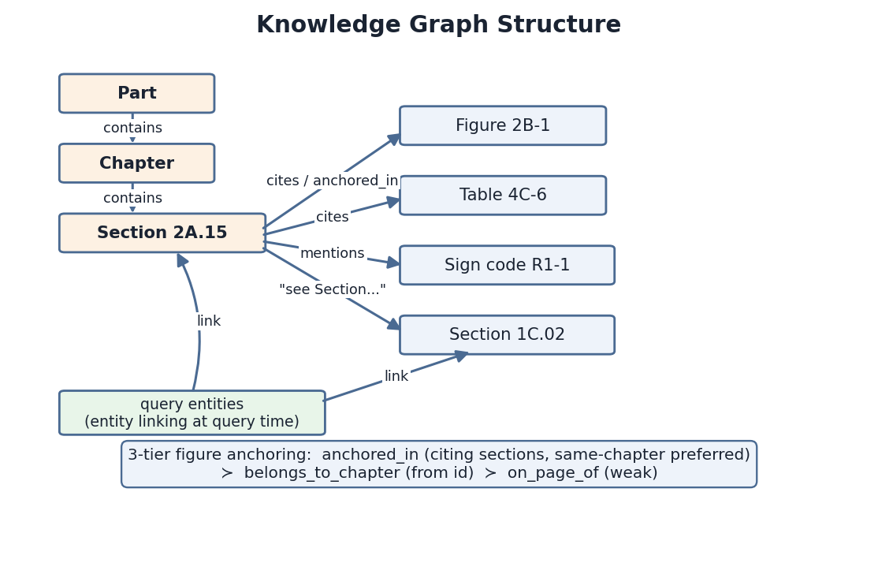
Nodes: sections, figures, tables, sign codes. Edges, two sources: the containment hierarchy (Part → Chapter → Section edges), and the extracted cross-references — a section that says “see Figure 2B-1” or “in accordance with Section 1C.02” gets an edge to that node.
At query time the system runs light entity linking over the question (the retrieval debug logs a query_entities list, so section IDs, sign codes, and figure names in the query get resolved to graph nodes). The graph then serves as a retrieval prior rather than a separate answer path: candidates that are graph-close to the query's entities or to other strong candidates get boosted. The proximity enters the fused score through a dedicated weight, w_graph.
Honesty note (recorded code audit, LE22): the “graph expansion” step in retrieval.py is a stub — the KG re-scores dense candidates via w_graph but does not add new candidates to the pool. Any paper claim must say re-ranking, not retrieval expansion.

6. The Query-Time Pipeline
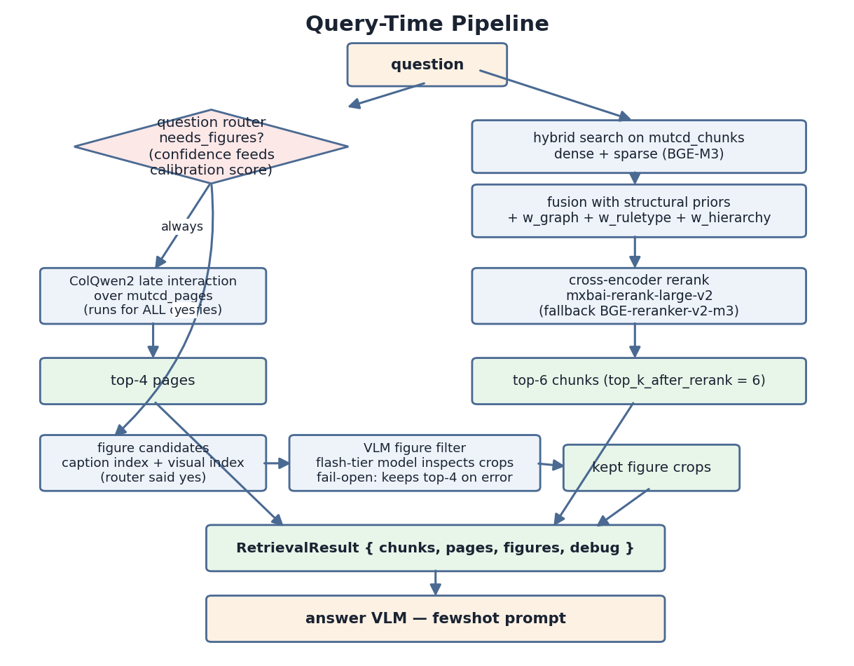
Stage detail, in order:
- Question router. A lightweight classifier decides whether visual evidence is needed at all, emitting a decision, a confidence, and a figure budget. The debug shows entries like needs_figures: False, confidence: 0.9, max_figures: 0. That confidence is also what feeds the calibration term in the reliability score, which is why disabling the router makes the full composite undefined.
- Text retrieval runs hybrid dense-plus-sparse search over the chunks and fuses the results with three structural priors added to the similarity signal: graph proximity (w_graph), a rule-type weight (w_ruletype) that favors provisions whose normative type fits the question, and a hierarchy prior (w_hierarchy) that rewards candidates clustered in the same section neighborhood.
- Rerank. The fused top-K candidates go through a cross-encoder reranker, mxbai-rerank-large-v2 (with a BGE-reranker fallback), which rescores query-document pairs and keeps the top 6 chunks (CFG.top_k_after_rerank = 6).
- Page retrieval runs alongside: ColQwen2 late-interaction search over page images returns the top 4 pages regardless of routing (logs show pages retrieved even for textual questions).
- Figure retrieval, only if the router asked for figures: candidate crops are gathered through both the caption index and the visual index, then pass through the VLM figure filter — a cheap flash-tier vision model looks at each candidate crop against the question and discards irrelevant ones, with a fail-open fallback that keeps the top 4 unfiltered if the filter errors.
- Packaging. Everything is packaged into a RetrievalResult with exactly four fields: chunks, pages, figures, debug.

7. Answer Generation
The answer model is a vision-language model chosen from a multi-provider harness — Anthropic, Google, and Alibaba backends across three capability tiers, twelve configurations total — receiving the question, the six reranked chunks, the four page images, and the filtered figure crops, under a few-shot prompt. The prompt enforces the output discipline seen in every run:
- a Direct Answer,
- verbatim Standard and Support quotations separated by normative status,
- an explicit visual-evidence statement,
- citations localized to section, provision, and page.
Claude Fable 5 in this harness was the configuration selected for in-depth analysis after winning the twelve-model comparison.

8. What the Ablations Proved About This Design
The leave-one-out study validated the design asymmetrically:
component removed | finding
A6 — reranker | The single most load-bearing component. The only change with a confidence interval entirely below zero; hurts both retrieval and answers.
A2 — VLM figure filter | A precision device. Trades ~12 seconds of latency for roughly a threefold improvement in visual-crop precision.
A3 — graph prior, A4 — rule-type prior | Effects near the noise floor on end scores at N=150.
A5 — hierarchy prior | Specifically protected strict completeness (full-credit rate) while barely moving mean correctness.
A1 — question router | Earned its keep through efficiency and calibration rather than correctness (correctness slightly improved without it, because always-visual routing adds context).

9. Known Caveats
- The known weak spot is context precision, sitting below 50 percent, because sparse retrieval is degraded (the open fix is swapping the sparse leg or the embedder).
- The fine-grained internals not restated here — the exact fusion arithmetic and KG edge weights — are authoritative only in mrag/retrieval.py, mrag/vector_store.py, and the KG-construction code, not in this summary.

Part II — Build Mechanics and Code Map

10. Where the Code Lives
Everything is in the repo, github.com/hannanazad/MRAG_stp2, split between the mrag/ package (the system) and scripts/ (the ingest orchestrators), driven by MUTCD_MRAG_HPRC.ipynb in Colab.
MRAG_stp2/
├── mrag/ the system package
│ ├── figure_core.py caption grammar + region geometry (NEW in v4)
│ ├── figures.py extraction engine, dual backend (v1 archived)
│ ├── parsing.py provision-level chunking
│ ├── kg.py knowledge graph v2 (v1 archived)
│ ├── embeddings.py BGE-M3, ColQwen2, mxbai reranker
│ ├── vector_store.py Qdrant wrapper, 4 collections, hybrid search
│ ├── question_router.py deterministic router (NEW in v4)
│ ├── retrieval.py Retriever: fusion, priors, rerank, pages
│ ├── vlm.py ALL prompts (P1 answer, P2 filter) + providers
│ ├── ask.py Pipeline, init_pipeline(), ask()
│ ├── config.py CFG: every toggle the ablations flipped
│ ├── figures_v1_deprecated.py archived broken v1 extractor
│ └── kg_v1_deprecated.py archived v1 graph builder
├── scripts/
│ ├── ingest_v4.py current ingest orchestrator (NEW in v4)
│ └── ingest_v3.py predecessor orchestrator
├── ablations/ ablation study harness (separate docs)
├── docs/REBUILD_V4.md v4 rebuild documentation
├── validation/ census_records.jsonl + coverage_report.json
└── MUTCD_MRAG_HPRC.ipynb main Colab driver notebook

11. Code Responsibility Map
file | responsibility
scripts/ingest_v4.py | The ingest orchestrator. Runs the full chain: figure/table extraction → rescue pass → coverage gate (--min-coverage 0.99, exits non-zero on failure so a silent gap is impossible) → chunk re-parse → KG build → embedding + Qdrant upsert. Archives old caches as *.bak. Its predecessor scripts/ingest_v3.py did the earlier version.
mrag/figure_core.py | The caption grammar and region geometry, backend-agnostic. This is where the cropping logic lives: the crop-below rule, column-aware bounds, TOC guard, dash normalization, sheet parsing, and the mention census used for validation.
mrag/figures.py | The extraction engine that applies that geometry through two PDF backends: PyMuPDF (fitz) for production crops, poppler as an independent validation backend. Contains rescue_missing() and validate_coverage(). The broken v1 is archived as figures_v1_deprecated.py.
mrag/parsing.py | Provision-level chunking of the text: splits sections into Standard/Guidance/Option/Support blocks and extracts figure_refs, table_refs, section_refs, sign_codes, modal_verbs per chunk, with the same dash normalization.
mrag/kg.py | Builds the knowledge graph (v2; v1 archived as kg_v1_deprecated.py). One node per canonical figure/table id with an image_paths tuple for multi-sheet figures, and three-tier anchoring: anchored_in edges to citing sections (same-chapter preferred), falling back to belongs_to_chapter derived from the id, falling back to a weak on_page_of edge. Exposes section_cites_figures() which the router uses.
mrag/embeddings.py | Loads the models: BGE-M3 (dense 1024-d + sparse), ColQwen2 (128-d multivectors), and the mxbai reranker with its BGE cross-encoder fallback.
mrag/vector_store.py | The Qdrant wrapper: creates and searches the four collections, including search_chunks_hybrid.
mrag/question_router.py | The deterministic router (rules detailed in section 14).
mrag/retrieval.py | The Retriever: hybrid fusion with the w_graph/w_ruletype/w_hierarchy priors, rerank to top-6, page retrieval for every query, figure paths gated on the router's decision.
mrag/vlm.py | All prompts live here and only here: P1 the answer prompt (zeroshot/oneshot/fewshot/cot styles) and P2 the figure filter, plus the multi-provider API clients.
mrag/ask.py, mrag/config.py | init_pipeline(), ask(), and the CFG object with every toggle the ablations flipped.

12. Ingest Orchestration Flow
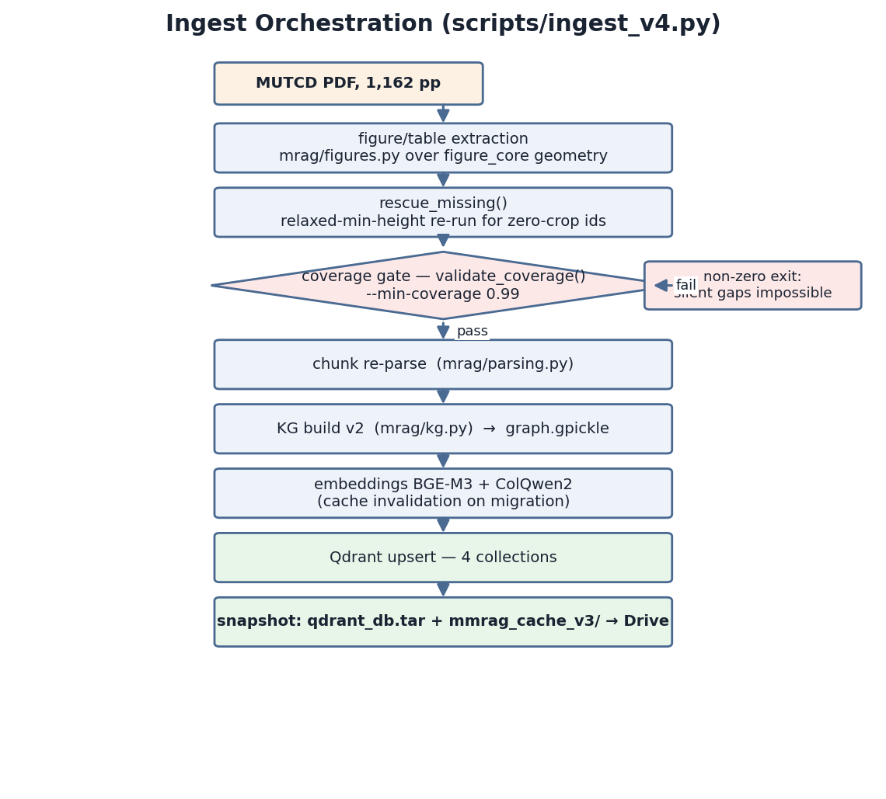

13. How Figures Were Actually Cropped (Deep Dive)
This was the hardest engineering problem in the project and it went through a full rewrite. The method: caption-anchored geometric cropping, no ML layout detection.
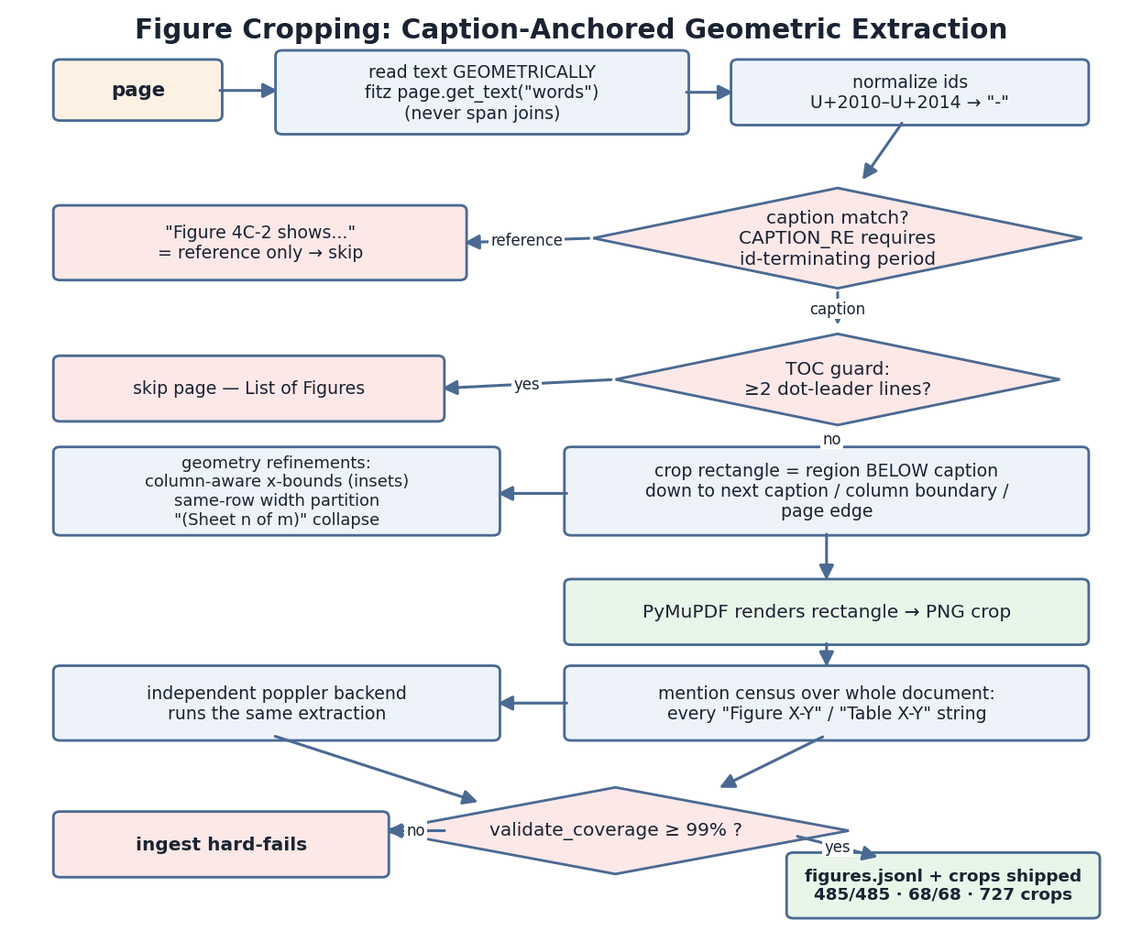
The v1 failure story. The original v1 code assumed captions sit below their figures and cropped above each caption. The MUTCD puts every caption above its content, so v1: silently dropped figures whose captions sat at the top of a page (the missing-11 problem), and produced crops of the previous figure for mid-page captions (the wrong-crop problem). The v4 rewrite inverted the rule and then handled the long tail of real-page pathologies:
pathology | example | fix
inset two-column figures | caption mid-line in the text layer (Fig 2C-4) | column-aware x-bounds
side-by-side captions on one row | Tables 4C-6 / 4C-7 were zeroing each other's regions | width partitioning of the shared row
table-of-contents pages matching the caption pattern | List of Figures pages | page-level guard: skip pages with ≥2 dot-leader lines
multi-sheet figures | “(Sheet n of m)” markers at the end of titles | collapse into one canonical id holding a tuple of image paths
tiny tables under the minimum crop height | Table 2A-3 (~37 pt) | relaxed-minimum-height rescue pass for zero-crop ids
non-breaking hyphens in Rev-1 ids | “Table 6B‑2” with U+2011, invisible to ASCII regex | normalize U+2010–U+2014 → “-” at every id-matching point (captions, mentions, chunk refs, query parsing)
external references that look like tables | “Table 3-1 / 3-3” are AASHTO citations, not MUTCD tables | auto-excluded from the coverage census
body sentences mimicking captions | “Table 2C-1 may be used.” at line start | CAPTION_RE requires the id-terminating period — true captions are always “Figure X-Y. Title”
The safety net that made it trustworthy:
- a mention census scans the entire document for every “Figure X-Y” and “Table X-Y” string,
- the same extraction runs through the independent poppler backend, and
- validate_coverage() hard-fails the ingest below 99 percent coverage.
That gate actually caught a real bug in production: fitz's span-joined text had encoding artifacts (“Figure4F-1.” with the space glyph missing, “4F- 1” with the id split across glyph runs) that made five 4F figures invisible — which is why extraction was rebuilt on geometric word segmentation (page.get_text(“words”)), mirroring the validated poppler path, plus canonicalize_ids() to repair fused/split ids.
Final validated state:
metric | value
figure coverage | 485 / 485 = 100.0%
table coverage | 68 / 68 = 100.0%
crop images | 727 (after junk purge from 743)
canonical ids | 553
duplicates | 0
previously-missing 11 figures | all confirmed extracted
external AASHTO refs (Table 3-1 / 3-3) | auto-excluded

14. The Router's Actual Rules
mrag/question_router.py is fully deterministic, every fired rule logged into debug:
stage | rule | effect
1. hard-yes | explicit figure/table ids or visual verbs in the question | needs_figures = True immediately
2. hard-no | definitional patterns with no visual evidence terms | needs_figures = False immediately
3. soft score | sign codes | +0.45
 | visual nouns | +0.30
 | placement terms | +0.15
 | textual markers | −0.35
 | KG prior: fraction of matched sections that cite figures | +0.35 × frac
decision | score vs threshold | 0.5
optional | VLM tie-break | off by default

15. Where the Outputs Land
location | contents
mmrag_cache_v3/ (Drive) | chunks.jsonl (the 5,705 parsed chunks), figures.jsonl (crop metadata and bounding boxes), graph.gpickle (the KG), sign_codes.json, embedding caches: chunks_dense.npy, chunks_sparse.json, figures_dense.npy, per-figure ColQwen2 vectors under colqwen_figures/<id>.npy
figures/ (Drive) | crop PNGs
page_images/ (Drive) | full-page renders
qdrant_db.tar (Drive) | snapshot of the populated vector store — extracted into /content/qdrant_db each Colab session
validation/ (repo) | census_records.jsonl (all 727 bounding boxes), coverage_report.json
docs/REBUILD_V4.md (repo) | the v4 rebuild documentation
Snapshot rule (recorded lesson): a working restore needs both the Qdrant tar and the mmrag_cache_v3/ folder — one without the other fails with FileNotFoundError or “Collection not found”.
Cache-invalidation rule (recorded lesson): per-figure embedding caches are keyed by id (colqwen_figures/<id>.npy) and go stale silently when the underlying crop images change with ids unchanged — any figure re-extraction must delete the visual cache directory, and a chunk re-parse must also invalidate chunks_dense.npy / chunks_sparse.json.

16. Paper-Facing Honesty Notes
- Graph re-scores, does not expand (LE22): the retrieval step-3 “graph expansion” is a stub — w_graph re-scores dense candidates only. Phrase graph claims as re-ranking, never retrieval expansion.
- Prompts have exactly one source of truth: mrag/vlm.py. P1 = answer prompt (CFG.prompt_style_answer), P2 = figure filter (CFG.prompt_style_filter, zeroshot only).
- Context precision sits below 50% because the sparse retrieval leg is degraded — the recorded open fix paths are pinning FlagEmbedding, patching the dtype kwarg, or swapping the embedder.
- Must-keep implementation details for the paper: the caption-anchored crop-below method with the 485/485 census validation, and the LE22 caveat above.

