MUTCD-150 Claude Fable 5 Ablation Study
Original RAG baseline and six component-removal conditions

Study Design
The study used the attached original Claude Fable 5 RAG as the baseline and held the model, few-shot prompt, 150-question benchmark, and scoring rubric fixed. The six runs removed the question router, VLM figure filter, graph-proximity term, rule-type term, hierarchy prior, or reranker. All 900 updated responses passed runtime validation.
The updated A2-A6 answers matched the prior audited answers byte for byte. A1 retained 132 prior answers and repaired T001-T018. GPT-5.6 applied the locked answer rubric to those 18 records. Scripts calculated the retrieval, visual, latency, calibration, and composite metrics.

Overall Results
Table 1. Original RAG baseline and ablation results.
Condition | Retrieval /25 | Generation /60 | Reliability /12 | Full score /100 | Δ full score | Common score /100 | Correctness | Completeness | Citation | Full credit | Median latency (s)
Original RAG baseline | 19.35 | 55.18 | 10.90 | 88.08 | 0.00 | 88.27 | 92.0% | 90.2% | 94.5% | 80.0% | 28.41
No question router | 18.85 | 55.74 | N/A | N/A | N/A | 88.34 | 93.4% | 92.0% | 95.2% | 76.0% | 29.89
No VLM figure filter | 19.59 | 55.12 | 10.70 | 88.06 | -0.01 | 88.48 | 91.9% | 90.1% | 94.4% | 74.7% | 16.64
No graph-proximity term | 19.59 | 55.21 | 10.68 | 88.13 | 0.05 | 88.57 | 92.1% | 90.4% | 94.5% | 76.0% | 24.40
No rule-type term | 19.65 | 55.35 | 10.60 | 88.24 | 0.16 | 88.78 | 92.3% | 90.5% | 95.0% | 74.7% | 23.54
No hierarchy prior | 19.59 | 55.10 | 10.54 | 87.86 | -0.21 | 88.45 | 91.9% | 90.1% | 94.4% | 72.7% | 23.15
No reranker | 17.78 | 52.77 | 10.38 | 83.43 | -4.65 | 83.90 | 86.0% | 84.6% | 88.4% | 68.7% | 22.96

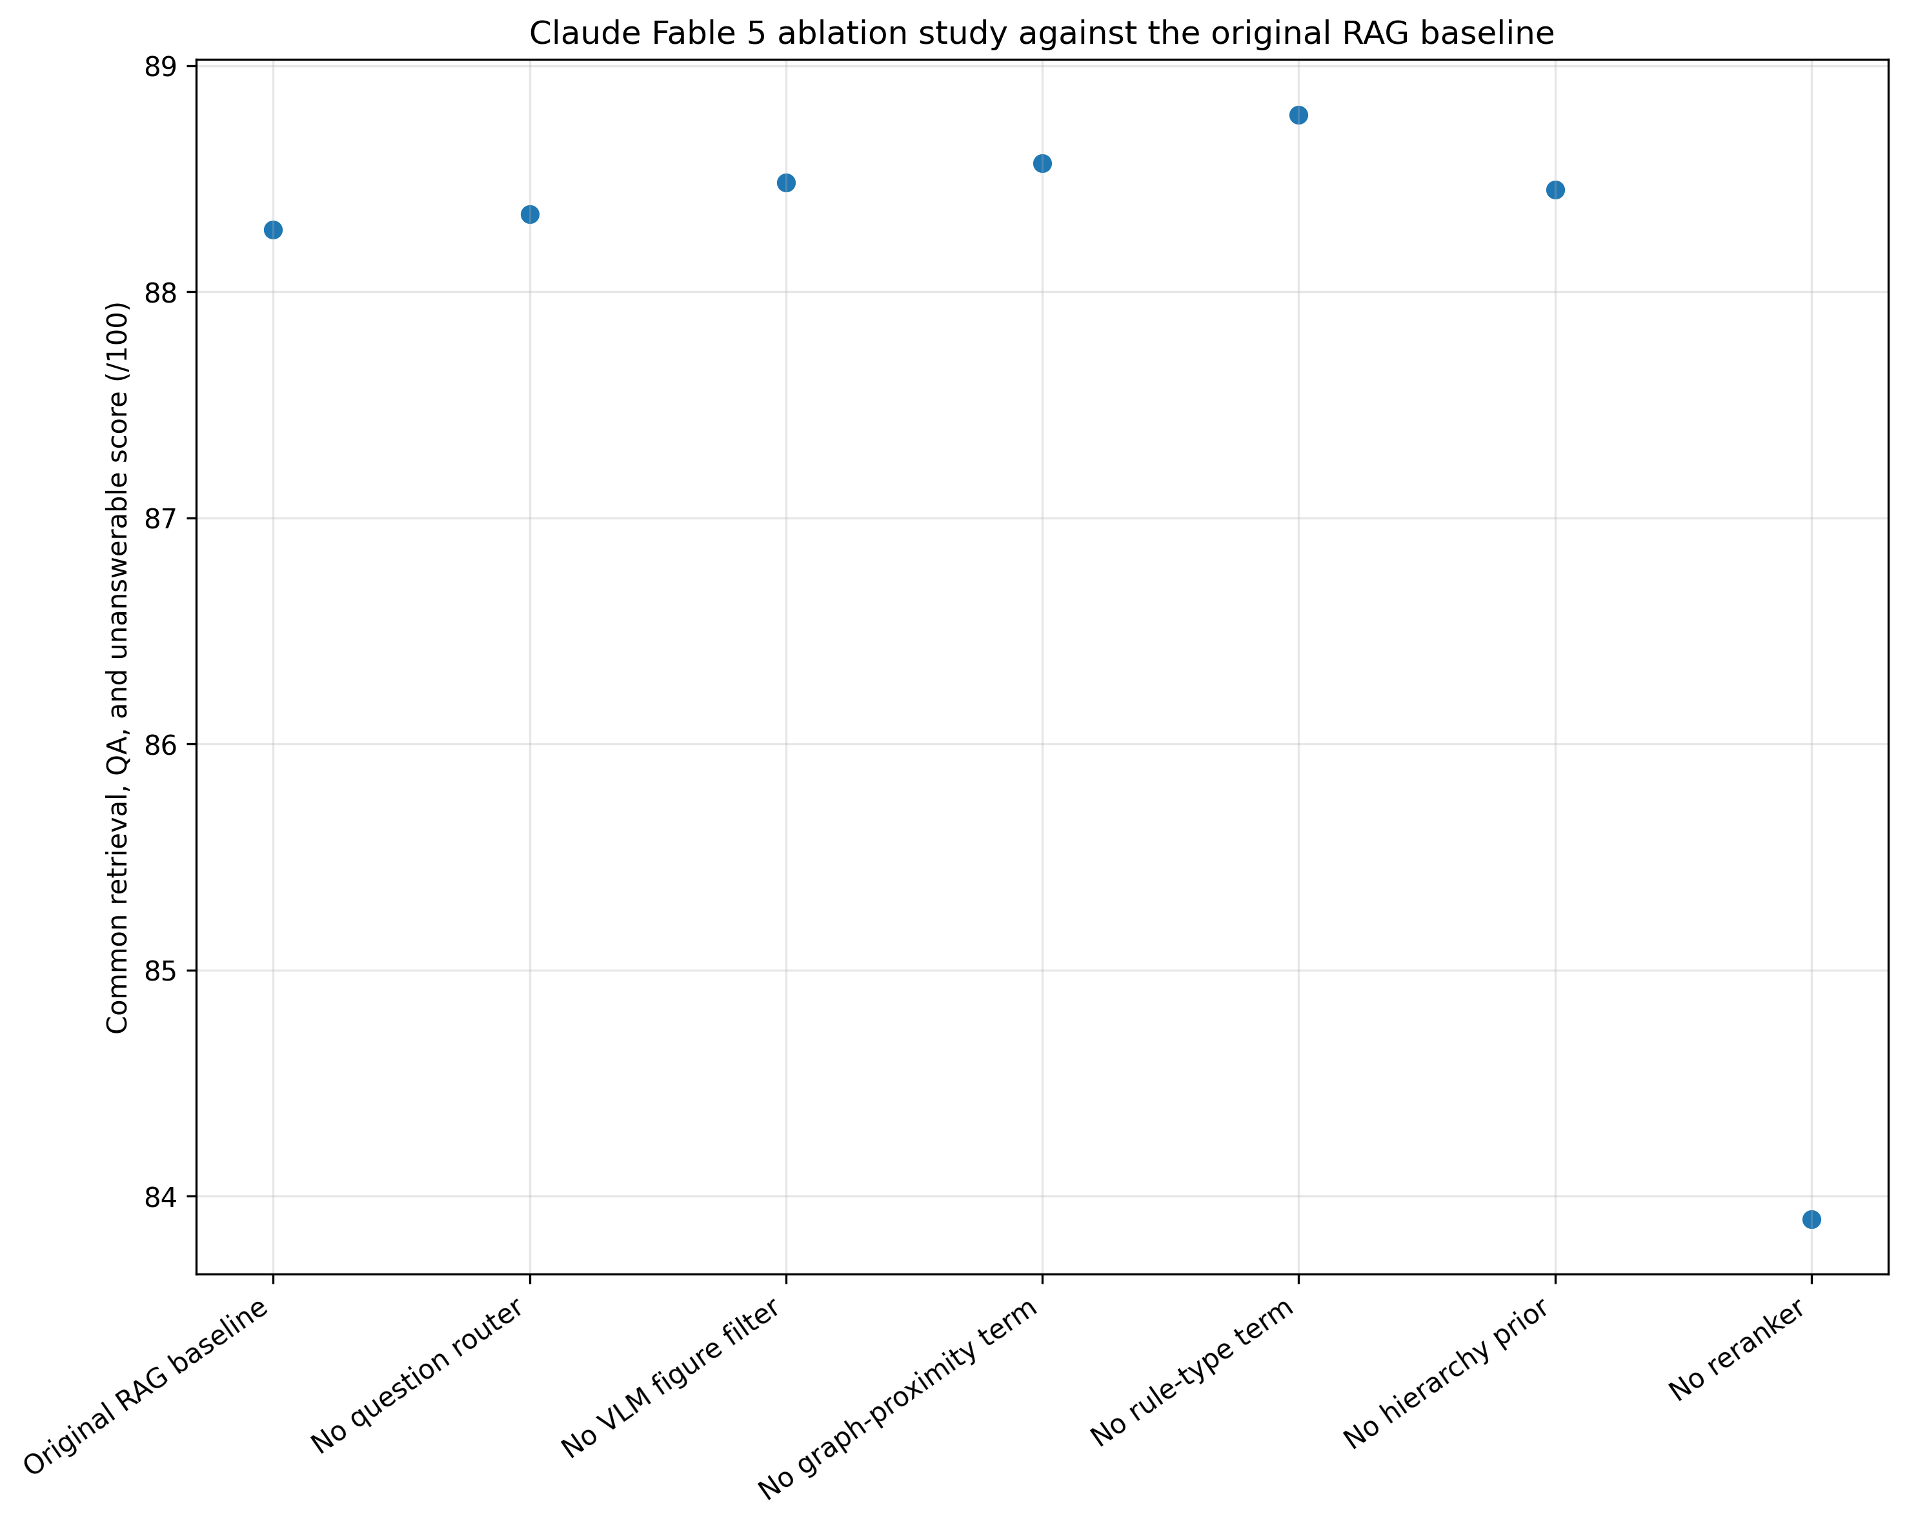
Figure 1. Common 91-point score for the original RAG and all ablation conditions.

Retrieval Performance
Table 2. Retrieval and visual-retrieval measures.
Condition | Recall@5 | MRR | nDCG@6 | Context precision | Routing | Evidence sufficiency | Exact visual hit | Visual precision | Page hit@1 | Page hit@3 | Page hit@4
Original RAG baseline | 86.7% | 82.6% | 81.3% | 47.6% | 78.0% | 93.3% | 76.5% | 72.5% | 64.7% | 88.2% | 90.6%
No question router | 87.3% | 82.9% | 81.7% | 48.8% | 56.7% | 93.3% | 78.8% | 70.8% | 64.7% | 88.2% | 90.6%
No VLM figure filter | 87.3% | 82.9% | 81.7% | 48.8% | 81.3% | 93.3% | 85.9% | 23.5% | 64.7% | 88.2% | 90.6%
No graph-proximity term | 87.3% | 82.9% | 81.7% | 48.7% | 81.3% | 93.3% | 72.9% | 67.0% | 64.7% | 88.2% | 90.6%
No rule-type term | 88.0% | 82.7% | 81.6% | 48.7% | 81.3% | 93.3% | 72.9% | 67.3% | 64.7% | 88.2% | 90.6%
No hierarchy prior | 87.3% | 82.8% | 81.7% | 48.8% | 81.3% | 93.3% | 72.9% | 67.3% | 64.7% | 88.2% | 90.6%
No reranker | 76.0% | 71.9% | 72.2% | 44.9% | 81.3% | 94.7% | 64.7% | 57.4% | 64.7% | 88.2% | 90.6%

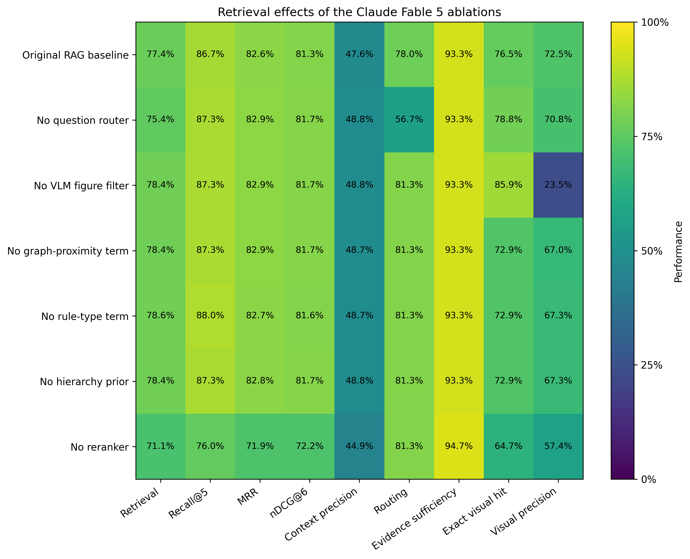
Figure 2. Retrieval effects of the six ablations.
Removing the reranker reduced Recall@5 from 86.7% to 76.0% and reduced the retrieval score from 19.35 to 17.78/25. Removing the VLM filter increased exact visual recovery to 85.9% but reduced visual precision to 23.5%.

Question Answering and Reliability
Table 3. Answer-quality and reliability measures.
Condition | Correctness | Completeness | Faithfulness | Citation | Visual reasoning | Full credit | Unanswerable | Brier | ECE
Original RAG baseline | 92.0% | 90.2% | 98.4% | 94.5% | 90.9% | 80.0% | 96.7% | 0.169 | 0.130
No question router | 93.4% | 92.0% | 97.8% | 95.2% | 92.1% | 76.0% | 96.7% | N/A | N/A
No VLM figure filter | 91.9% | 90.1% | 98.1% | 94.4% | 91.0% | 74.7% | 96.7% | 0.212 | 0.154
No graph-proximity term | 92.1% | 90.4% | 98.0% | 94.5% | 91.2% | 76.0% | 96.7% | 0.205 | 0.167
No rule-type term | 92.3% | 90.5% | 98.3% | 95.0% | 91.5% | 74.7% | 96.7% | 0.220 | 0.180
No hierarchy prior | 91.9% | 90.1% | 98.0% | 94.4% | 90.9% | 72.7% | 96.7% | 0.234 | 0.187
No reranker | 86.0% | 84.6% | 97.9% | 88.4% | 89.1% | 68.7% | 96.7% | 0.250 | 0.225

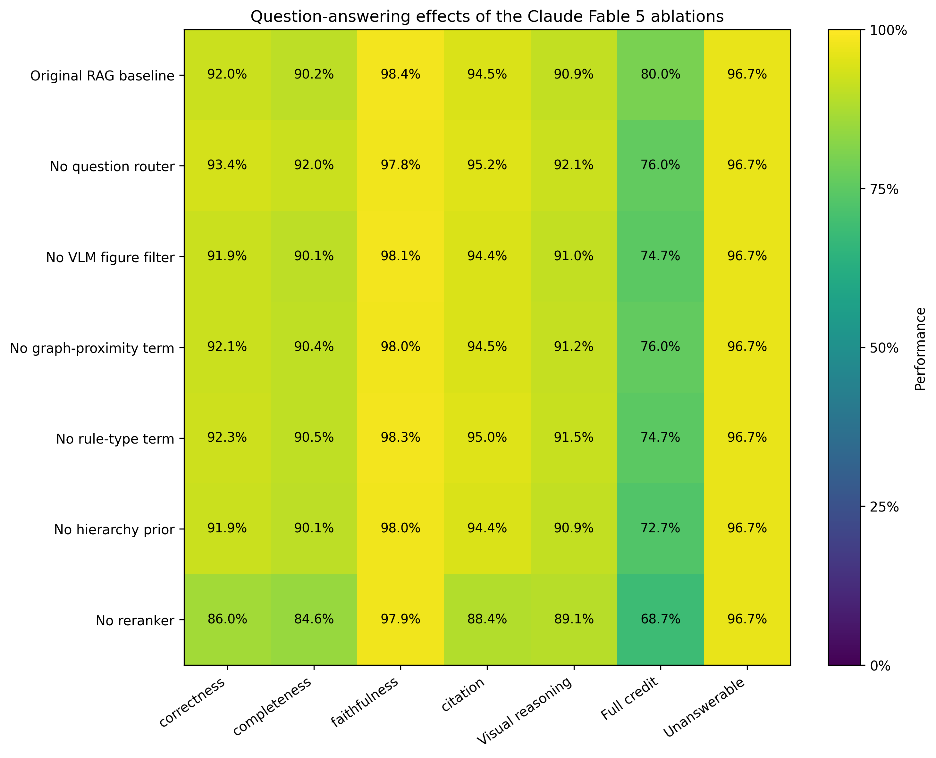
Figure 3. Question-answering effects of the six ablations.
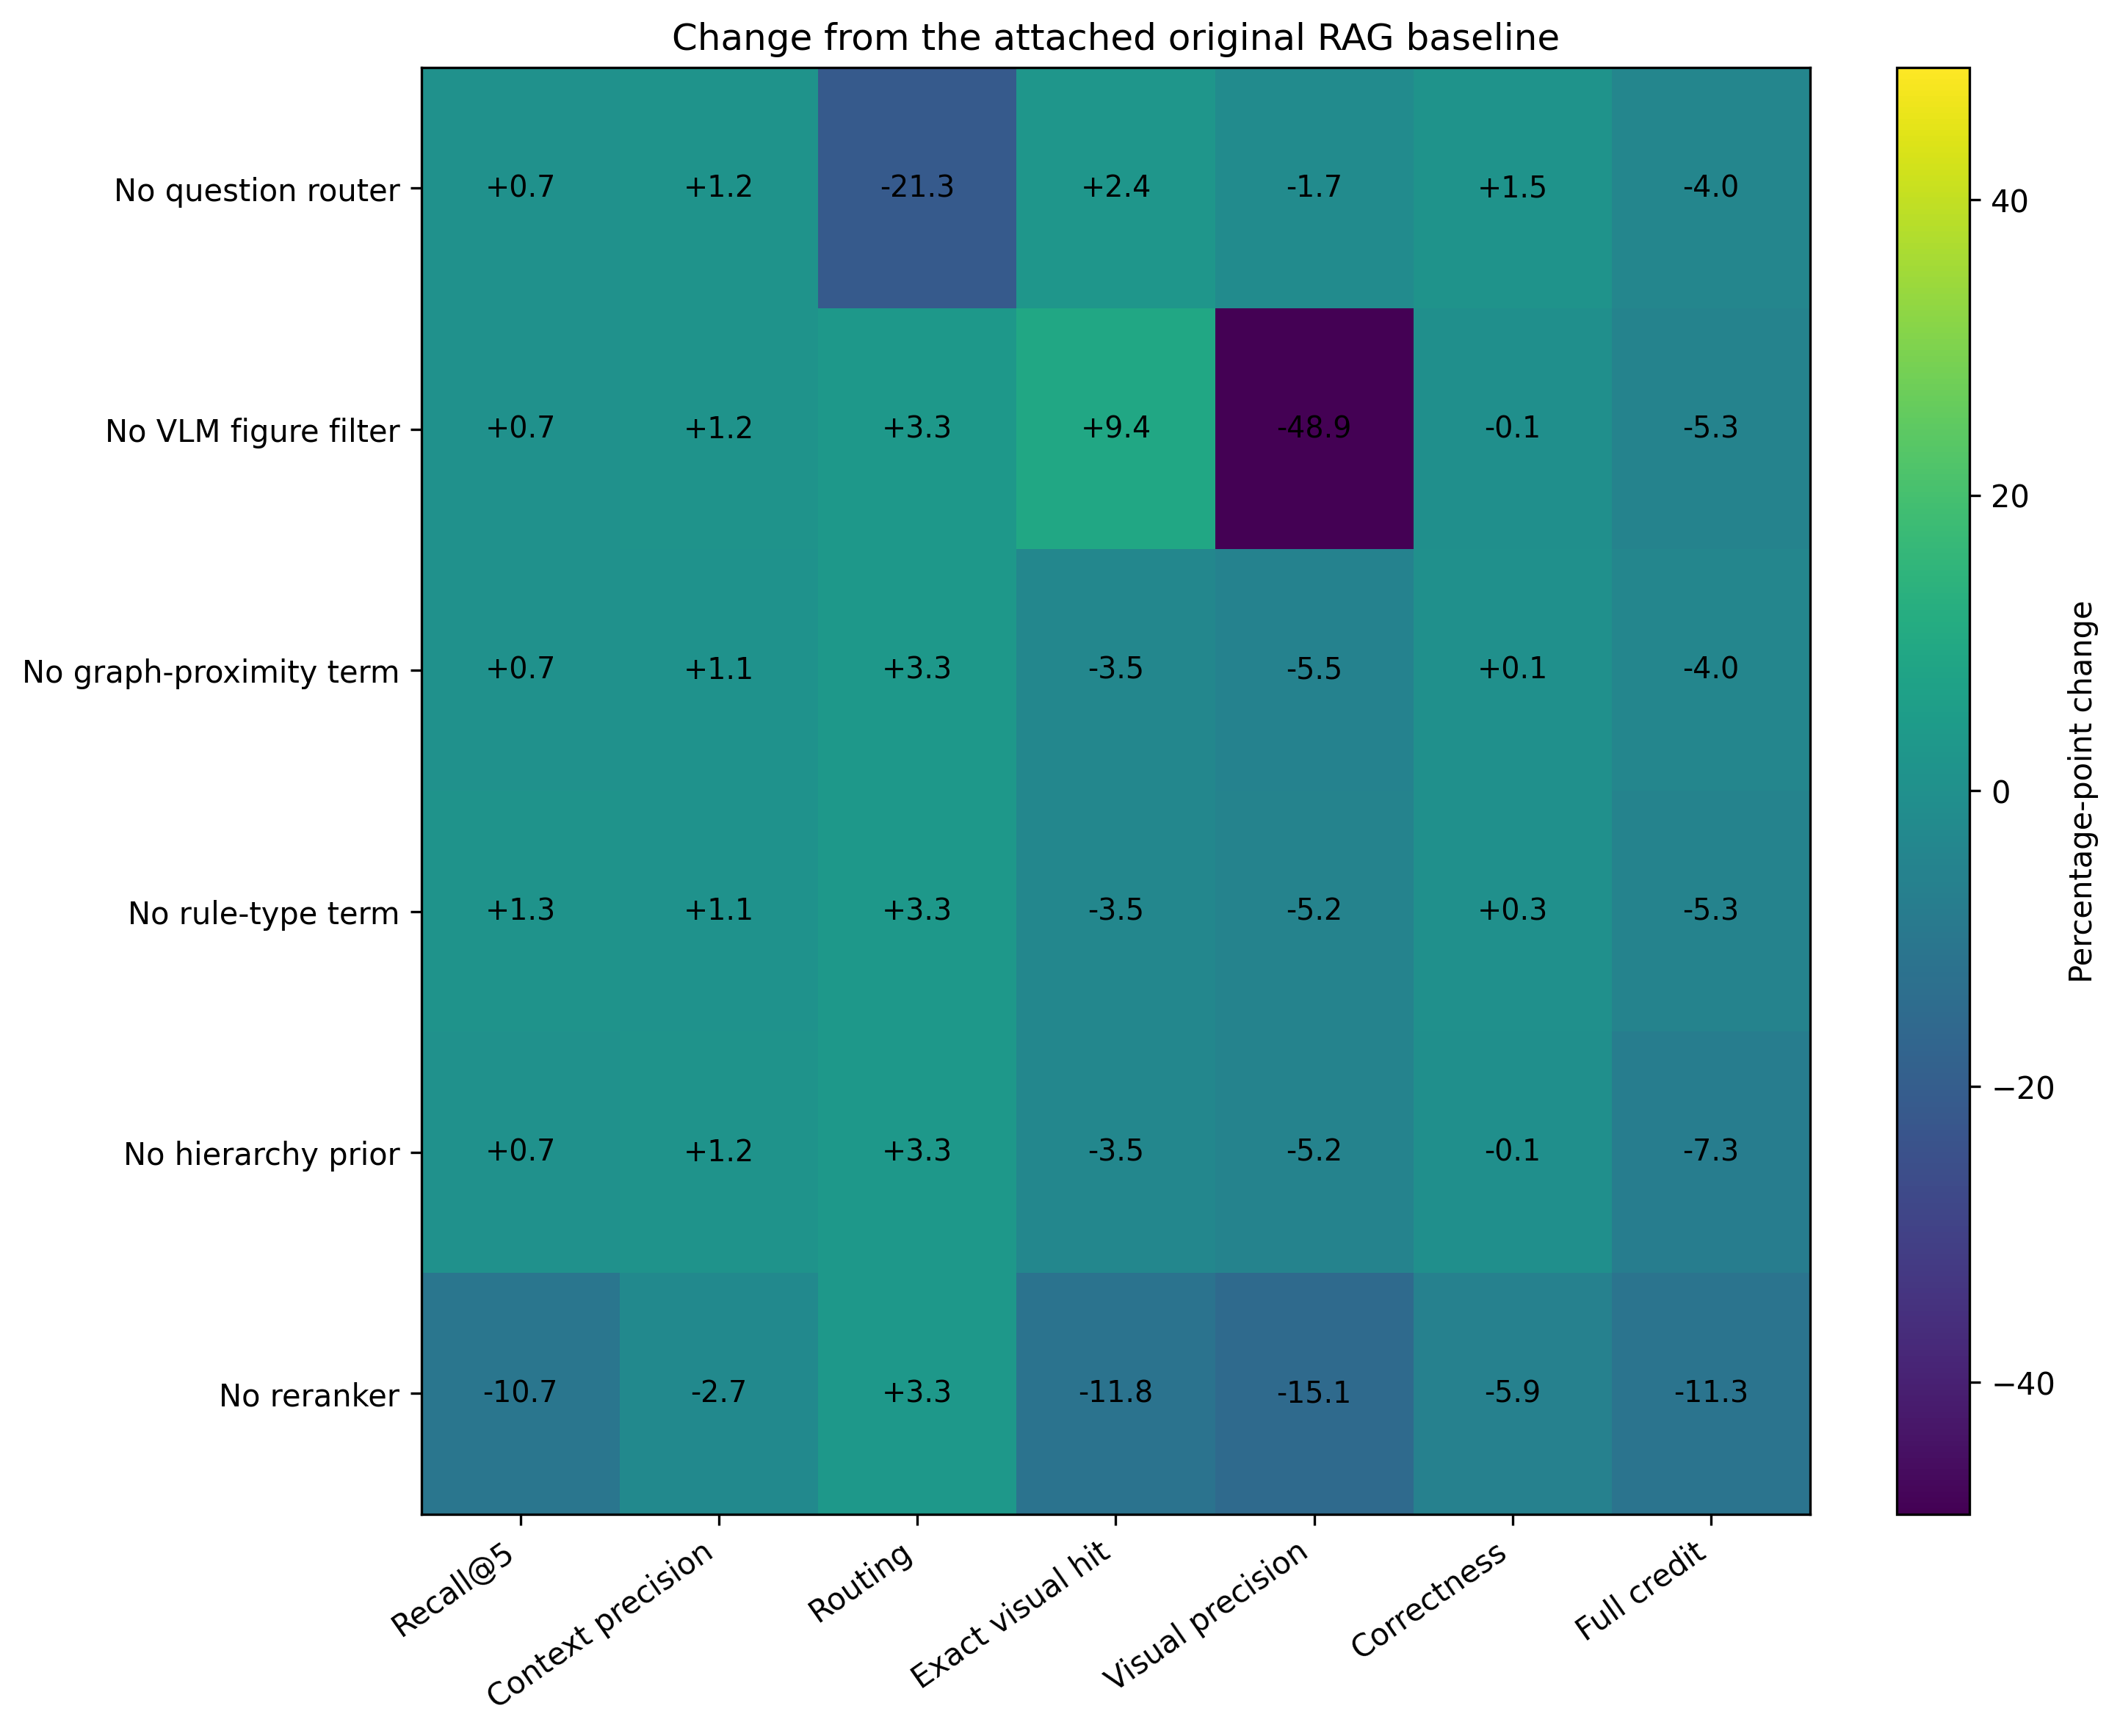
Figure 4. Percentage-point changes from the original RAG baseline.
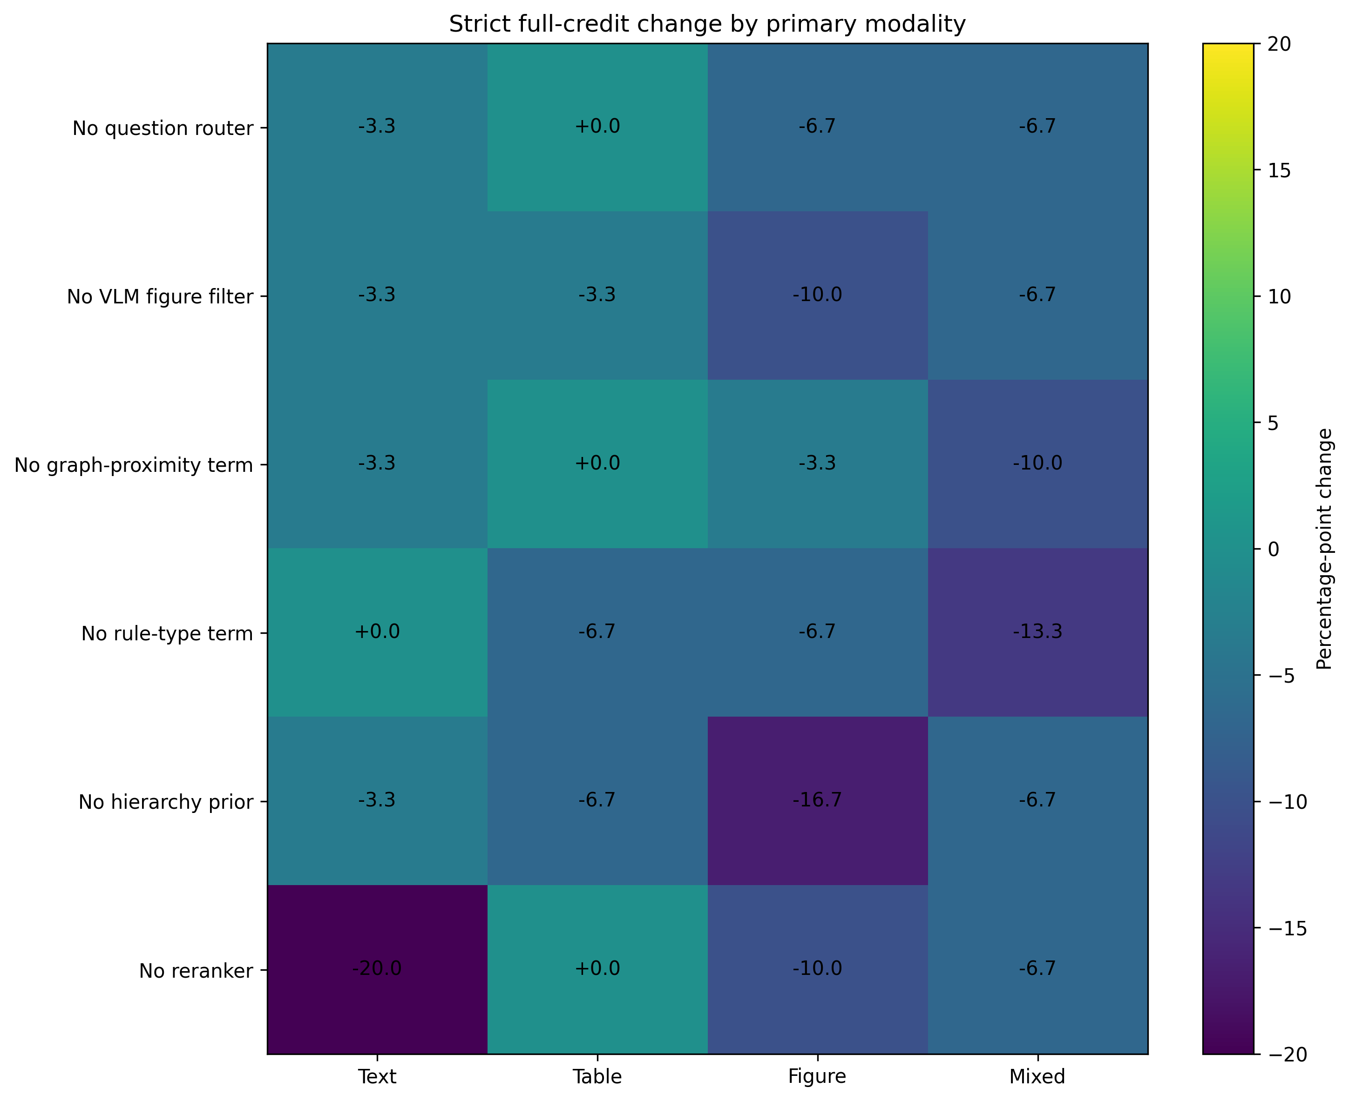
Figure 5. Strict full-credit changes by primary modality.

Paired Bootstrap
Table 4. Paired question-bootstrap intervals for score changes.
Condition | Full-score change (95% CI) | Common-score change (95% CI)
No question router | N/A | +0.07 [-0.56, +0.79]
No VLM figure filter | -0.01 [-0.43, +0.39] | +0.21 [-0.07, +0.60]
No graph-proximity term | +0.05 [-0.32, +0.44] | +0.29 [+0.03, +0.66]
No rule-type term | +0.16 [-0.41, +0.83] | +0.51 [+0.01, +1.17]
No hierarchy prior | -0.21 [-0.60, +0.19] | +0.17 [-0.06, +0.53]
No reranker | -4.65 [-6.91, -2.60] | -4.38 [-6.70, -2.31]

The no-reranker full-score interval remained below zero. The intervals for the other full-score comparisons included zero. These intervals represent benchmark-question sampling only; they do not capture model run-to-run variation.

Paper Interpretation
The reranker produced the largest measurable contribution. Its removal reduced the full score from 88.08 to 83.43/100 and reduced strict full credit by 11.3 percentage points.
The VLM filter controlled visual-context noise. The no-filter run raised exact visual recovery but reduced visual precision from 72.5% to 23.5%. The composite score does not weight visual precision directly.
The no-hierarchy run changed average correctness by only -0.1 percentage points but reduced strict full credit by 7.3 points. The graph and rule-type ablations produced small single-run changes whose paired intervals included zero.

Limitations
- The original RAG baseline predates the ablations_v3 harness, so small differences can include execution-version effects.
- The study contains one generation run per condition. Question-level bootstrap intervals do not measure stochastic generation variability.
- GPT-5.6 performed the structured answer audit; independent MUTCD-informed human validation remains pending.
- Repeatability remains pending, and router confidence is unavailable in the no-router condition.
- Visual precision remains a diagnostic measure rather than a weighted component of the retrieval score.

