PROJECT REPORT
ON
ChatBot for Recruitment
AT

SILVERTOUCH TECHNOLOGIES

In the partial fulfillment of the requirement
For the degree of
Bachelor of Computer Engineering

Prepared by
Mohammed Hannan Desai
(IU1441050013)
Uwais Mansuri
(IU1441050032)

Under guidance of

External Guide | Internal Guide
Yusuf Gandhi  (SilverTouch Technologies) | Prof. Madhavi Bhera  (INDUS UNIVERSITY)

Submitted to
INDUS Institute of Technology & ENGINEERING, AHMEDABAD,
Indus University
2014 – 2018
A PROJECT REPORT
On
ChatBot for Recruitment

Submitted by

Mohammed Hannan Desai (IU1441050013)
Uwais Mansuri (IU1441050032)

In fulfillment for the award of the degree

of

BACHELOR OF TECHNOLOGY

in

COMPUTER ENGINEERING



INDUS INSTITUTE OF TECHNOLOGY AND ENGINEERING, INDUS UNIVERSITY, RANCHARDA, VIA: THALTEJ
AHMEDABAD-382115. GUJARAT(INDIA)
Email: info@indusuni.ac.in
Web: www.indusuni.ac.in

MAY, 2018

CANDIDATE’S DECLARATION

I declare that final semester report entitled “ChatBot” is my own work conducted under the supervision of the guide Prof. Madhavi Bhera

I further declare that to the best of my knowledge the report for B.E. final semester does not contain part of the work which has been submitted for the award of B.E. Degree either in this or any other university without proper citation.

___________________________________ ___________________________________

Candidate’s Signature Candidate’s Signature

Mohammed Hannan Desai Uwais Mansuri

___________________________________

Guide: Prof. Madhavi Bhera
Department of Computer Engineering,
Indus Institute of Technology and Engineering
INDUS UNIVERSITY– Ahmedabad,
State: Gujarat

COMPANY CERTIFICATE

INDUS INSTITUTE OF TECHNOLOGY AND ENGINEERING
COMPUTER ENGINEERING
2014- 2018



CERTIFICATE

Date: <DATE>

This is to certify that the project work entitled “ChatBot for Recruitment” has been carried out by Mohammed Hannan Desai and Uwais Mansuri under my guidance in partial fulfillment of degree of Bachelor of Engineering in COMPUTER ENGINEERING (Final Year) of Indus University, Ahmedabad during the academic year 2014-2018.

___________________________ ________________________________
Prof. Madhavi Bhera Dr. Seema Mahajan
Assistant Professor, Head of the Department,
Department of Computer Engineering, Department of Computer Engineering,
I.I.T.E, Indus University I.I.T.E, Indus University
Ahmedabad Ahmedabad.

ACKNOWLEDGEMENT

Towards the successful completion of my B.Tech. Computer Engineering final year project training in SilverTouch Technologies, I feel greatly obliged to certain Specials.

I am sincerely gratitude to Mr. Yusuf Gandhi of SilverTouch Technologies, Ahmedabad, who providing me this opportunity and necessary support during the development of the project. I am also grateful to all staff members of this company for providing all the technical assistance and helping in solving problems arising during developments.

I have no other words to express my sincere thanks to all faculties of Indus University, Ahmedabad for their kind co-operation and able guidance. I would also like to thank Prof. Madhavi Bhera, my internal project guide in college without whom the project could not be executed.

- Mohammed Hannan Desai

- Uwais Mansuri

TABLE OF CONTENTS
Title Page No
ABSTRACT………………………………………………………… i
COMPANY PROFILE……………………………………………. ii
LIST OF FIGURES………………………………………………... iv
LIST OF TABELS…………………………………………………. v
ABBREVIATIONS………………………………………………… vi
CHAPTER 1 INTRODUCTION…………………………………. 1
1.1 Project Summary……………………………………. 2
1.2 Project Purpose………………………………………. 2 1.3 Project Scope………………………………………… 3
1.4 Objectives……………………………………………. 5
1.4.1 Main Objectives……………………………... 5
1.4.2 Secondary Objectives………………………. 5
1.5 Technology and Literature Overview…………….... 6
1.6 Synopsis……………………………………………... 12
CHAPTER 2 PROJECT MANAGEMENT……………………. 27

  - Project Planning Objectives………………………. 28
    - Software Scope……………………………. 28
    - Resource…………………………………… 28
      - Human Resource…………………... 29
      - Reusable Software Resources……... 29
      - Environment Resource……………. 29
    - Project Development Approach…………. 29
  - Project Scheduling……………………………….... 30
    - Basic Principal……………………………. 31
    - Compartmentalization ………………….… 31
    - Work breakdown structure………………… 31
    - Project Organization…………………….... 32
    - TimeLine Chart……………………………. 33
      - Time Allocation…………………… 33
      - Task Sets…………………………... 33
  - Risk Management……………………………….… 35
    - Risk Identification……………………….… 36
      - Risk Identification artifacts…….… 36
    - Risk Projection……………………………. 37
CHAPTER 3 SYSTEM REQUIREMENTS……………………. 38

  - User Characteristics……………………………… 39
3.2 Functional Requirement…………………………. 39
    - Activity and Proposed System…………. 39
  - Non-Functional Requirement…………………… 40
  - Hardware and Software Requirement…………. 40
    - Hardware Requirement…………………. 40
    - Software Requirement …………………. 41
    - Server Hosting Requirement……………. 41
CHAPTER 4 SYSTEM ANALYSIS…………………………. 42

4.1 Study of Current System………………………. 43
  - Problems in Current System……………………. 43
  - Requirement of new System……………….…… 44
  - Process Model………………….………….…… 45
4.5 Feasibility Study………………….………… 47
4.5.1 Technical Feasibility……….………. 47
4.5.2 Operational Feasibility………………… 48
    - Economical Feasibility………………… 48
4.5.4 Schedule Feasibility…………………… 49
4.6 Features of New System……………….……… 49
CHAPTER 5 DETAIL DESCRIPTION………………….…… 5

  - User/Employee Module………………………… 52
  - Administrator Module…………………………. 54
CHAPTER 6 Testing………………….……………………. 51

6.1 Black-Box Testing………………………. 52
  - White-Box Testing ………………………………. 53
6.3 Test Cases ………………………………… 54
CHAPTER 7 SYSTEM DESIGN………………….………… 55

  - Data Flow Diagrams……………………………… 56
  - Use–Case Diagrams………………….…… 57
  - Sequence Diagrams……………………………. 61
  - Activity Diagrams………………………………… 64
CHAPTER 8 LIMITATION AND FUTURE ENHANCEMENT… 66

  - Limitation…………………………………………. 67
8.2 Future Enhancement……………………………… 67
CHAPTER 9 CONCLUSION………………………………… 68

9.1 Conclusion………………………………………… 69

BIBLIOGRAPHY……………………………………………………. 79

ABSTRACT

ChatBot for recruitment is a MEAN Architecture-based Web Application which provides solution to employee recruitment and interview related tasks for a medium-scale or a large-scale company. MEAN architecture is an abbreviation for MongoDB, ExpressJS, AngularJS & Node.js.
Chatbot would be used for initial recruitment process in a company where an admin can register an interviewee and a dynamic ‘interview id’ would be generated, the interviewee could go onto the portal and start the interview session only after entering the interview id provided after requesting an interview.
In the interviewing session, the chatbot would select 15 (at random) questions from a collection of pre-defined questions for the interview specified by the client and then based on certain AI-concepts (pattern recognition, keyword recognition, etc.) the person being interviewed would be ranked among good, above average, average and below average.
The admin would get all these results along with the names and can have three options: whether to view the interview that took place and directly hire the person, reject the person or to call the person in for a personal interview if the results are inconclusive.

Company Profile

COMPANY OVERVIEW

SilverTouch Technologies is Information Technology Services, Solutions and Product Development Company based in Ahmedabad, India. Silver Touch from the day of its establishment in 1995, is endowing small and midsize enterprises with innovative IT solutions and re-engineering their workflow. Our team of experts from all walks of applied sciences work together to deliver super-smart organizational intelligence.

We are expert in custom enterprise work processing while turning everything in the digital matrix and cyber matrix. Running parallel with the technology trends; our experts are also adopting new technical innovation to deliver you tomorrow’s change today. Our team of more than thousand sharpened technical minds are rendering services that meet client’s requirements in the best possible way. The successful completion of more than four thousand projects and more than thousands of happy clients is the best achievement for us.

Our expert skills are transforming enterprise work processing into work facilitation with our start to finish solutions, with the aptest and most fulfilling technology meshed up for your business. The enterprise’s solution that we offer will save your time, resource and money but also be making you future ready. Every industry has a special needs and all those special needs ask for a special solution. At Silver Touch we offer solutions that are especially built to aid special characteristics of that specific industry.

Digital world is not the only thing that we look for, our efforts also strive for a green, healthy and a cooperative world. Our company’s social responsibility programs are putting efforts in improving the planet health and working towards promoting education through technology.
Our frequent programs of social activities are promoting cooperation and social upliftment of the society.

LIST OF FIGURES

Figure No | Title | Page No.
Figure 3.1 | Iterative model | 12
Figure 3.2 | Work Breakdown Structure | 15
Figure 3.3 | Project Organization | 15
Figure 3.4 | Timeline Chart | 16
Figure 8.1 | Zero Level Data Flow Diagram | 28
Figure 8.2 | Detailed Data Flow Diagram | 29
Figure 8.3 | Use-case Diagram | 30
Figure 8.4 | Sequence Diagram for login | 31
Figure 8.5 | Sequence Diagram for overall process | 32
Figure 8.6 | Login Activity Diagram | 33

LIST OF TABLES

Table No | Title | Page No.
Table 2.1 | Table Description | 17

ABBREVIATIONS

Abbreviations used throughout this whole document for Survey Application are:
HTML Hypertext Markup Language
XML Extensible Markup Language
HOD Head of the Department
UML Unified Modeling Language
CSS Cascading Style Sheet
DBMS Database management system
MySQL My Structure Query Language
BI Business Intelligence
AJAX Asynchronous JavaScript and XML
RIA Rich Internet Application
CSS Cascading Style Sheet
AngularJS Angular Java Script
NoSQL Non-Structured Query Language
MEAN MongoDB, ExpressJS, AngularJS & Node.js

CHAPTER 1
INTRODUCTION

- PROJECT SUMMARY
- PROJECT PURPOSE
- PROJECT SCOPE
- OBJECTIVES
- TECHNOLOGY AND LITERATURE OVERVIEW
- SYNOPSIS

1.1 PROJECT SUMMARY

Chatbot would be used for initial recruitment process in a company where an admin can register an interviewee and a dynamic ‘interview id’ would be generated, the interviewee could go onto the portal and start the interview session only after entering the interview id provided after requesting an interview.
In the interviewing session, the chatbot would select 15 (at random) questions from the 45 pre-defined questions for the interview specified by the client and then based on certain AI-concepts (pattern recognition, keyword recognition, etc.) the person being interviewed would be ranked among good, above average, average and below average.
The admin would get all these results along with the names and can have three options: whether to view the interview that took place and directly hire the person, reject the person or to call the person in for a personal interview if the results are inconclusive.

1.2 PROJECT PURPOSE

The project is aimed at automating interviews conveyed by companies to a point that no human interaction is needed and the A.I. Algorithms would accurately mimic human decision making of whether an interviewee is fit for the company or not.

It is because of this project that it is possible to convey multiple interviews simultaneously and without any need for the human factor.
This project is also a way of implementing a (basic) type of machine learning algorithm where a product is not so accurate initially but as and when it is used, it gets better and better. It reaches to a point where it can mimic or to a point even ascend human decision making.

1.3 PROJECT SCOPE

Functionalities of ChatBot for recruitment:
Sr.no | Process | Description
1 | Manage all new interviewee and potential candidate entries. | ChatBot can easily organize and arrange the entries by candidates and their resume/CV as per the client’s requirements.
2 | Conduct multiple interviews | ChatBot can be used to conduct multiple automated “un-manned” interviews simultaneously.
3 | Judge and Rate a(n) interviewee/Candidate | ChatBot can be used in order to judge and rate a(n) interviewee/candidate based on how fit is the interviewee/candidate for the job offered.
4 | Easy review for a candidate’s interview | Client can easily access all the previous records regarding a particular candidate/interviewee.
5 | Easy verdict for a(n) interviewee/candidate | It is very easy for a user (admin) to give a verdict for whether to accept or reject the interviewee/candidate and an automated email is sent to the interviewee regarding the verdict.

1.4 OBJECTIVES

The main objectives are:
- To automate the interview process for all companies big or small-scale. The human factor would no longer be necessary in the interviewing scenario.
- To implement and display an instance of machine learning. The product is not so accurate initially but as and when it is used, it gets more and more accurate to the point where it may mimic or even ascend human thinking and decision making for whether an interviewee is fit for a position in the company.
- To reduce the requirement of Human Resource in the fields of interviewing and analyzing. The small companies are no longer needed to invest unnecessarily in Human Resource.
- To increase effectiveness and convenience for the company managers and directors and making their job of deciding whether or not to employ an interviewee really convenient.

1.5 TECHNOLOGY AND LITERATURE OVERVIEW

ChatBot has been developed using AngularJS, HTML, CSS, Node.js and MongoDB (for database).
Angular4: Angular4 is a structural framework for dynamic web apps. It lets you use HTML as your template language and lets you extend HTML's syntax to express your application's components clearly and succinctly. Angular's data binding and dependency injection eliminate much of the code you currently have to write. And it all happens within the browser, making it an ideal partner with any server technology.
HTML: HTML stands for Hypertext Markup Language, and it is the most widely used language to write Web Pages. Hypertext refers to the way in which Web pages (HTML documents) are linked together. Thus, the link available on a webpage are called Hypertext. As its name suggests, HTML is a Markup Language which means you use HTML to simply "mark up" a text document with tags that tell a Web browser how to structure it to display.
CSS: It stands for Cascading Style Sheets. CSS describes how HTML elements are to be displayed on a screen. It controls layout of multiple pages at once.
Node.js: It is a platform built on Chrome’s JavaScript runtime for easily building fast and scalable network applications. Node.js uses an event-driven, non-blocking I/O model that makes it lightweight and efficient, perfect for data-intensive real-time applications that run across distributed devices.
MongoDB: MongoDB is a free and open-source cross-platform document-oriented database program. Classified as a NoSQL database program, MongoDB uses JSON-like documents with schemas. Instead of using tables and rows as in relational databases, MongoDB is built on an architecture of collections and documents.

1.5 SYNOPSIS

Sr.no | Process | Description
1 | Project Title | ChatBot
2 | Goal | To provide solutions and to automate employee recruitment and interviews completely.
3 | Project Type | Web application
4 | Tools | Visual Studio Code
5 | Languages | AngularJS, HTML, CSS, Node.js

CHAPTER 2
LITERATURE SURVEY

          - INTRODUCTION
          - WHY SURVEY?

2.1 INTRODUCTION OF SURVEY

As we begin down the path of creating a chat-based & utilitarian mobile experience for interview and employee recruitment, it’s important to note that do not consider ourselves to be experts in chatbots, artificial intelligence or conversational interfaces. We do consider ourselves to be experts in experience design and creative technology, but not chatbots. Yet. By the end of this year-long process we hope to be much closer to the expert side of the chatbot spectrum than the novice side. Acknowledging this, our primary goal right now is to learn as much as possible (as quickly as possible) from the experts that do exist within the bot domain. The process we intend to follow over the next semester will be relentlessly user-centered, research-based and iterative. We’re currently in deep with the first phase of this process — Formative Research and Evaluation — which is designed in-part to rapidly spin up the team’s knowledge base and understanding of the conversational experience landscape.

Benchmarking of existing expertise is a very important element of formative research, so the past few weeks the team has been performing a literature review of current thinking and writing on the topic. We’ve been aggregating these resources into a best-practice library — a chatbot book club of sorts. Since we’ve committed to a transparent process, it makes sense to publicly share these resources and acknowledge that they will be very important to the team as we move forward with the project.

Designing Bots: Creating Conversational Interfaces
Amir Shevat | O’Reilly Media
It’s already become our North Star. Shevat is one of the smartest thinkers in the bot space and this book is the most comprehensive resource we’ve found relating to design and development considerations.
The Ultimate Guide to Chatbots: Why they’re disrupting UX and best practices for building
Joe Toscano | Medium
A preview of Toscano’s forthcoming book on the disruptive nature of conversational experiences. The thesis hinges on the incredible potential of chatbots to individually and contextually communicate one-to-many.
Why Chat May Be King of the New Mobile Landscape
Cliff Kuang | Fast Co. Design
A short piece that dives into the potential for bots to frictionlessly infiltrate our mobile devices.
A Full Guide to 50 Chatbot Use Cases for Brands
Jan Buza | Exponia Blog
A pretty good landscape survey with some data points rolled in.
Chatbots: Are They Really Useful?
Bayan Abu Shawar, Eric Atwell
An academic paper highlighting some case studies and including a brief history of chatbots that extends back to the earliest experiments such as ELIZA (c. 1966).
The Case for Chatbots Being the New Apps
Sean Donnelly | Econsultancy
Don’t let the sensational-slash-clickbait headline fool you, there is some good foundational information in here.
Popular Use Cases for Chatbots
Kevin Scott | Chatbots Magazine
A short post that attempts to cut through some of the bot hype to address some big opportunities.
The Bot Rulebook
Amir Shevat | Slack Platform Blog
Shevat come through again in a big way with some foundational bot commandments. His guiding mission is fantastic: “A bot’s mission is to make human life better, to provide a helping hand, and to do so proficiently and courteously.”
Chatbot Architecture
Pavel Surmenok | Hackernoon
High-level architecture analysis. We’re not at the build stage yet, but we’ve thought a lot about infrastructure already and it’s never too early to start considering the puzzle pieces.
A Developer’s Guide to Chatbots
Michael Yuan | IBM developerWorks
IBM’s developer guide to designing and developing bots. A nice overview of platforms, frameworks and AI services that can serve as bot infrastructure.
Design Framework for Chatbots
Jesús Martín | Chatbots Magazine
An interesting approach to designing the bot experience. This is a nice walkthrough of how one might progress through a tiered or segmented design phase.
A list of artificial intelligence tools you can use today — for personal use (1/3)
Liam Hänel | Hackernoon
A comprehensive list of AI-driven bots and assistants organized by function.

2.2 WHY SURVEY?

Doing a careful and thorough literature review is essential when you write about research at any level. It is basic homework that is assumed to have been done vigilantly, and a given fact in all research papers. By providing one, usually offered in your introduction before you reach your thesis statement, you are telling your reader that you have not neglected the basics of research.
It not only surveys what research has been done in the past on your topic, but it also appraises, encapsulates, compares and contrasts, and correlates various scholarly books, research articles, and other relevant sources that are directly related to your current research. Given the fundamental nature of providing one, your research paper will be not considered seriously if it is lacking one at the beginning of your paper.
- It Creates a Rapport with Your Audience:
A literature review helps you create a sense of rapport with your audience or readers so they can trust that you have done your homework. As a result, they can give you credit for your due diligence: you have done your fact-finding and fact-checking mission, one of the initial steps of any research writing.

- It Helps You Avoid Incidental Plagiarism:
Imagine this scenario. You have written a research paper, an original paper in your area of specialization, without a literature review. When you are about to publish the paper, you soon learn that someone has already published a paper on a topic very similar to yours. Of course, you have not plagiarized anything from that publication; however, if and when you publish your work, people will be suspicious of your authenticity. Had you prepared a literature review at the onset of your research, you could have easily avoided such mishap. During the compilation of your review, you could have noticed how someone else has done similar research on your topic. By knowing this fact, you can tailor or tweak your own research in such a way that it is not a mere rehashing of someone else’s original or old idea.
- It Sharpens Your Research Focus:
As you assemble outside sources, you will condense, evaluate, synthesize, and paraphrase the gist of outside sources in your own words. Through this process of winnowing, you will be able to place the relevance of your research in the larger context of what others researchers have already done on your topic in the past
The literature survey will help you compare and contrast what you are doing in the historical context of the research as well as how your research is different or original from what others have done, helping you rationalize why you need to do this particular research.

CHAPTER 3
PROJECT MANAGEMENT

          - PROJECT PLANNING
          - PROJECT SCHEDULING
          - RISK MANAGEMENT

3.1 PROJECT PLANNING OBJECTIVES

Project planning is a discipline for stating how to complete a project within a certain timeframe, usually with defined stages, and with designated resources.
This Project is developed at NeoGen Infotech, Ahmedabad in the time duration of 136 days from 1nd January 2018 to 15th May 2018. Planning for this project began with studying the objective and scope of the project and identifying resources and deliverables. Then, planning the implementation phase into scheduled tasks to complete which estimated the total duration of the project.
As decided in the project planning, periodic updates were given to the project guide and review the tasks for any further changes if required.

3.1.1 SOFTWARE SCOPE

The scope of this project is to deliver a web application which is able to record information regarding various medicines administered during a medical procedure in an efficient manner. It allows doctors to create a new record, edit/delete an existing record, insert detailed notes through each step of the medical procedure, add comments to the record, etc.

3.1.2 RESOURCES

Planned project tasks are carried out using resources. There are mainly 3 types of resources which are taken into consideration when implementing the software.

3.1.2.1 HUMAN RESOURCES
The number of people and skills which are required in order to complete the development of the project successfully.
In this project, the human resources which are required are:
- Project guide
- Developer

3.1.2.2 REUSABLE SOFTWARE RESOURCE

There are 4 types of reusable software components:
- Off-the-shelf components: Existing software that can be acquired from a third party or that has been developed for past project.
- Full-experience components: Existing specifications, design, code developed for past projects that is similar to current developing project
- Partial-experience components: Existing designs, code developed for past project that is partially related to current developing project
- New components: Software components that must be built by the developer specifically for the needs of current project.
This project uses new software components as software resource.

3.1.2.3 ENVIORNMENT RESOURCE

Hardware and Software required during the development of the project and which supports the project to run.

3.1.3 PROJECT DEVELOPMENT APPROACH

This project started with a small specification and a small set of requirements. The initial development started with these limited specifications. The product was updated whenever new requirements and specifications came in.

This project follows “Iterative Model” as its development approach. In the Iterative model, iterative process starts with a simple implementation of a small set of the software requirements and iteratively enhances the evolving versions until the complete system is implemented and ready to be deployed. An iterative life cycle model does not attempt to start with a full specification of requirements. Instead, development begins by specifying and implementing just part of the software, which is then reviewed to identify further requirements. This process is then repeated, producing a new version of the software at the end of each iteration of the model. Consider an iterative lifecycle model which consists of repeating the following four phases in sequence:

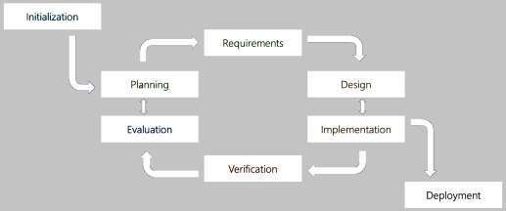

Figure 3.1 Iterative Model

A Requirements phase, in which the requirements for the software are gathered and analyzed. Iteration should eventually result in a requirements phase that produces a complete and final specification of requirements. A Design phase, in which a software solution to meet the requirements is designed. This may be a new design, or an extension of an earlier design.
An Implementation and Test phase, when the software is coded, integrated and tested.
A Review phase, in which the software is evaluated, the current requirements are reviewed, and changes and additions to requirements proposed. As the software evolves through successive cycles, tests must be repeated and extended to verify each version of the software.

Advantages:
- In iterative model we are building and improving the product step by step. Hence, we can track the defects at early stages. This avoids the downward flow of the defects.
- In iterative model we can get the reliable user feedback. When presenting sketches and blueprints of the product to users for their feedback, we are effectively asking them to imagine how the product will work.
- Some working functionality can be developed quickly and early in the life cycle.
- Parallel development can be planned.
- Progress can be measured.
- Testing and debugging during smaller iteration is easy.
- Risks are identified and resolved during iteration; and each iteration is an easily managed milestone.
- Easier to manage risk - High risk part is done first.
- Issues, challenges and risks identified from each increment can be utilized/applied to the next increment.

Disadvantages:
- Iterative waterfall model cannot satisfactorily handle different types of risk that project may suffer from. It assumes that requirements are completely specified before the development activity can start.
- It should not be used when customer is not clear about his requirements and can give rough requirements only. Costly system architecture or design issues may arise because not all requirements are gathered up front for the entire lifecycle.
- Each phase of an iteration is rigid with no overlaps.
- Defining increments may require definition of the complete system.

3.2 PROJECT SCHEDULING

The project schedule is the tool that communicates what work needs to be performed, which resources of the organization will perform the work and the timeframes in which that work needs to be performed. The project schedule should reflect all of the work associated with delivering the project on time. Without a full and complete schedule, the project manager will be unable to communicate the complete effort, in terms of cost and resources, necessary to deliver the project. Project schedule describes dependency between activities. It states the estimated time required to reach each milestones and allocation of people to activities.

3.2.1 BASIC PRINCIPLE
Project scheduling is concerned with the techniques that can be employed to manage the activities that need to be undertaken during the development of a project. It the discipline for stating how to complete a project within a certain timeframe, usually with defined stages, and with designated resources Scheduling is carried out in advance of the project commencing and involves:
- Identifying the tasks that need to be carried out.
- Estimating how long they will take.
- Allocating resources (mainly personnel).
- Scheduling when the tasks will occur.

3.2.2 COMPARTMENTALIZATION

The project is compartmentalized into following parts:
- Adding the functionalities given by the client.
- Design part of the web portal

3.2.3 WORK BREAKDOWN STRUCTURE

A work breakdown structure in project management and systems engineering, is a deliverable-oriented breakdown of a project into smaller components.
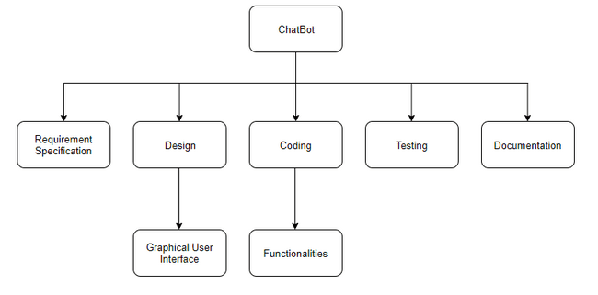
Figure 3.2 Work Breakdown Structure

3.2.4 PROJECT ORGANIZATION

This describes the way in which the development team is organized the people involved and their roles in team. Here Project Organization Chart is shown.
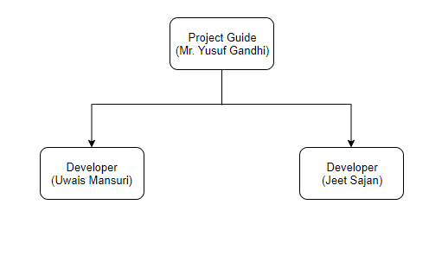
Figure 3.3 Project Organization

3.2.5 TIMELINE CHART
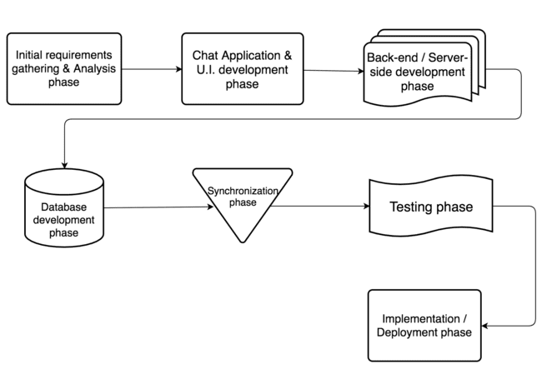

Figure 3.4 Timeline Chart

3.2.5.1 Time Allocation

Each task to be scheduled must be allocated some number of work units.

3.2.5.2 Task Sets
A tasks set is a collection of software engineering work tasks, milestones, and deliverables that must be accomplished to complete a particular project. Tasks set are designed to accommodate different types of projects.
Task sets of this project are as follows:
- Analysis of required system
  - Study about requirements
  - Study about technologies to be used
  - Study about current systems available
- Find out resources required
  - Identify resources used in current systems
  - Identify for new resources to be used
- Coding
  - Developing GUI
  - Developing Functionalities one by one
- Testing
a. Testing for developed function

CHAPTER 4
SYSTEM REQUIREMENTS

          - USER CHARACTERISTICS
          - FUNCTIONAL REQUIREMENT
          - NON-FUNCTIONAL REQUIREMENT
          - HARDWARE AND SOFTWARE REQUIREMENT

4.1 USER CHARACTERISTICS

The user of the system must have the following characteristics:
- Ability to read and understand English
- Ability to operate mobile application
- Ability to operate computer on basic level
- Familiarity with basic Graphical User Interface of Windows
- Basic understanding of the application and its output
- Ability to work with basic web browser.

4.2 FUNCTIONAL REQUIREMENT

These are the functional requirements that are required to get the proper results from website:
- One must be logged in to access any feature of the website.
- One must be complete the basic customer profile in order to save the record.
- One must be complete the basic technician profile in order to save the record.

4.3 NON-FUNCTIONAL REQUIREMENT

- Usability: Application should provide a simple and user-friendly interface comfortable to use.
- Availability: Application should be available to use at any times and connected to the database server.
- Efficiency: The application should work with ease under heavy usage of the system or by user.
- Reliability: Application should be responsive to user selections and if there is possibility of user error, it should display proper error messages.
- Understandability: Application should be easy to understand for the users who don’t have much knowledge about it.

4.4 HARDWARE AND SOFTWARE REQUIREMENT

The minimum hardware and software requirements (Development Environment) for the application to run are listed below:

4.4.1 HARDWARE REQUIREMENTS

- Intel i5 5TH Gen 2.20GHz
- 8 GB RAM
- 4MBps or faster internet connection
- Keyboard, mouse

4.4.2 SOFTWARE REQUIREMENTS
- Windows 10 Home or Ubuntu 14.0
- Mozilla Firefox /Chrome
- Visual Studio Code

CHAPTER 5
SYSTEM ANALYSIS

          - STUDY OF CURRENT SYSTEM
          - PROBLEMS IN CURRENT SYSTEM
          - REQUIREMENT OF NEW SYSTEM
          - PROCESS MODEL
          - FEASIBILITY STUDY
          - FEATURES OF NEW SYSTEM

5.1 STUDY OF CURRENT SYSTEM

The current system for recruitment solution is manual based. The company needs to employ an interviewer in order to conduct an interview and to judge the interviewee on the interview. For all of the below processes, the company needs to employ the interviewer and other:
- In order to review an interviewee’s resume/CV before conducting an interview.
- Invite the interviewee at a time convenient to the interviewer.
- For judging the interviewee based on the interview, how fit is the candidate.
- Creating an interviewee’s portfolio.
- Passing all the details of the interview and the judgment to higher authority for further review.
- Status of the interview judgment to the interviewee.
- Send details and judgment to the candidate.

5.2 PROBLEMS IN CURRENT SYSTEM

There is no such system related to ChatBot that implements A.I. concepts in order to conduct interviews. There are currently many ChatBots available in the market but none are applied for recruitment purpose. There are certain systems for recruitment but are only partial: some systems are used in order to queue the interviews for a company, some systems are used in order to conduct an interview through a chat application but requires another user (The interviewer) to be present on the other side asking questions.

5.3 REQUIREMENTS OF NEW SYSTEM

A new system is required in order to reduce the time involved and to create an automated format for recruitment in companies. The new system is digitized and easy to use. In the new system, interviews with many potential candidates can be conducted simultaneously. This makes it easy for the company regarding the recruitment procedure. A company executive can add detailed questions and requirements for each candidates at each step of the recruitment process from questions being asked to keywords required or patterns to be established.

5.4 FEASIBILITY STUDY

Feasibility is defined as the practical extent to which a project can be performed successfully. To evaluate feasibility, a feasibility study is performed, which determines whether the solution considered to accomplish the requirements is practical and workable in the software.

5.4.1 TECHNICAL FEASIBILITY
The web application is technically feasible because it runs in low device specifications too. A normal computer with normal specifications will easily support the application. So, this web application has nice technical feasibility.

5.4.2 OPERATIONAL FEASIBILITY
Operational feasibility is the measure of how well a proposed system solves the problems and takes advantage of the opportunities identified during scope definition and how it satisfies the requirements identified in the requirements analysis phase of system development.

5.4.3 ECONOMICAL FEASIBILITY
Analysis of a project's costs and revenues in an effort to determine whether or not it is logical and possible to complete. All the technologies and resources used in this project are open source and freely available thus eliminating the cost which makes it economically feasible.

CHAPTER 6
DETAIL DESCRIPTION

          - USER/INTERVIEWEE MODULE
          - ADMINISTRATOR MODULE

6.1 USER/INTERVIEWEE MODULE

The main user of this project would be an interviewee. The chatbot would conduct an interview of the interviewee through a chat application where the interviewee would be asked a series of questions and the response of the interviewee for those questions would be recorded and the interviewee’s likelihood to be accepted or for an interviewee to fit in perfectly in the company would be judged by the A.I. Algorithms.

The interviewee would be initially asked for an Interview ID that the interviewee would be provided by an admin after generating a random Interview ID and storing all the interviewee’s information in the database. Once the interviewee enters the correct Interview ID, the interviewee would be redirected to the chat application where the chatbot would conduct the interviewee’s interview. After interview ends, the interview session would be recorded and up for review by an admin.

6.2 ADMINISTRATOR MODULE

The client for this project would be treated as an administrator. The chatbot would conduct an interview of the interviewee through a chat application and would then give the admin all the information in order to review the interviewee or make any changes to the database. The final power to accept or reject an interviewee is in the hands of the client but the chatbot would suggest whether the interviewee should be accepted or not and how is he/she in comparison to other interviewees.

The administrator initially would go to the admin login page and enter his/her username and password. Once the admin is authenticated, the admin is then redirected to the admin dashboard. All the client-side functionalities offered by this project is handled by and through the admin dashboard. Some of the functionality includes:
- Dashboard: the admin is presented with all the basic information regarding the chatbot interviews as well as the interviewees.

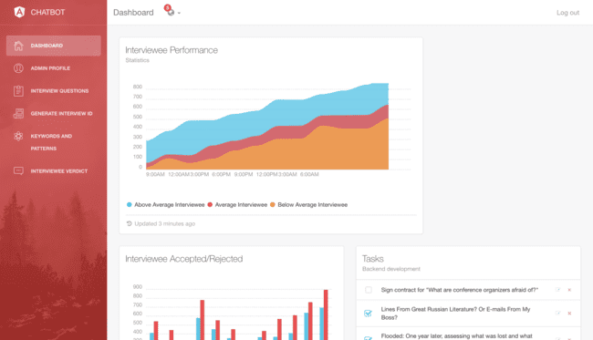

- Administrator profile viewer: The administrator profile viewer enables the user to view his/her profile details and also edit, add or delete certain aspects and attributes of his/her profile.
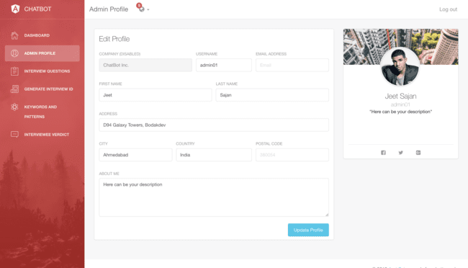
- Interview questions: This part of the project displays all the questions currently present inside the database used by the chatbot to conduct interviews. A user can either view all questions, delete a question or add a question category-wise.
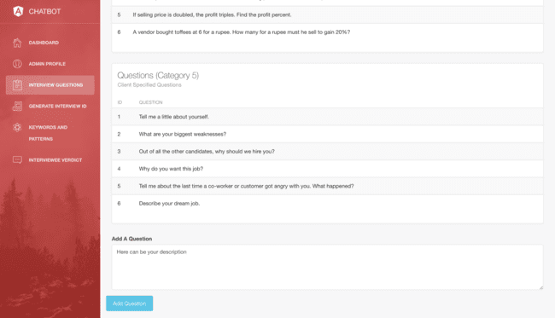
- Interview ID generator: This section allows an admin/user to enter the details of an interviewee. An interview ID is generated which is a unique identifier for each interviewee and which is required by an interviewee to give an interview.
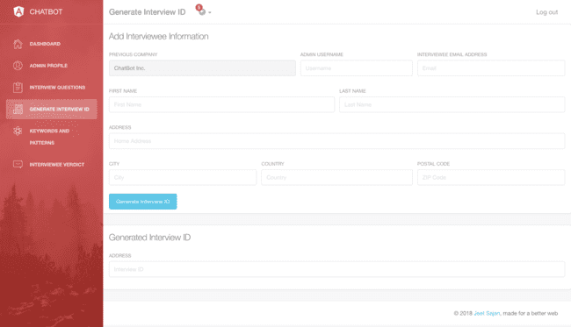
- Keywords & Patterns: This sections highlights all the keywords and patterns that are used by the A.I. Algorithms of the chatbot, user can either add, update or add keywords and/or patterns to the database.
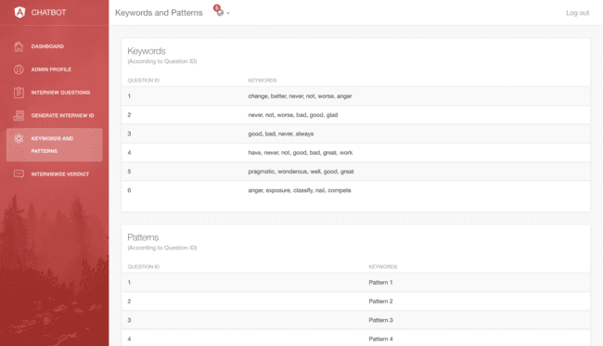
- Interviewee Verdict: The interview verdict module is for the admin to provide either the final verdict for an interviewee after review, view the resume/CV of the interviewee in question or review the whole interview given by an interviewee.

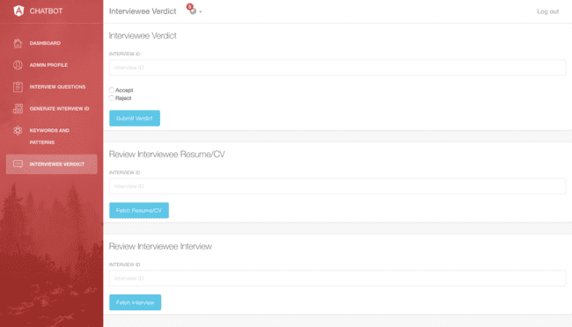

CHAPTER 7
TESTING

          - BLACK-BOX TESTING
          - WHITE-BOX TESTING
          - TEST CASES

7.1 BLACK-BOX TESTING

Black Box Testing, also known as Behavioral Testing, is a software testing method in which the internal structure/ design/ implementation of the item being tested is not known to the tester. For black-box testing the company took reference of multiple doctors. They didn’t have knowledge in structure, design or coding of the project. They tested the project and told me the missing components which I added afterwards.

7.2 WHITE-BOX TESTING

White Box Testing (also known as Clear Box Testing, Open Box Testing, Glass Box Testing, Transparent Box Testing, Code-Based Testing or Structural Testing) is a software testing method in which the internal structure/ design/ implementation of the item being tested is known to the tester. The tester chooses inputs to exercise paths through the code and determines the appropriate outputs. Programming know-how and the implementation knowledge is essential. White box testing is testing beyond the user interface and into the nitty-gritty of a system. For white-box testing, my guide tested my web application using his good knowledge in designing, coding and implementation of my project.

7.3 TEST CASES

We tested our project for following test cases:

6.3.1 COMPATIBILITY TESTING

In compatibility testing I checked my website runs in different browsers like Google Chrome, Mozilla Firefox, Opera Mini and Internet Explorer. My website is responsive so it automatically adjusts with different screen sizes.

6.3.2 FUNCTIONAL TESTING
Functional Testing is a testing technique that is used to test the features/functionality of the system or Software, should cover all the scenarios including failure paths and boundary cases.
When the user enters an invalid URL, he/she is redirected to the login page.

6.3.3 SECURITY TESTING

In these testing I checked following test cases:
- Test by pasting internal URLs directly onto the browser address bar without login. Internal pages should not open.
- Files should not be accessible directly unless they are given download option.

I entered invalid inputs in input fields like login username, password, input text boxes etc. Check the systems reaction on all invalid inputs.

CHAPTER 8
SYSTEM DESIGN

          - DATA FLOW DIAGRAMS
          - USE-CASE DIAGRAMS
          - SEQUENCE DIAGRAMS
          - ACTIVITY DIAGRAMS

8.1 DATAFLOW DIAGRAMS

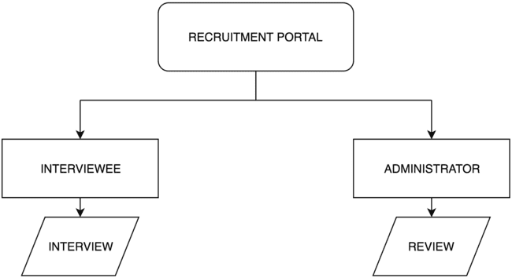

Fig. 8.1 Zero Level Dataflow Diagram

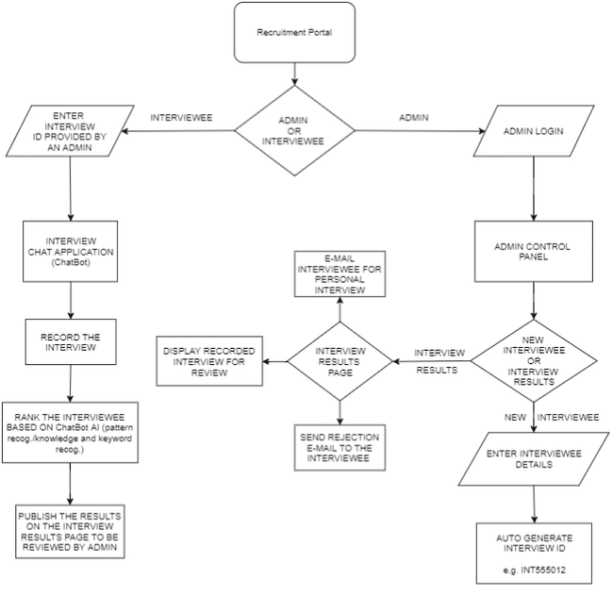

Fig. 8.2 Detailed Dataflow Diagram

8.2 USE-CASE DIAGRAMS

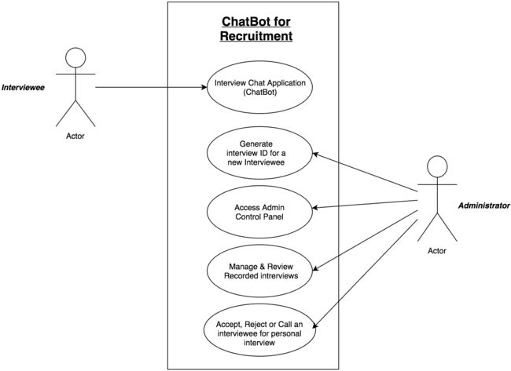

Fig. 8.3 Use-Case Diagram

8.3 SEQUENCE DIAGRAMS

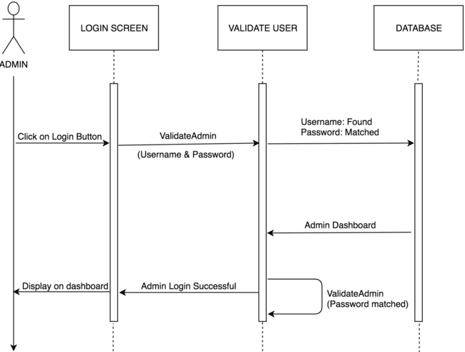

Fig. 8.4 Sequence Diagram for User Login

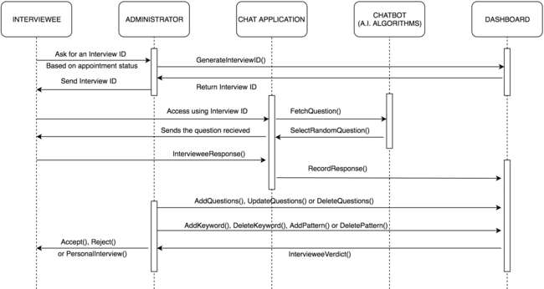

Fig. 8.5 Sequence Diagram for Overall Process

8.4 ACTIVITY DIAGRAMS

Fig. 8.6 Activity Diagram

CHAPTER 9
LIMITATION AND FUTURE ENHANCEMENT

          - LIMITATIONS
          - FUTURE ENHANCEMENT

9.1 LIMITATIONS

This project is based on a simpler version of machine learning and thus improves as and when it is used by the user and provided the keywords, patterns and other parameter in order to improve the accuracy and the effectiveness but even then we could predict and foresee some limitations to this project which we would work on eliminating in the future versions.

Following are the limitations of the project (ChatBot for Recruitment):

- May not be as efficient in the beginning: The ChatBot may not be as efficient as a personal interviewer in its initial stages as it is working only with a small set of patterns and keywords in its database that is specified by the client but with time it will improve as the keywords and patterns are added while it is being used.
- May not be as accurate: The A.I. algorithms may not be as accurate in reviewing an interviewee when compared to a personal interviewer.
- Its speed and efficiency depends upon the server it is used on: The ChatBot is limited by the server it is used/hosted on.
- Recorded Interviews are not secure: The recorded interviews used by admins to review the interviewee are not yet stored securely on the server.
- Extra-ordinary scenarios: The chatbot has a great functionality towards what it was designed for and it being a task-oriented chatbot. But the chatbot is not equipped with solution for every scenario ever. In case of an extra-ordinary scenario, the chatbot might provide inconclusive or incorrect results.

9.2 FUTURE ENHANCEMENTS

As and when new plugins and third-party packages become available in both AngularJS or Node.js, we would be sure to include them in order to increase or improve the overall functionality of the project. Other enhancements that we are planning to do in the near foreseeable future are:
- Including more and improved pre-defined keywords and patterns: Our project is solely based on the most basic idea of machine learning, the more you use it and give it the required input, the better it gets from time to time, but we are planning on including more keywords and patterns in order to improve it and make it effective right out of the box.
- Deploy the entire project onto a cloud server: We are also planning on moving our entire project onto a high-speed cloud server which would improve security as well as improve usability and reachability both at the same time.
- Improve and add algorithms: In the near foreseeable future we are also going to add new A.I. Algorithms as well as improve the currently employed algorithms in order to increase the response time and usability.
- Add more criterions for A.I. algorithms to work on: Adding more criterions by carrying out further research in NLP (Natural Language Processing), NLU (Natural Language Understanding) and NLG (Natural Language Generation).

CHAPTER 10
CONCLUSION

          - CONCLUSION

9.1 CONCLUSION

The objective of SilverTouch Technologies is to provide best and the most innovative engineering solutions to the working companies for marketing, recruitment, etc. It is to speed up and make the usual recruitment methods more efficient and effective whenever required and to create a new system which is fast, easy-to-use and understand.

Same is with ChatBot for recruitment where any small, medium and large-scale company can employ it in order to speed up the recruitment process and make it completely automated. ChatBot provides the complete package from conducting an interviewee’s interview to rating the interviewee on the basis of how likely is the interviewee is to fit in to the company scenario and to what extent is the interviewee fit for the position of application.

BIBLIOGRAPHY

www.material.angular.io | For angular material elements and designing.
www.stackoverflow.com/ | For coding related queries.
https://www.mongodb.com/ | For MongoDB learning references.

