National University of Computer and Emerging Sciences
FAST-NU, Lahore, Pakistan
CS3051 | Fundamentals of Software Engineering | Spring 2026
Grade & Grind
A Freelance Platform for University Students
Deliverable #3: Iteration 2 Report
Group Members & Roll Numbers:
Sadeem (24L-2502) — Project Lead
Mahnoor (24L-2533) — Full Stack Developer
Yousuf (24L-2539) — Full Stack Developer
Date of Submission: April 15, 2026

1. Project Title and Introduction
- Project Title: Grade & Grind
Introduction:
Grade & Grind is a specialized web-based freelance marketplace tailored for the university ecosystem. Iteration 2 focuses on the 'Gig Workflow System.' This phase moves the platform from a static listing site to a functional marketplace by implementing skill-based matching, a formal application and acceptance process, real-time status tracking for active projects, and a performance-based leaderboard to incentivize student excellence.
2. Sprint 2 Overview
Sprint Duration: 2 weeks (14 days)
Sprint Goal:
Deliver a fully functional gig workflow system with applications, acceptance, skill-based matching, and gig status management.
Modules Included:
• Skill-Based Gig Matching
• Gig Acceptance and Status Management
• Review and Rating System
• Leaderboard

3. User Stories (Full Sprint Backlog)

Story ID: US-09 | Skill-Based Gig Matching
Priority: High | Est. Hours: 35
User Story:
As a student, I want the system to automatically recommend gigs that match my skills so that I can find relevant opportunities without manually searching through all listings.
Description:
The platform analyzes skills from student profiles and compares them against gig requirements using keyword-based matching. A matching score is calculated for each student-gig pair, and the most suitable candidates are recommended to clients.
Sub User Stories:
- As a client, I want to see a ranked list of students whose skills best match my gig requirements.
Acceptance Criteria:
- System extracts skills from student profiles
- Matching algorithm compares student skills with gig requirements
- Matching score (0–100%) calculated for each student-gig pair
- Top 10 matching students displayed to clients for each gig
- Students see 'Recommended for You' gigs on their dashboard
- Match percentage displayed on gig cards

Story ID: US-10 | Gig Application
Priority: High | Est. Hours: 28
User Story:
As a student, I want to apply for gigs with a cover letter so that I can explain why I'm the best fit for the job.
Description:
Students can submit applications for gigs they're interested in. The application includes a cover letter and an optional portfolio link. Clients can review applications in their dashboard.
Sub User Stories:
- As a student, I want to track the status of my applications (Pending, Accepted, Rejected).
- As a client, I want to view all applications for a specific gig in one place.
Acceptance Criteria:
- Application form includes cover letter (required) and optional portfolio link
- Students can apply to multiple gigs
- Application status: Pending, Accepted, Rejected
- Clients can view all applications for a gig
- Students see application history on their dashboard

Story ID: US-11 | Gig Acceptance and Assignment
Priority: High | Est. Hours: 24
User Story:
As a client, I want to review applications and accept the best candidate so that I can assign the gig and start the project.
Description:
Clients review applications and select the best fit. Upon acceptance, the gig status changes and both parties are notified.
Sub User Stories:
- As a student, I want to receive confirmation when my application is accepted.
Acceptance Criteria:
- Client can view all applications with student profiles and match scores
- Accept/reject buttons for each application
- Accepting an application automatically rejects all others for that gig
- Gig status updates to 'In Progress' upon acceptance
- Both parties receive notifications

Story ID: US-12 | Gig Status Management
Priority: High | Est. Hours: 20
User Story:
As a user (student or client), I want to track and update gig progress through defined status stages so that both parties stay informed.
Description:
Gigs move through clearly defined stages: Open -> In Progress -> Submitted -> Completed -> Cancelled. Students can mark work as submitted and clients can mark it as completed.
Sub User Stories:
- As a student, I want to mark my work as 'Submitted' when I complete it.
Acceptance Criteria:
- Status transitions: Open -> In Progress -> Submitted -> Completed
- Students can mark gig as 'Submitted'
- Clients can mark as 'Completed'
- Status history is logged with timestamps
- Dashboard shows real-time status updates

Story ID: US-13 | Review and Rating System
Priority: Medium | Est. Hours: 24
User Story: As a user, I want to rate my experience after gig completion so that the platform maintains quality and builds trust.
Description: Upon gig completion, both students and clients can leave ratings (1–5 stars) and an optional short review. Reviews contribute to reputation scores.
Sub User Stories:
- As a student, I want to see my average rating on my profile.
- As a client, I want to view a student's rating before hiring them.
Acceptance Criteria:
- Rating scale: 1–5 stars (required)
- Written review: Optional, max 500 characters
- Reviews can only be submitted after gig is marked 'Completed'
- Average rating calculated and displayed on profiles
- Reviews are publicly visible on profiles

Story ID: US-14 | Student Leaderboard
Priority: Medium | Est. Hours: 20
User Story:
As a student, I want to see my rank on a leaderboard so that I can track my performance relative to peers.
Description:
The platform features a leaderboard ranking students based on average rating, completed gigs, and success rate.
Sub User Stories:
- As a client, I want to browse top-ranked students to find talent.
Acceptance Criteria:
- Ranking formula: (Average Rating x 40%) + (Completed Gigs x 30%) + (Success Rate x 30%)
- Top 100 students displayed
- Shows: Rank, Name, University, Rating, Completed Gigs, Success Rate
- Minimum 3 completed gigs required to appear on leaderboard
- Student profile links accessible from leaderboard

4. Design
Activity Diagram:
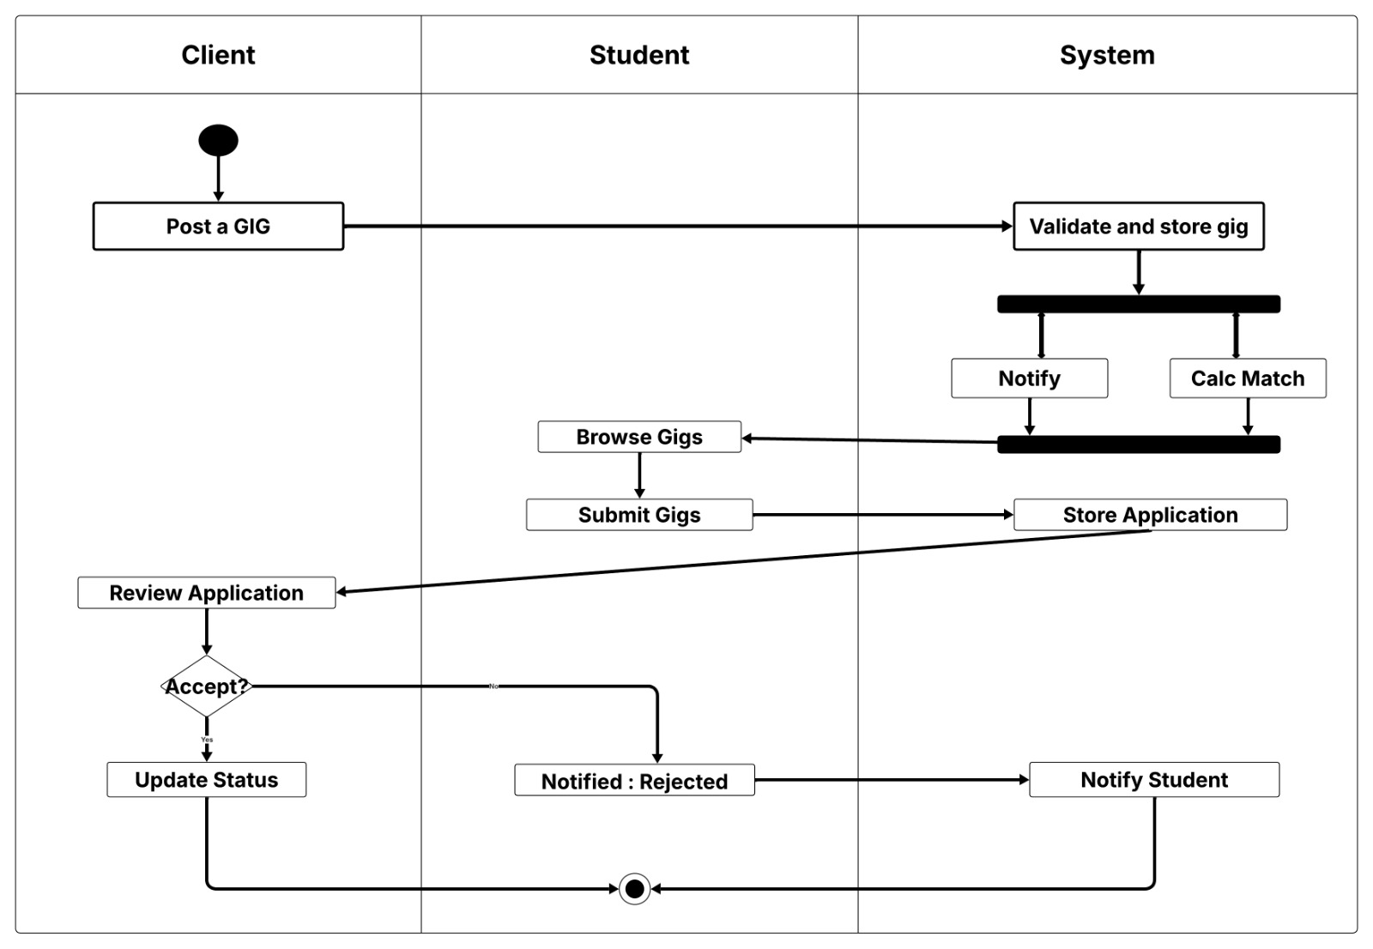
Sequence Diagram:
1) User Registration
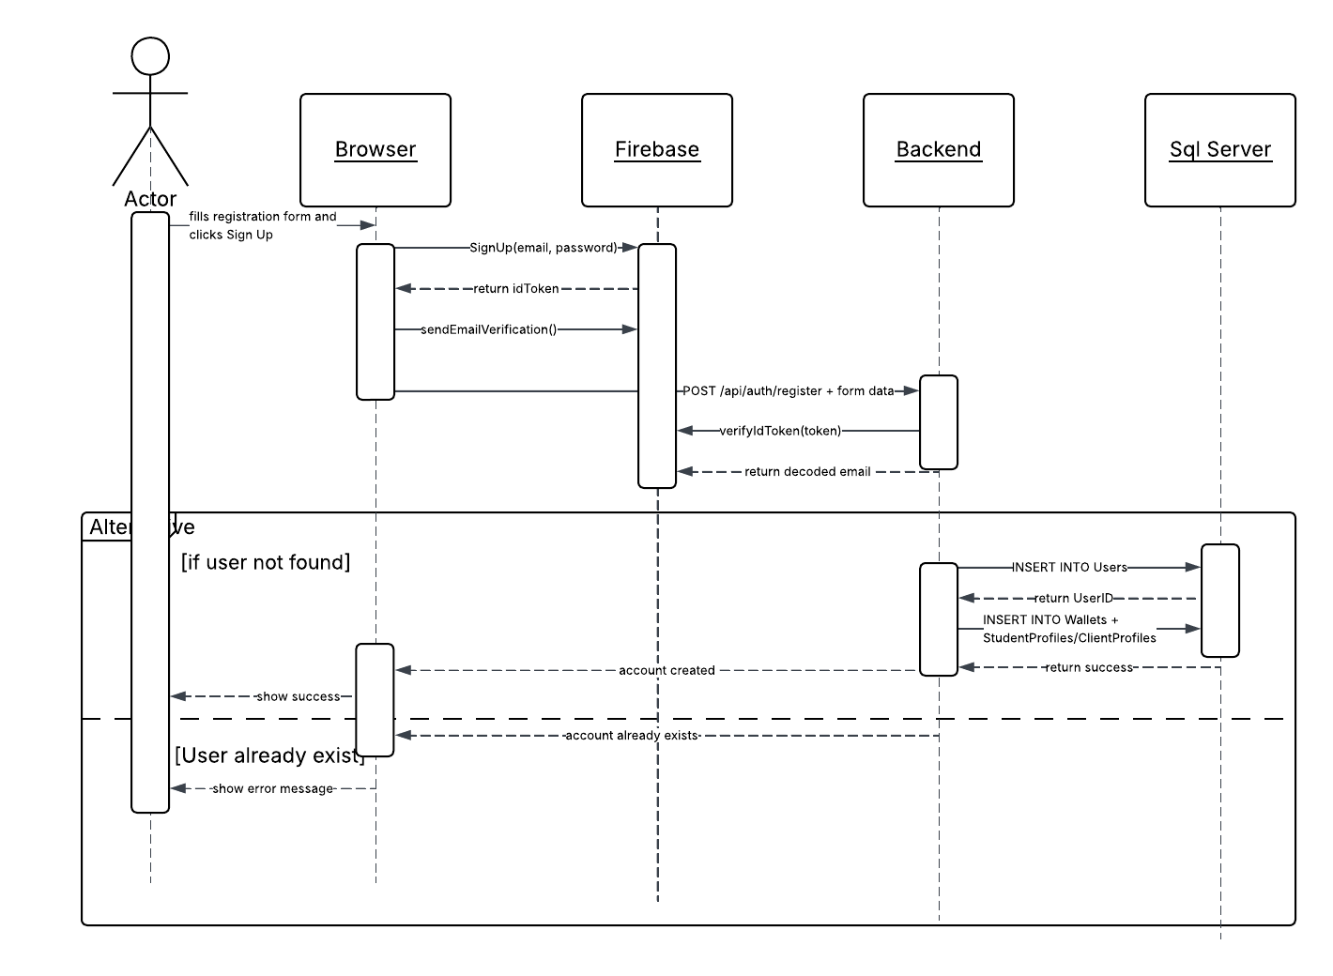

2) Create Gig
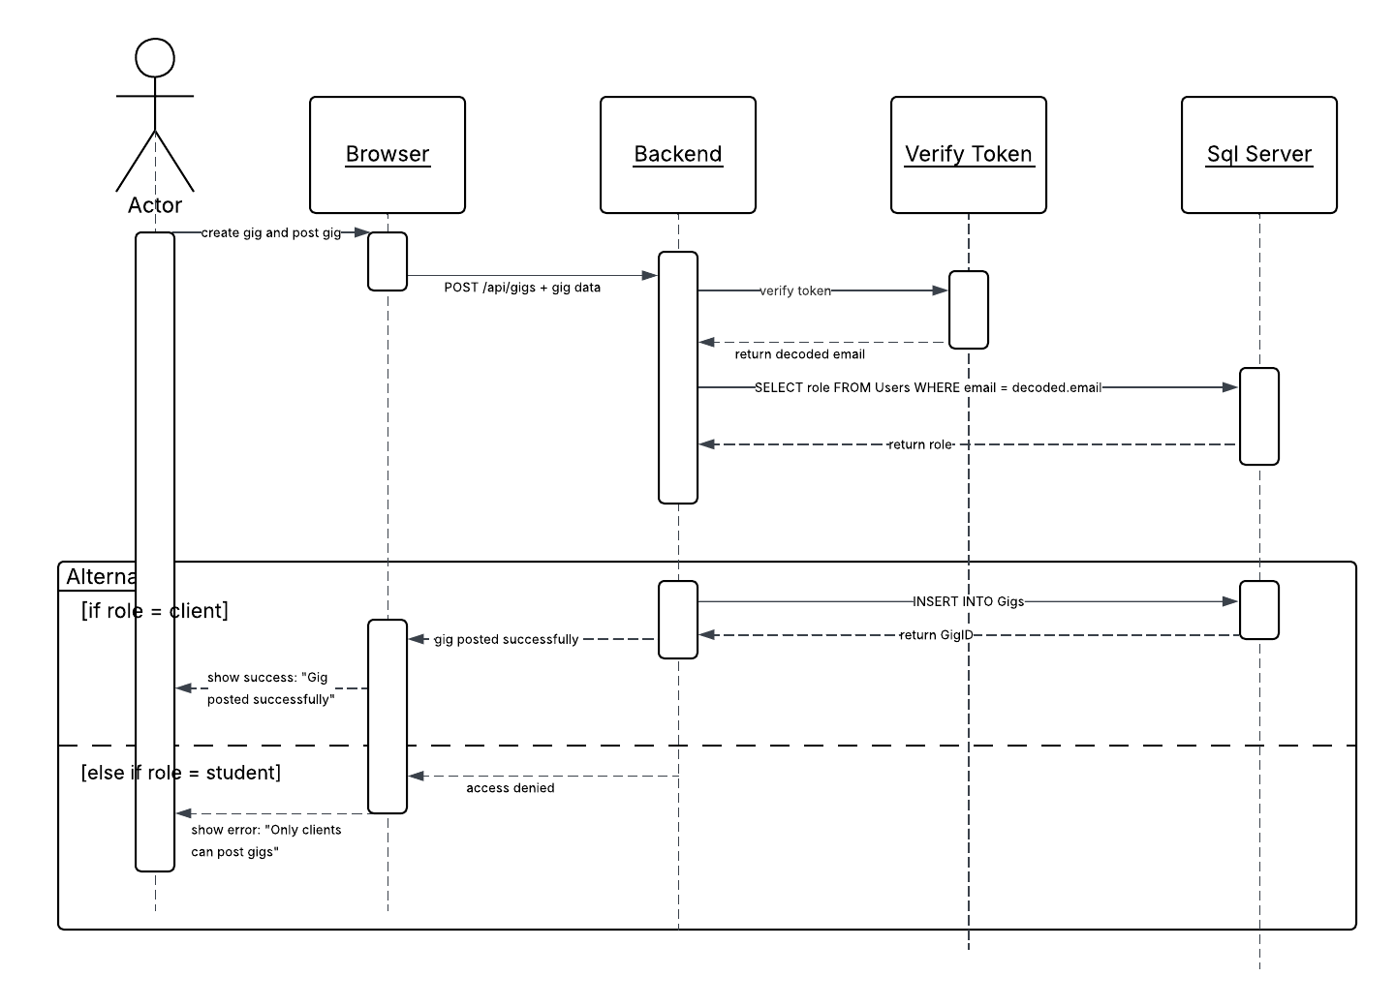

3) Profile Update & CV Upload
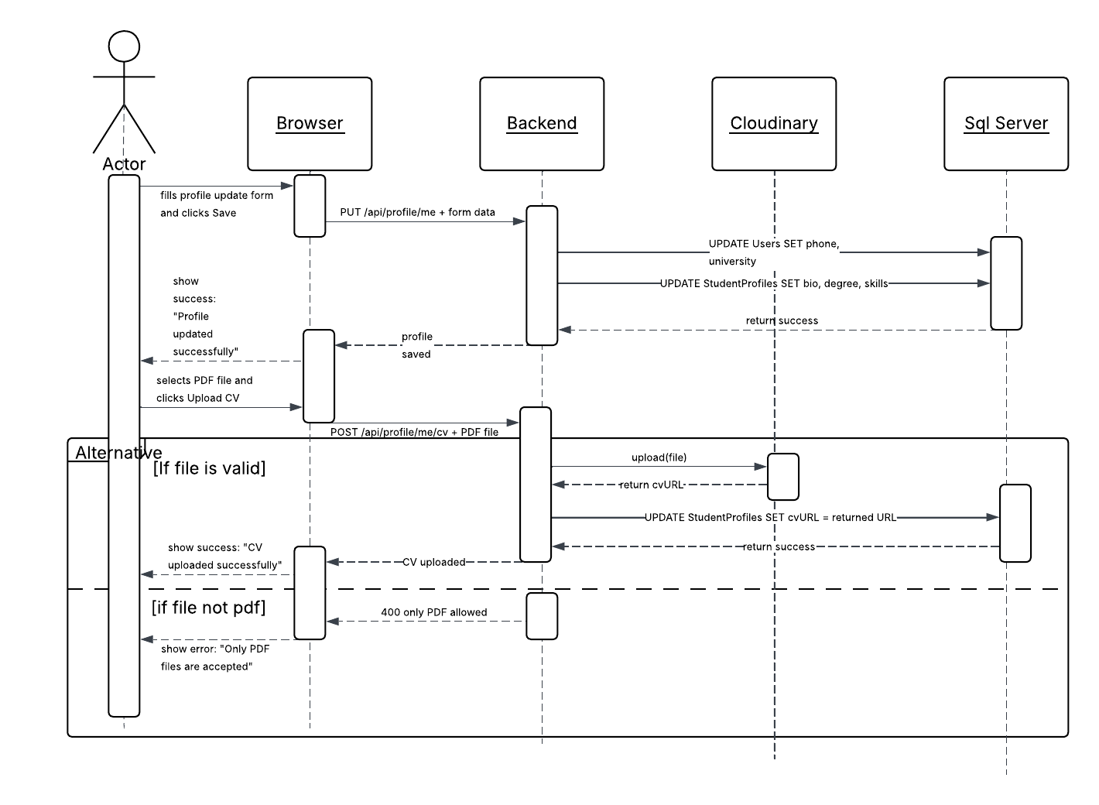

Use Case Diagram:
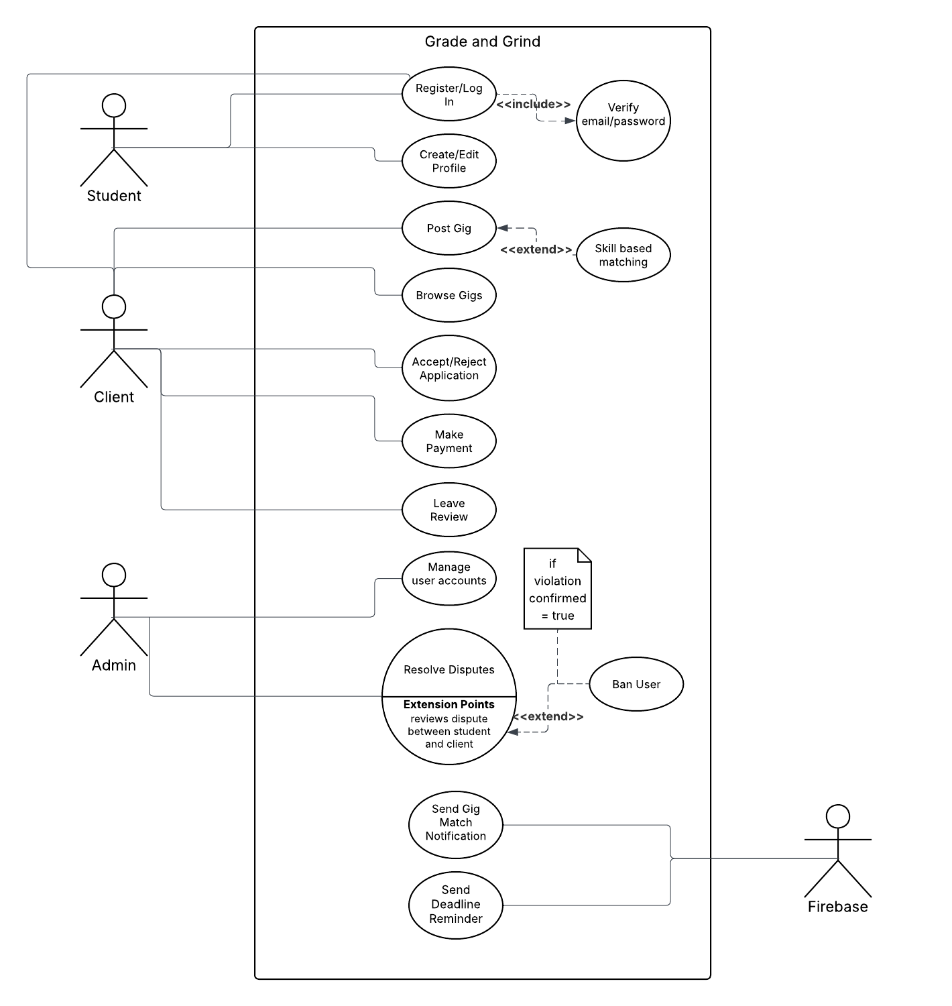
Class Diagram:
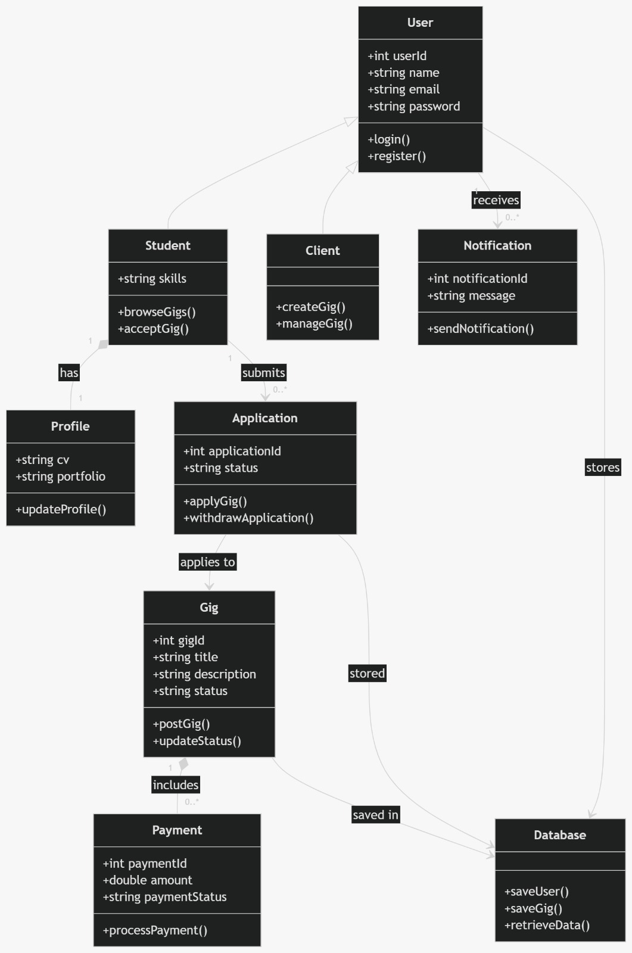

5. Scrum Board
Start:
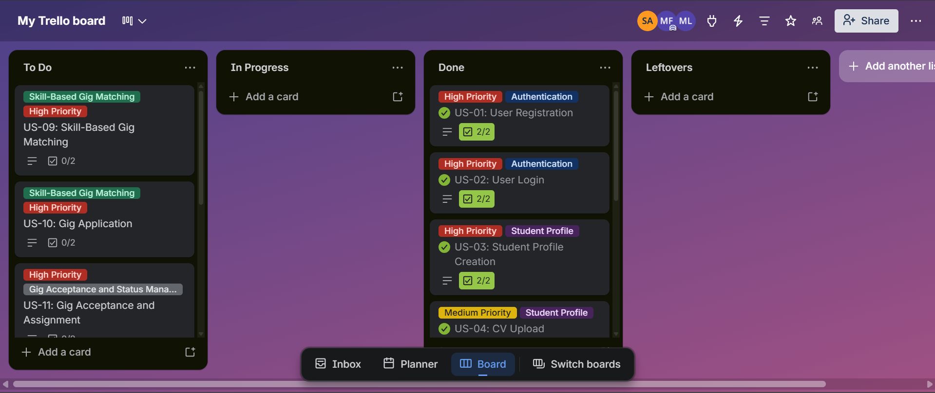
Mid:
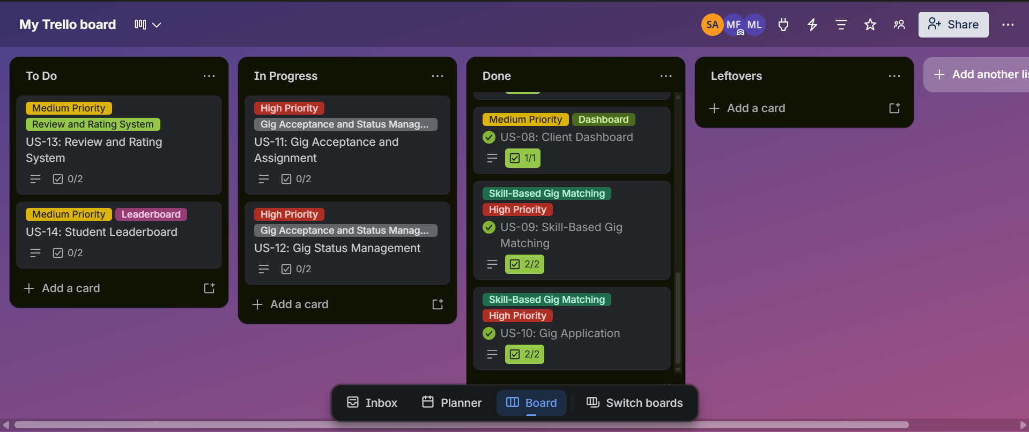
End:
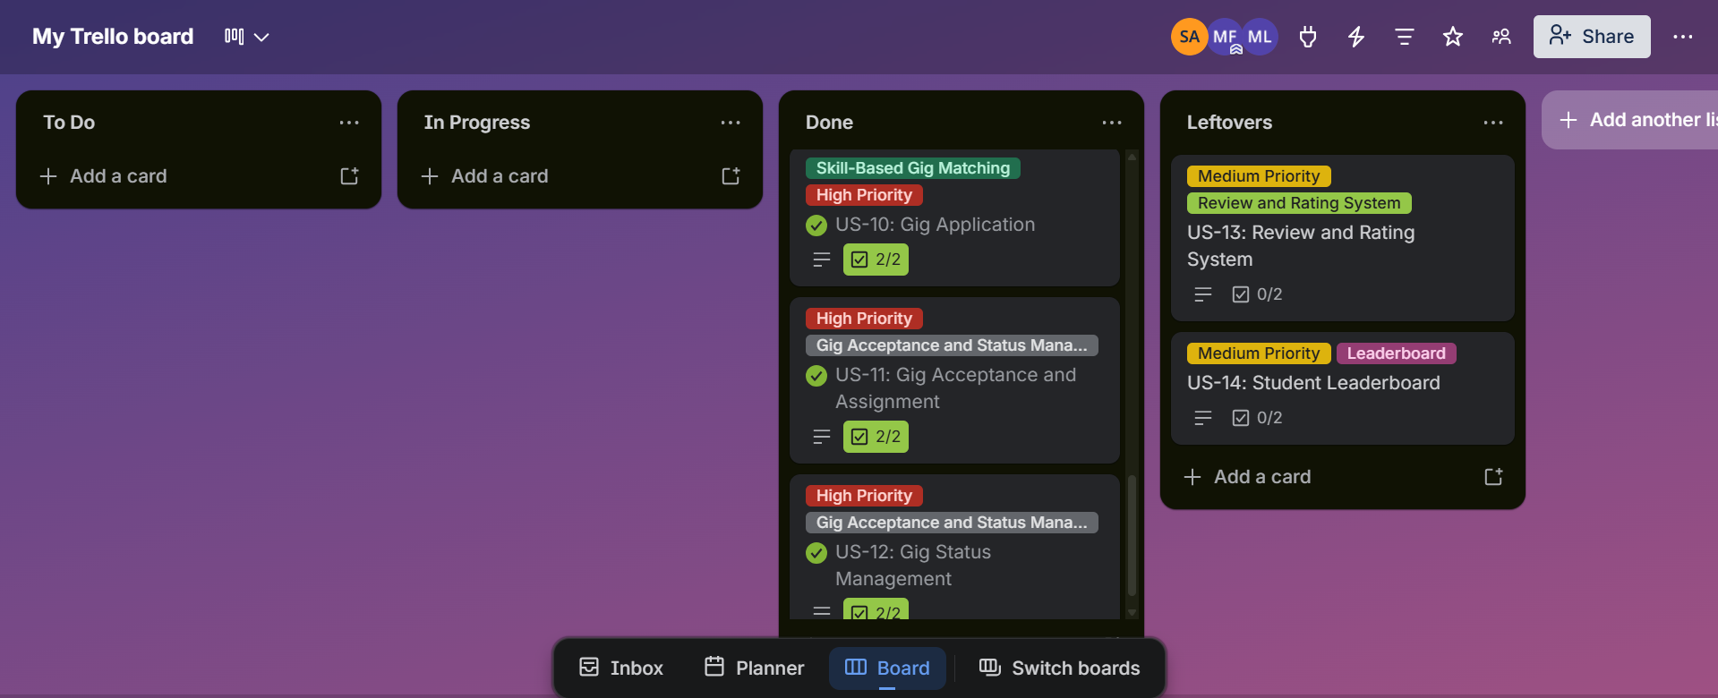

6. Work Division
Member | Role | Responsibilities
Sadeem | Project Lead | Skill matching
Mahnoor | Full Stack Dev | Acceptance workflow
Yousuf | Full Stack Dev | Status management, Testing

7. Implementation Screenshots
Student View:
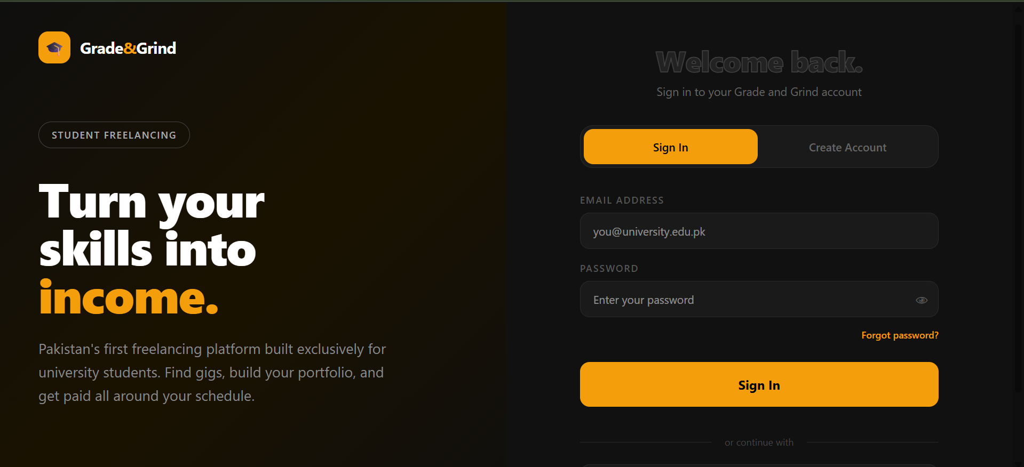
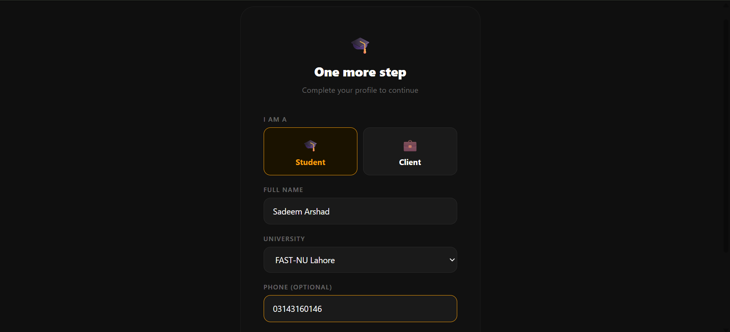
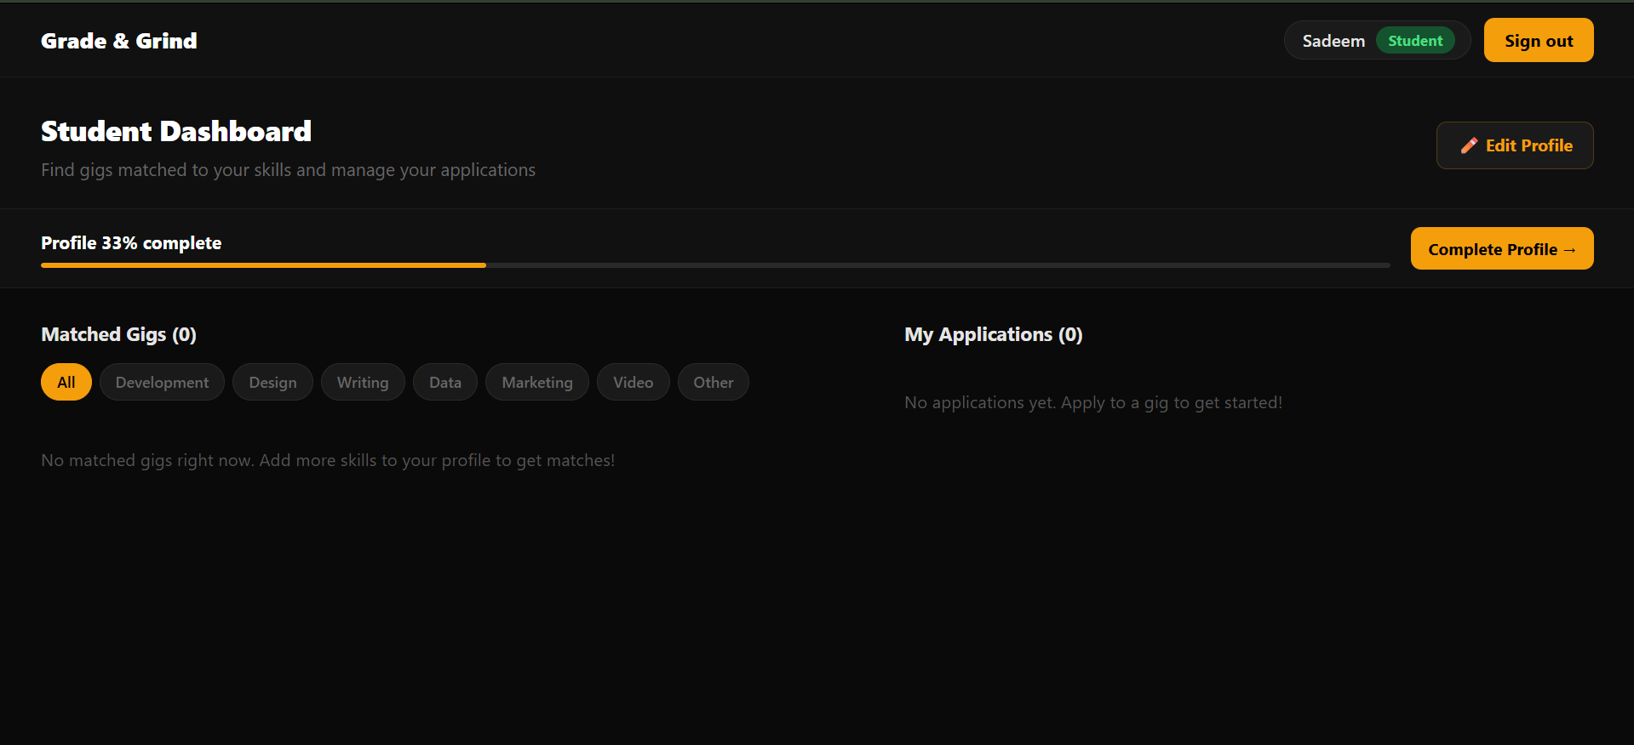
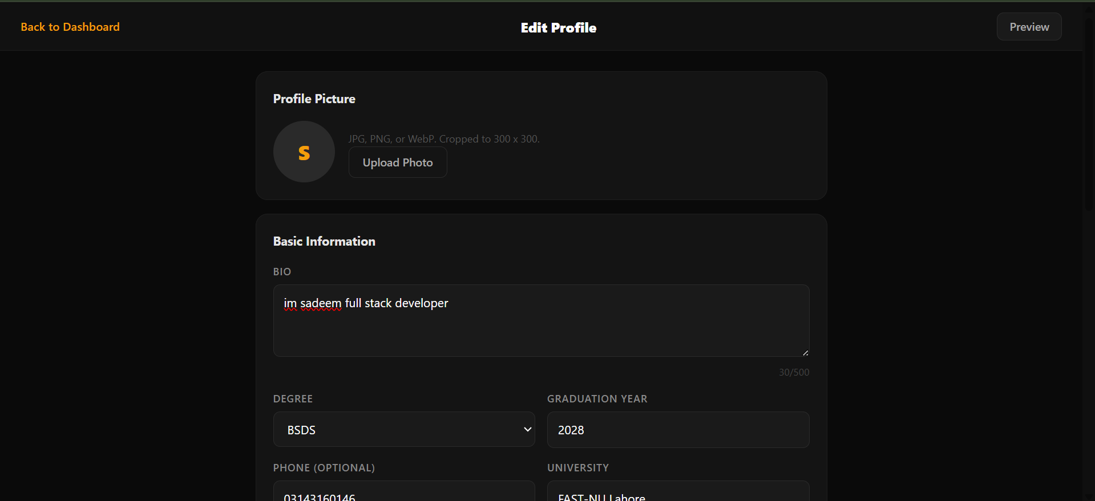
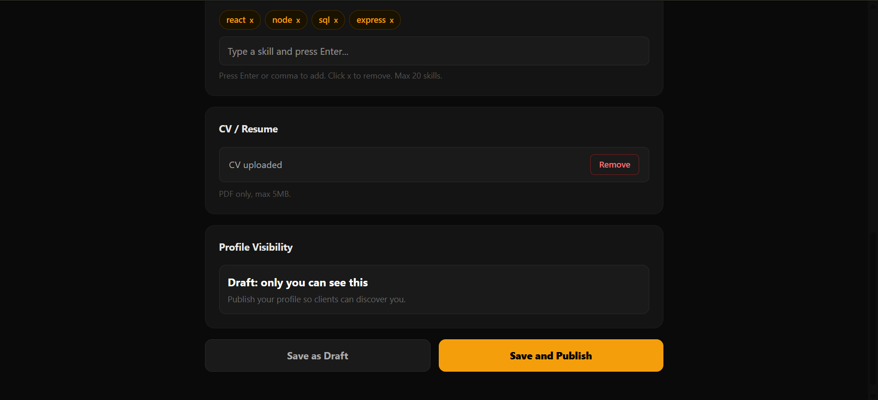
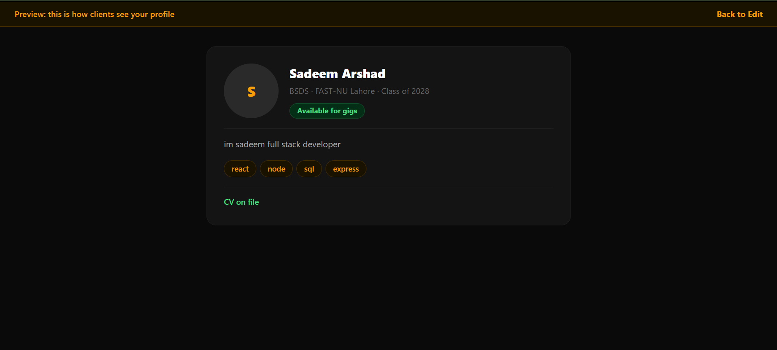
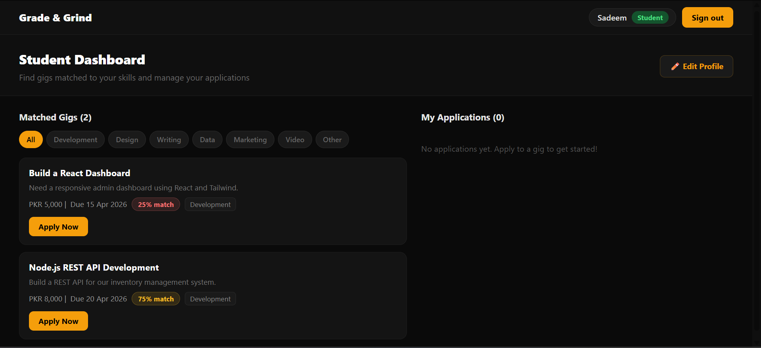
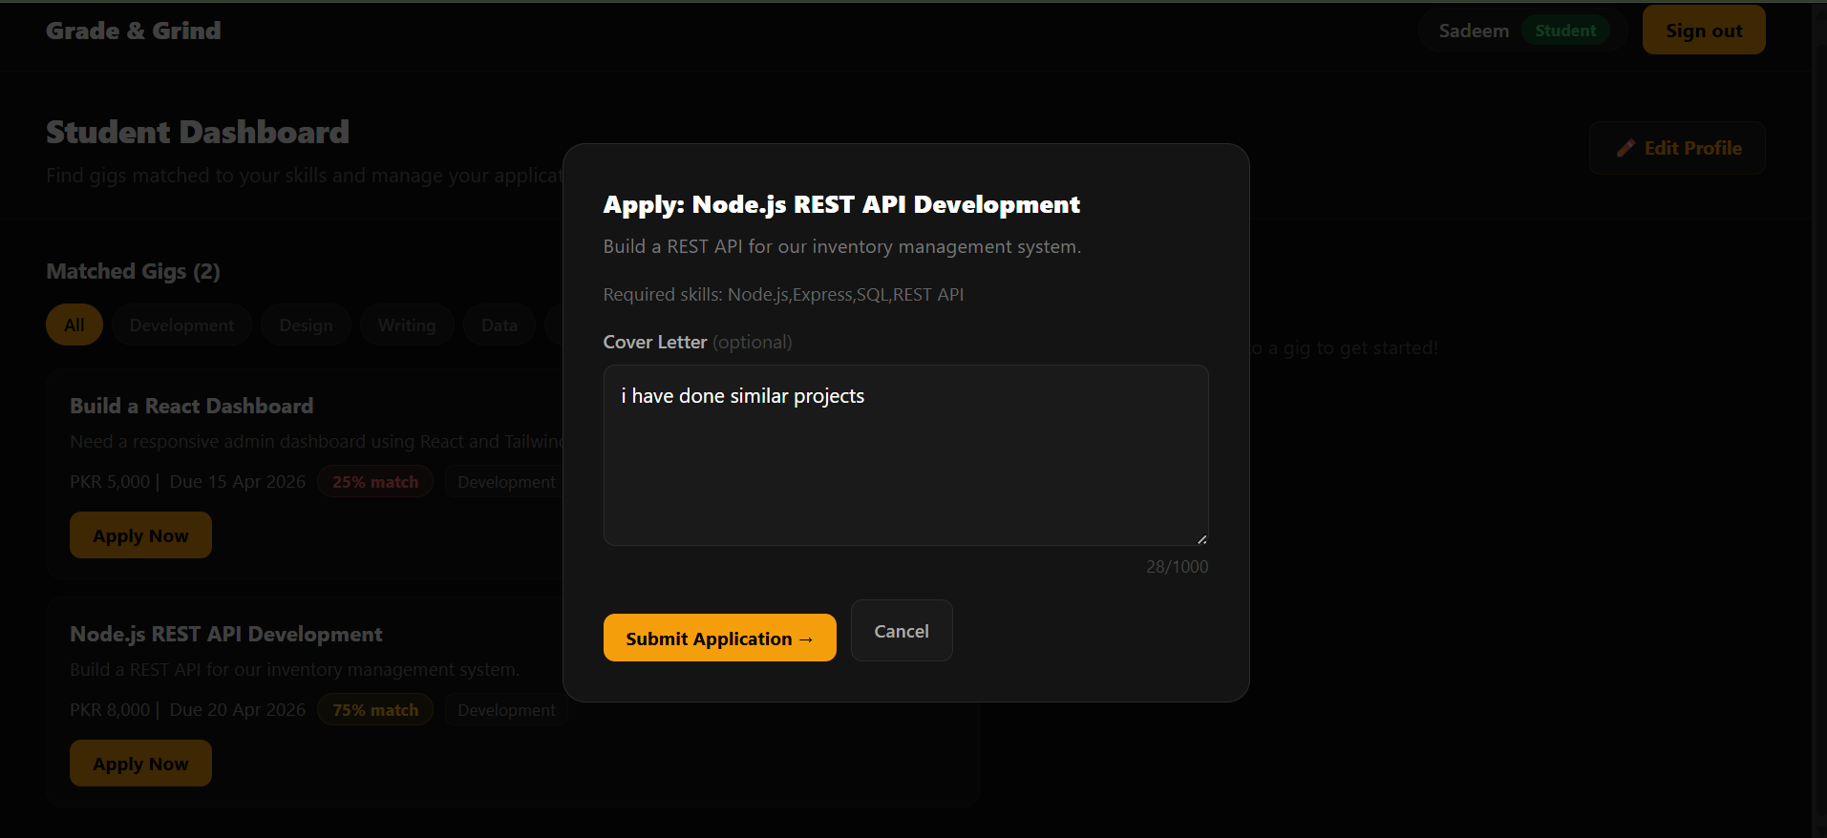
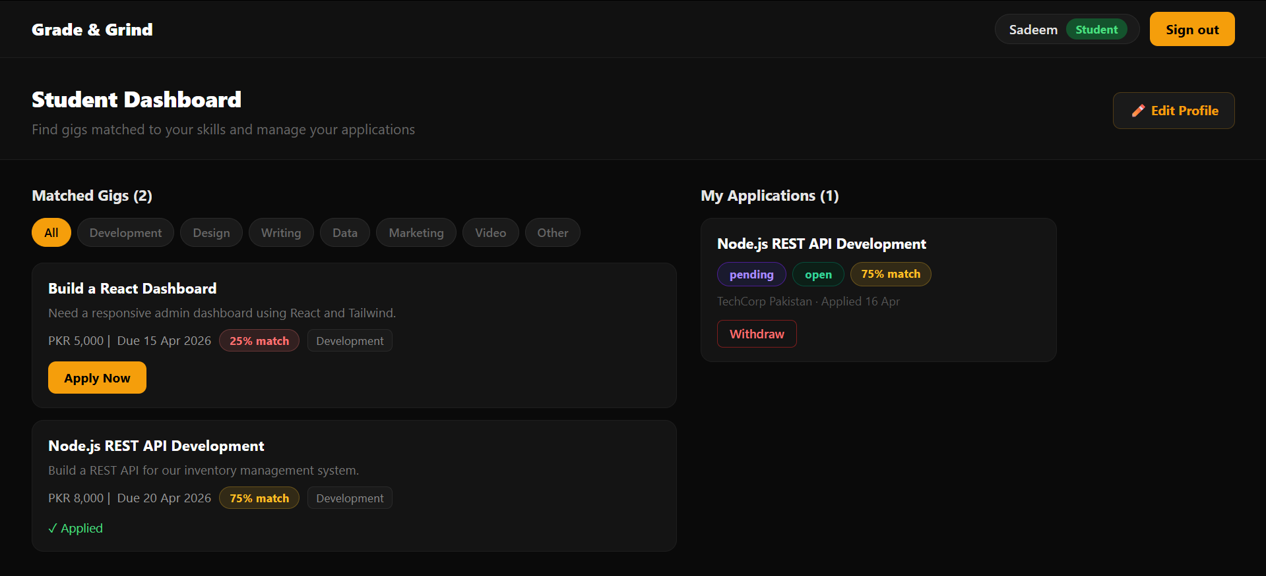

Client View:
