

School of Informatics & IT

Application Development Project (45%)
Database Application Development (35%)
(System Code Implementation)
AY 25/26 Oct Semester
Project 2 Report

Contents
Declaration of Originality 3
ADEV Part 2: System Code Implementation (45%) 5
Frontend Features Implementation (25%) 6
User Interface (10%) 6
Additional Feature (5%) 7
DBAV Part 2: System Code Implementation (35%) 8
API Implementation (20%) 9
Additional Feature (5%) 9
Error Handling (10%) 10

SCHOOL OF INFORMATICS & IT

Diploma in [Applied Artificial Intelligence]

Project 2 Report

Student Name (Matric Number) : Mohammed Hannan Noor (XXXXXXXX)

Tutorial Group : PC23
Jenny LING (TP)
Tutor : Alfred Teng

Submission Date : 8/2/2026

Declaration of Originality

I am the originator of this work and I have appropriately acknowledged all other original sources used as my references for this work.

I understand that Plagiarism is the act of taking and using the whole or any part of another person’s work, including work generated by AI, and presenting it as my own.

I understand that Plagiarism is an academic offence
and if I am found to have committed or abetted the offence of plagiarism in relation to this submitted work, disciplinary action will be enforced.

Declaration on the use of Generative AI tools for assignments

Describe how you have used Generative AI tools such as ChatGPT or Dall.E- in your assignment.

Share the link to the conversations you had with the AI tool (i.e., the prompts you used and the responses you get from the AI tool).

Please refer to this PDF on “How to share the conversations made with ChatGPT?”
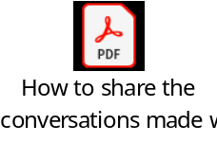

https://chatgpt.com/share/6988af30-e2c0-800e-aa43-c11fa5e55c1a

I used ChatGPT as a tutor to help explain JavaScript and CSS concepts to help develop my project. For example, I asked questions about form validation, error handling with status codes and formatting dates. The AI tool helped me understand these concepts which I then implemented myself in my own code. This allowed me to improve my understanding of web development to help me do my project while still designing and writing the solution independently. ChatGPT was used for explanation rather than direct code generation.

How do you indicate the reference?
The content generated by AI tools are not retrievable except by the user who generated them, so they are considered non-recoverable sources. Although non-recoverable data or quotations in APA Style papers are usually cited as personal communications, with ChatGPT-generated text there is no person communicating. Quoting text from ChatGPT chat is therefore more like sharing the output of an algorithm, with a reference list entry and the corresponding in-text citation.
According to the official APA Style site, ChatGPT references should be cited as:
E.g. OpenAI. (2024). ChatGPT (Feb 13 version) [Large language model].
https://chat.openai.com/chat

Note: The information in parentheses refers to the update or revision date of the model used. Refer to the release notes in the ChatGPT application.

Important Note:

- Do not copy answers produced by the AI tool in totality as it is considered as plagiarism.

- Do not rely on any information produced by the AI tool blindly. You should always verify the answer with other sources. Do not assume that these answers provided by the AI tool are correct.

- To achieve quality outputs from the AI tool, you should provide good prompt that is clear and specific. Be precise and provide context. Avoid asking open-ended questions.

ADEV Part 2: System Code Implementation (45%)

Frontend Features Implementation (25%)
List down all the URL to the different pages of the website.
Provide the sample input values if any.
URL | Purpose of the Page | Sample Inputs
http://localhost:8080/animal.html | User Home Page Gallery:  This page serves as the main entry point for adopters to browse the animal catalogue. It features dynamic filtering logic and interactive "cards" for each animal. Users can click "VIEW ANIMAL" to open a detailed profile or, if the pet is listed as 'Available', click "ADOPT ME" to be taken directly to the adoption application form. | Species Filter: Ferret  Status Filter: Available
http://localhost:8080/animalDetail.html | Detailed Profile and Gallery Page:  This page provides an in-depth look into a specific animal’s personality, age, temperament, gender, and adoption status. It also features an interactive image gallery where users can change the main display image by clicking the thumbnails to toggle between multiple photos and get a better view of the animal. | URL Parameter:  ?animal_id=3  Eg. (http://localhost:8080/animalDetail.html?animal_id=3)  (clicking on an animal in the home page automatically populates its ID in the URL to link the request.)
http://localhost:8080/addAnimal.html  http://localhost:8080/addAnimal.html?isadmin=true | Animal Creation Page:  This page is designed for both admin and public users to contribute to the website by registering new animals. It features a dynamic form that allows users to add all necessary information, a mandatory default image and optional additional images. The animal can later be viewed in the homepage/animal detail page. The header/Navigation bar of the page will also update dynamically depending whether the user came from a public page or admin page, ensuring correct navigation options are shown for each user context. | Name: Scamper  Age: 2 years 4 months  Species: hamster  Breed: Roborovski Dwarf  Gender: Male  Temperament: Playful  Adoption Status: Available  Default Image URL : https://images.squarespace-cdn.com/content/v1/610851f3364430278ffc5dcb/c9238cf3-0b5f-45a0-b146-c65a1b7a0adf/a-complete-guide-to-roborovski-hamsters.jpg?format=1500w  Additional image URL: https://pethelpful.com/.image/c_fill,w_1200,h_1200,g_faces:center/MjEyMTg4NTc0MjIzNzA1NjA5/roborovski-hamster-yellow.jpg
http://localhost:8080//admin.html | Admin Home Page Gallery:  This page is the homepage for administrators to manage the animal catalogue. It also features dynamic filtering logic to help admins quickly narrow down animals by species or adoption status. The page also contains interactive “cards” for each listing. From each card admins can click “EDIT” to update an animal’s details or “DELETE” to remove the animal from the system. | Species Filter: Ferret  Status Filter: Available
https://localhost:8080//editAnimal.html | Admin Animal Edit Page:  This page allows admins to modify existing animal listings in the system. It presents a pre-filled dynamic form where admins can update an animal’s details, change its adoption status and manage images by replacing the default image or adding/removing additional images in case details were input incorrectly or outdated. All changes are reflected immediately on the admin and public-facing pages, ensuring animal information is accurate and up to date. | URL Parameter:  ?animal_id=10  Eg. (http://localhost:8080/animalDetail.html?animal_id=10)  Name: Tom -> Tommy  Age: 6 years 6 months -> 6 years 7 months  Species: Rabbit (unchanged)  Breed: Lionhead -> Angora  Gender: Male(unchanged)  Temperament: calm -> feisty  Adoption Status: Adopted -> Available  Default Image URL: /images/Bella.jpg ->  https://www.thetinyherd.com/wp-content/uploads/2022/01/Angora-Rabbits-scaled.jpg

User Interface (10%)
Provide screenshot(s) of the user interface for each of the core features.
Add more tables if required.

Feature: Display Animals in Home Page & Filter by Species and Adoption status (Animal Home Page, http://localhost:8080/animal.html)
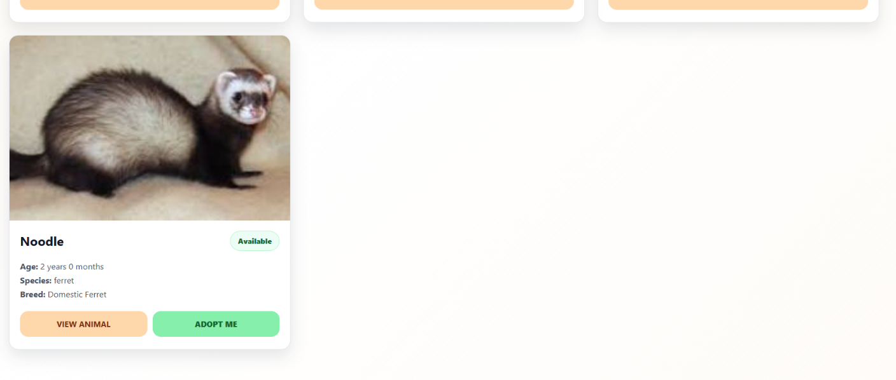
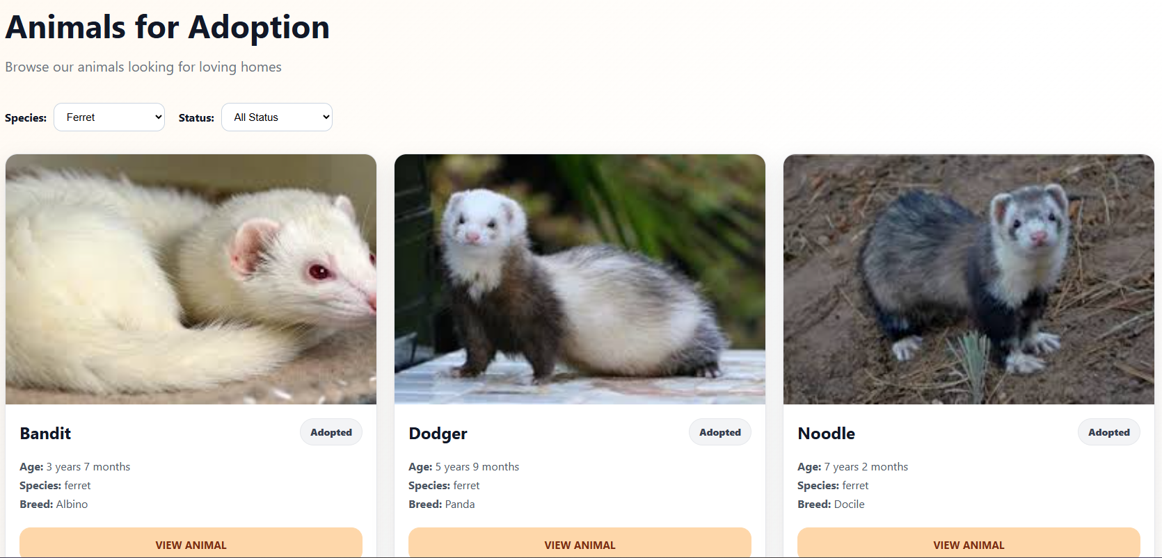
Filter by Species Ferret

Feature: View Animal Details (Animal Detail Page, http://localhost:8080/animalDetail.html)
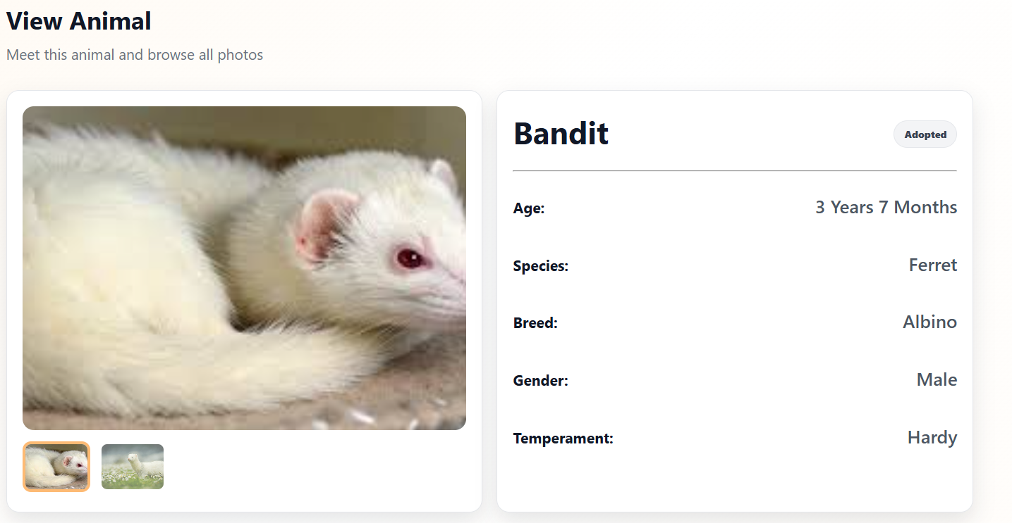
Click on Thumbnail to view full size image

Feature: Add a Animal (Add Animal Page, http://localhost:8080/addAnimal.html)
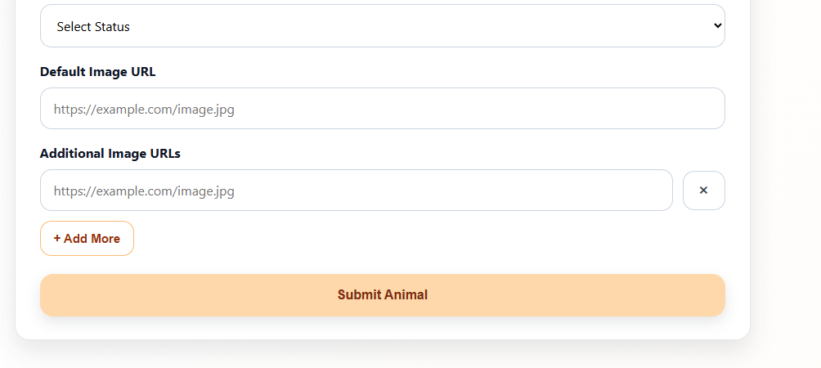
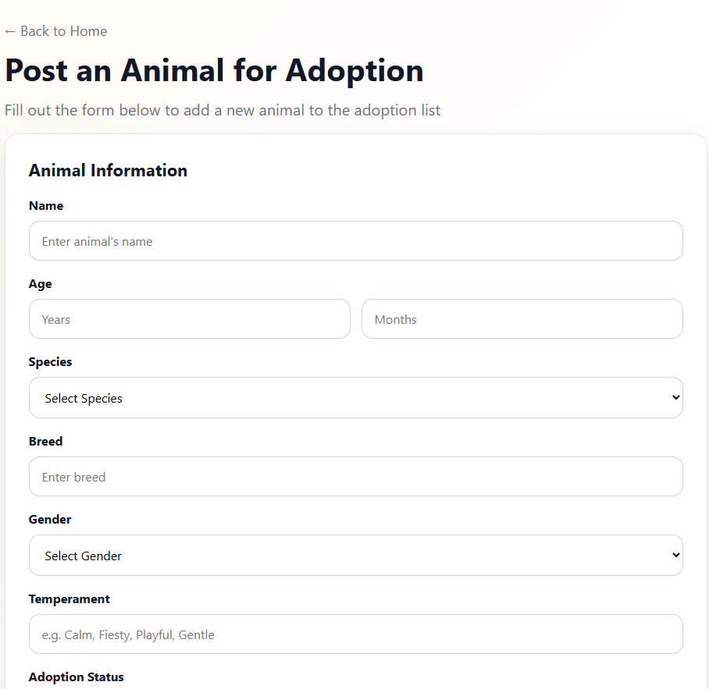
Click to remove additional fields
Click to add more fields for additional image URLs
Click on Thumbnail to view full size image

Feature: View Animals (admin view) (Admin Homepage, http://localhost:8080/admin.html)
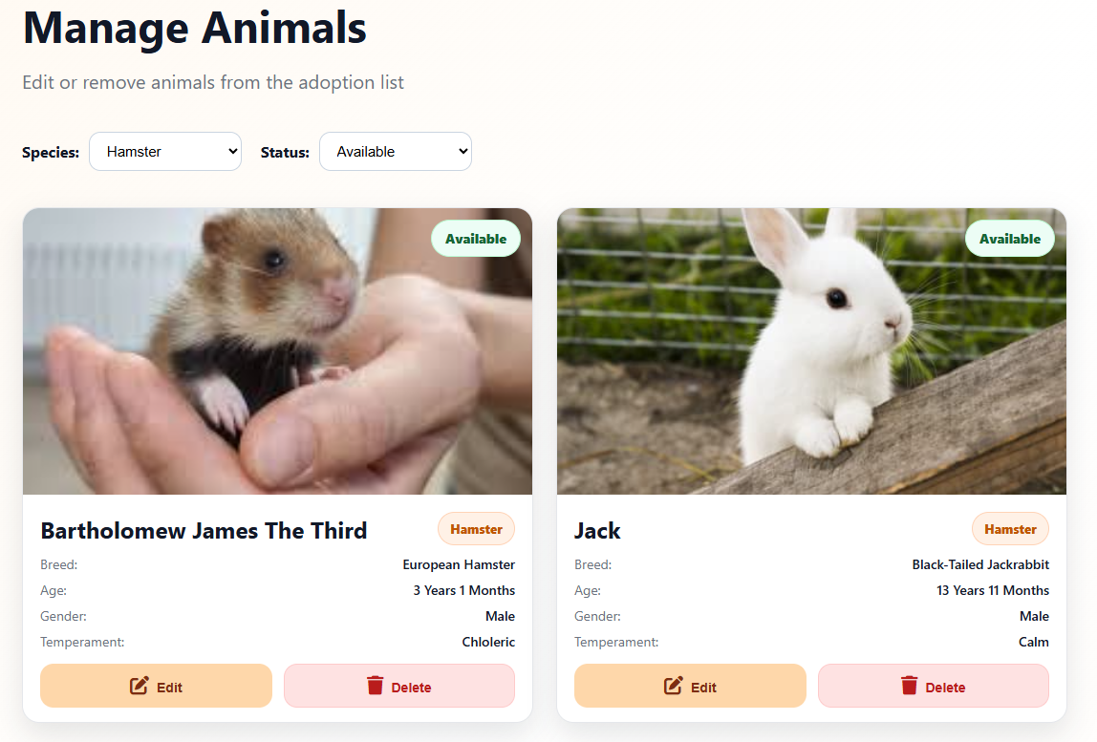
Click to Delete the Animal
Filter by Species: Hamster and Status: Available

Feature: Edit Animal Data (Edit animal page, http://localhost:8080/editAnimal.html)
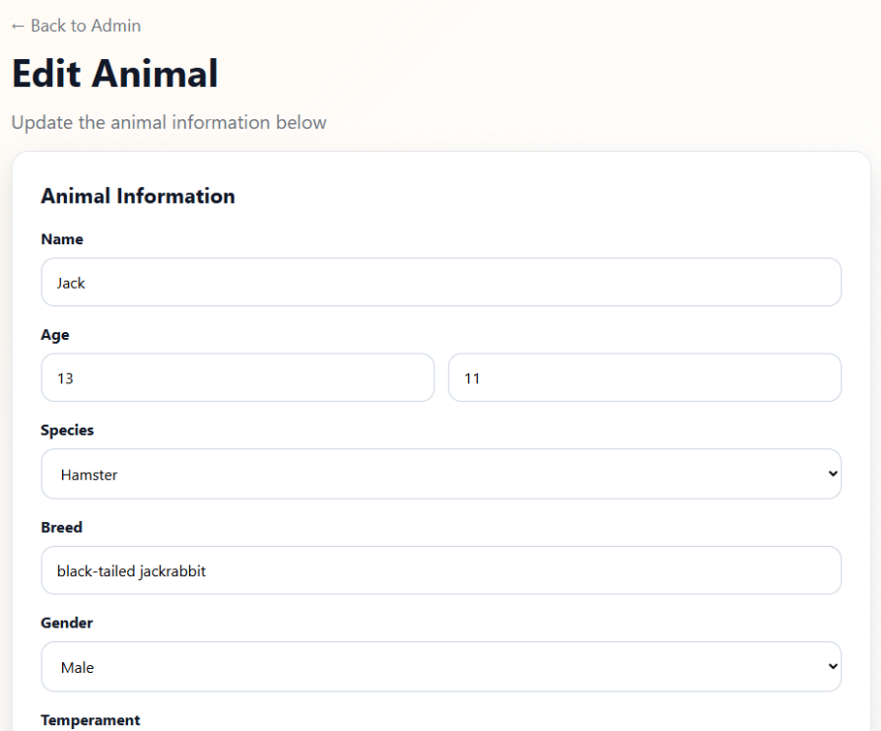
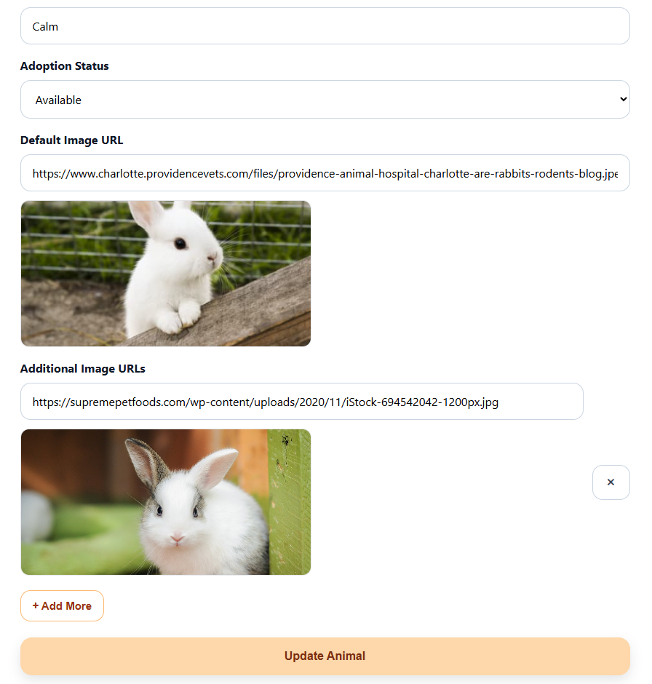
Click to delete additional image
Filter by Species: Hamster and Status: Available

Additional Feature (5%)
Provide screenshot(s) of the additional feature.
Explain how the additional feature enhances your website. Limit your explanation to no more than 150 words :
Additional Feature: Adoption Application System (Application and Application Management)
Page URLS’s:
Adoption Application Form : http://localhost:8080//adoptionForm.html
Application Management Page : http://localhost:8080//manageApplications.html

Screenshots:
Animal Card
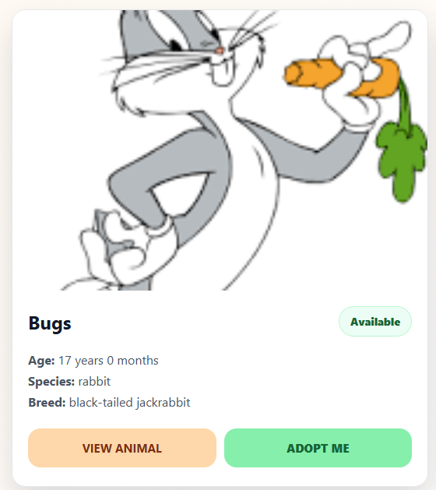
Button to go to adoption application page (only appears for animals which adoption status is available)
Adoption Form
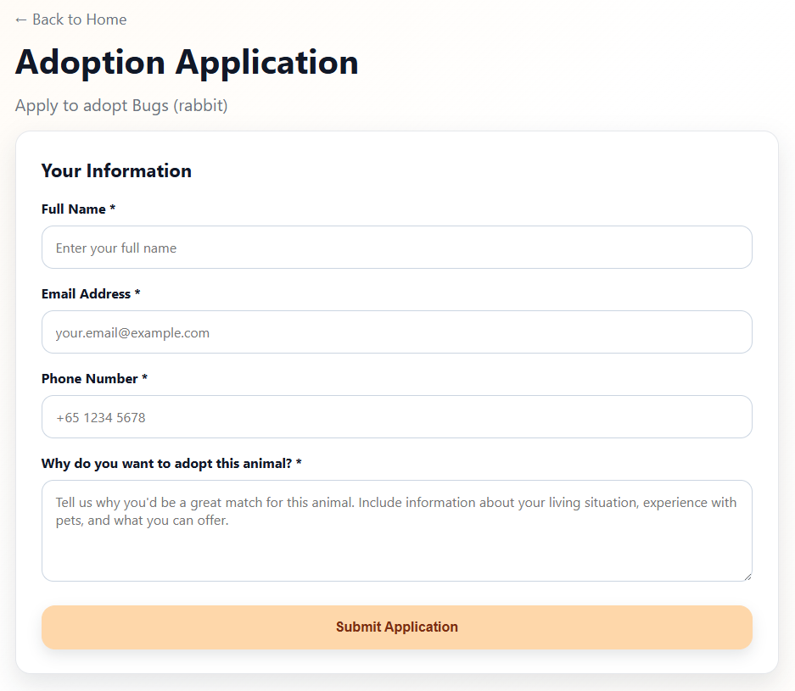
Button to go to manage applications page, number on top right shows number of pending applications
Header

Manage Applications
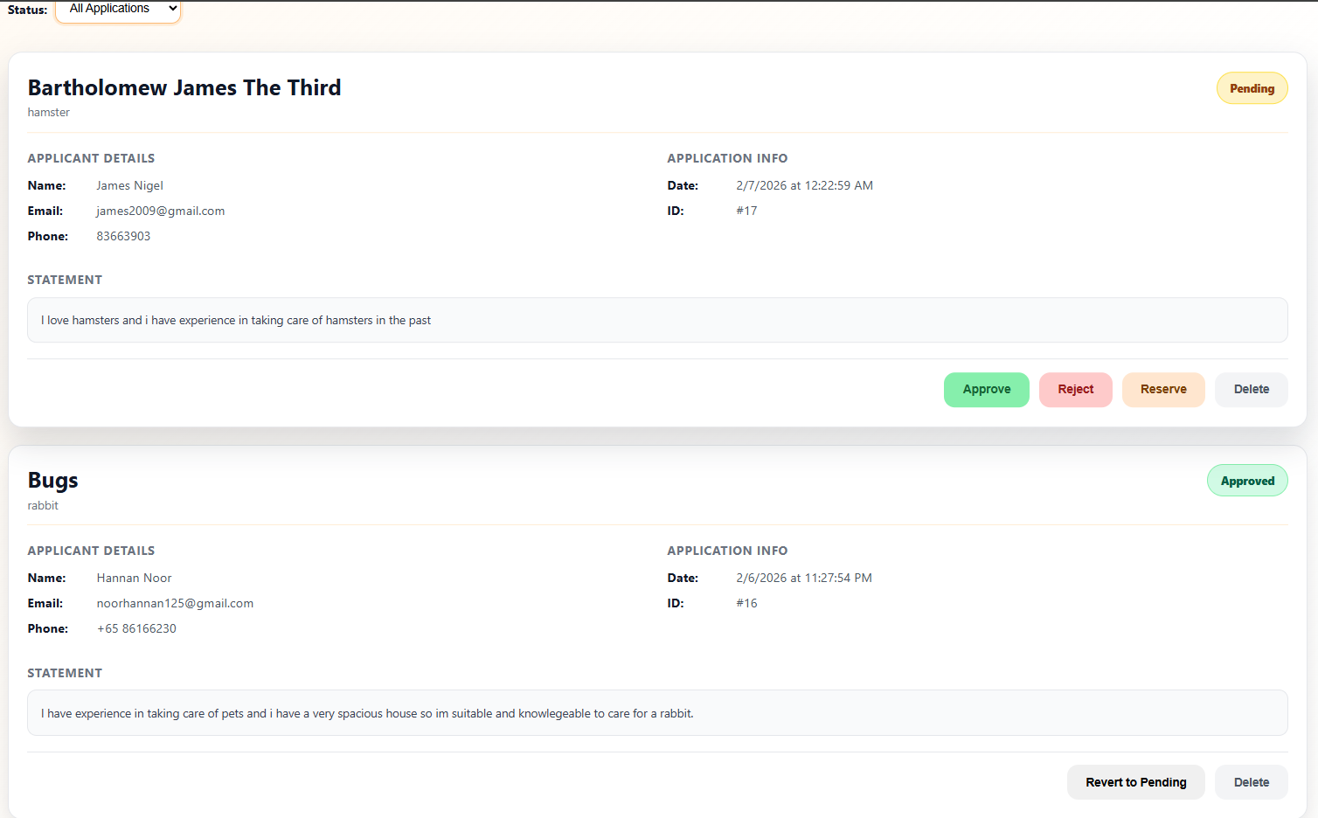
Shows status of application( i.e approved, reserved, rejected)
Admins can approve, reject applications or set the application to reserved

Explanation:
Previously approved, reserved and rejected applications can be reverted to pending(reset)
The adoption application system enhances the website by allowing adopters to submit adoption requests directly through the platform. From the animal listing and detail pages users can apply for animals marked as available. This creates a smoother and more interactive adoption flow, as users no longer need to rely on external forms or manual processes like going to the adoption centre to express interest.
On the admin side a dedicated management page is provided to review incoming adoption applications in one place. Admins can approve, reserve, or reject applications based on suitability, helping them manage adoptions more efficiently. A navigation button in the admin header also displays the number of pending applications, helping admins stay aware of new applications without needing to check multiple pages. Overall, this feature improved the website by making the adoption process more organised, purposeful and closer to how a real adoption website would function.

DBAV Part 2: System Code Implementation (35%)

API Implementation (20%)
Write out the related SQL statement, route pattern, HTTP method and payload (if any) for every functionality (except those related to the additional feature) that your web application has. You will demonstrate to your Lecturer if the functionalities work using Postman based on the routes you created in the route file, and the functions that you wrote in the controller and DB files.

Functionalities of Web Application | Related SQL code  (Full and complete SQL Statements, not partial) | URL Route Pattern | Payload | HTTP Method | Result From Postman  (Pass/Fail)  (To be filled by Lecturer)
Get all animals with their default images and species. | SELECT animal.*,  animal_images.image_url,  animal_species.species_name  FROM animal LEFT JOIN  animal_images ON  animal_images.animal_id =  animal.animal_id AND  animal_images.is_default = 1  LEFT JOIN animal_species  ON animal.species_id =  animal_species.species_id | /animal | N.A. | GET
Get the animal details of a certain animal by animal ID. (including default image and species) | SELECT animal.*,  animal_images.image_url,  animal_species.species_name  FROM animal LEFT JOIN  animal_images ON  animal_images.animal_id =  animal.animal_id AND  animal_images.is_default = 1  LEFT JOIN animal_species  ON animal.species_id =  animal_species.species_id  WHERE animal.animal_id =  ? | /animal/:animal_id | N.A. | GET
Get specific image by image ID | SELECT * FROM  animal_images WHERE  image_id = ? | /animal_image/:image_id | N.A. | GET
Get all images for  a specific animal | SELECT * FROM  animal_images WHERE  animal_id = ? | /animal/:animal_id/images | N.A. | GET
Get all species | SELECT species_id, species_name FROM animal_species ORDER BY species_name | /species | N.A. | GET
Add a new animal (without images) | INSERT INTO  animal_adoption.animal (name,  age_year, age_month, species_id,  breed, gender, temperament,  adoption_status) VALUES (?, ?,  ?, ?, ?, ?, ?, ?) | /animal | {"name":"Buddy", "age_year":3, "age_month":6, "species_id":1, "breed":"European Rabbit", "gender":"male", "temperament":"Friendly", "adoption_status":"available"} | POST
Add an animal image | INSERT INTO animal_adoption.animal_images (animal_id, image_url, is_default) VALUES (?, ?, ?) | /animal_image | {"animal_id":1, "image_url":"https://i.imgur.com/sVpKLV6.jpeg", "is_default":1} | POST
Update animal information (without images) | UPDATE animal_adoption.animal SET name=?, age_year=?, age_month=?, species_id=?, breed=?, gender=?, temperament=?, adoption_status=? WHERE animal_id=? | /animal/:animal_id | {"name":"Max", "age_year":4, "age_month":2, "species_id":1, "breed":"English Lop", "gender":"male", "temperament":"Playful", "adoption_status":"available"} | PUT
Update default image for an animal | UPDATE animal_adoption.animal_images SET image_url=? WHERE animal_id=? AND is_default=1 | /animal_image/default/:animal_id | {"image_url":"https://example.com/new-dog.jpg"} | PUT
Update a specific animal image | UPDATE animal_adoption.animal_images SET animal_id=?, image_url=? WHERE image_id=? | /animal_image/:image_id | {"animal_id":1, "image_url":"https://i.imgur.com/sVpKLV6.jpeg"} | PUT
Update only the adoption status of an animal | UPDATE animal_adoption.animal SET adoption_status = ? WHERE animal_id = ? | /animalstatus/:animal_id | {"adoption_status":"adopted"} | PUT
Delete a specific animal image | DELETE FROM animal_adoption.animal_images WHERE image_id=? | /animal_image/:image_id | N.A. | DELETE
Delete an animal (cascades to delete related images) | DELETE FROM animal_adoption.animal WHERE animal_id = ? | /animal/:animal_id | N.A. | DELETE

Additional Feature (5%)
Write out the related SQL statement, route pattern, HTTP method and payload (if any) for the additional feature in ADEV Part 2:

Functionalities of Web Application | Related SQL code  (Full and complete SQL Statements, not partial) | URL Route Pattern | Payload | HTTP Method | Result From Postman  (Pass/Fail)  (To be filled by Lecturer)
Get all adoption applications with animal details | SELECT adoption_application.*, animal.name as animal_name, animal.species_id, animal_species.species_name FROM adoption_application LEFT JOIN animal ON adoption_application.animal_id = animal.animal_id LEFT JOIN animal_species ON animal.species_id = animal_species.species_id ORDER BY adoption_application.created_at DESC | /application | N.A. | GET
Get all Applications for a specific animal | SELECT * FROM adoption_application WHERE animal_id = ? | /application/animal/:animal_id | N.A. | GET
Submit a new adoption application | INSERT INTO animal_adoption.adoption_application (animal_id, applicant_name, email, phone, application_statement, status) VALUES (?, ?, ?, ?, ?, 'pending') | /application | {"animal_id":1, "applicant_name":"John Doe", "email":"john@example.com", "phone":"91234567", "application_statement":"I love animals and would provide a great home"} | POST
Update application status (approve/reject) | UPDATE animal_adoption.adoption_application SET status = ? WHERE application_id = ? | /application/:application_id | {"status":"approved"} | PUT
Delete an adoption application | DELETE FROM animal_adoption.adoption_application WHERE application_id = ? | /application/:application_id | N.A. | DELETE

Error Handling (10%)
Explain how you implemented the 2 (TWO) error-handling mechanisms on your server-side system, and why they are important. Provide examples to support your answer. Write a report on no more than 200 words PER mechanism:

Error handling 1: Database Error Handling with Try-Catch
How you implemented:
Database operations in server-side app routes are wrapped in try-catch statements to handle unexpected errors. This prevents the server from crashing when encountering an error, which is better than using “throw error” as it would crash the server. Instead, errors are caught and handled. When a database query is unsuccessful, instead of crashing, the server responds with a status code 500 (server-side errors) and a clear error message.
For instance, in the GET /animal app route, if the database connection fails or the SQL query encounters an error, the error is detected and a response with status 500 is given, with a message like “Failed to fetch animals.” All the GET, POST, PUT and DELETE app routes use the same mechanism to ensure the server keeps running when encountering an error.
Importance:
This is important to ensure the server stays up. Without try-catch error handling, a single database error would crash the server. By catching these errors and returning a response, the website remains up and other features function normally. This also helps with debugging and user experience, as the server returns clear error messages indicating something went wrong while ensuring the website stays up.

Error handling 2: Input Validation and Client Error Handling
How you implemented:
Input validation is implemented at the start of all PUT and POST app routes to ensure valid values are received. Required fields are checked to ensure they are not empty, and numerical values like age_year and age_month are validated using isNaN (checking that input is actually a number). If the validation fails, the server returns a status 400 response (Bad Request) as well as a relevant error message, preventing an invalid data from being added to the database.
For example, in the POST /animal app route, the server verifies that fields like name, breed, and species_id are provided and that age values are valid numbers. If any check fails, the request is rejected without executing the database query and an error message like “Missing Required Fields” is given.
Importance:
Input validation helps maintain data integrity by preventing invalid or incomplete data from being input into the database. It also prevents unnecessary database errors by stopping erroneous requests early. Clear status 400 errors also help to debug as it implies that the issue lies with user input rather than the server, making it easier for users to correct mistakes and for developers to troubleshoot effectively

