

School of Informatics & IT

CIT1C18 - Computational Thinking
AY 25/26 Apr Semester
Project 1 (30%) Report

Contents
Declaration of Originality 3
Section A - Task 1 - Location Selection and Visual Documentation (4%) 4
Section B – Task 2 - Flowchart Design (16%) 5
Section C – Task 3 – Route Justification and Evaluation (10%) 7

SCHOOL OF INFORMATICS & IT

Diploma in [Applied Artificial Intelligence]

Project 1 Report

Student Name (Matric Number) : Mohammed Hannan Noor

Tutorial Group :
Jenny LING (TP)
Tutor : Lee Jin

Submission Date :

Declaration of Originality

I am the originator of this work and I have appropriately acknowledged all other original sources used as my references for this work.

I understand that Plagiarism is the act of taking and using the whole or any part of another person’s work, including work generated by AI, and presenting it as my own.

I understand that Plagiarism is an academic offence
and if I am found to have committed or abetted the offence of plagiarism in relation to this submitted work, disciplinary action will be enforced.

Section A -
Task 1 - Location Selection and Visual Documentation (4%)

Take a photo of each location and insert the THREE (3) photos in the table below.

Location | Photo
Location 1  (Start Location) | 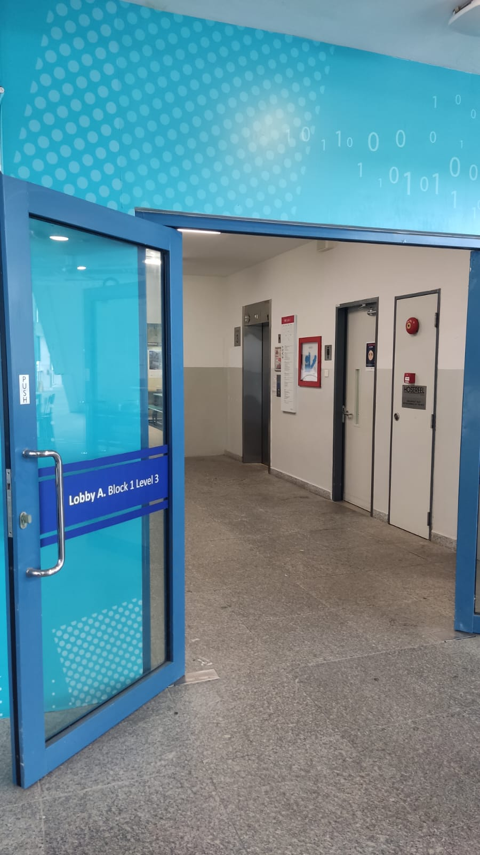
Location 2  (Little Skool House) | 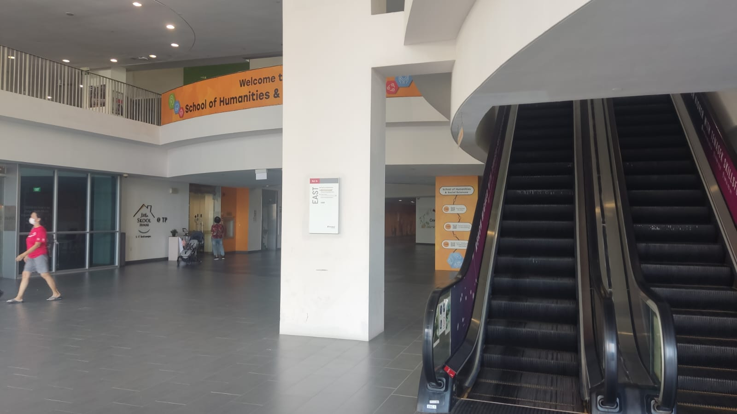
Location 3(Design Pad) | 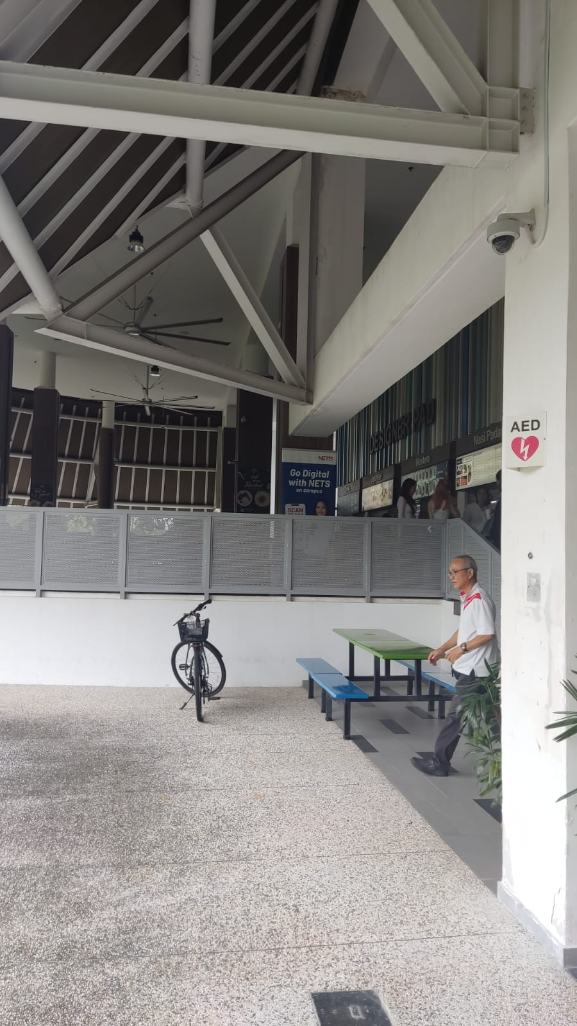

Section B –
Task 2 - Flowchart Design (16%)

Based on your selected locations from task 1:
- Take a screenshot of the TP Campus Map and plot out the routes to the locations.
(TP Campus Map - https://www.tp.edu.sg/about-tp/tp-campus-map.html)
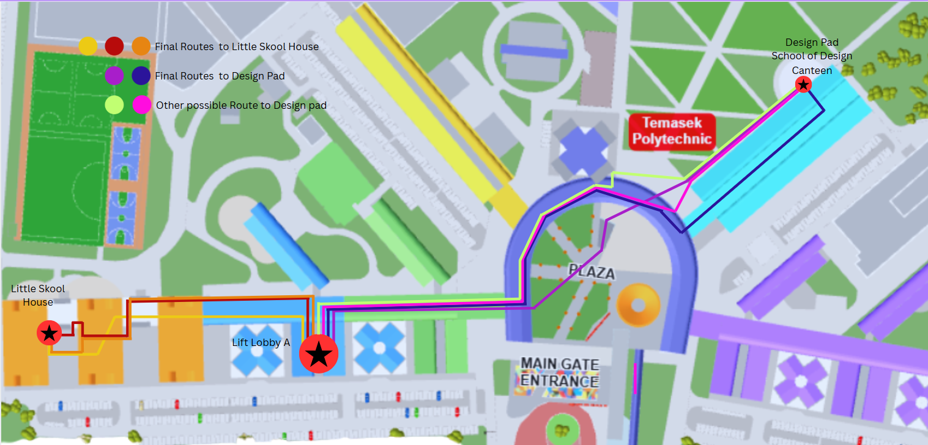

- Create a flowchart using the tool taught in class to illustrate a program.

You must limit your flowchart to no more than 60 blocks (decisions, actions, and input/output blocks combined), 15 decision blocks and 5 input blocks.

Here are the actions/instructions that you can use to guide the user:
- Walk straight towards [enter end point]
- Turn to face [enter location]
- Climb [x] level of the stairs up
- Climb [x] level of the stairs down
- Take [x] level of the lift up
- Take [x] level of the lift down

Your instructions should use nearby landmarks or recognisable points along the way to guide the user to the final destination. Avoid jumping directly to the final destination.

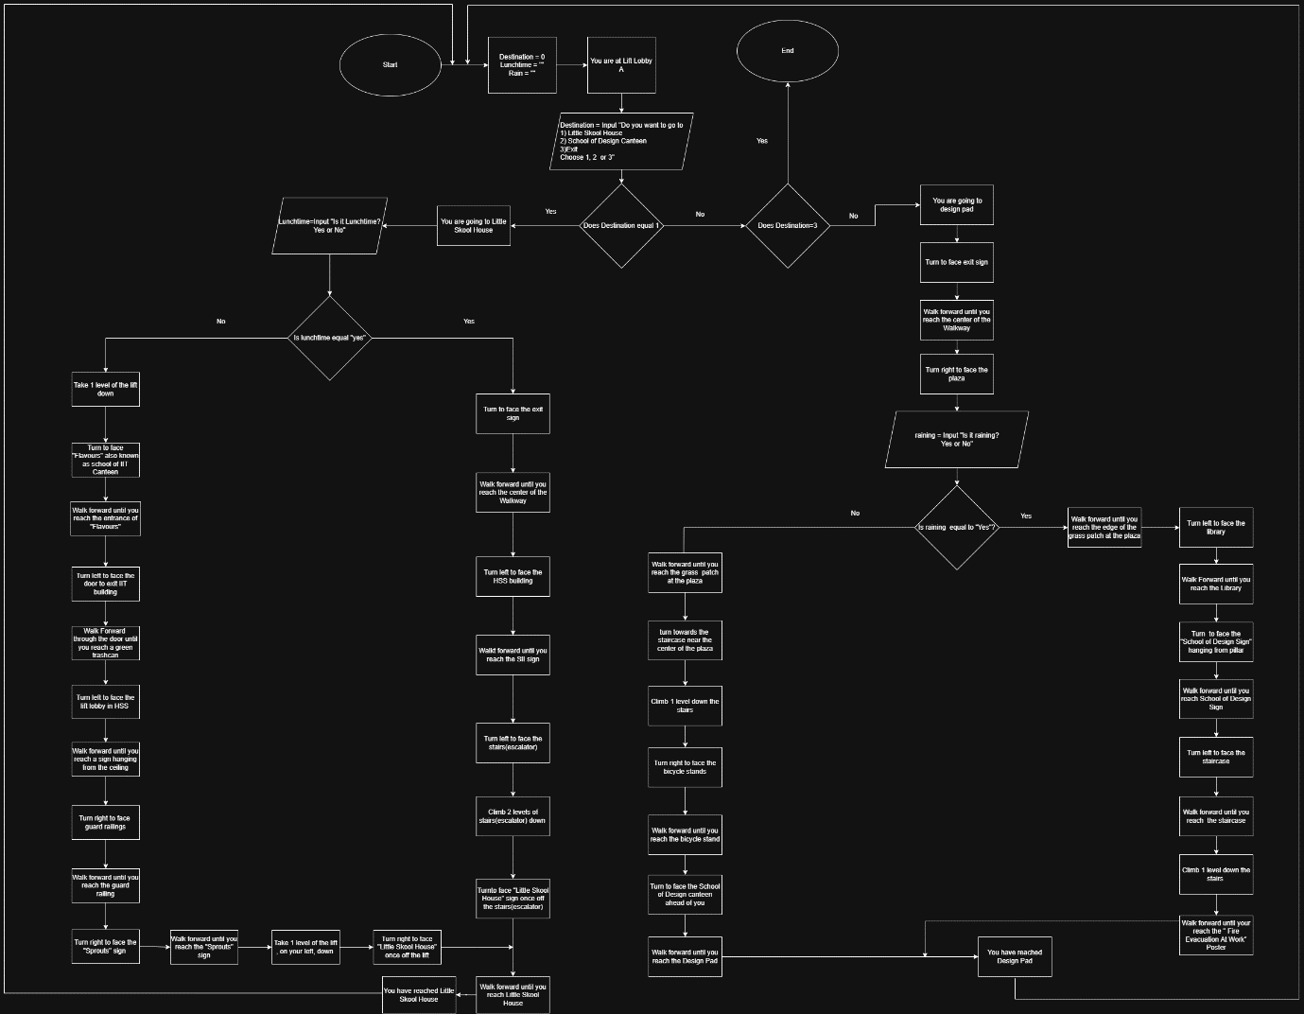

Total number of blocks: [55]

Section C –
Task 3 – Route Justification and Evaluation (10%)

After designing your flowchart, using the routes that you had mapped out to Location 3 and explain the following:

- Why did you choose these routes to reach Location 3 instead of other possible options. In your explanation, describe the different routes you considered, including the one you initially planned to take. Then, discuss how your choice was influenced or changed after considering real-world factors.

- What made you decide that these were the most suitable routes? What factors did you consider, and support your decision with data.

Your justification is not limited to just written words; you may include any data to support your decision.

You have a 500-word limit.
Routes | Route A (Final Route) | Route B(Final Route Sheltered) | Route C | Route D
Route Path:  (Routes are also illustrated on the campus map using matching colours.) | Lift Lobby A PlazaStaircase in PlazaBicycle Stand Design Pad (Destination) | Lift Lobby A Bench at edge of plazaLibrary School of Design Sign Staircase in School of Design Poster outside Design PadDesign Pad (Destination) | Lift Lobby A Bench at edge of plaza Library Staircase along pathway Bicycle Stand Design Pad (Destination) | Lift Lobby A Bench at edge of plazaStaircase next to library Bicycle StandDesign Pad (Destination)
Duration (Avg) | 3 Minutes 37 Seconds | 4 Minutes 42 Seconds | 4 Minutes 03 Seconds | 3 Minutes 54 Seconds
Navigation Difficulty | Easy | Hard | Medium | Medium
Other Remarks | Fastest Route, Exposed to Weather | Route is sheltered throughout | Partially Sheltered | Narrow stairs, crowded during peak hours

Why Route A?
Route A was chosen as the final route when it wasn’t raining. This is because it is the fastest route taking only 3 minutes and 37 seconds and is the easiest to navigate. There are clear landmarks like the bicycle stand and central plaza staircase which make it easy to follow. Other routes like Route C and Route D were considered but they have longer durations and are harder to navigate. Furthermore, Route D has a narrow staircase which can get congested during peak times making the journey less comfortable. Thus, Route A is the best route to take when it isn’t raining as it takes the most direct route and is the easiest to follow.
Why Route B?
Route B was selected as the final route during rainy weather. Although Route B is the longest route taking an average of 4 Minutes and 42 Seconds and is harder to navigate compared to other routes, it is fully sheltered ensuring users stay dry throughout. Initially, Route C was considered for when it was raining since it is shorter and is easier to navigate than Route B. However, it is only partially sheltered, leaving users exposed to rain. Route D was also considered but it is not sheltered at all, allowing users to get wet during adverse weather conditions. Thus, due to being fully sheltered Route B was chosen as the final route for when it is raining.
What factors were considered?
- Time taken (Measured using stopwatch)
- Shelter Availability
- Ease of Navigation(number of steps, number of recognisable landmarks)

