School of Informatics & IT
Diploma in Applied Artificial Intelligence
Machine Learning for Developers (CAI2C08)
AY2026/2027 April Semester
Program Codes
SUBMITTED BY:
(Name of student) | (Admin number)
Mohammed Hannan Noor | XXXXXXXX

Declaration of Originality
I am the originator of this work, and I have appropriately acknowledged all other original sources used as my reference for this work.
I understand that Plagiarism is the act of taking and using the whole or any part of another person’s work, including work generated by AI, and presenting it as my own.
I understand that Plagiarism is an academic offence
and if I am found to have committed or abetted the offence of plagiarism in relation to this submitted work, disciplinary action will be enforced.
(Name of student) | (Signature)
Mohammed Hannan Noor

AY2026-27 APRIL SEMESTER
Declaration on the use of Generative AI tools for assignments
Include the links of your Generative AI conversations below:
https://chatgpt.com/share/6a69ed36-9cb4-83ec-acf0-ab03209cfe35
Describe how you have used Generative AI tools such as ChatGPT or Dall.E-2 in your assignment.
Show snapshots of the conversations with the AI tool (i.e., the prompts you used and the response you get from the AI tool).
I used ChatGPT as a guide while developing and improving my Streamlit machine learning application. I asked it for suggestions on how to redesign the interface so it looked more like a proper dashboard, and for help implementing features such as a pulsing “LIVE” indicator and a floating churn-percentage card that stays visible while scrolling. ChatGPT provided explanations and example code, which I adapted to fit my own application and tested before adding it to the final project. I also used it to troubleshoot technical issues and understand steps such as running the Streamlit app and updating my GitHub repository.
For example, below is a snapshot of a conversation between me and ChatGPT where I ask it to assist me in debugging
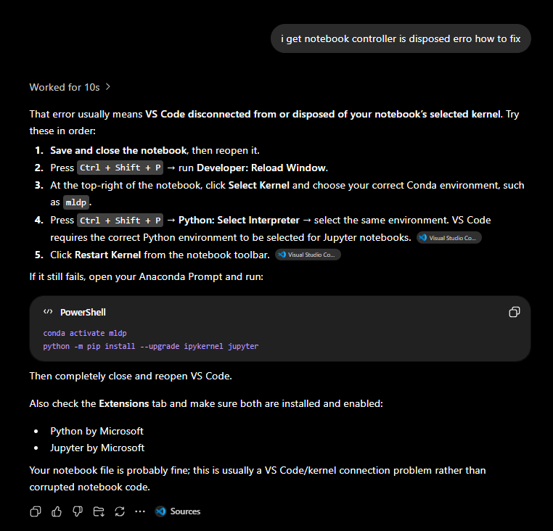
Below is another example where I ask ChatGPT to assist me to implement a flashing light in streamlit
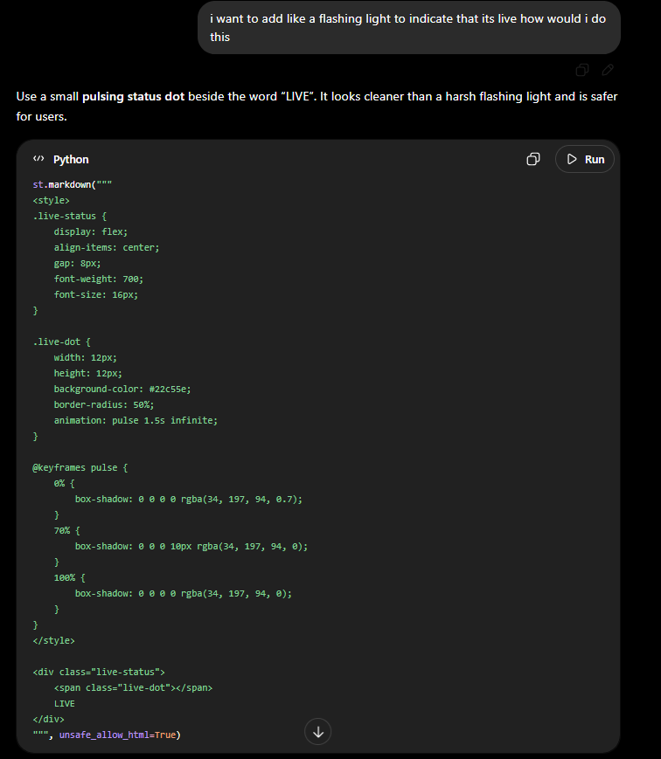
How to indicate the reference?
The content generated by AI tools is not retrievable except by the user who generated them, so they are considered non-recoverable sources. For non-recoverable sources:
- do not include in a reference list
- cite within the text as personal communications or correspondence
Based on APA 7th edition referencing format,
(Communicator, personal communication, Month Day, year)
E.g. (Paraphrase from OpenAI's ChatGPT AI language model, personal communication, March 8, 2023).

Important Note:
- Do not copy answers produced by the AI tool in totality as it is considered as plagiarism.
- Do not rely on any information produced by the AI tool blindly. You should always verify the answer with other sources. Do not assume that these answers provided by the AI tool are correct.
- To achieve quality outputs from the AI tool, you should provide good prompt that is clear and specific. Be precise and provide context. Avoid asking open-ended questions.

References / Citations

BlastChar. (2018). Telco customer churn [Data set]. Kaggle. https://www.kaggle.com/datasets/blastchar/telco-customer-churn
Harris, C. R., Millman, K. J., van der Walt, S. J., Gommers, R., Virtanen, P., Cournapeau, D., Wieser, E., Taylor, J., Berg, S., Smith, N. J., … Oliphant, T. E. (2020). Array programming with NumPy. Nature, 585(7825), 357–362. https://doi.org/10.1038/s41586-020-2649-2
Hunter, J. D. (2007). Matplotlib: A 2D graphics environment. Computing in Science & Engineering, 9(3), 90–95. https://doi.org/10.1109/MCSE.2007.55
McKinney, W. (2010). Data structures for statistical computing in Python. In Proceedings of the 9th Python in Science Conference (pp. 56–61). https://doi.org/10.25080/Majora-92bf1922-00a
Pedregosa, F., Varoquaux, G., Gramfort, A., Michel, V., Thirion, B., Grisel, O., Blondel, M., Prettenhofer, P., Weiss, R., Dubourg, V., Vanderplas, J., Passos, A., Cournapeau, D., Brucher, M., Perrot, M., & Duchesnay, É. (2011). Scikit-learn: Machine learning in Python. Journal of Machine Learning Research, 12, 2825–2830.
scikit-learn developers. (2024a). Metrics and scoring: Quantifying the quality of predictions. scikit-learn user guide. https://scikit-learn.org/stable/modules/model_evaluation.html
scikit-learn developers. (2024b). Tuning the hyper-parameters of an estimator. scikit-learn user guide. https://scikit-learn.org/stable/modules/grid_search.html
Streamlit Inc. (2019). Streamlit: A faster way to build and share data apps [Computer software]. https://streamlit.io
Waskom, M. L. (2021). seaborn: Statistical data visualization. Journal of Open Source Software, 6(60), 3021. https://doi.org/10.21105/joss.03021
MyBib Contributors. (2019). APA Citation Generator – FREE & Fast – (7th Edition, 2019). In MyBib. https://www.mybib.com/tools/apa-citation-generator

Source of dataset | https://www.kaggle.com/datasets/blastchar/telco-customer-churn
GitHub link | https://github.com/alvin-ps-tan/MLDP-C25U02-Apr2026/tree/hannan-noor
Streamlit link | https://hannan-noor-repo-urnb4gmsdju7kjo5dz585d.streamlit.app/  Streamlit Repo Link:  https://github.com/hannannoor/hannan-noor-repo

3 screenshots

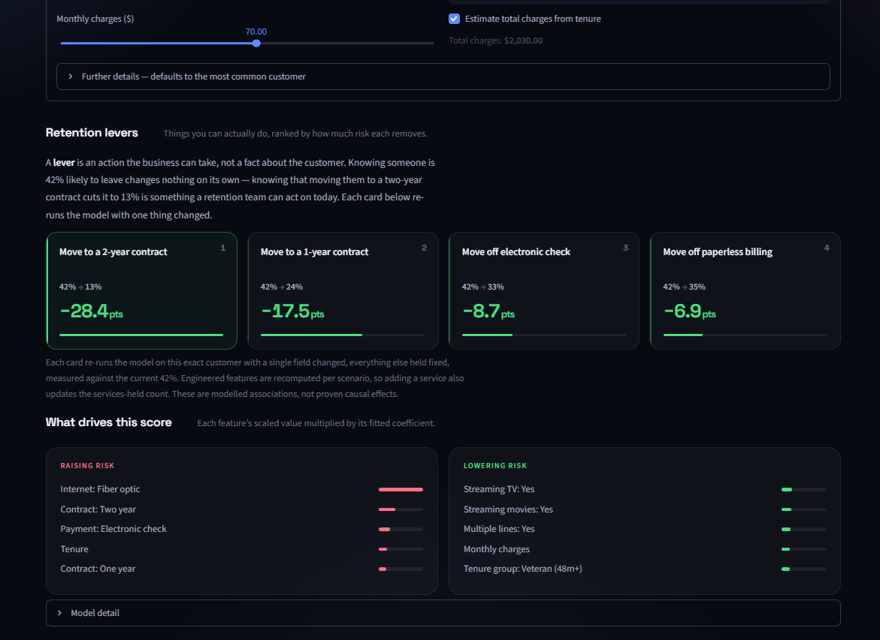
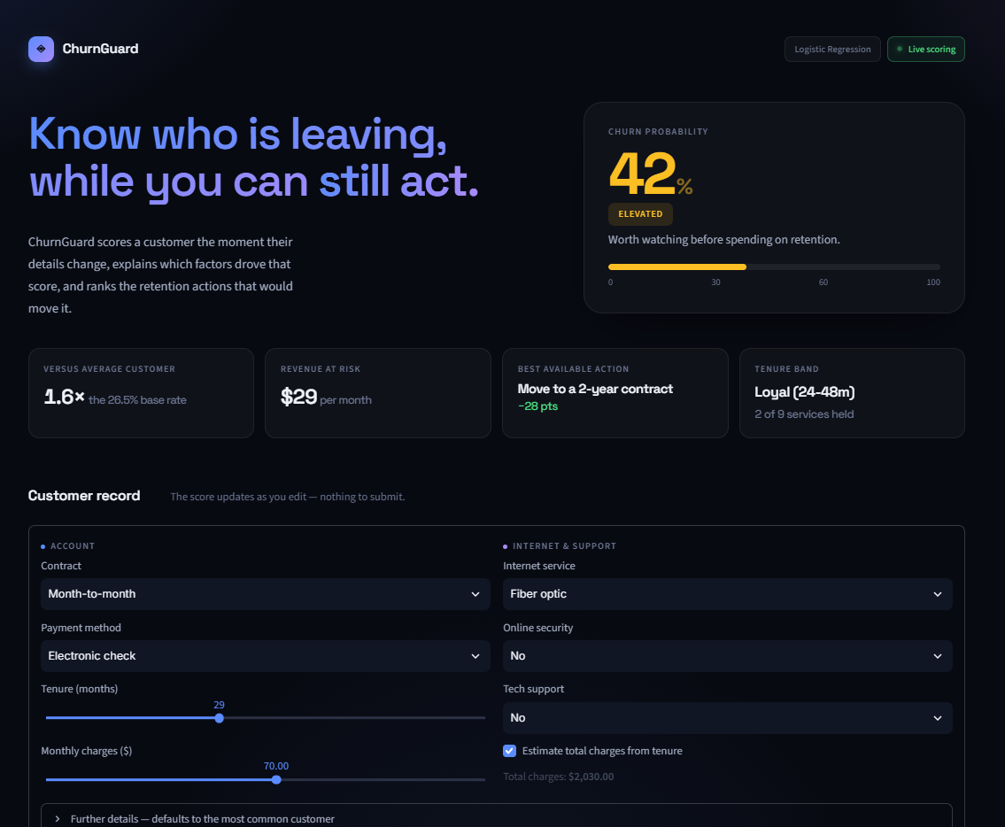
((1) Default state on load. The app opens with a representative customer profile already filled in and scored — 42% churn probability, Elevated risk.

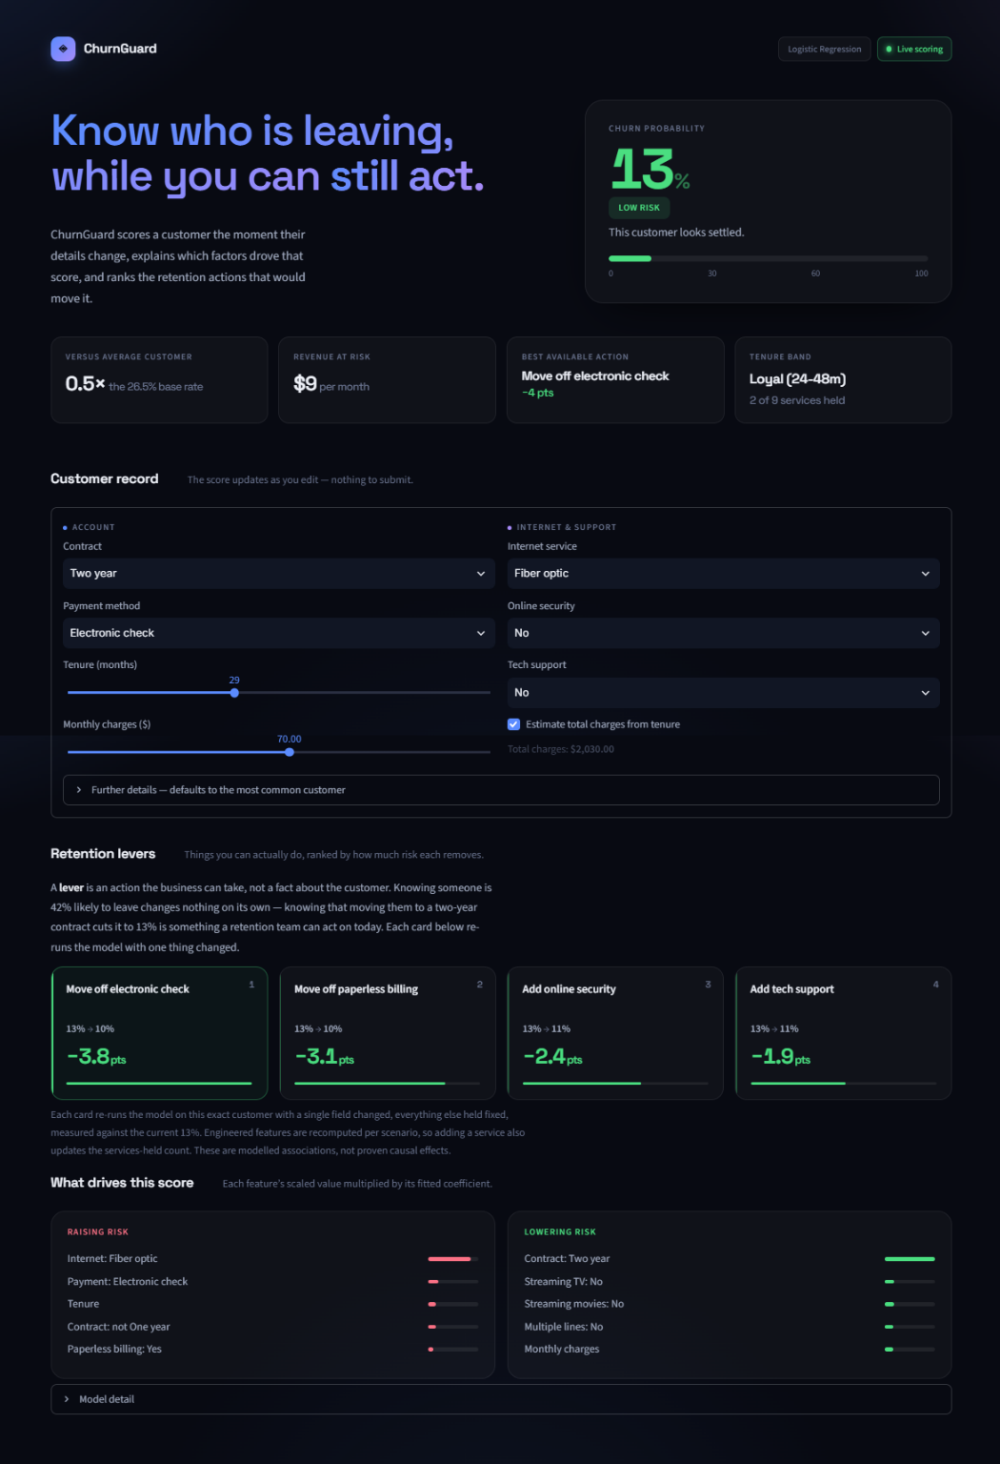
(2) After changing the contract field from month-month to Two year. The probability updates immediately to 13%.

(3) After further changes. The probability moves again to 1%.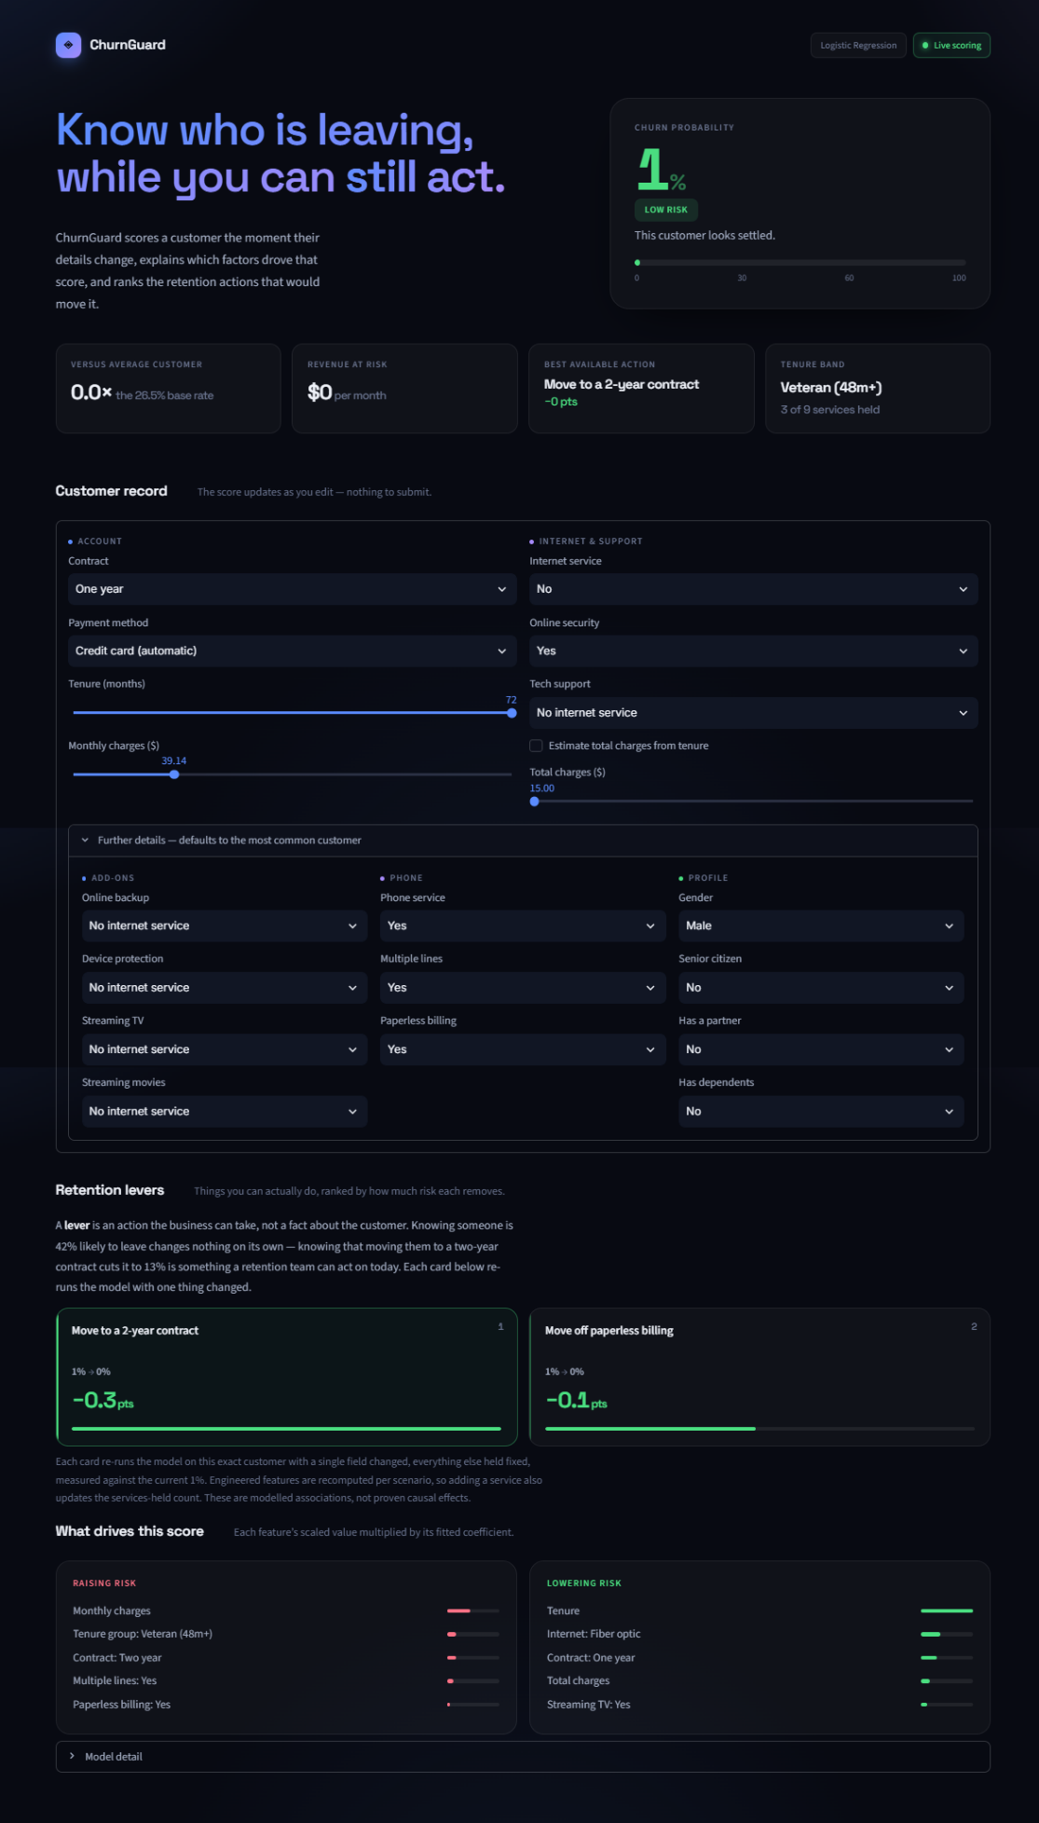

Screenshots of version control or development logs (if applicable)
Version Control and Development History of the Streamlit Application
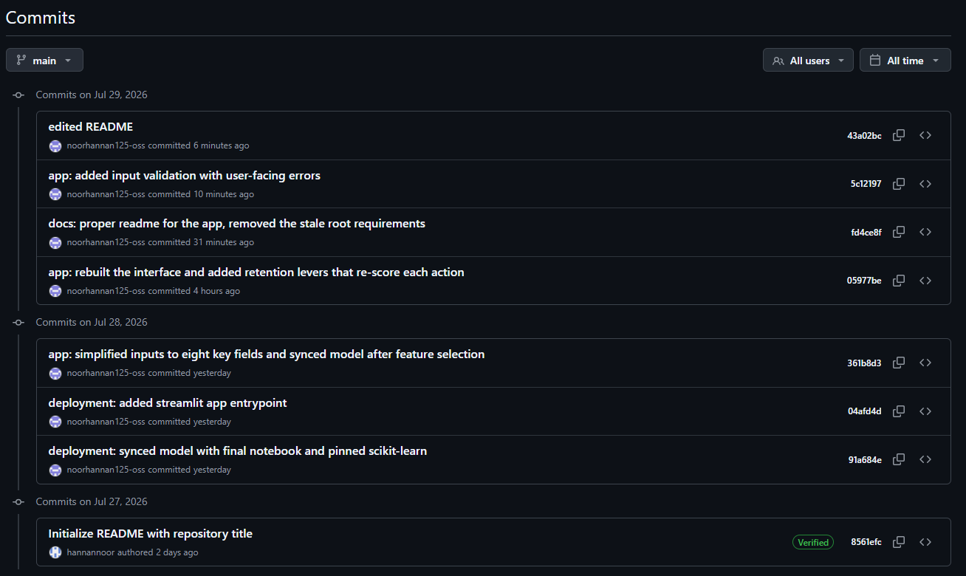

Version Control of the Machine Learning Project
GitHub was used to track the development of the machine learning project from the initial data preparation stage to the final deployment. Separate commits were created for data cleaning, exploratory analysis, feature engineering, model training, hyperparameter tuning, evaluation, documentation and deployment. This provides a clear chronological record of how the project was gradually developed and improved.
