TEMASEK POLYTECHNIC
SCHOOL OF INFORMATICS & IT

DIPLOMA IN APPLIED ARTICIFICAL INTELLIGENCE
DIPLOMA IN BIG DATA & ANALYTICS
COMMON ICT PROGRAMME
DIPLOMA IN CYBERSECURITY & DIGITAL FORENSICS
DIPLOMA IN IMMERSIVE MEDIA & GAME DEVELOPMENT
DIPLOMA IN INFORMATION TECHNOLOGY

AY2025/2026 OCTOBER SEMESTER
CASE STUDY (30%)

NETWORK AND CLOUD TECHNOLOGY (CCF1C04)

SUBJECT LEVEL: 1

INSTRUCTIONS TO CANDIDATES
- This Case Study consists of 8 pages (including cover page and appendix).
- The objective is to assess students in the following key areas:
  - Understanding the basic Cloud Services concepts
  - Application of the Cloud Services concepts
- You are to form a group consists of minimum of 2 and up to 4 members and divide the proposed tasks among your group members. Each member is required to complete
their allocated tasks for the Case Study individually.
- One report per group is required for submission.

Scenario
NECT Pte Ltd is a traditional SME logistic company based in Singapore. NECT Pte Ltd has been operating for the past 15 years. The company specialises in last-mile delivery, warehouse storage, and distribution for e-commerce and small retailers. The company’s network has expended incrementally without a clear long-term plan. The company background information is summarised below:
Company  Information | Details
Employees | 150 staff with the following breakdown:  - Admin & Finance: 15  - Warehouse Operations: 60  - Delivery Drivers/Riders: 40 (Full-time) and 22 (Part-time)  - Customer Service: 10  - IT Team: 3 (mostly junior roles)
Annual Revenue | Around SGD 8M (based on previous Financial Year performance)
Physical Footprint | 1 small HQ and 1 industrial warehouse (in Ubi area)
Key Characteristics | - Stable business, but not digitally modern  - IT systems expanded incrementally without a clear long-term plan  - Operations heavily reliant on staff to be physically onsite
IT Services | - Internet access  - Basic cloud-based solutions are used o A basic static corporate web site hosted on Wix that provides contact information  o Gmail for email service
Applications running  On Premise | - Email Server (ES)  - Web Server (WS)  - Warehouse Management System (WMS);  - Transportation Management System (TMS)  - Fleet Management System (FMS)  - Order Management System (OMS)  - File Sharing Server (FS)  - Print Server (PS)  - Basic database server for orders/inventory
Company  Information | Details
Operations with onpremise systems | - All systems (ES/WS/WMS/TMS/FMS/OMS/FS/PS) run on local servers  - Warehouse operations require LAN, scanners and local WMS  - Delivery drivers use manual job sheets  - Customer service staff updates orders manually  - Staff must be in the office because systems do not support remote access  - Admin staff has limited IT knowledge, causing slow updates and high risks  - Entire business depends mostly on hardware inside the office

Current company network topology as shown below.
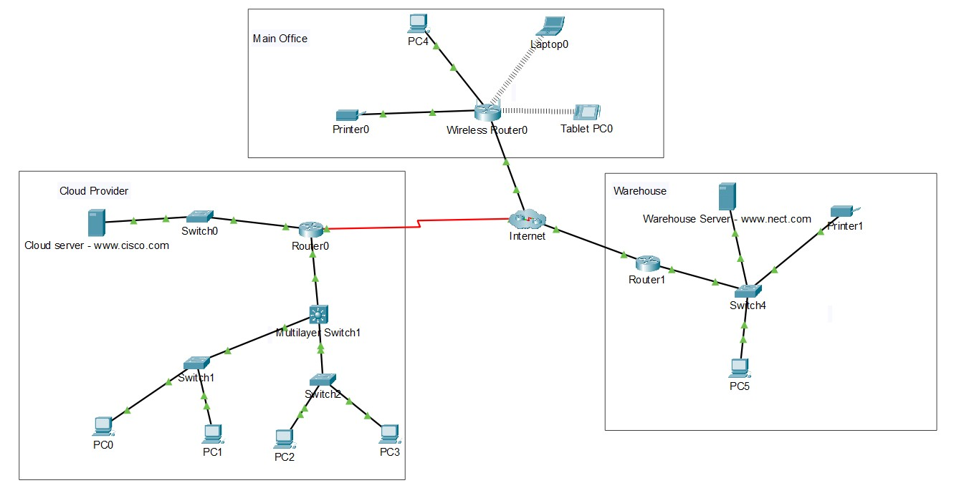

Tasks
You are hired as a Junior Network Technicians to help the company in improving their operation. The company is exploring the feasibility of migrating to a cloud deployment for either some or all their existing applications (i.e. ES/WS/WMS/TMS/FMS/OMS/FS/PS) currently running on local servers.
You are required to complete the following tasks using AI as your personal tutor.
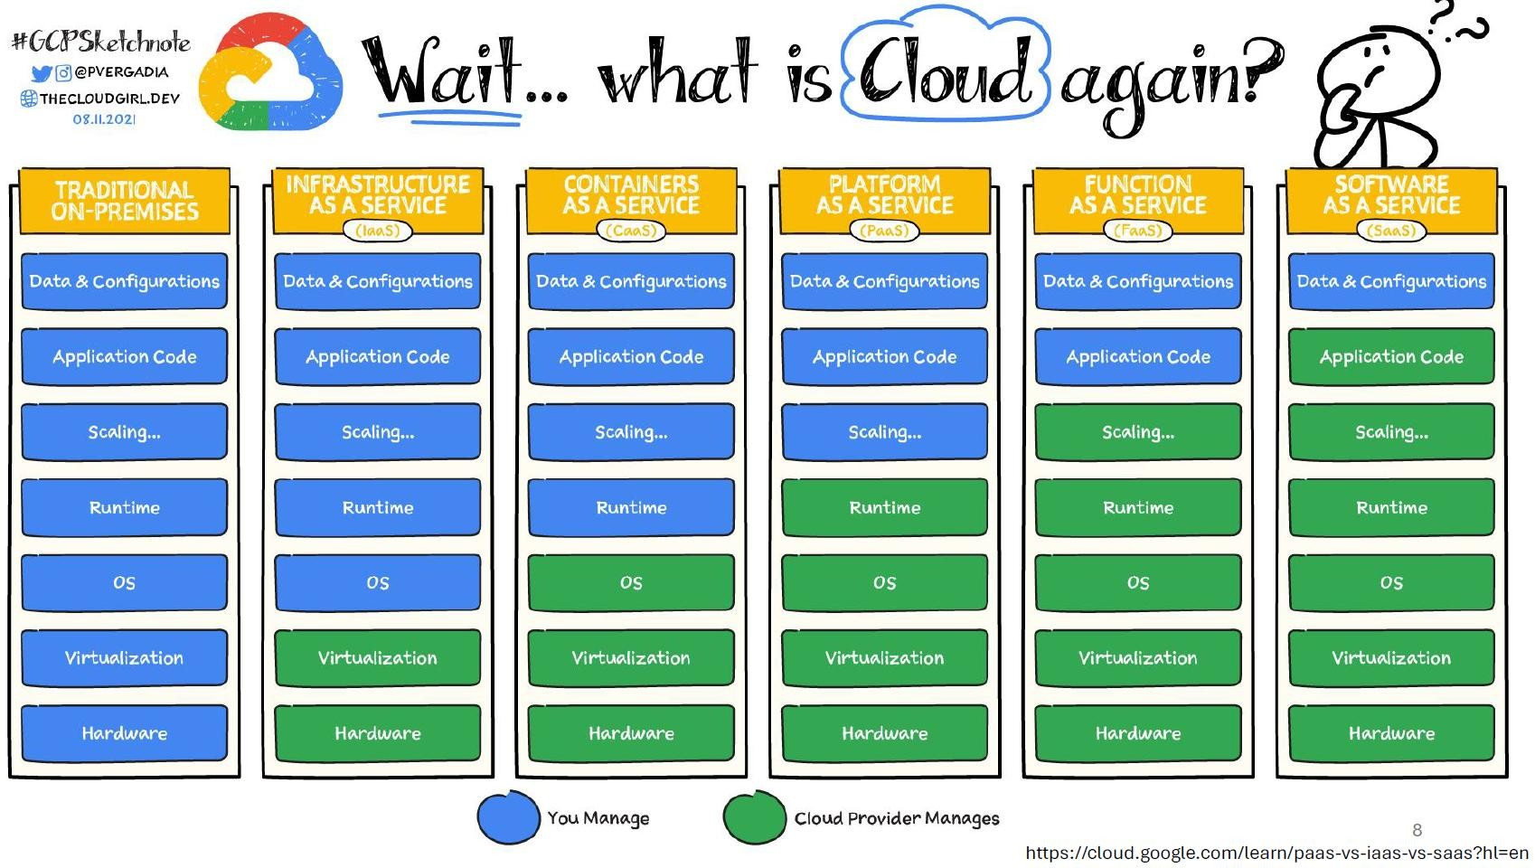
- As a group, choose one Cloud Service from the Cloud Services listed above for your research. Each member selects and concentrates on two distinct key areas from the
list provided below:
i. Availability ii. Performance
iii. Compliance and Governance iv. Scalability
v. Cost vi. Security
vii. Features viii. Sustainability
ix. Operation x. Vendor lock-in risk

- Your research should cover the following: -
  - Comparison of your chosen Cloud Service with the other Cloud Services
  - Explain how your chosen Cloud Service is applicable to NECT’s current on-
premise setup
  - Provide a comprehensive assessment on the pros and cons of chosen Cloud Service, and clearly justify why the recommended cloud service aligns best
with the company's requirements
- Evaluate AI’s responses critically for accuracy and quality, then enhance it using your
own knowledge and judgement. Illustrates your collaboration with AI by:
  - Specifying which task was AI used for
  - Recording AI’s generated output
  - Documenting your critiques
  - Documenting your improvements

Submission
You are required to submit One group report, not more than 40 pages (excluding cover page, table of content and appendixes), via POLITEMall. Refer to the Teaching Plan for the submission deadline. You may use the report template in Appendix A.

Assessment Scheme
Your report will be assessed on the following criteria.
- Research topic (15%)
- Report writing (15%)
Note: Plagiarism is not allowed and will result in a zero for the assignment. You are required to cite any sources used in your Case Study.

Late submissions
Late submissions will be imposed as follows.
- Late and < 1 day – 10% deduction from absolute marks given for the part of the work e.g. if the assignment was worth 100 marks, you were given 75 marks for
the work, after the penalty you are left with 65 marks i.e. 75 – 100x10%
- Late >= 1 and < 2 days – 20% deduction from absolute marks
- Late >= 2 days – no marks will be awarded
~~ End of Case Study ~~

Appendix A - Report Template


SCHOOL OF INFORMATICS & IT
Diploma in [ ]
Case Study Report

Student Name (Matric Number) :
Tutorial Group :
Tutor :
Submission Date :

Declaration of Originality
I am the originator of this work and I have appropriately acknowledged all other original sources used as my references for this work.
I understand that Plagiarism is the act of taking and using the whole or any part of another person’s work, including work generated by AI, and presenting it as my own.
I understand that Plagiarism is an academic offence
and if I am found to have committed or abetted the offence of plagiarism in relation to this submitted work, disciplinary action will
be enforced.
Table of Content

- Introduction

- Research
  - Research #1 (Member #1)
    - Comparison
    - Pros and Cons
    - Justification
    - Document of collaboration with AI
  - Research #2 (Member #2)
  - …

- Appendixes A- References
      - …
      - …

Operational Model of Infrastructure as a Service (IaaS)
Operation refers to the processes and activities involved in managing, maintaining and supporting IT infrastructure on a daily basis.
In an Infrastructure as a Service environment, operational responsibilities mostly focus on management of virtualised computing resources rather than physical infrastructure. Organisations provision and manage virtual machines, operating systems, applications and network configurations using cloud management platforms and automation tools. Tasks like system deployment, configuration changes, backup scheduling as well as resource monitoring are performed through software interfaces, while the service provider deals with physical server maintenance, power management, cooking and hardware replacement. This allows for systems to by managed remotely and have greater flexibility.
IaaS follows a shared responsibility model where operational responsibilities are split between the customer and the cloud service provider in which the cloud provider ensures the availability and reliability of the infrastructure while the customer or organisation remains responsible and controls system configuration and day to day usage. Thus, operational responsibilities shift towards managing operating systems, application deployments, access permissions and backup policies. Monitoring and logging tools given by the platform enable administrators to track system behaviour and respond to issues in a timely manner. This operational model reduces dependence on physical infrastructure but requires organisations to adopt cloud-oriented workflows and have the necessary technical expertise to manage and secure virtual environments effectively. Overall while IaaS removes the need to manage physical infrastructure it places a significant burden on organisations to correctly configure, monitor and maintain their virtual environments.
Comparing IaaS with Traditional on Premises (Operations)
Unlike IaaS, traditional on-premises infrastructure requires organisations to manage both physical and logical components of their IT environment. Operational tasks include maintaining servers and networking equipment, handling power and cooling requirements, performing hardware repairs and replacements, and managing physical security. These responsibilities increase operational workload and often require IT personnel to be physically present to resolve issues, resulting in slower response times and higher dependency on internal resources.
In addition, in a on-premises environment, the operational responsibilities associated with IaaS are also present. This means tasks such as operating system management, application deployment, access control and backup configuration must be carried out alongside hardware maintenance. As a result, operational teams must address a broader range of responsibilities, making on-premises operations more sources intensive and less flexible compared to IaaS.
Comparing IaaS with Containers as a Service (CaaS) (Operations)
Compared to IaaS, CaaS shifts the operational responsibilities away from managing individual virtual machines toward managing containerised applications and orchestration platforms. Like IaaS, in CaaS, the cloud service provider still manages the underlying infrastructure and hardware but in CaaS, the service provider will also provide the virtual machine layer and container runtime environment. This reduces the need for organisations to perform operating-system level management, as applications are deployed and executed within containers rather than full virtual machines.
From a operational perspective, CaaS placers a greater emphasis on managing container configurations orchestration policies, and application deployment workflows. Administrators are responsible for defining container images scaling rule sand service coordination through orchestration tools. Comparted to IaaS, the operational responsibilities are more application focused and less infrastructure- centric but still require specialised knowledge in container management. As a result, compared to IaaS, CaaS reduces some operational overhead associated with virtual machine maintenance while introducing new operational complexity at the platform and application level.
Comparing IaaS with Platform as a Service (PaaS) (Operations)
Compared to IaaS, PaaS significantly reduces the operational responsibilities by removing the need for organisations to manage operating systems and underlying system environments, instead this falls on the cloud service provider. In a IaaS model, administrators are responsible for configuring and maintain virtual machines, applying operating system updates, and managing system-level settings. Under PaaS, these responsibilities are handled by the cloud service provider, while organisations primary focus on deploying and managing their applications. This differs from the system-level tasks that are required in IaaS.
PaaS simplifies system management by giving a standardised application environment and automating tasks that would otherwise need to be handled manually in IaaS, such as system patching and runtime maintenance. However, this reduced operational responsibility also results in less control compared to IaaS as organisations must operate within the provider’s platforms and configurations. As a result, PaaS trades flexibility and control available for lower operational effort.

Comparing IaaS with Function as a Service (FaaS) (Operations)
Compared to IaaS, FaaS further reduces the operational responsibility by removing the need to manage virtual machines and operating systems entirely. In IaaS, administrators are responsible for configurating system environments and maintaining virtual instances. However, under FaaS, the cloud service provider manages this, while organisations can focus just on writing and deploying individual functions.
Overall, since most tasks are handled automatically by the provider, the day to day operational effort is significantly lower for FaaS compared to IaaS. However, this also limits visibility and control over underlying system. Thus, in terms of operational responsibility, FaaS has a lower burden compared to IaaS but trades off flexibility and control.
Comparing IaaS with Software as a Service (FaaS) (Operations)
Compared to IaaS, SaaS removes almost all the operational responsibilities related to system management. While in IaaS, organisations are responsible for managing a majority of the system components, under SaaS these responsibilities are handled entirely by the cloud service provider. Organisations rather interact with the software through user interfaces and configuration options rather than managing the underlying system.
Thus, compared to IaaS, the operational responsibilities are drastically lower. Day to day operational tasks is limited to user access management, basic configuration setting and data usage within the application. However, this reduction in operational responsibility results in limited control over system behaviour and configuration compared to IaaS. As a result while the operational responsibility for SaaS is much lower than IaaS it trades off operational control and flexibility.
Vendor Lock-in Risk in Infrastructure as a Service (IaaS)
Vendor Lock-in risk refers to the difficulty an organisation may face when attempting to migrate systems, data or services from one service provider to another. This risk comes about when technologies, configurations or certain processes become highly dependent on a specific providers environment. It is important to consider vendor lock-in risk as it can limit flexibility, increase long term costs and reduce an organisation’s ability to adapt to certain technical requirements.
In Infrastructure as a Service, vendor lock-in risk is moderate. Organisations deploy and manage their own virtual machines, operating systems, applications and data which provides a higher degree of control over system configurations since workloads are typically built using standard operating systems and common software platforms, migrating virtual machines and data to another IaaS provider or to an on premises environment is feasible although it may still require effort an planning.
IaaS follows a model where organisations retain responsibility for how systems are designed and deployed, which may help reduce dependency on provider-specific services. However, vendor lock-in can still occur if organisations rely heavily on provider specific proprietary tools, storage formats, or network configurations offered by the provider. Furthermore, data transfer costs, difference in service architecture and operational adjustments can further increase the complexity and effort required to migrate to another cloud service provider. Overall, while IaaS offers grater flexibility and generally low vendor lock-in risk, organisations must design their systems carefully to minimise dependency on a single provider.

