
SCHOOL OF INFORMATICS & IT
DIPLOMA IN APPLIED ARTIFICIAL INTELLIGENCE
CLOUD TECHNOLOGIES FOR AI (CAI2C09)
AY2026/2027 APRIL SEMESTER
Project Report
Findr: a cloud-native campus lost and found platform
Student Name (Matric Number) : Mohammed Hannan Noor (XXXXXXXX)
Class Group : PC02
Tutor : Lee Jin
Submission Date : 15 August 2026

Contents
Introduction of website 4
Pages of the website 4
Services used 9
Development of AWS Rekognition 11
Why a custom model was needed 11
Dataset preparation 11
Training the model 12
Evaluating the model 12
Integrating the model into the application 14
Moderation and text detection 15
Development of Amazon Bedrock 15
Why two different models are used 16
Ownership verification 16
Development of Amazon Cognito 18
Password policy and account confirmation 19
How the authorisation model works and why it is secure 19
Administrator access through groups 20
Development of Amazon Translate and Amazon Comprehend 21
How the two services work together 21
Design decisions in the translation layer 22
Development of Amazon Location Service 23
Development of Amazon SNS 24
Development of AWS WAF 25
Deployment process 26
Deploying the website 26
Deploying a Lambda function 27
Configuration settings 27
Service dependencies 28
Troubleshooting tips 28
Setup guide 29
Amazon S3 29
Amazon DynamoDB 30
Why DynamoDB rather than Amazon RDS 32
AWS IAM 33
AWS Lambda 34
Amazon API Gateway 36
Why a REST API rather than an HTTP API 37
How the API is structured 38
Amazon CloudFront 39
Amazon Rekognition 40
Amazon Bedrock 40
Amazon Translate and Amazon Comprehend 41
Amazon SNS 41
Amazon Location Service 42
AWS WAF 42
Amazon CloudWatch 43
How the services interact 43
Security measures 43
Storage layer 44
Transport layer 44
Identity and authorisation layer 44
Application data layer 44
Input handling 45
Least privilege 45
Reflection 45
Prompt design is a real engineering task 45
Giving a model the right input matters more than a better model 46
Cost shapes design, not just billing 46
Configuration failures do not look like configuration failures 46
What I would do differently 47
Conclusion 47
References 48

Introduction of website
The problem. Lost property at Temasek Polytechnic is not handled in one place. The main security office holds some of it, there is a lost and found box at the sports hall near the grandstand, and several of the canteens keep boxes of their own. None of these are connected to each other, so a student who has lost something has to guess which of them to try, and usually visits one, finds nothing, and gives up.
Each of those collection points works the same way: a physical counter, a paper logbook and a noticeboard. That approach fails in two ways, and being spread across campus makes both of them worse.
The first is discovery. Somebody who loses a water bottle in the library has no practical way of knowing that a bottle was handed in at the canteen three days earlier. The two people involved never meet, and the item sits in a box until it is eventually thrown away. The information exists, but it is not searchable and it is not in front of the person who needs it.
The second is proof of ownership. When an item is valuable and its description is public, anybody who reads the listing can describe it convincingly enough to be handed it. A noticeboard has no way of telling a genuine owner apart from somebody who simply read the notice, so the person holding the item is left to make a judgement call with nothing to base it on.
The website. Findr is a campus lost and found platform that gives those scattered collection points a single shared record, and addresses both problems using AWS. Students post items they have lost or found, Amazon Rekognition tags the photograph automatically, Amazon Bedrock drafts a description and finds semantic matches between lost and found reports, Amazon Translate presents listings in Singapore's four official languages, and an ownership verification step turns the private details a finder records into questions that only the real owner can answer.
Website URL: https://d3d5h347656j6.cloudfront.net
Region: ap-southeast-2 (Asia Pacific, Sydney)
Video demonstration: https://youtu.be/hrbYugO_jg8

Pages of the website
Each page exists to serve one step of the journey from losing an item to getting it back. This section explains what each page does and why it is needed.
Home. The landing page states what the service is in one line and gives the two actions a visitor could want: search for something they lost, or report something. It also shows live counts of reports, recovered items and open cases, pulled from the database rather than hard-coded. The purpose is to make the value obvious within a few seconds, because a student who has just lost something will not read an explanation.
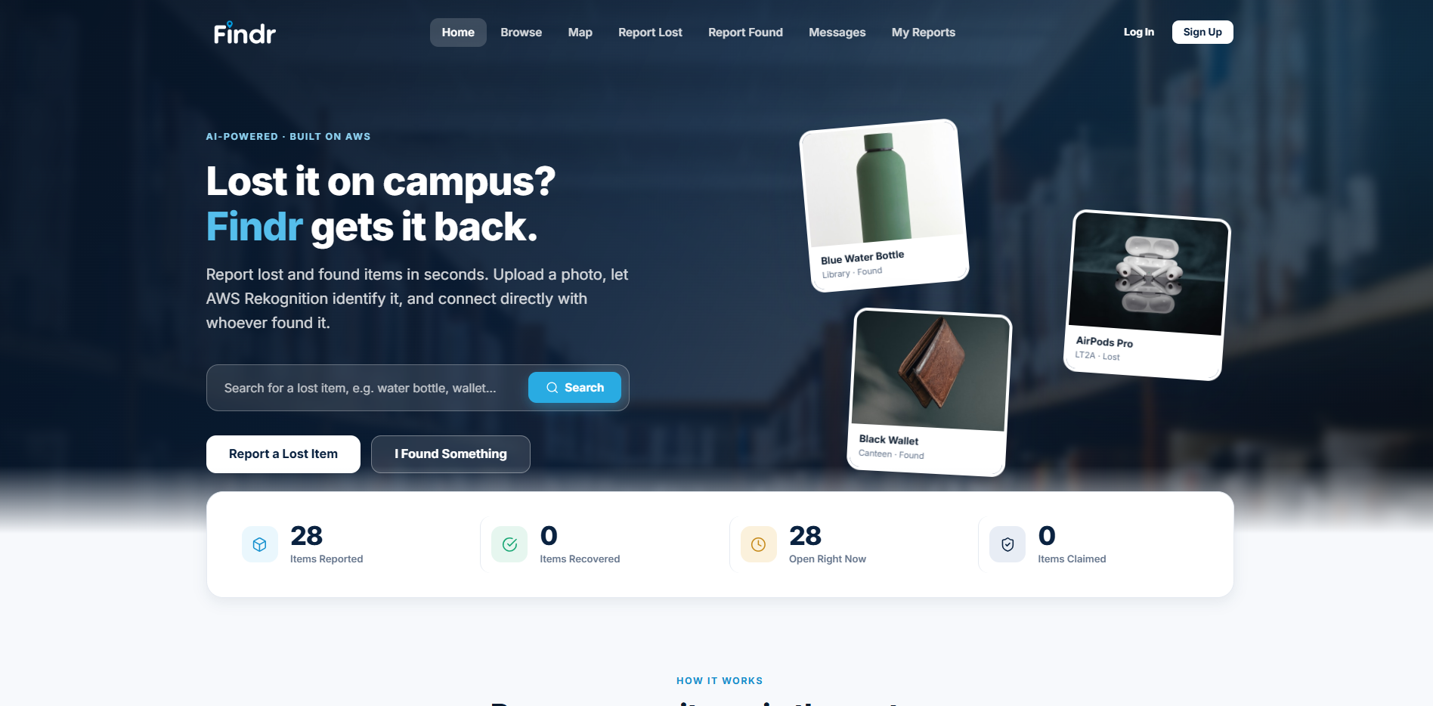
Figure 1: Home page
Browse. This is the discovery page and the direct answer to the first half of the problem. Every report on the platform is listed as a card with its photograph, location and date, and can be narrowed by type, category and status. Without this page a student would have no way of finding out that their item had already been handed in.
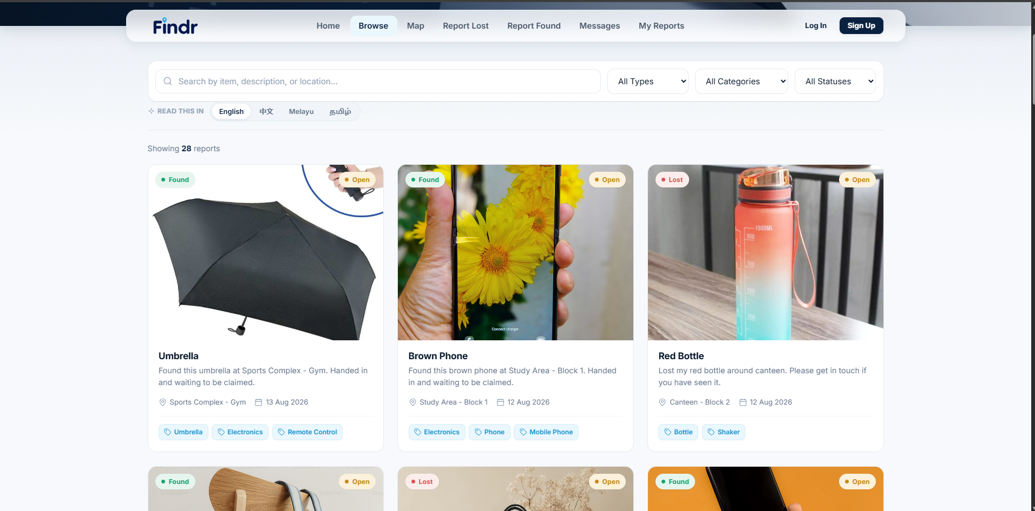
Figure 2: Browse, with filters for type, category and status
Item details. Browse gives the overview, but a student deciding whether a listing is really their item needs the full record: the photograph, where and when it was found, the category and the labels the image recognition produced. This page is also where the two actions that matter live, namely messaging the finder and starting an ownership claim.
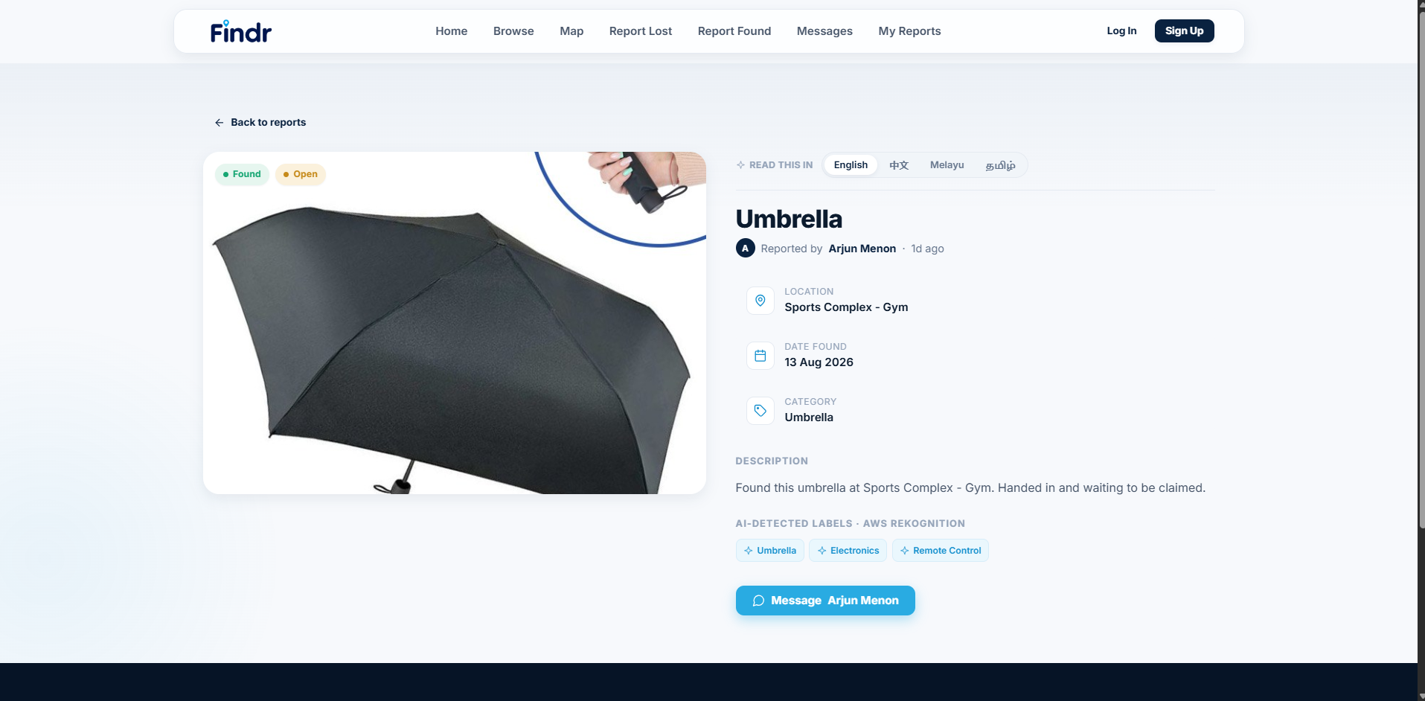
Figure 3: Item details, showing the labels returned by image recognition
Campus map. Location is often the strongest clue a person has. Somebody who knows they lost a bottle somewhere near the sports complex can scan the map far faster than they can read a list. Each marker shows the item photograph rather than a generic pin, so the map can be scanned visually.
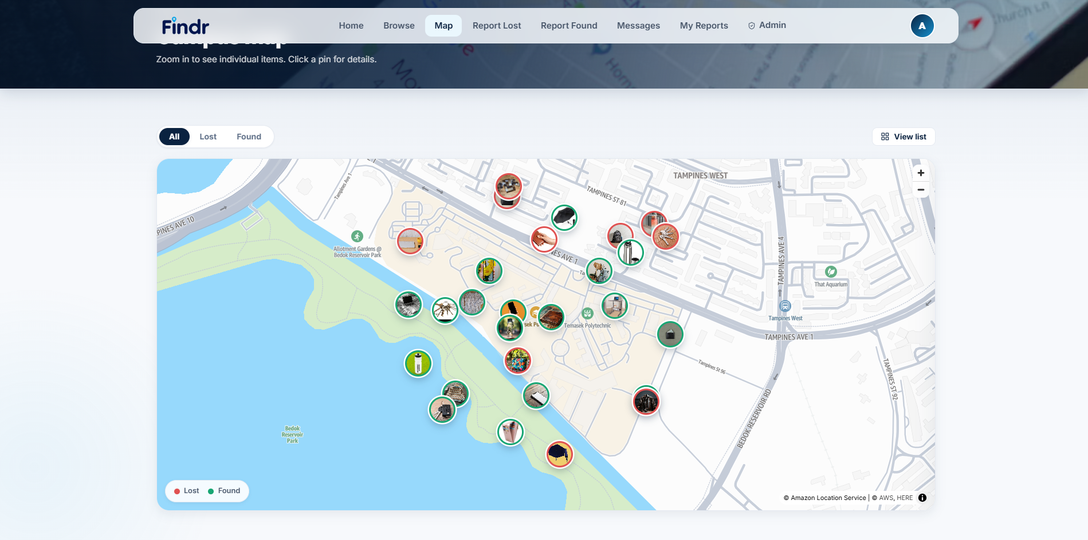
Figure 4: Campus map, rendered with Amazon Location Service
Report Lost and Report Found. These are the two entry points that create data. Their purpose is to make reporting fast enough that a student actually bothers, which is why the image recognition matters: uploading a photograph fills in the category and drafts a description automatically, so the form is mostly complete before the user types anything. The panel below shows the result returned by the image recognition API.
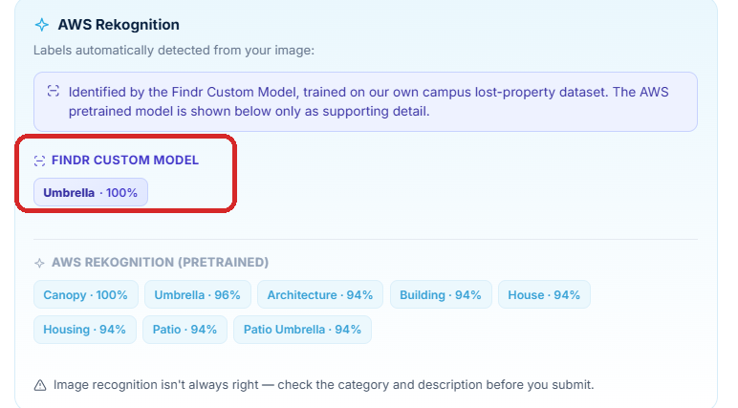
Figure 5: Result from the image recognition API on the Report Found page
My Reports. Reports are not always correct when first submitted, and items get returned. This page lets a user correct, close or delete their own reports. It is also where a finder edits the private verification details that the claim process depends on, and those details are visible here to the owner of the report and to nobody else.
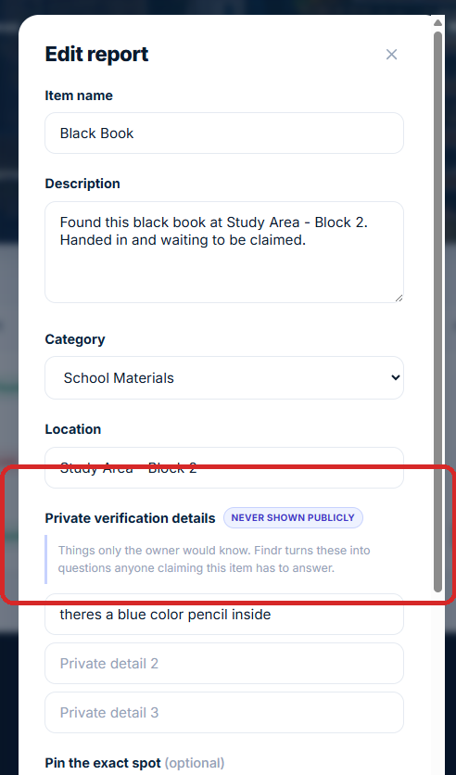
Figure 6: Editing a report. The private verification details are visible only to the person who wrote them
Verification wizard. This is the answer to the second half of the problem. Rather than the finder having to judge a stranger's claim, Amazon Bedrock generates questions from the private details and marks the answers.
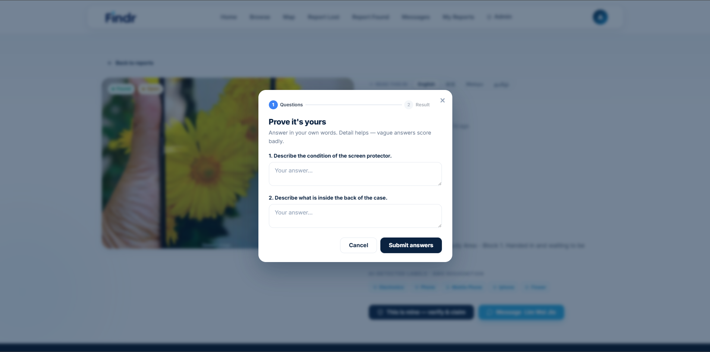
Figure 7: Verification questions generated by Amazon Bedrock
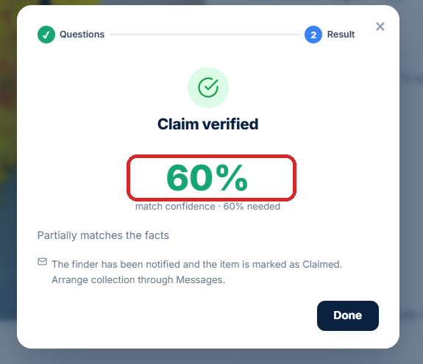
Figure 8: A correct claim passes and the item is marked as Claimed
Messages. Verification decides whether somebody is the owner, but the two people still have to arrange a handover. Messaging keeps that conversation inside the platform so neither party has to publish a phone number or an email address on a public listing.
Administrator dashboard. A public platform needs moderation. An administrator can see every report, filter and export them, and edit or delete any report regardless of who created it. The verification column shows the outcome and score of any claim attempt, which is what an administrator would need in order to review a disputed claim.
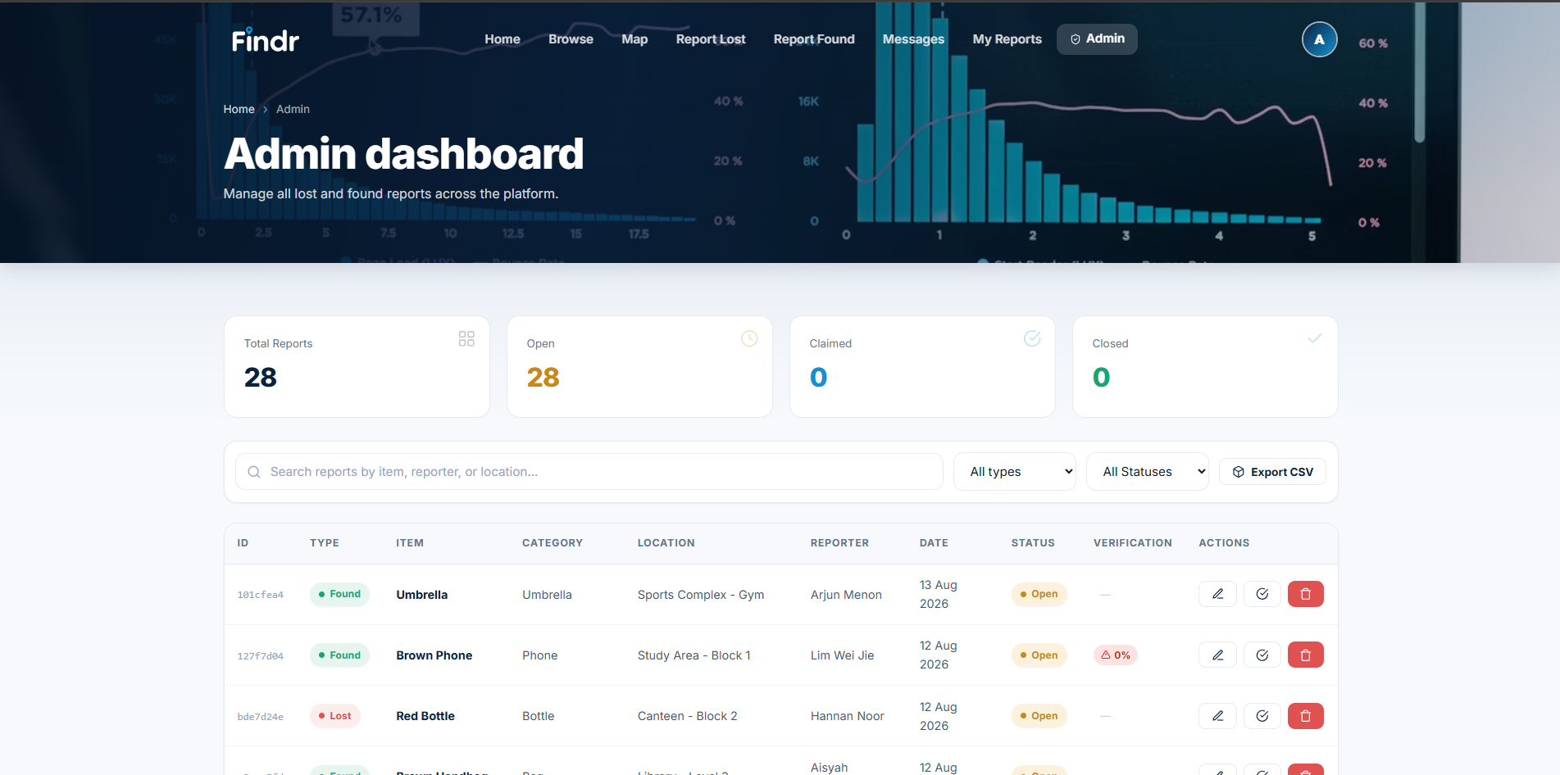
Figure 9: Administrator dashboard
Account, sign-in, sign-up and password reset. Reports have to belong to somebody for ownership checks to mean anything, so these pages support the identity layer that everything else depends on.

Services used
Findr is a static frontend backed by a serverless API. Nothing runs when the site is idle, which suits a campus service where traffic is unpredictable and mostly zero.
There are two main paths through the system. The browser requests the page from Amazon CloudFront, which reads the static files from a private Amazon S3 bucket. Separately, JavaScript in the browser calls Amazon API Gateway, which validates the caller's token and invokes an AWS Lambda function, which in turn reads and writes DynamoDB and calls the AI services.
A third, smaller path exists for large transfers. Map tiles are requested by the browser directly from Amazon Location Service, and item photographs are uploaded straight to S3 using a pre-signed URL. Keeping those two off the compute layer means Lambda never has to hold a multi-megabyte image in memory, which keeps both cost and execution time down.
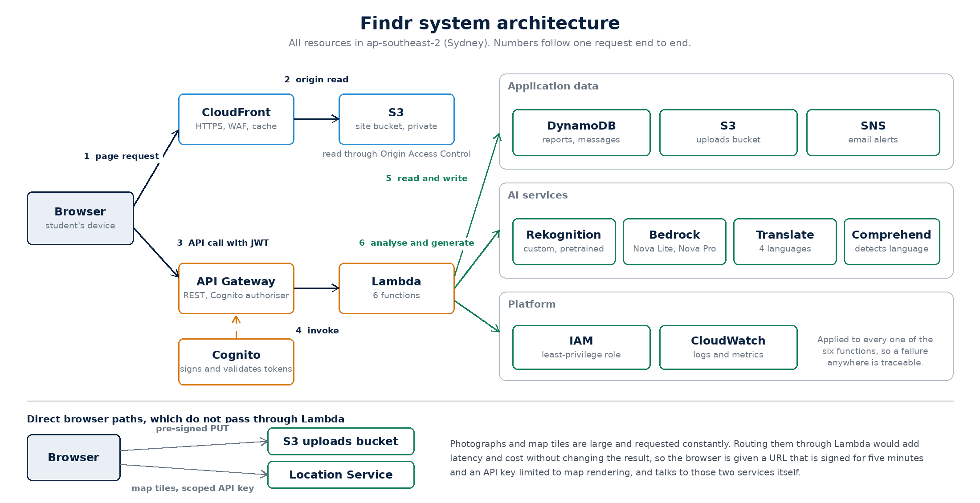
Figure 10: System architecture
Service | Category | Role in Findr
Amazon S3 | Storage | Static website files and private storage for item photographs
Amazon CloudFront | Content delivery | HTTPS delivery, reading the bucket through Origin Access Control
AWS WAF | Security | Managed web application firewall on the distribution
Amazon API Gateway | Networking | REST API with a Cognito authoriser on protected methods
AWS Lambda | Compute | Six functions holding all application logic
Amazon DynamoDB | Database | Two tables: reports and messages
Amazon Cognito | Identity | Registration, sign-in, JWTs and the administrator group
Amazon Rekognition | AI: vision | Label, text and moderation detection, plus a custom-trained classifier
Amazon Bedrock | AI: language | Descriptions, semantic matching, verification questions and marking
Amazon Translate | AI: language | Listings in English, Chinese, Malay and Tamil
Amazon Comprehend | AI: language | Source language detection for translation
Amazon SNS | Messaging | Email notifications to finders
Amazon Location Service | Maps | Campus map tiles
Amazon CloudWatch | Monitoring | Lambda logs and metrics
AWS IAM | Security | Scoped execution role for the Lambda functions

Development of AWS Rekognition
Rekognition is used in two distinct ways. The pretrained API provides general label detection, text detection and content moderation. Alongside it I trained a custom classifier on a purpose-built dataset so the service returns the categories this application actually files items under.

Why a custom model was needed
The pretrained model is broad, but it is not aligned to this problem. Asked about a photograph of a water bottle it returns labels such as Bottle, Shaker and Water Bottle. Those are reasonable descriptions, but the model has no concept of the eight categories Findr files items under, so every result has to be mapped by hand, and the mapping is guesswork.
It also returns labels that make no sense in this context. During testing, a photograph of a set of keys came back with the labels Gun and Weapon, and a bottle came back as a Mason Jar. Those would appear on a public lost property listing. A classifier trained on the eight categories the application actually uses returns the category directly, which removes the mapping step and avoids that class of result entirely.

Dataset preparation
I assembled a dataset of 398 images across eight labels. The categories were chosen to cover the overwhelming majority of what is handed in to a campus lost property counter, while staying distinct enough from each other that a classifier can separate them reliably.
Label | Why it is included
Bag | Backpacks, tote bags and handbags, the most commonly handed-in item
Bottle | Water bottles, left behind constantly in libraries and sports halls
Clothing | Jackets and jumpers removed indoors and forgotten
Keys | Small, easily dropped and high value to the owner
Laptop | High value, and the category most likely to be claimed falsely
Phone | High value, frequently mislaid in lecture theatres
Umbrella | Left in stands and doorways, especially in wet weather
Wallet | High value and the strongest case for ownership verification

Images were organised into one folder per label. Rekognition Custom Labels infers the label from the folder name on import, so no manual annotation was required, which is what made a dataset of this size practical to build in the time available.
The folders were uploaded to a dedicated S3 bucket and imported as a dataset, configured to split automatically into training and test sets. This produced 318 training images and 80 test images, giving ten held-out test images per label.
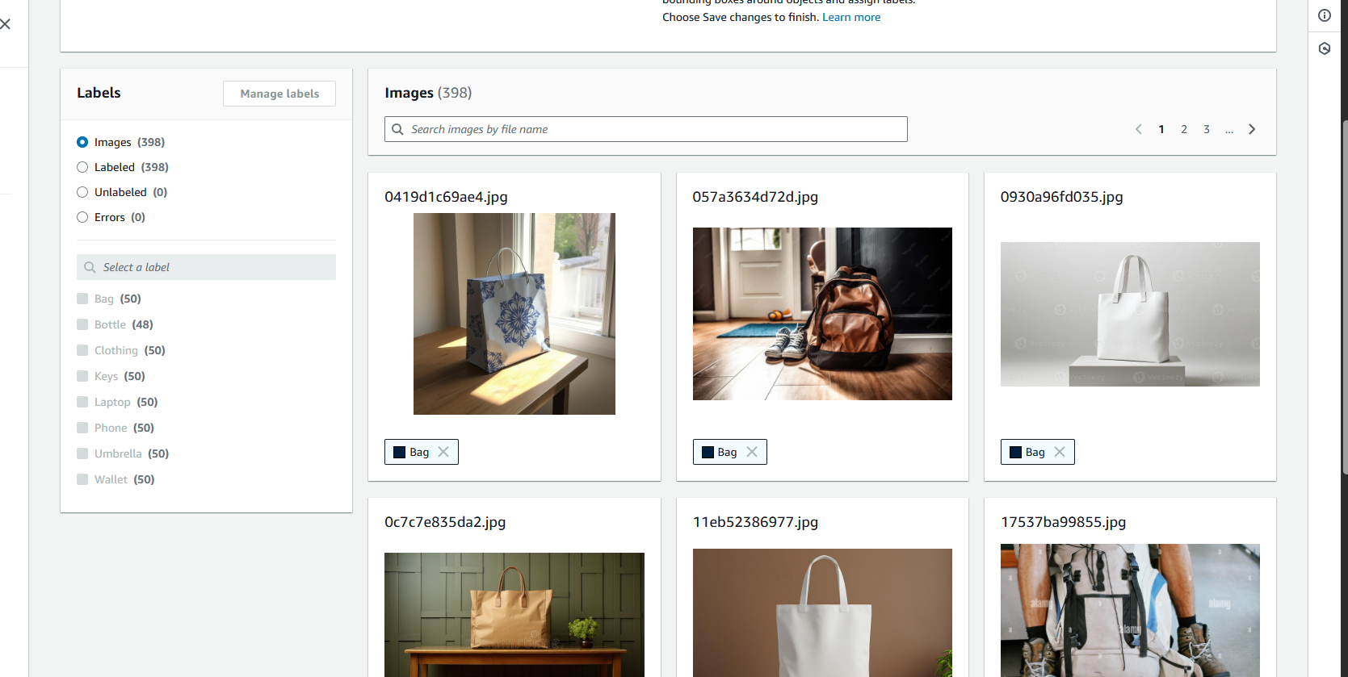
Figure 11: The imported dataset with all eight labels

Training the model
Training was started from the console. No hyperparameters are chosen by the developer, because Rekognition Custom Labels selects the algorithm and settings itself. That is the trade-off the service makes: less control over the training process, in exchange for not needing to be a machine learning specialist to produce a working model.
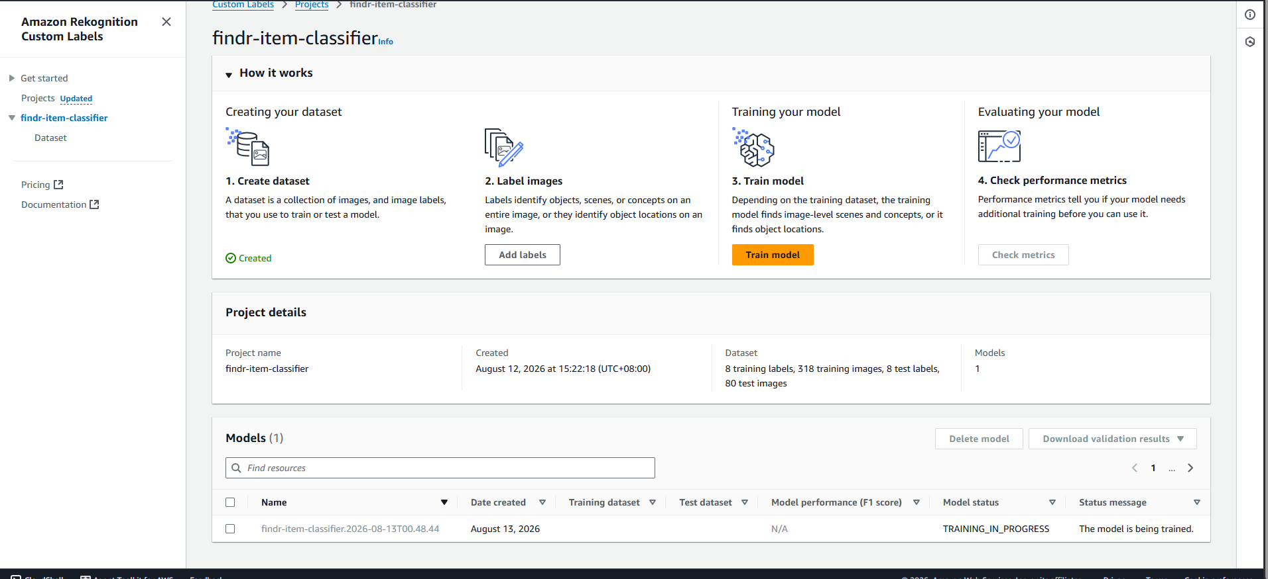
Figure 12: Training in progress
Training completed on 12 August 2026 and took 1.014 hours.

Evaluating the model
The trained model achieved an F1 score of 0.955, average precision of 0.976 and overall recall of 0.938 against the 80 held-out test images.
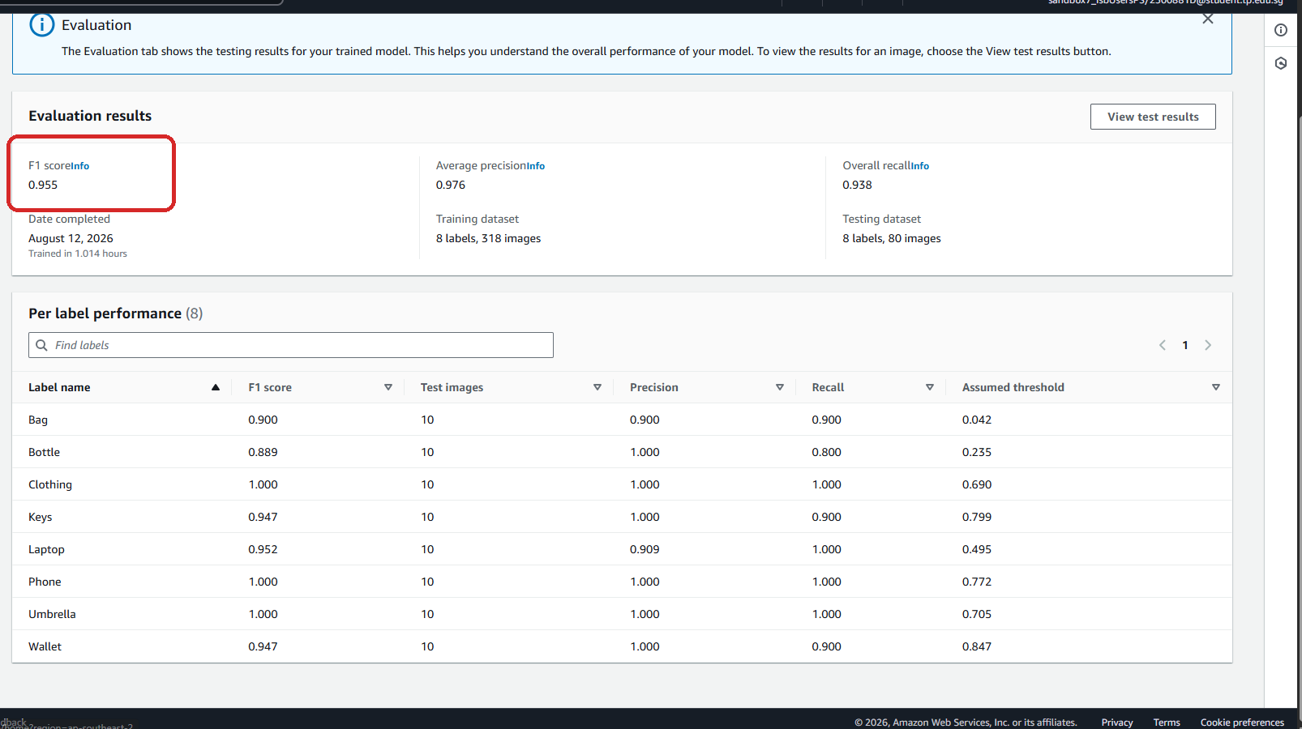
Figure 13: Evaluation results and per-label performance
Which metric matters most here. F1 is the headline number because it balances precision and recall, but the two are not equally important for this application. The classification is used to pre-fill the category field on a form that the user then confirms before submitting. That makes precision the more valuable metric, because a false positive puts a confidently wrong category in front of the user, while a missed detection simply leaves them to pick the category themselves, which is what they would have done anyway. On that measure the model performs very well: average precision of 0.976, and six of the eight labels achieve precision of 1.000.
The per-label results are strong across the board:
- Clothing, Phone and Umbrella scored a perfect 1.000 on every measure.
- Laptop scored 0.952 with recall of 1.000, so no laptop in the test set went unrecognised.
- Keys and Wallet both scored 0.947 with precision of 1.000, meaning the model never labelled something else as keys or a wallet.
- Bag scored 0.900, which is a good result for a category that spans tote bags, backpacks and handbags, shapes that share very little visually.
- Bottle was slightly lower at 0.889, with precision of 1.000 and recall of 0.800.
Bottle is worth a comment because it is the one label where the two metrics differ noticeably. Precision is perfect, so the model never labels something else as a bottle. The lower recall means it is simply more conservative about bottles than about other categories, and where it is unsure it declines to guess. Given that a missed detection costs the user one dropdown selection while a wrong detection would put incorrect data on a public listing, that is the safer way for the model to be wrong, and in practice the application handles it cleanly by falling back to the pretrained labels.
The assumed threshold column varies widely, from 0.042 for Bag to 0.847 for Wallet. This is the confidence value at which each label achieves its best F1. The spread is a useful finding in itself: it shows that applying one global confidence threshold across all labels would be the wrong approach, and it is why the application uses the service's own per-label thresholds rather than imposing a single cut-off.

Integrating the model into the application
Custom Labels bills per hour while a model is running, which shaped the integration. The model cannot be left running permanently on a student account, so the application had to behave sensibly when it is stopped rather than simply failing.
The analysis function calls the custom model first and classifies the response into one of four states: the model answered, the model is running but did not recognise the object, the model is stopped, or the call failed for some other reason. The pretrained model is then always called as well, so there is always a result to show.
What the application does with those two results is the part I consider most important:
- When the custom model answers, its classification is treated as authoritative, and the pretrained labels are shown underneath as supporting detail.
- When the custom model is stopped, the pretrained results are used instead, and the interface states this explicitly rather than quietly presenting generic labels as though they came from the trained model.
The close-up below shows both blocks on the report form. The custom model returned Umbrella at 100%, while the pretrained model returned Canopy, Umbrella, Architecture, Building, House, Housing, Patio and Patio Umbrella. Several of the pretrained labels are not useful on a lost property listing, and keeping the two sets visually separate means a user can always tell which model produced which result.
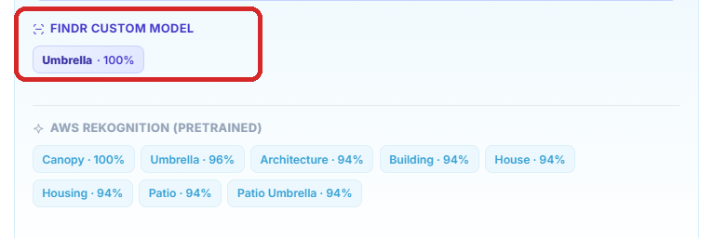
Figure 14: The custom model's classification, kept visually separate from the pretrained labels
The classification also drives the description. The image itself is sent to Amazon Bedrock along with the custom model's answer, and the prompt instructs Bedrock to treat that classification as correct and to use the pretrained labels only for supporting detail such as material or colour.
One development detail is worth recording. An earlier version passed Rekognition's detected text to Bedrock labelled as "visible text on the item". Because stock photographs often carry watermarks, this produced descriptions such as "a wallet with labels Mag, Magnit, Magnific". Sending the image itself and dropping that assertion resolved it at the root, because the model can then judge for itself whether text is printed on the object or stamped across the photograph.

Moderation and text detection
Two other Rekognition APIs are used. Every uploaded image runs through moderation detection before anything else happens. If it is flagged, the object is deleted from S3 immediately and the upload is rejected, so inappropriate content never reaches the database in the first place. This matters because any user can upload a photograph to a public listing.
Text detection is also run, and any writing found on an item, such as a name on a bottle, is stored with the report. This is genuinely useful for a lost and found service, because a name written on an item is often the strongest ownership clue available.

Development of Amazon Bedrock
Bedrock provides access to foundation models through a single API without provisioning any infrastructure, which is what made the verification feature achievable within this project. The alternative would have been hosting a model myself, which would have meant a running instance, a much larger cost and far more setup than the rest of the application combined.
It is used in four places:
Where it is used | Model | What it does
Item descriptions | Nova Lite | Drafts a listing description from the image and the custom model's classification
AI matching | Nova Lite | Re-ranks a shortlist of candidate matches by meaning rather than label overlap
Verification questions | Nova Pro | Turns the finder's private facts into questions
Marking answers | Nova Lite | Scores a claimant's answers against the real facts

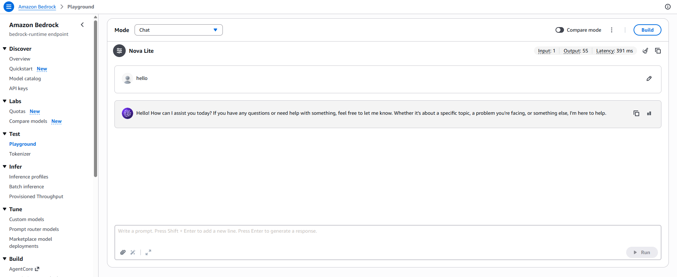
Figure 15: Testing prompts in the Bedrock playground before integrating them

Why two different models are used
Using Nova Lite for three tasks and Nova Pro for one was a deliberate decision rather than an oversight, and it comes down to matching the difficulty of the task and its frequency against the cost of the model.
Nova Lite handles the three easy, frequent tasks. Drafting a description, re-ranking matches and marking answers are all tasks where the model is given the information it needs and asked to summarise or compare. There is a correct answer available in the input, and the model does not have to reason its way to something new. Descriptions in particular run on every single photograph uploaded, so this is by far the highest-volume call in the application, and using a larger model here would multiply the running cost for no measurable gain in quality.
Nova Pro handles the one hard, rare task. Writing a verification question is a genuinely harder problem than it first appears, because the question has to satisfy three constraints at once: it must be answerable from the fact, it must not reveal the fact, and it must not ask for information the fact does not contain. Satisfying all three requires the model to reason about what the claimant would and would not know, which is a different class of task from summarising.
The frequency argument makes the cost side easy. Questions are only generated when somebody actually starts a claim, which is rare compared with photograph uploads, so the more capable model is used exactly where it earns its cost and nowhere else. The model identifiers are supplied as environment variables rather than hard-coded, so either can be changed without editing the code.

Ownership verification
Where this feature came from. When I submitted the project proposal, my tutor raised the obvious weakness in what I had described: if a listing is public and describes the item, then anybody who reads it can describe it back convincingly, and the person holding the item has no way of telling a genuine owner from somebody who simply read the page. Nothing in the proposal answered that. Ownership verification is the feature I added in response, and it is the part of the platform I spent the most time on.
The idea behind it is that the listing and the proof have to be different pieces of information. The listing describes the item well enough to be recognised. The proof has to be something the listing never shows.
When somebody reports a found item they may record up to three private details, meaning things that are visible to whoever is holding the item but not to somebody reading the listing. Those details never leave the database and are never sent to any other user's browser.
When a claim is made, Bedrock converts those facts into open questions. Getting the prompt right took the most work of anything in the project. An early version instructed the model not to mention any part of the fact, which produced a specific and instructive failure. Given the fact "there is a coin compartment inside", the model stripped the word "coin", was left with "compartment", and asked "how many compartments does the wallet have?". The real owner cannot answer that correctly, because the fact never stated a number, so a genuine claimant would have failed.
Three changes fixed it. An explicit constraint was added stating that every question must be answerable using only what the fact contains, and that the model must never ask for a quantity, colour, brand or measurement unless the fact gives one. Question generation was moved to Nova Pro, which follows that constraint far more reliably. Finally the temperature was lowered from 0.4 to 0.1, because consistency matters more than variety when the output is a test that somebody has to pass.
Figure 16: Questions generated from the facts "the screen protector is cracked in the top left corner" and "there is a photo tucked inside the back of the case"
Neither question above reveals its fact. They ask about the condition of the screen protector and what is inside the back of the case, leaving the claimant to supply the specific detail. That is exactly the behaviour the revised prompt was designed to produce.
Answers are marked by a second Bedrock call against the real facts and scored out of 100, with 60 required to pass. The threshold was set after testing, high enough that a vague guess fails and low enough that a genuine owner who words things differently still passes. Both outcomes were tested, because a verification system that only ever approves is not verifying anything:
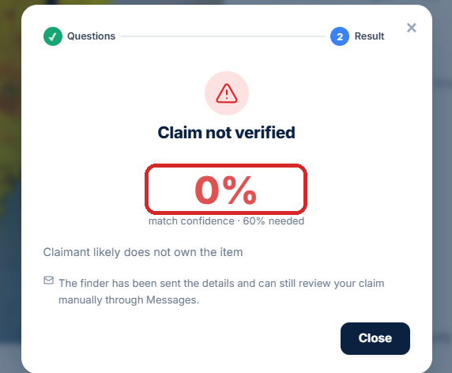
Figure 17: A claimant who does not know the details scores 0% and is refused
Figure 18: A claimant who does know them passes and the item is marked as Claimed
Every Bedrock call degrades gracefully. If description generation fails the form simply arrives empty for the user to fill in, and if question generation fails a set of open fallback questions is used instead. The application never blocks on an AI service being unavailable, which matters because an outage in a drafting feature should never stop somebody reporting a lost item.

Development of Amazon Cognito
Cognito handles registration, sign-in and authorisation. The alternative would have been storing usernames and password hashes in DynamoDB and writing the sign-in logic myself, and I chose against that deliberately. Authentication is the part of an application where a small mistake has the largest consequences, and a managed service provides password hashing, token signing, token expiry, account confirmation and password reset flows that are correct by default. Writing those from scratch would have produced a weaker result and consumed time better spent on the features that make this project distinctive.
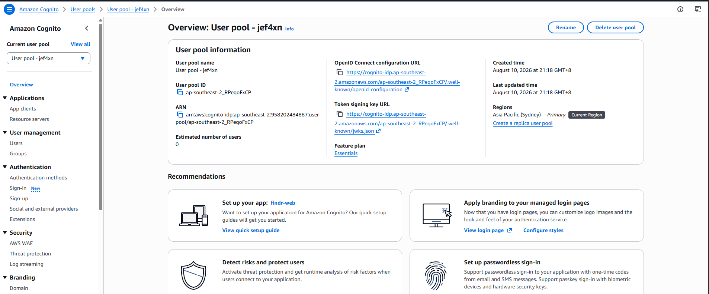
Figure 19: The Cognito user pool

Password policy and account confirmation
The password policy requires at least eight characters including an uppercase letter, a number and a symbol. The sign-up form states exactly the same requirements, which is a deliberate detail: if the two disagree, a user is told their password is acceptable and is then rejected by Cognito after submitting, which is a frustrating and avoidable failure.
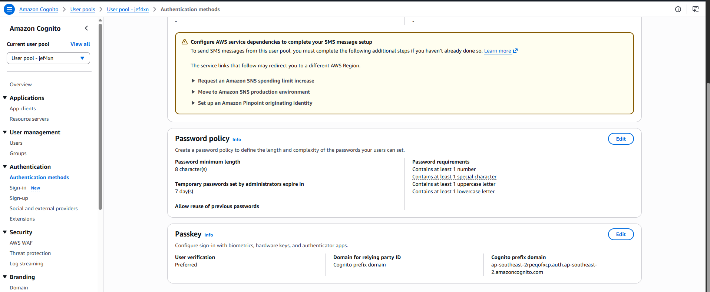
Figure 20: Password policy enforced by the user pool
Accounts are confirmed by a six digit code emailed by Cognito. This matters for this application specifically, because ownership claims and messages are tied to an account. An unverified address would let somebody create disposable accounts to make repeated claim attempts, so requiring a real, reachable email raises the cost of that meaningfully.

How the authorisation model works and why it is secure
A JSON Web Token has three dot separated parts: header, payload and signature. The payload is base64 encoded JSON and is readable by anyone, and it is not encrypted. What makes it trustworthy is the signature, which Cognito produces with a private key and which anyone can verify using Cognito's public key. The token is therefore readable by all and forgeable by none.
Three properties of this design are what make the application's authorisation trustworthy:
- Validation happens before compute. API Gateway checks the signature before the Lambda function is invoked, so a request carrying a missing, expired or tampered token is rejected at the edge. This is both a security property and a cost property, because an invalid request never consumes a Lambda invocation.
- Identity is never taken from the request body. Every function derives the caller's user ID and role from the token's claims. Because those claims are inside a signed token, a user cannot impersonate another account or promote themselves to administrator by editing the JSON they send.
- Ownership is enforced on the server. Editing and deleting a report both check the caller's ID against the record's owner in the Lambda function, not in the browser. Hiding a button in the interface stops nothing, since anybody can call the API directly.
The update path additionally uses an allow-list of editable fields, so even a valid request from the correct owner cannot reassign a report to a different user by including a userId in the body. The field is simply ignored.
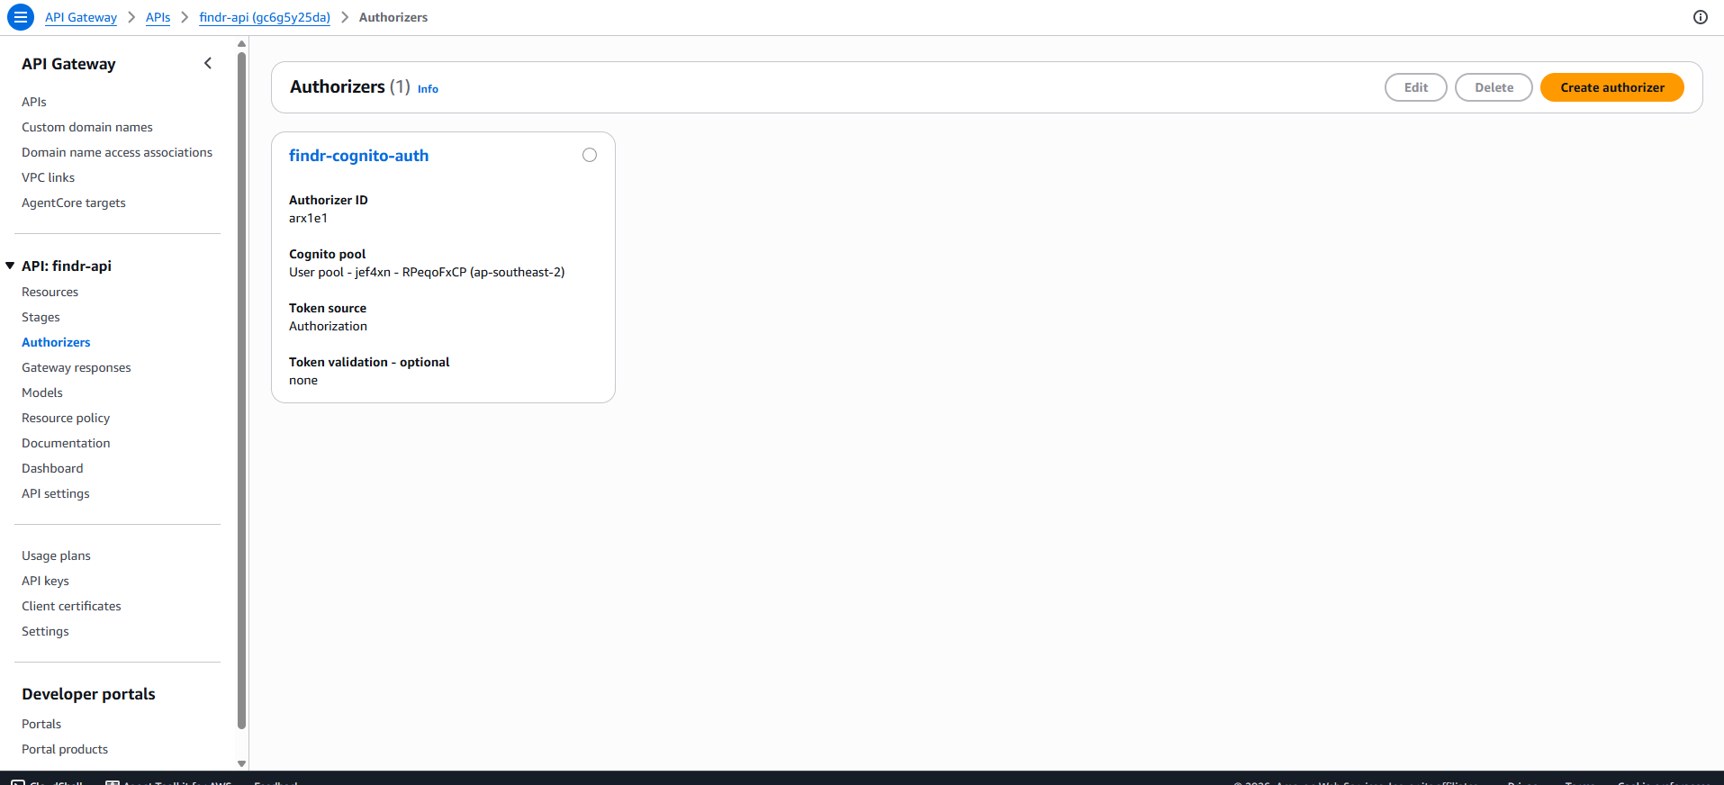
Figure 21: The Cognito authoriser attached to the API

Administrator access through groups
Administrator rights come from a Cognito group named admin. Membership appears in the issued token as a cognito:groups claim, which the Lambda functions read to decide whether a caller may edit or delete a report they do not own.
Using a group rather than a flag on the user record means the privilege travels inside the signed token and cannot be forged, and it can be granted or revoked from the console without a code change or a database write. The claim only appears in tokens issued after the user joined the group, so an existing session has to be signed out and back in, which is a small operational detail worth knowing.
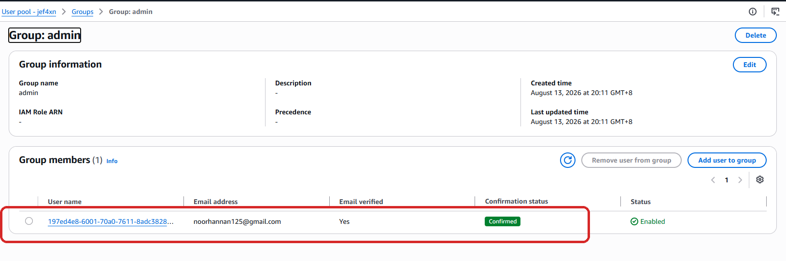
Figure 22: The admin group and its member

Development of Amazon Translate and Amazon Comprehend
Why the platform needs more than one language. Singapore has four official languages, and a campus lost and found service is used by everybody on that campus, including exchange students, visitors and staff who are more comfortable reading in Chinese, Malay or Tamil than in English. The consequence of getting this wrong is specific rather than abstract: if a listing cannot be read, the item is not identified, and the whole point of the platform fails for that person. Translation is therefore not decoration here, it is what makes the service usable by its whole audience.
There is a second, less obvious reason. Reports are written by users, and a user may well describe their lost item in their own language. Because the platform can translate in both directions, a listing written in Malay is just as findable by an English-speaking student as the reverse.

How the two services work together
Amazon Translate performs the translation. The findr-translate Lambda accepts a title, a body and an array of short strings, and returns them translated into the requested language.
Amazon Comprehend determines the source language. Translate's SourceLanguageCode parameter is set to auto, which invokes Comprehend behind the scenes to detect the language of the incoming text before translating it.
Using automatic detection rather than asking the user to state their language is a deliberate choice. The alternative would be storing a language field on every report and trusting the user to set it correctly, which adds a field to the form, adds a way for the data to be wrong, and fails completely when somebody writes a title in one language and a description in another. Detection removes all of that, and it is what allows a listing to be translated back into English without the platform ever having recorded what language it started in.
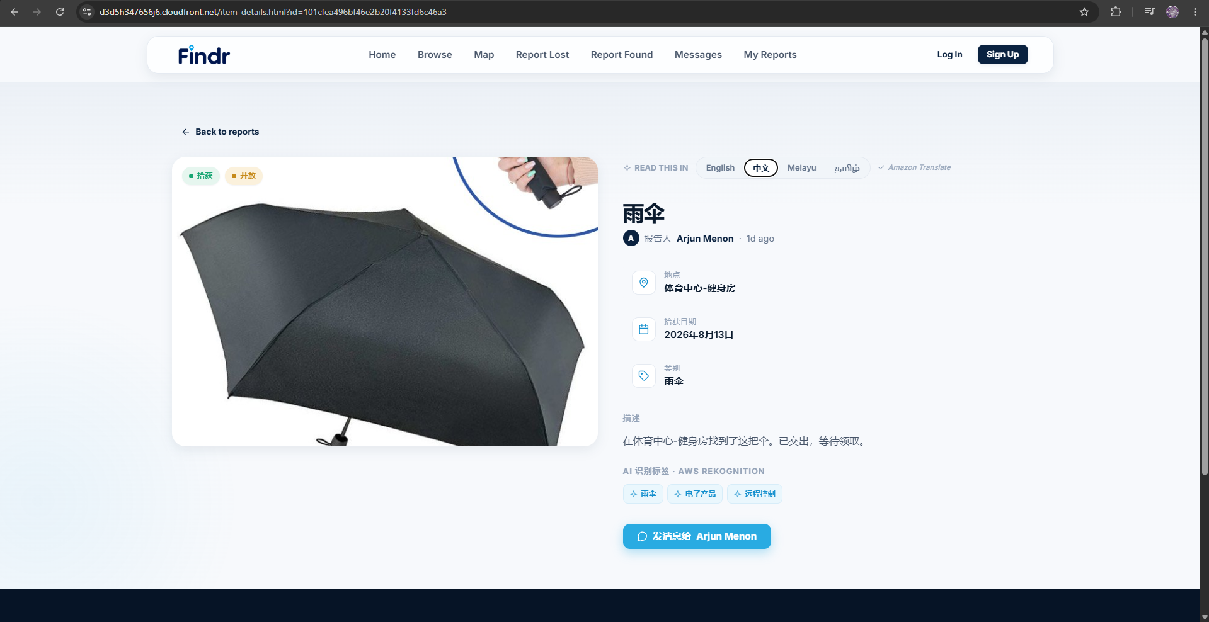
Figure 23: An item page translated into Chinese
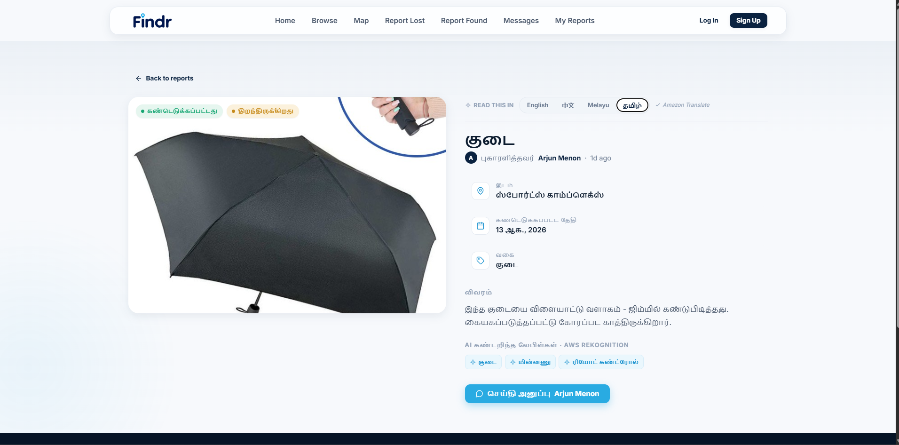
Figure 24: The same item page in Tamil

Design decisions in the translation layer
The target language is validated against a fixed list of four. Without that check, the endpoint would be a general purpose translation API available to anybody who found the URL, and Translate charges per character.
Fixed interface text is not sent to the API. Headings such as Location, Category and Description never change, so they are translated once from a dictionary held in the frontend. Only the listing's own words, meaning the title, description, location, category and detected labels, are sent to Amazon Translate. This keeps the cost proportional to the content that actually varies, and it makes language switching feel instant because most of the page does not wait on a network call.

Development of Amazon Location Service
Why a map is needed. For a lost item, where is usually the strongest piece of information the owner has. A student rarely remembers the exact time they lost something, but they can almost always narrow it to a building or a route across campus. A list sorted by date cannot express that, whereas a map lets somebody scan the area they walked through and recognise their item immediately. The map converts vague human memory into a usable search.
It also helps the finder. Dropping a pin at the exact spot an item was found records information that a text field cannot capture precisely, such as which entrance or which side of a building.
Why Amazon Location Service. Using it rather than a third party mapping provider keeps the entire application inside AWS, under one bill and one set of IAM controls, with no external account or separate terms of service to manage. It works with MapLibre GL JS, an open source renderer, so the map is fully interactive rather than a static image.
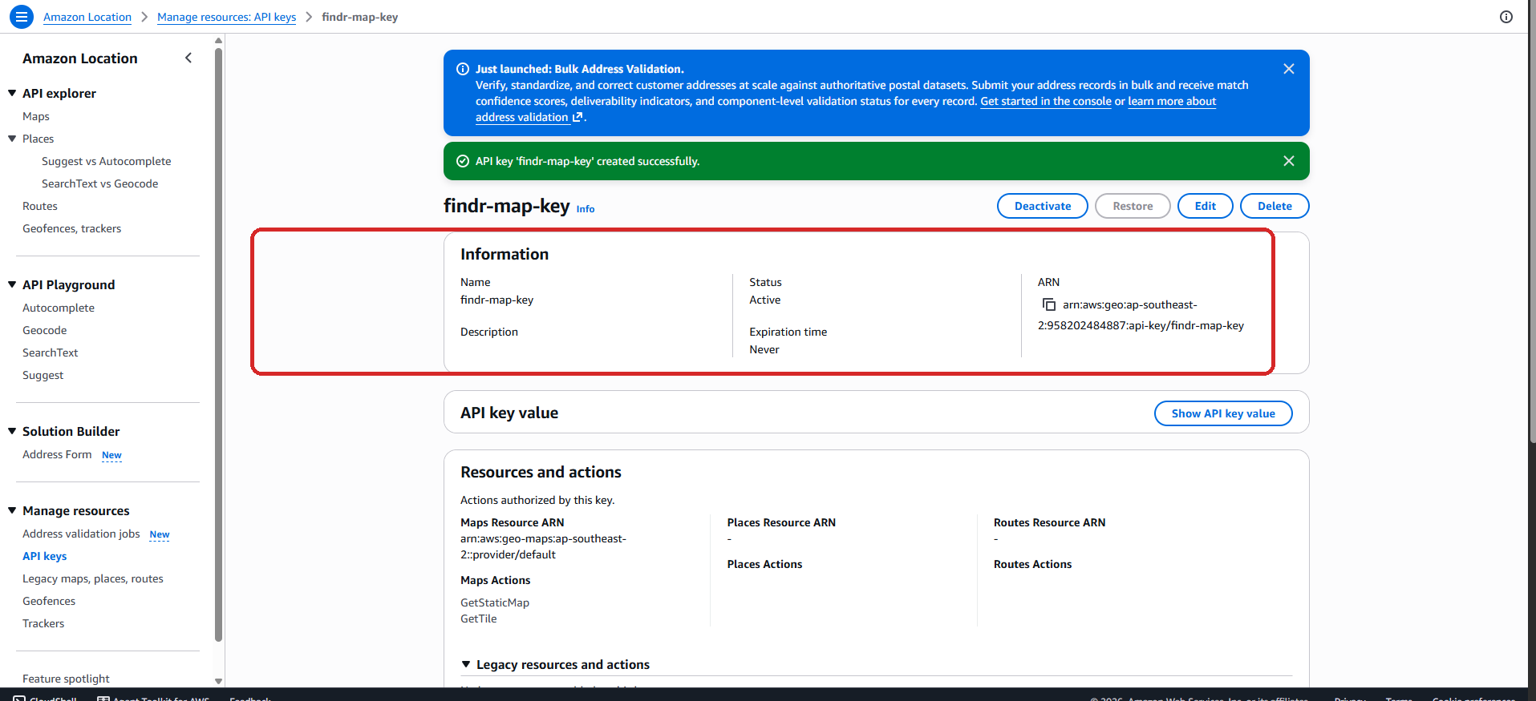
Figure 25: The Location Service API key, scoped to map rendering
An API key was created and scoped to map rendering only. The browser requests style and tile resources directly from the service rather than proxying them through Lambda, because map tiles are numerous and large, and routing them through compute would add both latency and cost for no benefit.
Each marker is rendered as an HTML element showing the item photograph rather than a generic pin, which turns the map into something that can be scanned visually.
Figure 26: Reports plotted on the campus map, each marker showing the item photograph

Development of Amazon SNS
Why notifications are needed. The weakness of any noticeboard is that it only works when somebody is looking at it. A finder who hands in an item has no reason to keep checking the site, so without notifications a successful claim could sit unnoticed for days, which is exactly the delay the platform exists to remove. Notifications turn Findr from something a user has to remember to visit into something that contacts them when it matters.
It is also a matter of trust. When a claim is made on an item somebody handed in, that person should be told, and should be told who claimed it and on what basis, rather than discovering later that the item was given away.
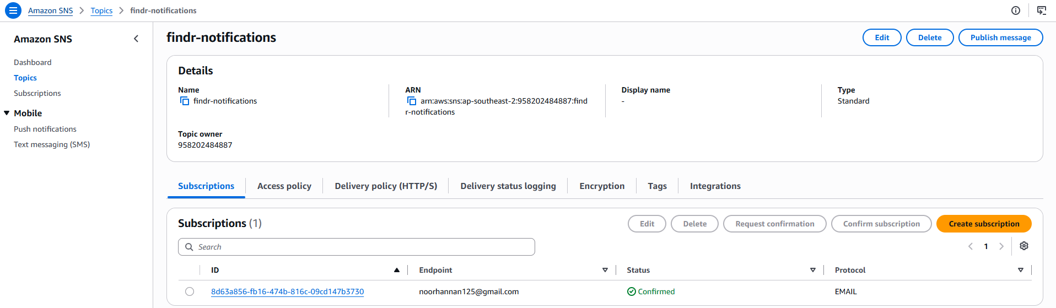
Figure 27: The SNS topic and its email subscription
A single topic, findr-notifications, receives messages when a report is created, when its status changes, when a message is sent and when somebody attempts to claim a found item. Using one topic with subscribers, rather than sending email directly from each Lambda function, means the delivery mechanism can be changed later without touching application code. Adding SMS or a mobile push channel would be a subscription change rather than a code change.
The notification sent after a claim deliberately includes the outcome, the confidence score and the assessment, so the finder can review a decision they disagree with rather than the system simply handing the item over on the model's say-so. The AI advises and the human decides.
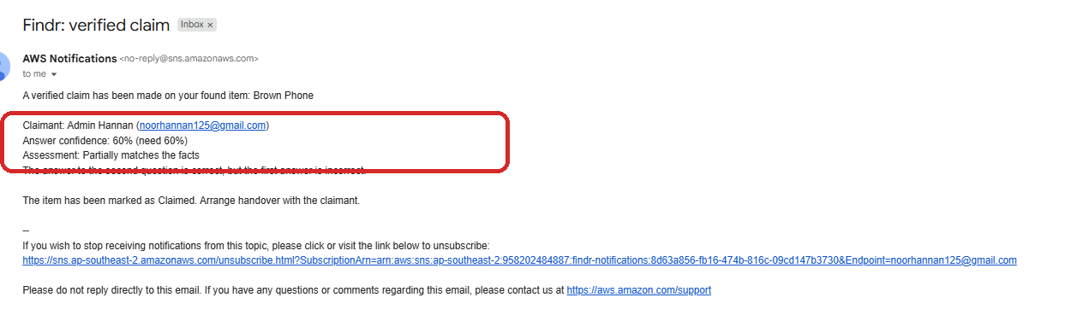
Figure 28: The email a finder receives after a verified claim
Every SNS publish is wrapped in its own error handler. A notification that fails to send should never cause the underlying action to fail, so if the publish raises an error it is logged and the request continues normally. Reporting an item is more important than the email about it.

Development of AWS WAF
What a web application firewall does. WAF inspects HTTP requests before they reach the origin and blocks those matching known attack patterns, such as SQL injection strings, cross-site scripting payloads, requests from known malicious IP ranges, and traffic from bots and scanners. It operates at the edge, so a blocked request never reaches CloudFront's origin or the API behind it.
Why it is worth having here. Findr is a public website with forms that accept free text and file uploads, which is exactly the surface automated scanners probe. The application already validates and escapes input at the application layer, but defence in depth means not relying on a single control: WAF filters the obvious hostile traffic before it arrives, so the application layer only has to handle what gets through.
Enabling CloudFront's security protections provisions a managed AWS WAF web ACL associated with the distribution, which applies AWS-managed rule groups. Using managed rule groups rather than hand-written rules is the right choice at this scale, because AWS maintains and updates them as new attack patterns appear, whereas a hand-written rule set would be frozen at the moment I wrote it.
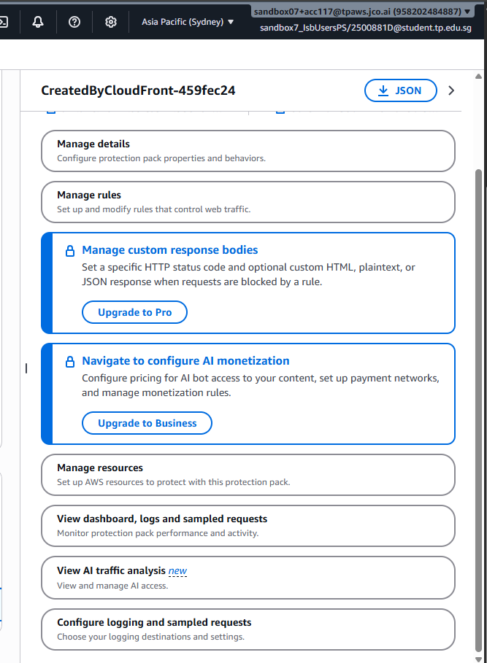
Figure 29: The WAF web ACL associated with the CloudFront distribution

Deployment process
The frontend is a set of static files with no build step, no bundler and no dependencies to install. That was a deliberate choice: it means deployment is a file copy, the deployed files are identical to the files in the repository, and there is no build environment that can drift or break.

Deploying the website
- Open the findr-site-XXXXXXXX bucket in the S3 console.
- Upload the changed files, preserving the folder structure so that js/, css/ and images/ keep their paths. Uploading a file to the wrong level is the most common way to break the site, because the HTML references it by relative path.
- Open the CloudFront distribution, go to the Invalidations tab and create an invalidation for /*.
- Wait for the invalidation status to change to Completed, which usually takes under a minute.
- Load the site and confirm the change, with the browser console open to catch any JavaScript error.
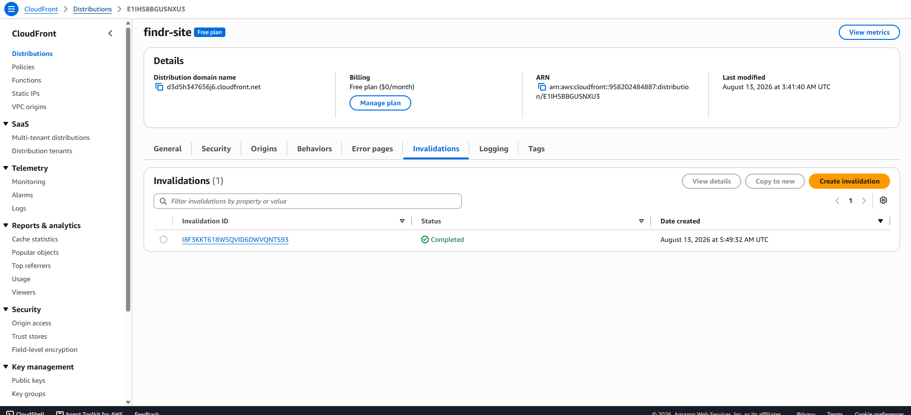
Figure 30: Creating an invalidation on the CloudFront distribution
Why the invalidation step is necessary. CloudFront is a cache. When a file is requested, the edge location keeps a copy and serves that copy to everybody who asks for it until it expires, which can be hours. This is what makes the site fast, but it means that uploading a new file to S3 changes the origin without changing what visitors receive. The invalidation tells every edge location to discard its cached copy and fetch the file again on the next request.
Skipping this step is the single most common cause of a deployment appearing not to have worked. The file is genuinely updated in S3, the site genuinely still shows the old version, and nothing in the AWS console reports an error, so it looks like the change failed when it simply has not propagated. Invalidating /* rather than individual paths costs nothing at this scale and removes any chance of a stale file being missed.

Deploying a Lambda function
Lambda changes are deployed separately from the website. Paste the updated function into the console editor and click Deploy, then confirm the timestamp under the function name has updated.
Editing the code without clicking Deploy is easy to miss, because the console continues to display the new text while the old version is still what runs. If a change appears to have no effect, checking that timestamp is the fastest way to rule this out.

Configuration settings
Setting | Value | Reason
CloudFront viewer protocol | Redirect HTTP to HTTPS | The site cannot be served unencrypted
CloudFront origin access | Origin Access Control | Keeps the S3 bucket private and reachable only through the distribution
Lambda timeout (findr-images) | 30 seconds | Four sequential AWS calls including a multimodal Bedrock request
Lambda timeout (findr-verify) | 30 seconds | Two sequential Bedrock calls, one of them on the larger model
Lambda memory | 512 MB | Raised from the default for the image and verification paths
Pre-signed PUT expiry | 5 minutes | Long enough to upload a photograph, short enough to limit reuse
Pre-signed GET expiry | 1 hour | Item photographs have no permanent public URL
Verification pass mark | 60% | Set after testing both correct and incorrect answers
DynamoDB capacity mode | On-demand | No provisioned capacity to pay for while the site is idle

Service dependencies
Deployment order matters whenever a change alters the contract between the frontend and the backend:
- Lambda before frontend. If the frontend is deployed first it may request a field the backend does not yet return, which shows up as a blank section rather than an obvious error.
- API Gateway resources before Lambda logic. A function that handles a new route does nothing until the resource and method exist and the API has been redeployed to the prod stage. Creating the method is not enough on its own; the stage has to be deployed.
- IAM before everything. A function calling a service it has no permission for fails at runtime with AccessDeniedException, not at deployment, so a missing permission looks like a working deployment until the feature is used.
- Cognito group before testing administrator features. Group membership only appears in a token issued after the user joined the group, so an existing session has to be signed out and back in.

Troubleshooting tips
Symptom | Cause and fix
A change does not appear on the site | CloudFront is serving a cached copy. Create an invalidation for /*.
Toast messages display as "undefined" | Lambda proxy integration is unticked on that API Gateway method, so the whole response dictionary arrives as the body. Tick the box and redeploy the stage.
AccessDeniedException in the logs | The execution role is missing a permission for that service or resource.
403 on a request containing %23 | API Gateway rejects an encoded # inside a path parameter. Pass the value as a query string parameter instead.
The analysis panel shows an offline notice | The Custom Labels model is stopped. Start it from the Rekognition console, or continue with the pretrained fallback.
The administrator dashboard is empty for an admin user | The token predates the group membership. Sign out and back in.
A Bedrock feature returns nothing | The call failed and the code fell back. Check the function's CloudWatch log group for the logged exception.
A photograph fails to upload | The pre-signed URL has expired, or the file type is outside the allow-list. Reload the form and retry.

Setup guide
This section documents how each service was configured, with the reasoning behind each setting. Everything was created in ap-southeast-2 (Sydney) so that all resources sit in one region, which avoids cross-region latency and data transfer charges between services that call each other constantly.

Amazon S3
Two buckets are used, and separating them is deliberate: the website files are world-readable content served through a CDN, while item photographs are private user data. Keeping them apart means one bucket policy cannot accidentally expose the other.
- Create a bucket named findr-site-XXXXXXXX in ap-southeast-2 for the website files.
- Create a second bucket named findr-uploads-XXXXXXXX for item photographs.
- Leave Block all public access enabled on both. Neither bucket should be reachable directly, and CloudFront does not need public access in order to read the site bucket.
- On the uploads bucket, open Permissions and add a CORS configuration allowing PUT, GET and HEAD.
- Create a folder named uploads/ inside the uploads bucket. All object keys are written under this prefix so the IAM policy can be scoped to it.
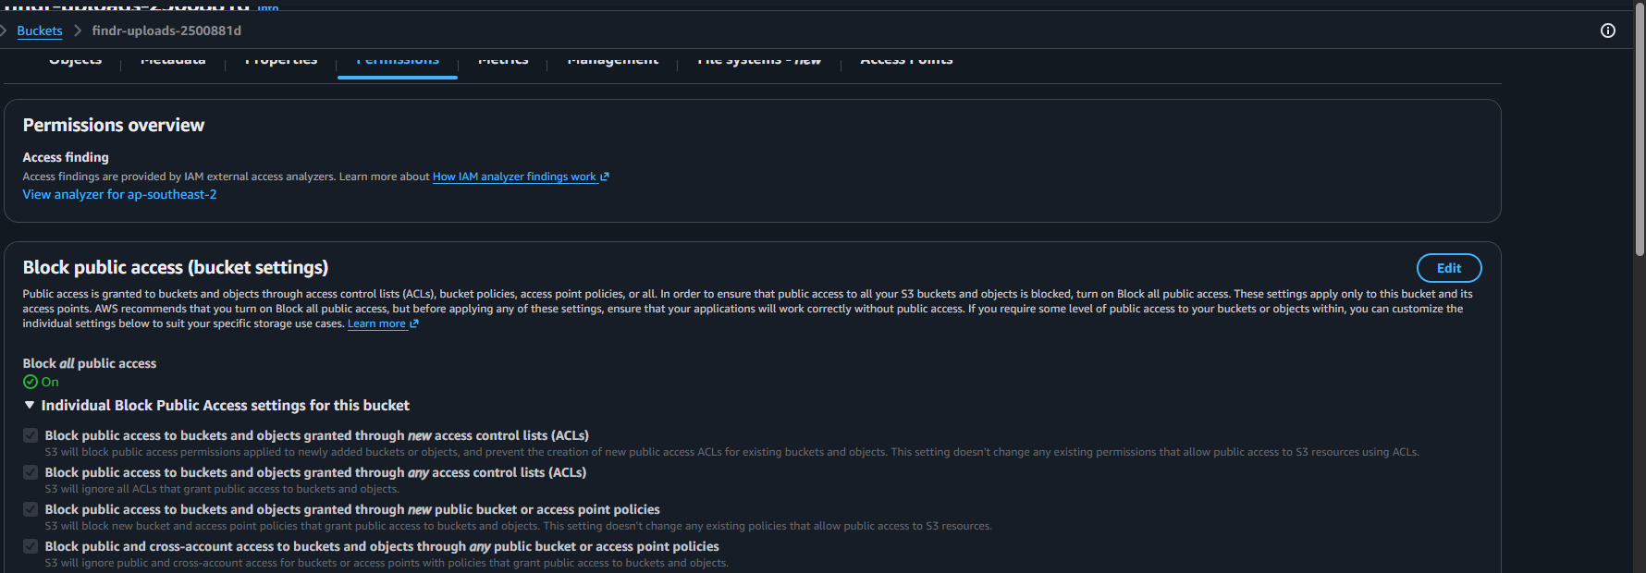
Figure 31: Block Public Access enabled on the bucket
Why CORS is required on the uploads bucket. The browser uploads photographs directly to S3 using a pre-signed URL rather than sending them through Lambda. That is a cross-origin request from the CloudFront domain to the S3 domain, and without a CORS configuration the browser blocks it before it is ever sent.
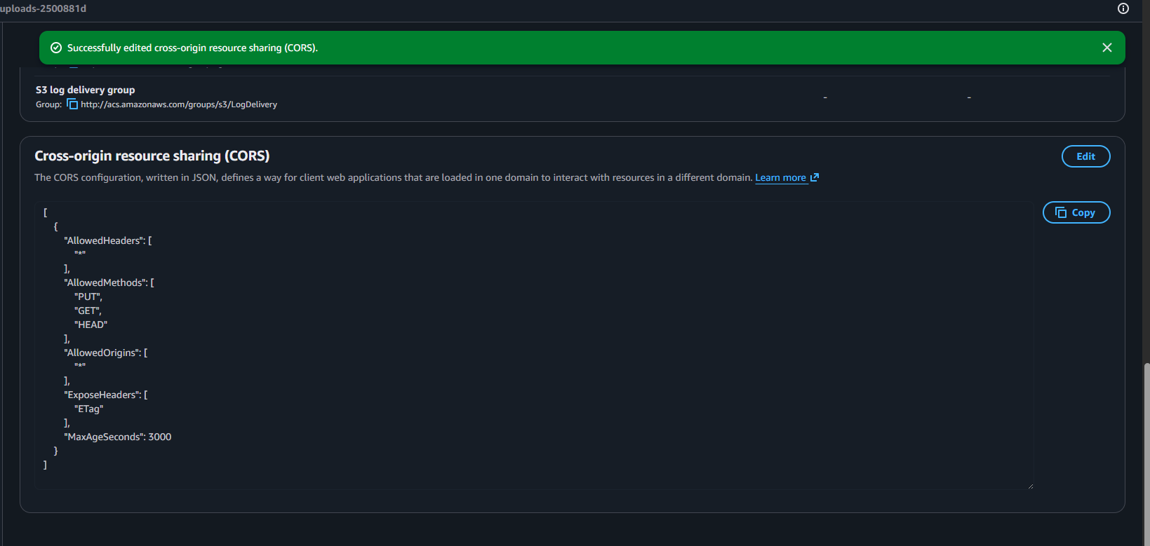
Figure 32: CORS configuration on the uploads bucket
Static website hosting was enabled on the site bucket during early testing, before CloudFront was introduced. It is documented here because it was part of the build process, but the deployed site is served through CloudFront rather than the website endpoint.
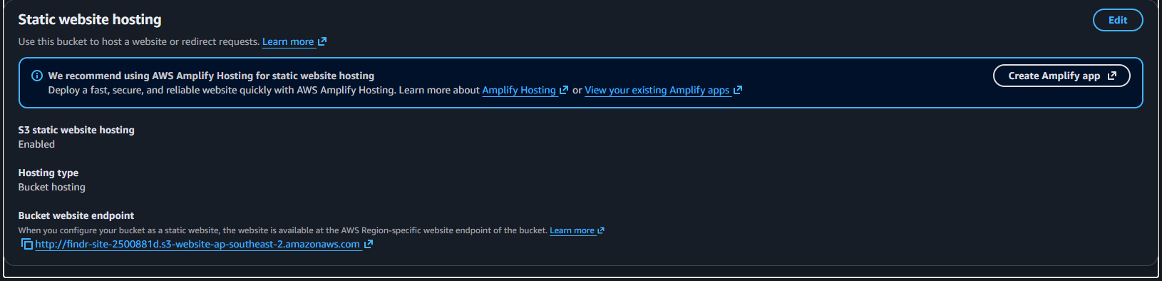
Figure 33: Static website hosting, used during initial testing

Amazon DynamoDB
Two tables are used, both in on-demand capacity mode so there is nothing to pay for while the site is idle, which suits traffic that is unpredictable and mostly zero.
- Create a table named findr-reports with a partition key of reportId (String).
- Set capacity mode to On-demand.
- Create a global secondary index named type-createdAt-index with type as the partition key and createdAt as the sort key.
- Create a second table named findr-messages with a partition key of conversationId (String) and a sort key of sentAt (String).
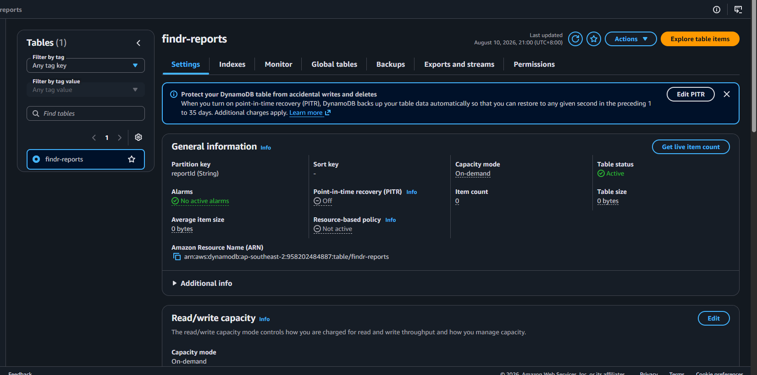
Figure 34: The findr-reports table
Why the secondary index exists. The most common query in the application is "show me all lost items, newest first". Without an index, DynamoDB has to scan the entire table and sort the results in the application. With type as the partition key and createdAt as the sort key, the same request becomes a query that reads only matching rows and returns them already ordered, which is both faster and cheaper because DynamoDB charges for what it reads.
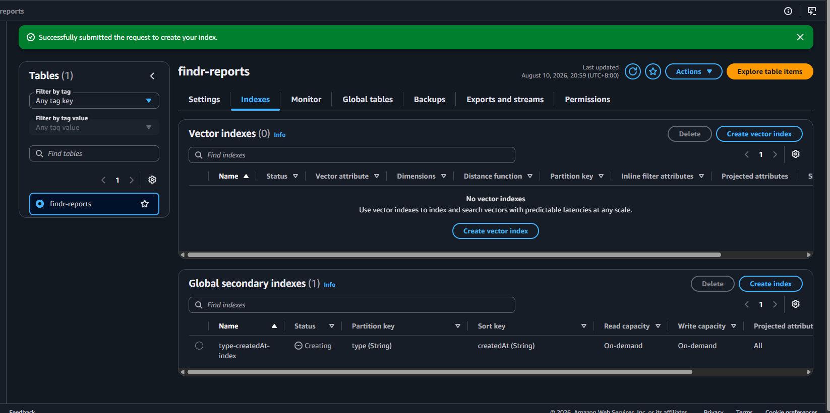
Figure 35: The type-createdAt-index global secondary index
Why the messages table uses a composite key. A conversation identifier is built from the two participants' user IDs sorted alphabetically, joined with the report identifier. Sorting the IDs means both participants always derive the same conversation identifier without needing a lookup table, and using sentAt as the sort key means a query for one conversation returns its messages already in chronological order.

Why DynamoDB rather than Amazon RDS
A lost and found platform has reports, users and messages, which sounds like a relational schema, so choosing a NoSQL database needs justifying.
The access patterns are few, and all of them were known before any code was written. Fetch one report by its identifier. List reports of a given type, newest first. List the messages in one conversation, in order. Filter reports by category or status. Not one of these needs a join, and there is no requirement anywhere in the application to run a query that was not anticipated in advance. That is the condition under which a key-value store is the better fit, and it is worth being explicit that if the application did need ad-hoc reporting across tables, the answer would be different.
Cost while idle was the deciding factor. An RDS instance bills for every hour it exists, whether or not anybody uses it, and a campus service is idle most of the time: overnight, at weekends, and through the holidays. DynamoDB in on-demand mode charges per request, so an idle platform costs effectively nothing. For a service whose traffic is unpredictable and mostly zero, paying for a database that sits waiting is the wrong shape of cost.
RDS would have pulled the whole application into a VPC. RDS lives inside a VPC, so every Lambda function that touches the database has to be attached to that VPC. Those functions also call Bedrock, Rekognition, Translate and SNS, which are reached over the public AWS endpoints, so the VPC would then need NAT gateways for those calls to work. A NAT gateway bills per hour as well, which means the serverless design would have acquired two always-on charges purely because of the database choice.
The records are not uniformly shaped. A report may or may not have coordinates, may or may not carry private verification details, may or may not have a claim record attached, and holds a variable-length list of detected labels. In a relational schema most of that becomes nullable columns or extra join tables. As a document it is simply the fields that happen to be present.
There is no operational overhead. No instance to size, no engine version to patch, no storage to grow, no backup window to schedule. For a project built and run by one person, that matters more than the query flexibility being given up.
Consideration | Amazon DynamoDB | Amazon RDS
Cost while idle | Effectively zero, billed per request | Billed per hour regardless of traffic
Networking | Public endpoint, no VPC needed | Inside a VPC, so Lambda needs VPC plus NAT
Query flexibility | Only the patterns designed for | Any query, including joins and ad-hoc reporting
Schema | Fields vary per record | Fixed columns, optional fields become nullable
Operational work | None | Sizing, patching, backups, version upgrades

The honest trade-off. What this choice gives up is the ability to ask questions of the data that were not planned for. If Findr needed a report on recovery rates by category and month, or a join across users, reports and claims, that would mean either a table scan or exporting the data somewhere else. At the scale and scope of this project that has not been needed, but it is the cost of the decision rather than a free win.

AWS IAM
All six Lambda functions share one execution role. Sharing a role is reasonable here because the functions form a single application with overlapping needs, and the policy grants only actions the code actually performs.
- In IAM, create a role with AWS service as the trusted entity type and Lambda as the use case.
- Attach AWSLambdaBasicExecutionRole, which allows the function to write logs to CloudWatch.
- Create a customer managed policy granting the DynamoDB, S3, Rekognition, Bedrock, Translate, Comprehend and SNS actions the functions use.
- Scope every action to a specific resource ARN wherever the service supports resource-level permissions.
- Attach the policy to the role, then select this role when creating each function.
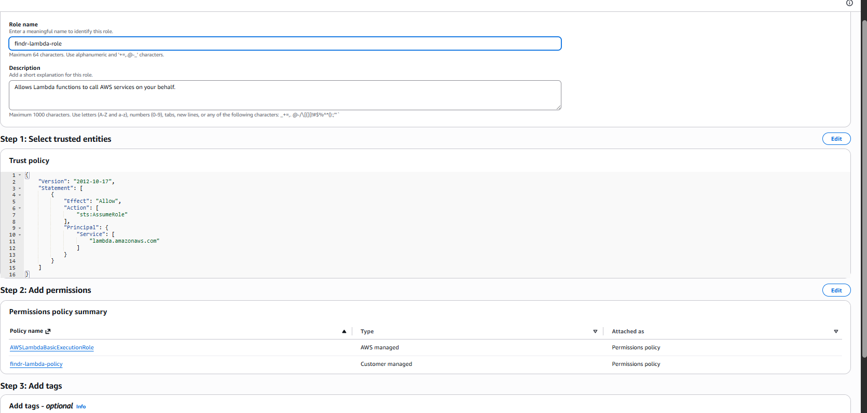
Figure 36: Creating the Lambda execution role
How the policy is scoped. DynamoDB permissions name the two tables and their indexes explicitly, so a function cannot read a table that is not part of this application. S3 permissions are restricted to the uploads/* prefix rather than the whole bucket, so the functions cannot read or delete anything outside the folder they own. SNS publishing is restricted to the single Findr topic.
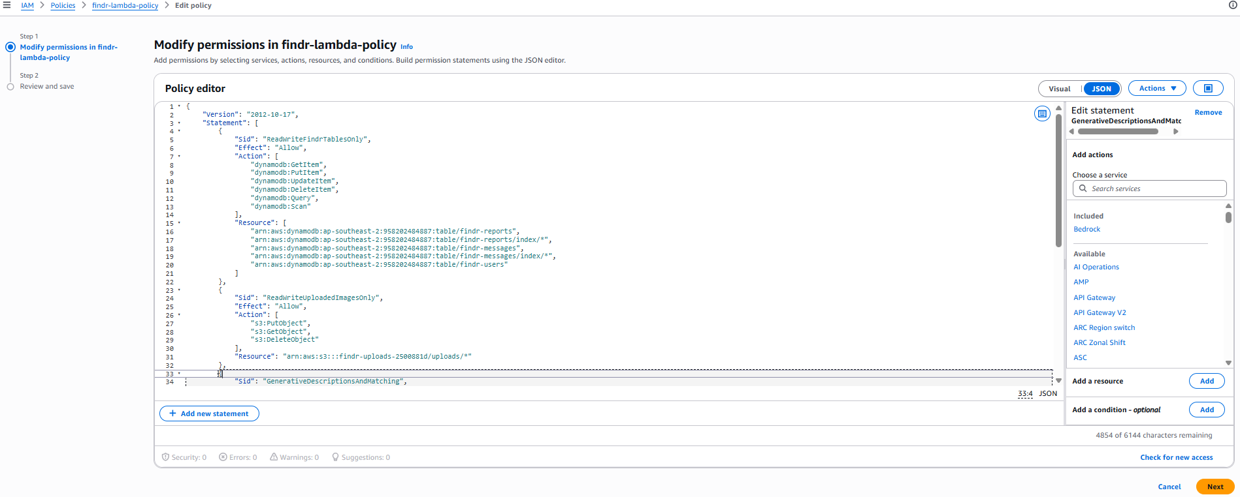
Figure 37: The execution role policy, scoped per resource
Three services are granted with Resource: "*". For Rekognition and Translate this is unavoidable, because neither exposes resource-level ARNs for the operations used, so * is the only valid value rather than a shortcut.

AWS Lambda
Six functions hold the application logic. Splitting them by responsibility rather than writing one large function means each has a small blast radius, a clear purpose and its own log group, which makes a failure easy to locate.
Function | Responsibility
findr-reports | Full CRUD for reports, ownership checks, image URL signing
findr-images | Pre-signed upload URLs, moderation, Rekognition analysis, Bedrock descriptions
findr-messages | Conversation listing, reading and sending
findr-match | Label shortlisting followed by Bedrock semantic re-ranking
findr-verify | Ownership verification: question generation and answer marking
findr-translate | Listing translation into the four supported languages

- Create each function with the Python 3.12 runtime.
- Under Permissions, choose Use an existing role and select the Findr execution role.
- Paste the function code and click Deploy.
- Under Configuration, add the environment variables the function needs.
- For findr-images and findr-verify, raise the timeout to 30 seconds and memory to 512 MB.
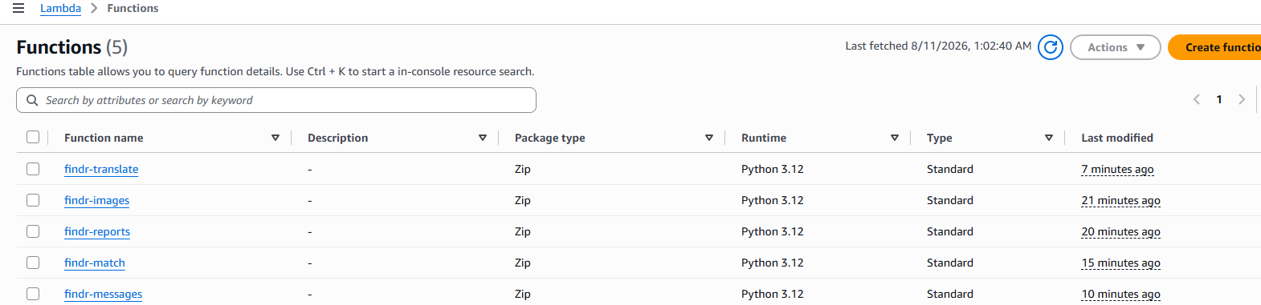
Figure 38: The Lambda functions
Why environment variables rather than hard-coded values. Table names, the bucket name, the SNS topic ARN, the Bedrock model identifiers and the custom model ARN all differ between environments and can change independently of the code. Supplying them as environment variables means the same code can be pointed at different resources, and it also means the Custom Labels model ARN can be cleared to disable the custom model without editing or redeploying anything.
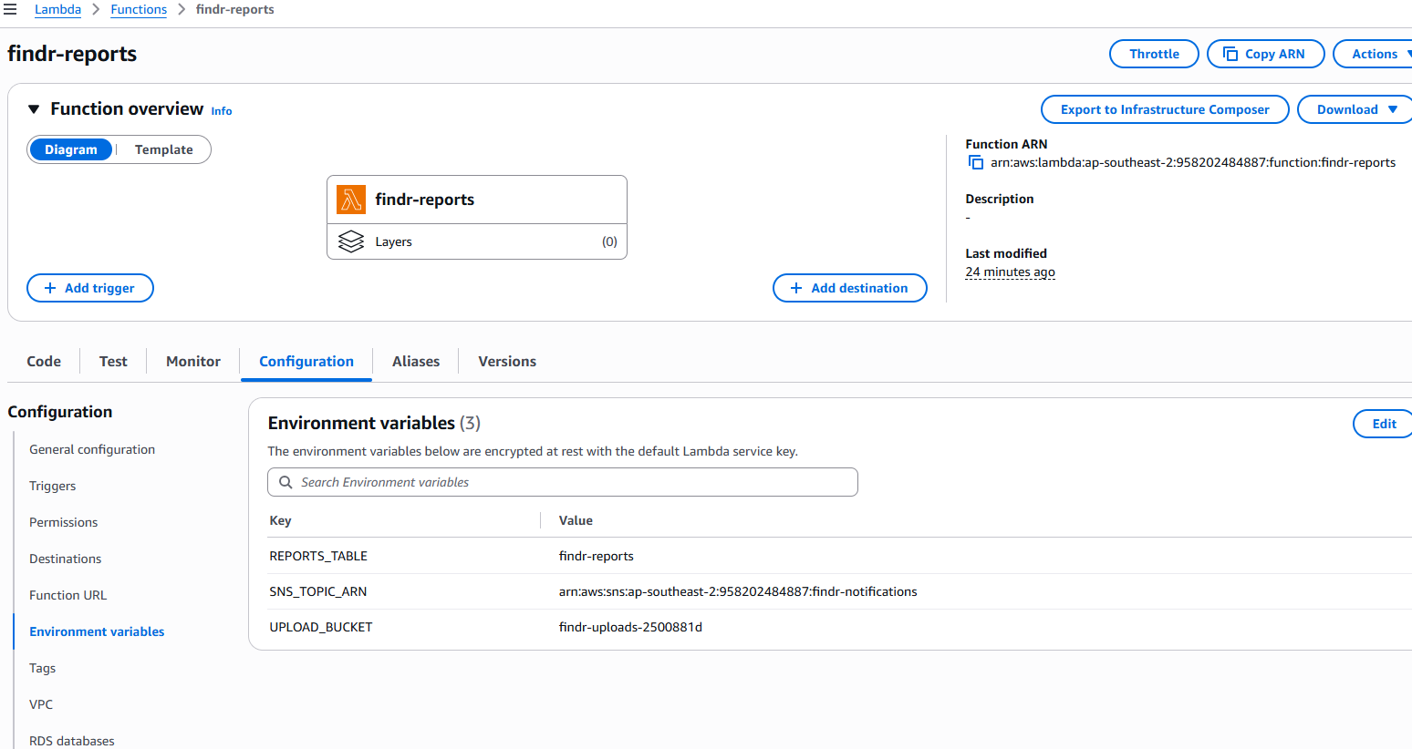
Figure 39: Environment variables on findr-reports
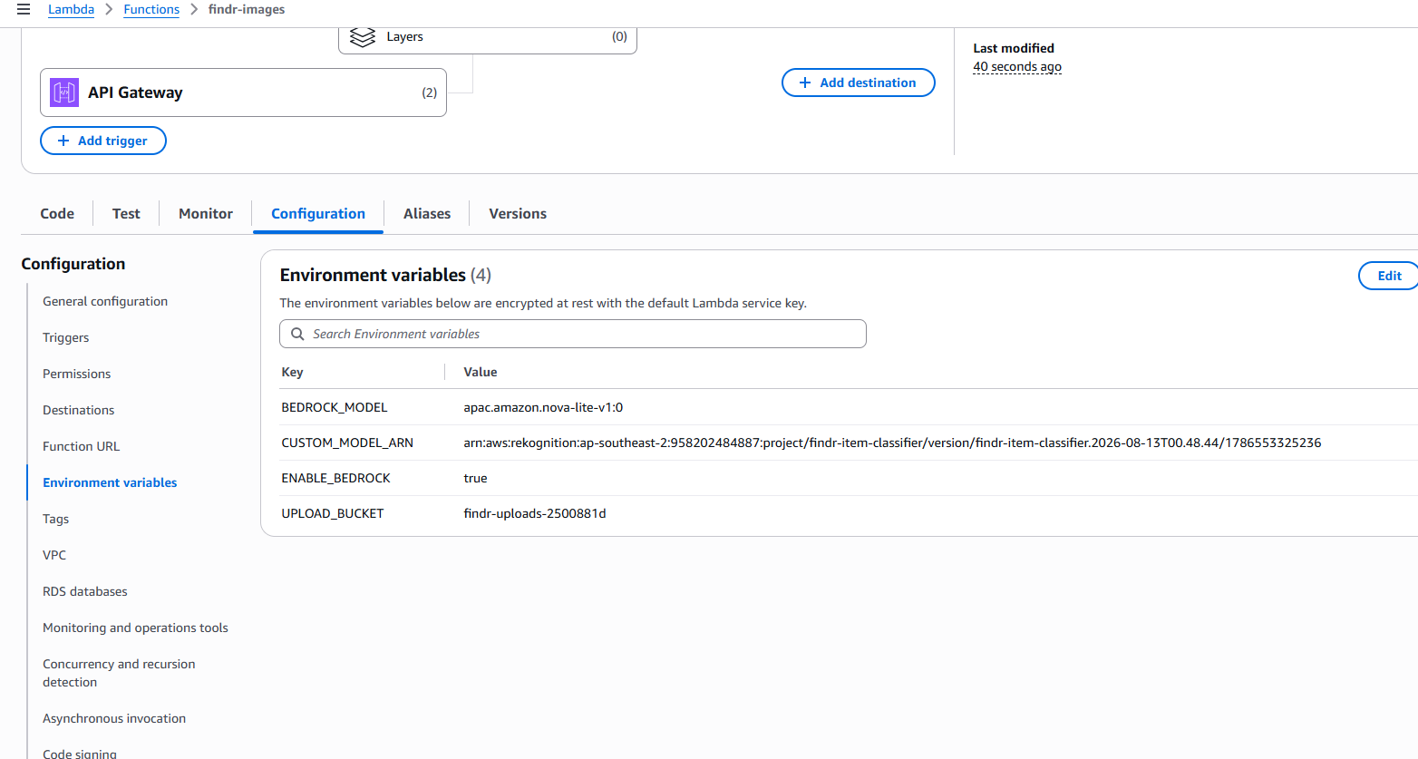
Figure 40: The custom model ARN supplied to findr-images
Why the timeouts were raised. The default timeout is three seconds. findr-images performs four sequential AWS calls, one of which sends an image to Bedrock, and findr-verify waits on two Bedrock calls. Both routinely exceed the default, and the resulting failure looks like an application bug rather than a configuration problem, which makes it worth setting deliberately.
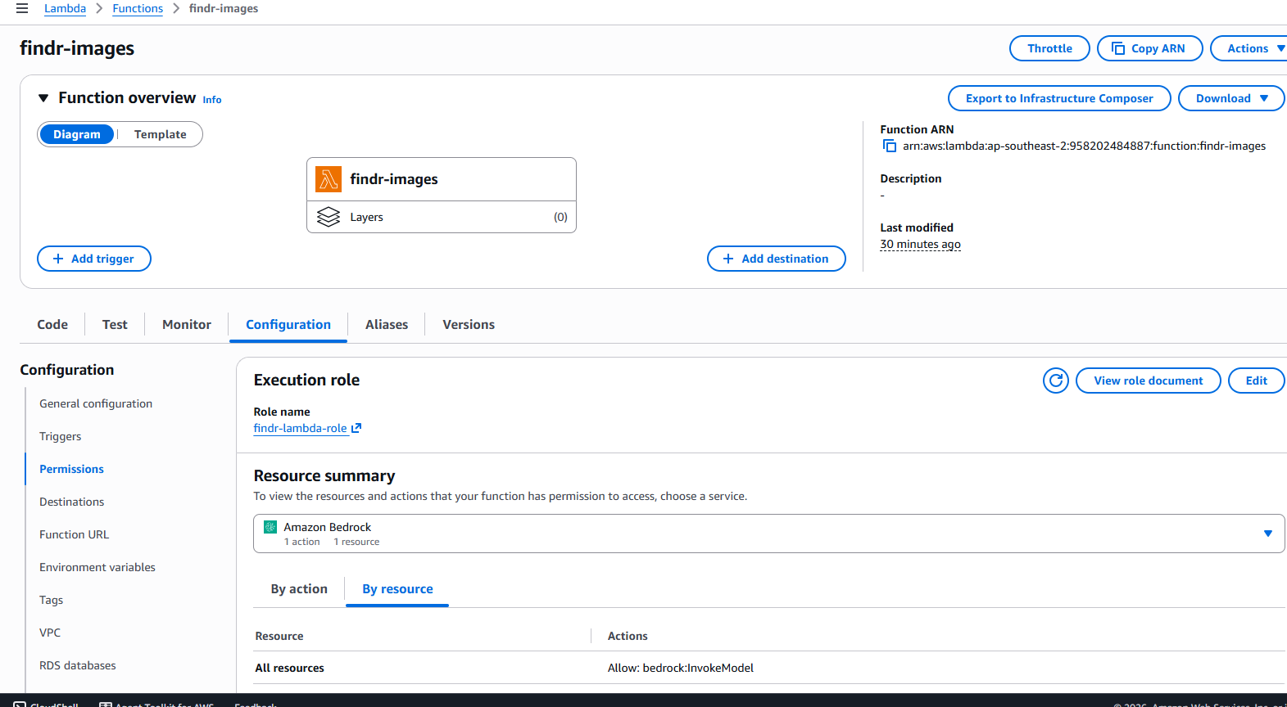
Figure 41: The execution role as attached to a function

Amazon API Gateway
A REST API was created and deployed to a stage named prod.
- Create a REST API (not HTTP API) and name it.
- Create an Authorizer of type Cognito, pointing at the user pool, with Authorization as the token source.
- Create the resources and methods for each route.
- On every method, tick Use Lambda Proxy integration and select the correct function.
- On protected methods, set Authorization to the Cognito authoriser under Method Request.
- Enable CORS on every resource, which creates the OPTIONS preflight method the browser requires.
- Deploy the API to the prod stage. Changes do not take effect until the stage is deployed.
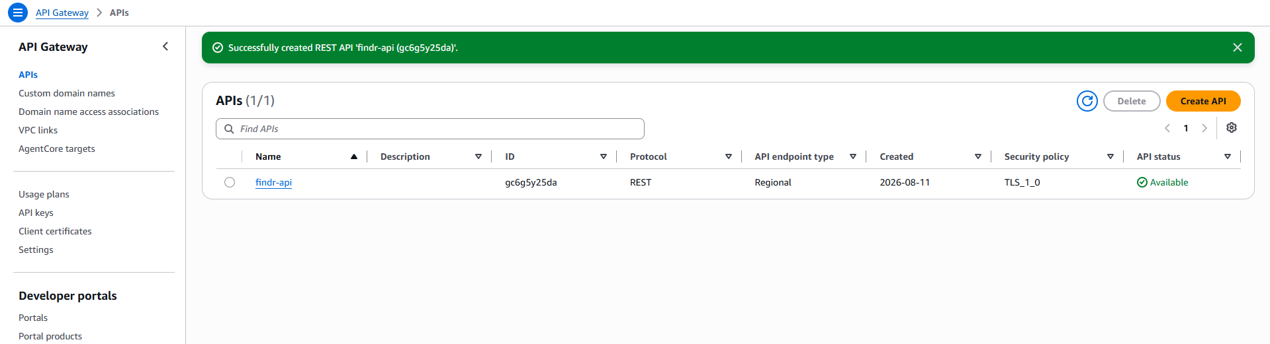
Figure 42: Creating the REST API
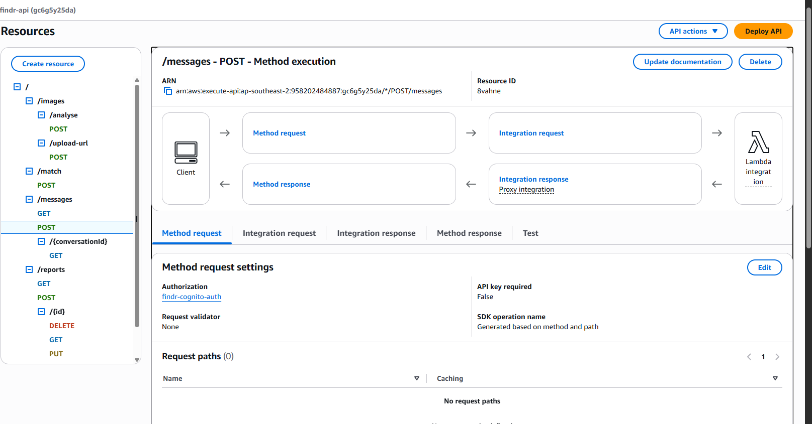
Figure 43: The API resource tree

Why a REST API rather than an HTTP API
API Gateway offers two kinds of API, and HTTP APIs are roughly 70% cheaper with lower latency, so why choose REST API.
REST APIs support several capabilities that HTTP APIs do not:
- AWS WAF can be attached directly to a REST API. It cannot be attached to an HTTP API at all. Given that this application accepts free text and file uploads from the public, having the option to filter malicious requests at the API tier matters.
- Usage plans and API keys allow per-method throttling. That is directly relevant here, because the translation endpoint and the verification endpoint are both expensive per call and both potentially abusable.
- Request validation against a JSON schema rejects malformed input before Lambda is invoked, so a bad request costs nothing.
- Resource policies allow IP based restrictions, which HTTP APIs do not support.
At campus scale the cost difference between the two is negligible, whereas those controls are not available on an HTTP API at any price. Given that the application handles personal data and ownership claims, I prioritised the available security surface over per-request cost.
The trade-off is real and worth stating: the REST API required CORS headers to be written by hand in all six Lambda functions, where an HTTP API provides CORS configuration as a built-in setting.

How the API is structured
Only /reports is a resource in the REST sense, and it carries the full set of verbs: POST to create, GET to read, PUT to update and DELETE to remove. Everything else in the API is an operation rather than a noun, and each of those is a POST.
This is deliberate rather than convenient. GET is defined as safe and must not change state, but /verify/answers writes a claim record and sends an email. GET is also cacheable, and a cached or replayed Bedrock result would be wrong. GET has no request body, and /match needs to send labels, a title, a description and a location, which does not belong in a query string.
There is a security reason too. Query strings are logged in browser history, in CloudWatch access logs and by intermediate proxies. The answers to ownership verification questions have no business appearing in a URL, whereas a POST body stays out of all of those.
Verifying the authoriser works. A protected method can be called directly from a browser without a token. The response confirms that API Gateway rejects it before the Lambda function is reached, which is the behaviour the authoriser exists to provide:
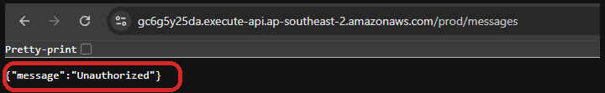
Figure 44: A protected endpoint called with no token returns Unauthorized
The ringed response is the important part. The request never reached the Lambda function, no data was returned, and no compute was consumed. Anybody attempting to read the messages endpoint without signing in receives this and nothing else.

Amazon CloudFront
CloudFront serves the site over HTTPS and is the only route to the site bucket.
- Create a distribution with the site bucket as the origin.
- Under Origin access, choose Origin access control and create a new OAC.
- Copy the bucket policy CloudFront generates and apply it to the site bucket.
- Set the viewer protocol policy to Redirect HTTP to HTTPS.
- Set the default root object to index.html.
- Enable the security protections, which provisions the WAF web ACL.
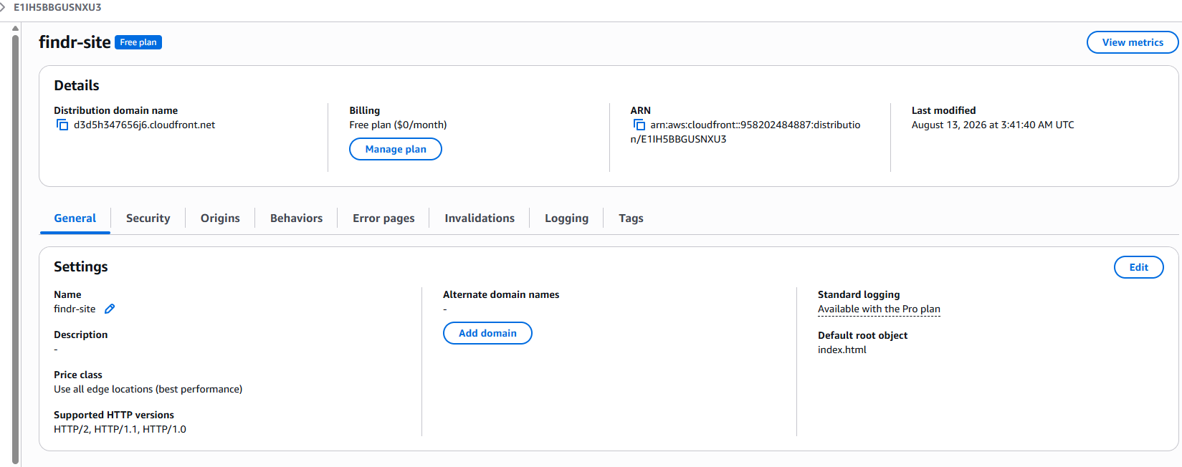
Figure 45: The distribution origin configured with Origin Access Control
What the bucket policy does. It allows the CloudFront service principal to read objects, and the AWS:SourceArn condition restricts that to this distribution specifically. Without the condition, any CloudFront distribution in any AWS account could use the bucket as an origin. Both clauses are ringed below.
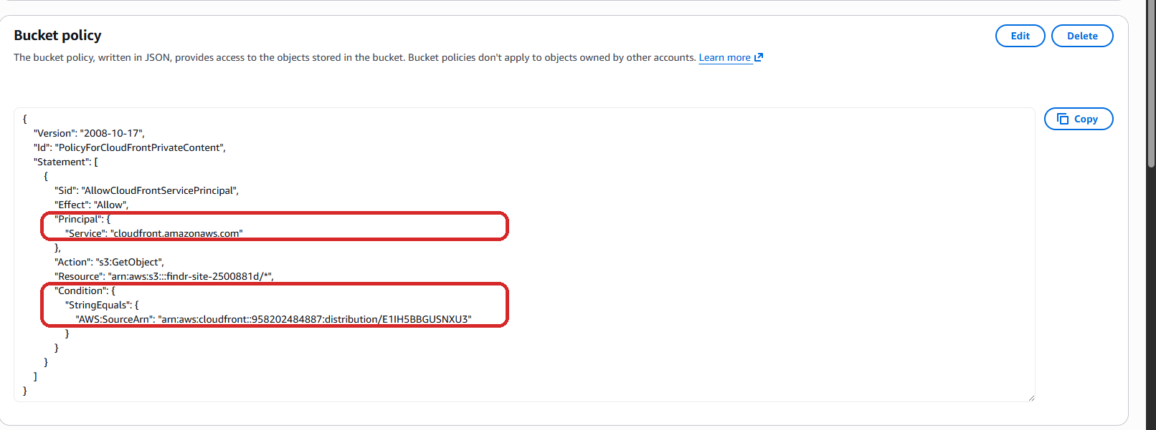
Figure 46: The site bucket policy, with the service principal and the SourceArn condition ringed
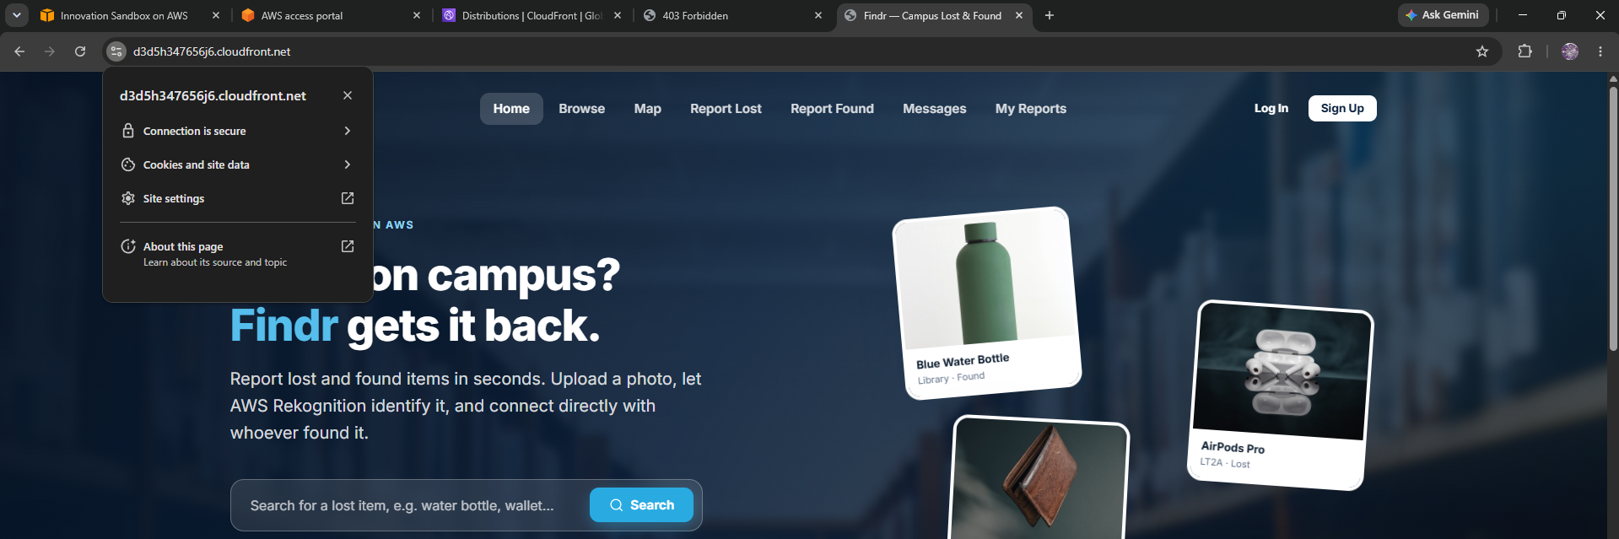
Figure 47: The deployed site served over HTTPS

Amazon Rekognition
Rekognition is used in two ways, and only one of them needs anything created in advance.
The pretrained API needs no setup at all. There is no resource to provision, no endpoint to deploy and nothing to configure. Once the execution role is allowed to call rekognition:DetectLabels, rekognition:DetectText and rekognition:DetectModerationLabels, the function calls the API with the image bytes and gets a result back. This is worth stating plainly, because it is the pattern several of the services in this project follow: the setup is the IAM permission.
The custom model does need setting up, and that process is documented in full in the Development of AWS Rekognition section earlier. In summary:
- Create a dedicated S3 bucket for the training images, findr-training-XXXXXXXX.
- Upload one folder per label, using the folder name as the label.
- In Rekognition, open Custom Labels, create a project, and create a dataset by importing from that S3 bucket. Choose the option to split automatically into training and test sets.
- Train the model, then wait for it to finish. Training took 1.014 hours.
- Copy the trained model's ARN and set it as the CUSTOM_MODEL_ARN environment variable on findr-images.
- Start the model before use, and stop it afterwards.
Why the start and stop step matters. Custom Labels bills per hour for as long as a model is running, whether or not it is being called. It is the only resource in this project that costs money while idle, which is why the application is written to detect a stopped model and fall back to the pretrained labels rather than fail.

Amazon Bedrock
Bedrock has almost no infrastructure to set up. There is no endpoint to deploy and nothing to keep running, which is precisely why it was chosen: hosting a language model directly would have meant a running instance and a cost far larger than the rest of the application combined.
- Open the Bedrock console in ap-southeast-2 and go to Model access.
- Request access to Amazon Nova Lite and Amazon Nova Pro. Access to the Amazon-owned Nova models is granted immediately.
- Add bedrock:InvokeModel to the Lambda execution role.
- Set the model identifiers as environment variables on the functions that use them, rather than hard-coding them.
- Test the prompt in the Bedrock playground before writing any code.
Why model access has to be requested. Bedrock does not expose any foundation model to an account by default. A call to a model that has not been enabled fails with an access error that looks like an IAM problem but is not one, and this is a common way to lose time.
Why the model identifiers are environment variables. The application uses two different models, amazon.nova-lite-v1:0 for the high-volume tasks and amazon.nova-pro-v1:0 for question generation. Keeping them in configuration means either can be swapped without editing or redeploying code, which is how the switch to Nova Pro for question generation was made during development.
Testing in the playground first is worth the few minutes it takes. The verification prompt went through several revisions there before any of it reached a Lambda function, which is much faster than deploying to find out.

Amazon Translate and Amazon Comprehend
Neither service has anything to create. There is no resource, no endpoint and no configuration file. Both are called directly over the API, and the entire setup is a permission on the execution role.
- Add translate:TranslateText to the Lambda execution role.
- Add comprehend:DetectDominantLanguage to the same role.
- Deploy findr-translate, which calls Translate with SourceLanguageCode set to auto.
- No resource ARN is required, because neither service exposes resource-level permissions for these operations.
Why Comprehend needs no separate call in the code. Setting SourceLanguageCode to auto makes Translate invoke Comprehend behind the scenes to detect the language before translating. The application still needs the Comprehend permission on its role, but it never calls the service directly. This is the neatest example in the project of two services being composed with no integration code at all.
Why the target language is validated in code rather than by configuration. There is no setting in Translate that restricts which languages an account may request. Without the check in findr-translate the endpoint would be a general purpose translation API for anybody who found the URL, and Translate charges per character, so the restriction to four languages has to be enforced by the function itself.

Amazon SNS
SNS is the one messaging service in the project and takes about a minute to set up.
- In the SNS console create a Standard topic named findr-notifications.
- Copy the topic ARN.
- Create a Subscription on that topic with protocol Email and the address that should receive notifications.
- Open the confirmation email and click the confirmation link. Until this is done the subscription stays in Pending confirmation and nothing is delivered.
- Add sns:Publish to the Lambda execution role, scoped to that topic ARN.
- Set the topic ARN as an environment variable on the functions that publish to it.
Why a topic with subscribers rather than sending email directly. The functions publish to one topic and know nothing about how the message is delivered. Adding SMS or mobile push later would be a new subscription on the same topic rather than a change to six Lambda functions.
Why the confirmation step catches people out. A pending subscription produces no error when a message is published. The publish succeeds, the function logs success, and no email ever arrives, so it looks like an application bug rather than an unconfirmed subscription.

Amazon Location Service
Location Service is the only service the browser talks to directly, so its setup is slightly different from the rest.
- In the Location Service console create a Map resource and choose a map style.
- Create an API key, and scope its allowed actions to map rendering only (geo:GetMap*).
- Set an expiry date on the key.
- Reference the key and the map name in the frontend, where MapLibre GL JS requests the tiles.
Why an API key rather than the Lambda execution role. Map tiles are requested in large numbers as the user pans and zooms. Routing them through API Gateway and Lambda would add latency to every tile and a compute charge for work that returns the same bytes each time, so the browser fetches them itself.
Why the key is scoped and given an expiry. An API key used in a browser is visible to anyone who opens the developer tools; there is no way to hide it. The protection is therefore not secrecy but restriction: the key can render maps and do nothing else, it cannot read or write any other resource in the account, and it stops working on a known date.

AWS WAF
The web application firewall is provisioned through CloudFront rather than created by hand.
- Open the CloudFront distribution and go to the Security tab.
- Enable security protections. CloudFront creates a WAF web ACL and associates it with the distribution.
- Leave the AWS-managed rule groups enabled.
- Confirm the web ACL appears in the WAF console, associated with the distribution.
Why managed rules rather than hand-written ones. AWS maintains the managed rule groups and updates them as new attack patterns appear. A rule set written by hand would be frozen at the moment it was written, and at this scale there is no requirement that the managed groups do not already cover.
Why WAF has to be created in the CloudFront console for a distribution. A web ACL for CloudFront is a global resource and lives in us-east-1 regardless of where the rest of the application sits. Creating it from the CloudFront console avoids having to remember that, which is why it is documented this way here.

Amazon CloudWatch
CloudWatch requires no setup beyond attaching the right policy. When AWSLambdaBasicExecutionRole is attached to the execution role, each function creates its own log group named /aws/lambda/<function-name> on first invocation, and writes to it automatically.
This is worth mentioning in a setup guide precisely because there is nothing to configure. The only decision is a practical one: because each function has its own log group, a failure can be traced to a single function without reading the logs of the other five, which is one of the reasons the logic was split into six functions rather than written as one.

How the services interact
Reporting a found item with a photograph exercises most of the system, and following it end to end shows how the pieces connect:
- The browser asks the API for a pre-signed upload URL. API Gateway validates the Cognito token, then invokes findr-images, which uses its IAM role to generate a URL from S3 valid for five minutes.
- The browser uploads the photograph directly to S3, bypassing Lambda entirely.
- The browser calls the analysis endpoint. findr-images runs Rekognition moderation, then the custom model, then pretrained label detection, then sends the image and the classification to Bedrock for a description.
- The user submits the form. findr-reports validates it, writes to DynamoDB, and publishes to SNS, which emails the notification.
- CloudWatch captures the logs from every one of those invocations, which is what makes a failure anywhere in the chain traceable.

Security measures
Security was treated as a design constraint throughout rather than something added at the end. This section sets out the controls applied at each layer and, where possible, demonstrates them working.

Storage layer
Both S3 buckets have Block Public Access enabled and neither is directly readable. The site bucket is reachable only through CloudFront using Origin Access Control, with the bucket policy conditioned on the distribution ARN.
The uploads bucket is never public at all. Photographs are written using pre-signed PUT URLs valid for five minutes and restricted by content type, and read back using pre-signed GET URLs valid for one hour, generated by Lambda on demand. This means an item photograph has no permanent public address, so a URL copied out of the page stops working within the hour.
Demonstration. Requesting an object from the S3 bucket URL rather than through CloudFront is refused, which confirms the bucket is not serving content directly:
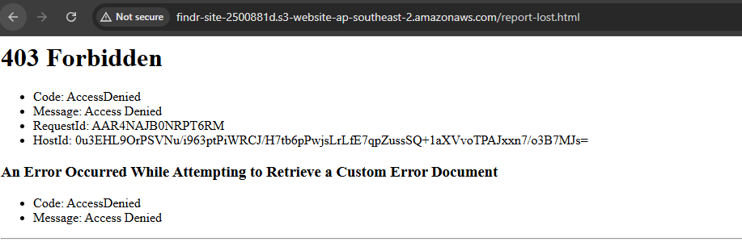
Figure 48: A direct request to the S3 bucket URL returns 403 Forbidden

Transport layer
CloudFront redirects HTTP to HTTPS, so the site is never served in the clear. The uploads bucket policy additionally denies any request where aws:SecureTransport is false, which blocks plain HTTP at the storage layer as well, independently of CloudFront.

Identity and authorisation layer
Authentication uses Cognito-issued JWTs, validated by API Gateway before Lambda runs. Every function derives identity and role from the token's claims rather than from the request body, so a user cannot impersonate another account or grant themselves administrator rights.
Ownership is enforced server side on both editing and deletion, and the update path uses an allow-list of editable fields so a report cannot be reassigned to another user.
Demonstration. The unauthorised response shown earlier in the Setup guide confirms that a protected endpoint rejects a request with no valid token.

Application data layer
The private verification details are the mechanism the entire claim feature depends on, so they must never reach the browser of anybody except the person who wrote them. All four read paths in findr-reports pass through a single function that strips those details before a record is returned. Concentrating this in one place means a future read path cannot forget to apply it.
The same function removes the reporter's email address, and removes claim records containing a claimant's name and score from anybody who is not the owner or an administrator.

Input handling
Report titles, descriptions, locations, user names and message text are all written by users and rendered into the page. Without escaping, a report title containing an HTML tag with an event handler would execute for every visitor who loaded the Browse page.
An escaping helper is applied to every place where server-supplied data is interpolated into HTML, including less obvious cases such as text returned by Bedrock, Rekognition label names, and values placed inside HTML attributes where a single quotation mark would otherwise break out of the attribute.
On the upload path, content type is restricted by an allow-list, file size is capped, and every image passes through Rekognition moderation before it is stored.

Least privilege
The Lambda execution role grants only the actions the code calls, scoped to named resources wherever the service supports it. DynamoDB permissions name the tables and indexes, S3 permissions are limited to the uploads/* prefix, and SNS publishing is limited to a single topic.

Reflection
This section records the problems encountered during development, how they were diagnosed and what was changed as a result. Several of them changed how I approach the underlying service.

Prompt design is a real engineering task
The clearest lesson came from the verification questions. My first prompt was reasonable in plain English and produced questions that a genuine owner could not answer.
What I wrote first:
- "Write one open question that checks whether the claimant knows this fact. Do not mention any part of the fact in the question."
Given the fact "there is a coin compartment inside", the instruction not to mention any part of it left the model with almost nothing to build on. It removed the word "coin", kept "compartment", and produced:
- "How many compartments does the wallet have?"
The real owner cannot answer that correctly, because the fact never stated a number. The question is unanswerable from the information the finder actually recorded, so a genuine claimant would have been refused.
What I replaced it with:
- "Write one open question that a person holding this item could answer from the fact below, without the question itself revealing the answer. The question must be answerable using only what the fact contains. Never ask for a quantity, colour, brand, size or measurement unless the fact gives one. Ask about the same feature the fact describes, and leave the specific detail for the claimant to supply."
The same fact now produces questions of the form "what is inside the wallet, and where in it?", which the owner can answer and a stranger cannot.
Three things changed, and the order matters. The constraint was made explicit rather than implied. The task was moved to Nova Pro, which follows a multi-part constraint far more reliably than Nova Lite. And the temperature was dropped from 0.4 to 0.1, because consistency matters more than variety when the output is a test somebody has to pass.
The wider lesson was to treat a prompt as a specification rather than a request, and to test it against its failure modes rather than writing it once and trusting it. Every constraint in the final prompt exists because a specific bad output made it necessary.

Giving a model the right input matters more than a better model
Item descriptions were initially poor, and my first instinct was that the model was at fault. The real cause was the input: Rekognition's detected text was being passed as "visible text on the item", so watermarks in stock photographs were being described as though printed on the object.
Sending the image itself to a multimodal model and dropping the incorrect assertion fixed the problem completely, without changing the model. The lesson was to check what the model is actually being told before concluding it is not capable enough.

Cost shapes design, not just billing
Rekognition Custom Labels bills per hour while a model is running, which cannot be left on permanently for a student project. Rather than treat that as a limitation, it drove one of the better design decisions in the application: the analysis path detects that the model is stopped and falls back to the pretrained labels, while stating clearly in the interface which model produced the result.
The same thinking led to uploading photographs directly to S3 rather than through Lambda, translating fixed interface text from a dictionary instead of the API, and using the smaller Bedrock model for the high-volume calls.

Configuration failures do not look like configuration failures
Two problems cost more time than they should have. The first was Lambda proxy integration being left unticked on one API Gateway method, which caused the whole response dictionary to arrive as the body, so the frontend read a success flag that did not exist and displayed "undefined". The second was API Gateway returning 403 for an encoded # inside a path parameter, which made a working function look broken.
Neither produced an error message pointing at the cause. Both were found by reading CloudWatch logs and comparing what the function returned against what the browser received. The habit I took from this is to check the boundary between two services before assuming the fault is in the code on either side of it.

What I would do differently
I would build the security controls in from the first commit rather than auditing for them later. Escaping user input and stripping private fields on read are both far easier to apply consistently while the code is being written than to retrofit across a finished application.
I would also test with realistic data much earlier. Several issues, including duplicate category mappings and how listings look when a photograph is missing, only became visible once the platform held a realistic number of reports rather than three test entries.

Conclusion
Findr set out to solve two specific problems with campus lost property: items are not discoverable by the people who lost them, and there is no reliable way to establish that a claimant is the genuine owner. The finished platform addresses both, and does so using fifteen AWS services combined into a serverless application that costs nothing while idle.
On the first problem, the platform makes every report searchable, filterable and visible on a campus map, and uses AI matching to connect lost reports with found ones that describe the same item in different words. On the second, the verification feature turns private details recorded by the finder into questions generated by Amazon Bedrock, marks the answers, and notifies the finder of the outcome either way. Both the passing and failing cases were tested, which is the part that demonstrates the feature actually works rather than simply runs.
The custom Rekognition classifier achieved an F1 score of 0.955 with average precision of 0.976 across eight categories. More useful than the headline number is how it is integrated: the application distinguishes clearly between the trained model and the pretrained one, and continues to work sensibly when the trained model is stopped, which is a realistic constraint rather than a hypothetical one.
The architecture holds up well against the requirements. The frontend is delivered privately through CloudFront with Origin Access Control, so the storage bucket is never exposed. Authentication is handled by Cognito and validated at the gateway before any compute runs. Application logic sits in six small Lambda functions sharing a least-privilege execution role. Large transfers bypass the compute layer entirely, which keeps both latency and cost down.
Recommendations for future work. The most valuable extension would be automatic matching on submission. The AI matching step currently runs only when a user asks for it, and running it whenever a new report is created, then notifying both parties when a strong match appears, would turn Findr from a service people have to search into one that contacts them. That single change would address the discovery problem more completely than anything else on this list.
Expanding the training dataset would be the next priority, particularly for the Bottle and Bag categories where the model is most conservative. The evaluation suggests the model would benefit from a wider variety of images rather than any change in approach.
Push notifications would shorten the gap between an item being handed in and its owner hearing about it, which is where the platform creates most of its value. Multi-factor authentication would be a natural addition once Amazon SES is configured, since Cognito requires it for email-based MFA. Finally, integrating with the physical lost property counter, so that items handed in at the counter appear on the platform automatically, would remove the last gap between the two systems that currently exist in parallel.

References
Amazon Web Services (2026) Amazon Rekognition Custom Labels Developer Guide. Available at: https://docs.aws.amazon.com/rekognition/latest/customlabels-dg/
Amazon Web Services (2026) Amazon Bedrock User Guide: Converse API. Available at: https://docs.aws.amazon.com/bedrock/latest/userguide/
Amazon Web Services (2026) Restricting access to an Amazon S3 origin using Origin Access Control. Available at: https://docs.aws.amazon.com/AmazonCloudFront/latest/DeveloperGuide/private-content-restricting-access-to-s3.html
Amazon Web Services (2026) Amazon Cognito Developer Guide: Using tokens with user pools. Available at: https://docs.aws.amazon.com/cognito/latest/developerguide/amazon-cognito-user-pools-using-tokens-with-identity-providers.html
Amazon Web Services (2026) Amazon API Gateway Developer Guide: Choosing between REST APIs and HTTP APIs. Available at: https://docs.aws.amazon.com/apigateway/latest/developerguide/http-api-vs-rest.html
Amazon Web Services (2026) Amazon DynamoDB Developer Guide: Best practices for using secondary indexes. Available at: https://docs.aws.amazon.com/amazondynamodb/latest/developerguide/bp-indexes.html
Amazon Web Services (2026) AWS WAF Developer Guide: AWS Managed Rules rule groups. Available at: https://docs.aws.amazon.com/waf/latest/developerguide/aws-managed-rule-groups.html
Amazon Web Services (2026) Amazon Location Service Developer Guide. Available at: https://docs.aws.amazon.com/location/latest/developerguide/
Amazon Web Services (2026) Amazon Translate Developer Guide. Available at: https://docs.aws.amazon.com/translate/latest/dg/
Amazon Web Services (2026) Amazon Comprehend Developer Guide: Language detection. Available at: https://docs.aws.amazon.com/comprehend/latest/dg/how-languages.html
MapLibre (2026) MapLibre GL JS Documentation. Available at: https://maplibre.org/maplibre-gl-js/docs/

