

SCHOOL OF INFORMATICS & IT

Part 1: Project Proposal

Student Name (Matric Number) : XXXXXXXX

Tutorial Group : TC20
Jenny LING (TP)
Tutor : Kent Tan

Submission Date : 222/5/2026

Declaration of Originality

I am the originator of this work and I have appropriately acknowledged all other original sources used as my references for this work.

I understand that Plagiarism is the act of taking and using the whole or any part of another person’s work, including work generated by AI, and presenting it as my own.

I understand that Plagiarism is an academic offence
and if I am found to have committed or abetted the offence of plagiarism in relation to this submitted work, disciplinary action will be enforced.

Declaration on the use of Generative AI tools for assignments

Describe how you have used Generative AI tools such as ChatGPT or Dall.E-2 in your assignment.

Show snapshots of the conversations with the AI tool (i.e., the prompts you used and the response you get from the AI tool).

https://chatgpt.com/share/69f93e18-04b8-8399-a9c0-69fb0329a642 (Findr Homepage image generation)

https://chatgpt.com/share/6a0b247e-e7c8-83ec-9d82-d26be29515aa(Findr Report Creation and Claim Status page image generation)

ChatGPT, or more specifically the DALLE Image generation system within ChatGPT was used in order to generate the images which were used in designing and analysing possible pages for my app Findr. In the above links, the prompts I used as well as the output generated can be found.

How do you indicate the reference?
The content generated by AI tools are not retrievable except by the user who generated them, so they are considered non-recoverable sources. Although non-recoverable data or quotations in APA Style papers are usually cited as personal communications, with ChatGPT-generated text there is no person communicating. Quoting text from ChatGPT chat is therefore more like sharing the output of an algorithm, with a reference list entry and the corresponding in-text citation.

According to the official APA Style site, ChatGPT references should be cited as:

E.g. OpenAI. (2023). ChatGPT (Sep 25 version) [Large language model].
https://chat.openai.com/chat

Important Note:

- Do not copy answers produced by the AI tool in totality as it is considered as plagiarism.

- Do not rely on any information produced by the AI tool blindly. You should always verify the answer with other sources. Do not assume that these answers provided by the AI tool are correct.

To achieve quality outputs from the AI tool, you should provide good prompt that is clear and specific. Be precise and provide context. Avoid asking open-ended questions.


School of Informatics & IT

Mobile App Development (CIT2C18)

AY 26/27 Apr Semester

Project Proposal

(Part 1)

Table of Contents
Application Description 5
Database Design 6
Design Analysis and Wireframe 7
Widget Tree 8
Additional Features 9
References 10

The yellow text in each section is provided as a guide. Please make sure to REMOVE them before submitting your work.

Application Description

Application Name | Findr  Findr is a lost-and-found mobile application designed to help students report, search, and recover lost items more easily. Users can post lost or found item reports, browse existing listings, and make claims. The app also includes a reward-based system to encourage users to return items.
Target Audience | The primary target audience for Findr is students at Temasek Polytechnic who lose or find items on campus. Students often carry personal belongings such as water bottles, electronic devices, and wallets while moving between classes and facilities, which makes it easy to misplace items.  To justify this target audience, a short survey was conducted among 35 students.  The results show that 80% of respondents have lost items in school, showing that this is a common issue. However, only 53% of those who lost items were able to recover them, which suggests that current methods are not very effective.  This shows that students frequently face this problem but do not have a reliable way to solve it. Therefore, students are a suitable target audience for Findr.
Authentication Features | Findr will implement user authentication to ensure that all interactions within the application are secure and associated with verified users. This is very important as users will be posting lost or found items, making claims, and handling reward-based transactions.  The application will contain the following authentication features:  - User Registration:  New users can create an account using their email and password. Basic input validation will be applied to ensure that the information provided is valid and that the password created is secure enough.  - User Login:  Registered users can log in securely using their credentials to access the main features of the application.  - Password Reset:  Users who forget their password will be able to reset it via email verification.  - User Logout:  Users can log out of their account to ensure account security, especially when using shared devices.  Furthermore, Findr will support Google Sign-in for faster access and improved user convenience.
‘  CRUD-related Features | Findr will support one main set of CRUD operations for item reports. These reports will contain details of lost and found items submitted by users.  The Application will contain the following CRUD operations:  - Create:  Users can create a new lost or found item report by entering details such as the item name, category, description, brand, condition, location, date/time, photo and reward amount if applicable.  - Read:  Users can browse and view existing lost and found item reports. They can also search and filter reports by category, location, date and item status to find relevant items more easily.  - Update:  Users can update their own reports if they need to correct item details, change the reward amount, or update the report status, such as from “Open” to “Claimed”.  - Delete:  Users can delete their own reports if the item was posted by mistake, is a duplicate, or is no longer relevant.  These CRUD operations form the core functionalities of Findr, letting users to report and manage lost and found items in a structured way. Instead of relying on other ineffective methods users can use the application as a centralised platform to track item status and updates from any location.  The workflow starts when a user creates a report, after which other users can view and search for relevant items. When users connect over a lost and found item (e.g. a user identifies their missing item or a finder recognises the owner), the report can be updated to reflect changes such as the item being claimed or returned. Once an item has been successfully returned, the report status can be updated to “Resolved”. This helps completed reports be separated from active reports, keeping the system organised and relevant.
Applied AI Feature | Findr will have a matching score feature powered by AI to help Users find lost/found items faster and more effortlessly. Users enter information about an item, like its name, category, description, colour, brand, condition and location. Then, the system will look at this information and compare it to existing reports.  Findr will show possible matches along with a matching score, like 85% match or 60% match, after processing the data. This will help users quickly find the most relevant results. For instance, if someone reports a black wallet missing near the library, the app can automatically suggest similar found item reports that match these details.  This will help users find relevant lost or found items faster instead of having to manually scroll through every report.  The diagram below illustrates the workflow of the AI matching feature. It was created using Microsoft PowerPoint and added to the report as a screenshot. 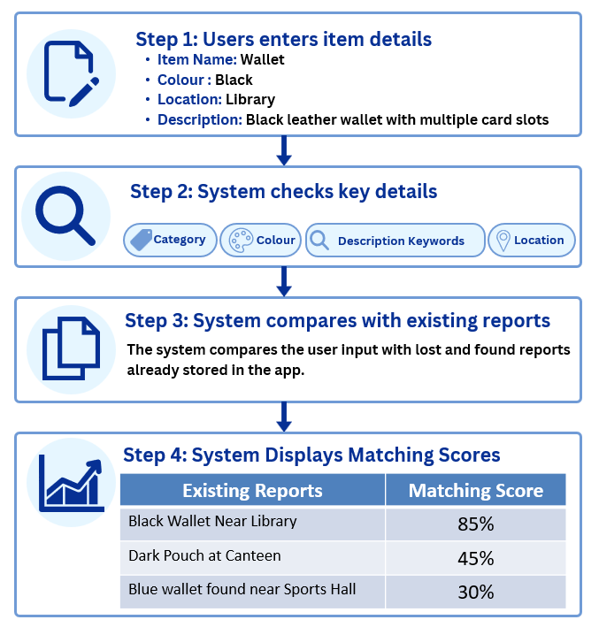
Suitable NETS QR Payment Scenario | Findr will implement a NETS QR Payment system to support the use of rewards for returning lost items. When a user posts a lost item, they can choose to include a reward amount to encourage others to return the item.  The user will first make payment through NETS QR, and the cash will be held by the system. Once the finder successfully returns the item and the owner confirms the claim, the reward will then be transferred to the finder. This approach ensures the transaction is secure and reliable, as the reward is only released after the item has been returned. It also discourages dishonest behaviour and motivates users to return items, especially in situations where they might otherwise be too lazy or not bothered to do so.  This reward approach is supported by Japan’s real world lost and found system as part of Japan’s “Lost Goods Law”, where finders may receive a reward upon returning an item. A news article by Al Jazeera reports that finders of lost items may receive a “reward of between 5 and 20% of the item’s value” when the owner claims the lost item. This supports Findr’s reward system, as it proves that financial incentives can be used to incentivise people to return valuable items. Similarly, Findr will facilitate the reward payment via NETS QR and release the funds once the item has been returned. (https://www.aljazeera.com/features/2017/7/23/lost-your-phone-in-japan-youll-probably-get-it-back)  Overall, integrating NETS QR payment makes the process more efficient, fair, and trustworthy, while increasing the chances of lost items being returned.

Database Design

ER Diagram
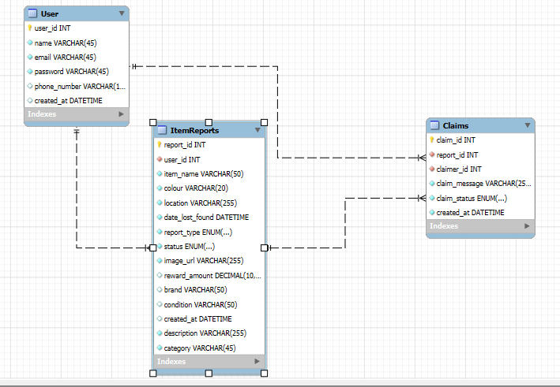

Data Dictionary (Table: User)
Field Name | Data Type | Field Size | Primary/ Foreign key | Description | Example
user_id | Integer (AUTO_INCREMENT) | 8 | Primary key | Unique identifier for each user, auto-generated | 10000001
name | Varchar | 45 | - | Name of the user | ‘John Doe’
email | Varchar | 45 | - | Email address of the user | ‘johndoe@gmail.com’
phone_number | Varchar | 15 | - | Contact number of the user | ‘+6591234567’
created_at | DATETIME | - | - | Account creation date and time | 29/01/2013 10:12:20

Data Dictionary (Table: ItemReport)
Field Name | Data Type | Field Size | Primary/ Foreign key | Description | Example
report_id | Integer (AUTO_INCREMENT) | 8 | Primary key | Unique identifier for each report, auto-generated | 20000001
user_id | Integer | 8 | Foreign key | References user who created report | 10000001
item_name | Varchar | 50 | - | Name of the item | ‘Wallet’
colour | Varchar | 20 | - | Colour of the item | ‘Black’
location | Varchar | 255 | - | Location item was lost/found | ‘Library, Level 3, Learning pod 3’
date_lost_found | DateTime | - | - | Date and time item was lost/found | 14/09/2020 10:12:20
report_type | ENUM("lost", "found") | - | - | Type of report (Lost/Found) | ‘lost’
status | ENUM("open", "closed") | - | - | Current status of report | ‘open’
image_url | Varchar | 255 | - | Link to an Image of the Item | ‘image.jpg’
reward_amount | Decimal | 10,2 | - | Reward amount offered for returning a lost item | 20.00
brand | Varchar | 50 | - | Brand of the item, if known | ‘Apple’
condition | Varchar | 50 | - | Condition of the item, if known | ‘Slightly scratched’
created_at | DateTime | - | - | Report creation date | 30/01/2013 12:12:20
description | Varchar | 255 | - | Detailed description of the lost or found item | ‘Black leather wallet with a small scratch’
category | Varchar | 45 | - | Category of the item | ‘electronics’

Data Dictionary (Table: Claims)
Field Name | Data Type | Field Size | Primary/ Foreign key | Description | Example
claim_id | Integer (AUTO_INCREMENT) | 8 | Primary key | Unique identifier for each claim, auto-generated | 30000001
report_id | Integer | 8 | Foreign key | References related item report | 20000001
claimer_id | Integer | 8 | Foreign key | References user making the claim | 10000002
claim_message | Varchar | 255 | - | Message from claimer | ‘I think this is mine can I have it back’
claim_status | ENUM(‘pending’,’rejected’,’accepted’) | - | - | Status of the claim | ‘pending’
created_at | DATETIME | - | - | Claim creation date and time | 01/02/2013 12:12:20

Design Analysis and Wireframe

To support the design selection process, a short Google Form was used to gather feedback on the AI-generated design concepts. A total of 24 responses were collected. Respondents were shown the different design options for each page and asked to choose the design they liked best. They were also given an optional question to explain their reason. The feedback was used as supporting evidence when making the final design decisions. However, the final design was not based only on the most popular option. The responses were considered together with usability, clarity, visual consistency, and how well each design supported Findr’s purpose as a lost-and-found app. The collected response data has been included at the bottom of this document, below the references section, to show the evidence used during the design selection process.

HOME PAGE
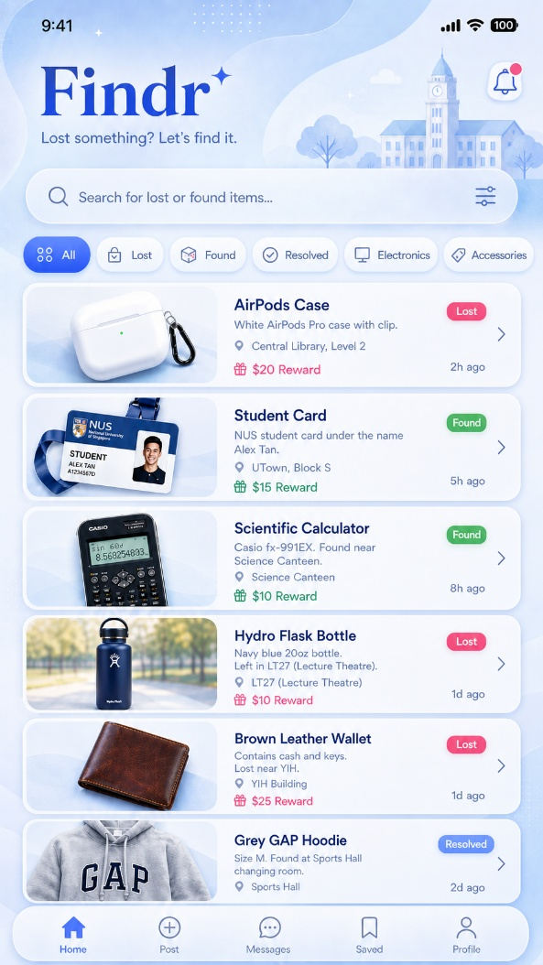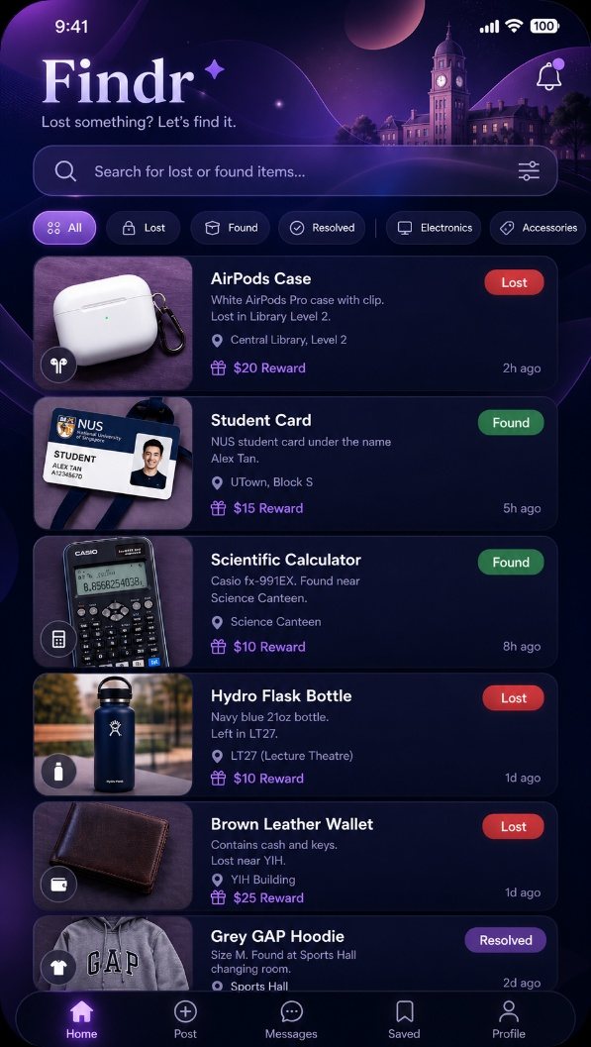
Diagram 2
Diagram 1

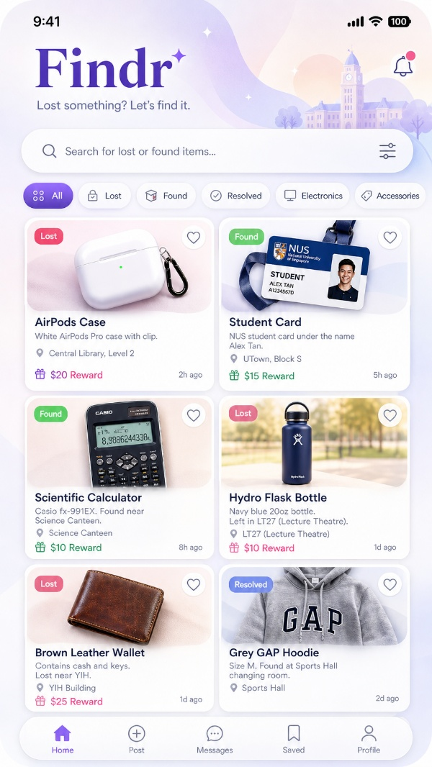
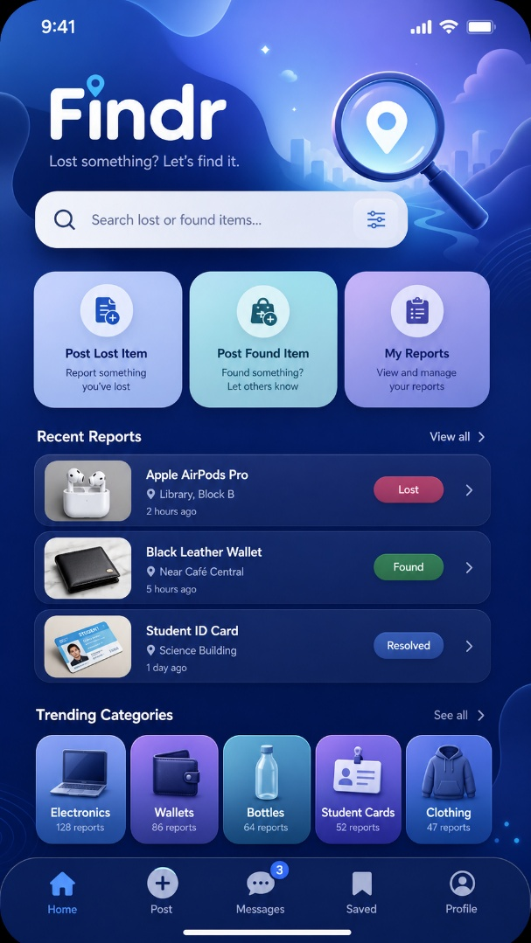
OpenAI. (2026). ChatGPT (May version) [Large language model].
(Images generated)

Diagram 4
Diagram 3

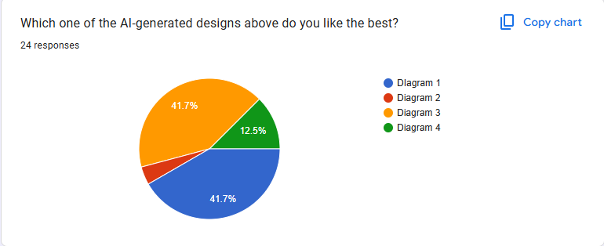
These 4 AI-generated images explore different ways Findr could present lost and found reports to users. Overall, all the designs have useful elements, but not all of the elements fully fit the purpose of the app. Since Findr is made to help students quickly report and recover lost items, the final design has to be clear, trustworthy, easy to scan, and practical.

Based on the Google Form results, Diagram 1 and Diagram 3 were the most preferred designs, with both receiving 41.7% of the responses. Diagram 4 received 12.5%, while Diagram 2 received the least support. Some optional comments also supported this direction. For example, respondents mentioned that the design had a “clean and safe feeling”, that “the colour nice and calm”, and that “the cards easier to see”. These comments support the idea that the final design should combine a calm visual theme with clear item cards.
.

Theme and Visual Style
In terms of themes, Diagram 1 is the strongest. The blue is calm, clean, and trustworthy, which suits a lost and found app well. Considering the target audience is users who may have lost valuable or personal belongings, the app should not be overly playful or overly decorative, as the purpose of the app involves recovering important personal belongings. Therefore, it needs to feel reliable and trustworthy. This is also supported by the Google Form feedback, as Diagram 1 was one of the most preferred designs. Some respondents commented that the design had a “clean and safe feeling”, and that the blue colour fit the app. This supports the decision to use a soft blue theme for the final design.

While Diagram 2’s theme also looks visually nice, the purple, darker theme feels less suitable as the default colour scheme for the lost and found purpose. Perhaps it could be an optional alternate theme for users. However, as the main theme, the darker style may not give the same calm and trustworthy feeling as Diagram 1. However, the final design should still avoid looking too plain. The subtle abstract background from the designs can be kept, as it gives the app more personality without distracting users from the item reports.

Layout and Card Design
For the card layout, Diagram 3 has the better card structure. The grid-style cards make the home screen feel more modern and marketplace-like, similar to apps like Carousell and Facebook Marketplace. This fits well as users are browsing item reports in a similar way to browsing listings. Larger item images also make it easier for users to identify items faster, which is important for a lost and found app.

This was also supported by the Google Form feedback, as Diagram 3 received 41.7% of responses. Respondents mentioned that the cards were easier to see, that they could see the items faster, and that the layout made it easier to compare items. This supports using Diagram 3’s card-based layout for the final home page.
.
- Only the lost posts should contain reward amounts, as the reward is meant to be optionally offered by the owner to encourage others to return the item. Found posts should not show reward amounts, as it may feel unethical or misleading if the owner feels pressured to pay before receiving their item back.
- The “Lost” and “Found” status tags do not fit well with the overall design. The bright red and green tags feel out of place compared to the softer blue theme of the app. A more consistent colour palette should be used so that the status tags still stand out but do not clash with the rest of the interface.

Functionality and Practicality
In Diagrams 1, 2, and 3, there is not a clear way for users to access essential actions on the home page, such as managing existing reports. In this regard, Diagram 4 is better as it has clear actions for posting lost items, posting found items, and managing reports.
Although Diagram 4 was not one of the most preferred designs overall, it still received some useful feedback. One respondent mentioned that the design made it easier to find the main actions, which supports taking some of Diagram 4’s functional ideas into the final design.
At the same time, not everything from Diagram 4 is useful. The Trending Categories section does not really fit the purpose of Findr. Users are unlikely to browse “trending” lost items because the main goal is to find or report a specific item. This section might make the interface seem cluttered and less focused.

Final Design Decision
Based on the above comparisons, the final home screen design will combine the strongest parts from the different AI-generated screens:
- Use the logo style from Diagram 4, as it looks clean, modern, and memorable, while the other logos look too plain.
- Use the colour scheme and overall theme from Diagram 1, as the pastel blue fits the lost-and-found concept better and creates a more trustworthy feel.
- Use the card style from Diagram 3, as the marketplace-like cards make item reports easier to browse and help users visually identify items.
- Take the essential buttons and functions from Diagram 4 while removing unnecessary functions to reduce clutter on the home page.

REPORT CREATION PAGE

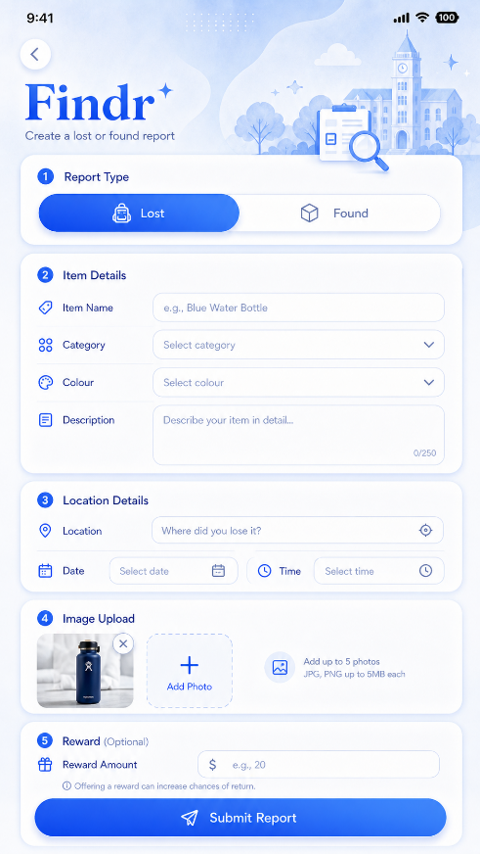
Diagram A

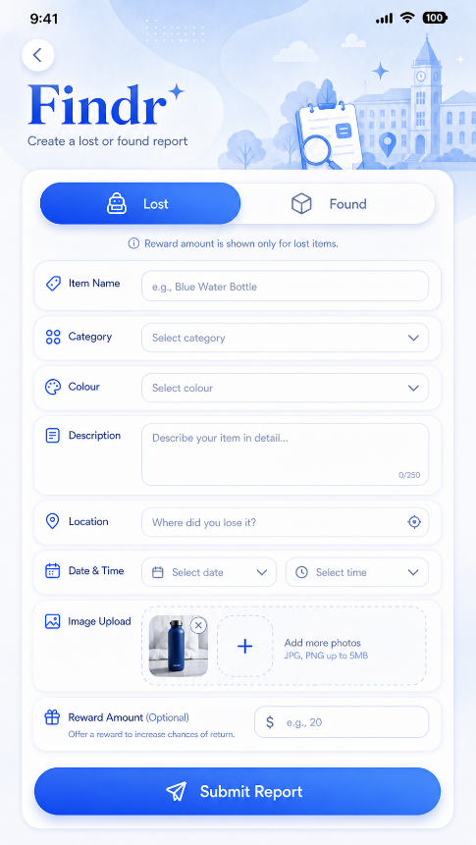
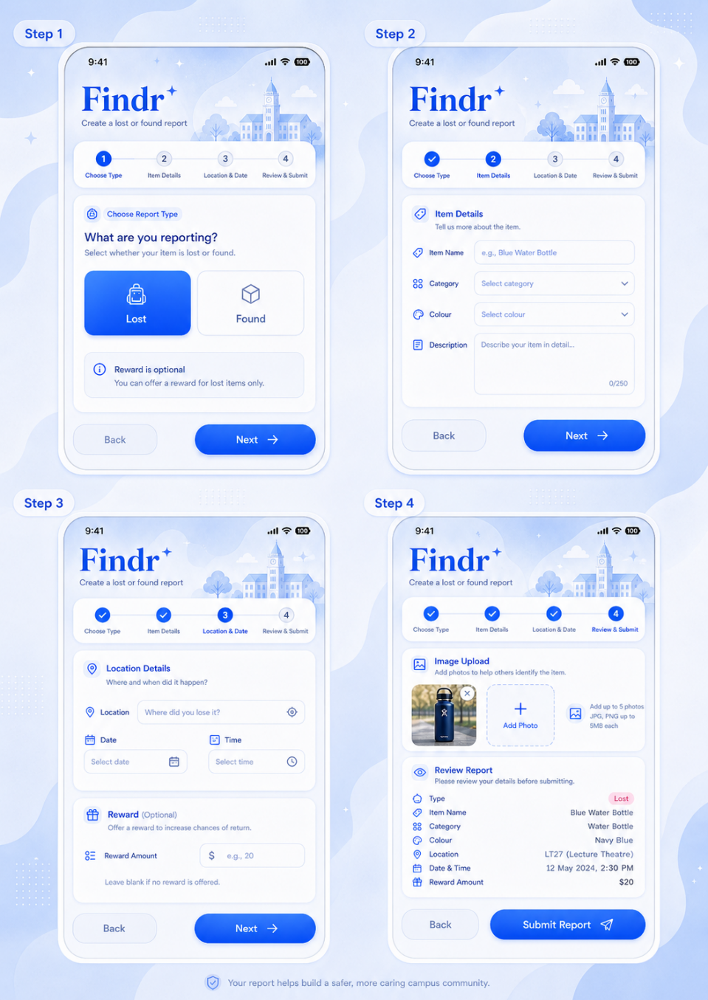
Diagram B
Diagram C
OpenAI. (2026). ChatGPT (May version) [Large language model].
(Images generated)

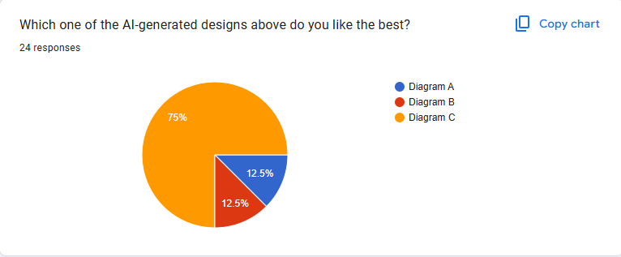
The three AI-generated designs for the Create Report page explore different ways users can submit a lost or found report in Findr. Since the theme was already decided from the home screen analysis, these images were also generated with a similar theme to maintain consistency. This allows the comparison to focus primarily on the form structure, usability, and flow.

A short Google Form was also used to collect feedback for the Create Report page. From the responses, Diagram C was the most preferred design, as respondents generally felt that it looked easier to use and less messy. Some optional comments included “the step by step format looks easier to use”, “because the form is split up”, and “i like the review part where can re if everything is correct”.

These comments support the idea that users prefer a guided form instead of having everything shown at once. Since the page requires users to enter many details like item name, category, colour, description, location, date/time, a photo, and reward amount, the design needs to stay clear, organised, and not too overwhelming despite the amount of information that needs to be input.

Form Structure and Ease of Use
In terms of structure, Diagram B uses a simple single-page form where all the input fields are placed in a single container. While this approach makes the screen look clean and straightforward, it feels quite packed as users have to view and complete everything at once. It also does not separate the different sections of the report clearly.
Diagram A improves on this by separating the different sections like Report Type, Item Details, Location Details, Image Upload, and Reward. This makes the form much easier to understand as users can clearly see what each section is for. However, since all the sections are still on one long screen, the page may still feel slightly lengthy, especially for users who just want to submit a report quickly.

Diagram C seems to have the strongest structure in this regard as it uses a step-by-step form layout. Instead of showing all the fields at once, it breaks the process into smaller stages, which makes the form feel less overwhelming and helps users focus on one part at a time.
This is also supported by the Google Form comments. One respondent said that the step-by-step format looks easier to use, while another mentioned that it is better because the form is split up. This shows that Diagram C is likely easier for users to follow, especially when they are already stressed about losing an item.

User-Friendliness and Clarity
For a lost-and-found app, the report creation process should be easy as users may already be frustrated or stressed when reporting a missing item. In this regard, Diagram C is also the most user-friendly as the progress indicator clearly shows where the user is in the process. The clear Next and Back buttons also make the flow easy to control across multiple pages.

Another strong point in Diagram C is the Review Report step before submission. This is useful as users can check their details before posting the report, reducing mistakes like wrong location, missing item details, or an incorrect reward amount. This was also supported by one of the optional responses, where a respondent said they liked the review part because they could check if everything was correct.

At the same time, the clear section headings in Diagram A provide an effective structure that makes the process easy to follow. Similarly, the reward note in Diagram B adds valuable clarity by specifying that reward amounts are only displayed for lost items.
.

Final Design Decisions
Based on the comparisons, Diagram C is the most suitable design for the Create Report screen. Its step-by-step layout makes the reporting process feel more guided, manageable, and less overwhelming compared to the single-page forms in Diagrams A and B.

However, there are still useful elements from the other diagrams. Therefore, for the final design, I would use:
- The step-by-step structure from Diagram C
- The clear section grouping from Diagram A
- The reward explanation from Diagram B
- The same pastel blue theme across all designs for consistency.

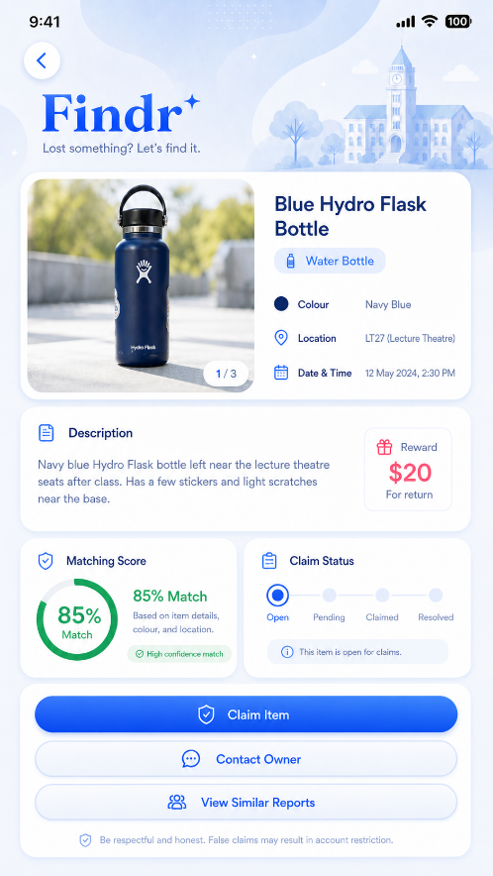
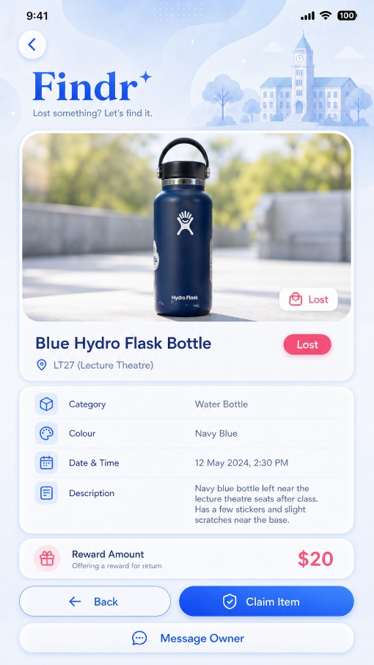
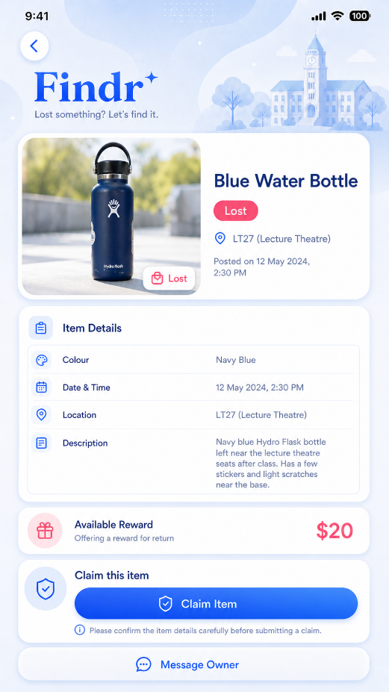
CLAIM STATUS PAGE
OpenAI. (2026). ChatGPT (May version) [Large language model].
(Images generated)

Diagram Z
Diagram Y
Diagram X
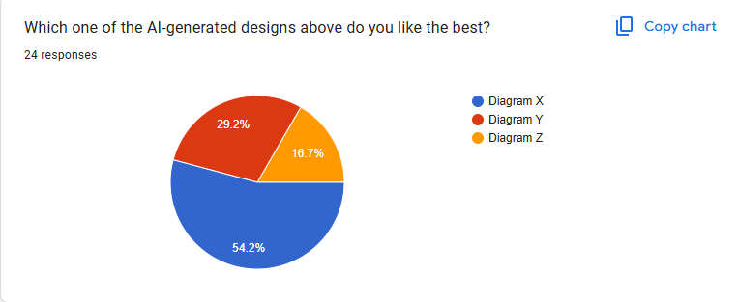
The three AI-generated designs above for the Item Details page show different ways Findr can present information about a lost or found item. Since this page is where users decide whether an item is theirs and whether they want to claim it, the design needs to be clear, focused, and easy to understand. It should show all necessary information for users to identify the item, but should not include too many unnecessary sections that make the page feel cluttered.

Based on the Google Form feedback, Diagram X was the most preferred design, receiving 54.2% of the responses. Diagram Y received 29.2%, while Diagram Z received 16.7%. This shows that most respondents preferred the design that was clearer and easier to read, instead of the one with too many extra sections.

Some optional comments also supported this. Respondents mentioned that Diagram X “looks clear” and is “simple to read”. Another response mentioned that “Z has too much on the screen” and that Diagram Y has less information overload. This supports the decision to avoid making the item details page too cluttered.
.

Layout and information structure
In terms of layout, Diagram X seems to be the strongest. It shows the image of the item clearly at the top, followed by important details like the item name, location, category, colour, date/time, description, and reward amount. The information is arranged neatly, so users can quickly understand the item details without feeling overwhelmed. The Claim Item button is also clearly shown at the bottom of the screen, making the screen practical for the app’s purpose. This is supported by the Google Form results, as Diagram X received the highest percentage of responses. Since this page is meant to help users confirm whether an item belongs to them, it is important that the design is easy to scan and does not distract users with too many extra elements.

Diagram Y is also organised and easy to read, but it has some unnecessary empty space, especially near the lower sections. The “Claim This Item” section also does not need to take up an entire row because the main action is simply the Claim Item button. Because of this, Diagram Y feels slightly longer and less efficient compared to Diagram X.Diagram Z has a more advanced look, but it feels much too cluttered. It includes extra sections such as matching score, claim status, and viewing similar reports, which are not needed on the Item Details page. While these features could be useful in other parts of the app, showing all of them on the Item Details page makes the screen feel overcrowded. This was also reflected in the optional survey comments, where one respondent mentioned that “Z has too much on the screen”.
.

Visual consistency and Usability
A small issue in both Diagram X and Diagram Y is that some of the colours feel slightly contradictory to the soft bluish pastel theme. The status tags and reward amount should still stand out, but the colours should fit better with the overall design. In terms of usability, Diagram X is still the strongest because it keeps the focus on the item and the key action. Since users are likely checking the page to decide whether to claim the item, the design should not make them scroll through too many unnecessary sections before understanding the item details.

Final Design Decisions
Overall, Diagram X has the preferred design for the final Item Details screen. It is the most clear and practical as it focuses on the essential item information without overcrowding the page.

For the final design:
- Keep the main structure of Diagram X
- Adjust the accent colors so they better fit the theme
- Avoid adding unnecessary sections like matching score

Final Hi-Fi Wireframes
The following screens show the final high-fidelity wireframes designed in Figma for Findr. These screens demonstrate the main user flow, including authentication, browsing reports, creating reports, viewing item details, managing reports, and using the AI search feature.

Link to Figma:
(https://www.figma.com/design/jEdek2lYQ273G8rUDWHb5M/Untitled?node-id=0-1&t=oHkC3E4T4ZiJuKxR-1)

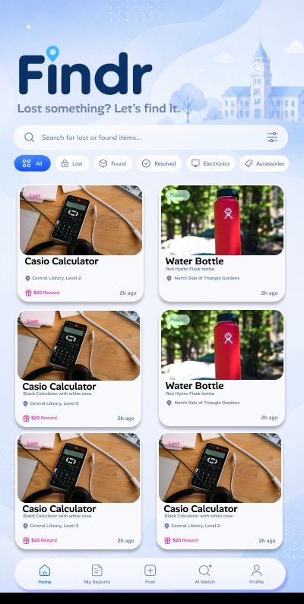
HOME PAGE

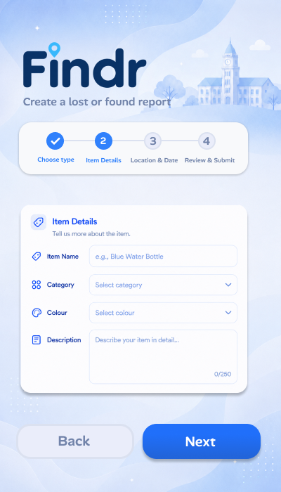
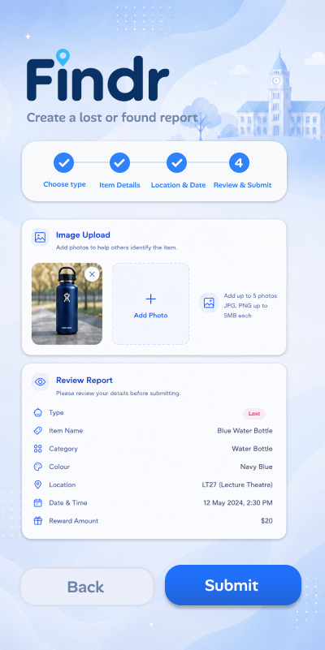
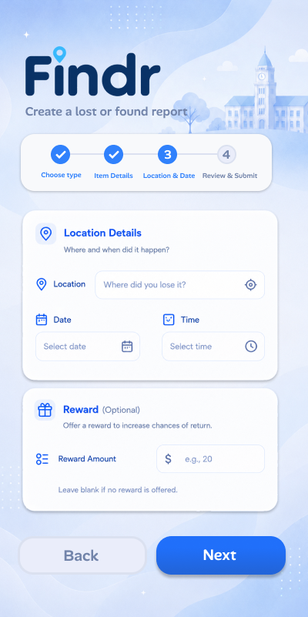
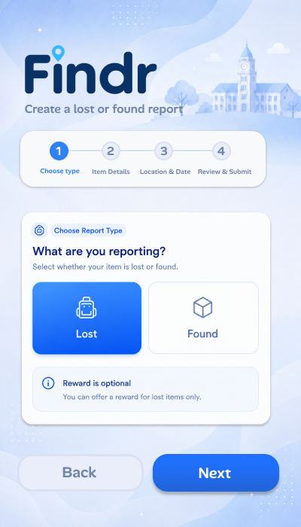
REPORT CREATION PAGES

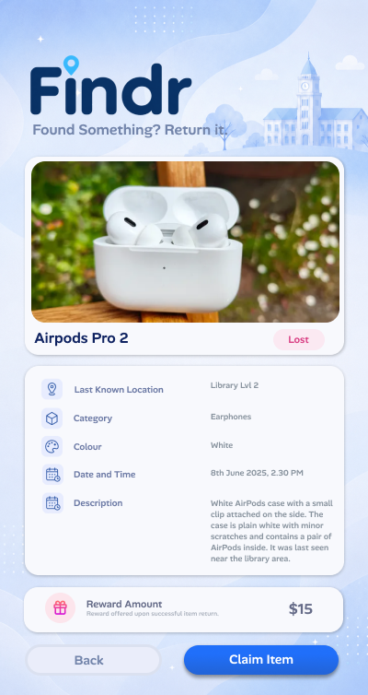
CLAIM STATUS PAGE

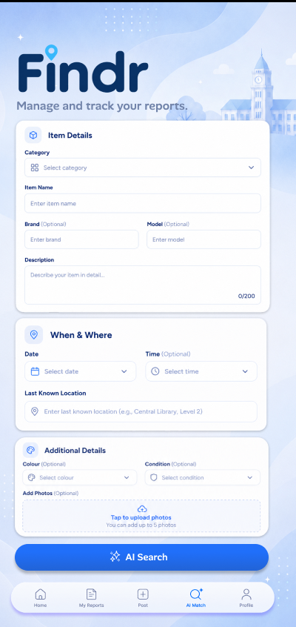
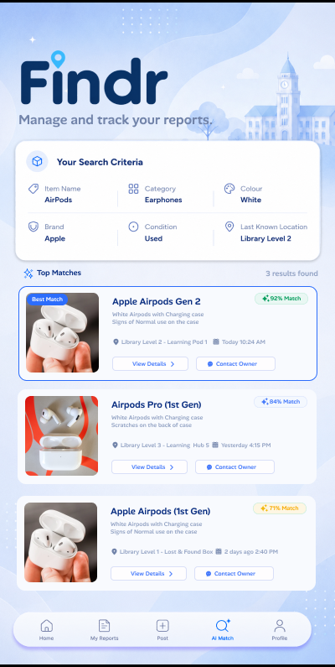
AI SEARCH PAGE

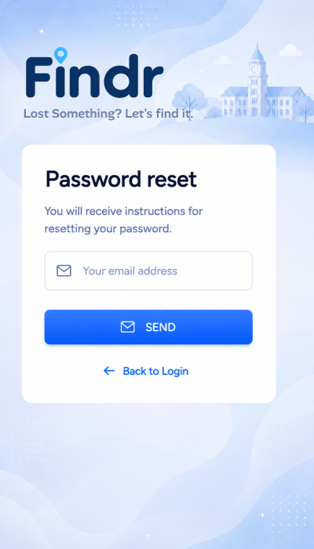
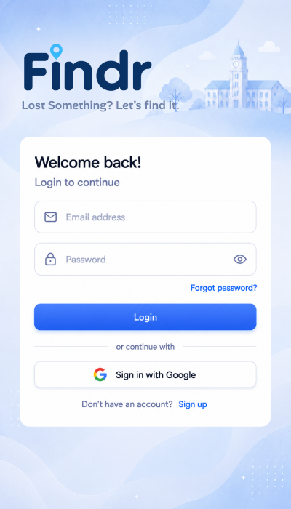
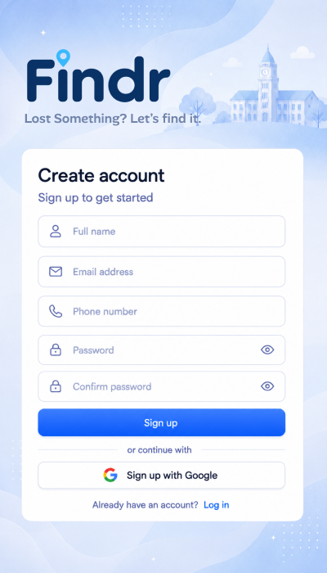
AUTHENTICATION PAGES

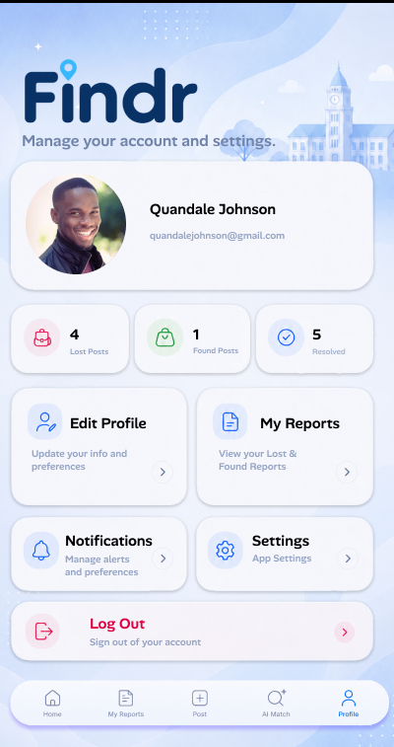
PROFILE PAGE

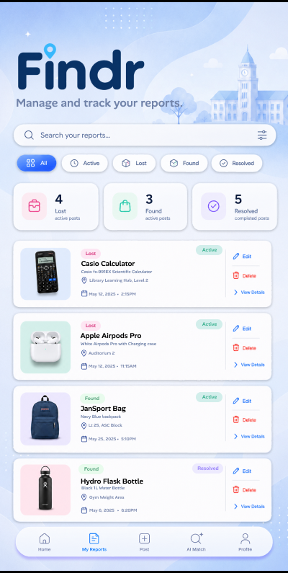
MY REPORTS PAGE

Widget Tree
Wireframe Screenshot (Main Screen)
Widget Tree (Made in draw.io)
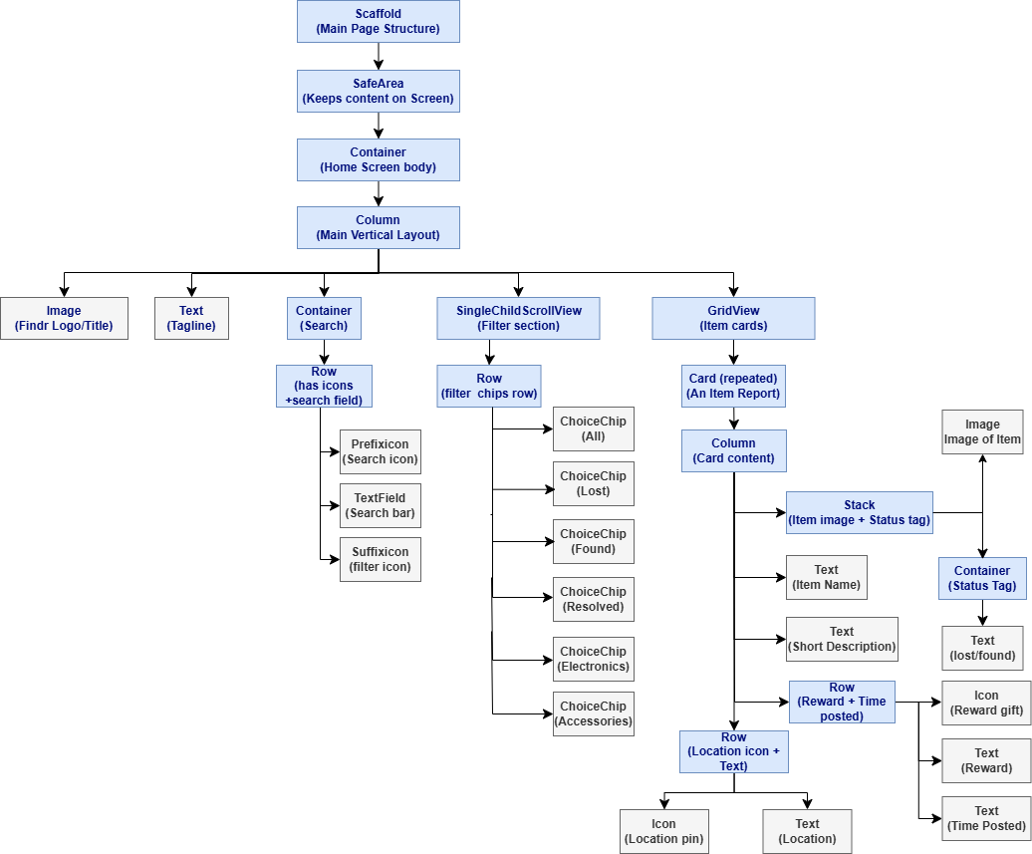

Additional Features
In addition to the core functionalities of the application, the following non-CRUD feature(s) will be implemented to enhance the overall user experience:

Feature Name | Automated Poster Generator
Description | The Automated Poster Generator will allow users to create a digital lost item poster for their lost items. After creating a lost item report, the user can open the report details page and select the Generate Poster option. Findr will then use the details from that report, such as:  - Item name  - Item Photo  - Category  - Last Seen Location  - Date/Time  - Description  - Reward Amount (If applicable)  in order to create a clean and organised poster layout. The poster will present the key information clearly so that other students can quickly understand what item is missing, where it was last seen, and what details to look out for. Once generated, the user can save or share the poster through their preferred platforms like Instagram, Telegram, or WhatsApp. This makes it easier for users to spread awareness of their lost item without needing to manually design a poster themselves.
Purpose / Benefit | This feature is useful as students may want to spread awareness of their lost item outside of the Findr app. While Findr allows users to browse/create reports within the app, not every student may use the app regularly or have the app downloaded. Thus, a shareable poster will help the report reach a wider audience through platforms that students already use daily.  It also saves time as users do not need to spend time designing a poster manually. Since the poster is generated from the existing report details, the information stays consistent and organised. This reduces the chance of missing out on important details.  This feature is especially useful for valuable or urgent lost items such as wallets, AirPods, calculators, student cards, or laptops because these items may affect a student’s daily school life, cost a lot to replace, or contain personal information. A generated poster allows the user to quickly share the report outside the app, such as in class group chats or social media, so more people can see it and help return the item sooner.  Furthermore, a study conducted by Lost Pet Research shows that well-designed posters can be effective in recovering lost pets, as they spread awareness to people who may have seen the missing pet. The source states that “well-designed posters are one of the more effective methods for finding a lost pet”, which supports the use of the poster generator feature in Findr. This is because the same idea applies to lost items. If a lost item poster is clear, noticeable, and easy to share, more students will see the report and recognise the item. Therefore, Findr’s Automated Poster Generator can help users quickly create proper lost item posters instead of designing them manually, increasing the chances of the lost item being noticed and returned.  (https://lostpetresearch.com/2024/04/effective-long-term-lost-pet-search-methods/
Integration with Application | The Lost Item Poster Generator will be accessed via a button on the item report page.  The user will follow this flow:  - User opens a lost item report  - User taps generate poster button  - Findr shows a poster preview  - User saves or shares the poster  The generated poster will include:  - Item Image  - Item Name  - Last known location  - date/time lost  - short description  - reward amount (If applicable)  This keeps the poster generator separate from normal report creation, which makes the reporting process simpler and less overwhelming. Users can submit a report first, then choose to generate a poster only if they feel the lost item is important enough to share more widely. This gives users more control and makes the feature easier to implement because the poster can be generated using details that are already saved in the report. It also makes the feature more convenient, as users do not need to re-enter the same information again when creating the poster or spend extra time designing one manually.

Feature Name | Smart Notification System
Description | The Smart Notification System will keep users updated whenever something happens to their lost/found item reports. Instead of having to constantly open the app and check manually, Findr can send alerts when there is activity that needs their attention. This helps users stay informed about important updates even when they are not actively using the app.  For example, users can receive notifications when another user submits a claim for their item, when a user contacts them, or when there is an update about a reward. Users may also receive notifications when a possible AI match is found for their lost or found item report. If a student loses something important like their wallet, student card, phone, or AirPods, they would want to know as soon as there is a possible lead instead of finding out much later.  This feature allows Findr to send alerts in the background so users do not need to manually check the app for every update. This makes the app feel more responsive, reliable, and practical for everyday student use.
Purpose / Benefit | This feature is useful as recovering a lost item often depends on how quickly users respond. If someone finds an item or submits a claim, a delayed response could slow down the entire process. Smart Notifications help reduce this by immediately informing users when something important happens.  It also makes the app more convenient as students may be moving between classes, food courts, study areas, and CCAs, and might not remember to check Findr repeatedly throughout the day. Notifications allow the app to support them in the background and alert them only when there is something worth checking. This is especially useful for urgent items such as wallets, student cards, phones, or AirPods, where a faster response may increase the chances of the item being returned.  Furthermore, an article by Actito explains that push notifications are useful because they allow applications to “reach customers instantly” through real-time alerts. This supports the use of the Smart Notification System in Findr because the same idea applies to lost item recovery. If users receive immediate notifications about claims, possible matches, or reward updates, they can respond faster instead of constantly checking the app manually. Therefore, Findr’s Smart Notification System can help make the recovery process feel more active, convenient, and reassuring for users.  (https://www.actito.com/en-BE/blog/push-notifications/)  Overall, this feature will make Findr feel more reliable as users are not left wondering whether anything has happened to their report. Instead, they can stay updated without having to constantly check the app, making the recovery process feel more efficient and user-friendly.
Integration with Application | The Smart Notification System will send notifications to the user’s phone and will be completely optional. Users can turn it off in the settings if they find the notifications annoying or unnecessary. Example notifications could include:  - Possible Match Found  A white AirPods case near the library may match your lost item report  - New Claim Received  Someone has submitted a claim for your found wallet  Overall, this feature connects naturally with the item reports, claims, AI matching and reward system because it keeps users informed about the most important actions happening in the app.

References

- O’Donoghue, J. J. (2017, July 23). Lost your phone in Japan? You’ll probably get it back. Al Jazeera.
https://www.aljazeera.com/features/2017/7/23/lost-your-phone-in-japan-youll-probably-get-it-back

- Flaticon. (n.d.). File icons.
https://www.flaticon.com/free-icons/file

- Wallpaper Flare. (n.d.). Scientific calculator wallpapers.
https://www.wallpaperflare.com/search?wallpaper=scientific+calculator

- Unsplash. (n.d.). Water bottle images.
https://unsplash.com/s/photos/water-bottle

- PCMag. (n.d.). Apple AirPods (2nd generation) review.
https://www.pcmag.com/reviews/apple-airpods-2nd-generation

- PicMonkey. (n.d.). Create the best profile picture.
https://www.picmonkey.com/blog/create-the-best-profile-pic

- Flutter. (n.d.). Widget catalog. Flutter documentation.
https://docs.flutter.dev/ui/widgets

- OpenAI. (2026). ChatGPT [Large language model].
https://chatgpt.com/
- Lost Pet Research. (2024, April). Effective long-term lost pet search methods.
https://lostpetresearch.com/2024/04/effective-long-term-lost-pet-search-methods/
- Actito. (n.d.). Push notifications: Definition, benefits & examples.
https://www.actito.com/en-BE/blog/push-notifications/

Data obtained from google forms for design analysis

aisyah | Diagram 1 |  | Diagram C | the step by step format looks easier to use | Diagram X
Leon Jr | Diagram 3 | the cards easier to see | Diagram C |  | Diagram X | looks clear
Rach | Diagram 1 |  | Diagram C |  | Diagram X
Nurul | Diagram 1 | the colour nice and calm | Diagram C |  | Diagram X
Wei Jie | Diagram 3 | looks more like real app | Diagram C |  | Diagram X
Marcus | Diagram 4 |  | Diagram C |  | Diagram Z | looks cool af
Amelia Wong | Diagram 1 | clean and safe feeling | Diagram A |  | Diagram X
jia en | Diagram 3 | bigger pictures makes it easier to see | Diagram C |  | Diagram X
harith | Diagram 1 |  | Diagram B |  | Diagram Y
Syafiq | Diagram 3 |  | Diagram C | because the form is split up | Diagram Z
chloe tan | Diagram 3 |  | Diagram C | its less messy a and b more messy | Diagram X
priya | Diagram 3 |  | Diagram C |  | Diagram X | simple to read
jay han yi | Diagram 1 |  | Diagram A |  | Diagram X
ethan | Diagram 1 |  | Diagram B |  | Diagram Y
Hakim | Diagram 4 | easier to find the main actions | Diagram C |  | Diagram X
fatima | Diagram 3 | easier to compare items | Diagram C |  | Diagram Y
Vanessa | Diagram 3 |  | Diagram C |  | Diagram X
Anis Suhaimi | Diagram 4 | the logo looks cooler | Diagram B |  | Diagram Z
Arjun Nair | Diagram 2 |  | Diagram A | the sections are clear | Diagram Z
Hannah | Diagram 1 | soft colours fit the app | Diagram C |  | Diagram Y
Ian Khoo Rei Jin | Diagram 1 |  | Diagram C |  | Diagram Y | Z has too much on the screen Y is less information ovreload
zhi hao | Diagram 3 | can see the items faster | Diagram C |  | Diagram X
Syed Ghazi | Diagram 1 | I like the blue color betterf | Diagram C | i like the review part where can ree if everything is correct | Diagram Y
Duke Lucas HO | Diagram 3 |  | Diagram C |  | Diagram Y

