

SCHOOL OF INFORMATICS & IT

Part 2: Basic Application and Authentication

Student Name (Matric Number) : Mohammed Hannan Noor( 0000000X)

Tutorial Group : TC20
Jenny LING (TP)
Tutor : Kent Tan

Submission Date : 5/7/2026

Declaration of Originality

I am the originator of this work and I have appropriately acknowledged all other original sources used as my references for this work.

I understand that Plagiarism is the act of taking and using the whole or any part of another person’s work, including work generated by AI, and presenting it as my own.

I understand that Plagiarism is an academic offence
and if I am found to have committed or abetted the offence of plagiarism in relation to this submitted work, disciplinary action will be enforced.

Declaration on the use of Generative AI tools for assignments

Describe how you have used Generative AI tools such as ChatGPT or Dall.E-2 in your assignment.

Show snapshots of the conversations with the AI tool (i.e., the prompts you used and the response you get from the AI tool).

Chatgpt was used in order to teach me how to implement certain authenthication methods as well as to help in debugging. Below is a link to the chat where my prompts can be viewed.

https://chatgpt.com/share/6a4533a5-ac84-83ec-9d3f-2b72b453b1de

How do you indicate the reference?
The content generated by AI tools are not retrievable except by the user who generated them, so they are considered non-recoverable sources. Although non-recoverable data or quotations in APA Style papers are usually cited as personal communications, with ChatGPT-generated text there is no person communicating. Quoting text from ChatGPT chat is therefore more like sharing the output of an algorithm, with a reference list entry and the corresponding in-text citation.

According to the official APA Style site, ChatGPT references should be cited as:

E.g. OpenAI. (2023). ChatGPT (Sep 25 version) [Large language model].
https://chat.openai.com/chat

Important Note:

- Do not copy answers produced by the AI tool in totality as it is considered as plagiarism.

- Do not rely on any information produced by the AI tool blindly. You should always verify the answer with other sources. Do not assume that these answers provided by the AI tool are correct.

To achieve quality outputs from the AI tool, you should provide good prompt that is clear and specific. Be precise and provide context. Avoid asking open-ended questions.


School of Informatics & IT

Mobile App Development (CIT2C18)

AY 25/26 Apr Semester

Basic Application

(Part 2)

Table of Contents
Screen 1: Authentication-related screens 5
Screen 2 6
Screen 3 7
Screen 4 8
Screen 5 9

Screen 1: Authentication-related screens

Screen Name: LoginScreen

Wireframe Screenshot | Flutter Screenshot (Chrome/Virtual Device)
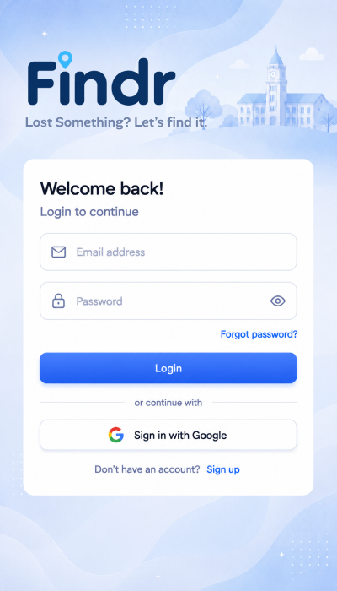 | 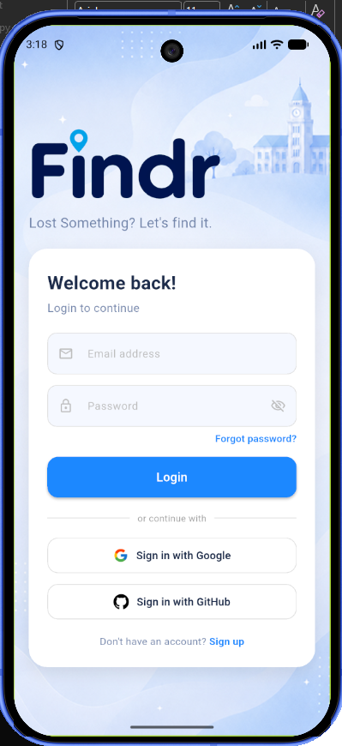
Reason for deviation (if any):
The login screen was adjusted slightly from the original wireframe to better fit the final Flutter implementation. Firstly, a GitHub sign-in button was added because the project requirements include having two different authentication methods, so Google and GitHub login were included to meet this requirement.
Secondly, the screen aspect ratio is slightly different from the wireframe because the Flutter version was adjusted and tested using a Google Pixel 10 virtual device in Chrome. Since the device size is not exactly the same as the original wireframe canvas, some spacing and alignment had to be adjusted so the page would still look balanced on the emulator.
Lastly, the input field colours are slightly different from the wireframe. This was changed to improve contrast and readability, especially against the light blue background. The updated colour makes the email and password fields easier to see while still keeping the same overall Findr theme and design style.

Screen Name: RegisterScreen

Wireframe Screenshot | Flutter Screenshot (Chrome/Virtual Device)
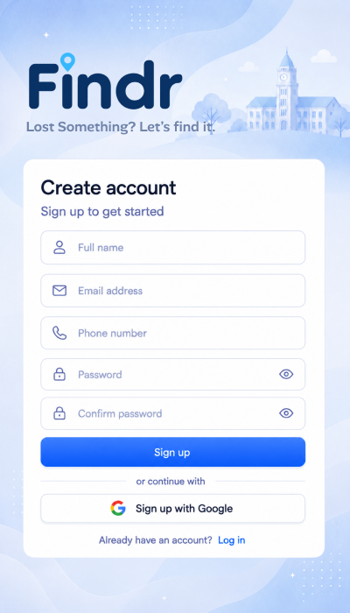 | 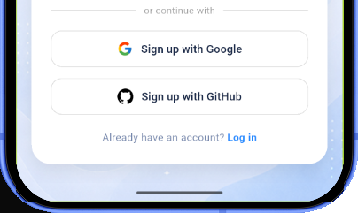  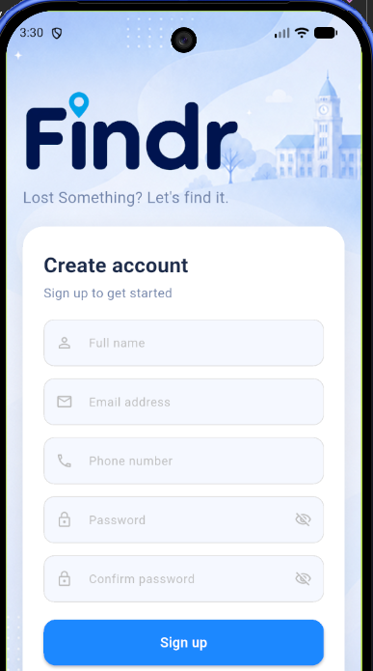  (Images were spliced together to show whole screen)
Reason for deviation (if any):
Similar to the login screen, the sign-up screen was adjusted slightly from the original wireframe to better fit the final Flutter implementation. A GitHub sign-up button was added because the project requirements ask for two different authentication methods, so both Google and GitHub authentication were included.
The aspect ratio and spacing are also slightly different because the Flutter version was adjusted and tested using a Google Pixel 10 virtual device. Since the sign-up screen has more input fields than the login screen, some spacing had to be reduced so that the form, buttons, and login link could fit properly on the device screen.
The input field colours are slightly different from the wireframe as well. This was done to create better contrast against the light blue background and make the fields easier to see and read. Overall, the screen still follows the same Findr theme, layout, and visual style from the original wireframe.

Screen Name: ResetPasswordScreen

Wireframe Screenshot | Flutter Screenshot (Chrome/Virtual Device)
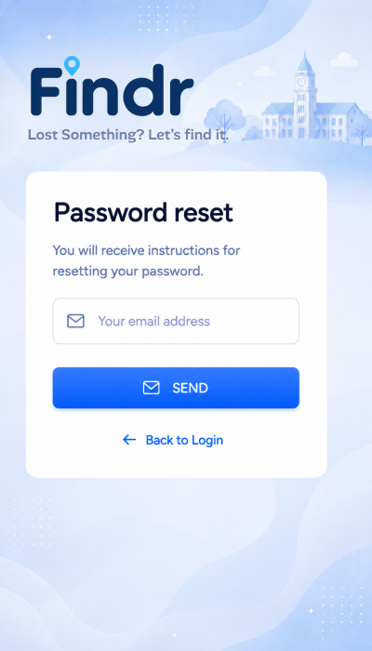 | 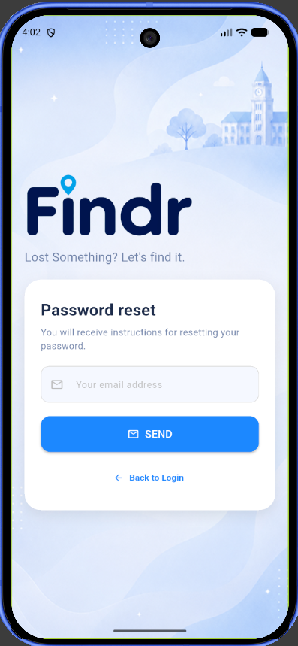
Reason for deviation (if any): Minimal Changes

Screen Name: EmailVerification

Flutter Screenshot (Chrome/Virtual Device)
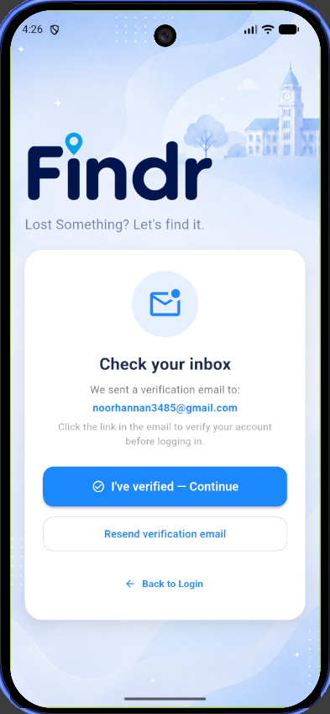
Reason for deviation (if any):
The email verification screen was added even though it was not included in the original wireframe. During the coding stage, this screen became necessary because Firebase Authentication supports email verification, and adding it helps fulfil the authentication features of the project more completely.
After a user signs up, the app sends a verification email to the email address they entered. Instead of sending the user straight into the app, this screen tells the user to check their inbox and verify their account first. This makes the sign-up process clearer and helps ensure that the account is linked to a real email address.
The screen also includes useful options such as “I’ve verified — Continue”, “Resend verification email”, and “Back to Login”. These buttons improve the user experience because the user can continue after verifying, request another email if they did not receive it, or return to the login page.
Although this screen was not in the original wireframe, it still follows the same Findr design style. It uses the same light blue background, Findr branding, rounded white card, and simple blue buttons. Therefore, it was added as a practical improvement to support Firebase Authentication and make the app feel more complete.

Screen 2
Screen Name: HomeScreen

Wireframe Screenshot | Flutter Screenshot (Chrome/Virtual Device)
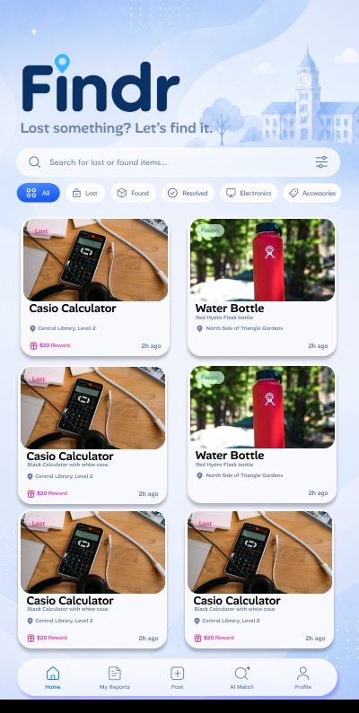 | 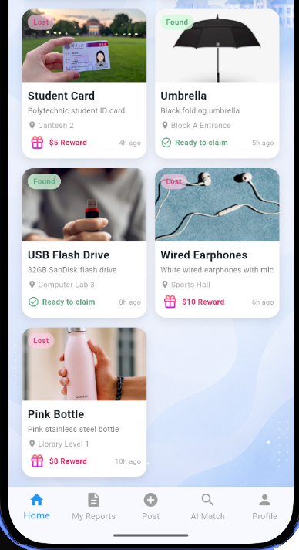  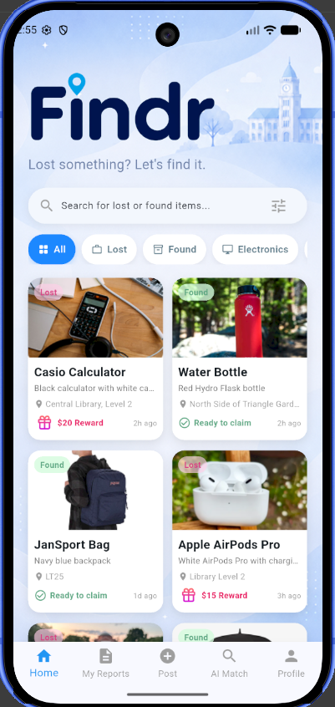  (Images were spliced together to show whole page.)
Reason for deviation (if any):
The Home screen was adjusted slightly from the original wireframe to better fit the final Flutter implementation. One main change is the bottom navigation bar. In the original wireframe, the navigation bar was placed at the bottom of the full page, which means users would need to scroll down to reach it if the content became longer.
In the Flutter version, a sticky bottom navigation bar was used instead. This means the navigation bar stays in the same position at the bottom of the phone screen while the user scrolls through the lost and found item cards. This makes the app easier to use because users can quickly move between pages such as Home, My Reports, Post, AI Match and Profile without needing to scroll all the way down.
The layout was also adjusted to fit the dimensions of the phone screen used for testing. Since the virtual device has a different aspect ratio from the original wireframe, the card sizes, spacing, search bar and filter chips were slightly adjusted so that the screen looks cleaner and fits properly on the phone.
Overall, the Home screen still follows the same Findr design style from the wireframe, including the blue background, item cards, search bar, category filters and bottom navigation. The changes were mainly made to improve usability and make the screen work better on an actual phone layout.

Screen 3
Screen Name: AiMatchScreen

Wireframe Screenshot | Flutter Screenshot (Chrome/Virtual Device)
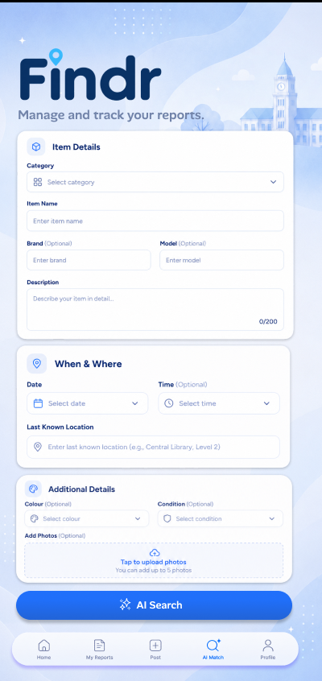 | 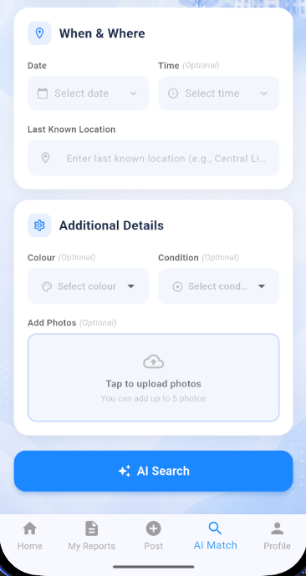  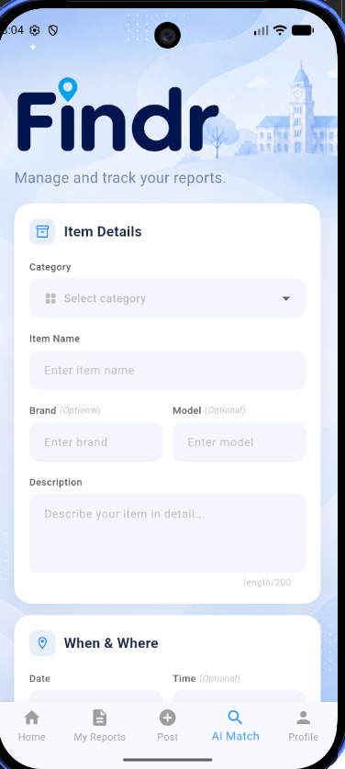  (images were spliced to show whole page)
Reason for deviation (if any): Minimal Changes only adjusted to fit phone aspect ratio

Screen 4

Screen Name:postStep1Screen, postStep2Screen, postStep3Screen, postStep4Screen,
Wireframe Screenshot | Flutter Screenshot (Chrome/Virtual Device)
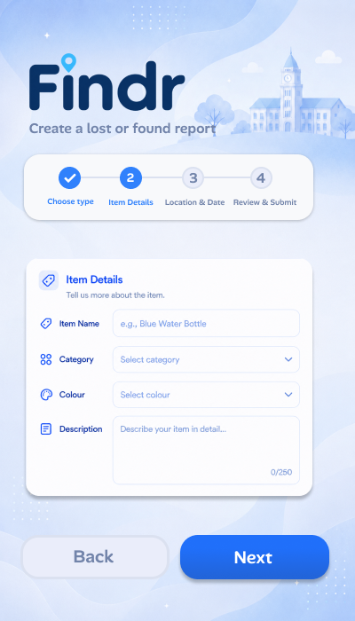  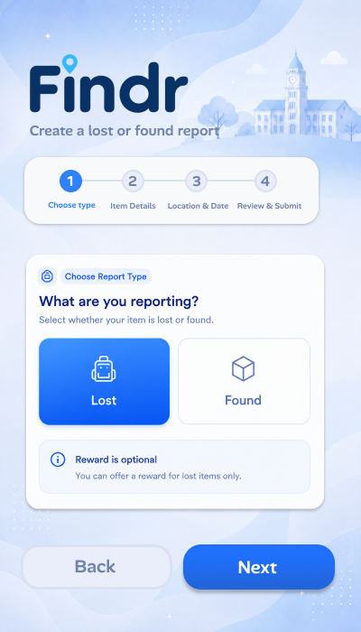  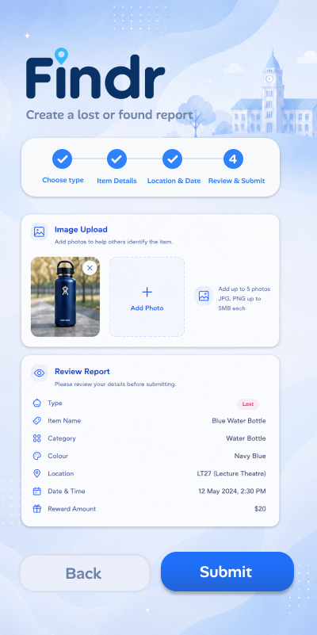  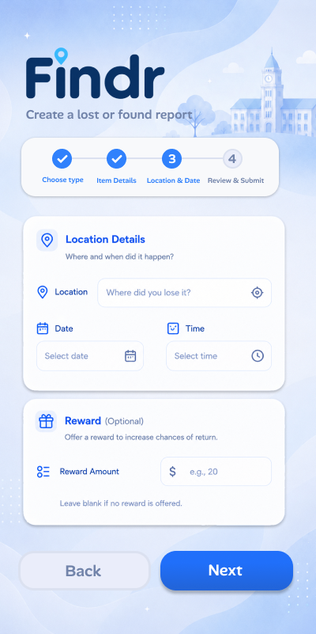 | 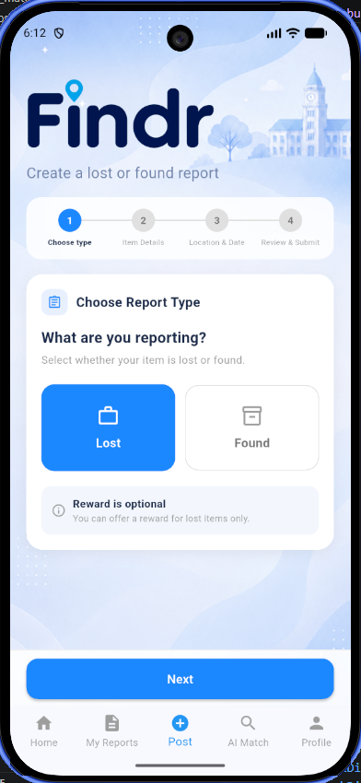  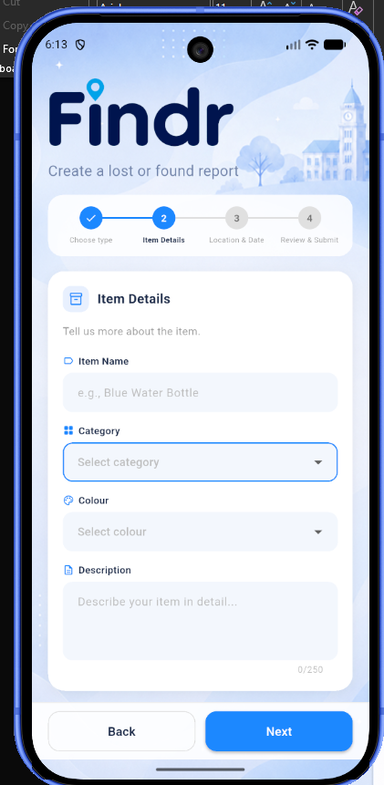  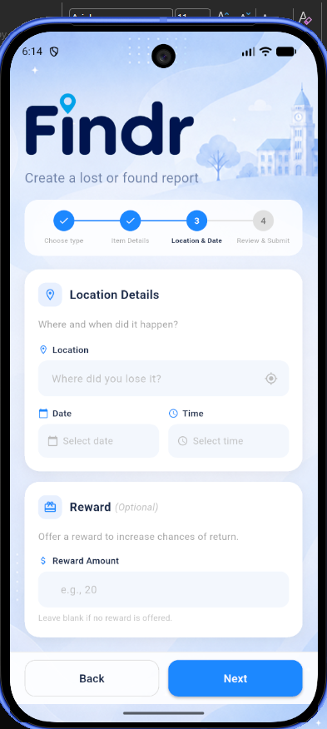  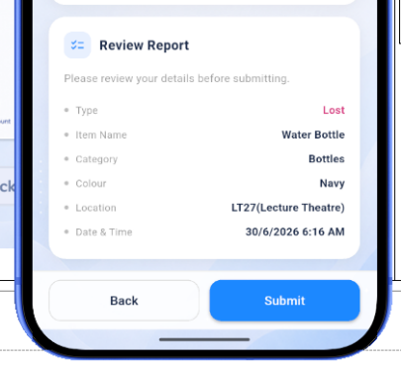  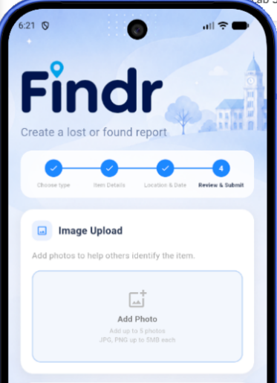  (Images were spliced together to see the whole screen)
Reason for deviation (if any):
For Post Step 1, there were no major changes made to this screen compared to the original wireframe. The overall layout, step progress bar, report type selection cards, reward note and Next button were kept mostly the same. The main difference is that the icons were changed to simpler icons in the Flutter version. This was done so the icons would look cleaner and match the default Flutter icon style better. The simpler icons also make the screen look more consistent with the rest of the app. The layout was also slightly adjusted to fit the phone screen used for testing, but the purpose and design of the screen remain the same as the original wireframe. Overall, this screen still follows the intended Findr design and user flow.
For Post Step 2, there were only minor changes made to this screen. The overall layout and purpose stayed the same as the wireframe, including the progress bar, item details form, and Back and Next buttons. The main difference is that the spacing and form fields were slightly adjusted to fit better on the phone screen. The input fields also look slightly different because Flutter’s default form styling was used and adjusted to match the app’s design.
For Post Step 3, there were only minor changes made to this screen. The overall layout stayed the same as the wireframe, including the progress bar, location details, date and time fields, reward section, and Back and Next buttons. The main difference is that the spacing and input fields were adjusted slightly to fit the phone screen better. The form fields also look a bit lighter in the Flutter version so that they match the rest of the app’s clean and simple design.
For Post Step 4, there were only minor changes made to this screen. The overall purpose stayed the same as the wireframe, including the review report section and the Back and Submit buttons. The main difference is that the spacing and layout were adjusted to better fit the phone screen used for testing. The review details also appear more compact in the Flutter version so that the important report information can be shown clearly before the user submits the form.

Screen 5

Screen Name: profileScreen

Wireframe Screenshot | Flutter Screenshot (Chrome/Virtual Device)
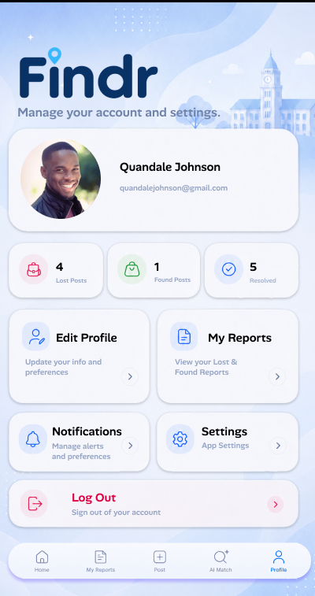 | 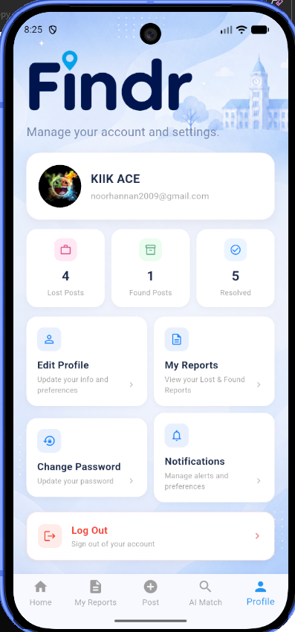
Reason for deviation (if any):
The Profile screen was adjusted slightly from the original wireframe to better fit the phone screen used for testing. The top profile section showing the profile picture, name and email was made smaller so that the page would fit better and leave more space for the account options below. Some of the option cards were also rearranged and adjusted.
A Change Password option was added because it helps fulfil the authentication features of the project. This gives users a clearer way to manage their account security from the Profile screen.
Overall, the screen still follows the same Findr design style, including the profile card, account statistics, rounded option cards and bottom navigation bar. The changes were mainly made to improve spacing and support the required authentication functions.

References
- https://firebase.google.com/codelabs/firebase-auth-in-flutter-apps#0
- https://medium.com/flutter-community/implementing-firebase-github-authentication-in-flutter-1c49a172c648 (tutorial on how to implement GitHub login)
- https://www.pexels.com/ (Stock images used )

