Appendix A - Report Template


SCHOOL OF INFORMATICS & IT
Diploma in [Applied Artificial Intelligence]
Project Report

Student Name (Matric Number) : Mohammed Hannan Noor(XXXXXXXX)
Tutorial Group : PC23
Tutor : Simon Ngeow
Submission Date : 19/1/2026

Declaration of Originality
I am the originator of this work and I have appropriately acknowledged all other original sources used as my references for this work.
I understand that Plagiarism is the act of taking and using the whole or any part of another person’s work, including work generated by AI, and presenting it as my own.
I understand that Plagiarism is an academic offence
and if I am found to have committed or abetted the offence of plagiarism in relation to this submitted work, disciplinary action will be enforced.

Table of Content
- Introduction

- Implementation of Tasks
2.1 Tasks #1
2.2 Tasks #2
  - Tasks #3
  - Tasks #4
  - Tasks #5

3. Conclusion

1. Introduction
This document contains the configuration of the network infrastructure for NECT’s Main Office and Warehouse using Cisco Packet Tracer according to the specified requirements. It includes setting up wired and wireless networks, allocating IP addresses and gateways, configuring DHCP for automatic IP allocation, and implementing DNS and HTTPS services to support network communication and access.

2.1 Task#1 Add Network Devices and End devices

I first added the end devices for the Main Office, I added a printer , a PC, a tablet and a Laptop and added copper straight through cables to connect the wireless router in the main office to the Printer and the PC in the Main Office. I didn’t add any connection for the Laptop and the Tablet as I will later connect to these devices wirelessly.

I then added the end devices and network devices for the warehouse. I added a printer, a PC and a server.
I also added copper straight through cables between the router and the switch in the warehouse and copper straight through cables between the switch and the server, the pc and printer in the warehouse. I also renamed all devices in both the Main Office and the Warehouse so that each device name reflects its location, such as renaming PC0 to PC_Warehouse, to clearly identify device location and simplify network management. The image below shows a picture of the topology after adding the devices and cables as said above.

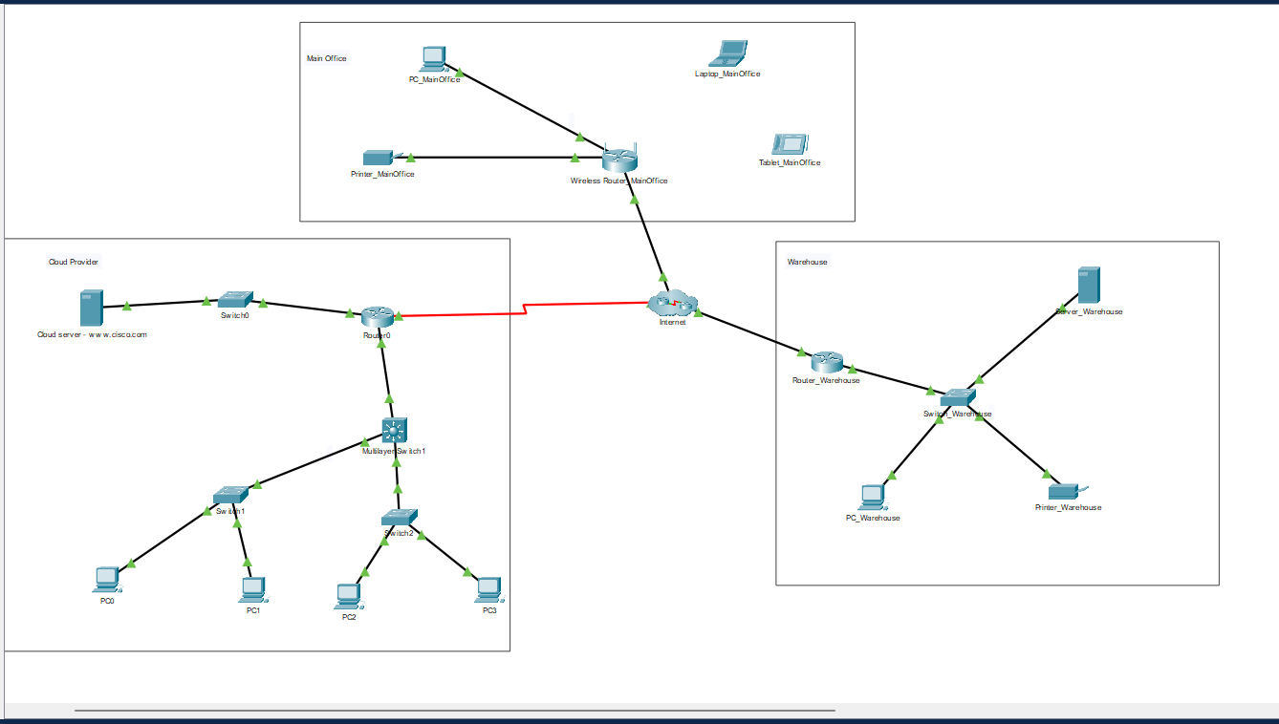

2.2 Task#2 Implement Wi-Fi for the main office

In order to implement Wi-Fi for the main office I adjusted the basic wireless settings to change the SSID of the 2.4GHz network to NECT and change the SSID of the 5GHz -1 Network to Guest and disabled the 5GHz -2 Network as it is unnecessary.

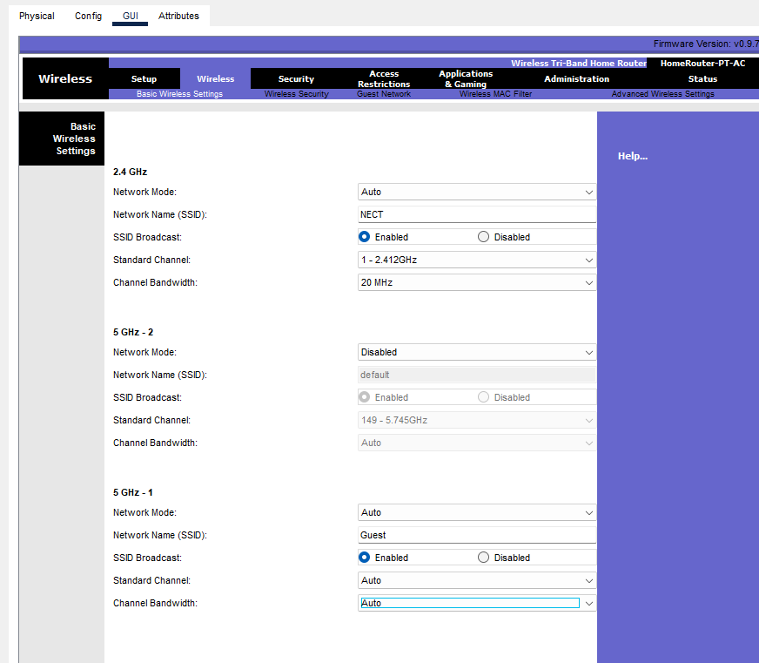

Then I adjusted the Wireless Security settings to change the Security Mode of the 2.4GHz network (NECT network) to WPA2 Personal and disabled the Security Mode for the 5GHz network(Guest Network), as shown below.
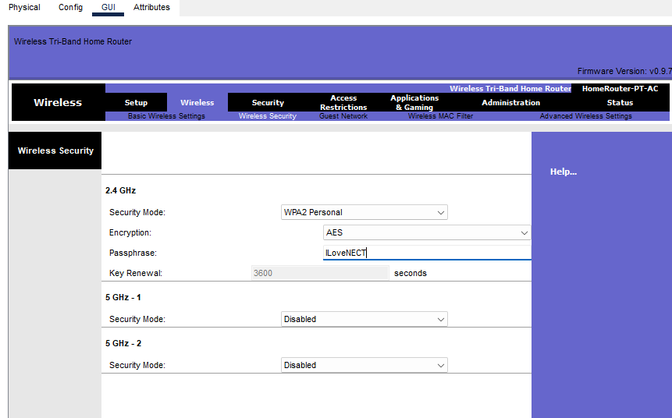

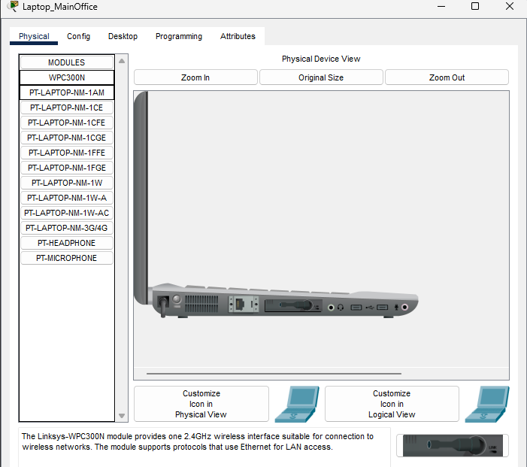
Then I shut off the laptop and added the WPC300N module so that the laptop can connect to the NECT network.
WPC300N Module
Then I went to PC Wireless in the Desktop Tab
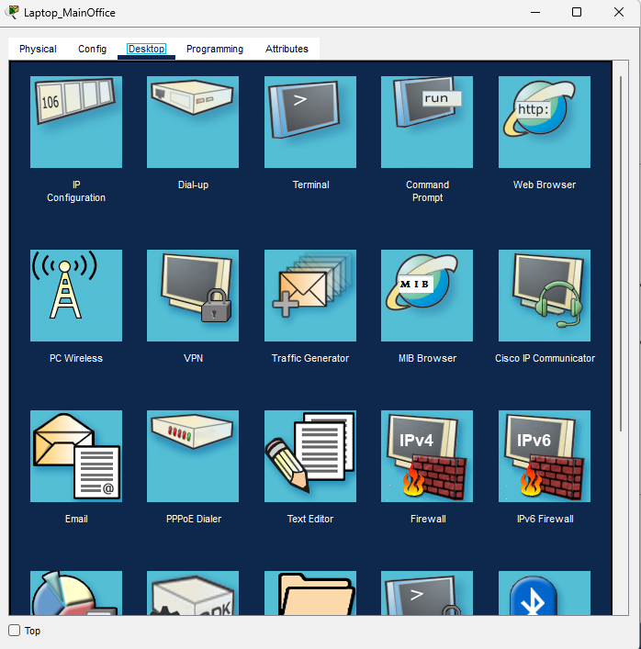

Next I Connected to the NECT Network
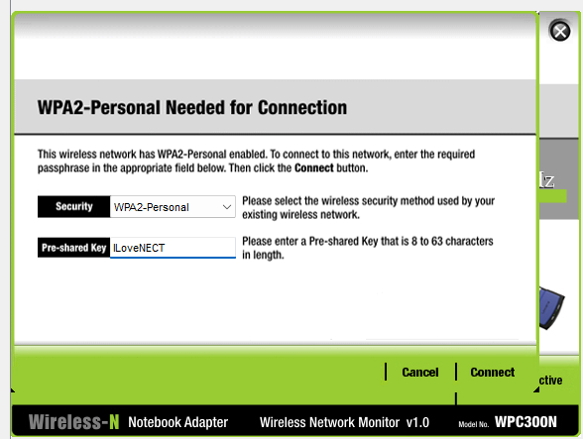

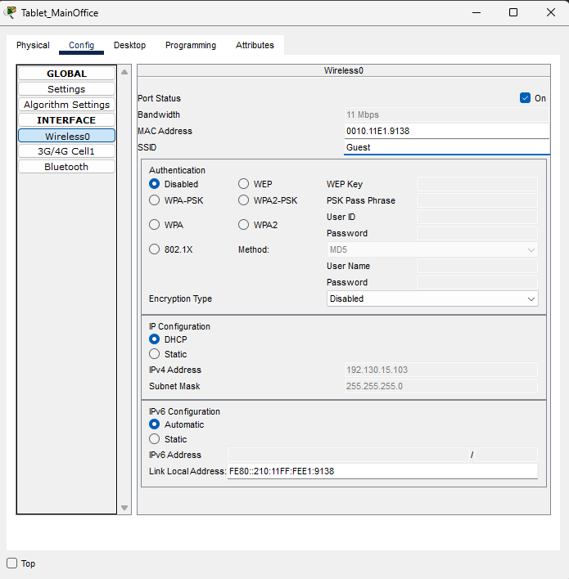
For the tablet, to connect to the Guest Network, I navigated to the Wireless0 tab, then I changed the SSID field from default to Guest

2.3 Task#3 Implement DHCP for both Main Office and Warehouse server.

First, I implemented DHCP for the Main Office.
In the GUI of the Main office router Internet Setup section I changed the Internet Connection type from static IP to Automatic Configuration-DHCP.
Then I changed the router IP to 192.130.15.1.

Next, I set the start IP address as 192.130.15.50

Next, I set the maximum amount of Users to 100

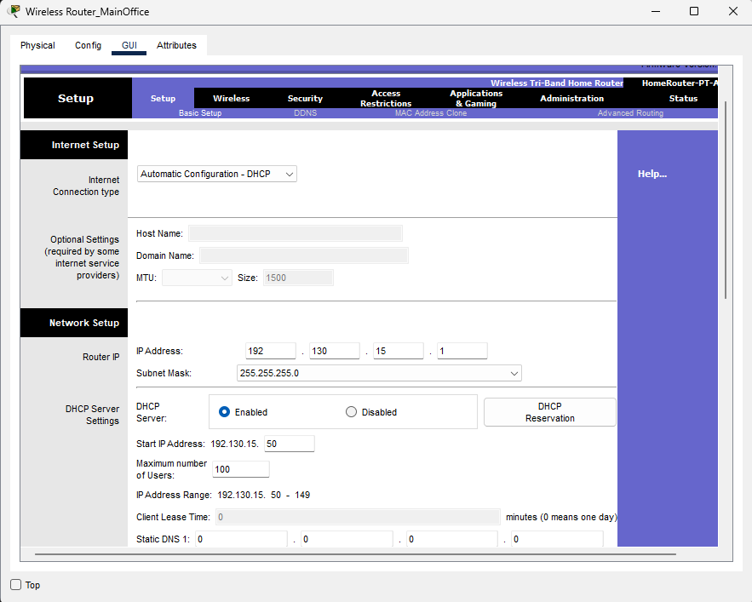

Next, to implement DHCP for warehouse server I navigated to the DHCP tab and
changed the start IP address to 172.136.15.50,
set the maximum amount of users to 100,
set the Default Gateway to
turned the DHCP service from off to on.
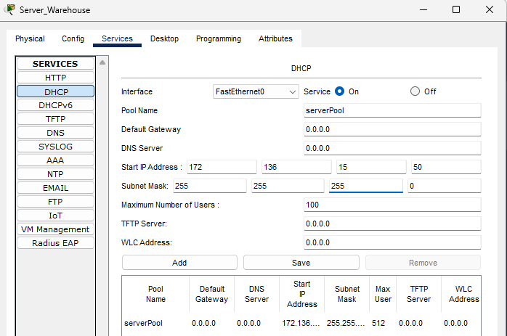

2.4 Task#4 Implement certain configs for warehouse server
First I set its IP address to 172.136.x.10 and the subnet mask to 255.255.255.0, as shown below.

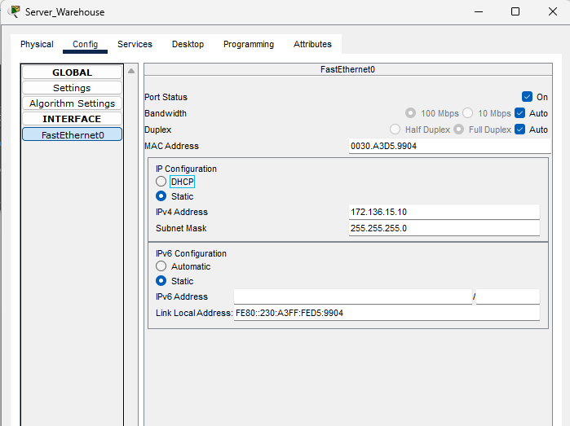

Then I edited the HTML code as such, to show I Love NECT on the website.
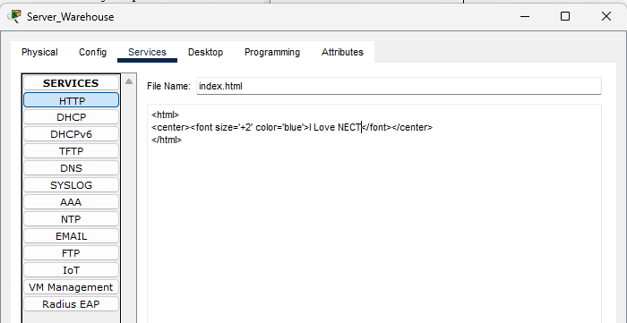

Next, I changed the DNS Server field in the config, in the FastEthernet0 tab to 172.136.15.10, as shown below.

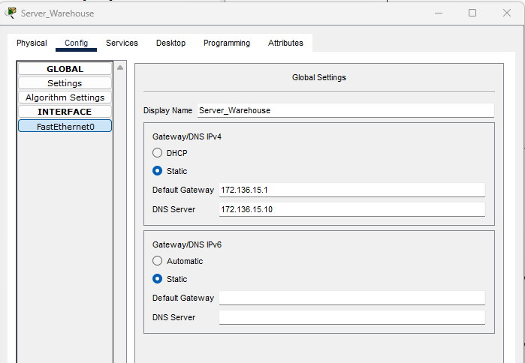

Next, to add the DNS and DNS record, I turned on DNS service,
Added a DNS record with the name www.nect.com (so the website can be accessed with this url)
the address 172.136.15.10, As shown below.

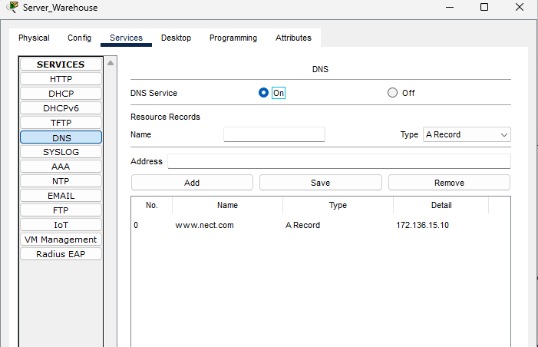

Next to test that the website can be accessed with the url www.nect.com and that the DNS server is working properly, in the warehouse server’s web browser I searched www.nect.com and as shown below it came up with the webpage.
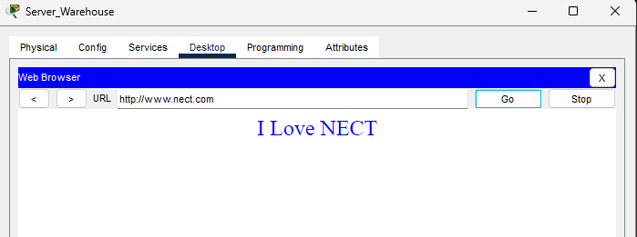

2.5 Task#5 Implement Test cases

a.i.1)First, I tested to make sure that the PC, tablet and laptop could receive IP addresses via DHCP, and as shown below all of these devices could receive IP addresses via DHCP

Main Office Laptop
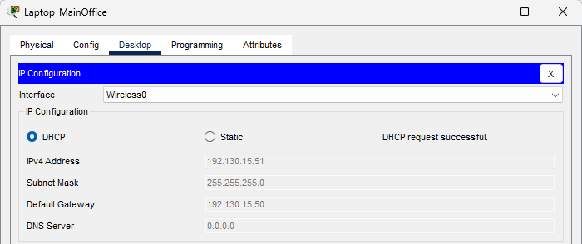

Main Office PC
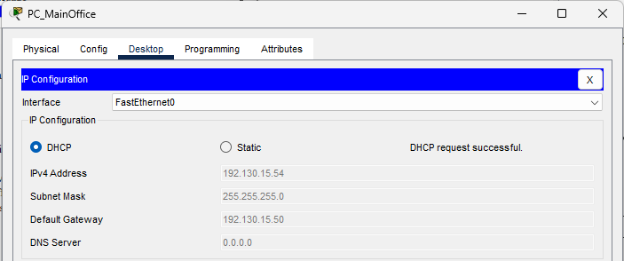

Main Office tablet
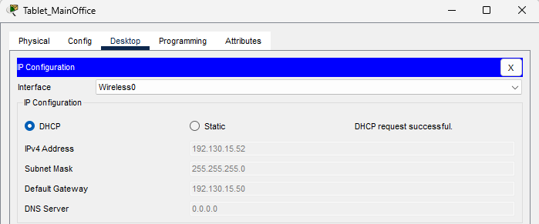

a.i.2) Next I tested to see if the laptop, tablet and PC could access Cloud Provider web server by using both it’s IP address and name, and as shown below they can:

For PC:
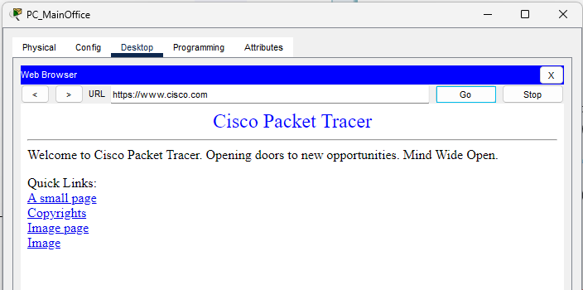
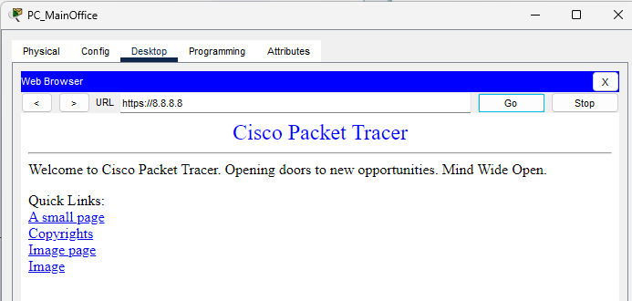

For Laptop:
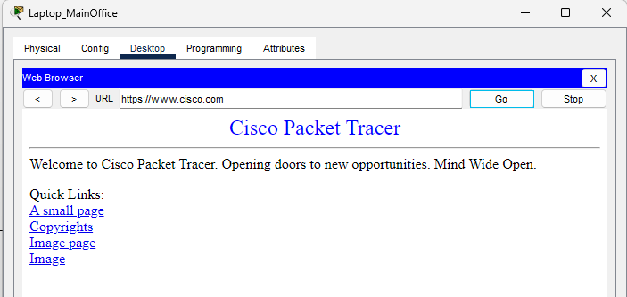
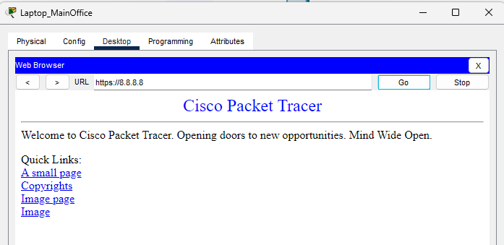
For Tablet:
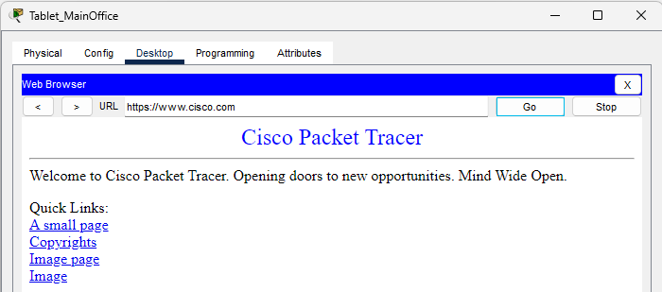
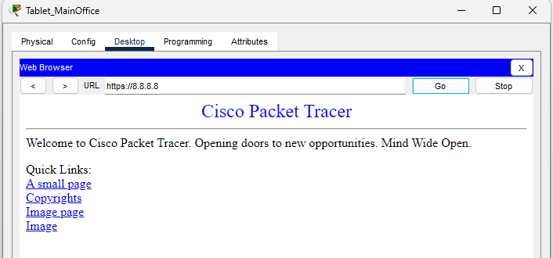

a.i.3) Next I tested to see if the laptop, tablet and PC in the Home Office can ping the cloud provider’s web server’s IP address and as shown below they can:

For PC:
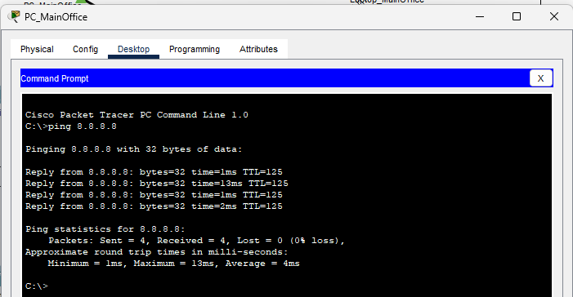
For Laptop:
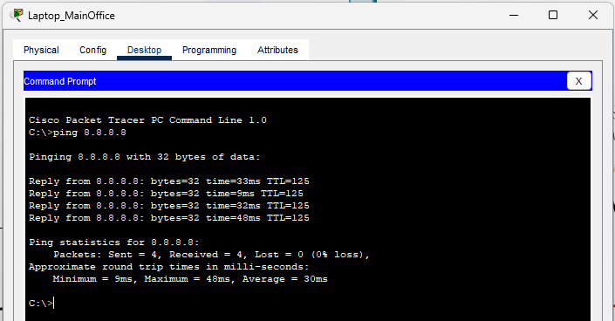
For Tablet:
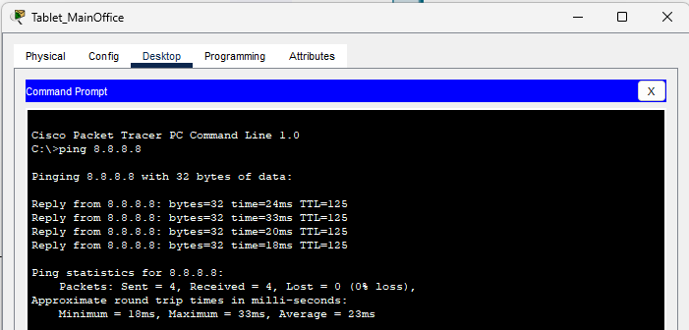
a.ii.1) Next I set the Printer’s IP address to 192.130.15.11 as shown below:
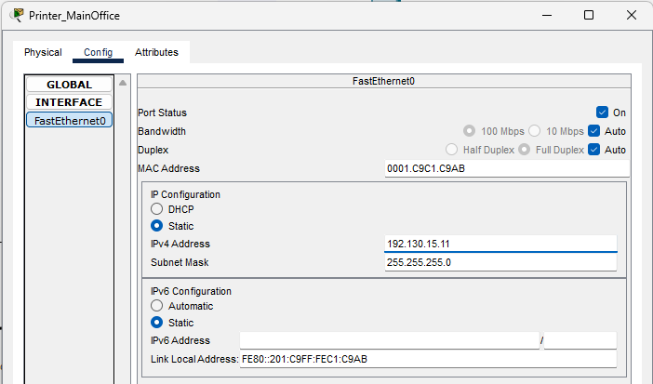

b.i.1)Next, for the warehouse, I tested to see if the PC could get IP address via DHCP, and as shown below it could:

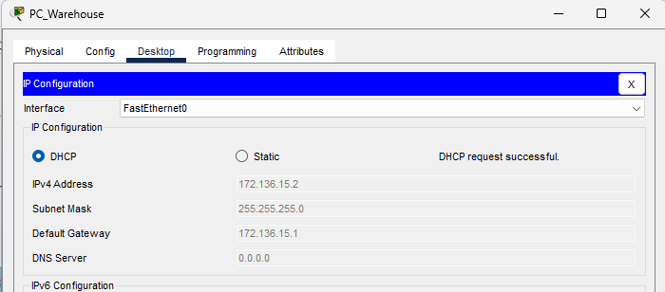

b.i.2)Next, for the warehouse, I tested to see if the PC could access the warehouse server via www.nect.com and as shown below it can
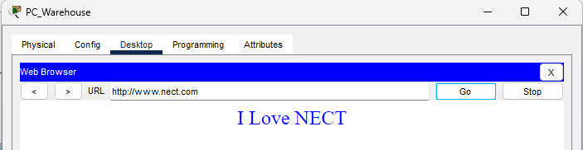

b.i.3)Next, I tested to see if the PC in the warehouse can ping the cloud provider’s server and as shown below, it can:

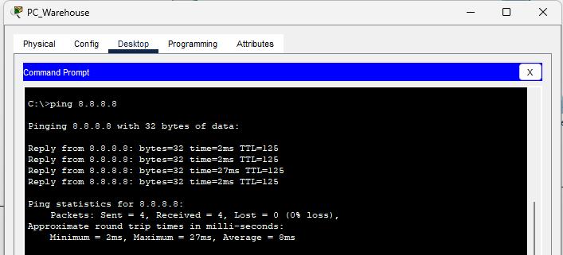

b.ii.1)Next, I set the printer’s ip address to 172.136.15.11

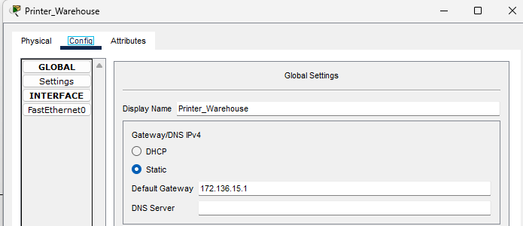

And Lastly, I added labels, showing the IP of every device as shown below. This is to improve readability and clarity.
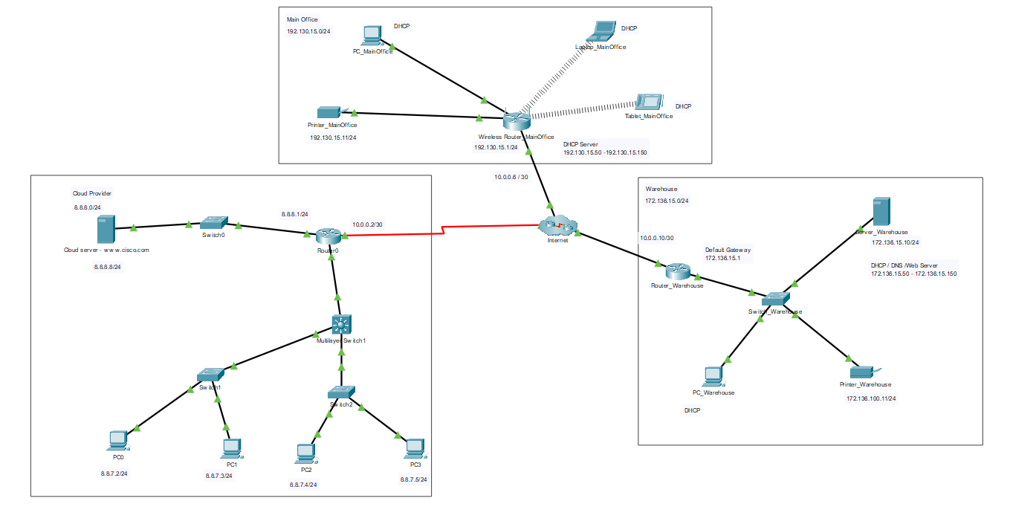

3.Conclusion
Through completing this project, i gained experience in setting up and managing a small-scale company using Cisco Packet Tracer. I learned how IP addressing, DHCP, DNS, wireless configuration, and servers work together to maintain proper connectivity. The testing and troubleshooting process also helped improve my ability to verify whether a network is correctly configured. Overall, this project helped me apply networking concepts in a practical scenario.

