

SCHOOL OF INFORMATICS & IT

Data Visualisation & Analytics
(CIA1C11)

DA Assignment

AY2025/2026 Apr Semester

Student Name (Matric Number) : Mohammed Hannan Noor(XXXXXXXX)

Practical Group : PC23
Jenny LING (TP)
Tutor : Alice Haruno

Submission Date : 31/7/2025

Declaration of Originality

I am the originator of this work and I have appropriately acknowledged all other original sources used as my references for this work.

I understand that Plagiarism is the act of taking and using the whole or any part of another person’s work, including work generated by AI, and presenting it as my own.

I understand that Plagiarism is an academic offence
and if I am found to have committed or abetted the offence of plagiarism in relation to this submitted work, disciplinary action will be enforced.

It’s Data Prep Time

1a. Data Profiling

There are inconsistent categorical values in the column Gender. This column includes a mix of
short forms and full words i.e. M, F as well as Male, Female. This is shown in the Statistics
Node with 744 occurrences of Female, 727 Occurrences of Male, 15 Occurrences of F and 14 Occurrences of M. To rectify this a rule engine node can be used to convert the M and F into Male and Female.

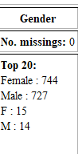
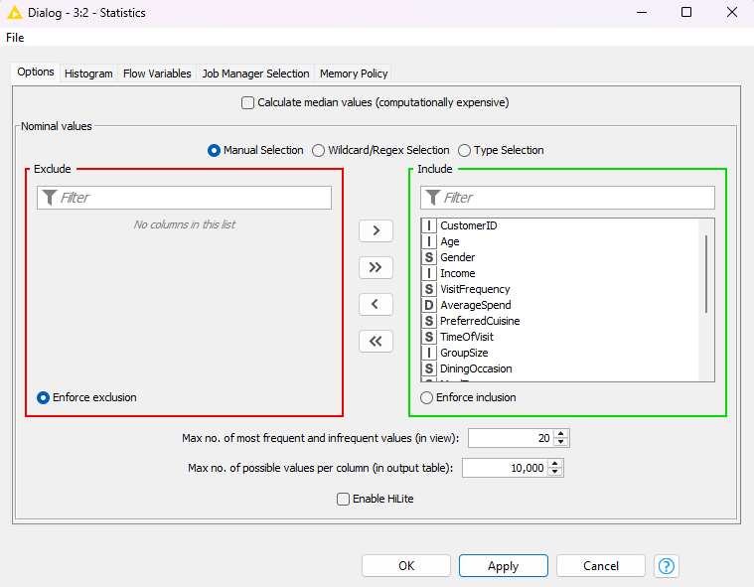

Next, in the statistics node it also shows missing values in 5 columns AverageSpend, PreferredCuisine, DiningOccasion, MealType, and WaitTime
It also shows there are entries of “Undefined” in the Preferred Cuisine column which should be treated as a missing value. To remedy this a missing value node can be used .
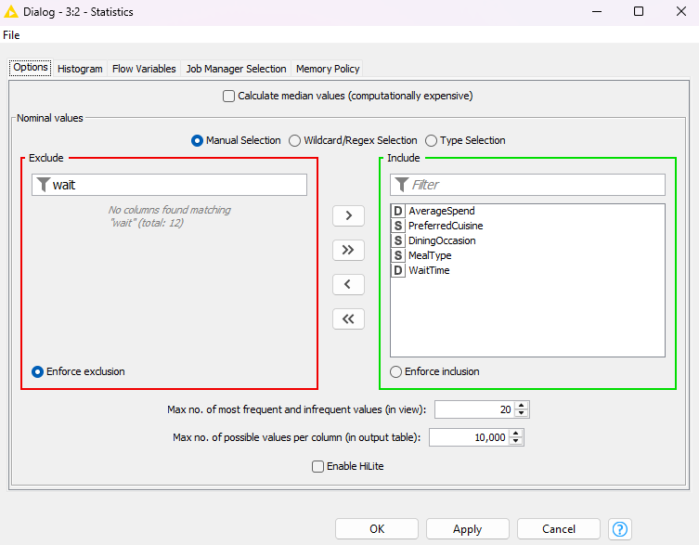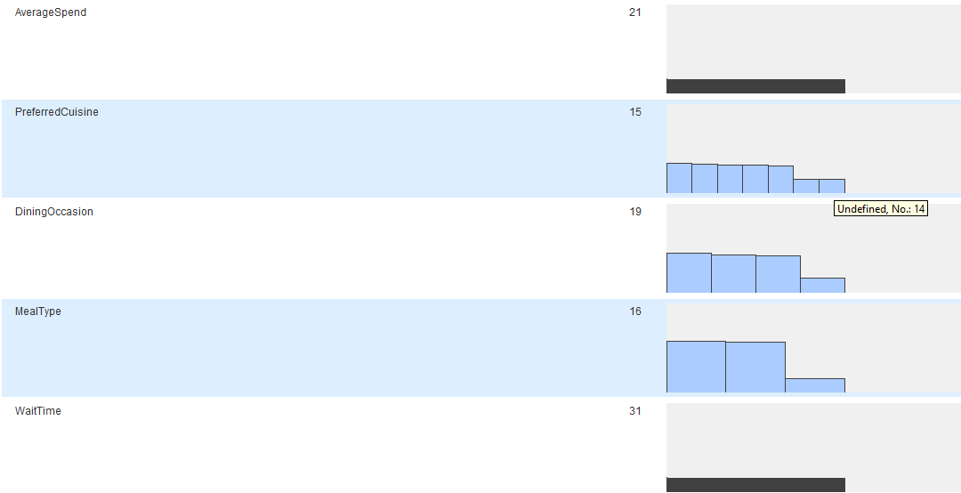

Next, unusually high values were found for Income.

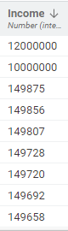
This image was obtained from the file reader node by sorting by descending income

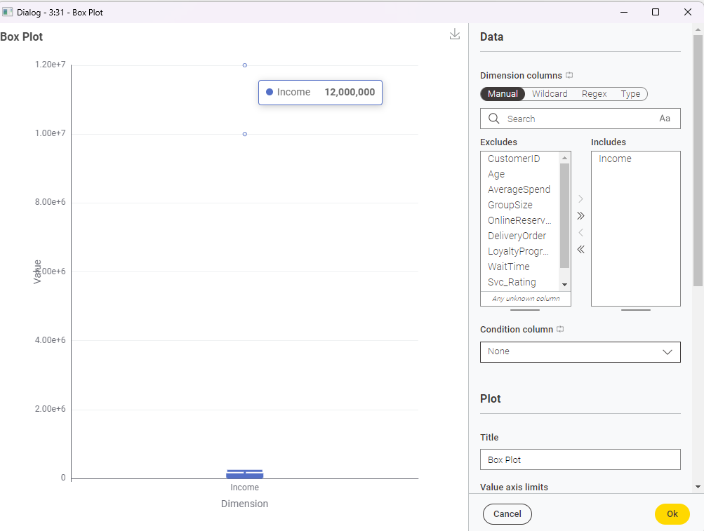

Using the box plot for income two outliers were found. Furthermore, by looking at the data in the file reader node and sorting it by descending income it shows there are 2 outliers 12,000,000 and 10,000,000 which are very different from the next values (the next highest value is 149875). Such outliers can distort statistics, like affecting the mean value drastically, and provide misleading data. To remedy this a row filter can be used to filter out the rows with these values.

Next in the file reader node it is shown that the Customer ID values are all Numbers(Integers)
To remedy this a Number to String Node can be used to convert these values into strings.
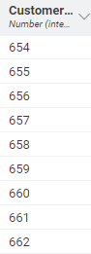
Image obtained from file reader node

In conclusion
This data profiling revealed these data issues
- Missing Values in 5 columns
- Inconsistent Gender entries
- Extreme values for Income
- Incorrect Data Type for Customer ID

1b. Data Cleaning

1bi) Create the Combined_Rating Column by adding Svc_Rating and Food_Rating.

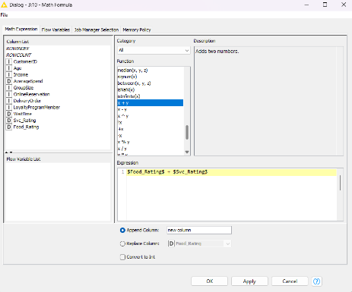
Configuration of Math Formula node

Before, After,
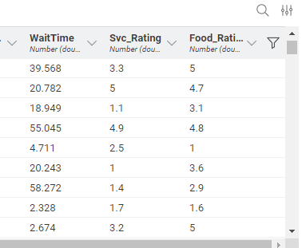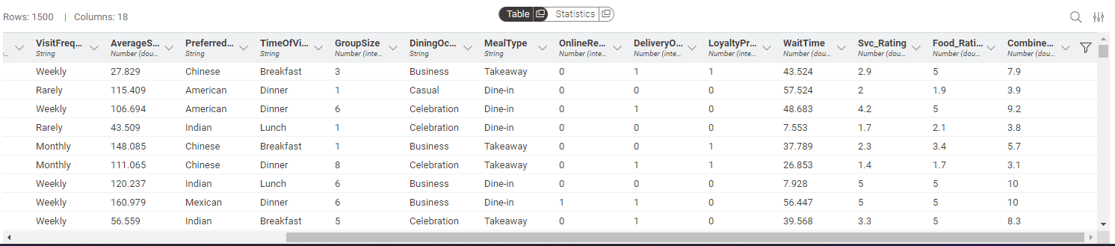
Added Combined_Rating column

A new column Combined_Rating was derived by summing the Svc_Rating and Food_Rating columns using a Math Formula node. This helps provide a single unified score to represent overall satisfaction

1bii) Fix Problem in Gender Column using Rule Engine node

Before,
Statistics node shows 4 different types of Entries Female,Male,F and M
This is also shown in the raw data (screenshot obtained from file reader)

Configuration of Statistics Node:

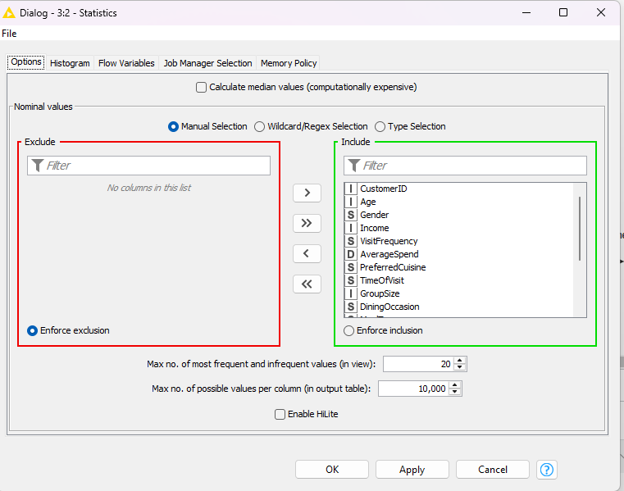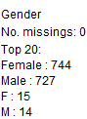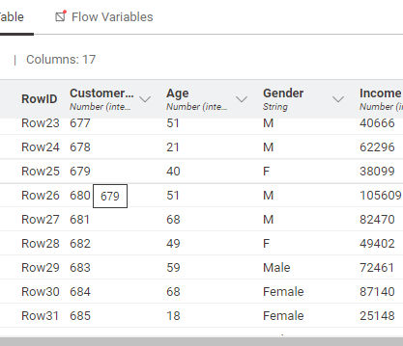
Includes M,F, Male and Female
After,
Statistics node (downstream from Rule Engine) only shows 2 different types of Entries, Male and Female
Configuration of Statistics Node: Data from file reader also shows only Male and female
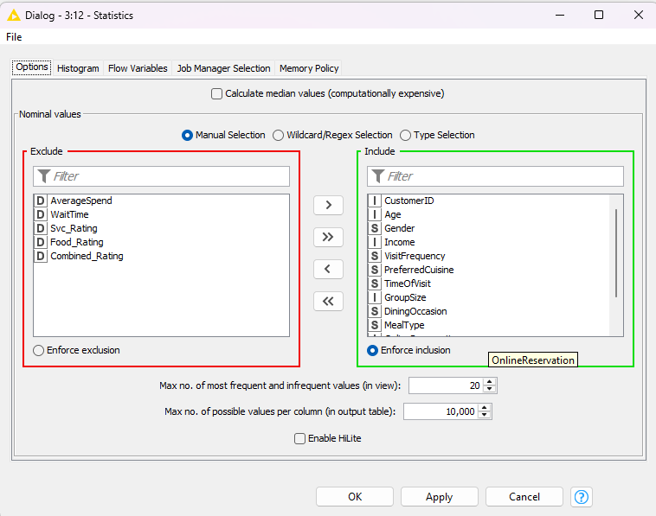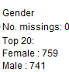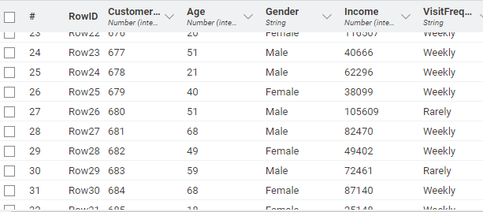
Only Male and Female, no M and F

The Gender column contained inconsistent values such as “M”, “F”, “Male”, and “Female”.

Hence, A Rule Engine node was used to standardise all entries to “Male” and “Female”. This ensures consistency.

Configuration of Rule Engine node

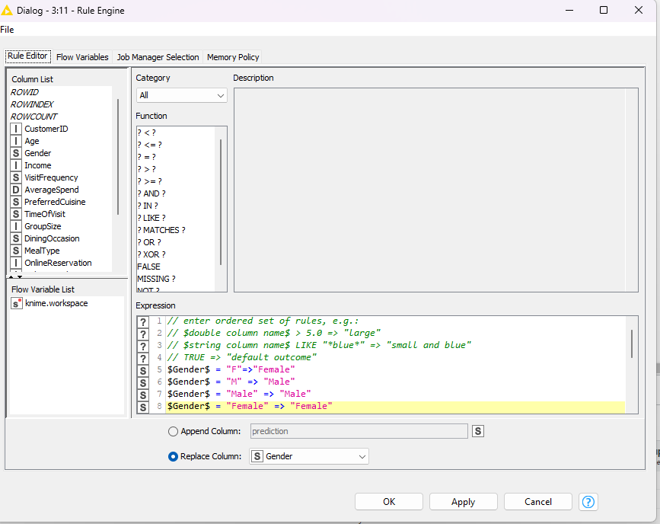

1biii) Convert Column Customer_ID to String

Before: After:
(Screenshot Obtained from File reader) (Screenshot Obtained from Number to String Node
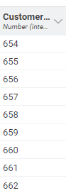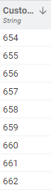
Is a String
Is Number
(integer)

CustomerID is an integer when it should be a string hence a Number to String Node is used to convert the column from a number to a String.

Configuration of Number to String Node
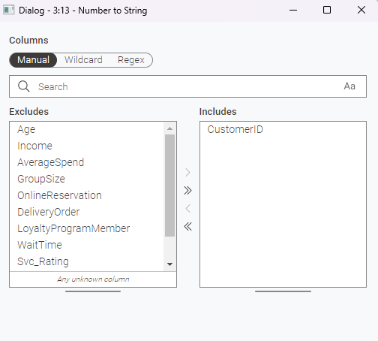

1biv) Handle missing values

Before,
There are missing values for 5 key columns AverageSpend, PreferredCuisine, DiningOccasion, MealType, WaitTime

Screenshot Obtained from Statistics node
downstream from file reader
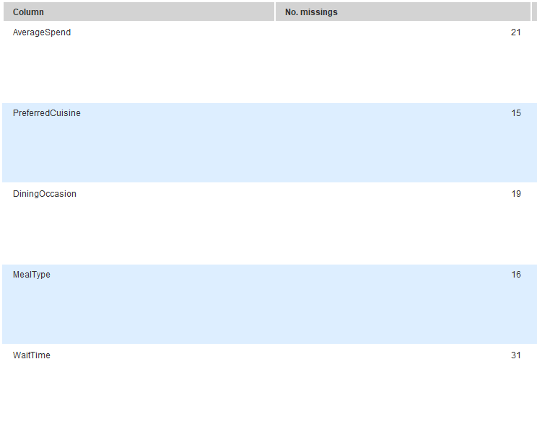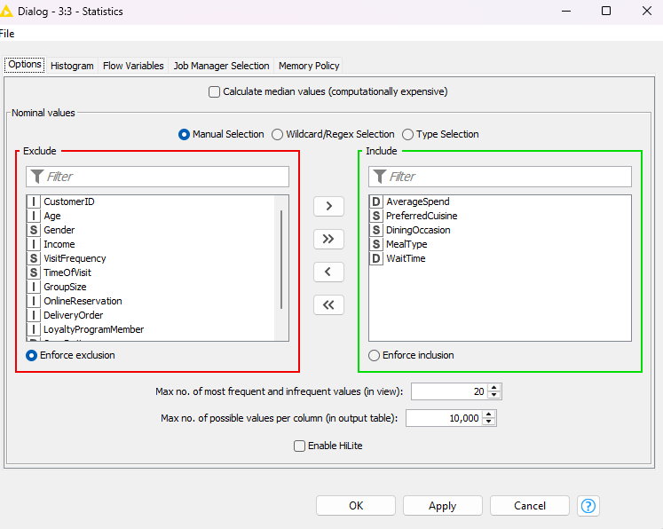

Hence, to fill the missing values a missing value node is used to replace the missing values.

Configuration of Missing Value Node
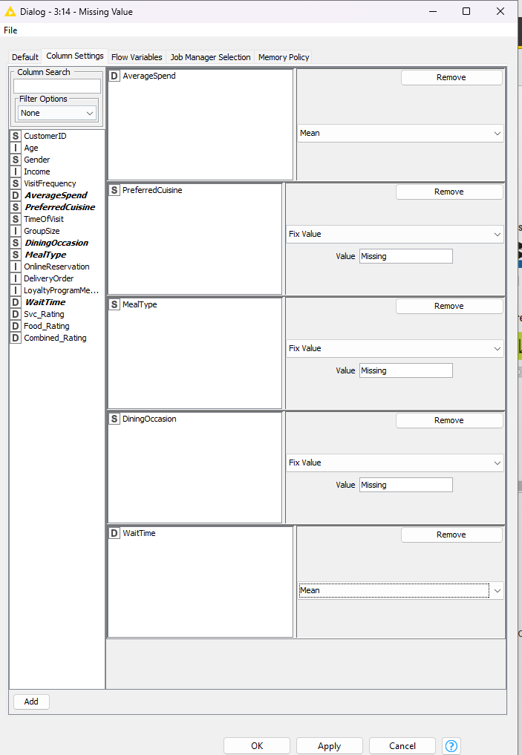

For AverageSpend and WaitTime the missing values are replaced with the mean because it gives a better idea of the middle value. There aren’t extreme values for AverageSpend and WaitTime so the mean would not be skewed, hence, the missing values are replaced with the mean. The boxplots of AverageSpend and WaitTime show roughly normal distribution without major outliers.

Boxplot of Average Spend Boxplot of WaitTime
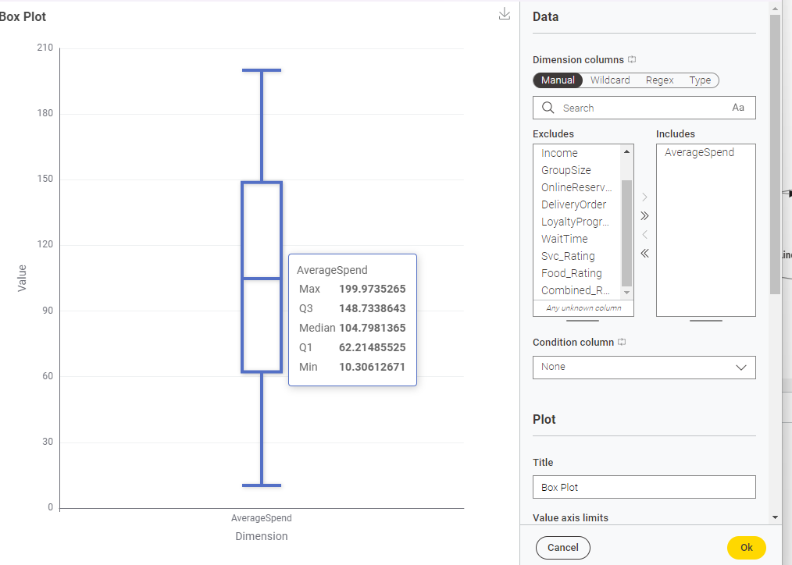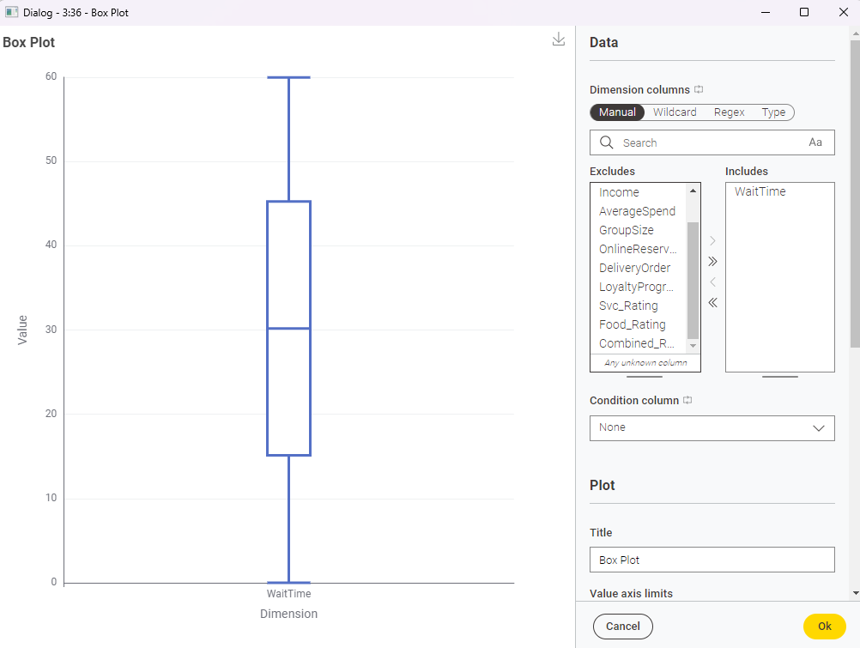

For PreferredCuisine,DiningOccasion,MealType the missing values are replaced with the string “Missing”. The reason I assigned the string “Missing” instead of using the most common category is to avoid skewing the distribution of the existing values. By replacing the missing values with the most frequent category like “Casual”,”Takeaway” and “Itallian”. It would inflate that category’s count which will make the data less accurate or misleading.

After,
(Screenshot obtained from Statistics node downstream from Rule Engine Node)

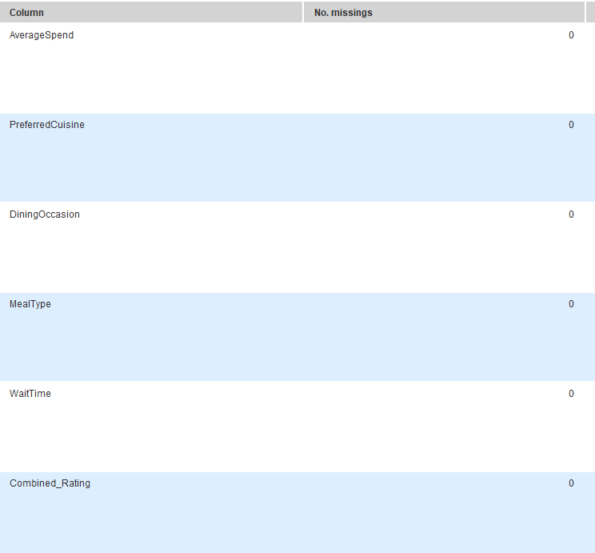

1bv)Remove redundant columns

The columns Svc_Rating and Food_Rating were removed using the Column Filter node. This is because they are now redundant as they have been combined earlier into a single column, Combined_Rating.
Screenshot of Configuration of Column Filter Node
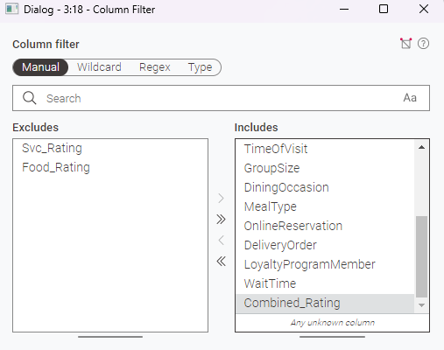

1c. Other possible improvements
There are extremely high values in Income, during data profiling, extreme outliers were detected with values of $12 million and $10 million, which can distort statistics, like affecting the mean value drastically, provide misleading data and significantly skew the data distribution. Hence, I added a Row Filter node to remove the rows with income values greater than $200,000 (which include the income of $10 million and $12 million. This step improves clustering, for example, later on when normalizing the data in preparation for k-means clustering, having the outliers can compress the normalized values of typical income entries closer to 0, this can result in the clustering focusing less on income differences and misgrouping customers. It also improves linear regression by reducing skewness and ensuring the model fits the overall data trend more accurately, leading to more reliable and stable predictions.
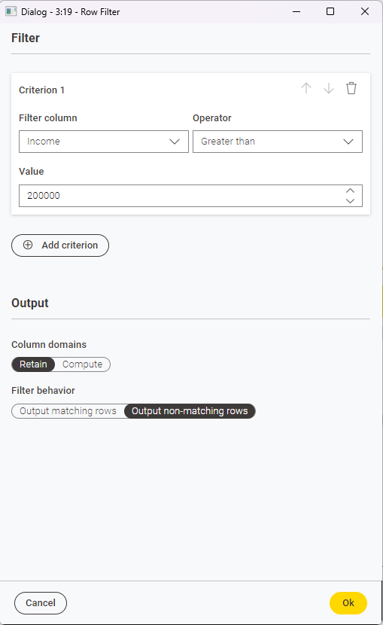
Configuration of the row filter node
Before, (Image obtained from statistics node downstream from file reader)(same as from 1a)
Max is ubserdly high at
12,000,000

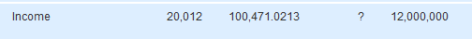

After,(Image obtained from statistics node downstream from math formula node)
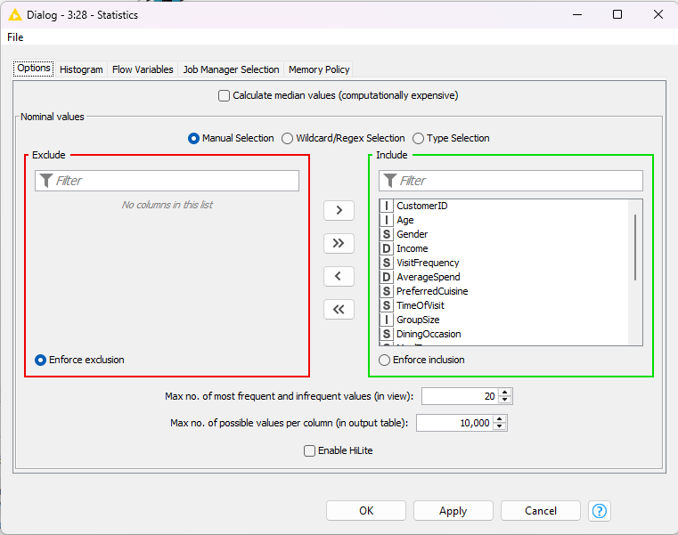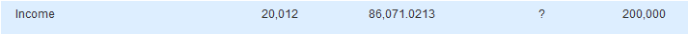
Mean is not as high as it isn’t skewed by the extreme values
Max is a more reasonable 200,000

Next, in the preferred cuisine column there is a value of “Undefined” which does not represent a valid cuisine type and behaves like a missing entry. Therefore, the “Undefined” values were replaced with "Missing" using a Rule Engine node downstream from the missing value node to avoid skewing the distribution and to maintain consistency with how actual missing values were treated. This step improves linear regression by ensuring the categorical data is clean and consistent, which helps the model produce more accurate predictions

Configuration of Rule Engine Node
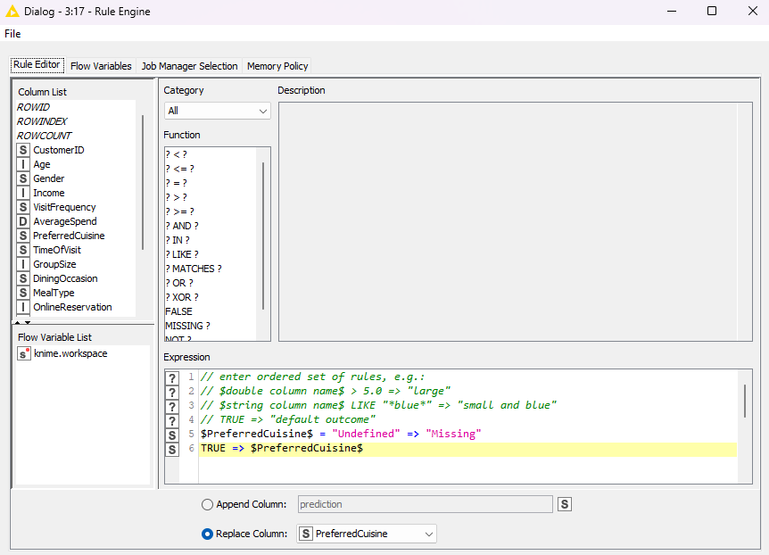

Before,(obtained from statistics node downstream from Missing Value Node)
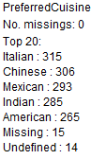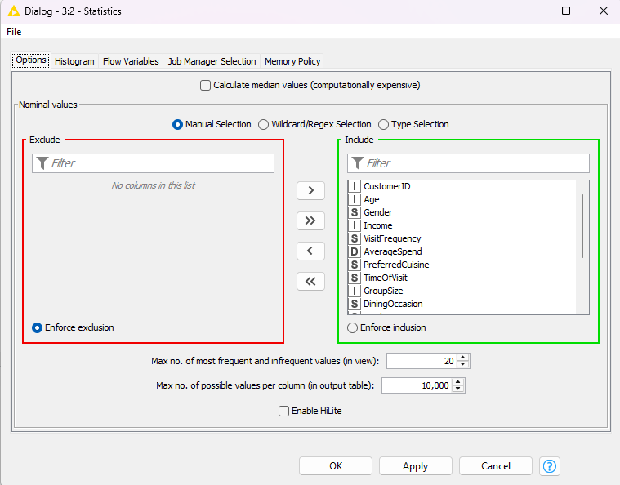
Theres 14 values of “Undefined”

After,(obtained from statistics node downstream from Rule Engine Node)
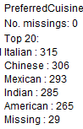
The undefined were converted to “Missing”

Clustering

2a. Steps taken:
First, I used the Normalizer node to scale the values so that no single feature, such as Income or WaitTime, would dominate the clustering process due to its larger numerical range. I excluded OnlineReservation, DeliveryOrder and LoyaltyProgramMember as they are binary values and are only 0 or 1.
Heres the configuration for the normalizer node
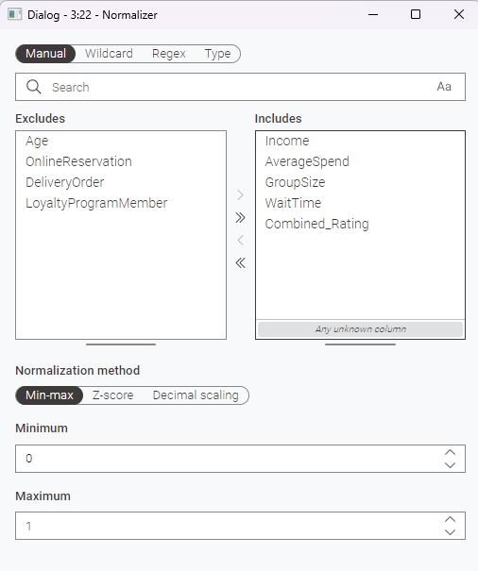
Next I added the K-means node downstream from the normalizer node. The K-means node was configured to have 4 clusters. The Age column was intentionally excluded for later analysis.
Here is the configuration for the K-means node
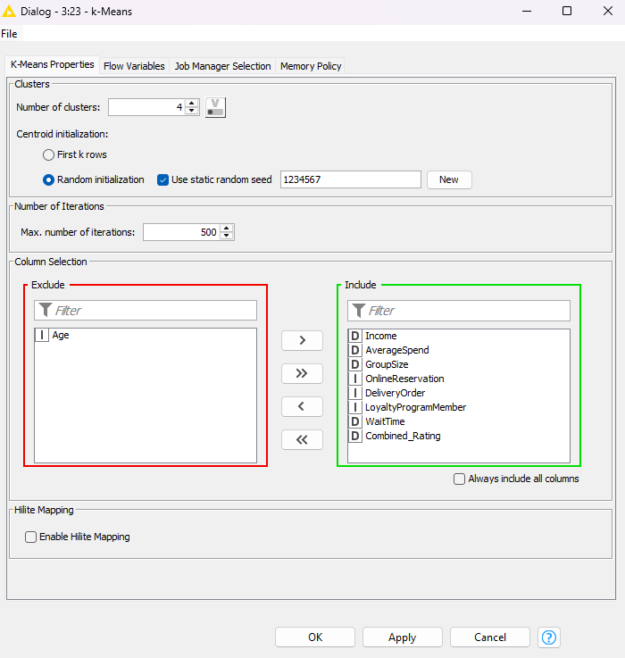
After,This screenshot was obtained from the k-means node
New column for cluster
It shows a new column for clusters
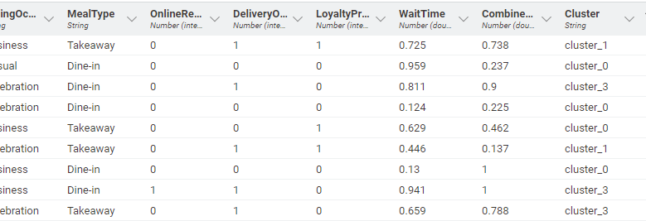
Next I added a denormalizer node downstream from the k-means node in order to restore original values of columns like Income, WaitTime and AverageSpend, which were previously normalized, this allows for meningful interpretation later in Power BI.
Here is the configuration for the Denormalizer node
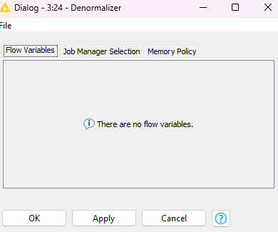
Values are between 0-1
Before,
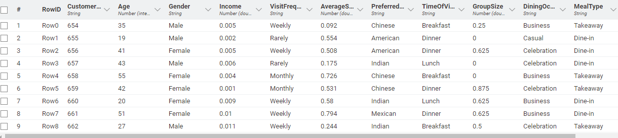
After,
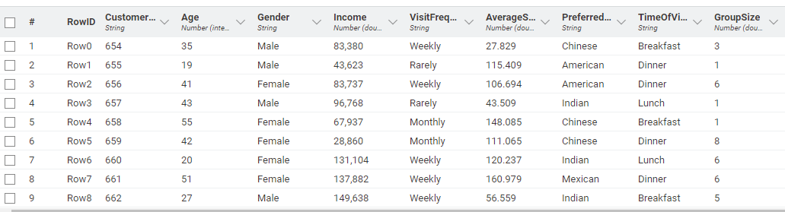
Values are back to normal
2aii) Perform Binning of Age
Before, no column for binned age
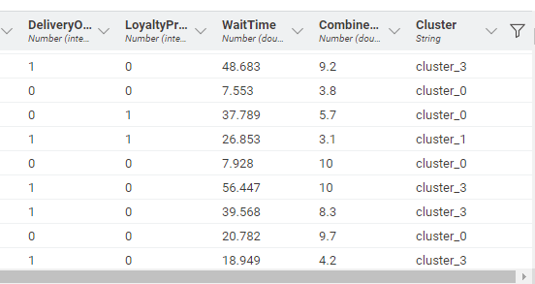
I added a Numeric Binner Node to bin the age column into 4 bins, in this case for teenager the age range -∞ to 20 acts the same as 18-20 as the minimum value for age of customer is 18, this can be found in the file reader node and sorting by ascending age.
(screenshot obtained from File reader node)
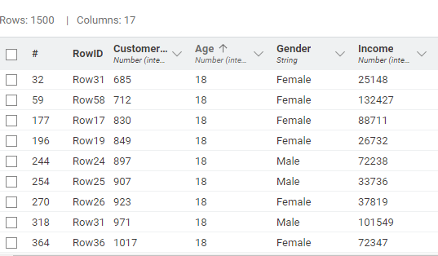
Lowest value for age is 18
Here is the configuration for the Numeric Binner Node
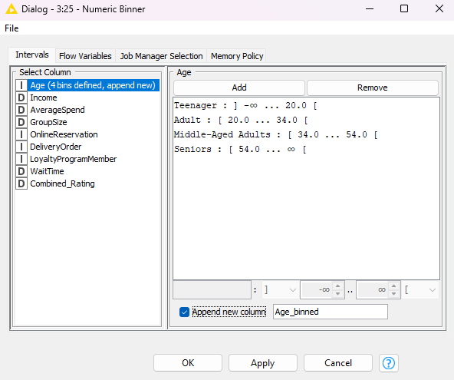

After,
using the Numeric Binner there is a new column to show the age group.
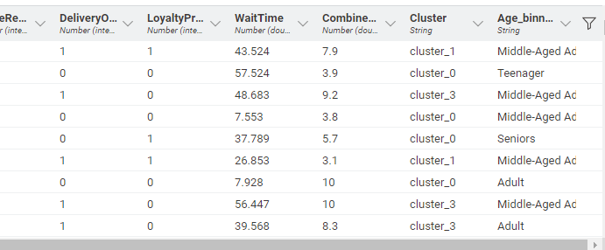
New column, Age_binned which should the binned age i.e. shows the age group.
2aiii) Use Power BI to determine if there’s high correspondence between clusters and Age.
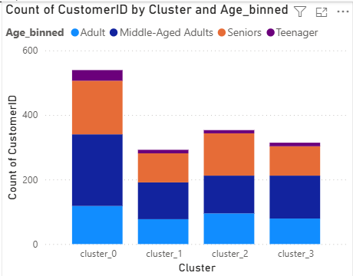
A stacked column chart was created in Power BI to analyze the correspondence between clusters and age groups. As shown in the charts, all the clusters contain a mix of age groups, and no cluster is exclusively or uniquely dominated by a specific age group. Even though the counts differ with some clusters having higher total counts, the proportions of age groups are similar across all the clusters. In Cluster 0 there’s a much higher number of customers. However, the proportions are relatively similar compared to the other clusters. This shows that age was not a major factor in the clustering process, and that there is a low degree of correspondence between clusters and age group. If there had been a high correspondence between clusters and age group, each age group would have been concentrated primarily in a specific cluster. However, the chart shows the opposite the age groups are spread relatively in even proportions across all the clusters. Thus, this stacked column chart shows there is a low degree of correspondence between clusters and age groups.
2b. Findings / Explanation from Power BI:
2bi) Writing Brief note about each cluster
Visualisations for Cluster 0
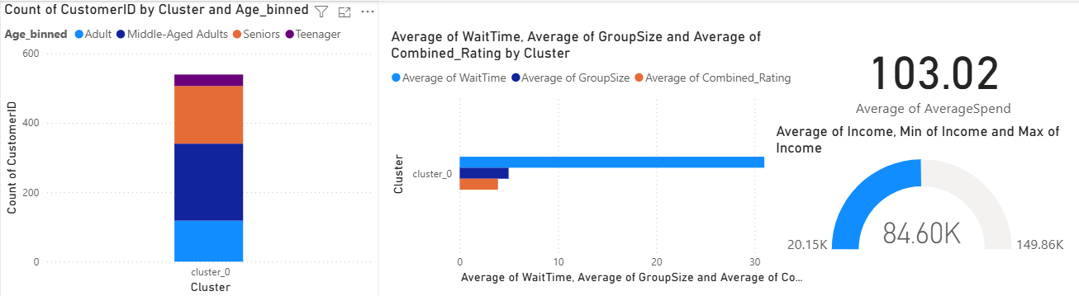
Cluster 0: All age groups are present, mostly middle-aged adults and seniors. Average income is $84.60K. Average spend is $103.02. Average wait time is 30.99 minutes. Average group size is 4.97, and average combined rating is 3.89.
Visualisations for Cluster 1
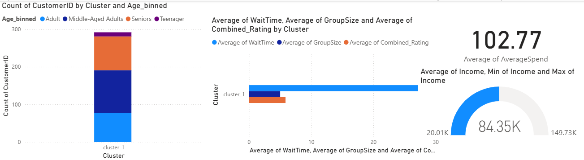
Cluster 1: All age groups are present, mostly middle-aged adults and seniors. Average income is $84.35K. Average spend is $102.77. Average wait time is 28.58 minutes. Average group size is 5.02, and average combined rating is 5.88.
Visualisations for Cluster 2
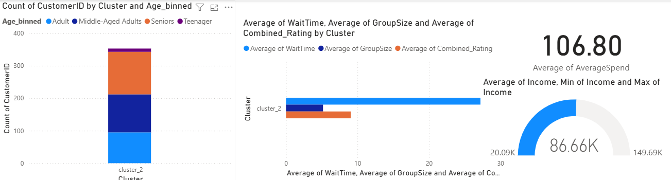
Cluster 2: All age groups are present, mostly middle-aged adults and seniors. Average income is $86.66K. Average spend is $106.80. Average wait time is 29.22 minutes. Average group size is 5.18, and average combined rating is 9.05.
Visualisation for Cluster 3
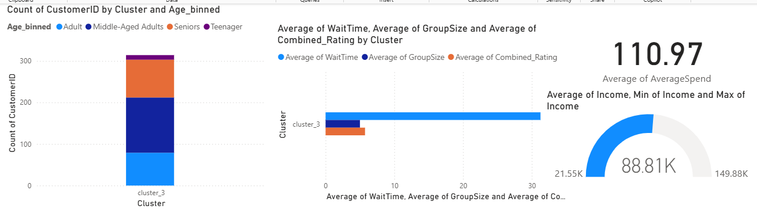
Cluster 3: All age groups are present, mostly middle-aged adults and seniors. Average income is $88.81K. Average spend is $110.97. Average wait time is 31.26 minutes. Average group size is 5.00, and average combined rating is 5.74.
2bii) Produce additional charts to make profiling more insightful
To make profiling more insightful, a pie chart was added to observe the percentage of customers who had their orders delivered and those who did not. I also added a donut chart in order to show the distribution of customers based on whether or not they have the Loyalty Program membership. These new charts can help to identify patterns across clusters, like the delivery preferences and loyalty program participation. This can improve the ability to compare clusters later on.
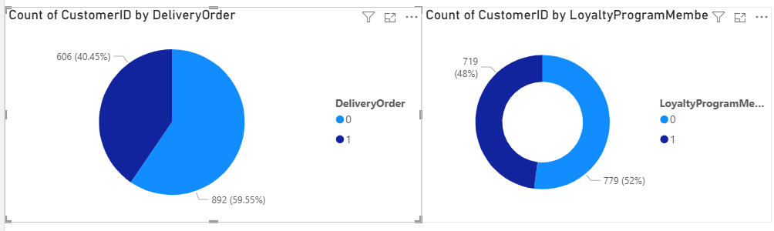

2biii)
All of the four clusters show a mix of age groups in similar proportions, but are mostly made up of middle-aged adults as well as seniors. However, their behavioural and spending patterns vary.
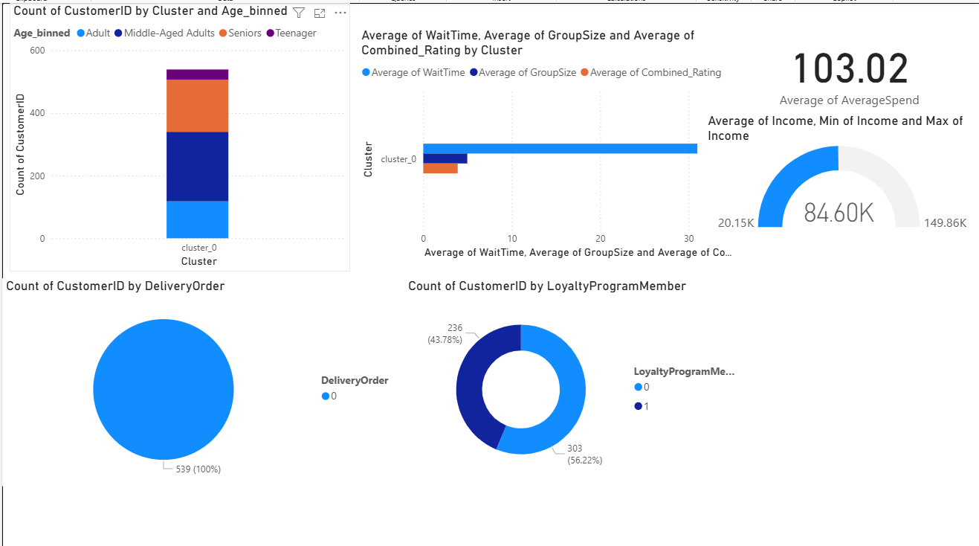
Cluster 0 consists solely of customers who did not have their food delivered as shown in the pie chart with 100% of customers who had the value 0(which represents no) for delivery order. Customers from Cluster 0 also have the lowest combined rating at only 3.89 as well as the lowest average group size at 4.97. Customers from Cluster 0 also have a relatively low average income at $84.60K compared to the other clusters. Customers from Cluster 0 also mostly consist of customers who aren’t loyalty program members with 56% of customers being a loyalty program member .This cluster represents the customers who prefer not getting their food delivered, like eating food with a smaller group but being dissatisfied with the restaurant.
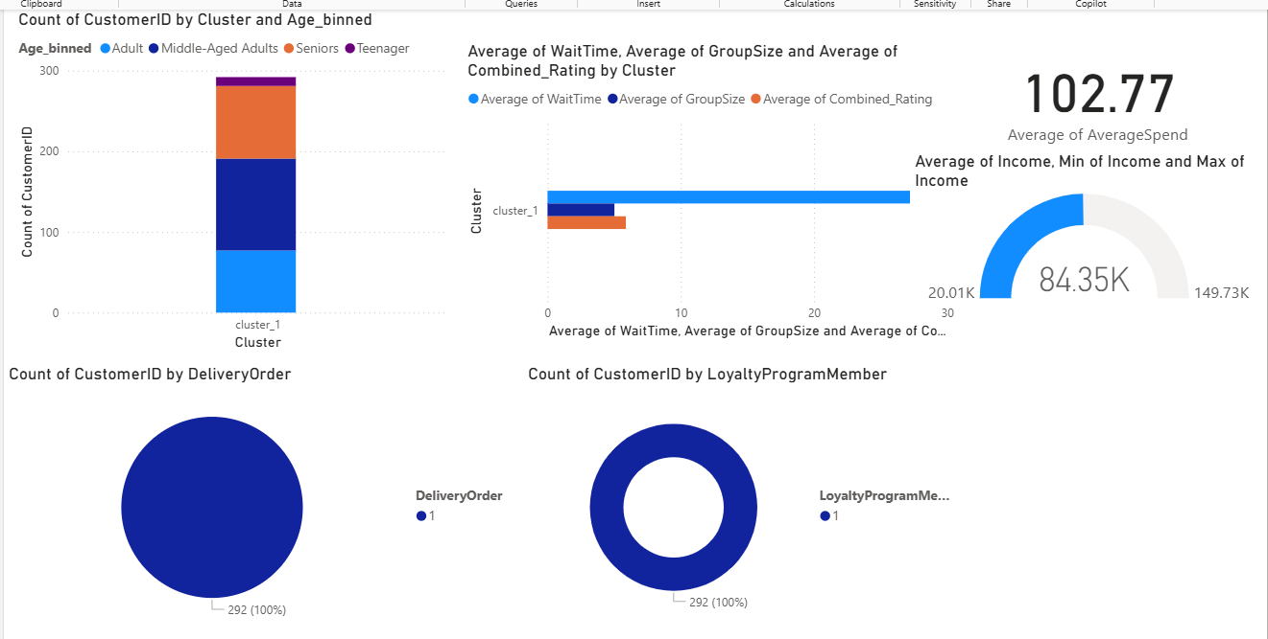
On the contrary, Cluster 1 consists solely of customers who have their food delivered. They also have an moderate combined rating of 5.88 when compared to other clusters . However, spend the lowest amount with an average spend of only $102.77 and have the lowest wait time at only 28.58 minutes. They also have the lowest average income at $84.35k. While their average group size is slightly larger than cluster 0 at 5.02, customers in cluster 1 still have a relatively small group size. All the customers in cluster 1 are also a loyalty program member. This cluster represents customers who are a loyalty program member, prefer having their food delivered but are less wealthy.
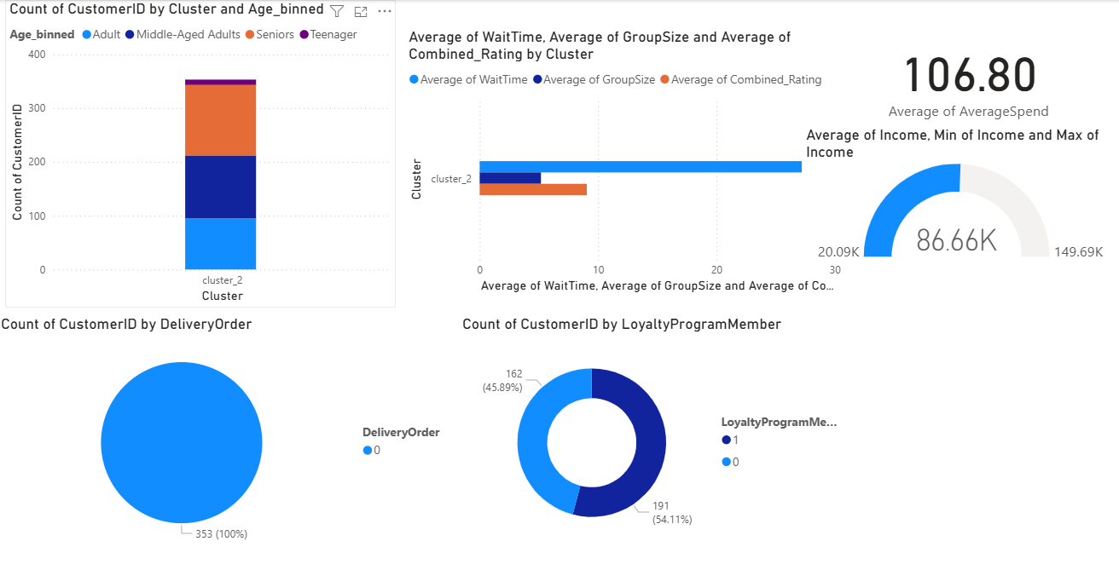
Cluster 2 ,similar to cluster 0 consist solely of customers who don’t have their food delivered.They also have the highest average group size at 5.18 . They also have a relatively high average income of $86.66K. They also have a relatively higher average spend at $106.80. Furthermore, they have the highest combined rating at 9.05. They also have more loyalty program members than non-loyalty program members with 54.11% of customers being a loyalty program member. This group represents the customers who prefer not having their food delivered, prefer eating with a larger group and being very satisfied with the restaurant.
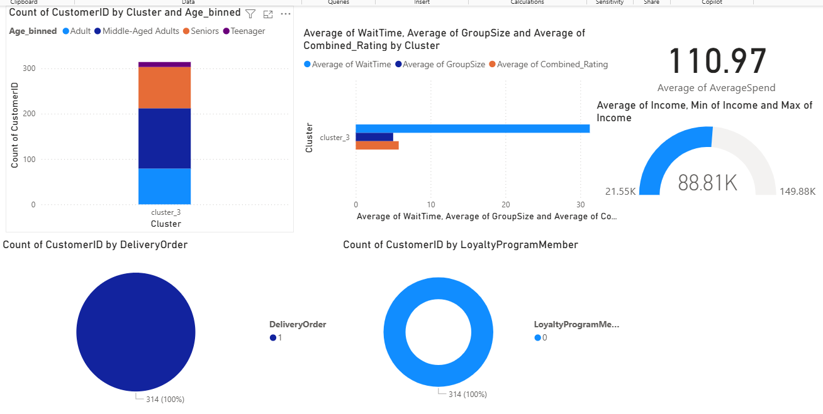
Cluster 3 similar to Cluster 1 consists solely of customers who have their orders delivered. Cluster 3 has the highest average income at $88.81K and highest average spend at $110.97. Despite not being the lowest this cluster has a relatively small average group size at 5.00. They also have a smaller combined rating at 5.74. However, none of the customers in this cluster are a loyalty program member. Furthermore, they have the highest average wait time at 31.26 minutes. This group represents the wealthy customers who spend more money but still have a relatively low combined rating and prefer having their orders delivered. This group also on average have to wait a longer time for their food
In summary Clusters 0 and 2 consist entirely of non-delivery customers, while Clusters 1 and 3 consist solely of customers who have their order delivered. Cluster 3 stands out for having the highest income and spending but still a relatively low combined rating. In contrast, Cluster 2 has the highest satisfaction score, largest group size and a relatively high average spend. Cluster 1 stands out for having customers with lowest average income and amount spent but still having a moderate combined rating. Meanwhile Cluster 0 stands out for having the lowest combined rating and group size.

Linear Regression

3a. Steps taken:
Q3ai)
First, I converted some of the data columns which are strings into numeric data types. I did this using the category to number node, I converted all string columns into number data types except for customer_id. This is because linear regression in knime only works with numeric data types. I excluded customer_id as it is an identifier and does not carry any meaningful predictive information.
Configuration of category to number node
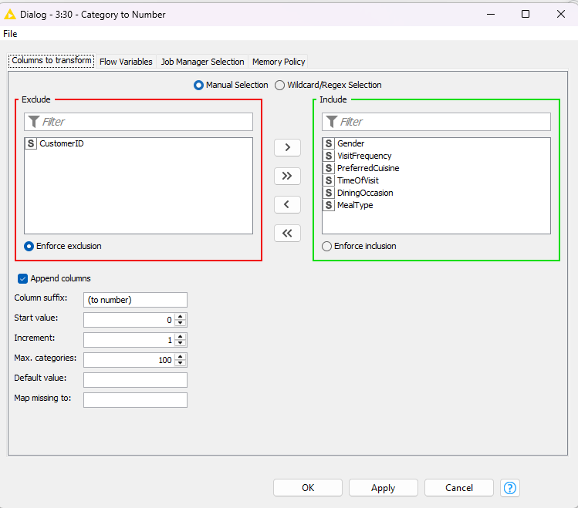
Before, After,
(screenshots obtained from category to number node)
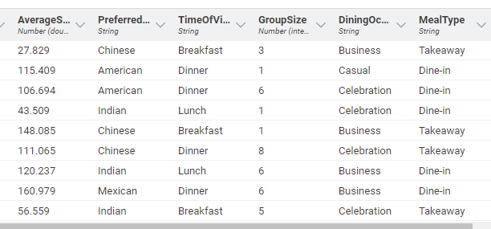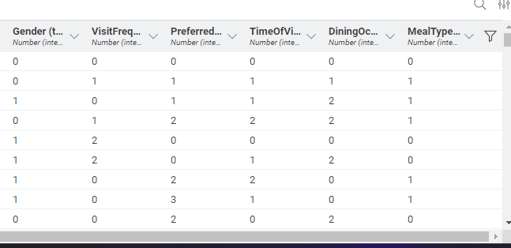
Next, I partitioned the dataset using the Partitioning node. I split the data into 70% and 30%, 70 %for training and 30 % for testing. This is done to see how well the linear regression model later performs on unseen data. Splitting the data ensures the model’s performance is tested more reliably.
Here is the configuration for the Partitioning node
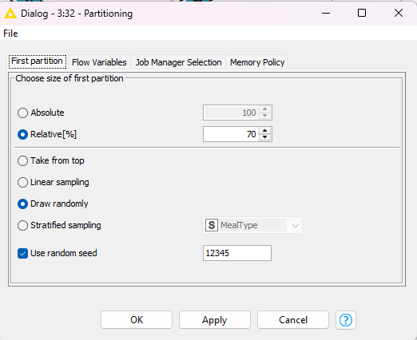
Before, After,(screenshot obtained from (screenshot obtained from overview table overview table from partitioning node) in the category to number node)
Rows split up between 2 partitions in the ratio of 70:30
Contains all the rows
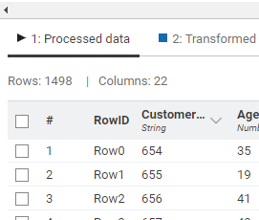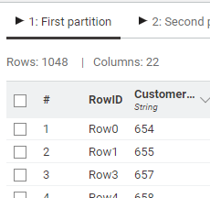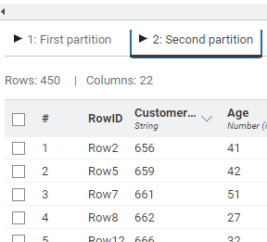
Next, I added a Linear Regression Learner node downstream from the first partition(70 percent partittion), and included all numeric values except customer_id as it is an identifier and does not carry any meaningful predictive information, and also set combined rating as the target. This will train the model to learn the relationship between the numeric features and Combined_Rating, allowing it to predict satisfaction levels based on the given inputs.
This is the configuration for the Linear Regression learner node
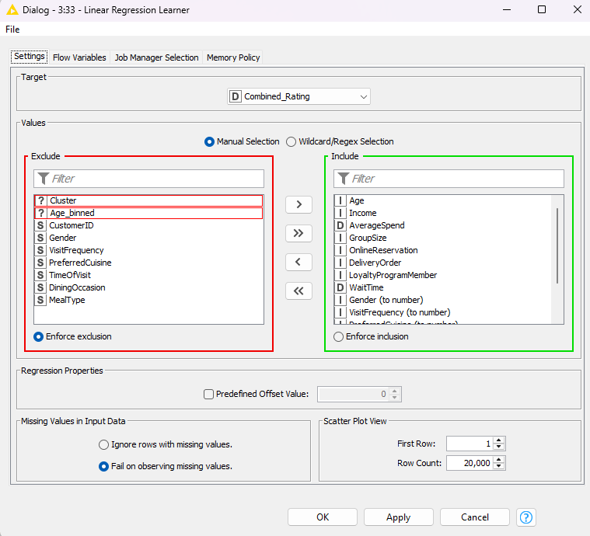
Next, after executing the Linear Regression learner node , I looked at the output table under coefficients and statistics, then I looked at the P>t values, this is because the values in this column which have a low p value (<0.05) is likely to be a meaningful addition to the regression model because changes in the predictor’s value are related to changes in the target variable. In this table it shows AverageSpend,WaitTime,VisitFrequency and DiningOccasion to have a P value of less than 0.05. Hence this indicates that these values are deemed to be important predictors for combined rating. (ignore the p value for intercept as it is not a predictor but is a necessary part of the model)
The output table for the Linear Regression Learner:
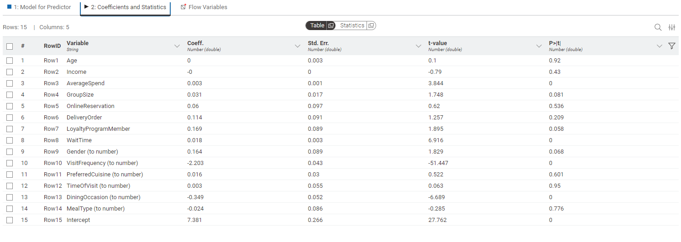
The P values for these rows are less than 0.05
Next, I re-configured the Linear Regression Learner node to only use AverageSpend, WaitTime, VisitFrequency, and DiningOccasion as the inputs (independent variables). These variables were chosen because their p values were below 0.05 in the initial model, showing that they are statistically significant predictors for Combined_Rating. By narrowing down onto these important predictors, the model is expected to offer more reliable and interpretable results.
New configuration for Linear Regression Learner node,
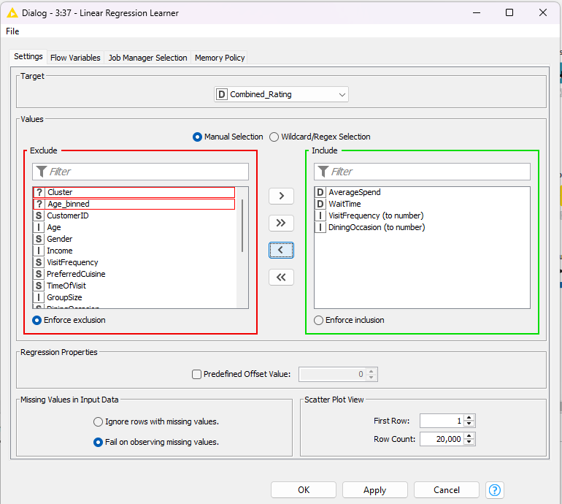
Next I observed the output table under Coefficients and Statistics for the Linear Regression Learner, it shows that the P values remain at 0 showing that AverageSpend, WaitTime, VisitFrequency, and DiningOccasion are indeed the important features that can determine the predicted values for Combined_Rating.
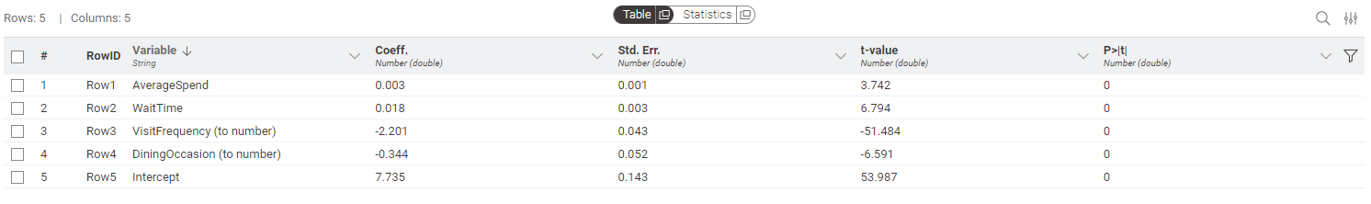
Using the values from the table above I can also formulate the regression equation, a regression equation is a formula that models the relationship between a dependent variable( (the target), combined_rating and the independent variables ( (the inputs), AverageSpend, WaitTime, VisitFrequency, and DiningOccasion). To formulate this equation I used the formula (ŷ = m1 x1 + m2 x2 + … + c), hence the equation is
Predicted Combined Rating = 7.735-0.344*(DiningOccasion(to number))-2.201*(VisitFrequency(to number))+0.018*(WaitTime)+0.003*(AverageSpend)
3b. Findings / Explanation from Power BI:
In order to determine accuracy of the regression model, I first added a regression predictor node, this node allows me to make use of the regression model produced by the Linear Regression Learner node and carry out prediction based on input data. I first tested it with the training data by adding it downstream from the first partition(same partition that the model was trained with)The configuration for the regression predictor was left as default after that I added a numeric scorer downstream from the regression predictor , which provides a summary of the quality of the regression model.
This is the configuration for the Numeric Scorer
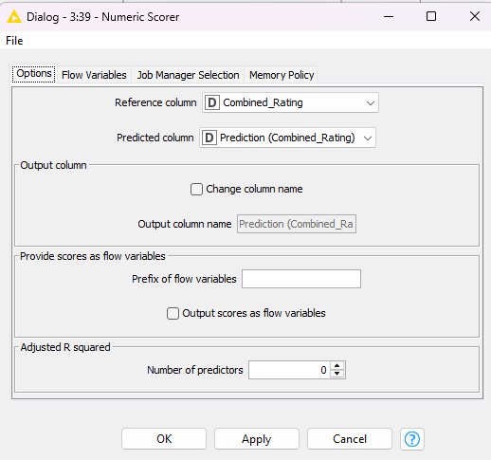
Data from Numeric scorer (obtained from output table of numeric scorer):
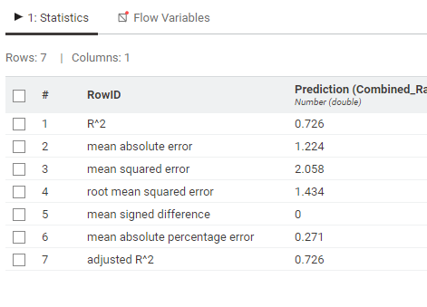
The data from the numeric scorer shows that the R^2 value is 0.726 and this means that the model is relatively accurate (the closer the value is to 1 the better the model) hence it shows that the regression model is relatively accurate. The root mean square error is 1.434, considering that the range of combined rating is 2-10 with a mean of 5.887. This shows that the predictions have a reasonable deviation from the actual combined ratings. Hence the model is relatively accurate.

Next I added another regression predictor node and numeric scorer. However for this regression predictor node the input data is the testing partition. The configuration for the regression predictor is the default.
Configuration of Numeric Scorer
Data from numeric scorer (obtained from output table of numeric scorer):
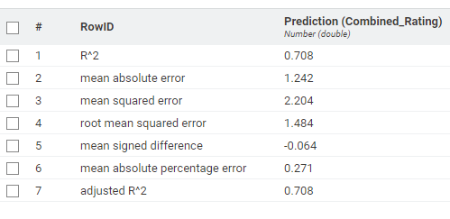
The value of R^2 is slightly lower for the testing partition compared to the training partition, which indicates that the model still fits the data in the testing set reasonably well, although with slightly reduced explanatory power. A slight drop is expected and given that the drop is not very big it suggests that the model generalizes well to unseen data. Additionally, the Root Mean Square Error only increased slightly to 1.484 in the testing set, reinforcing that the predictions remain close to the actual values. The minimal change in both R^2 and root mean square error suggests that the model is not overfitting the training data and maintains consistent performance on new data, which is a desirable outcome in predictive modelling. This therefore further supports that the regressive model is relatively accurate.
Hence, by testing the model with both the training data and testing data helps to determine that the regressive model is indeed accurate.
Next I added another Regression Predictor node (the configuration is left as default), this time it uses the entire dataset, this is done by making it downstream from the category to number node instead of the partitioning node. I then added a CSV Writer node downstream from this third Regression Predictor node and configured it to include Row ID and Column header.
Here is the configuration for the CSV writer:
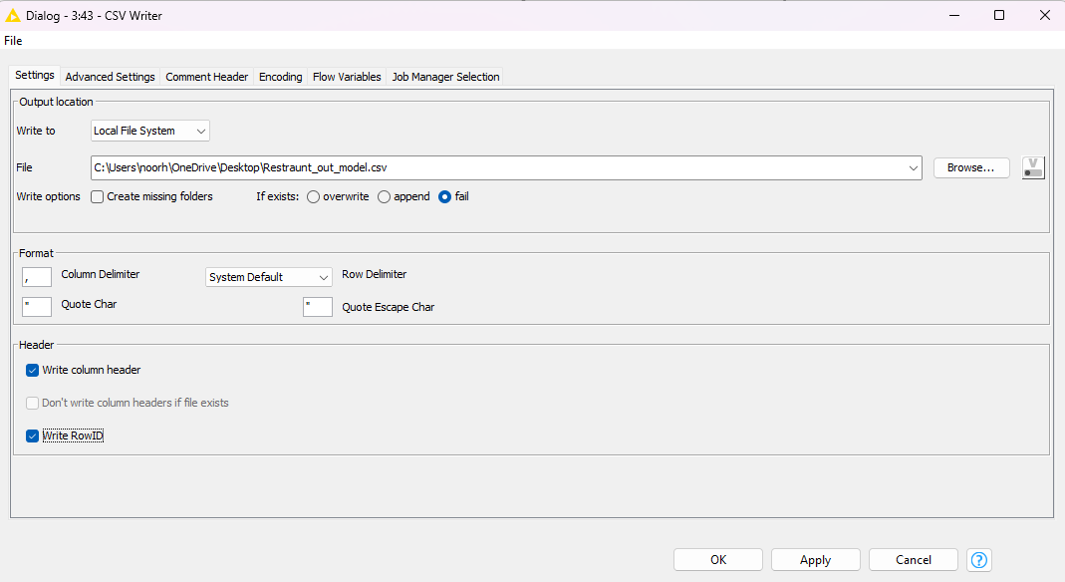
I then used imported this CSV file into power BI, I then created a new column for Residual in power bi. The residual is the difference between observed value of the dependent variable (combined rating) and the predicted value.
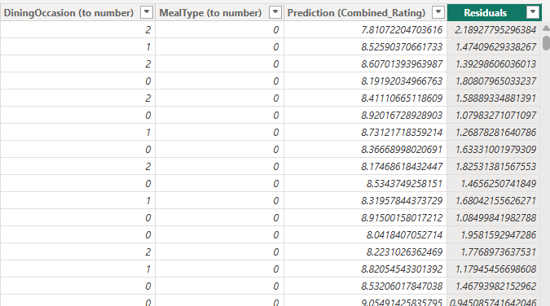
New column for residuals
I Then created 2 scatter charts , the first is for predicted combined rating against actual combined rating and the 2nd is predicted combined rating against residuals.
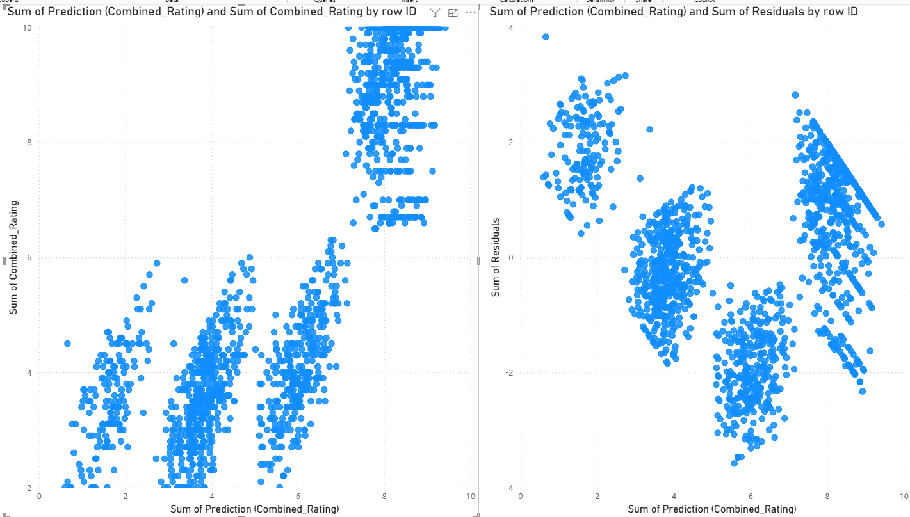
For the first chart, the Predicted vs Actual graph, a ideal model would predict the price with 100% accuracy and means that the predicted and combined ratings would be the same. This would be represented with the model forming a perfect diagonal line in the graph. While a lot of the points on the graph are falling on this diagonal line, there are still a lot of points not on the line. There are 4 distinct clusters indicating that the model might have produced repeated or rounded predicted values. This shows that while the model does make some accurate predictions there are still some predictions which are off, this shows that the model is moderately accurate.
For the right scatter plot, which displays the residuals against Combined Rating. Ideally the residuals should be randomly scattered around 0. However, in this case while a lot of the residuals are relatively close to the horizontal axis there are still many residuals away from 0. Furthermore, there are visible patterns/groupings. This indicates that some of the variance is not explained or taken into account in the model. However, relatively the spread of residuals is moderately small supporting that the model performs reasonably well and doesn’t suffer from severe prediction errors or bias. This shows that the model is moderately accurate.

Screenshot of my overall KNIME workflow is shown below.
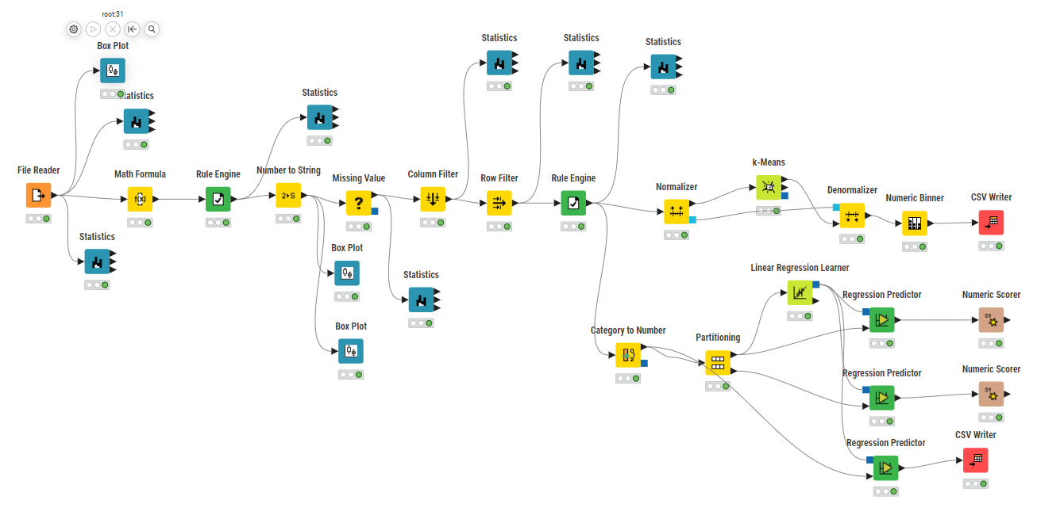
SUBMISSION INSTRUCTIONS

- Save this file as “DA_Assignment_[Your Class]_[Your Full Name]_[Your Student ID]”,
e.g. “DA_Assignment _P01_ALBERT EINSTEIN_XXXXXXXX”.
- Export your KNIME workflow [In KNIME, select File -> Export KNIME Workflow - > Enter the destination file path and name -> Finish]
- Submit your report, together with your KNIME (.knwf) and Power BI (.pbix) files, to DAVA LMS site > Assessment > DA Assignment > Look for the appropriate link to submit your work.

***** END OF DA ASSIGNMENT *****

