

School of Informatics & IT

Database Application Development (45%)
Application Development Project (35%)
(Web Application Design + Database Design)
AY 25/26 Oct Semester
Project 1 Report

Contents
Declaration of Originality 3
DBAV: Database Design (45%) 6
Section A: Website Proposal (5%) 6
Section B: Interview Findings (5%) 7
Section C: Entities (5%) 8
Section D: Data Dictionary (10%) 9
Section E: ERD and Relationships (10%) 10
Section F: Normalisation (10%) 11
ADEV: Web Application Design (30%) 12
Section G: Implementation, Design & Layout (15+5%) 12
Section H: Justification (10%) 13

SCHOOL OF INFORMATICS & IT

Diploma in Information Technology

Project 1 Report

Student Name (Matric Number) : Mohammed Hannan Noor(XXXXXXXX)

Tutorial Group : PC23
Jenny LING (TP)
Tutor : Alfred Teng

Submission Date : 6/12/2025

Declaration of Originality

I am the originator of this work and I have appropriately acknowledged all other original sources used as my references for this work.

I understand that Plagiarism is the act of taking and using the whole or any part of another person’s work, including work generated by AI, and presenting it as my own.

I understand that Plagiarism is an academic offence
and if I am found to have committed or abetted the offence of plagiarism in relation to this submitted work, disciplinary action will be enforced.

Declaration on the use of Generative AI tools for assignments

Describe how you have used Generative AI tools such as ChatGPT or Dall.E- in your assignment.

Share the link to the conversations you had with the AI tool (i.e., the prompts you used and the responses you get from the AI tool).

Please refer to this PDF on “How to share the conversations made with ChatGPT?”

I used ChatGPT in order to learn certain HTML and CSS elements as well as troubleshoot certain bugs. I did not copy from ChatGPT but just learned how to use certain elements such as <form> and in CSS display:flex.

https://chatgpt.com/share/69343f05-e194-800e-95af-f49418b3dd79

How do you indicate the reference?
The content generated by AI tools are not retrievable except by the user who generated them, so they are considered non-recoverable sources. Although non-recoverable data or quotations in APA Style papers are usually cited as personal communications, with ChatGPT-generated text there is no person communicating. Quoting text from ChatGPT chat is therefore more like sharing the output of an algorithm, with a reference list entry and the corresponding in-text citation.
According to the official APA Style site, ChatGPT references should be cited as:
E.g. OpenAI. (2024). ChatGPT (Feb 13 version) [Large language model].
https://chat.openai.com/chat

Note: The information in parentheses refers to the update or revision date of the model used. Refer to the release notes in the ChatGPT application.

Important Note:

- Do not copy answers produced by the AI tool in totality as it is considered as plagiarism.

- Do not rely on any information produced by the AI tool blindly. You should always verify the answer with other sources. Do not assume that these answers provided by the AI tool are correct.

- To achieve quality outputs from the AI tool, you should provide good prompt that is clear and specific. Be precise and provide context. Avoid asking open-ended questions.

DBAV Part 1: Database Design (45%)

Section A: Website Proposal (5%)
Ensure that your website proposal covers the following points:

Proposed online website idea | Proposed Website would be called ByteBite  The proposed website ByteBite, is a online food-ordering platform designed specifically for Flavours, the canteen located within Temasek Polytechnic’s School of Informatics and IT. ByteBite will allow students and staff to easily browse food options from all the stalls in Flavours and place orders for self collection, while also enabling stall owners to manage the orders via their own interface/webpage.  Main features of ByteBite will include:  - Menu viewing system which will display available dishes from all the stalls, along with details like name, descriptions and prices.  - An order placement feature where users can choose dishes they want to purchase, view the total cost and then place the order.  - An Order tracking feature that allows users to check the status of their order and notifying them when it is ready for collection.  These features will make ByteBite a convenient platform that simplifies meal ordering for both vendors and customers.
Purpose | The main purpose of ByteBite is to simplify the way food can be ordered at Flavours and eliminate the time wasted queueing up for food by allowing users to place orders digitally instead of in person. In doing so, ByteBite promotes a more organised and time-efficient way to order food for customers.  By making the process online on a website, ByteBite will reduce congestion in the already packed Flavours canteen as well as the time customers have to wait for food. Furthermore, for vendors it reduces the manpower needed, and vendors focus on actually making the food instead of time wasted taking orders.
How it will enhance the experience of the IIT students | With ByteBite made available for IIT students, students will no longer have to waste time standing in long queues or waiting for their food to be prepared after ordering. This can especially save students time during lunchtime when almost every student is rushing to purchase food. Instead of having to race to the canteen to be the first to place their order, students can simply place their orders a few minutes before their class ends and collect it as soon as their lunch break begins.  Furthermore, this website will also make things clearer and easier for students by providing an online list of all the stalls and the dishes they serve which makes it easier for students to choose what to eat. This eliminates the need to walk around the canteen comparing options, saving both time and effort.  Overall, ByteBite makes ordering easier and faster, which reduces stress during busy times and gives students more time to relax or get ready for their next class.
The need and demand for such an online website | The Need:  The Flavours canteen in the School of Informatics and IT is one of the busiest areas in Temasek Polytechnic, especially during lunchtime when large crowds of students arrive at the same time. This is made even worse as there aren’t many nearby alternatives to Flavours. This often leads to long queues, crowded walkways and limited seating space. Many students with short breaks end up spending most of their time queueing and waiting for their food rather than eating. In addition, the menus for these stalls can be difficult to read at a distance, and customers often find out that the dish they want to order is actually sold out once they get their turn in line. These recurring issues show an increasing need for a more efficient ordering system which ByteBite provides.  The Demand:  I conducted a survey with 25 Temasek poly students eating at Flavours, asking if they would order food at Flavours online through a website if given the option. These are the results:  The results show that almost 64% of students would use a online ordering system with 16% of students “maybe” using the online ordering system. This proves that there is strong interest and high demand for a faster more efficient ordering system at Flavours. With most respondents open to or in favour of using an online system, it suggests that implementing a platform like ByteBite would be well received by the IIT community.  Furthermore, an article published by Hashmoto on November 2025 states “Off-premise dining, which includes takeout, curbside pickup, and delivery—has firmly established itself as the backbone of the restaurant industry. More than 60% of total restaurant sales now come from these channels.” This further proves that people increasingly prefer online ordering systems which eliminate wating and improve efficiency. It’s also quite evident that Temasek Polytechnic students will also appreciate having a similar option at Flavours. A website like ByteBite would meet this demand by giving students an easier and faster way to get their meals without the usual wait.  Sources used: https://hashmato.com/online-mobile-food-ordering-statistics-and-revenue-in-2025/

Section B: Interview Findings (5%)
Interview 5 (FIVE) IIT students to identify what kind of features they would want in the online website.

Student name & email | Desired feature
Ian Khoo Rei Jinn  XXXXXXXX@student.tp.edu.sg | An order history page showing previous orders for easy reordering.
Mohamed Anis Bin Mohamad Suhaimi  XXXXXXXX@student.tp.edu.sg | Display estimated waiting time for each order making it easier to decide which stall to buy from.
Leon Jr Chua  XXXXXXXX@student.tp.edu.sg | Ability to filter stalls by cuisine, food type, halal-certification, so users can quickly find what they want.
Molina Adiel Vince Espiritu  XXXXXXXX@student.tp.edu.sg | Real time messaging feature for users to contact stall vendors directly about special requests or changes.
Duke Lucas Ho Shu Huang  XXXXXXXX@student.tp.edu.sg | Show stall operating hours to provide clarity and know which stalls will be open.

Evidence of collection of responses: 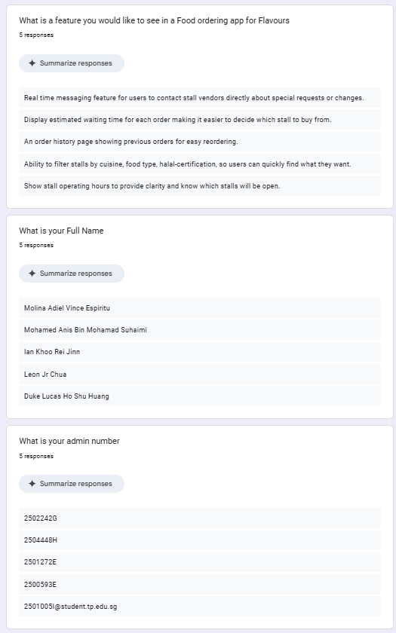

Provide an insightful summary on the interview findings, listing all the features you would like to include in your proposed website:
After considering all suggestions, three features were chosen for the final design, stall filtering, estimated waiting time and order history as they are the most relevant and practical for this project. The other two features, Real-Time Messaging and Stall Operating hours were discarded as they were impractical and would create more problems than benefit provided. The stall filtering feature was implemented as it would help students decide what to eat faster by categorising stalls according to cuisine or food type, which makes browsing more convenient and can be implement easily. The estimated waiting time feature was selected as it improves convenience and makes time management easier. By showing the approximate preparation time for each stall students can plan their breaks better and avoid long waits. The order history feature was also added for its usefulness, and reduces the time taken to reorder the same meal and especially benefits frequent users.

Features which will be implemented:

- Order History Page
The Order History feature would give students a record of their past orders. This would allow users to conveniently reorder past meals without having to search for them again, saving time for frequent buyers.

- Estimated Waiting Time
The Estimated Waiting Time feature would show an approximate preparation time for each stall, helping users decide which stall to order from. Students can compare the waiting time for different stalls before ordering, which would benefit students by reducing the uncertainty of time before their order is ready.

- Stall Filtering
The stall filtering feature would categorise stalls by food type or cuisine , such as noodles, Italian Food, halal food. This will make it easy for users to locate what they want instead of browsing through every stall manually. This simplifies decision making and makes the ordering process quicker which is particularly useful during lunch rush when queues are long.

Features which will not be implemented:

- Real-Time Messaging
The Real-Time Messaging feature was found to be impractical for this project. While it could improve the communication between the vendor and customer, it would constantly require staff to monitor messages while also preparing food, which is especially unrealistic during busy hours. Furthermore, this feature could bring up other issues such as delayed responses, misuse and message management. As a result it would create more problems than benefits, thus it will not be implemented.

- Stall Operating hours
The stall operating hours also presents challenges. Stall schedules can differ daily depending on the vendor, school events, or term breaks, making it difficult to keep the information accurate. Requiring owners to manually update their opening and closing hours daily would add unnecessary effort and could lead to outdated or incorrect information. Thus this feature will not be implemented

Updated Features of ByteBite

- Menu Viewing system which will display available dishes from all the stalls, along with details like name, descriptions and prices.

- An Order Placement feature where users can choose dishes they want to purchase, view the total cost and then place the order.

- An Order Tracking feature that allows users to check the status of their order and notifying them when it is ready for collection.

- Estimated Waiting Time display which shows how long each stall typically takes to prepare an order.

- Stall Filtering system that categorises stalls based on cuisine or food type.

- Order History page that records user’s past orders allowing them to quickly reorder previous meals.

Section C: Entities (5%)
Identify 4 (FOUR) to 6 (SIX) entities that will be required. The entities identified must meet all the requirements of the website proposed in Section A/B and have a clear purpose.
Entities | Reasoning for including it
User | Stores details of students or staff using ByteBite to place orders. This entity is essential as its needed to identify who placed each order and to allow for features like order history.
Stall | Represents each food stall at Flavours. It contains information like stall name, cuisine type, status(open/closed) and if the stall has halal certification. This feature is needed for showing which stall an order belongs to and to support features like stall filtering.
Menu_Item | Contains information about the dish sold by each stall, such as name, description, price and category. This allows for the menu viewing system and allows for features like filtering.
Order | Records each order placed, including which user placed it, which stall is preparing it, total cost and order status. This entity is needed as it links the users to the stalls they are ordering from.
Order_Detail | Stores the individual items inside each other (e.g. which menu item was chosen and in what quantity). It is needed to allow one order to contain multiple dishes and helps stall see exactly what they need to prepare.
Item_Attribute | This entity allows each menu item to have multiple attributes(e.g. Halal, Vegetarian, Western). This is essential for item/stall filtering without breaking normalisation. Using this table keeps the database simple while enabling multi criteria filters.

Section D: Data Dictionary (10%)
For each entity listed in Section C, list at least 2 (TWO - minimum) to 5 (FIVE - maximum) relevant attributes.

Table Name: User
Description: This table contains information of students/staff who use ByteBite to place and manage food orders
(Take a Screen-shot of the actual table from MYSQL Workbench to replace the below Screen-shot)
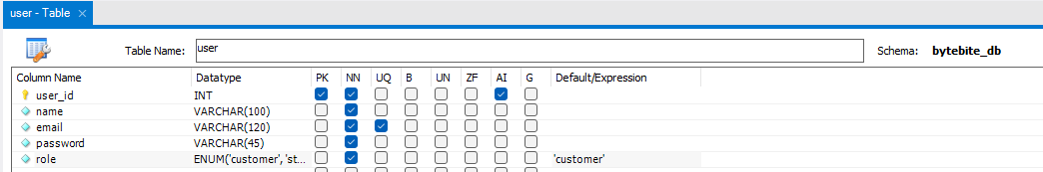
(Complete the table below for Entity 1 table – The first row is an example. Please replace with your own FK(if any), examples and justifications for each field names that you have)
Field Name | FK  (Parent Table Name) | Example | Justification
user_id | - | 1,5 | user_id is the primary key for the User table and uses the auto increment constraint to automatically assign a unique ID to every new customer. The purpose of user_id is to uniquely identify each person using ByteBite so no duplicate accounts exist. It is also needed to link users to their records, such as retrieving their past order history.
name | - | Hannan,Leon | The purpose of name is to store the customer's display name. It has a Not Null constraint because every user needs a name. This name appears on the website interface and on the order receipts. It helps stall vendors easily identify the correct customer when they come to the counter for order pickup.
email | - | Hannan2009@gmail.com,  Hannan8753@tp.edu.sg | email functions as the main login ID and is used for sending notifications. It has a Unique constraint to ensure that each user has a different account, which prevents people from registering twice with the same email. This is necessary for password resets and account security.
password | - | p@ssword,h@nn@n2OO8 | password stores the login password set by the user. It has a Not Null constraint because an account must be secured. This is necessary to control access so that only the user can log in to view their own personal data and current orders.
role | - | staff,customer | role is used to distinguish between a 'customer' and a 'staff' account using an ENUM constraint. This is useful because it ensures that regular customers only see the food ordering pages and do not have access to the management webpages used by vendors.

Table Name: Stall
Description: Contains data for each stall at the Flavours Canteen
(Take a Screen-shot of the actual table from MYSQL Workbench to replace the below Screen-shot)
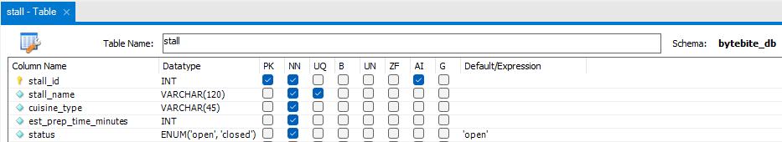
(Complete the table below for Entity 1 table – The first row is an example. Please replace with your own FK(if any), examples and justifications for each field names that you have)
Field Name | FK  (Parent Table Name) | Example | Justification
stall_id | - | 101,105 | stall_id uniquely identifies each stall and serves as the primary key. It uses the auto increment constraint to make sure every stall gets a unique ID. stall_id is needed to link menu items and orders to the correct vendor so the system knows which stall a customer ordered from.
stall_name | - | Western Stall,Chicken Rice Stall | stall_name stores the display name of the shop. The Unique constraint ensures there are no duplicate stall names, which would confuse users. This attribute is needed so students can easily identify stalls on the website, and it allows for the search function to work when looking for a specific place.
cuisine_type | - | Western | cuisine_type categorizes the stalls by the food they serve (e.g., Western, Korean). This supports the stall filtering feature, allowing users to quickly find the type of food they want without scrolling through every single stall.
est_prep_time | - | 10,15 | This attribute stores an estimate of how long a stall takes to prepare a standard order. This allows for the "Estimated Waiting Time" feature. This is useful as it ensures students can know roughly when their order will be ready, which prevents them from waiting at the stall for too long.
status | - | Open,closed | status indicates if a stall is 'open' or 'closed' using an ENUM data type. This is necessary to control the ordering buttons on the website. It ensures that students can only place orders when the stall is actually open and ready to cook.

Table Name: Menu_Item
Description: Stores food and drink items offered by each stall
(Take a Screen-shot of the actual table from MYSQL Workbench to replace the below Screen-shot)
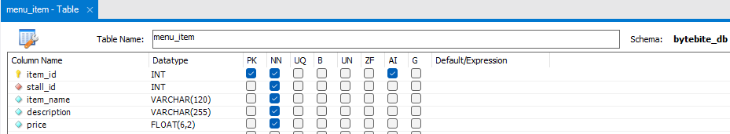
(Complete the table below for Entity 1 table – The first row is an example. Please replace with your own FK(if any), examples and justifications for each field names that you have)
Field Name | FK  (Parent Table Name) | Example | Justification
Item_id | - | 501,503 | item_id is the unique identifier for each dish and is the primary key. It has the auto increment constraint to ensure every dish has its own ID. item_id is necessary to link the food item to other records, such as the order details, so the chef knows exactly what was ordered.
stall_id | stall | 101,105 | stall_id is a foreign key that connects the item to the stall that sells it. This is necessary to create a specific menu list for each vendor. It ensures that when a user clicks on a stall, they only see the food items that belong to that specific shop.
Item_name |  | Chicken Chop | item_name stores the name of the dish displayed to users (e.g., Chicken Rice). It has a Not Null constraint. This is useful when users are browsing the menu as it allows them to identify the dish easily and decide what they want to eat.
description |  | Grilled chicken with brown sauce | description provides extra information to help users decide what to order, such as ingredients. This is useful as it allows users to decide what food they would like to purchase faster, so they don't have to spend as much time guessing what the dish is like.
price |  | 5.00 | price records the cost of the item. A Float data type is used for accurate calculations. This is needed to calculate the total cost of the order in the shopping cart so the user knows how much they have to pay.

Table Name: item_attribute
Description: Allows each menu item to have multiple tags(e.g., Halal,Vegetarian,Spicy) for filtering
(Take a Screen-shot of the actual table from MYSQL Workbench to replace the below Screen-shot)
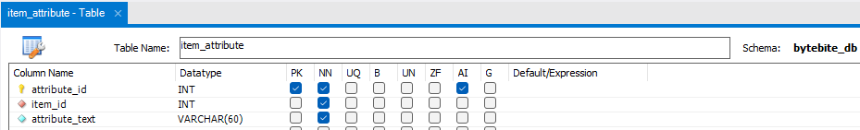
(Complete the table below for Entity 1 table – The first row is an example. Please replace with your own FK(if any), examples and justifications for each field names that you have)
Field Name | FK  (Parent Table Name) | Example | Justification
attribute_id | - | 9001,9002 | attribute_id uniquely identifies each attribute entry and is the primary key. It uses auto increment. This is necessary to avoid anomalies when managing attribute in the database, allowing each attribute to be updated or deleted individually.
item_id |  | 501,502 | item_id links the attribute to a specific menu item using a foreign key. This is necessary so that filters and labels display correctly on the menu. It is used to show the specific dietary attributes of that item.
attribute_text |  | Halal,Vegetarian | attribute_text stores the name of the attribute (e.g., Halal, Vegetarian). This allows a menu item to have multiple tags. This is useful when users want to filter for a certain type of food. It provides convenience to users to easily view all food of the same type, which helps them find what they are looking for faster.

Table Name: Order
Description: Contains information about each order placed by users
(Take a Screen-shot of the actual table from MYSQL Workbench to replace the below Screen-shot)
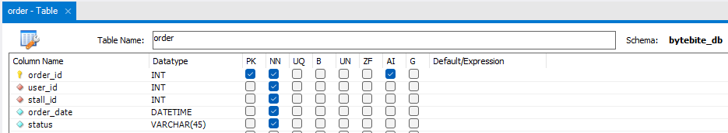
(Complete the table below for Entity 1 table – The first row is an example. Please replace with your own FK(if any), examples and justifications for each field names that you have)
Field Name | FK  (Parent Table Name) | Example | Justification
order_id | - | 1001.1002 | order_id assigns a unique identifier to each transaction. It acts as the primary key and uses auto increment to make sure each order ID is unique. This is needed to track orders and allows users to reference a specific order if they have a problem.
user_id | User | 1,2 | user_id is a foreign key that links the order to the customer who placed it. It has a Not Null constraint. This is necessary for the order history feature, as it allows the website to show a student a list of all the food they have ordered in the past.
stall_id | Stall | 101,102 | stall_id identifies which stall receives the order. It acts as a foreign key. This allows vendors to view and manage only the orders that are meant for their stall, separating them from orders made to other shops.
Order_date |  | 2025-11-12 14:32 | order_date logs the date and time the order was placed. It has a Not Null constraint. This is needed for the order history feature and helps vendors prioritize orders to ensure food gets prepared on time based on when it came in.
status |  | Preparing, Ready for collection | status represents the order's current stage (e.g., Preparing, Ready). This is needed for the order tracking feature. It allows the student to check their phone and see if their food is ready for collection without having to walk to the stall to check.

Table Name: Order_Detail
Description: Stores individual items for each order
(Take a Screen-shot of the actual table from MYSQL Workbench to replace the below Screen-shot)
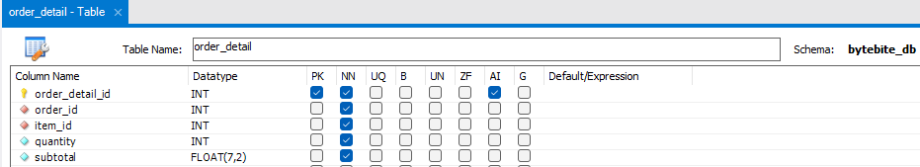
(Complete the table below for Entity 1 table – The first row is an example. Please replace with your own FK(if any), examples and justifications for each field names that you have)
Field Name | FK  (Parent Table Name) | Example | Justification
order_detail_id | - | 2001,2002 | order_detail_id assigns a unique identifier to each line item and acts as the primary key with auto increment. This is necessary to prevent anomalies in the database by giving every single item line its own unique ID.
order_id | order | 1001,1002 | order_id links the item to its parent order using a foreign key. This is necessary as it allows users to see exactly what items are inside their order receipt. Without this, the system wouldn't know which order this item belongs to
Item_id | menu_item | 501 | item_id identifies which specific menu item was ordered using a foreign key. It has a Not Null constraint. This is needed so the system can pull the correct name and price of the food to display on the receipt.
quantity |  | 1,2 | quantity shows how many units of a specific item were purchased. It has a Not Null constraint. This is useful for the kitchen staff so they know how many portions to cook, and it ensures the total price is calculated correctly.
subtotal |  | 10.00 | subtotal stores the calculated cost of the line (price × quantity). It has a Not Null constraint. This is useful for showing the user a breakdown of costs in their Order Summary before they make a payment.

(Repeat the above for all the entities that you have)

Section E: ERD and Relationships (10%)
Paste a screenshot of your Entity-Relationship Diagram in this section.
Please make your screenshot image are sharp and clearly shown all the attributes and their data type for each entity.

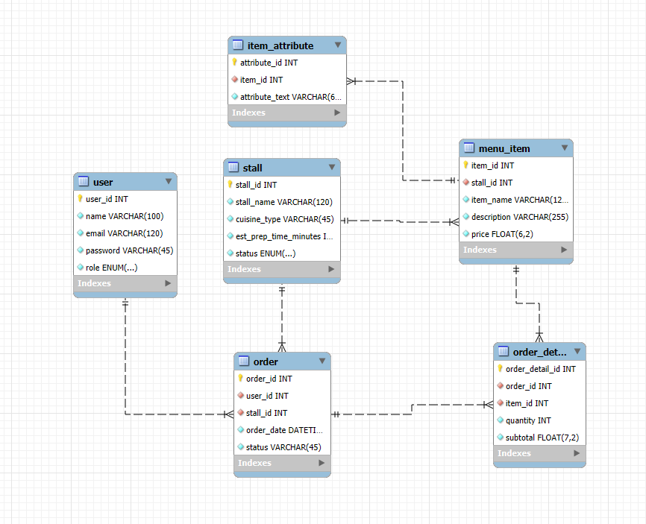

For each relationship, identify the entities involved and explain clearly the rationale of the relationship in terms of meeting the requirements of the proposed online website in Task 1

Entity 1 | Entity 2 | Relationship | Justification
User | Order | One to Many | One User can place many orders, but each order can only belong to one user.  This ensures that the system can keep track of all the orders made and link each order to the correct user. This also allows customers to view their order history and track ongoing orders without confusion.
Stall | Menu_item | One to Many | One stall can have many menu items but each menu item can only belong to one stall.  This makes sure that each dish is correctly grouped under the right stall at Flavours. It also helps customers browse the menu more easily and prevents items from being mixed between stalls.
Stall | Order | One to Many | One stall can receive many orders, but each order can only belong to one stall.  This prevents mix-ups between different stalls. It also allows each stall to focus only on preparing their own incoming orders.
Menu_Item | Order_Detail | One to Many | One menu item can appear in many order details, but each order detail entry refers to only one menu item.  This ensures that when a customer orders multiple items, each item is recorded correctly. It also helps the system calculate quantities and subtotals accurately.
Order | Order_Detail | One to Many | One order can have many order details, but each order detail can only belong to one order.  This structure supports orders with multiple items and makes sure every item inside the order is grouped together. It also helps customers see a proper breakdown of what they purchased.
Menu_Item | Item_Attribute | One to Many | One menu item can have many attributes, but each attribute entry belongs to one menu item.  This allows items to have multiple tags such as “Halal”, “Spicy”, or “Vegetarian”. It also ensures the filtering feature works properly and that each attribute is connected to the correct item

Section F: Normalisation (10%)
Write a report of no more than 300 words on how you address the following issues:
- How does your design prevent insertion anomalies?
- How does your design prevent update anomalies?
- How does your design prevent deletion anomalies?
Include significant examples to illustrate how your design addresses each anomaly.
Insertion anomalies:
Insertion anomalies occur when a new record cannot be added because required data is missing or stored incorrectly. My database design prevents this by making sure that non-null values are provided, and that foreign key constraint is met with respective entities before the record can be added. One such example is, a order cannot be created without a stall_id and user_id, as the foreign key constraint needs to be met, and placeholder texts cannot be used. This means that in the case that either of the foreign keys are missing or have a invalid ID a order cannot be created maintaining the accuracy of the data.
Update anomalies:
An update anomaly occurs when data is required to update in multiple areas. My database design prevents this by making sure that each piece of data exists at only one location, preventing duplicates. For example, when a stall name is updated, it only needs to be updated in the stall entity, as the order entity is linked to the stall entity through a foreign key. This prevents duplicate attributes, ensuring that the data is consistent.
Deletion anomalies:
A deletion anomaly can occur when the deletion of one piece of data unintentionally causes related data to be lost. My database design prevents this by making sure that each important data is stored separately. For example, when an item in an order is deleted, the order will not be deleted as the order_detail entity is linked to the order entity through a foreign key. This means that when an item in an order is deleted, the related order will still be intact, ensuring that no important data is lost.

ADEV: Web Application Design (30%)

Section G: Implementation (15%), Design & Layout (5%), Justification (10%)

Include screenshots of each page implemented under this section. Clearly label each page name. Explain and justify the HTML design choices you made in your implementation. Your explanation should describe how the selected HTML elements support the structure and requirements of your ER diagram submitted under Task 4, why they are suitable for presenting the application’s data and functionality, and how they contribute to usability for the intended users.

Image of Home page
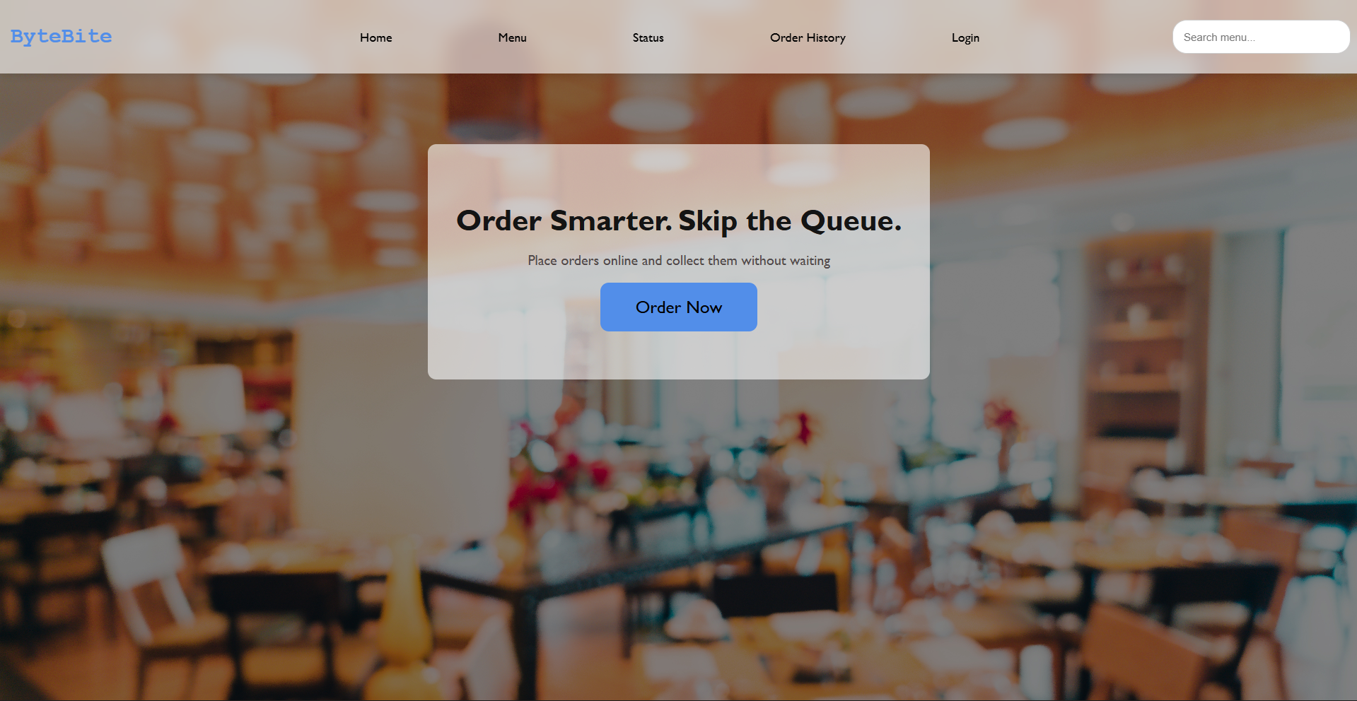

<home.html>

The home page is the first page most users will see, so I decided to keep the design clean and uncluttered to avoid overwhelming the user on entry. A <header> at the top of the screen contains a navigation bar with links to Home, Menu, Order Status, Order History and Login. This same navigation bar appears on every page except the login screen, ensuring consistency making it easy for users to navigate around the website. In the center of the page, I added a welcome panel that briefly explains what the system does and invites users to start ordering. I used <h2> headings and a short <p> text to keep the information light and easy to read. I also added a prominent "Order Now" button, made by wrapping a <button> inside a <a> tag in order to guide users to the menu page and start ordering.

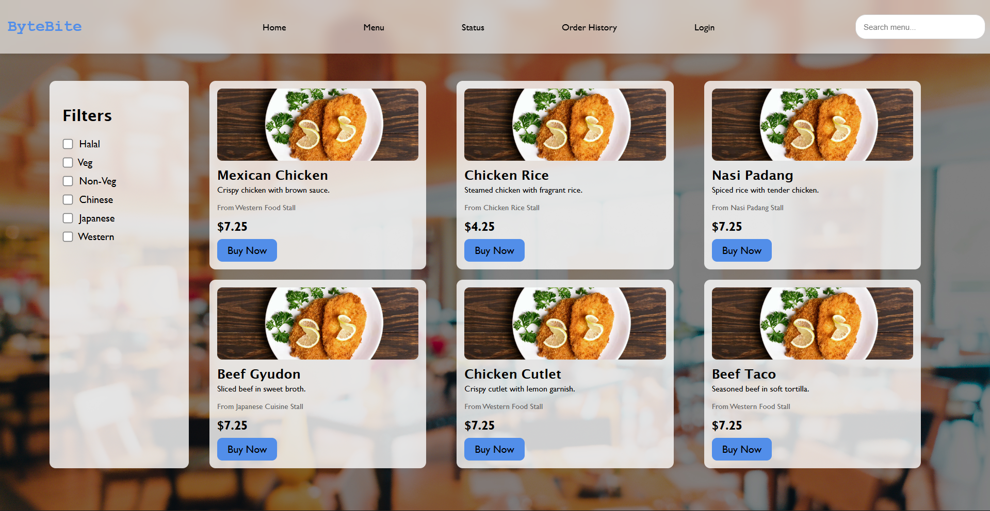
Image of Menu Page

<menu.html>

The Menu page is where users browse items before placing an order, so it was specifically designed to present each dish clearly. The navigation bar remains at the top to maintain website consistency. The page layout is split into two sections: a filter panel on the left and a menu grid on the right. The filter panel, made using a <div> housing <label> elements and <input type="checkbox"> fields, forms a column of filters. This lets users to narrow down items by categories linked to attributes from Menu_Item and Item_Attribute entities in the ERD. In the menu grid, each dish appears in a <div> card, which includes <img> for the picture, <h3> heading for the name, and <p> elements for the description, stall, and price. Each card also features a "Buy Now" button wrapped in an <a> tag, directing users to the Order Status page to track their order.

Image of Order Status Page

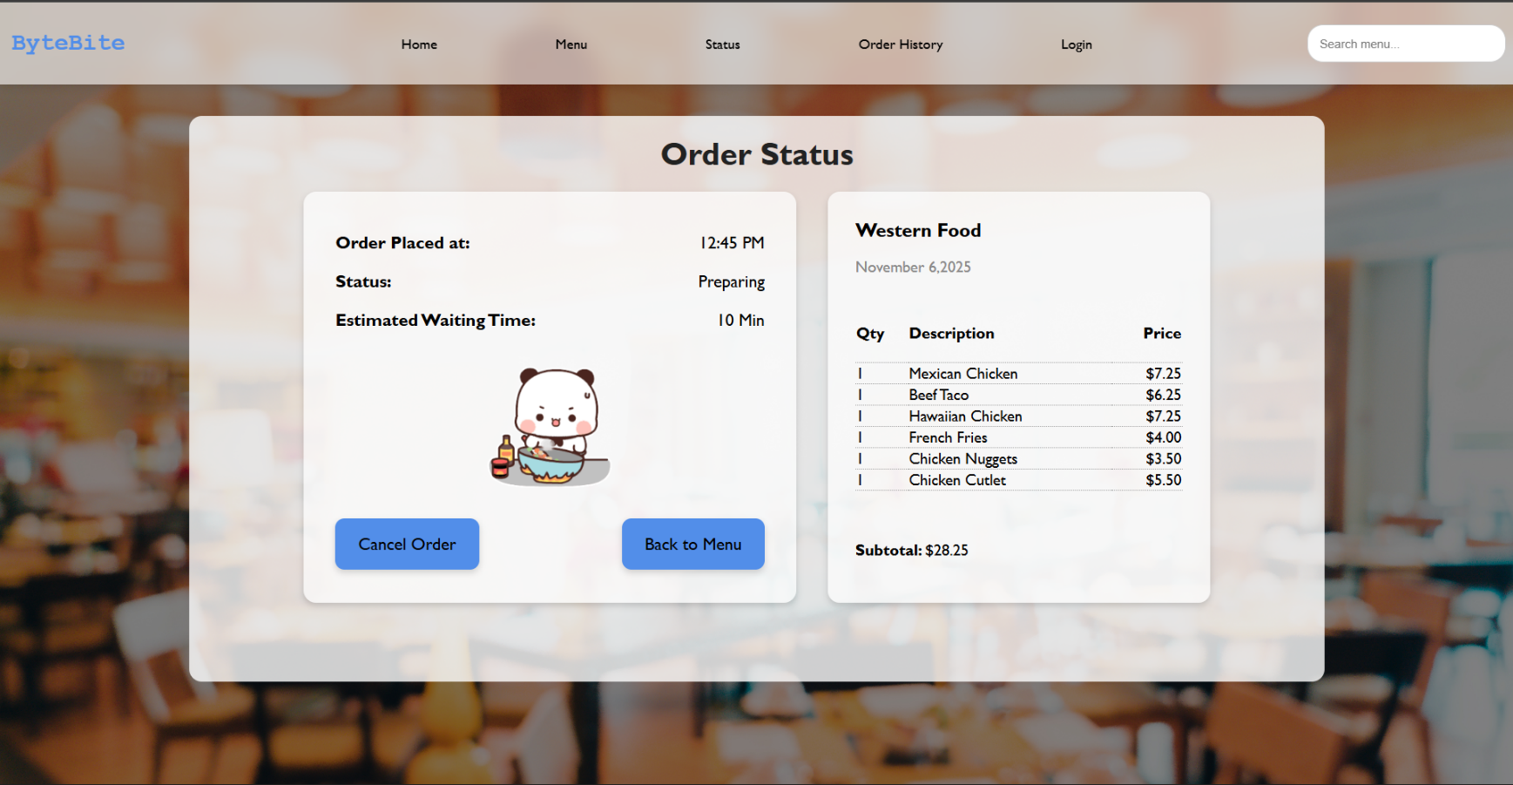
<status.html>

The Order Status page shows users the progress of their active order, so the layout was structured to make key details easy to find at a glance. The consistent <header> navigation bar is included at the top for website consistency. The main content is divided into two sections: the left panel for order metadata and the right panel for ordered items. The left panel uses <p> elements in a small <table> structure to present the order time, status, and estimated waiting time—attributes corresponding to the Order and Stall entities in the ERD. A Gif is added for engagement while the user waits. Two buttons wrapped in <a> tags allow users to return to the menu or cancel the order, providing control. The right panel uses a structured <table> to list each item, quantity, and price, representing the Order_Item relationship and giving users a purchase summary.

Image of Login page

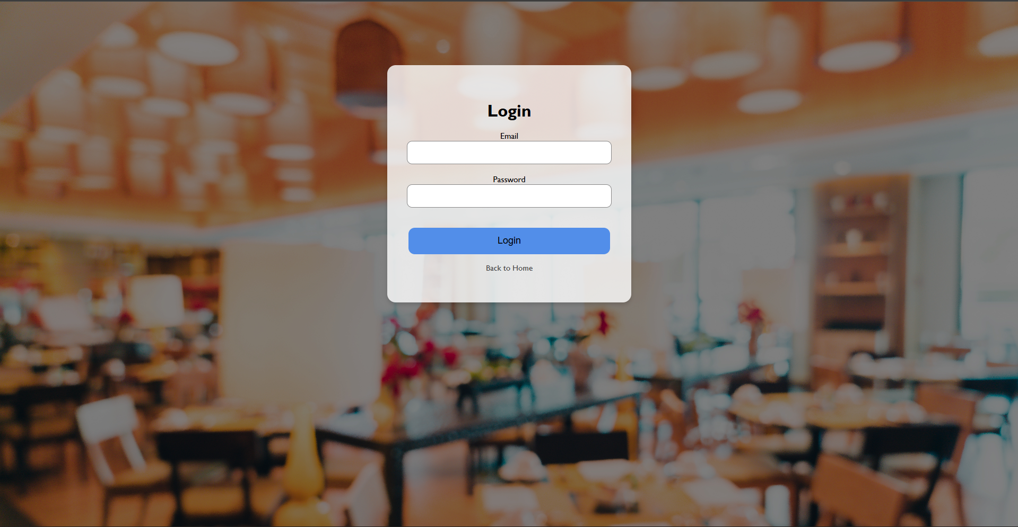
<login.html>

The Login page is designed to be simple and focused, giving users a clear entry point into the website. Unlike the other pages on the website, this one intentionally excludes the <header> navigation bar. Removing navigation prevents users from accessing pages that require authentication and keeps their focus on completing the login process. The main content is centred on the screen using a structured <div> that contains the login form. The form uses a <label> with <input> fields for the email and password, ensuring the layout is easy to follow. A concise <p> message guides user on what to enter, keeping instructions clear. Below the inputs, a "Login" button created with a <button> element submits the form and directs user into the system. The overall layout keeps the page clean, straightforward, and consistent with the design choices across the site.

Image of Order History Page

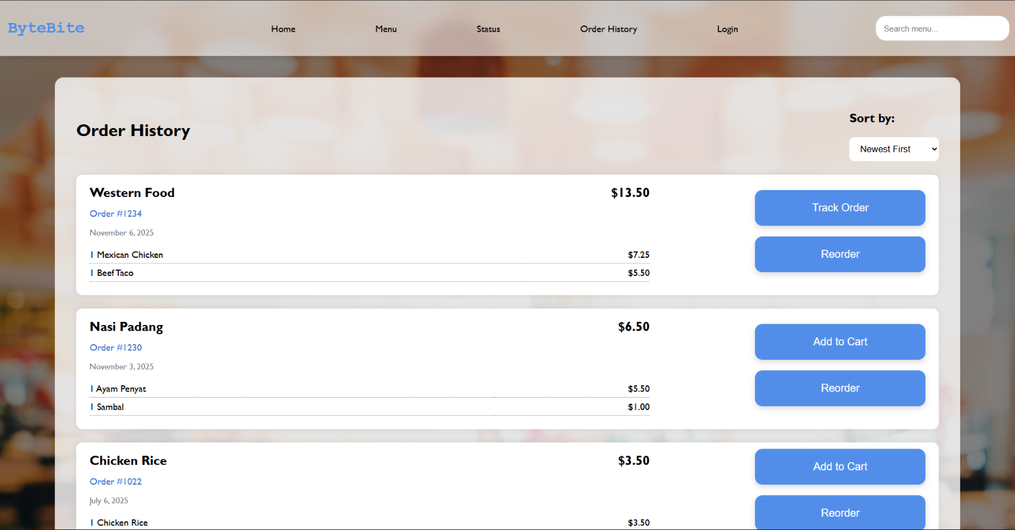
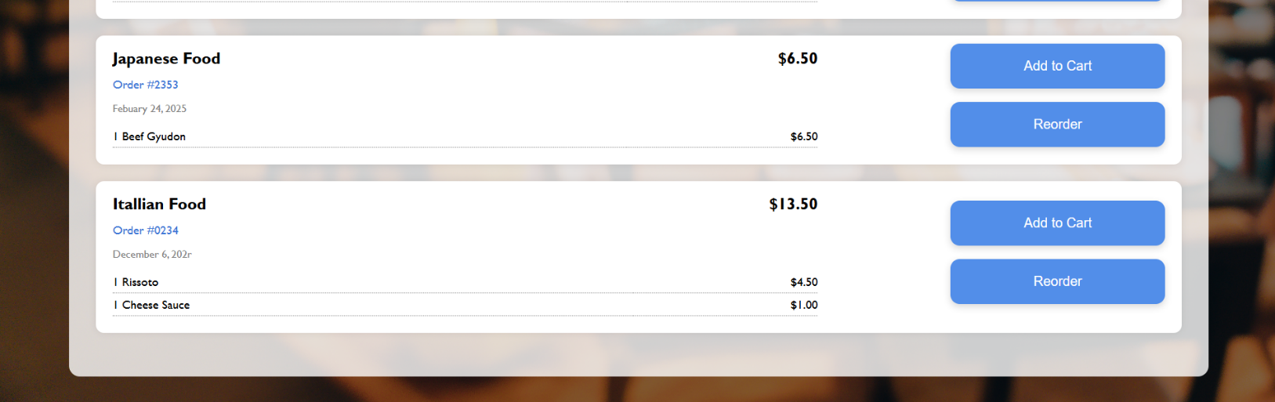

<history.html>

The Order History page allows users to review their past purchases, so the design focuses on clarity and easy scanning. The page begins with the consistent <header> navigation bar. Below the navigation, a "Sort by" dropdown is included using a <select> element, allowing users to narrow down their past orders. This enhances usability while aligning with attributes in the Order entity of the ER diagram. Each past order is built with a <div> card. In each card, the stall name, order number, and date are shown using <h2> and <p> tags, showing data from the Order and Stall entities. A <table> is also used to list items and prices, giving users a detailed breakdown. On the right side, buttons made with <button> elements allow users to reorder past orders, add past orders to their cart, and track active orders, providing convenient options for managing past orders.

