Temasek Polytechnic
School of Informatics & IT
Diploma in Applied Artificial Intelligence
Robotic Process Automation (CAI2C01)
AY2026/2027 April Semester

Proposal

Student Name :Mohammed Hannan Noor

Student Admin No. : XXXXXXXX

Tutorial Group : PC02
Jenny LING (TP)
Tutor : Ms Shuyun

Submission Date : 28/5/2026

Robot Name
Supplyr

Business Domain
Retail Inventory and Procurement
Supplyr operates in the retail inventory and procurement domain. This domain focuses on how retail stores and businesses manage product stock, monitor inventory levels, identify low-stock items, communicate with suppliers, and prepare reorder requests. In retail businesses such as supermarkets, minimarts, and electronics stores, having the right amount of stock is important because if stock is too low, businesses may lose sales, but if they overstock, they may waste storage space and increase costs.
This is especially important for small and medium-sized businesses, as they often deal with many products and suppliers at the same time but have limited manpower. Stock levels can also change frequently due to daily sales, seasonal demand, supplier delays, or inaccurate manual records. Due to this, inventory and procurement activities need to be done regularly and accurately to ensure that the business can continue operating smoothly.
Overall, this domain involves common business activities such as monitoring stock levels, maintaining supplier information, preparing purchase-related documents, and communicating with supplier companies. This makes it a suitable business domain for an RPA project because these activities are important, repetitive, and commonly found in retail operations
Target Department/Users
The target users for Supplyr are staff members directly involved in the day-to-day inventory and procurement operations of small or medium-sized retail businesses. This user base primarily encompasses three core roles:
- Inventory Clerks / Staff: Responsible for monitoring stock levels and maintaining accurate product records. They ensure the business has visibility into which items are available or running low. According to the International Standard Classification of Occupations (ISCO-08), stock clerks are formally tasked with maintaining records of goods received, issued, or dispatched, making them a primary user group for Supplyr's core tracking features.
- Procurement and Purchasing Clerks: Tasked with handling supplier-related workflows and tracking reorder requests. The ISCO-08 framework classifies procurement clerks as professionals responsible for preparing purchasing documents, compiling information on requirements, and tracking order statuses. Supplyr directly addresses these duties by providing tools for supplier communication and order tracking.
- Store or Operations Managers: While they may not manage individual product records manually, they rely on the system's data to monitor overall stock levels and purchasing activity. They require a high-level overview to ensure restocking pipelines are running smoothly and supplier requests are being prepared accurately.
Ultimately, Supplyr is tailored specifically for professionals whose daily responsibilities require direct interaction with stock records, supplier directory data, and purchase documentation.
.

Project Scope
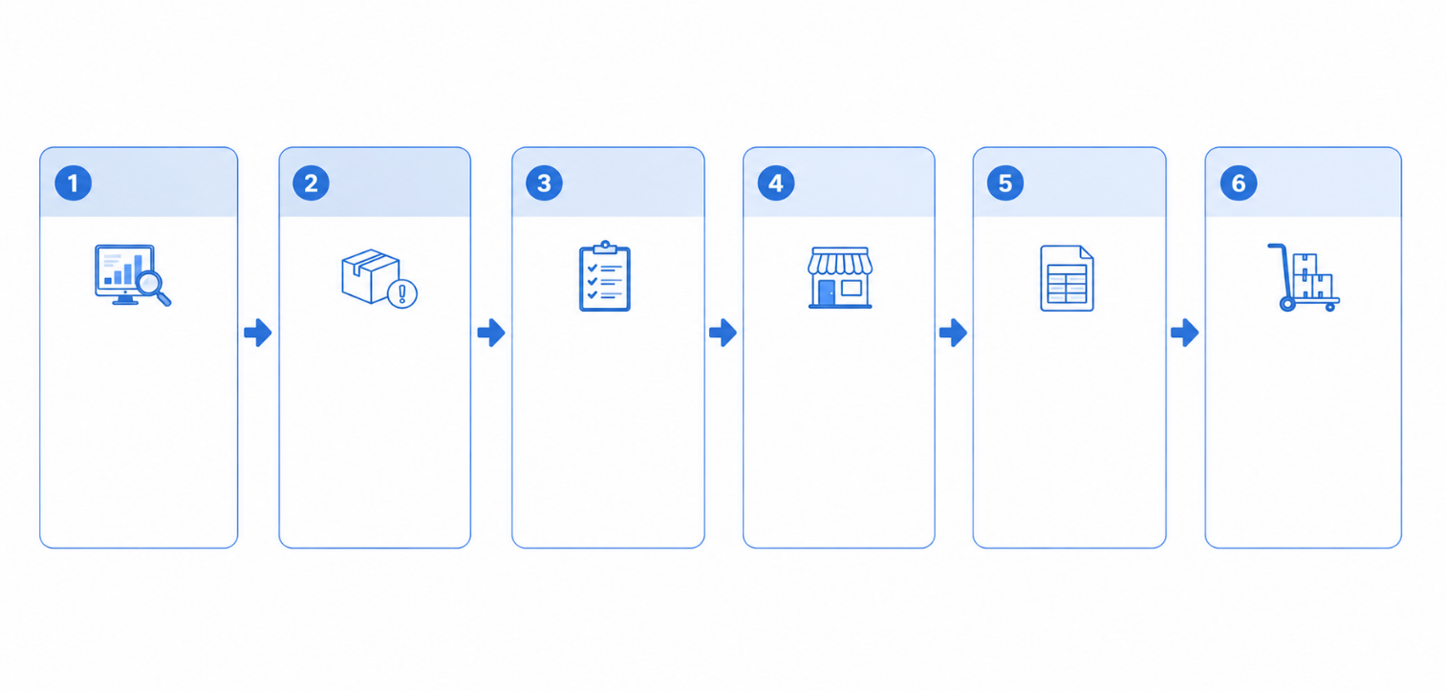
Supplyr is a robot that supports the retail inventory and procurement process by helping small and medium-sized businesses manage stock replenishment more effectively. The main purpose of Supplyr is to reduce the amount of manual work involved when staff need to check inventory records, identify products that require restocking, prepare purchase documents, contact supplier companies, and update the necessary records after a reorder request has been made.
Track inventory levels for all items.
Stock Monitoring
Detect low stock
Identify items at or below minimum reorder levels
Confirm the required reorder quantities before contacting suppliers
Review Stock
Obtain Information
Get supplier availability, contact information, price of item, etc
Purchase Order
Get supplier availability, contact information, price of item, etc
Receive Stock
Receive items and update inventory stock
Handled by Supplyr
The diagram above shows the general restocking process and highlights the section that will be handled by Supplyr. While stock monitoring and receiving stock will still involve staff, Supplyr will focus on the middle stages of the process, from detecting low-stock items to preparing the purchase order. This makes the project scope clear, as the robot is not automating the entire retail operation, but only the repetitive procurement-related steps that occur after low stock is found.
Supplyr will use five main applications: MySQL database, Python script, Microsoft Word, Microsoft Outlook, and Microsoft Excel. The MySQL database will store product details, stock levels, supplier information, unit prices, and reorder records. These reorder records are needed to check whether an item has already been reordered, which helps prevent duplicate orders. The Python script will then calculate the reorder priority, estimated cost, and select the most suitable supplier.
After the reorder information is confirmed and passed over from the Python script, the robot will generate a formatted draft purchase order in Microsoft Word. This document will include proper headings, font sizes, tables, supplier details, product information, and priority labels where needed. In Microsoft Outlook, a reorder request email will then be sent to the selected supplier company with the purchase order attached. Lastly, in Microsoft Excel, a summary report will be generated showing the products checked, items selected for reorder, suppliers contacted, estimated costs, purchase order status, and any skipped records or errors.

Justification
Inventory and procurement processes should be automated because poor stock management can create serious problems for retail businesses. If stock is too low, customers may not be able to buy the products they want, causing the business to lose sales. At the same time, if the business orders too much stock, it may waste storage space and increase holding costs. According to Blue Yonder’s Retail Inventory Distortion Report, the total global cost of inventory distortion was projected to reach US$1.77 trillion in 2023, with out-of-stocks accounting for US$1.2 trillion and overstocks accounting for US$562 billion. This shows that both low stock and excess stock are major issues in retail, not just small operational problems.

The graph shows that out-of-stocks losses make up the larger portion of inventory distortion costs, which supports the need for Supplyr to help identify low-stock products before they become a bigger problem. When low-stock items are not detected early, staff may only realise the issue after customers are already unable to purchase the item, resulting in lost sales. The graph also shows that overstocking is also a major cost at US$562 billion. This supports the need for a more organised reorder process, because staff should not simply reorder products blindly. Supplyr will help by checking stock records, supplier information, and reorder status so that reorder requests are prepared more carefully.
Another issue in manual procurement is the risk of repeated or duplicate ordering. If staff do not update reorder records properly, another staff member may not know that the item has already been requested and may prepare another order for the same product. This can lead to overstocking, wasted storage space, and unnecessary spending. A real example of this issue can be seen in Cisco’s case, where a Stanford Graduate School of Business paper discussed Cisco’s US$2.2 billion inventory write-off and explained how duplicate orders can cause companies to overestimate demand and make poor inventory decisions. Although Supplyr is designed for a smaller retail business, this example shows how inaccurate or repeated ordering can create serious inventory problems if records are not managed properly.
Supplyr also provides value by reducing the workload of staff involved in inventory and procurement. Instead of manually checking stock records, reviewing supplier information, preparing purchase documents, writing supplier emails, updating reorder records, and creating summary reports one by one, Supplyr can handle these repetitive tasks in a more organised workflow. This allows staff to spend less time on repetitive administrative work and more time on tasks that require human judgement, such as checking special supplier terms, handling urgent business issues, or reviewing unusual cases.
Overall, Supplyr improves productivity by making the reorder process more consistent, organised, and easier to track. It helps reduce delays in identifying low-stock products, lowers the chance of duplicate reorder requests, and improves record keeping by updating the reorder status and generating a summary report. By using MySQL, Python, Microsoft Word, Microsoft Outlook, and Microsoft Excel together, Supplyr supports a smoother inventory and procurement process while still keeping the final business decision understandable and traceable for staff.
Robot Category
Unattended
Supplyr will be a unattended robot as the process can run without staff having to control every step. The robot can be scheduled to run at a fixed time, such as once every morning or at the end of each working day, when the latest inventory data has been updated. This is suitable as the robot only requires staff to review final output or any records that were skipped due to missing information.

Current Scenario
Currently, small and medium-sized retail businesses handle inventory and procurement tasks manually using a combination of inventory records, supplier information, purchase documents, email communication, and summary reports. When stock needs to be checked, staff have to move between different records and applications to confirm product details, decide whether an item should be reordered, contact suppliers, and update the necessary records. This can become inefficient when many products need to be checked, especially if the business has limited manpower.
The current process also depends heavily on staff updating records properly. If a reorder request is not recorded clearly, other staff may not know whether the product has already been requested. This may cause confusion, delayed restocking, or repeated ordering. Therefore, the current manual process can take up staff time and may create errors if information is missed or updated late.

Current Manual Steps
- Inventory staff open the inventory records and check product stock levels.
Staff first open the business’s inventory records to view the list of products and their current stock levels. This allows them to see how much stock is left for each product before deciding if any action is needed.

- Staff compare the current stock level with the minimum stock level.
Staff then compare each product’s current stock level against its minimum stock level. If the current stock is lower than the minimum stock level, the product may need to be reordered.

- Staff identify products that may require restocking.
After checking the stock levels, staff identify which products are low in stock. They may also need to confirm product details, such as the product name, product ID, and reorder quantity, before moving on to supplier checking.

- Staff check supplier information for the selected products.
Staff look through supplier information to find the supplier company linked to the product. This may include checking the supplier name, email address, unit price, available quantity, and delivery details.

- Procurement staff prepare the purchase-related document manually.
Once the supplier and product details are confirmed, procurement staff manually prepare the purchase-related document. This document may include details such as the product ID, product name, quantity requested, unit price, estimated total cost, and supplier details.

- Procurement staff write and send an email to the supplier company.
Staff then manually write an email to the supplier company to request the stock replenishment. The purchase-related document may also need to be attached to the email before it is sent.

- Staff update the inventory or reorder record to show that the item has been requested.
After the supplier has been contacted, staff update the inventory or reorder records to show that a reorder request has been made. This is important so that other staff know the product has already been requested.

- Staff prepare a summary report and save the purchase document for future reference.
Lastly, staff prepare a summary report to record the products checked, items selected for reorder, suppliers contacted, and purchase documents created. The purchase document is also saved for future reference and tracking.

Automation Scenario
When Supplyr is executed, the robot will automate the main inventory and procurement tasks using MySQL Database, Python Script, Microsoft Word, Microsoft Outlook, and Excel/CSV. Instead of staff manually checking stock records, preparing purchase documents, emailing suppliers, and creating summary reports, Supplyr will handle these repeated steps in a more organised workflow. This helps make the reorder process faster, clearer, and easier to track.
The robot will first retrieve inventory and supplier data from the MySQL database. It will then identify products that are below the minimum stock level and use a Python script to support the reorder decision. After that, Supplyr will prepare a formatted purchase order in Microsoft Word, send it to the selected supplier company through Microsoft Outlook, and create an Excel/CSV summary report for record keeping. If any required details are missing, such as supplier email, unit price, or available quantity, the robot will record the issue so staff can review it later.
Automation Steps:
- Supplyr connects to the MySQL database.
The robot starts by connecting to the MySQL database where inventory and supplier information is stored. This database contains important details such as product ID, product name, current stock level, minimum stock level, supplier name, supplier email, unit price, available quantity, and delivery time.

- Supplyr retrieves inventory records and supplier information.
After connecting to the database, the robot retrieves the product and supplier records needed for checking. This allows Supplyr to access the latest available information before deciding which products need further action.

- Supplyr compares each product’s current stock level with its minimum stock level.
The robot checks whether each product’s current stock level is lower than its minimum stock level. This helps the robot identify which products may require restocking without staff checking each record manually.

- Products below the minimum stock level are identified as items that may need restocking.
If a product is below the minimum stock level, Supplyr marks it as a low-stock item. Products that still have enough stock will not proceed to the reorder stage.

- The low-stock product and supplier data is passed into a Python script.
The robot sends the relevant product and supplier details into a Python script for further processing. This allows the reorder decision to be based on more than just the stock level.

- The Python script calculates the reorder priority, estimated reorder cost, and most suitable supplier.
The Python script uses factors such as stock shortage, supplier price, available quantity, and delivery time to decide which item should be prioritised and which supplier is most suitable. It also calculates the estimated cost based on the reorder quantity and unit price.

- Supplyr updates the MySQL database with the reorder decision and latest status.
After the reorder details are confirmed, the robot updates the database to show that a reorder request has been prepared. This helps prevent confusion or repeated ordering because the reorder status is recorded clearly.

- Supplyr generates a formatted draft purchase order using Microsoft Word.
The robot creates a draft purchase order document using Microsoft Word. The document includes details such as supplier company, product ID, product name, requested quantity, unit price, estimated total cost, and delivery request.

- Supplyr applies formatting to the Word document.
The purchase order is formatted with headings, adjusted font sizes, structured tables, and priority labels where needed. This makes the document clearer and more professional instead of being a plain text document.

- Supplyr opens Microsoft Outlook and prepares an email to the selected supplier company.
The robot creates an email addressed to the selected supplier company. The email includes a short reorder request message explaining that the business would like to request stock replenishment.

- Supplyr attaches the generated purchase order document to the email.
The formatted Word purchase order is attached to the email before it is sent. This ensures the supplier receives the full product and order details in a proper document.

- Supplyr sends the email to the supplier company.
The robot sends the email through Microsoft Outlook to request stock replenishment from the supplier company. This reduces the need for staff to manually write and send repeated supplier emails.

- Supplyr generates an Excel/CSV summary report for record keeping.
After processing the reorder requests, the robot creates a summary report showing the products checked, items selected for reorder, suppliers contacted, estimated costs, and purchase order status.

- Supplyr records skipped items or errors for staff review.
If any required information is missing, such as supplier email, unit price, or available quantity, Supplyr records the issue in the summary report. This allows staff to review problem records later instead of the whole process stopping completely.

Process Flow Chart
Flow chart to illustrate the process identified for automation.
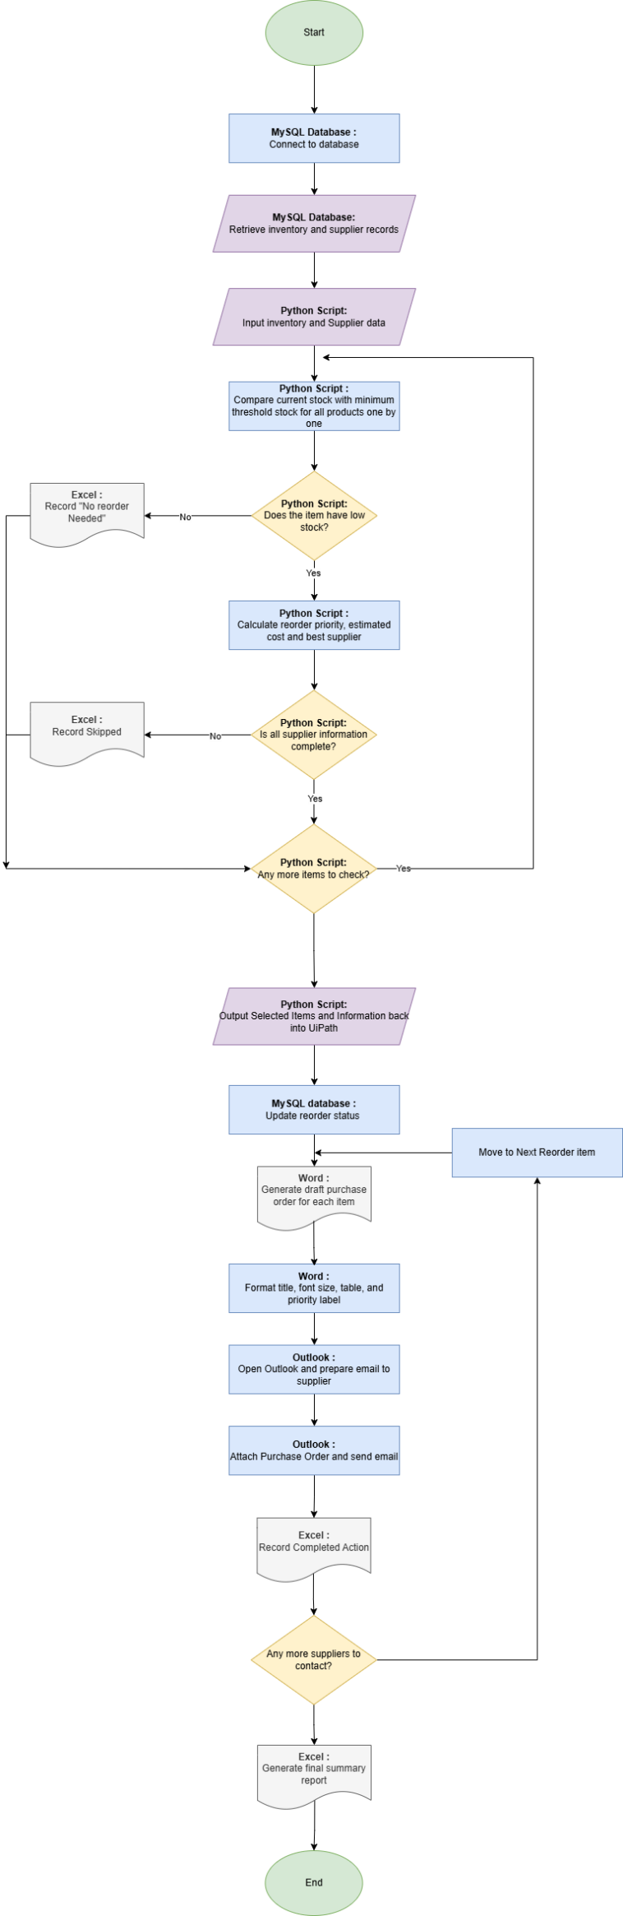

References
International Labour Office. (2012). International Standard Classification of Occupations (ISCO-08). Structure, group definitions and correspondence tables (Vol. 1). International Labour Organization. (https://ilostat.ilo.org/methods/concepts-and-definitions/classification-occupation/)
Blue Yonder. (2023). Retail Inventory Distortion Report. Blue Yonder.
https://blueyonder.com/resources/retail-inventory-distortion-report
Armony, M., & Plambeck, E. L. (2005). The impact of duplicate orders on demand estimation and capacity investment. Stanford Graduate School of Business.
https://www.gsb.stanford.edu/faculty-research/working-papers/impact-duplicate-orders-demand-estimation-capacity-investment
NetSuite. (2024). What Is Automated Inventory Management?
NetSuite explains that automated inventory management uses a data-driven approach, reducing guesswork and helping businesses avoid overstocks and stockouts. https://www.netsuite.com/portal/resource/articles/inventory-management/automated-inventory-management.shtml?
BILL. (n.d.). What Is a Purchase Order and How Does It Work?
This explains that a purchase order is an official document sent from a buyer to a seller to record the sale of products or services to be delivered later. https://www.bill.com/learning/purchase-order?
draw.io Ltd. (2025). draw.io: Security-first diagramming for teams. https://www.drawio.com/

