

School of Informatics & IT

CIT1C18 - Computational Thinking
AY 25/26 Apr Semester
Project 2 (30%) Report

Contents
Declaration of Originality 3
Task 1 – Flowchart Design (3%) 4
Chosen stations 4
Flowchart 4
Task 2 – Code out the flowchart (7%) 5
Task 3 – Enhancing your code (6%) 5
Discount System 5
TWO interconnected lines 5
Task 4 – Additional Features (7%) 6
Task 5 – Program justification (7%) 6

SCHOOL OF INFORMATICS & IT

Diploma in [Applied Artificial Intelligence]

Project 2 Report

Student Name (Matric Number) : Mohammed Hannan Noor(XXXXXXXX)

Tutorial Group : PC23
Jenny LING (TP)
Tutor : Lee Jin

Submission Date : 3/7/25

Declaration of Originality

I am the originator of this work and I have appropriately acknowledged all other original sources used as my references for this work.

I understand that Plagiarism is the act of taking and using the whole or any part of another person’s work, including work generated by AI, and presenting it as my own.

I understand that Plagiarism is an academic offence
and if I am found to have committed or abetted the offence of plagiarism in relation to this submitted work, disciplinary action will be enforced.

Task 1 – Flowchart Design (3%)

Chosen stations

Station | Line | Distance to Tampines West (DT31)
Yishun | North-South Line | 23.3km  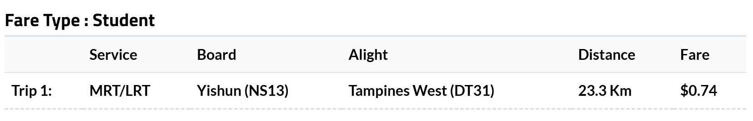
MacPherson | Circle Line | 6.9km
Simei | East-West line | 2.7km

Flowchart
[Attach screenshot of the flowchart, making sure it is visible. Else please submit a CLEAR image file separately]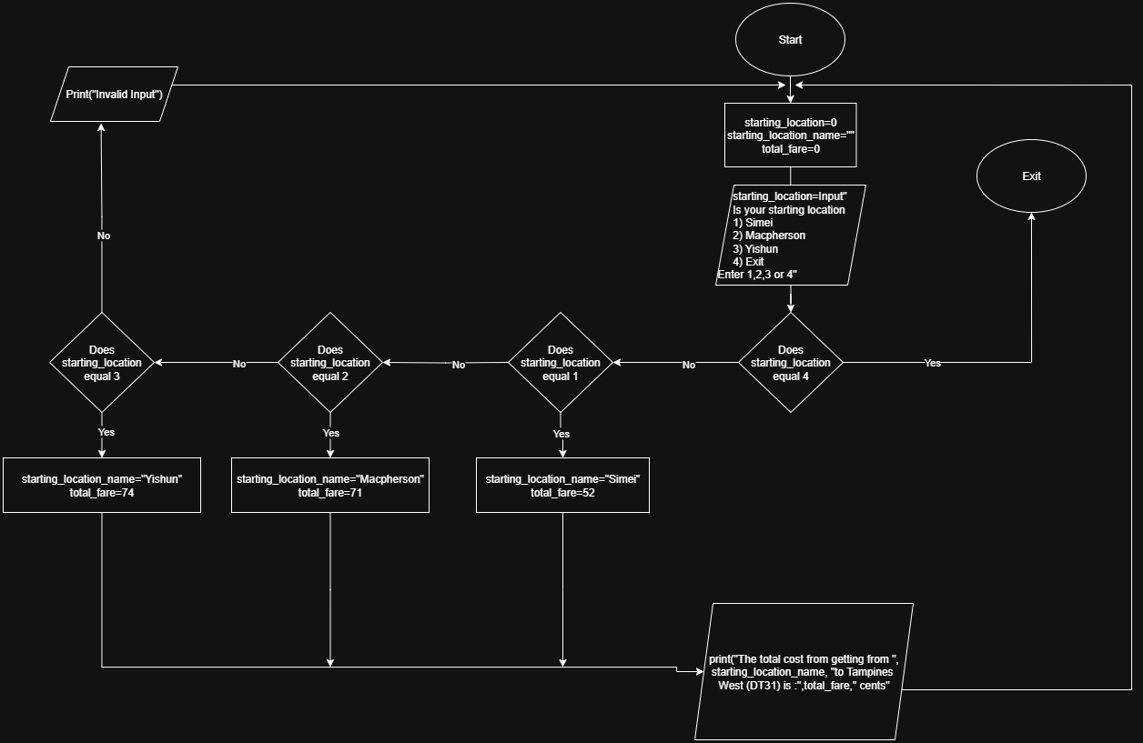

Task 2 – Code out the flowchart (7%)

[Please submit Task 2 code as .ipynb (Jupyter notebook file format)]

Task 3 – Enhancing your code (6%)

Discount System

Tiers | Discount | Short justification
Peak time | 0 percent off | No discount is given to reduce the incentive to travel during peak hours. This helps to ease overcrowding and congestion on public transport.
Non-Peak time | 15 percent off | A big discount is offered to encourage commuters to travel during off peak periods which helps to spread demand more evenly throughout the day.
[To replace with your own discount system]

TWO interconnected lines

Line 1 | Line 2 | Connecting Station(s)
North-East Line | North-South Line | Dhoby Ghaut

[Please submit Task 3 code as .ipynb (Jupyter notebook file format)]

Task 4 – Additional Features (7%)
[Please submit Task 4 code in the same file as Task 3]

Task 5 – Program justification (7%)

Based on the two (2) features that you have suggested and implemented in task 4, justify why they are important features to be added. Explain your implementation and provide scenarios and evidence to support your claim as much as possible.

In the report template given (COMT_AY2526_Project_2_Template.docx), write a report on no more than 500 words PER feature. Your justification is not limited to just written words; you may include any form of data to support your decision.

Feature 1
Description:
This feature calculates the Carbon Dioxide emissions generated by different modes of transport (Bus, Motorbike, Car, MRT) for the given travel distance. User selects travel medium and inputs the travel distance to view the estimated emissions in grams of Carbon Dioxide. Then it offers comparison with other travel mediums. This feature uses arrays, loops and if statements to handle input validation and display comparisons

Implementation:
This feature includes 2 main arrays
travel_modes = ["Bus", "Motorbike", "Car", "MRT"]
emission_rates = [82.0, 102.03, 140.0, 13.2]
the index of the travel medium also corresponds with its emission rates.
It prompts users to input
- Travel medium
- Travel distance
It then calculates the carbon emissions by multiplying the distance with the corresponding value of grams of Carbon Dioxide per KM based on the travel medium entered.

Then if the user wants to compare the carbon emission with other travel mediums. It uses a loop to print the emission from the other travel mediums.
Scenario of how this feature works:
A commuter can decide between taking a car or MRT for a 15 km trip based on the emissions from each. User inputs the total the travel medium for which he wants to know the carbon emissions of (MRT)then inputs the travel distance(15km) then is given this result,

The total carbon emission is 198.0 grams of CO2.
for 15.0 kilometres in a MRT.

The user is then prompted with “Would you like to know the carbon emission for other travel mediums? Enter Yes or No”

User inputs Yes, so he can compare the emissions, and is then shown this,
- Bus: 1050.0 grams of CO2
- Motorbike: 1695.0 grams of CO2
- Car: 1815.0 grams of CO2

This major difference of carbon emission could influence the commuter to choose greener options i.e. take MRT
Importance of feature and evidence:
The Carbon Emission Calculator is a relevant and impactful addition to the MRT fare calculator. Which aligns with Singapore's and the world's sustainability goals. As sustainability becomes a bigger priority around the world, helping users make informed decisions about sustainability is increasingly important. By including this feature, the MRT fare calculator promotes responsible and informed commuting. Overall, the feature encourages users to consider public transport alternatives, which supports environmental awareness as well as national sustainability efforts.
Evidence:
According to Singapore’s Ministry of Transport, land transport contributes to about 15% of the country’s emissions. LTA (Land transport authority) has a goal to reduce this by promoting public transport instead of private vehicles. By letting users compare emissions across transport options it promotes this shift. The Singapore Green Plan 2030 also supports this change. Thus, this feature supports Singapore’s goal of reducing emissions showing this feature is important and relevant.
Sources: For Carbon emission per person in MRT : https://www.eco-business.com/news/singapores-mrt-lines-be-graded-green-ness/
For Car : https://www.bbva.es/en/general/sostenibilidad/soluciones-para-personas/huella-de-carbono-personas/repositorio/conducir-1-km-en-coche.html
For Bus:
https://www.climatiq.io/data/emission-factor/372acaa4-170a-48be-b8a7-f74bad0e275e
For motorbike:
https://www.co2everything.com/co2e-of/motorbike

Feature 2
Description:
This feature allows users to input distances and travel medium (Bus or MRT) for multiple trips and receive estimated travel times based on fixed average speeds. It calculates estimated time for each trip, total travel time, average time per trip, and longest trip duration. It uses loops, arrays and if-else conditions to accept multiple inputs and then provide users with useful insights about their journey. 67

Implementation:
This feature uses an average speed of 42km/h for MRT and 20km/h for bus (adjustable) to calculate travel time for multiple trips and uses arrays to store estimated travel times, distances and travel medium. This feature uses loops to accept multiple inputs for different trips and validate them so only valid inputs are received.

This feature includes 3 arrays
travel_timings=[]
distances=[]
travel_mediums[]
Which are appended for each trip. After all the distances are entered a loop calculates and prints
- Total travel time
- Longest travel time
- Average travel time
In addition, a summary of each the trips entered is also printed to give an overall look at all the trips.

Scenario of how this feature works:
Imagine a student traveling to Temasek Polytechnic from Jurong East. The student must take MRT from Jurong East to Tampines then take a bus to Temasek Polytechnic. Knowing the estimated travel time helps him leave on time without cutting into his sleep.
Example of Student using the program:
Student inputs the distance travelled for the first trip(Jurong east to Tampines )-29.5KM then inputs the travel medium-MRT. Then user inputs the distance travelled for 2nd trip(Tampines Interchange to Temasek Polytechnic)-2.7Km and then inputs travel medium-Bus. Next, the student inputs 0 to finish. The program then gives him these results:
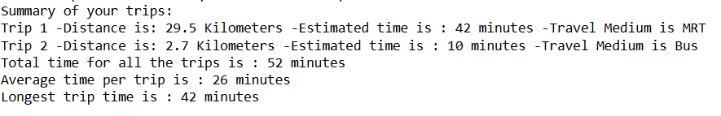
Importance of feature and evidence:
The Travel Time Estimator provides significant value as it allows users to plan their journey not only based on cost but also time. Time is an important factor for commuters, especially students. By giving them an estimate of how long trips will take it allows for better time management and helps make better decisions. This feature doesn't modify fares or MRT operations. It supports better planning for users, during exam seasons, job interviews, or medical appointments all situations where time sensitivity is high.
Evidence:
Official Land Transport Authorities’ app MyTransport has a Plan Your Journey tool which estimates travel time helping them make informed decisions, reviews on Google Play show users find it helpful. One says, “Very handy... helps me plan my travel times so I’m never late.” This shows that knowing travel times is something users benefit from, and this feature solves this by giving estimated travel times.
Sources for speed
MRT:
https://danielbowen.com/2016/06/10/singapore-mrt/
Bus:
https://medium.com/from-the-red-line/lets-talk-average-bus-speeds-e532eff5b550

