

SCHOOL OF INFORMATICS & IT

DIPLOMA IN APPLIED ARTICIFICAL INTELLIGENCE
DIPLOMA IN BIG DATA & ANALYTICS
DIPLOMA IN COMMON ICT PROGRAMME
DIPLOMA IN CYBER & DIGITAL FORENSICS
DIPLOMA IN IMMERSIVE MEDIA & GAME DEVELOPMENT
DIPLOMA IN INFORMATION TECHNOLOGY

AY2025/ 2026 APRIL SEMESTER
CYBERSECURITY FUNDAMENTALS (CCF1C03)

PROJECT REPORT

Student Name (Matric Number) : Mohammed Hannan Noor

Tutorial Group : PC23
Jenny LING (TP)
Tutor : Pauline Teo

Submission Date : 31/7/2025

Declaration of Originality

I am the originator of this work and I have appropriately acknowledged all other original sources used as my references for this work.

I understand that Plagiarism is the act of taking and using the whole or any part of another person’s work, including work generated by AI, and presenting it as my own.

I understand that Plagiarism is an academic offence
and if I am found to have committed or abetted the offence of plagiarism in relation to this submitted work, disciplinary action will be enforced.

Table of Contents
Declaration of Originality 0
1. LinkedIn Profile 2
2. Windows Lab 2
3. Network Services 2
4. CIS Benchmark 2
5. Conclusion 3
6. Appendix and References 3

Provide a complete TOC to the various sections/sub-sections in your report.

Suggested Project Report Format / Contents:
The documentation should not be more than 25 A4 size pages (excluding Appendix and References), font size 12, Times New Roman, and should minimally consists of the following documentation:

LinkedIn Profile (5 marks)
- Screenshot of the completed Windows certifications
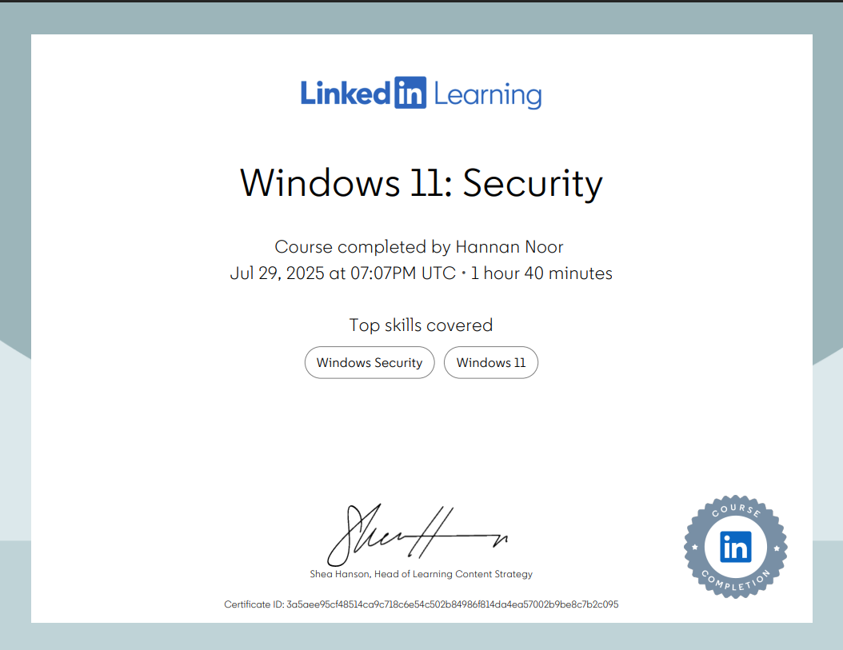
- Screenshot showing the certification of completion in the LinkedIn Profile
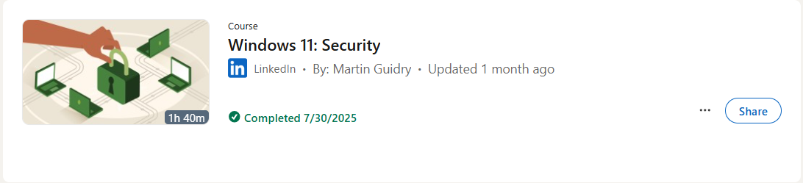
- URL link to your LinkedIn Profile page
https://www.linkedin.com/in/hannan-noor-875648361/

Windows Lab (5 marks)
Screenshots results of the following done in your VM
- Lab exercise “2.4 Creating and using groups” 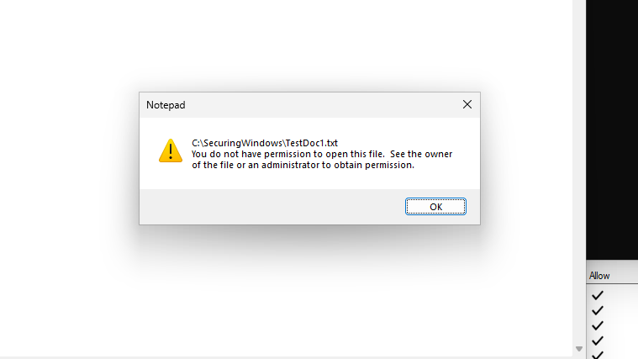
- Lab exercise “3. Using Bit Locker” Bit Locked drive E: 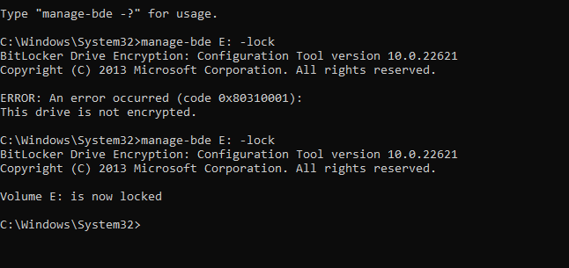
- Lab exercise “3.1 Using EFS” encrypt <your name>.txt file 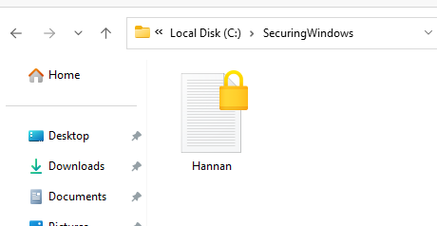
- Lab exercise “4. Firewall and Network protection”
successful ping from laptop to VM
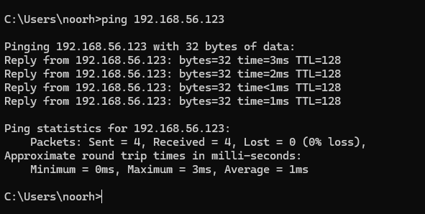
- Lab exercise “5.1 Using Group Policy to audit actions in Window”
Audit Failure captured event for failed login
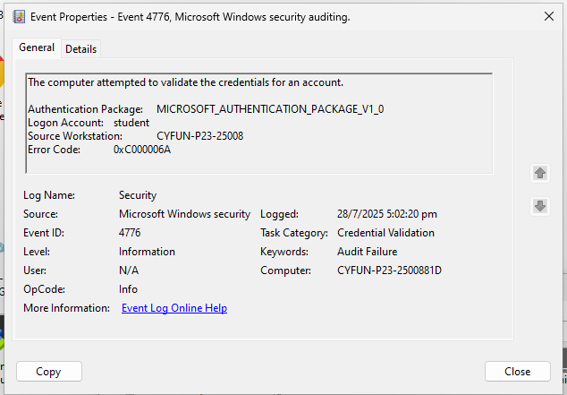

Network Services (10 marks)
- PART 1: SET UP SECURE FTP (FTPS) WITH SSL/TLS

First I set the network adapter attached to Host-Only Adapter. A Host-Only Adapter creates a private network between the host computer and the virtual machine. It allows file transfers and secure service testing (like FTP) without giving the VM internet access. Only the host and VM can communicate on this network.
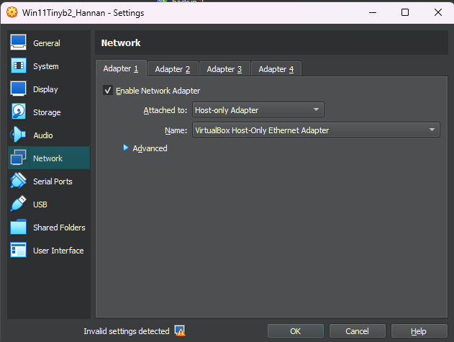

What is SSL/TLS?

SSL/TLS are protocols that encrypt data sent over networks. TLS is the newer, more secure version. It works by using certificates to establish trust and encryption keys to secure data. This ensures safe communication between systems, such as in FTPS and HTTPS.

Then I installed IIS FTP Features. I did this by navigating to Control Panel > Programs > Programs and Features > Turn Windows features on or off. Then I enabled IIS management console and FTP service. This will enable the windows features (FTP Service and IIS management console) which is needed to host an FTP server
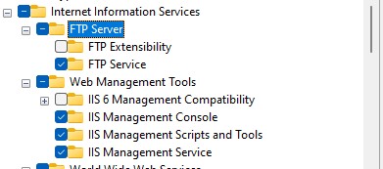

Next, I created a Self-Signed SSL Certificate. I did this by opening IIS manager open IIS > Server Certificates then created a Self Signed Certificate. This certificate is used later to secure the FTP connection with encryption.
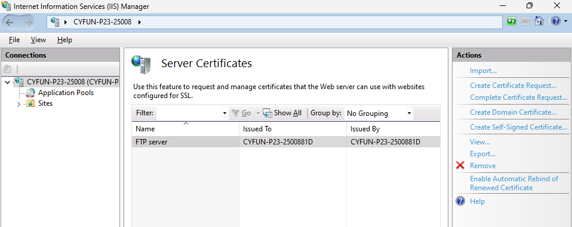

Next I enabled FTP Rules in Windows Firewall, I did this by navigating to Control Panel > System and Security > Windows Defender Firewall⁴ > Advanced Settings > Inbound Rules . Then enabled the three FTP rules. I did this as if I do not enable the rules the FTP server might block incoming connections and the WinSCP later might not be able to connect to the VM.
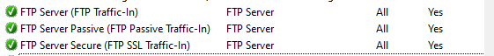

Next I Added the FTP Site. I did this by navigating to IIS Manager then Navigating to sites then clicking on the Add FTP Site action. I made sure to select Require SSL to disallow non-encrypted connections. I also allowed the user student to read and write.Now the FTP Site has been created
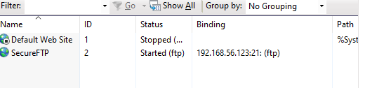

Next I Installed WinSCP on my laptop(not the VM), and connected to the VM
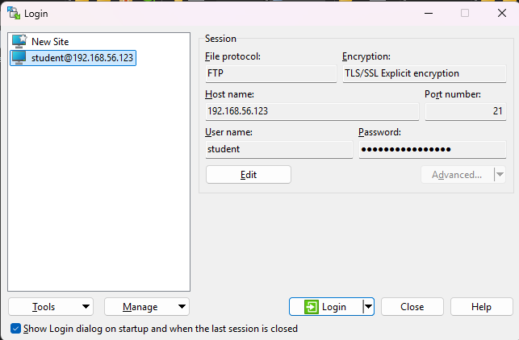

Next I successfully sent over a file called HELLO VM through the FTP from host machine(my laptop ) to the VM.
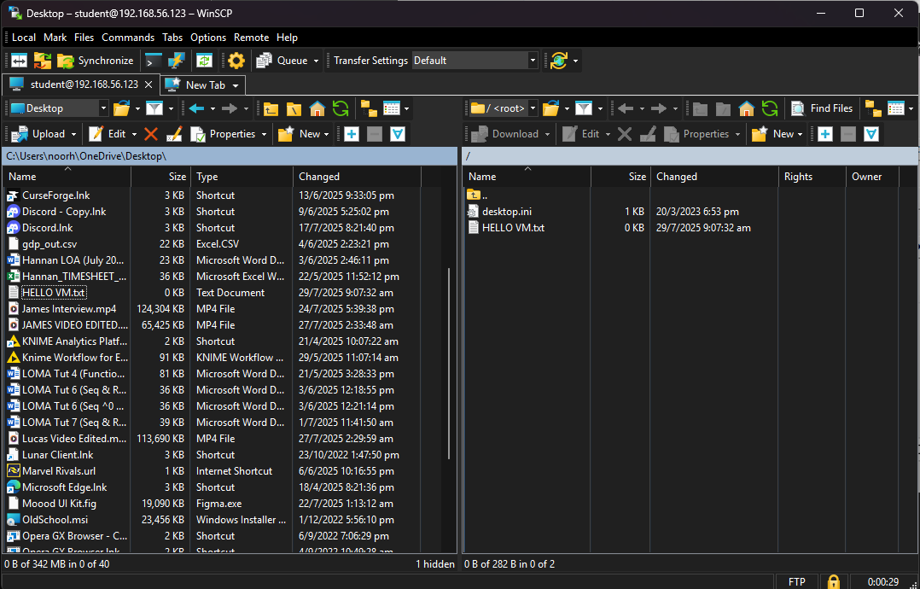
File was found in downloads fold er
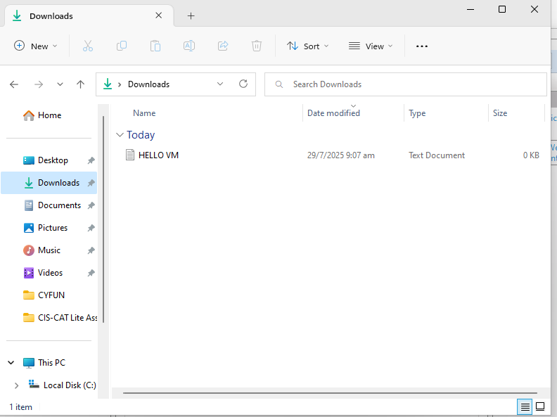

Set up secure IIS web service with SSL using self-signed certificate

First I configured the network settings in virtual box, I set the adapter type to NAT and added a rule for port forwarding. NAT is a virtualbox network adapter that lets the VM access the internet but it blocks the connections from the laptop(not VM) to the VM, hence the rule for port forwarding is setup in order to let the FTP through to it.
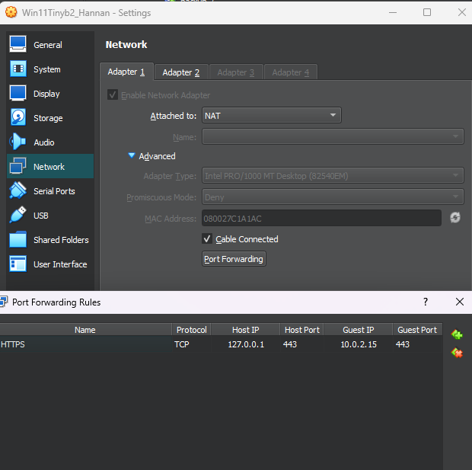

To prepare the system for IIS-based FTP and web services, I enabled required IIS features using Command Prompt and the Deployment Image Servicing and Management (DISM) tool.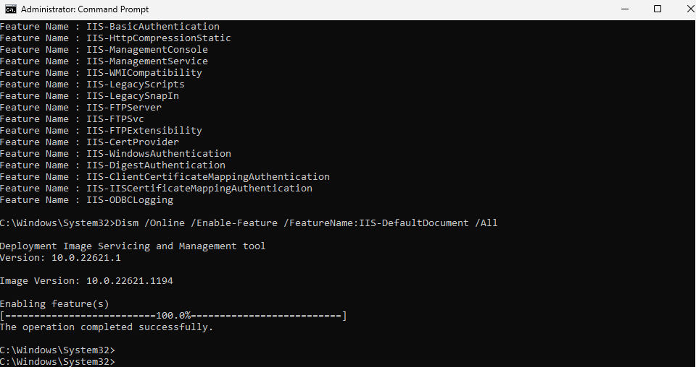

Next, in order to setup IIS SSL self-signed website on my Win VM to listen on VM NAT Adapter network (10.0.2.15), I opened the IIS manager and edited the default website and added a binding. This ensures the IIS site listens for HTTPS traffic within the VM’s NAT network, and works with VirtualBox port forwarding to allow access from my host browser via https://127.0.0.1

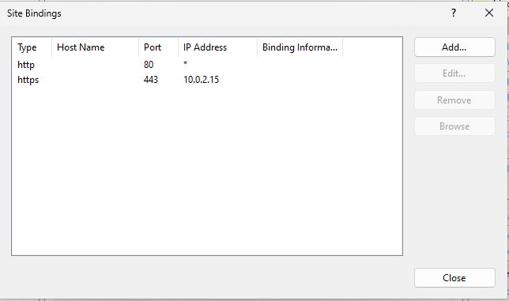

I then Successfully connected to the website on my laptop (not VM) with the link https://127.0.0.1. The ip address 127.0.0.1 is a loopback address that refers to the host device. It is normally used for testing local network services. In this case, port forwarding maps the IIS HTTPS service on the VM to the host's loopback address. This allows my host browser(on my laptop not VM) to access the VM's web server through https://127.0.0.1
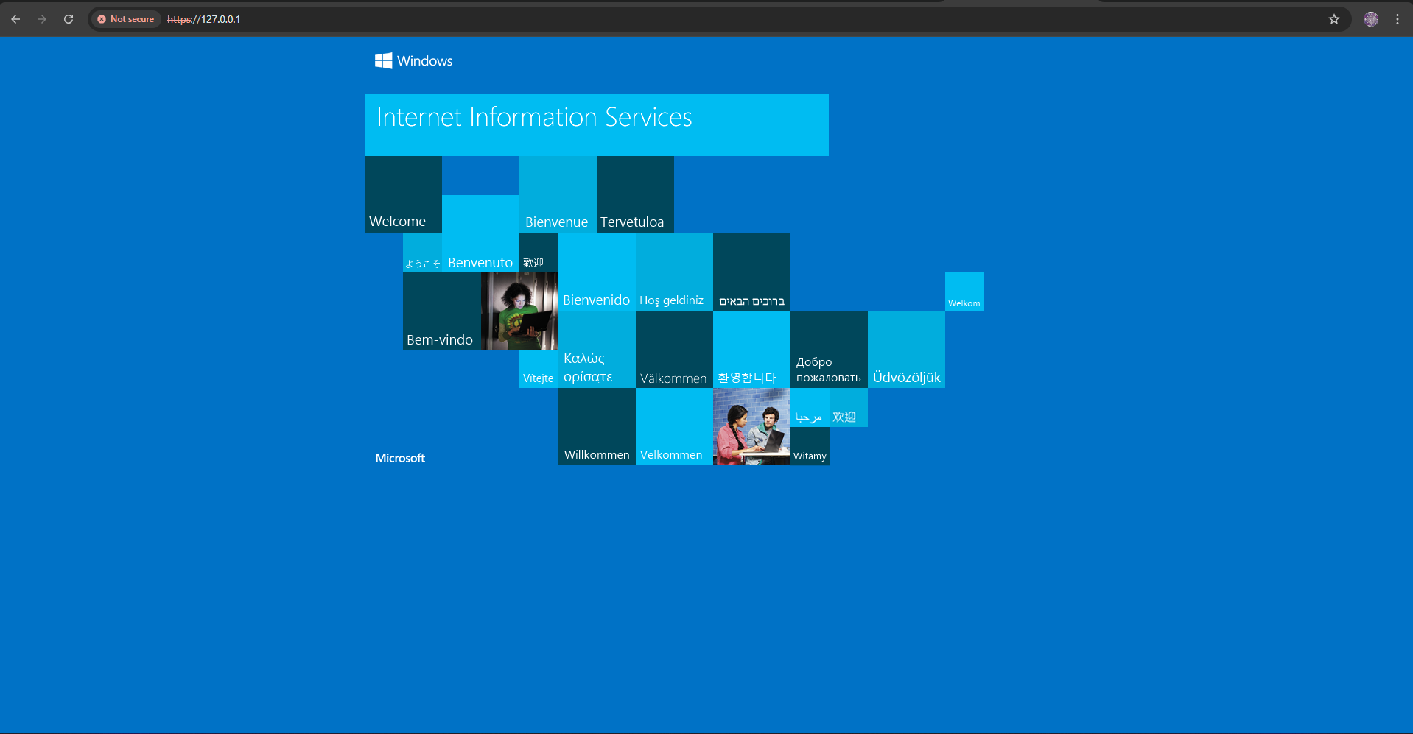

CIS Benchmark (2 marks for each rectification x 10 = 20 marks)
- Screenshots of CIS before rectification and after rectification results
Account Policies
Before rectification:
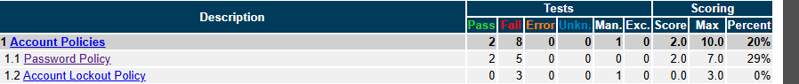
For account policies I first rectified 1.0, 1.1.1. (L1) “Ensure Password History” is set to 24 or more passwords. I did this by using group policy editor and navigating to ComputerConfiguration\Policies\WindowsSettings\SecuritySettings\AccountPolicies\Password Policy\Enforce password history. Then changing the value for “ Keep password History for ___ passwords remembered.” From 0 to 24. This will make it so that users cannot use the same password as any of their last 24 password hence increasing security, as using the same password as their last passwords is a common vulnerability. Enforcing history of 24 passwords prevents reuse and improves security.
Next I rectified 1.0 1.1.4 (L1) Ensure 'Minimum password length' is set to '14 or more character(s)'I did this by using group policy editor and navigating to ComputerConfiguration\Policies\WindowsSettings\SecuritySettings\AccountPolicies\Password Policy\Minimum password length. Then I changed the value for “___ characters) from none to 14. This makes it so passwords have to be at least 14 characters long, this results in stronger passwords that are harder to crack through brute force attacks.
After rectification:
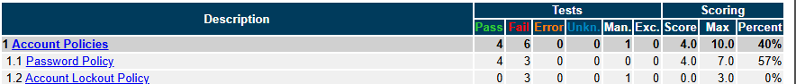
Local Policies
Before rectification:
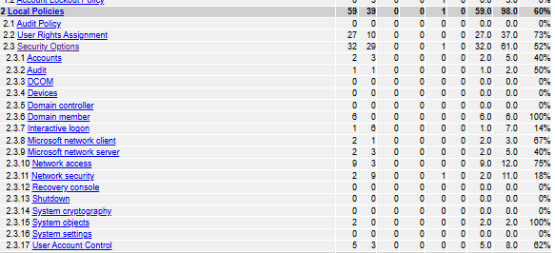
For Local Policies I first rectified 2.3.1.4 (L1) Configure 'Accounts: Rename administrator account'. I did this my navigating to Computer Configuration\Policies\Windows Settings\Security Settings\Local Policies\Security Options\Accounts: Rename administrator account, in group policy editor . I then changed the name of the built-in administrator account from “Administrator” to Hannan Noor. This makes it harder for attackers to guess the default admin username, which is a common target in brute force or dictionary attacks. By renaming it, the system becomes less predictable and therefore more secure.
Next I rectified 2.2.38 (L1) Ensure 'Shut down the system' is set to 'Administrators, Users’. I did this by navigating to Computer Configuration\Policies\Windows Settings\Security Settings\Local Policies\User Rights Assignment\Shut down the system. I then removed Backup Operators from this path so that only Administrators and Users are listed. This setting controls who’s allowed to shut down the machine and restricting it prevents irregular users or malicious software from shutting down the machine which could result in disruption or exploitation.
After Rectification:
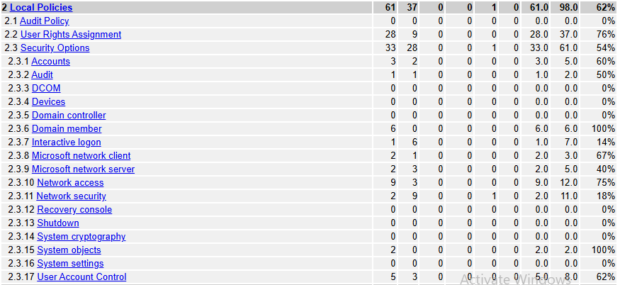
System Services
Before Rectification(System Services):

For system services I first rectified 5.23 (L1) Ensure 'Remote Procedure Call (RPC) Locator (RpcLocator)' is set to 'Disabled'. I did this by opening registry editor then navigating to SYSTEM\CurrentControlSet\Services\RpcLocator, then clicking on Start then adjusting the Start dword value from 3 to 4. This disables the RpcLocator service from starting. Since RpcLocator is a legacy service that is rarely needed on modern systems, disabling it reduces the number of potentially vulnerable services running, thereby lowering the system’s overall attack surface.

Next I rectified 5.36 (L1) Ensure 'Windows Mobile Hotspot Service (icssvc)' is set to 'Disabled'. I did this by opening the registry editor then navigating to HKEY_LOCAL_MACHINE\SYSTEM\CurrentControlSet\Services\icssvc, I then changed the Start dword value from 3 to 4. This disabled the Mobile Hotspot service, which is used to share internet connection over Wi-Fi. Disabling this prevents unauthorized network sharing, which can expose the internal network to wardrivers or other hackers.
After rectification:
Windows Defender Firewall with Advanced Security
Before rectification:
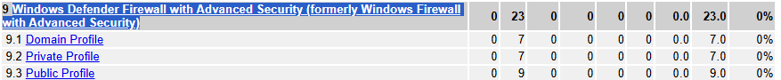
For Windows Defender Firewall with Advanced Security I first rectified 9.3.1(L1) Ensure ‘Windows Firewall: Public: Firewall state’ s set to ‘On (recommended)’. I did this by navigating to Computer Configuration\Policies\Windows Settings\Security Settings\Windows Defender Firewall with Advanced Security\Windows Defender Firewall with Advanced Security\Windows Firewall Properties\Public Profile\Firewall state, In Group Policy Editor then changing the firewall state from not configured to On. This enables the firewall when connecting to public networks. By doing this it prevents traffic from being able to access the system and makes it harder for an attacker to remotely exploit a weakness in a network service.
Next I rectified 9.3.7 (L1) Ensure 'Windows Firewall: Public: Logging: Size limit (KB)' is set to '16,384 KB or greater'. I did this by navigating to Computer Configuration\Policies\Windows Settings\Security Settings\Windows Defender Firewall with Advanced Security\Windows Defender Firewall with Advanced Security\Windows Firewall Properties\Public Profile\Logging Customize\Size limit (KB), in Group policy editor, then changing the size limit from 4,096 to 16,384. This increases the log file size to retain more firewall events, which helps with security auditing and prevents important log data from being overwritten.
After rectification:
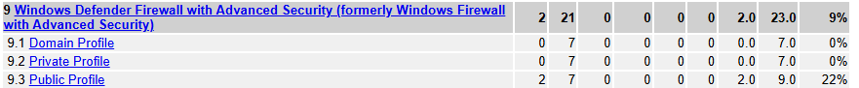
Advance Audit Policy Configuration
Before rectification:
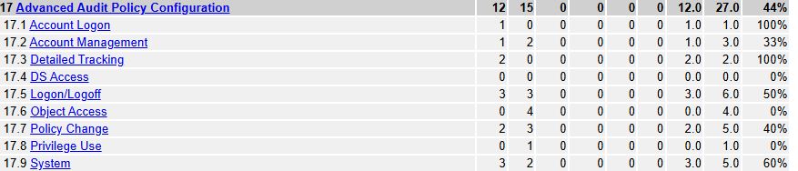
For Advance Audit Policy Configuration, I first rectified 17.5.1 (L1) Ensure 'Audit Account Lockout' is set to include 'Failure'. I did this by navigating to Computer Configuration\Policies\Windows Settings\Security Settings\Advanced Audit Policy Configuration\Audit Policies\Logon/Logoff\Audit Account Lockout, In Group policy editor, then enable failure. This makes it so failed account lockout events are logged and auditing these events may be useful when investigating a security incident.
Next I rectified 17.2.3 (L1) Ensure 'Audit User Account Management' is set to 'Success and Failure' . I did this by navigating to Computer Configuration\Policies \Windows Settings\Security Settings\Advanced Audit Policy Configuration\Audit Policies\Account Management\Audit User Account Management, in Group policy editor, then enabling both success and failure. This makes sure events related to User Account Management like account creation and password creation are logged. These logs can be useful for detecting unauthorised changes and when investigating a security incident.
After rectification:
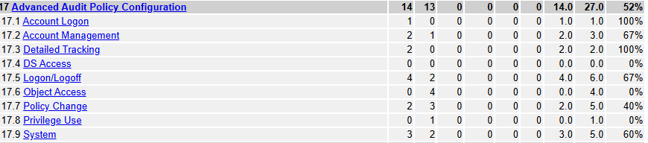

After rectification:

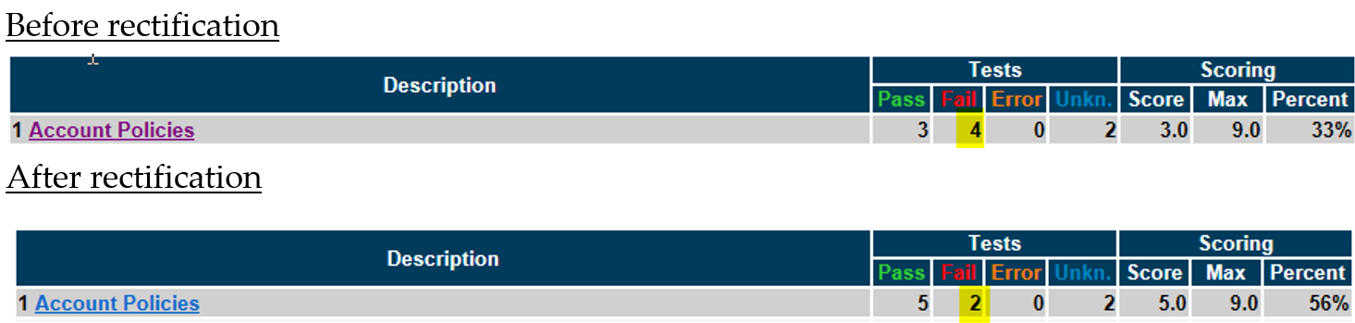

Conclusion
Through this project i gained experience in securing windows systems using Group Policy Editor, CIS-CAT and IIS. I learned to find and remediate security weaknesses using the CIS Benchmark and also learned setup secure FTP and HTTPS services with SSL/TLS. I also learned about concepts like NAT, host-only adapters and port forwarding. Overall, this project taught me how to harden systems and how each configuration contributes to increased security.

In addition to technical skills, this project also allowed me to develop non-technical skills. I improved my research skills by independently researching how to setup FTP and set up secure IIS web service / I also learned to manage my time more effectively, as I had to juggle doing multiple assignments. When I faced technical issues like configuration errors or FTP connection problems i learned to troubleshoot camply and persistently by using online resources and trial and error to find solutions

Appendix and References
- Reference Sources :
https://www.youtube.com/watch?v=MQ5meMLV6bc&t=140s
https://winscp.net/eng/docs/guide_windows_ftps_server#on_windows_desktop_windows_11_windows_10_ windows_8_windows_7_and_windows_vista
https://learn.microsoft.com/en-us/iis/manage/configuring-security/how-to-set-up-ssl-on-iis
https://www.itechguides.com/how-to-install-iis-in-windows-11/#:%7E:text=How%20Do%20I%20Enable%20IIS,Then%20click%20the%20OK%20button
https://www.activecountermeasures.com/port-forwarding-with-virtualbox/

- Include a screenshot of your completed TESSy Survey response

