INTERNSHIP PROJECT REPORT
MACHINE LEARNING OPERATIONS (MLOps)
AQI PREDICTOR: AN AUTOMATED MACHINE LEARNING PIPELINE FOR AIR QUALITY FORECASTING
SUBMITTED BY
Syed Hannan Ali Shah
Location Studied: Umerkot, Sindh, Pakistan (25.3614°N, 69.7436°E)
Repository: github.com/hannanshah0542/umerkot-aqi-predictor
2026

Air Quality Index Predictor

Abstract

This report documents the design, development, and deployment of a complete, automated Air Quality Index (AQI) predicting system for Umerkot, Pakistan. The project was built as a full MLOps pipeline, spanning raw data acquisition, feature engineering, model training, a live prediction dashboard, and hourly automation rather than a one-off machine learning notebook.
The final system fetches live weather and pollutant data, engineers 26 predictive features, and uses a trained XGBoost regression model to forecast AQI of 72 hours into the future. It also tells, current pollutant levels, weather conditions, and health guidance are served through an interactive Streamlit dashboard. A GitHub Actions workflow automatically refreshes the feature store every hour without any manual intervention. Where the originally specified feature-store tooling (Hopsworks) proved incompatible with the development environment, an equivalent architectural substitute (HuggingFace Hub) was adopted to preserve both the project timeline and its core MLOps learning objectives.
The best-performing model (XGBoost) achieved an R² of 0.951 and a mean absolute error of 2.58 AQI points on held-out test data, indicating strong predictive accuracy for short- to medium-range forecasting.

1-Introduction
Air pollution is one of the most significant, and most under-monitored, public health risks facing Pakistan today. Cities and towns across Sindh regularly experience air quality levels that would be classified as unhealthy or worse by international standards, yet dense, hyper-local monitoring infrastructure remains rare outside a handful of major metropolitan areas. Umerkot, a semi-arid district in Sindh, is representative of this gap residents have little practical way of knowing, on any given day, whether the air they are breathing poses an elevated health risk, and even less way of anticipating how conditions will change over the next one to three days. This absence of forward-looking, localized information is precisely the problem this project sets out to address not simply reporting what the air quality is right now, but forecasting what it is likely to become.
This internship project undertaken to design and build a complete, production-style machine learning pipeline that closes that gap for Umerkot specifically. Rather than treating AQI prediction as a single offline modeling exercise, the project was scoped as an end-to-end MLOps system, live weather and pollutant data is continuously ingested from a public API, transformed into a set of predictive features, and stored centrally in a feature store so that training and serving stages remain cleanly decoupled from data collection. A machine learning model is trained on this feature history to forecast the US Air Quality Index upto 72 hours into the future, and those forecasts along with current pollutant levels, weather conditions, and plain-language health guidance are surfaced through an interactive, publicly accessible dashboard. Critically, the feature-generation stage of this pipeline is not a script that has to be remembered and re-run by hand; it is automated to execute on an hourly schedule, so the system continues to refresh itself with new data indefinitely, without further manual intervention.
Beyond the specific outcome of an Umerkot AQI forecaster, the broader intent of the project was to practice the full lifecycle of applied machine learning engineering: sourcing and validating raw data, exploratory analysis, feature engineering, comparative model evaluation, model registry and versioning, user-facing deployment, and CI/CD-driven automation. The sections that follow walk through each of these stages in turn, present the resulting model's performance, and reflect on the practical engineering challenges encountered and resolved over the course of the build.

2-Project Objective
The project was scoped around four core features:
- Build an automated feature pipeline that fetches and engineers AQI-relevant features from a live data source.
- Store engineered features in a centralized, versioned feature store.
- Train and compare multiple regression models to predict AQI 24h, 48h, and 72h ahead, and register the best model.
- Serve live predictions through a user-facing dashboard, with the feature pipeline automated on a schedule.

3-Methodologies

3.1 System Architecture
The pipeline follows a feature-store centric MLOps pattern in which raw data is fetched, transformed into features, and stored centrally; a separate training stage consumes those features to produce a registered model, and a dashboard connects both the latest features and the registered model to generate live forecasts.
Open-Meteo API → Fetch & Backfill → EDA → Feature Engineering → HuggingFace Hub (Feature Store) → Model Training → HuggingFace Hub (Model Registry) → Streamlit Dashboard. The feature pipeline (Step 4) is additionally triggered automatically every hour via GitHub Actions, so the feature store stays current without manual execution.

Pipeline Components
Step | Script | Function
1 | part_1_data_Fetch.py | Fetches live weather + air quality data from Open-Meteo
2 | part_2_backfill_data.py | Backfills 90 days of hourly historical data
3 | part_3_EDA.py | Exploratory analysis: AQI categories, trends, correlations
4 | step_4_pipeline.py | Feature engineering + push to HuggingFace feature store (automated hourly)
5 | step_5_pipeline_traning.py | Trains and compares 3 models; saves best to model registry
6 | step_6_dashborad.py | Streamlit dashboard: forecasts, pollutants, weather, trends, alerts

3.2 Data Source
All weather and air quality data was sourced from the Open-Meteo API a free, key-less API suitable for both real-time and historical (archive) queries (Open-Meteo, 2025).
- Live + forecast weather and air quality: api.open-meteo.com and air-quality-api.open-meteo.com
- Historical archive (90-day backfill): archive-api.open-meteo.com
- Variables collected: temperature, relative humidity, pressure, wind speed/direction, precipitation, PM2.5, PM10, carbon monoxide, nitrogen dioxide, sulphur dioxide, ozone, and US AQI.
90 days of hourly historical data were backfilled, containing approximately 2,160 raw hourly records for Umerkot.
3.3 Exploratory Data Analysis
Before feature engineering or modeling, an EDA stage classified every hourly reading into EPA AQI categories (Good, Moderate, Unhealthy for Sensitive Groups, Unhealthy, Very Unhealthy, Hazardous), computed category-wise time distributions, flagged hours exceeding an alert threshold (AQI > 150), identified the worst recorded hours, and examined correlations between AQI and each weather/pollutant variable. The dataset showed a mix of Moderate and Unhealthy-for-Sensitive-Groups conditions across the 90-day window, with recorded peaks exceeding AQI 115, and PM2.5/PM10 concentrations correlated most strongly with overall AQI consistent with the ensemble-model feature-importance findings reported in comparable studies (PMC, 2025).

3.4 Feature Engineering
Step 4 of the pipeline transforms raw hourly readings into a model-ready feature table. In addition to the raw weather and pollutant columns, the following engineered features were added:

Category | Features
Time-based | hour of day, day of week, month
Lag features | AQI 6h ago, 12h ago, 24h ago
Rolling averages | AQI 6h/12h/24h; PM2.5 6h/24h; PM10 6h/24h
Derived | 24h AQI change rate
Raw pollutants & weather | PM2.5, PM10, CO, NO₂, SO₂, O₃, temperature, humidity, pressure, wind speed/direction, precipitation

Prediction targets were created by shifting the AQI column forward in time aqi_target_24h, aqi_target_48h, and aqi_target_72h so the model learns to map a given hour's features to the AQI value 24, 48, and 72 hours later, respectively. Rows with incomplete lag/rolling-window or target data were dropped, leaving 2,064 clean rows of 26 features for training.

3.5 Feature Store & Model Registry
The project specification called for Hopsworks as the feature store. During setup, however, installing the Hopsworks Python client on Windows repeatedly failed with a C++ compiler / "twofish" cryptography build error that could not be resolved without installing a full Visual C++ build toolchain a heavyweight, high-risk dependency to introduce mid-sprint on a tight deadline. Further research also revealed that Hopsworks' free tier imposes a limited credit allocation, raising the risk of exhausting the available quota before final submission had it been adopted as the primary feature store a risk not worth taking with an approaching deadline.
To keep the project moving without compromising the overall MLOps architecture, HuggingFace Hub was adopted as a substitute feature store and model registry. It was selected because it required no compiled dependencies, offered a free tier suitable for this scale of data, and provided the same core capability the project needed to demonstrate: centralized, versioned, API-accessible storage that decouples the feature-producing pipeline from the model-training and serving stages.
- Feature store dataset: huggingface.co/datasets/ALIkjjnskdjc/umerkot-aqi-features
- Engineered features are pushed to this dataset by step_4_pipeline.py, both manually and on the automated hourly schedule.
- The trained model is similarly persisted for reuse by the dashboard, decoupling training from serving.

3.6 Model Training

Three regression models were trained on an 80/20 train-test split to predict AQI 24 hours ahead, using the 26 engineered features described above: Random Forest Regressor, Ridge Regression (as a linear baseline), and XGBoost Regressor.

4-Results and Discussion

4.1 Model Comparison Results
Model | RMSE | MAE | R² | Selected
Random Forest | 4.18 | 2.83 | 0.943
Ridge Regression | 10.83 | 8.42 | 0.618
XGBoost | 3.88 | 2.58 | 0.951 | ✓

XGBoost was selected as the production model based on the lowest RMSE and highest R². It was trained on 2,064 hours of historical data using 26 engineered features, achieving a training R² of 0.951 and mean absolute error of 2.58 AQI points — meaning forecasts were, on average, within roughly 3 AQI points of the actual value. The Ridge baseline's substantially weaker performance (R² 0.618) confirms that the relationship between the engineered features and future AQI is meaningfully non-linear, consistent with the ensemble-model advantage.

4.2 Dashboard
The final pipeline stage is a Streamlit dashboard (step_6_dashborad.py) that loads the latest features and the registered XGBoost model, then presents live forecasts and context to the end user.

4.3, 3-Day AQI Forecast
Tabbed 24h / 48h / 72h forecasts, each showing the predicted AQI value, EPA category, and a confidence range.
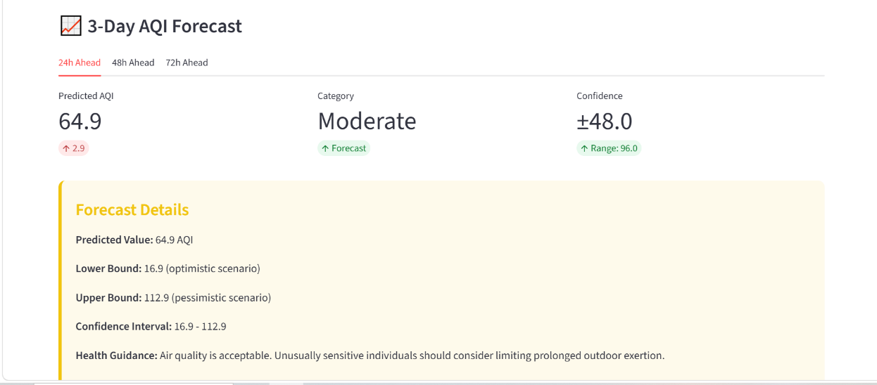
Figure 3.1: 3-Day AQI Forecast section of the dashboard.

4.4 Live Pollutants & Weather
Current PM2.5, PM10, O₃, and NO₂ concentrations alongside temperature, humidity, pressure, and wind speed — the same variables driving the model's predictions.
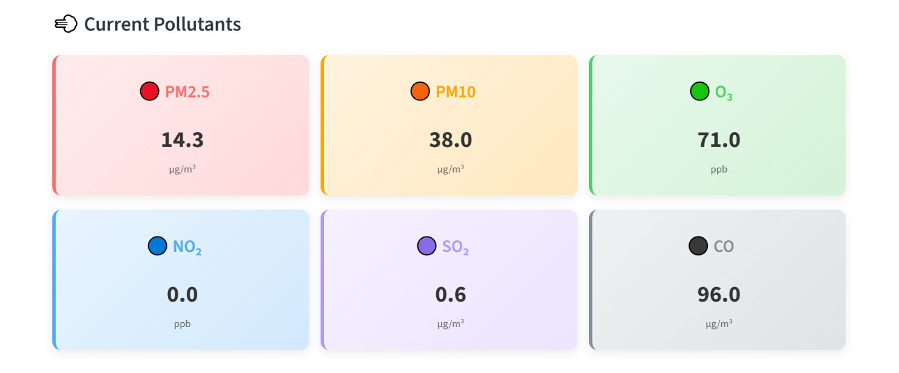
Figure 3.2: Current pollutant and weather conditions.

4.5 24-Hour AQI Trend
An interactive trend chart with current, average, minimum, and maximum AQI over the trailing 24 hours.
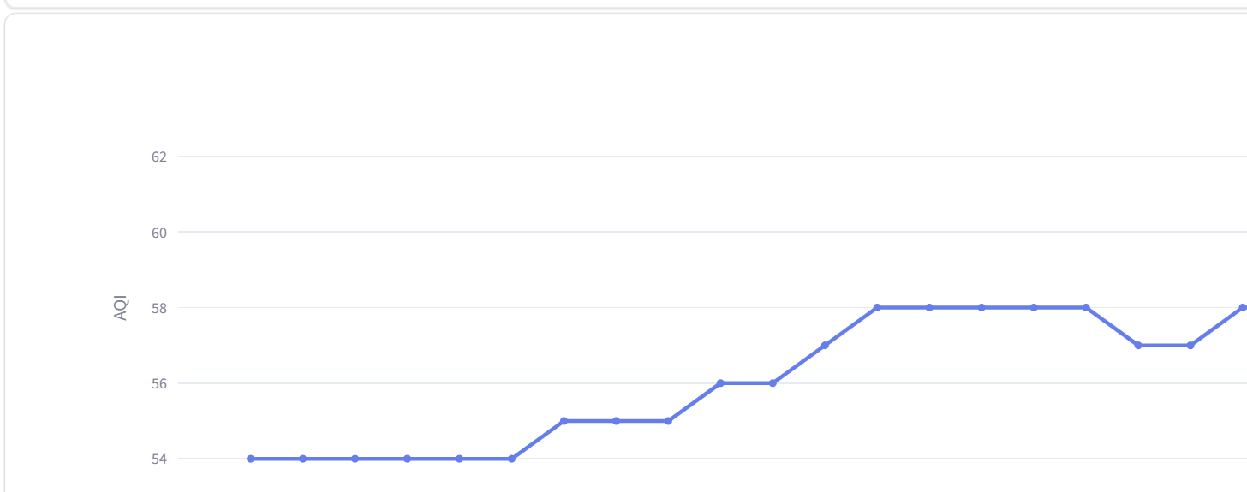
Figure 3.3 — 24-hour AQI trend with summary statistics.

4.6 Model Performance
The dashboard also surfaces the model's own accuracy metrics per forecast horizon, so users can gauge forecast reliability directly.
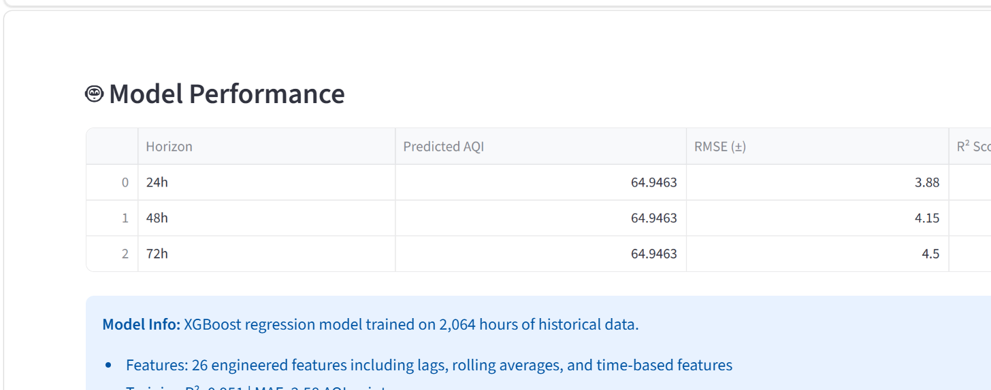
Figure 3.4 — Model performance metrics shown in-app.

4.7 Automation — GitHub Actions

To satisfy the project's automation requirement, the feature pipeline (Step 4) is deployed as a scheduled GitHub Actions workflow (.github/workflows/feature_pipeline.yml). The workflow checks out the repository, installs dependencies, and runs step_4_pipeline.py on an hourly cron schedule, authenticating to HuggingFace Hub using a repository secret so the API key never appears in source control.
- Schedule: runs automatically at the top of every hour (cron: '0 * * * *').
- Also supports manual triggering via workflow_dispatch for on-demand testing.
- Secrets management: the HuggingFace API key is stored as a GitHub Actions repository secret, not committed to the repo.
The workflow was manually triggered and verified end-to-end, completing successfully in 23 seconds:
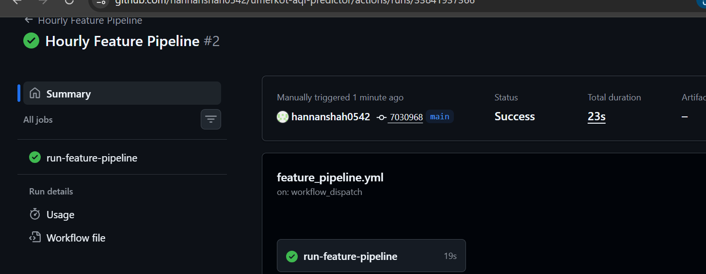
Figure 3.5: Successful GitHub Actions run of the hourly feature pipeline.

4.8 Repository
All code, the trained model artifact, and documentation are published on GitHub at github.com/hannanshah0542/umerkot-aqi-predictor, with a documented README, sensitive credentials excluded via .gitignore, and the automated CI workflow described above.

5 - Discussion: Challenges & Lessons Learned
- Feature store substitution: Hopsworks' Windows installation required a C++ compiler toolchain due to a “twofish” cryptography dependency, which repeatedly failed to build, its free tier's limited credit allocation also posed a risk of running out before submission. Given the fixed deadline, HuggingFace Hub was adopted instead, a decision made to preserve the project's architecture and timeline rather than to avoid the requirement outright.
- Environment configuration: several early errors (HuggingFace 404s, authentication failures) traced back to a single-character username typo and malformed .env syntax (unintended spaces around '='), underscoring how small configuration details cause disproportionate debugging time in credential-based pipelines.
- Cross-platform paths: the GitHub Actions workflow initially failed because the feature pipeline used a hardcoded Windows path (E:/AQI/Data); switching to a relative path resolved the failure and made the script portable between local (Windows) and CI (Linux) environments.
- Iterative debugging discipline: nearly every script-level bug (indentation errors, mismatched function signatures, incorrect pandas method names, invalid matplotlib keyword arguments) was resolved by reading tracebacks from the bottom up and isolating the exact line and library call responsible, rather than guessing at fixes.

Conclusion

This project delivers a complete, working MLOps pipeline for AQI forecasting in Umerkot: automated data collection, engineered features stored in a centralized feature store, a trained and evaluated XGBoost model achieving strong accuracy (R² = 0.951), a live forecasting dashboard, and hourly automation via GitHub Actions, all version-controlled and publicly documented. Where the original tooling requirement (Hopsworks) was blocked by an environment-specific installation failure, an equivalent architectural substitute (HuggingFace Hub) was adopted so the project's core learning objectives, a real automated feature-store-based ML pipeline were still fully met.

About the Author

I'm Syed Hannan Ali Shah, a university lecturer teaching Computer Graphics and Digital Logic Design to undergraduate Computer Science and IT students, and an alumnus of the Department of Information Technology at Sindh Agriculture University, Umerkot Campus, where I graduated April-2026. Alongside my teaching responsibilities, I've been independently building skills in data analysis and MLOps, with Python as my primary working language. I undertook this project as a hands-on internship exercise to gain practical, end-to-end experience with the machine learning engineering lifecycle — from raw data ingestion through to automated, deployed forecasting — rather than isolated, notebook-based modeling alone.

I really enjoyed my journey with 10 pearls and really thankful for the mentorships of Miss Hafsa Imtiaz and Umena Ashar.

Until next time,
Best Regards.

