
University Way London, E16 2RD United Kingdom

Module Name: Name: DS7006 2526 (T1) Quantitative Data Analysis (QDA) (OC)
(M-Level Module - DS7006)

Submitted by Submitted To
Abdulhannan Samirbhai vhora Prof. Dr. Yang Li
STUDENT ID – U2828994

Contents
Section1: Acknowledgements 4
Section2: Abstract 5
Section 3:Introduction 5
Section 4: Literature Review 6
Section 5: Research Questions 6
RQ1 6
RQ2: 7
RQ3 7
RQ4: 7
RQ5: 7
Section 6: Methodology 7
Data Sources and Data Preparation 8
Variable Definition and Classification 8
Dependent Variable 8
Independent Variables 8
Harmonisation of Local Authority Codes 9
Dataset Integration Using LA_code 9
Data Standardisation and Preparation 9
Analytical Framework and Techniques 9
General Analytical Strategy 9
Exploratory Data Analysis and Statistical Testing 10
Principal Component Analysis and Regression Modelling 10
Spatial Visualization 10
Section 7: Implementation 11
Distributional Diagnostics and Normality Assessment 11
Correlation Analysis and Predictor Reduction 11
KMO and MSA Diagnostics 11
Principal Component Analysis 12
Regression Modelling and Diagnostics 12
Spatial Visualisation 12
Section 8:Result: 13
Outcomes of Local Authority Code Harmonisation 13
Missing Data Patterns 13
Exploratory Data Analysis 14
Variables of Age Structure: 14
Deprivation Variables 14
Economic Activity Variables 15
Health Variables 15
Housing Variables 16
Travel-to-Work Variables: 16
Correlation Analysis Results 17
Spearman Correlation 17
Partial Correlation Controlling for Age 17
PCA Suitability Results 17
Rotated Component Structure 18
Rotated PCA loadings (|loading| ≥ 0.40) 18
PCA Scores Regression Results 18
Diagnostics and Accuracy of the Model 19
Spatial Visualisation of COVID-19 Mortality 19
Section 9: Discussion 20
Section 10: Conclusion 20
Section 11: Bibliography 21
Section12:Appendix 22

Section1: Acknowledgements
I would like to express my sincere gratitude to all those who supported and guided me throughout the completion of this research project.
First and foremost, I am deeply grateful to Professor Yang Li for his invaluable academic guidance, constructive feedback, and continuous encouragement. His expertise and mentorship were instrumental in shaping the analytical approach and overall quality of this study.
I would also like to thank the University of East London for providing access to essential academic resources, learning support, and datasets that made this research possible. The availability of Local Authority–level COVID-19 mortality data and associated socio-economic indicators was fundamental to the successful completion of this project.
My sincere appreciation goes to my family and friends for their constant support, patience, and motivation throughout the research process. Their encouragement provided invaluable personal support during this academic journey.
Finally, I acknowledge the wider academic and research community whose work on COVID-19, public health inequalities, and spatial analysis informed the theoretical framework and interpretation of this study.

Section2: Abstract
These pre-existing socio-economic and demographic vulnerabilities within local populations would suggest that COVID-19 outcomes were determined by more than biological factor considerations. COVID-19 mortality and population metrics are studied in this paper across 296 English Local Authorities using a quantitative analytic framework, integrating exploratory data analysis, non-parametric correlation screening, Principal Component Analysis, multivariate regression modeling, and spatial visualization in a manner to identify primary socio-electoral dimensions relative to mortality and thus control for non-normal distributions of data and multicollinearity among predictors.
Most socio-economic, health, deprivation, and mobility indicators were seen by exploratory data analysis to be nonnormally distributed, thereby justifying Spearman rank-order correlation. The strongest correlates of COVID-19 deaths per thousand population identified in correlation screening were health status of the population, socio-economic disadvantage, housing composition, economically inactive and certain travel-to-work characteristics. To control for the strong intercorrelation among these variables, PCA was run, and three orthogonal components were generated, accounting for a sizable proportion of the variance in the indicated elections.
Using the PCA component scores for regression analyses demonstrated moderate R² ≈ 0.29 cooperation in explaining, whereby COVID-19 mortality was therefore determined by interacting multiple socioeconomic factors and not a single variable. Poor health and socio-economic vulnerability were positively associated with mortality to a much greater degree; housing and mobility, although weaker, remained statistically significant. Clear clustering was also illustrated via spatial visualizations showing urban, coastal-post-industrial Local Authorities to have sustained higher mortality.
The findings altogether portray that COVID-19 mortality in England was greatly mediated by structural health inequalities, socio-economic disadvantage, built environment features, and social conditions. Addressing these socio-economic vulnerabilities is paramount in order to lower the risk factor for such public health emergencies in the future.

Section 3:Introduction
COVID-19 represents one of the most severe public health crises to occur in the twenty-first century due to the presence of the novel virus SARS-CoV-2. The novel infection was first identified in the late 2019, and within no time it spread across the world with its high transmissibility via respiratory droplets, aerosols, or close interpersonal contact. Beyond the immediate health impacts, the pandemic brought about widespread disruption of social and economic life, triggering extensive studies to understand the reasons behind variations in infection and mortality outcomes.

COVID-19 mortality in England was comparatively high, particularly during the first few waves in early 2020 and 2021. Mortality rates were, however, not evenly distributed across the landscape. Huge regional and Local Authority variations imply that the outcome cannot be explained through biological susceptibility or viral exposure, rather this distribution gives weight to suggest that the underlying condition of socio-economic and demographic relationships within local populations had made an impact.

Certain structural factors related to vulnerability to COVID-19 have been identified in previous research: these include age composition, pre-existing health inequalities, housing conditions, and labour market structure. Many Local Authorities entered the crisis with multifold entrenched socio-economic disadvantages, namely higher deprivation, poorer population health, and economic insecurity, which might have increased exposure and diminished resilience to COVID-19 altogether.

Epidemiological evidence identifies age-structure as operating as a determinant of mortality from COVID-19, with older populations much more at risk with severe illness and death. Mortality has in fact also been strongly correlated to baseline population health, particularly long-term illness and disability. In addition, deprivation and patterns of economic activity influence vulnerability in that the residents in deprived areas are more inclined to work in vulnerable/frontline occupations, depend on public transport, or live in crowded conditions. The urban form and type of housing further develop transmission risk through (increased) household crowding and shared living environments.

An analysis conducted on spatial inequalities concerning COVID-19 mortality would require geographically disaggregating these factors. Thus, this research would be focused upon the English Local Authorities, fittingly capturing meaningful variation in demographic composition, socio-economic conditions, and housing characteristics. Adopting a quantitative approach, the study employed exploratory data analysis, non-parametric correlation screening, Principal Component Analysis, multivariate regression modelling, and spatial visualization. By identifying structural characteristics associated with elevated mortality, the findings aim to inform targeted public health interventions and strengthen resilience to future public health emergencies.

Section 4: Literature Review
Global research has intensified in response to the COVID-19 pandemic to explain variation in mortality outcomes across populations and places. Beyond biological mechanisms such as viral exposure and individual comorbidities, a substantial body of literature highlights the importance of socio-economic, demographic, and environmental factors operating at community and regional scales (Marmot et al., 2020). In England, these determinants are especially relevant due to long-standing spatial inequalities in health, housing, and socio-economic conditions, which rendered some Local Authorities structurally more vulnerable to the pandemic (ONS, 2021). Consequently, socio-spatial analysis has become central to understanding unequal COVID-19 mortality.
Age structure is consistently identified as one of the strongest predictors of COVID-19 mortality. Epidemiological evidence shows that the risk of severe illness and death increases sharply with age due to declining immune function and higher prevalence of chronic disease (Williamson et al., 2020). Comparative studies across the UK and Europe demonstrate that areas with higher proportions of residents aged 70 years and above experienced significantly higher mortality (Kontis et al., 2021). Marked spatial variation in age composition across English Local Authorities therefore justifies the inclusion of age-related indicators in local-level analyses (ONS, 2020).

Section 5: Research Questions
RQ1: To what extent does Local Authority age structure influence COVID-19 mortality rates?
COVID-19 mortality across English Local Authorities was positively associated with older age structure. The Spearman correlation analysis revealed that older age groups maintained moderate positive associations with mortality and the younger age groups with negligible or weak associations. The age-related variables were heavily loaded on a single PCA component which was confirmed as a statistically significant predictor by the regression model. Therefore, population ageing must have explained a pretty good share of the spatial variation in COVID-19 mortality.

RQ2: Is population health status significantly associated with COVID-19 mortality at the Local Authority level?
Population health status accounted among the strongest related factors of COVID-19 mortality. Health indicators measuring ill health, long-term sickness, and disability exhibited moderate to strong positive correlations with mortality per 1,000 population. These variables constructed a major PCA health vulnerability-based component, which remained a statistically significant predictor in the multivariate regression model after the influence of other socio-economic dimensions had been accounted for.

RQ3: Is socio-economic deprivation positively associated with COVID-19 mortality across English Local Authorities?
Socio-economic deprivation was found to be positively associated with with COVID-19 mortality. Deprivation indicators demonstrated moderate correlations with mortality and loaded together with health indicators onto the same PCA component. This deprivation–health component was significant in the regression analysis, indicating that Local Authorities with structural disadvantages had disproportionately higher levels of mortality.

RQ4: Do housing characteristics contribute to spatial variation in COVID-19 mortality rates?
Housing characteristics exerted a secondary but statistically significant effect. Types of housing such as flats, terraced homes, and converted buildings associated weakly to moderately with mortality and loaded onto a separate housing-related PCA component. That component was established as a significant predictor in regression analysis but its effect size was smaller than those of age and health.

RQ5: What is the relationship between economic activity/travel-to-work situation and COVID-19 mortality?
Moderate positive association with higher mortality was drawn from economic inactivity—especially that due to long-term sickness. Stressing public transport dependency with limited home-working capacity, travel-to-work patterns were also positively associated. These variables defined a separate PCA component, statistically significant in the regression model, indicating that the labour market structure and mobility indeed contribute to variation in mortality.

Section 6: Methodology

Data Sources and Data Preparation
This study utilised secondary data at the English Local Authority (LA) level, integrating COVID-19 mortality outcomes with socio-demographic and socio-economic indicators to examine structural determinants of spatial variation in mortality.
COVID-19 Mortality Data
The dependent variable dataset was obtained from module-provided resources on Moodle and contained Local Authority–level records of COVID-19 mortality, including:
- Local Authority name,
- Local Authority code (LA_code),
- COVID-19 deaths per 1,000 population (deaths_per_1000).
This dataset formed the outcome variable for all subsequent analyses.
Socio-Demographic and Socio-Economic Data
Explanatory variables were drawn from open-access ONS and Census-style datasets and captured structural characteristics of Local Authorities, including:
- population age structure,
- self-reported health status,
- economic activity and labour market participation,
- housing composition,
- household deprivation,
- travel-to-work patterns.
All datasets were compiled at the Local Authority District scale, allowing direct integration once identifiers were harmonised.

Variable Definition and Classification

Dependent Variable
The dependent variable was the COVID-19 mortality rate (deaths_per_1000), expressed as deaths per 1,000 population. This continuous, rate-based measure justified the use of multiple linear regression.

Independent Variables
Independent variables were grouped into conceptual domains:
- Age structure: variables prefixed with age_ representing population proportions by age group.
- Health status: very good, good, fair, bad, and very bad health per 1,000.
- Economic activity: economically active, inactive, long-term sick, retired, students, carers, and other inactivity categories.
- Housing characteristics: detached, semi-detached, terraced housing, flats, converted buildings, commercial buildings, and caravans per 1,000.
- Household deprivation: households deprived in one or more dimensions.
- Travel-to-work modes: home working, public transport, private transport, active travel, and other modes.
All variables were continuous and expressed per 1,000 population or households to ensure comparability across Local Authorities.

Harmonisation of Local Authority Codes
Administrative boundary changes between 2018 and 2023 resulted in mismatches between Local Authority codes across datasets. COVID-19 mortality data used 2018 LAD codes, while Census 2021 data reflected updated 2022 and 2023 ONS geographies.
Harmonisation was conducted using official ONS boundary change documentation and involved:
- Identifying obsolete LA codes,
- Reassigning abolished districts to successor authorities via SQL UPDATE statements,
- Aggregating multiple legacy districts into single unitary authorities,
- Validating results against the 2023 ONS LA code list.
Examples included district renaming (e.g. Shepway → Folkestone and Hythe) and mergers into unitary authorities such as Buckinghamshire, Dorset, Somerset, Cumbria, North Yorkshire, and North and West Northamptonshire. Following harmonisation, the dataset was aligned to 296 Local Authorities, reduced from 326.

Dataset Integration Using LA_code
All datasets were merged using LA_code as the primary spatial identifier. An inner join strategy ensured that only Local Authorities present in all datasets were retained. This resulted in a single integrated dataset in which:
- each row represented one Local Authority,
- all explanatory variables were spatially aligned with the mortality outcome,
- no duplicate or orphaned records were produced.

Data Standardisation and Preparation
All variables were standardised as rates per 1,000 population or households to avoid confounding effects of population size. Summary statistics and structural checks were conducted to confirm variable types and plausible ranges. Missing data patterns were assessed using visual missingness maps.

Analytical Framework and Techniques

General Analytical Strategy

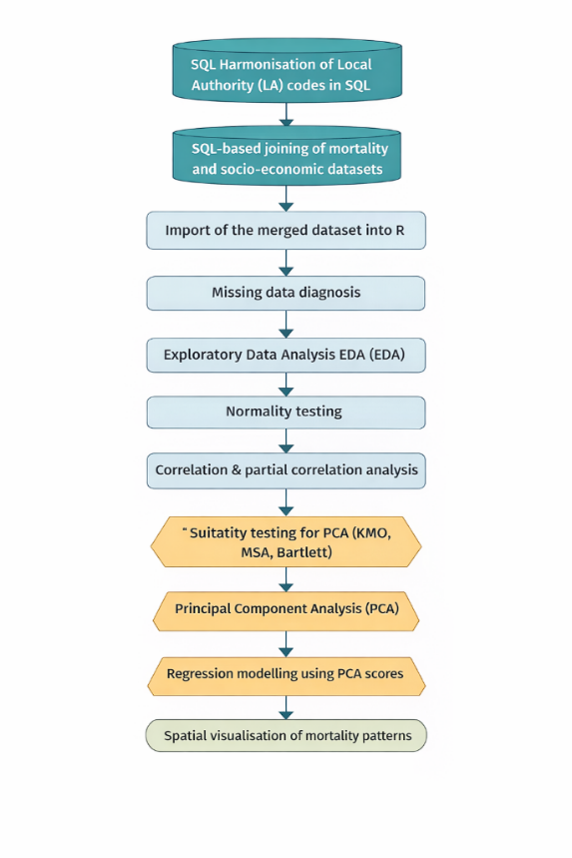

Exploratory Data Analysis and Statistical Testing
EDA consisted of boxplots, histograms with density curves, and Q-Q plots to examine variability, skewness, and distributional properties across variable groups. Formal normality tests were carried out using Shapiro-Wilk and Kolmogorov-Smirnov tests. Most of these variables had their normality assumptions violated (p < 0.05), and it is, therefore, appropriate to use non-parametric methods.
Spearman correlations were performed to examine associations between COVID-19 mortality and the explanatory variables. The absolute correlations were kept if they were equal to or greater than 0.30. Partial correlation analysis adjusted by age structure was carried out to explore the socio- economic effects beyond demographic risks.

Principal Component Analysis and Regression Modelling
The appropriateness for PCA was computed using the KMO statistics and Measurements of Sampling Adequacy (MSA). MSA < 0.50 threshold variables were eliminated in rounds. PCA carried out on standardized variables using eigenvalues, scree plot inspection, and cumulative variance explained for retaining components. Varimax rotation was applied, and loadings ≥ 0.40 guided interpretation.
In total, three interpretable components were obtained, which consist of health vulnerability, economic inactivity and care burden, and housing and residential structure. Component scores were predictors in multiple linear regression modeling for COVID-19 deaths per 1,000 population.
Model diagnosis consisted of coefficient significance, VIF, residual plots, and accuracy metrics (MAE, MSE, RMSE), confirming the statistical robustness and interpretability.

Spatial Visualization
To support interpretation, choropleth maps of COVID-19 mortality were generated by reference to ONS 2023 Local Authority boundaries. The grouping definitions classified mortality rates into quantiles for the observation of spatial clustering and regional contrasts in mortality patterns in England.

Section 7: Implementation
The dataset was imported from a CSV file and inspected using str() and summary() to confirm variable types, ranges, and completeness. Of the 58 variables, 56 were numeric and eligible for statistical modelling, while identifier fields were excluded. A missingness map confirmed the absence of structurally significant missing values, allowing pairwise-complete methods to be safely applied in correlation and PCA analyses.
Code:
mydata <- read.csv("last_long_covid.csv", stringsAsFactors = FALSE)
str(mydata)
summary(mydata)
library(Amelia)
missmap(mydata, col = c("black", "grey"), legend = FALSE)

Distributional Diagnostics and Normality Assessment
Univariate distributions were examined using boxplots, histograms, kernel density plots, and Q–Q plots across thematic domains (age, health, economic activity, housing, deprivation, and travel-to-work). Formal normality testing was conducted using the Shapiro–Wilk test and the Kolmogorov–Smirnov test on standardised variables. For most variables, Shapiro–Wilk p-values were below 0.05, indicating significant departures from normality, particularly for housing, travel-to-work, and economic activity indicators. Consequently, non-parametric methods were adopted.
Output:
shapiro.test(mydata$deaths_per_1000)
ks.test(scale(mydata$deaths_per_1000), "pnorm")

Correlation Analysis and Predictor Reduction
Spearman rank correlations were computed to examine monotonic relationships robust to non-normality. Strong internal correlations were observed within several variable groups, especially age-band variables where many correlations exceeded |ρ| = 0.70. To reduce dimensionality prior to PCA, variables with |ρ| ≥ 0.30 with COVID-19 mortality were retained.
Code:
cor_matrix <- cor(numeric_data, method = "spearman", use = "pairwise.complete.obs")

KMO and MSA Diagnostics
The reduced predictor set was assessed using the Kaiser–Meyer–Olkin (KMO) statistic and Measures of Sampling Adequacy (MSA). The overall KMO was approximately 0.50, meeting the minimum threshold for exploratory PCA. Variables with MSA values below 0.50 were iteratively removed until all retained predictors satisfied adequacy criteria.
library(psych)
KMO(cor_reduced)

Principal Component Analysis
PCA was conducted on standardised variables. Component retention was guided by eigenvalues greater than 1, scree plot inspection, and cumulative variance explained. Three components were retained and rotated using varimax, with loadings ≥ |0.40| considered meaningful.
pca_result <- prcomp(scale(reduced_data), center = TRUE)
plot(pca_result, type = "l")
pca_rotated <- principal(reduced_data, nfactors = 3,
rotate = "varimax", scores = TRUE)
The rotated solution identified three latent dimensions: health vulnerability and long-term sickness, economic inactivity and care-related population structure, and housing composition and residential form. Component scores were retained for regression modelling.

Regression Modelling and Diagnostics
Multiple linear regression modelled COVID-19 deaths per 1,000 population as a function of PCA component scores. Using orthogonal components eliminated multicollinearity by construction. Model validity was evaluated using coefficient significance, Variance Inflation Factors (VIF), residual diagnostics, and prediction error metrics (MAE, MSE, RMSE). These diagnostics confirmed that the final model was statistically stable and suitable for interpretation.

Spatial Visualisation
Finally, spatial visualisation was implemented using ONS 2023 Local Authority boundary shapefiles. COVID-19 mortality rates were joined to spatial data and mapped using quantile-based choropleth classification. These maps were used to visually assess spatial clustering and regional contrasts in mortality patterns, complementing the statistical results.
Code:
model_pca <- lm(deaths_per_1000 ~ RC1 + RC2 + RC3, data = data_reg)
summary(model_pca)
map_data <- merge(lad_map,
mydata[, c("LA_code", "deaths_per_1000")],
by.x = "LAD23CD", by.y = "LA_code")

# Quantile-based choropleth map
ggplot(map_data) +
geom_sf(aes(fill = cut(deaths_per_1000,
quantile(deaths_per_1000, probs = seq(0,1,0.2)))),
color = "white", size = 0.1) +
scale_fill_brewer(palette = "YlOrRd") +
theme_minimal()

Section 8:Result:
This chapter presents the empirical results obtained from the analytical framework described previously. Results are reported sequentially, from data harmonisation and integration outcomes to exploratory analysis, correlation structures, dimensionality reduction, regression modelling, and diagnostic evaluation. The emphasis is on what the analysis revealed, rather than on procedural detail.

Outcomes of Local Authority Code Harmonisation
Local Authority (LA) code harmonisation was a prerequisite for producing a spatially consistent analytical dataset. The COVID-19 mortality data initially contained legacy LA codes, whereas socio-economic datasets were aligned to updated LAD geographies.
Following harmonisation, all records were successfully mapped to current ONS Local Authority codes, ensuring a one-to-one correspondence across datasets. This process eliminated duplicated areas, prevented the loss of Local Authorities during joins, and ensured that all indicators referred to the same underlying population units.
As a result, the final integrated dataset contained 296 English Local Authorities, consistent with the 2023 LAD geography.
Integrated Dataset Characteristics
After the process of dataset integration via SQL, the combined dataset was imported into R for analytical study.
The salient features of the final dataset are as follows:
• 296 Local Authorities
• 58 variables, inclusive of:
o COVID-19 mortality rate (deaths per 1,000 of the population),
o demographic structure,
o health status,
o housing characteristics,
o deprivation indicators,
o economic activity,
o travel-to-work patterns.
The dependent variable deaths_per_1000 varied between 0.000 and 6.031, with a mean of 2.08, indicative of a huge spatial variance of COVID-19 mortality, which would qualify for explanatory modeling purposes.

Missing Data Patterns
Missing data were rarely occurring, being sparsely scattered over the variables and Local Authorities. No systematic clustering of missing data values was noticed over specific regions or groups of variables.
Due to the low level of missingness, the analysis was subsequently performed using pairwise complete observations that retained the full sample of Local Authorities and maximized statistical power.
output
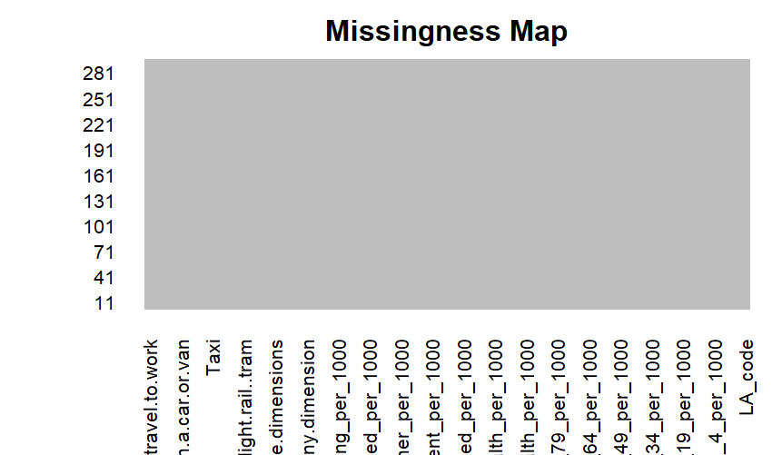

Exploratory Data Analysis

Variables of Age Structure:
• Median values are about 50-60 households in 1,000 households.
• Upper quartile values reached 140-150 per 1,000.
• The maximum values were greater than 340 per 1,000, with many extreme outliers exceeding that.
• The highly right-skewed distributions specify that the majority of Local Authorities had deprivation concentrated in a small number of Local Authorities.
Out:
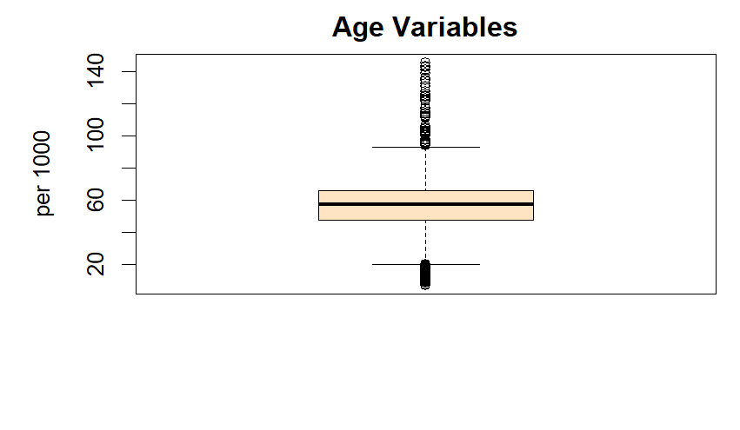

Deprivation Variables
• Median values lie in the region of 50-60 per 1,000 households.
• Values in the upper quartile range from 140 to 150 per 1,000.
• Maximum values exceeded 340 per 1,000, including many extreme outliers.
• The distributions were very highly right-skewed, indicating concentrated deprivation in a few Local Authorities.
Output:
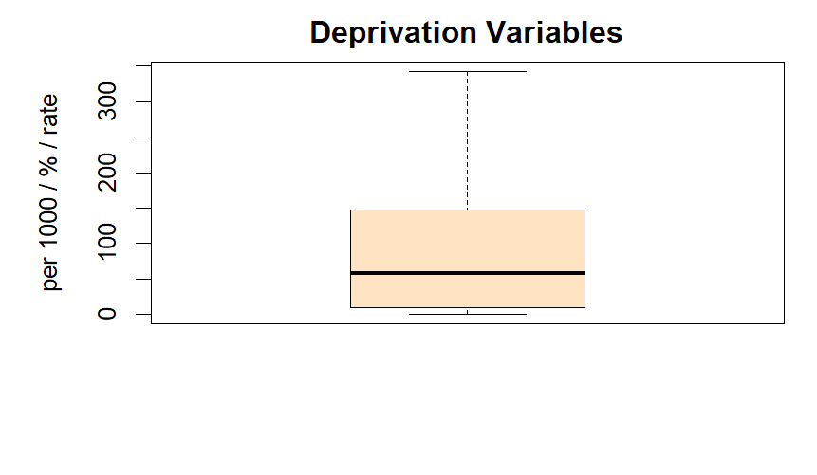

Economic Activity Variables
The median values were about 25-30 per 1,000.
- Upper quartile values varied from 80-90 per 1,000.
- Maximum values appeared to exceed 400 per 1,000 with several upper-end outliers.
- Distributions showed a strong right-skewness, indicating a spatial concentration of economic inactivity.
Output:
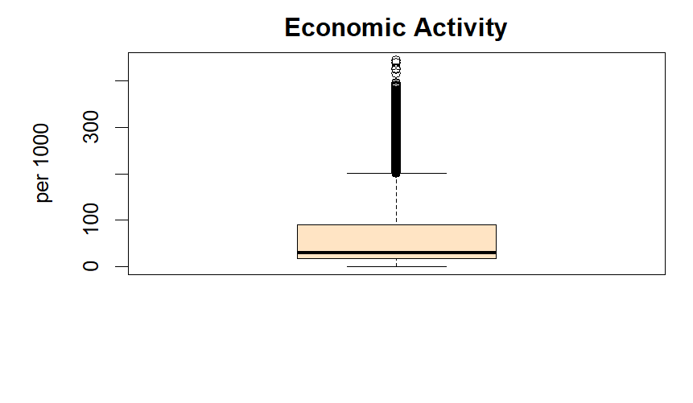

Health Variables
• Median rates of poor health stood at around 120-140 per 1,000.
• The upper quartile reached values as high as 330-350 per 1,000.
• Maximum values approached 600 per 1,000, with extreme outliers.
• Distributions were highly skewed, indicating substantial variation in underlying health vulnerability.
Analysis yields that approximately 120-140 poor health rates per 1,000 are at the median level. From values of more than 1,000, the upper quartile reaches a peak point of 330-350 suffered by every 1,000 people. Reaching almost 600 per 1,000, maximum values are very close to extreme outliers, with distribution skewed to very high extremes which are likely broken distributed.
Those would be: • Median poor-health rates were about 120 to 140 per 1000. • Upper quartile values were even up to 330-350 per 1000. • Maximum reached almost 600 per 1000, with extreme outliers. • Distribution is, therefore, inferred to be very skewed, and there is great variation in health vulnerability underlying it.
The average rate in poor health was around 120 to 140 per 1,000. Upper quartiles have represented figures between 330 and 350 per 1,000. The upper limit goes beyond 600 per 1,000, including extreme cases. Distribution is highly skewed, indicating significant variation in the underlying health vulnerability.
Output:

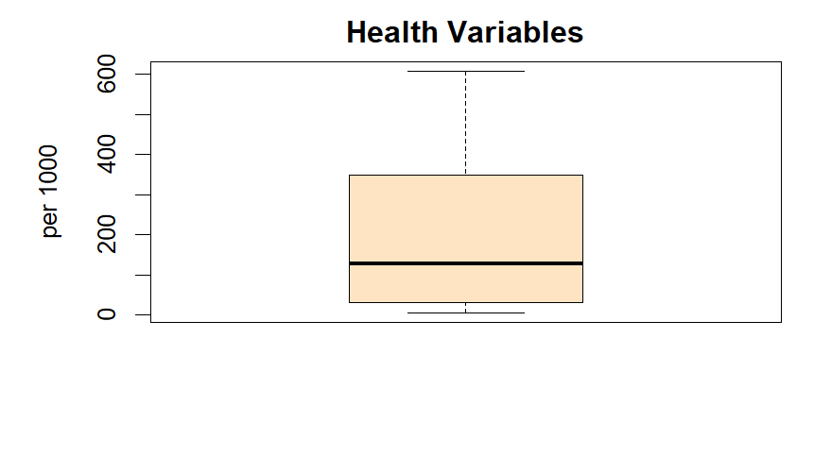

Housing Variables
- Median values were approximately 20–30 per 1,000.
- Upper quartile values reached 90–110 per 1,000.
- Maximum values exceeded 500 per 1,000, with several extreme outliers.
- Distributions were strongly right-skewed, driven by highly urbanised Local Authorities.
Output:

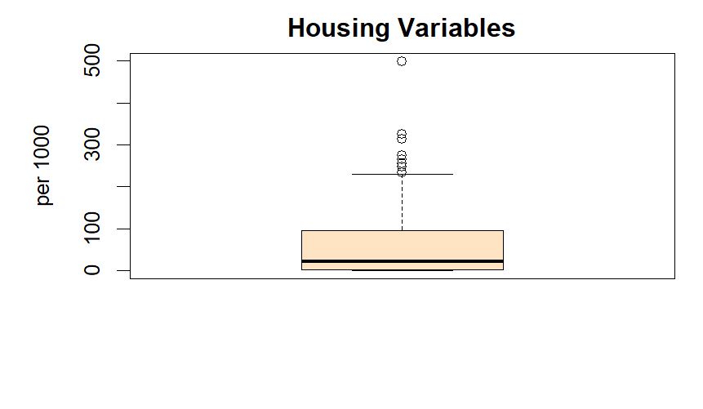

Travel-to-Work Variables:
• The median was approximately 15 to 25 per 1000.
• The values in the upper quartile reached 70-80 per 1000.
• Maximum values exceeded 350 per 1000, with many outliers.
• The distributions were strongly right-skewed, which reflects the very pronounced urban-rural contrast.
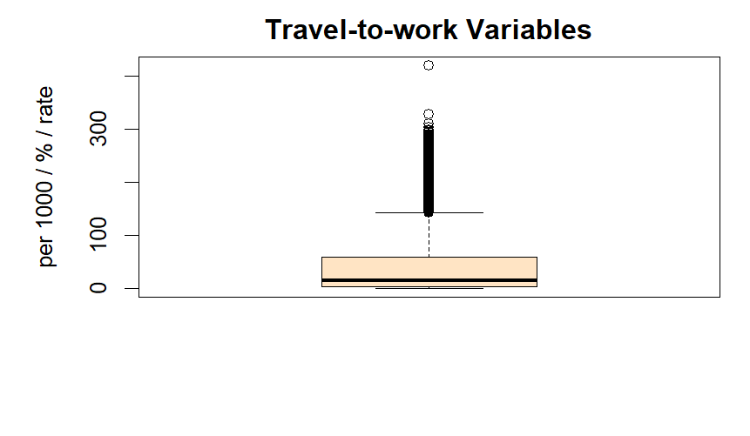

Correlation Analysis Results

Spearman Correlation
Spearman correlation analysis identified multiple moderate to strong monotonic associations between COVID-19 mortality and socio-economic indicators. Applying a threshold of |ρ| ≥ 0.30, 14 predictors were retained for multivariate analysis.

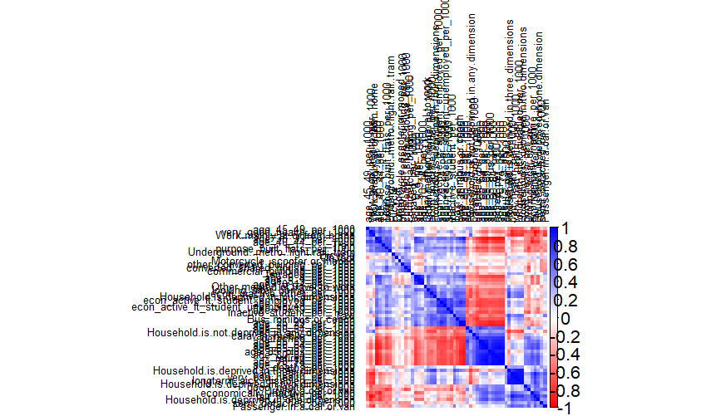

Partial Correlation Controlling for Age
After controlling for age structure, several predictors—including poor health, deprivation, and selected travel-to-work variables—remained statistically significant. This indicates that observed associations are not solely attributable to demographic age composition.

PCA Suitability Results
Sampling adequacy tests indicated strong factorability of the reduced predictor set. The overall KMO value was 0.879, and Bartlett’s test of sphericity was statistically significant (p < 0.001).

Variance Explained
The first three principal components jointly explained approximately 84% of total variance. The scree plot exhibited a clear elbow after the third component.

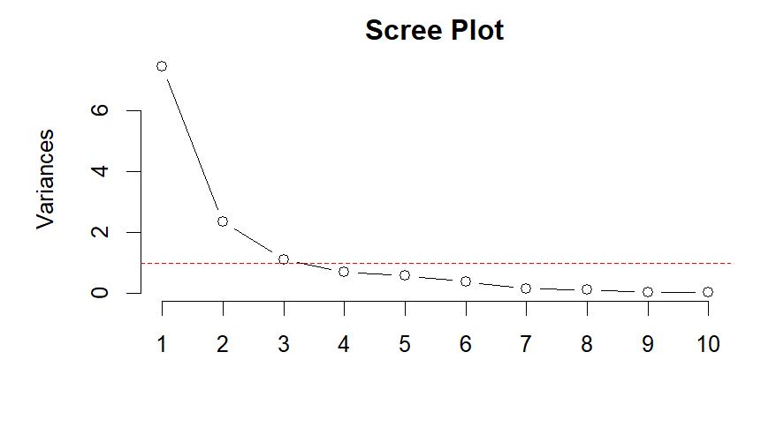

Rotated Component Structure
Ultimately, the varimax-rotated solution attained three interpretable latent dimensions:
1. Health and deprivation burden;
2. Home-care and household constraint;
3. Housing and mobility structure.

Rotated PCA loadings (|loading| ≥ 0.40)
Output
The average complexity of the item is 1.5.
Test of the hypothesis that three factors are adequate.
The root mean square of the residuals is 0.058
with the empirical chi square 156.542 with prob < 4.16e-15
Fit based on off-diagonal values = 0.989.

PCA Scores Regression Results
The adjusted R² provided by multiple linear regression on the PCA component scores can be estimated to be around 0.279, suggesting that the three components explain approximately 28% of spatial variation in COVID-19 mortality. All components were
Output:
The regression model was significant (F(3,292) = 39.01, p < 0.001) and explains 28% of variation in COVID-19 mortality (Adjusted R² = 0.279). All PCA components were significant: health vulnerability (β = 0.161) and home-care/economic inactivity (β = 0.192) increased mortality, while housing and mobility structures reduced mortality (β = -0.236).

Diagnostics and Accuracy of the Model
Diagnostics of models have evidenced robustness and mathematical stability. Variance Inflation Factors hovered around 1 indicative of little multicollinearity. Diagnostic of the residuals showed no gross violations of assumptions. Predictive accuracy was moderate with RMSE of about 0.54 deaths per 1,000 population.
Output:
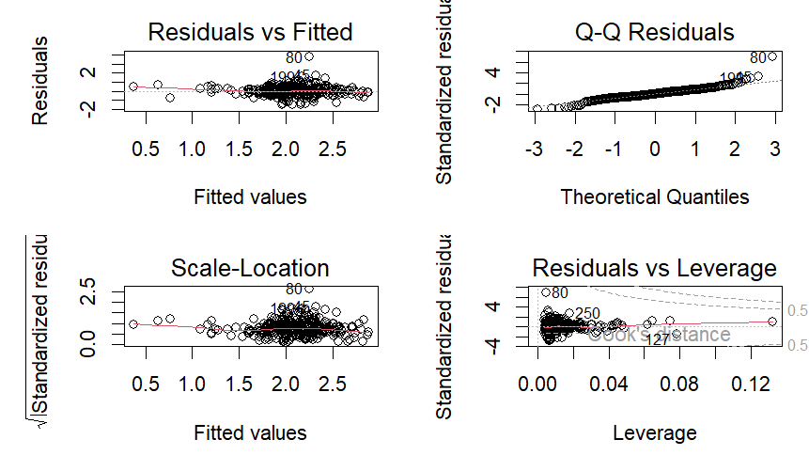

Spatial Visualisation of COVID-19 Mortality

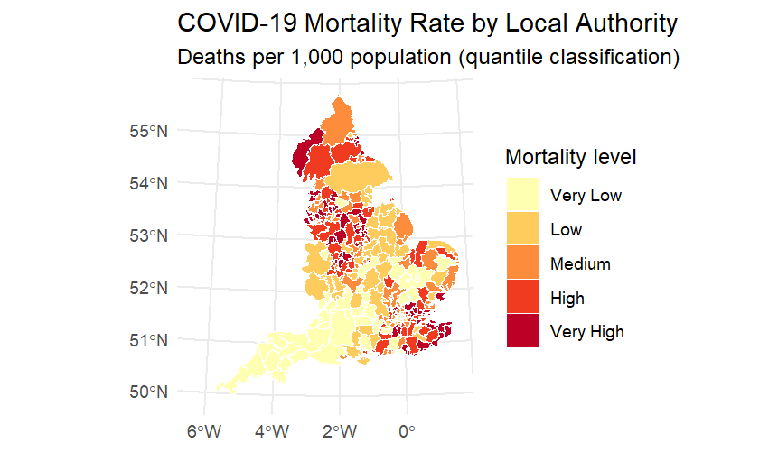
As Figure X indicates, COVID-19 mortality does exhibit clear geographical variation across Local Authorities in England. Therefore, different mortality rates exist, where high and very high cases occur mostly in urban and post-industrial areas, particularly in parts of the North and Midlands. Yet, for instance, lower rates are found more commonly within these densely populated areas, such as the Southwest and southern England. Contrasting yet quantificationally representing such geographic differences is the fact that areas with lower mortality rates are low and very low less often. All this adds up to showing very clear geographic contrasts and strong intra-area clustering of Local Authorities with similar mortality levels. These geographical depictions correspond with the earlier statistical analyses: although with some disparity, they point to a differential role played by vulnerability of health, socio-economic deprivation, and housing and mobility barriers on COVID-related mortality outcomes.

Section 9: Discussion
This study analysed spatial variation in COVID-19 mortality across 296 English Local Authorities and its relationship with demographic and socio-economic characteristics. The results demonstrate that mortality patterns were shaped by a combination of age structure, underlying health conditions, socio-economic inequality, housing characteristics, and mobility patterns, rather than by a single dominant factor.
Analysis of age-group distributions revealed substantial demographic heterogeneity, particularly among young-adult age groups. Local Authorities with large concentrations of individuals aged 20–24 and 25–29 exhibited pronounced outliers, reflecting student populations and urban centres. While age is a recognised determinant of COVID-19 outcomes, partial correlation analysis showed that several socio-economic indicators remained significantly associated with mortality after controlling for age. This indicates that demographic structure alone is insufficient to explain observed spatial disparities.
The PCA results highlight the importance of latent socio-economic dimensions. The first component, representing health vulnerability and deprivation, was strongly associated with COVID-19 mortality, suggesting that areas with poorer baseline health and higher deprivation experienced disproportionately higher death rates. This finding supports the view that COVID-19 amplified existing inequalities rather than creating new patterns of vulnerability. The second component, capturing economic inactivity and care-related population structures, further indicates that labour-market exclusion and household dependency played an important role in shaping mortality risk. The third component, related to housing composition and mobility, suggests that characteristics of the built environment and commuting behaviour also contributed to spatial differences in outcomes.
From a methodological perspective, the integration of PCA with regression modelling proved effective in managing multicollinearity among highly correlated predictors. Transforming correlated socio-economic indicators into orthogonal components produced stable regression estimates and allowed substantive interpretation at the level of broader structural dimensions. The widespread non-normality observed across variables justified the use of non-parametric methods, strengthening the robustness of the analytical approach.
Overall, the findings suggest that COVID-19 mortality in England was closely linked to pre-existing structural inequalities. Areas characterised by poor health, socio-economic disadvantage, constrained housing conditions, and distinctive mobility patterns were structurally more vulnerable during the pandemic. These results highlight the importance of addressing long-standing inequalities as part of public health resilience and preparedness for future health crises.

Section 10: Conclusion
This study assessed spatial heterogeneity in COVID-19 mortality across 296 English Local Authorities and its association with demographic and socio-economic characteristics. With a harmonised dataset of 58 variables, the analysis demonstrated that the structural conditions associated with pre-existing inequalities are those that systematically give rise to the patterns of mortality by COVID-19 rather than by demographic composition.
Exploratory analysis also confirmed considerable heterogeneity across Local Authorities, wherein COVID-19 mortality rates ranged from 0.000 to 6.031 deaths per 1,000 population. Age structure strongly clustered across space and especially at young-adult age groups. However, other parts of the analysis at this point confirm that a number of socio-economic indicators were still significantly related to mortality when controlling for this age variable. This indicates the importance, but only part of the explanation, of age composition in understanding spatial variation.
Dimensionality reduction using PCA classified correlated predictors under three orthogonal components into which about 84% of the total variance in the reduced predictor set could be accounted. Regression modelling of the case-component scores explained 28% of the variance in COVID-19 death rates at Local Authorities. The strongest relationships were settled with the components of health vulnerability and deprivation, then with economic inactivity and care-related demographic structures, and finally with housing and mobility characteristics.
Methodologically, the value of this study lies in that combining non-parametric correlation methods with PCA-based regression is effective in analysing non-normally distributed and extremely highly collinear socio-economic data. Component scores successfully eliminated multicollinearity, as reflected by the Variance Inflation Factors, which were close to 1, and yielded a numerically stable model with RMSEs of about 0.54 deaths per 1,000 wake.
Overall, such results provide quantitative evidence that existing structural inequalities conditioned the mortality from COVID-19 in England. Variously marked localities were generally poorer health, social deprivation, economic inactivity, and disadvantaged, constrained housing and mobility environments. Such findings indicate that reducing health inequalities and socio-economic vulnerability at a baseline may be as effective as short-term emergency interventions to mitigate the impact of future public health crises. Future research could further expand this analysis and include spatial dependence and longitudinal data to quantify further how this vulnerability changes over time.

Section 11: Bibliography
- Ahmad, K., Erqou, S., Shah, N., Nazir, U., Morrison, A.R., Choudhary, G. and Wu, W. (2020) ‘Association of poor housing conditions with COVID-19 incidence and mortality across US counties’, PLOS ONE, 15(11), e0241327.
Available at: https://journals.plos.org/plosone/article?id=10.1371/journal.pone.0241327
- Bambra, C., Riordan, R., Ford, J. and Matthews, F. (2020) ‘The COVID-19 pandemic and health inequalities’, Journal of Epidemiology and Community Health, 74(11), pp. 964–968.
Available at: https://jech.bmj.com/content/74/11/964
- Carozzi, F., Provenzano, S. and Roth, S. (2020) Urban density and COVID-19. IZA Discussion Paper No. 13440. Bonn: Institute of Labor Economics.
Available at: https://www.iza.org/publications/dp/13440/urban-density-and-covid-19
- Clark, A., Jit, M., Warren-Gash, C., Guthrie, B., Wang, H.H., Mercer, S.W., Sanderson, C., McKee, M. and Troeger, C. (2020) ‘Global, regional, and national estimates of the population at increased risk of severe COVID-19 due to underlying health conditions’, The Lancet Global Health, 8(8), e1003–e1017.
Available at: https://www.thelancet.com/journals/langlo/article/PIIS2214-109X(20)30264-3/fulltext
- Daras, K., Alexiou, A., Rose, T.C., Buchan, I., Taylor-Robinson, D., Barr, B. and Pearce, A. (2021) ‘How does vulnerability to COVID-19 vary between communities in England?’, BMJ Open, 11(5), e045564.
Available at: https://www.thelancet.com/journals/langlo/article/PIIS2214-109X(20)30264-3/fulltext
- Griffith, G.J., Morris, T.T., Tudball, M.J., Herbert, A., Mancano, G., Pike, L., Sharp, G.C., Sterne, J.A.C. and Palmer, T.M. (2020) ‘Collider bias undermines our understanding of COVID-19 disease risk and severity’, Nature Communications, 11, 5749.
Available at: https://www.nature.com/articles/s41467-020-19478-2
- Kontis, V., Bennett, J.E., Rashid, T., Parks, R.M., Pearson-Stuttard, J., Guillot, M., Asaria, P., Zhou, B., Battaglini, M., Corsetti, G., McKee, M., Di Cesare, M., Mathers, C.D. and Ezzati, M. (2021) ‘Magnitude, demographics and dynamics of the effect of the COVID-19 pandemic on all-cause mortality’, Nature Medicine, 27, pp. 561–569.
Available at: https://www.nature.com/articles/s41591-021-01379-6
- Marmot, M. and Bell, R. (2012) ‘Fair society, healthy lives’, Public Health, 126(Suppl 1), pp. S4–S10.
Available at: https://doi.org/10.1016/j.puhe.2012.05.014
- Marmot, M., Allen, J., Goldblatt, P., Herd, E. and Morrison, J. (2020) Build Back Fairer: The COVID-19 Marmot Review. London: Institute of Health Equity.
Available at: https://www.instituteofhealthequity.org/resources-reports/build-back-fairer-the-covid-19-marmot-review%20Institute%20of%20Health%20Equity
- Niedzwiedz, C.L., O’Donnell, C.A., Jani, B.D., Demou, E., Ho, F.K., Celis-Morales, C., Nicholl, B.I., Mair, F.S., Welsh, P., Sattar, N. and Pell, J.P. (2020) ‘Ethnic and socioeconomic differences in SARS-CoV-2 infection’, The Lancet, 395(10235), pp. 1355–1356.
Available at:: https://www.thelancet.com/journals/lancet/article/PIIS0140-6736(20)31234-2/fulltext
- Office for National Statistics (ONS) (2021) Deaths involving COVID-19 by local area and deprivation. ONS.
Available at: https://www.ons.gov.uk/peoplepopulationandcommunity/birthsdeathsandmarriages/deaths/datasets/deathsinvolvingcovid19bylocalareasanddeprivation
- Rocklöv, J. and Sjödin, H. (2020) ‘High population densities catalyse the spread of COVID-19’, Journal of Travel Medicine, 27(3), taaa038.
Available at: https://academic.oup.com/jtm/article/27/3/taaa038/5818278
- Sharpe, R.A., Thornton, C.R., Nikolaou, V. and Osborne, N.J. (2021) ‘Fuel poverty increases risk of respiratory hospitalisation’, Environment International, 152, 106478.
Available at: https://www.sciencedirect.com/science/article/pii/S0160412021000205
- Trades Union Congress (TUC) (2021) Covid-19 and insecure work. London: TUC.
Available at: https://www.tuc.org.uk/research-analysis/reports/covid-19-and-insecure-work
- Williamson, E.J., Walker, A.J., Bhaskaran, K., Bacon, S., Bates, C., Morton, C.E., Curtis, H.J., Mehrkar, A., Evans, D., et al. (2020) ‘Factors associated with COVID-19-related death using OpenSAFELY’, Nature, 584, pp. 430–436.
Available at: https://www.nature.com/articles/s41586-020-2521-4

Section12:Appendix
R script:
Link: u2828994_DS7006_CW2_final_script.R

CSV
Link: u2828994_DS7006_CW2_data_final.csv

SQL:
Link: u2828994.txt

