***Mental Health Group***

*Hanna Song and Anh Nguyen*

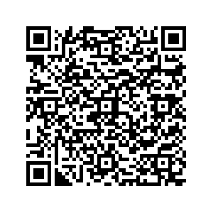

**Research Question**

Does COVID impact post trends and engagements within mental health-related subreddits?

**Data from 9 subreddits**

Depression, ADHD, anxiety, bipolar, PTSD, schizophrenia, eating disorders, brain fog, and suicide watch

**Sample Raw Data**

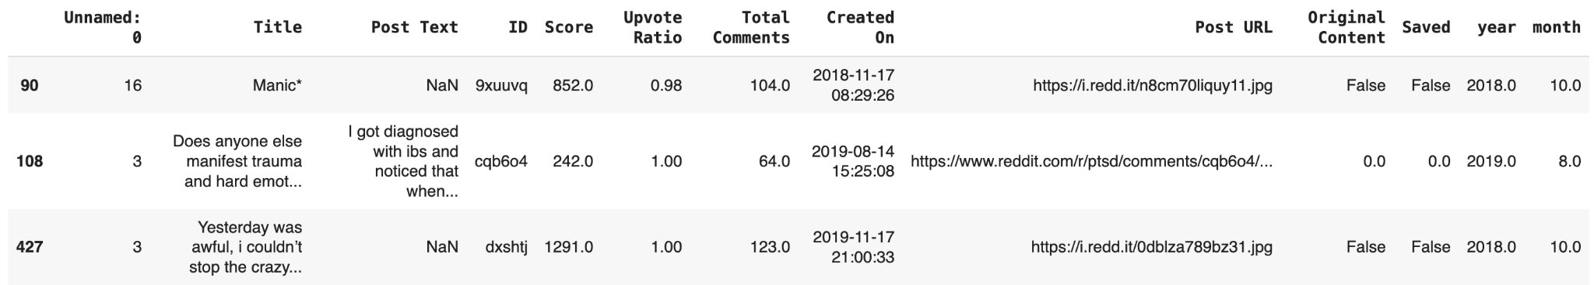

Post Trends: Title, Post Text

Post Engagements: Score, Upvote Ratio, Total Comments

Methodology:

*ETL → EDA → Text Classification (BERT + DistilBERT + BERTopic) →*

*Propet Time Series Analysis → Cross Validation → Results*

Add us on LinkedIn:

 