INTERNSHIP REPORT
Task 2 – Data Cleaning and Pre-processing

Sales Dataset Analysis using Python

Prepared as part of Internship Training

1. Objective
The objective of this week’s internship task was to practice data cleaning and pre-processing techniques using Python. The work focused on inspecting a sales dataset, identifying possible data-quality issues, checking missing values and duplicate records, visually investigating outliers, performing appropriate data transformations, and producing an analysis-ready dataset.

2. Task Overview
The selected dataset is a sales dataset containing order-level information such as order ID, date, region, state, product category, product, quantity, sales and profit. The dataset was loaded into a Pandas DataFrame and systematically examined before and after preprocessing.

3. Tools and Technologies Used
Tool / Library | Purpose
Python | Programming language used for data processing and analysis
Pandas | Data loading, inspection, cleaning and transformation
NumPy | Numerical/data-processing support
Matplotlib | Data visualization
Seaborn | Visualization support
Jupyter Notebook | Interactive coding, outputs and documentation

4. Dataset Description
The dataset was loaded from the file sales_data.csv. The initial dataset contains 1,200 rows and 9 columns.
Column | Data Type | Description
Order_ID | String | Unique order identifier
Date | String initially | Date of the order
Region | String | Geographical region
State | String | State/location
Category | String | Product category
Product | String | Product name
Quantity | Integer | Number of units ordered
Sales | Float | Sales amount
Profit | Float | Profit amount

5. Data Inspection and Initial Quality Assessment
The first stage was to inspect the structure and quality of the dataset. The dataset was loaded using Pandas and the shape, column names, data types and DataFrame information were checked.
import pandas as pd
import numpy as np
import matplotlib.pyplot as plt
import seaborn as sns
df = pd.read_csv("sales_data.csv")
df.shape
df.columns
df.dtypes
df.info()
Initial inspection confirmed:
- 1,200 observations and 9 variables were present.
- Quantity was stored as an integer.
- Sales and Profit were stored as floating-point numerical values.
- The remaining fields were stored as string/text values, with Date initially represented as a string.
- All 1,200 records had non-null values in every column.

6. Missing Value Analysis and Treatment
Missing values were examined using both a direct null-value count and a summary report containing missing counts and percentages.
df.isnull().sum()
missing = df.isnull().sum()
missing_report = pd.DataFrame({
"Missing Count": missing,
"Missing Percentage": (missing / len(df)) * 100
})
display(missing_report)
Column | Missing Count | Missing Percentage
Order_ID | 0 | 0.0%
Date | 0 | 0.0%
Region | 0 | 0.0%
State | 0 | 0.0%
Category | 0 | 0.0%
Product | 0 | 0.0%
Quantity | 0 | 0.0%
Sales | 0 | 0.0%
Profit | 0 | 0.0%
Decision and justification: No imputation or deletion was required because the dataset contained no missing values. Introducing imputed values would not be justified when the original data are already complete.

7. Duplicate Records and Consistency Checks
Duplicate records were investigated using Pandas. The duplicated() method was first used to identify duplicate rows and duplicated().sum() was then used to obtain the total number of duplicates.
df.duplicated()
df.drop_duplicates()
df.duplicated().sum()
Result: the duplicate count was 0. Therefore, no records were removed from the final dataset.
The drop_duplicates() operation was also inspected as part of the cleaning workflow. Since no duplicate rows were present, applying duplicate removal did not change the number of observations.

8. Outlier Investigation and Treatment
Outliers were investigated visually for the two main numerical financial variables, Sales and Profit, using boxplots. Boxplots are useful for identifying observations that fall unusually far from the central distribution.
df[["Sales", "Profit"]].plot(
kind="box",
subplots=True,
figsize=(10, 5)
)
plt.tight_layout()
plt.show()
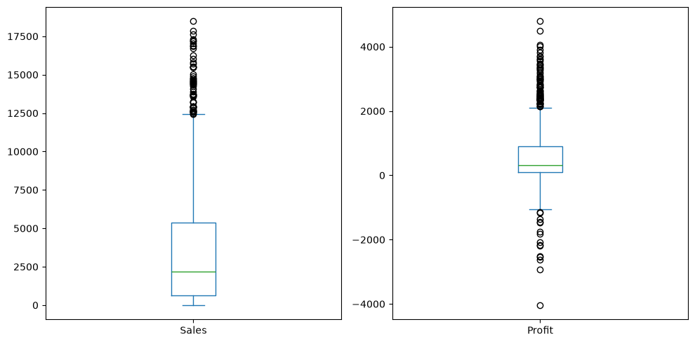
Figure 1: Boxplots used to inspect Sales and Profit for possible outliers.
Treatment decision: the notebook uses the boxplot for investigation but does not automatically delete outliers. This is an appropriate conservative approach because an unusually high Sales or Profit value may represent a genuine business transaction rather than an error. Therefore, no outlier rows were removed without additional business/domain evidence.

9. Data Transformation and Feature Engineering
The Date column was transformed from a string representation into a proper datetime format. The conversion used errors='coerce', which allows invalid date strings to become missing datetime values instead of causing the program to fail.
df["Date"] = pd.to_datetime(
df["Date"],
errors="coerce"
)
df["Order Year"] = df["Date"].dt.year
df["Order Month"] = df["Date"].dt.month
Two new features were created:
New Feature | Purpose
Order Year | Extracts the year from the order date for yearly analysis.
Order Month | Extracts the month from the order date for monthly/time-based analysis.
Feature-engineering decision: scaling, normalization and categorical encoding were not applied in this task. The assignment focused on data cleaning and preprocessing, and no machine-learning model was built in this notebook. Therefore, applying these transformations at this stage was unnecessary. They can be introduced later if a model requires numerical scaling or encoded categorical variables.

10. Final Dataset and Export
df.to_csv("cleaned_sales_dataset.csv", index=False)
print("Cleaned dataset saved successfully!")
print("Final shape:", df.shape)
After the preprocessing steps, the final dataset contained 1,200 rows and 11 columns. The two additional columns were Order Year and Order Month. The cleaned dataset was exported as cleaned_sales_dataset.csv for future analysis.

11. Cleaning Decisions Summary
Data Issue / Step | Investigation | Action / Decision | Reason
Missing values | isnull() and missing report | No treatment required | 0 missing values in all columns
Duplicates | duplicated() and count | No rows removed | 0 duplicate records
Outliers | Sales and Profit boxplots | Retained; no automatic deletion | Potential outliers may be valid business observations
Date format | Data type inspection | Converted to datetime | Required for reliable time-based analysis
Feature engineering | Date components | Created Order Year and Order Month | Improves usefulness for time-based analysis
Scaling/encoding | Requirement considered | Not applied | No ML model in this task; not necessary for current objective

12. Reproducibility and Documentation
The workflow is reproducible because the notebook records the Python commands used for loading, inspecting, cleaning, transforming and exporting the data. Another analyst can follow the same sequence of operations on the same source dataset to reproduce the cleaning process.
- Load the source CSV file.
- Inspect shape, columns, data types and DataFrame information.
- Check missing values and calculate missing percentages.
- Check duplicate rows and duplicate counts.
- Create boxplots for numerical variables to investigate possible outliers.
- Convert the Date column to datetime format.
- Create Order Year and Order Month features.
- Export the cleaned dataset to a new CSV file.

13. Python Skills Demonstrated
- Reading CSV data with Pandas.
- Working with DataFrames and DataFrame attributes.
- Inspecting data types and dataset structure.
- Detecting missing values and generating summary reports.
- Detecting and evaluating duplicate records.
- Creating visualizations with Matplotlib/Pandas plotting.
- Performing datetime conversion and date-based feature extraction.
- Exporting processed data to CSV.

14. Conclusion
This task provided practical experience in preparing a sales dataset for further analytics. The investigation showed that the dataset was already complete with no missing values and no duplicate records. Numerical variables were visually inspected for possible outliers, and the observations were retained rather than removed automatically because their business validity could not be established from the dataset alone. The Date column was converted into a proper datetime format and two useful time-based features, Order Year and Order Month, were created. Finally, the processed dataset was saved as a separate cleaned CSV file. Overall, the task strengthened practical Python and Pandas skills and produced a clean, analysis-ready dataset for future analytics or modeling work.

15. Expected Deliverable Checklist
- Data inspection and quality assessment – Completed.
- Missing-value investigation and justified treatment – Completed.
- Duplicate and consistency checks – Completed.
- Outlier visual investigation using boxplots – Completed.
- Data transformation and feature engineering – Completed.
- Python code snippets and explanatory notes – Included.
- Final cleaned dataset export – Completed.
- Reproducible workflow documentation – Included.

