Abstract & Introduction
There is a distinct lack of vegan-friendly restaurants in the United States. The quality of vegan options among restaurants varies greatly with high quality options tending to be more expensive. Many restaurants specify vegan options as specials or limited time items that are removed from menus as well. Data analysis would assist those in search of vegan options through finding locations throughout the United States with high quality and fairly priced vegan options.

Prior research on vegan locations tends to analyze the amount of people identifying as vegan in a given area rather than checking out the vegan options available for them to eat at local restaurants. This lack of prior analysis poses an important question for Americans interested in a cruelty-free meal. Does geographic location influence the cuisine type, price, and quality of vegan food?

Data Description & Preliminary Analysis
The first dataset, a subset of a larger dataset created by Datafiniti, is a list of 211 vegan/vegetarian friendly restaurants located in the United States. For this project, data analysis is completed on four variables: latitude, longitude, cuisine type, and max price range.

The second dataset, created by WalletHub, is a list of the largest 100 cities in the United States ranked by scores based on affordability, diversity, accessibility, quality, and local vegetarian-friendly events. For this project, data analysis is completed on three variables: latitude, longitude, and total score.

Figure 1 and Figure 2 display scatterplots of both latitude and longitude vs the total score for each city in the vegan city dataset. There are a few outliers based on latitude and longitude, but they will remain in the datasets as to accurately represent each restaurant in varying locations across the United States.

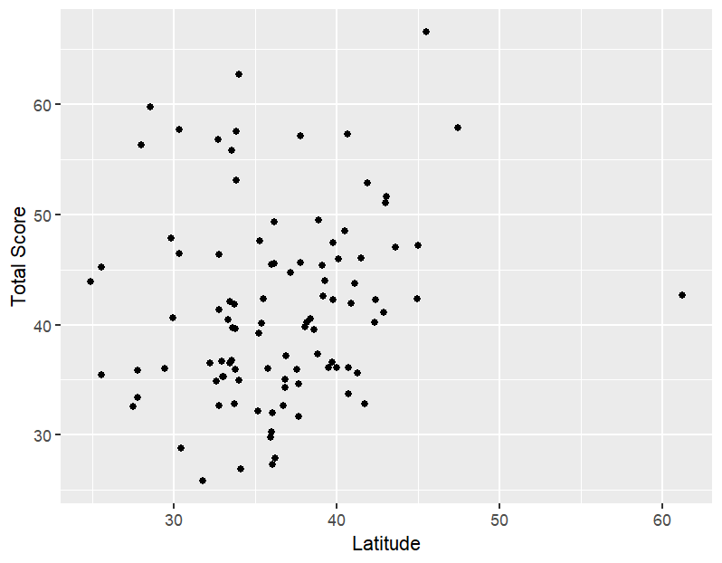
Figure 1: Scatterplot of Latitude VS Total Score

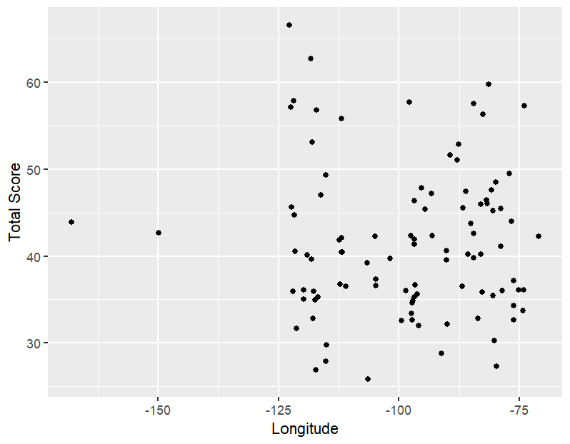
Figure 2: Scatterplot of Longitude VS Total Score

Exploratory Analysis
For the vegan restaurant dataset, most data points are located in the Northeastern United States. Latitude coordinates are between 20 to 48 degrees while longitude coordinates are between -157 to -69 degrees. The max price range for each restaurant is between $12 to $55.

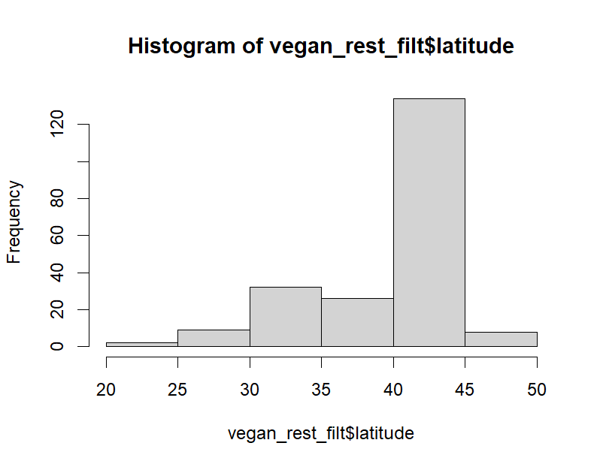
Figure 3: Histogram of Latitude – Vegan Restaurant Dataset

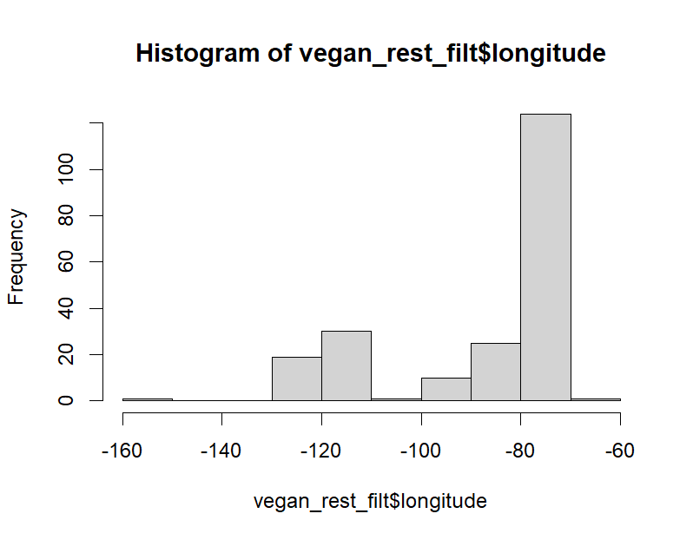
Figure 4: Histogram of Longitude – Vegan Restaurant Dataset
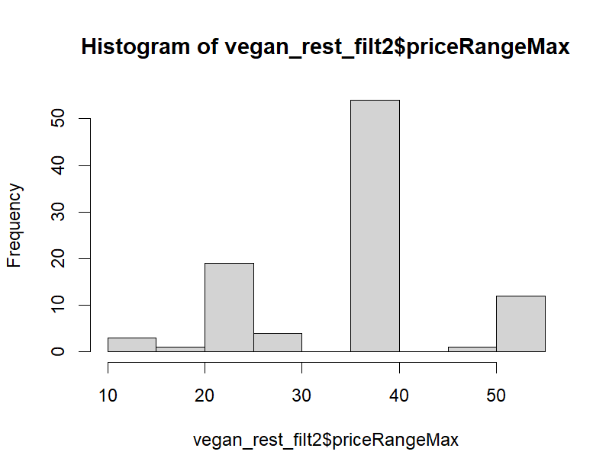
Figure 5: Histogram of Max Price Range – Vegan Restaurant Dataset

For the vegan city dataset, datapoints are more evenly distributed throughout the United States. Latitude coordinates are between 24 to 62 degrees while longitude coordinates are between -169 to -71 degrees. The total score for each restaurant is between 25 to 67 points.

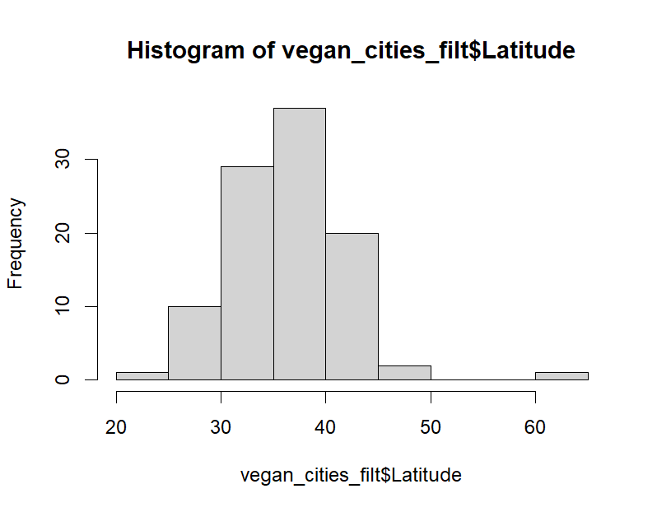
Figure 6: Histogram of Latitude – Vegan City Dataset

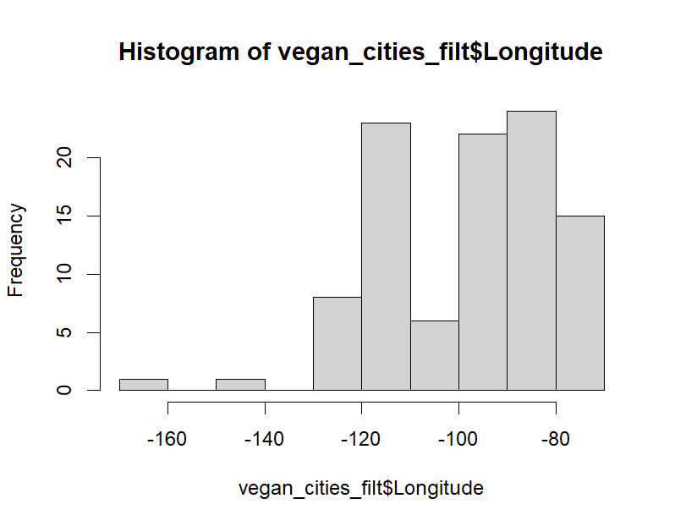
Figure 7: Histogram of Longitude – Vegan City Dataset

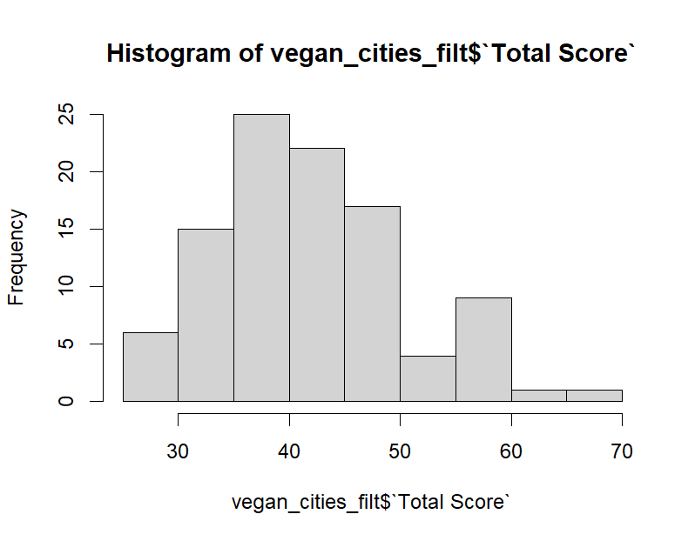
Figure 8: Histogram of Total Score – Vegan City Dataset

Model Development & Application of Models
For the vegan restaurant dataset, Figure 9 and Figure 11 display two k-means clustering models. Figure 9 utilizes latitude and longitude to predict the cuisine type of a given restaurant. Cuisine types are split into 23 different classes including Thai, Indian, American, Italian, etc. The average balanced accuracy among all clusters in the model is 49%. Figure 10 shows a 0.57 average silhouette width which indicates an average cluster distinction within the model. Figure 11 utilizes latitude and longitude to predict the max price range of a given restaurant. Price ranges are split into 4 classes defined by max prices being less than $25, $25-$40, $40-$50, and greater than $50. The average balanced accuracy among all clusters in the model is 55%. Figure 12 shows a 0.75 average silhouette width which indicates a strong cluster distinction within the model. Overall, the accuracy of both k-means models is not strong, but the clusters within the models are well defined.

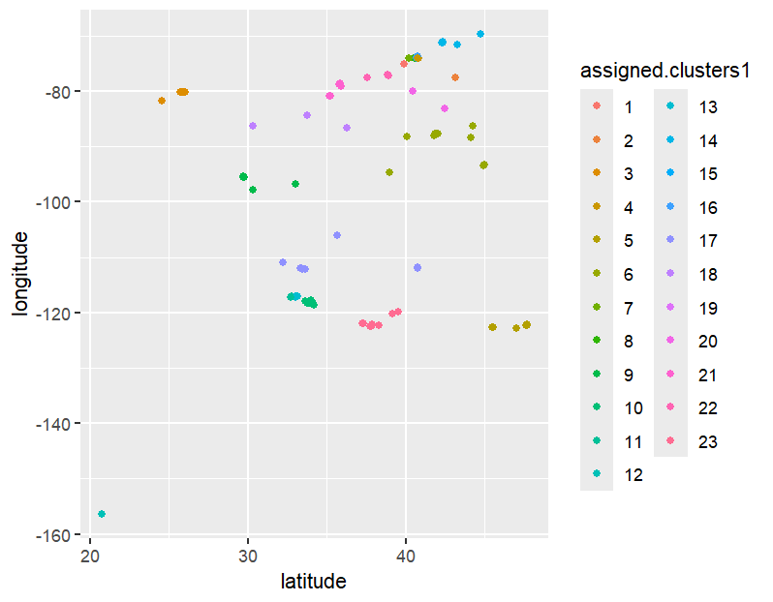
Figure 9: K-Means Latitude and Longitude Predict Cuisine Type

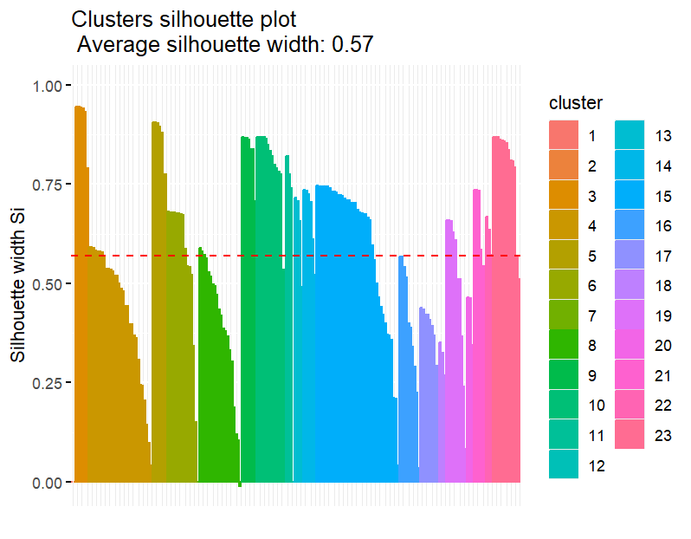
Figure 10: K-Means Cuisine Type Silhouette Plot

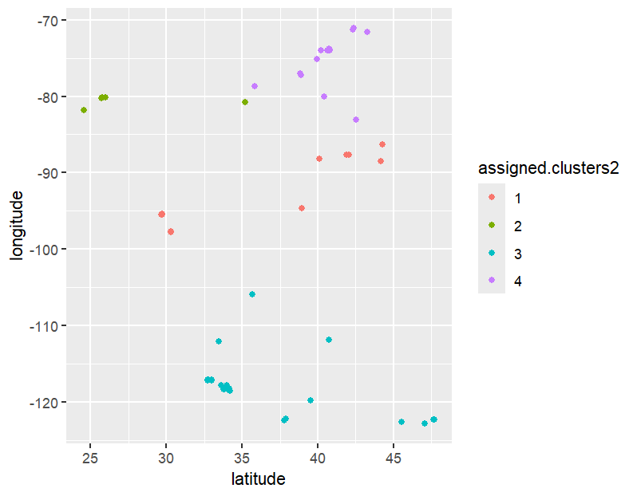
Figure 11: K-Means Latitude and Longitude Predict Max Price Range

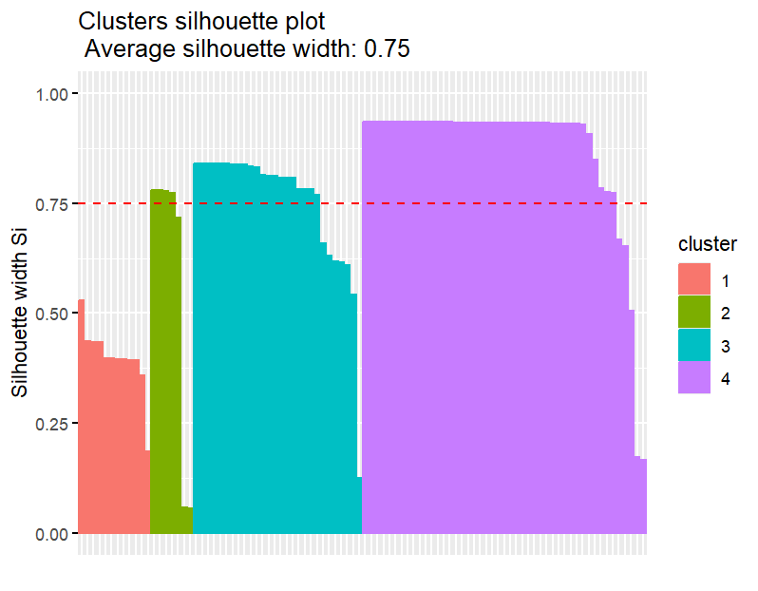
Figure 12: K-Means Max Price Range Silhouette Plot

For the vegan cities dataset, Figure 13 and Figure 16 display two linear regression models that predict total score. Figure 13 shows a positive correlation between latitude and total score among vegan cities. According to Figure 14, these results are statistically insignificant due to the p-value being 0.11 which is greater than 0.05. The residual plot, Figure 15, indicates an average quality linear regression with potentially one data point as an outlier. Figure 16 shows a slight negative correlation between longitude and total score among vegan cities. According to Figure 17, these results are statistically insignificant due to the p-value being 0.75 which is greater than 0.05. The residual plot, Figure 18, indicates an average quality linear regression with potentially two data points as outliers.

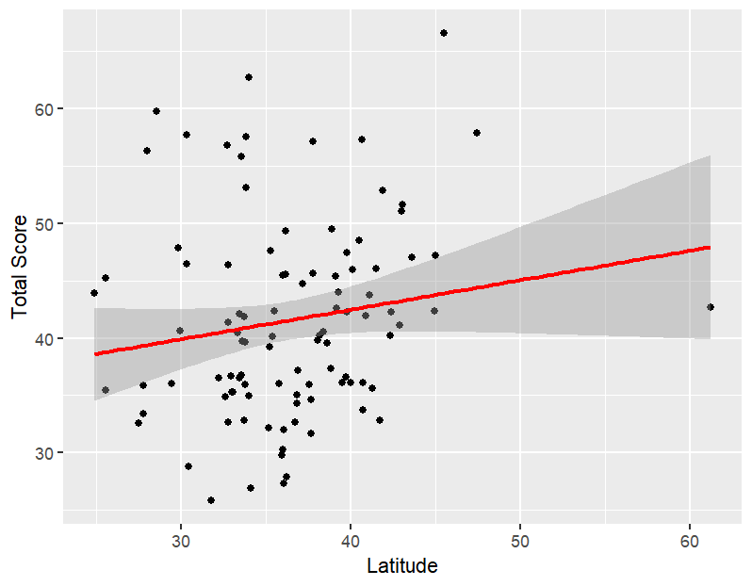
Figure 13: Linear Regression Latitude VS Total Score

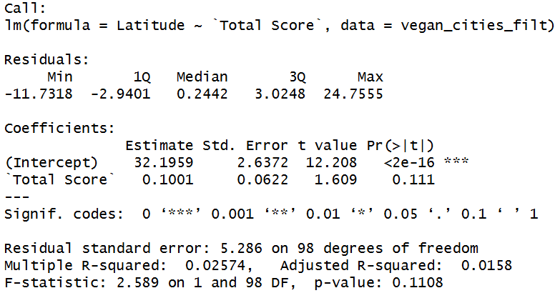
Figure 14: Linear Regression Latitude VS Total Score Results

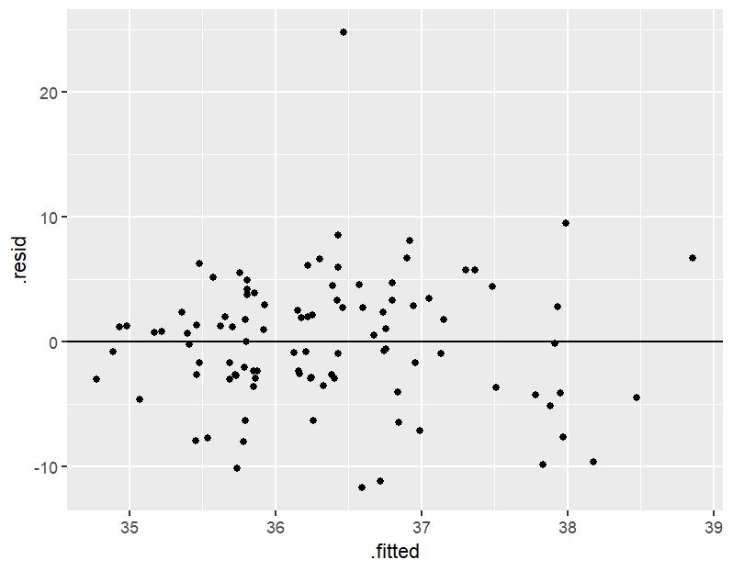
Figure 15: Residual Plot for Latitude VS Total Score

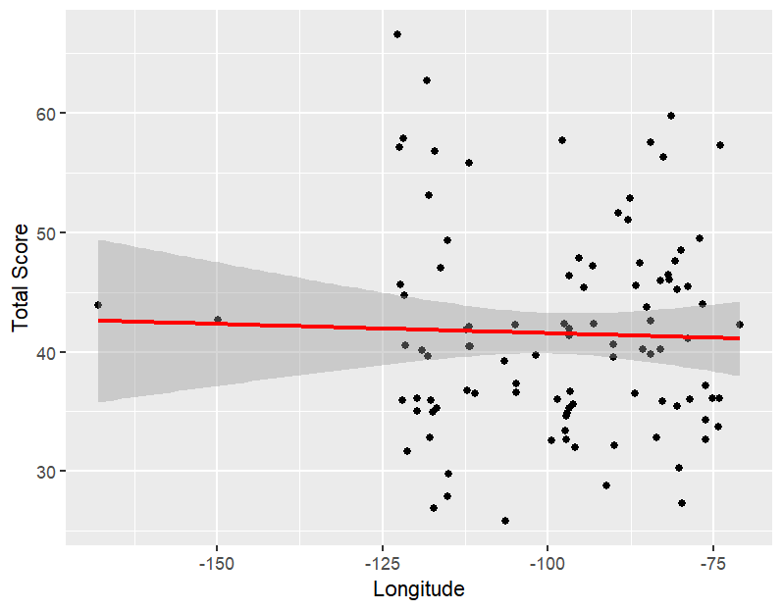
Figure 16: Linear Regression Longitude VS Total Score

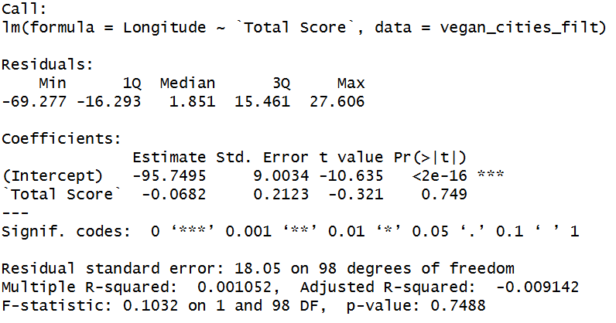
Figure 17: Linear Regression Longitude VS Total Score Results

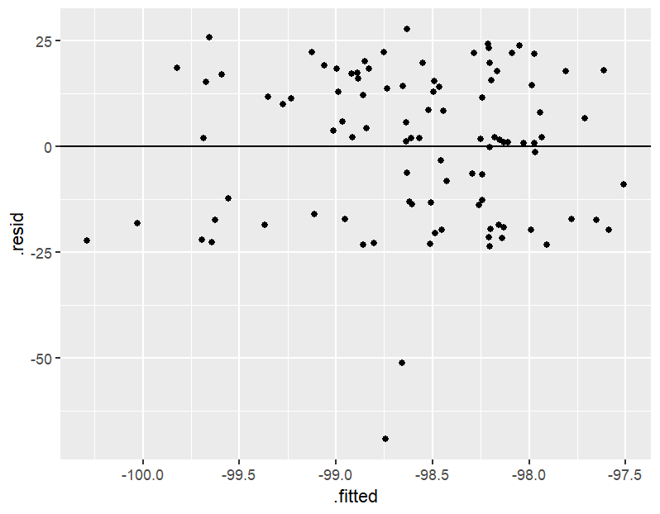
Figure 18: Residual Plot for Longitude VS Total Score

Conclusions & Discussion
The k-means clustering models analyzing the vegan restaurant dataset emphasize that it is difficult to predict the type of cuisine and max price range of vegan restaurants based on location alone. The linear regression models analyzing the vegan city dataset highlight that it is also difficult to predict the vegan-friendliness of a city based on location alone.

The results of these four models are statistically insignificant which suggests that geographical location does not influence cuisine type, price, or quality of vegan food in the United States. There are several limitations to this data analysis that should be considered before accepting this conclusion.

There are several potential biases among the two datasets. Most vegan restaurants from the restaurant dataset were from the Northeastern United States which may have influenced the results of these models or be a subtle indicator as to where many vegan/vegetarian restaurants in the United States tend to be located. The restaurant dataset is a small sample with only 211 data points which could have excluded potential trends existing within the population. Additionally, the vegan city dataset relied on subjective rankings created by the researchers that may not accurately capture the full variety of vegan options in each city. For example, the number of vegan friendly festivals in a city may not be relevant to those only in search of vegan restaurant experiences when visiting or moving to a new location.

Future research should utilize a larger vegan restaurant dataset to get a better scope of the variety of vegan options available throughout the United States. Both datasets also relied on data points from cities and restaurants featuring just vegetarian options as well, which may have inflated the overall number and variety of options due to vegetarian options being more commonly available. Future research should consider excluding vegetarian only options from a vegan data analysis.

References
Vegan Restaurant Dataset: https://data.world/datafiniti/vegetarian-vegan-restaurants
Vegan Cities Dataset: https://data.world/dataremixed/2019-best-us-cities-for-vegans-and-vegetarians

